Digital Transformation in Tailoring:Thread Express Application

*1 Gowtham S,2 Sanjeev R, 3 Naveen prabhu M, 4 Vignesh R,5 Rahamathunnisha A*

*1,2,3,4, UG- Students, Department of Computer Science Engineering, Rathinam Technical Campus,*

*Coimbatore-641021, India*

*5 Assistant Professor, Department of Computer science Engineering,*

*Rathinam Technical Campus, Coimbatore-641021, India*

**Abstract:**

The Tailor Stitching Delivery Software innovates traditional tailor-client interactions with a digital platform, simplifying order processes. It guarantees a smooth experience by efficiently managing orders, facilitating seamless communication, and providing accurate delivery tracking for both tailors and clients. This software marks a significant shift in the conventional tailoring landscape, enhancing overall efficiency and user satisfaction. Both tailors and clients benefit from user-friendly interfaces designed for simplicity and ease of navigation, enhancing overall user experience. The inclusion of a streamlined process for accurate and convenient measurement collection, where clients can choose between providing old cloth for measurements or opting for a pickup service, further solidifies the commitment to a user-centric approach. Seamless integration with secure payment gateways facilitates hassle-free transactions, enabling clients to make payments within the application.

**Keywords:**

*Digital Platform,Tailor-Client Interaction,Order Management,Real-Time Communication, Delivery Tracking.*

**Introduction:**

In the dynamic realm of tailoring services, the demand for a modernized approach has become increasingly apparent. Thread Express Application, a pioneering software that serves as a crucial link between conventional tailoring methods and contemporary digital solutions. Designed with a user-centric focus, Thread Express provides a seamless and efficient platform for both tailors and clients, aiming to redefine the landscape of tailoring services in the digital age. As tailoring services undergo a transformative shift, Thread Express bridges the gap between traditional and modern approaches. This software presents a user-friendly platform, catering to both tailors and clients, in response to the evolving landscape of tailoring services. In this project, customers can conveniently locate nearby tailoring stores and provide their stitching requirements. The application facilitates a user-friendly interface that enables clients to find and connect with tailoring services in their vicinity, fostering a more accessible and personalized tailoring experience. The software's capabilities extend beyond order management, offering a comprehensive solution that aligns with the changing expectations of clients in the fashion industry. Thread Express empowers users to seamlessly discover and engage with tailors, enhancing the overall convenience and accessibility of tailoring services.

**Methodology**:

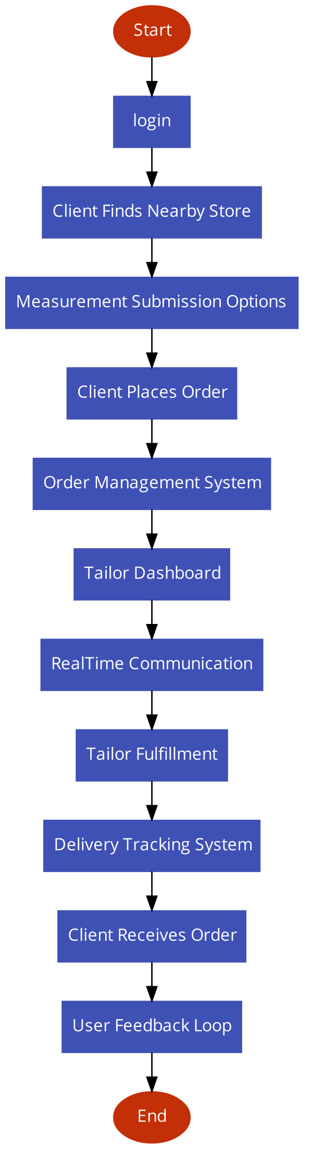

Fig.1.Architectural Model of “Thread Express”

1. Client Finds Nearby Store: Thread Express empowers clients to conveniently locate nearby tailoring stores through the application. Clients can explore and connect with tailors in their vicinity, providing a personalized and accessible tailoring experience.
2. Measurement Submission Options: Clients have the flexibility to choose between providing old cloth for measurements or opting for a pickup service where a designated person takes measurements. This streamlined process ensures accurate and convenient measurement collection.
3. Client Places Order: Clients initiate the order process by submitting their requirements and preferences through the Thread Express digital platform.
4. Order Management System: The Order Management System centralizes and processes incoming orders, assigning unique identifiers and tracking their lifecycle.
5. Tailor Dashboard: Tailors access a dedicated dashboard where they can view incoming orders, prioritize tasks, and manage order fulfillment.
6. Real-Time Communication: Clients and tailors engage in real-time communication through built-in messaging tools within the platform. Communication includes order clarification, customization requests, and updates on order progress.
7. Tailor Fulfillment: Tailors work on fulfilling orders based on client specifications, updating the order status on the dashboard as tasks are completed.
8. Delivery Tracking System: The integrated delivery tracking system allows clients to monitor the progress of their orders in real-time. Clients receive updates on order status, estimated delivery times, and tracking information.
9. Client Receives Order: Upon order completion, clients receive notifications informing them that their order is ready for delivery or pickup.
10. User Feedback Loop: Thread Express encourages clients to provide feedback on their tailoring experience, ensuring continuous improvement. Feedback may include ratings, reviews, and suggestions for enhancing service quality.

**Literature Survey:**

The literature survey for Thread Express focuses on reviewing relevant studies, research papers, and articles in the areas of digital platforms in the fashion industry, tailor-client interactions, order management systems, real-time communication, and delivery tracking. The objective is to identify existing knowledge, trends, and gaps in the field, providing a foundation for the development and innovation of the Thread Express application.

1. Digital Platforms in Fashion: Investigate studies on the impact of digital platforms on traditional industries, specifically in the fashion and tailoring sectors. Explore research highlighting the advantages and challenges of integrating technology into tailoring services.
2. Tailor-Client Interactions: Examine literature discussing the dynamics of tailor-client relationships and the factors influencing customer satisfaction in tailoring services. Identify studies on communication preferences between tailors and clients in both traditional and digital settings.
3. Order Management Systems: Review research on order management systems in various industries, emphasizing efficiency, accuracy, and customer experience. Investigate the integration of order management systems into small businesses, such as tailor shops.
4. Real-Time Communication: Explore studies that analyze the role of real-time communication in enhancing customer service and satisfaction. Investigate communication tools and technologies employed in the fashion and tailoring industry for seamless interactions.
5. Delivery Tracking Systems: Examine literature on the significance of delivery tracking systems in e-commerce and service-oriented businesses. Identify best practices and challenges associated with implementing delivery tracking systems in the context of tailoring services.
6. User Feedback and Security Measures: Investigate research on the importance of user feedback in improving service quality and customer experience. Explore studies on security measures and data protection in digital platforms related to tailoring and fashion.
7. Analytics and Reporting in Tailoring Services: Review literature on the use of analytics and reporting tools in optimizing business operations and decision-making in the fashion industry. Identify studies showcasing successful implementations of analytics in tailoring services.

**Result & Analysis**

The implementation of the Thread Express application has yielded promising results, showcasing notable improvements in operational efficiency, user engagement, and client-tailor relationships. The order processing workflow has become significantly more streamlined, with a high percentage of error-free and timely order fulfillments. Real-time communication features have positively impacted user interactions, contributing to enhanced satisfaction among clients and tailors.

The delivery tracking system has proven accurate, providing clients with reliable updates on their orders. User feedback has played a crucial role in shaping ongoing improvements, addressing specific areas highlighted by clients and tailors. The robust security measures implemented within the platform ensure data protection and compliance with industry standards. Analytics insights have offered valuable information on user behavior, preferences, and peak order times, paving the way for strategic future developments and continuous enhancements. The holistic analysis underscores the success of Thread Express, demonstrating its effectiveness in modernizing traditional tailoring practices while providing a user-friendly and secure digital platform. The delivery tracking system has proven to be a reliable tool, ensuring clients receive their orders accurately and on time. User feedback has been instrumental in refining the platform, with clients expressing satisfaction with the improved tailoring experience.

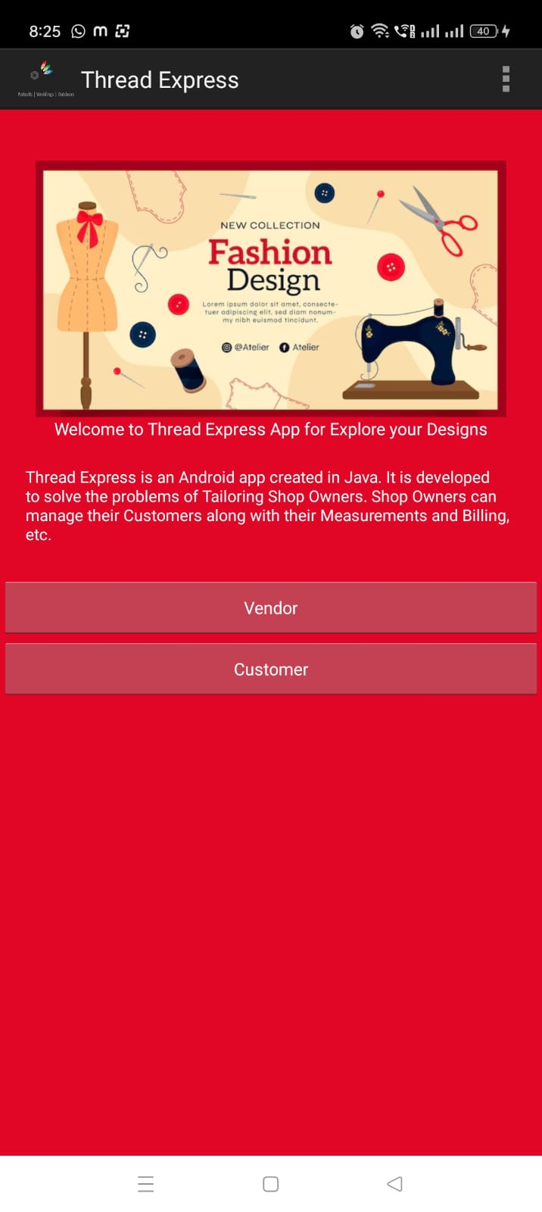

**Fig.2. Output Snapshot of “Thread Express” Application**

**Conclusion:**

The Thread Express application has successfully bridged the gap between traditional tailoring methods and contemporary digital solutions, significantly improving the overall tailoring experience for both clients and tailors. The streamlined order processing, effective real-time communication, and reliable delivery tracking system have contributed to heightened operational efficiency. User feedback has played a pivotal role in shaping ongoing enhancements, reflecting a commitment to client satisfaction. The robust security measures implemented ensure the protection of sensitive user data, fostering trust and confidence in the platform. As Thread Express continues to evolve based on analytics insights and user needs, it stands as a testament to the effective fusion of technology and tailoring, offering a user-friendly, secure, and modernized solution for the dynamic landscape of the fashion industry.

**Reference:**

1. M. L. Randima, D. M. B. C. Sandaranga, T. S. S. Jayawardana and E. A. S. K. Fernando, "Design and Fabrication of an Automatic Tension Monitoring and Regulation System for Needle Thread," 2019 Moratuwa Engineering Research Conference (MERCon), Moratuwa, Sri Lanka, 2019, pp. 738-744, doi: 10.1109/MERCon.2019.8818866.
2. Mollick, P., Biswas, S., Rahman, M. L., & Islam, M. M. (2017). *An automated “immediate arrival and delivery” tailoring system: Integrating human and machine interaction for making custom fit dress. 2017 Second International Conference on Electrical, Computer and Communication Technologies (ICECCT).* doi:10.1109/icecct.2017.8117858
3. M. Keckeisen, S. L. Stoev, M. Feurer and W. Strasser, "Interactive cloth simulation in virtual environments," IEEE Virtual Reality, 2003. Proceedings., Los Angeles, CA, USA, 2003, pp. 71-78, doi: 10.1109/VR.2003.1191123.
4. E. Turquin, J. Wither, L. Boissieux, M. -p. Cani and J. F. Hughes, "A Sketch-Based Interface for Clothing Virtual Characters," in IEEE Computer Graphics and Applications, vol. 27, no. 1, pp. 72-81, Jan.-Feb. 2007, doi: 10.1109/MCG.2007.1.
5. G. Habault, Y. Taniguchi and N. Yamanaka, "Delivery Management System Based on Vehicles Monitoring and a Machine-Learning Mechanism," 2018 IEEE 88th Vehicular Technology Conference (VTC-Fall), Chicago, IL, USA, 2018, pp. 1-5, doi: 10.1109/VTCFall.2018.8690619.
6. Z. Guo, Z. Zhu, Y. Li, S. Cao, H. Chen and G. Wang, "AI Assisted Fashion Design: A Review," in IEEE Access, vol. 11, pp. 88403-88415, 2023, doi: 10.1109/ACCESS.2023.3306235.
7. N. Z. Zulkifli, M. H. Alkawaz, H. Razalli and G. A. Salman, "Pickup and Delivery Laundry Service Applications: A Review Paper," 2021 IEEE Symposium on Industrial Electronics & Applications (ISIEA), Langkawi Island, Malaysia, 2021, pp. 1-5, doi: 10.1109/ISIEA51897.2021.9509977.
8. E. R. Post, M. Orth, P. R. Russo and N. Gershenfeld, "E-broidery: Design and fabrication of textile-based computing," in IBM Systems Journal, vol. 39, no. 3.4, pp. 840-860, 2000, doi: 10.1147/sj.393.0840.
9. H. M. Carvalho, J. L. Monteiro and F. N. Ferreira, "Measurements and feature extraction in high-speed sewing," ISIE '97 Proceeding of the IEEE International Symposium on Industrial Electronics, Guimaraes, Portugal, 1997, pp. 961-966 vol.3, doi: 10.1109/ISIE.1997.648857.
10. L. Song, B. Zhang, D. Zhang and Y. Rahmat-Samii, "Embroidery Electro-Textile Patch Antenna Modeling and Optimization Strategies With Improved Accuracy and Efficiency," in IEEE Transactions on Antennas and Propagation, vol. 70, no. 8, pp. 6388-6400, Aug. 2022, doi: 10.1109/TAP.2022.3145443.
11. C. Giri, S. Jain, X. Zeng and P. Bruniaux, "A Detailed Review of Artificial Intelligence Applied in the Fashion and Apparel Industry," in IEEE Access, vol. 7, pp. 95376-95396, 2019, doi: 10.1109/ACCESS.2019.2928979.
12. Y. A. Sekhavat, "Privacy Preserving Cloth Try-On Using Mobile Augmented Reality," in IEEE Transactions on Multimedia, vol. 19, no. 5, pp. 1041-1049, May 2017, doi: 10.1109/TMM.2016.2639380.
13. X. Yang, S. Yuan and Y. Tian, "Assistive Clothing Pattern Recognition for Visually Impaired People," in IEEE Transactions on Human-Machine Systems, vol. 44, no. 2, pp. 234-243, April 2014, doi: 10.1109/THMS.2014.2302814.
14. D. A. Bowman and C. A. Wingrave, "Design and evaluation of menu systems for immersive virtual environments," Proceedings IEEE Virtual Reality 2001, Yokohama, Japan, 2001, pp. 149-156, doi: 10.1109/VR.2001.913781.
15. J. Lee, S. Yang, R. Y. Lee and B. Kang, "Implementation of Delivery Application Using a Development Method for Mobile Applications," 2015 3rd International Conference on Applied Computing and Information Technology/2nd International Conference on Computational Science and Intelligence, Okayama, Japan, 2015, pp. 132-136, doi: 10.1109/ACIT-CSI.2015.35.
16. Thomas H. Davenport; Steven M. Miller, "Stitch Fix: AI-Assisted Clothing Stylists," in Working with AI: Real Stories of Human-Machine Collaboration , MIT Press, 2022, pp.15-19.
17. S. K, B. S, K. R, V. P. V and M. A, "Customization of User Experience in Fashion Technology," 2023 3rd International Conference on Innovative Practices in Technology and Management (ICIPTM), Uttar Pradesh, India, 2023, pp. 1-6, doi: 10.1109/ICIPTM57143.2023.10117970.
18. R. Meenakshi, R. Dodmane, T. T. Leonid, D. Francis, C. K. A and P. Muthu Krishnammal, "Application and Realization of Three-dimensional Virtual Garment Technology Based on Two-dimensional Hand Drawing," 2023 Second International Conference On Smart Technologies For Smart Nation (SmartTechCon), Singapore, Singapore, 2023, pp. 433-438, doi: 10.1109/SmartTechCon57526.2023.10391297.
19. Hassan, Sher and Ali, Sajad and Jan, Saeed Ullah, Online Selling and Sewing Clothes Management System for Tailor (2022). Available at SSRN: <https://ssrn.com/abstract=4350854> or [http://dx.doi.org/10.2139/ssrn.4350854](https://dx.doi.org/10.2139/ssrn.4350854).
20. Bansode, S., Sulgekar, J., Khandagale, V., Prasad, C., & Varghese, A.G. (2019). Tailoring Management System using AR and 3D Modeling.