**DocCourt SaaS Software**

Harsh Srivastava1, Shraddha Gupta2, Kritika Anand3, Ashnika Sharma4

*1,2,3,4(Final Year B.TECH(IT) Students, Department of COMPUTER SCIENCE & ENGINEERING, INSTITUTE OF*

*TECHNOLOGY & MANAGEMENT, INDIA)*

*Corresponding Author: harshsrivastava09682@gmail.com*

________________________________________________________________________________________________________

*Abstract*: *This research paper explores the utilization of MERN (MongoDB, Express.js, React, Node.js) stack technologies in the development of a Software as a Service (SaaS) platform named DocCourt. Built upon Next.js 13, React, Prisma, tRPC, and Tailwind CSS, DocCourt aims to revolutionize document management through a combination of innovative features and modern web technologies. this paper concentrates on how they include Next.js, React, Prisma, TRPC, and Tailwind CSS into the MERN (MongoDB, Express.js, React, Node.js) stack. With a careful analysis of the architecture, functions, and complications, this study seeks to offer a thorough grasp of the technological developments behind this groundbreaking methodology. The foundation of these systems is the use of Prisma for effective database administration, Next.js and React for creating dynamic and responsive user interfaces, TRPC for reliable API connectivity, and Tailwind CSS for contemporary and beautiful styling. A comprehensive strategy like this tackles the difficulties in processing PDF documents for user identification, question answering, and facilitating seamless communication between frontend and backend components.*

*Keywords:* *PDF-Driven, MERN, TRPC, API.*

*________________________________________________________________________________________________________*

# **INTRODUCTION**

Due to the growing need for scalable, affordable, and easily available solutions in the age of digital solutions, there is an increasing demand for creative Software as a Service (SaaS) platforms. The project "PDF-Chat SaaS Platform Using MERN Stack," which was highlighted in this introduction, is a prime example of how SaaS development is being modernized by using cutting-edge web technologies. It is now commonplace to share papers in a variety of fields, including business, education, research, and publishing, using Portable Document Format (PDF) files. Nevertheless, passive viewing is frequently the only option available with conventional PDF viewers, which discourages participation and teamwork. This constraint is acknowledged, and in response to the demand for dynamic and interactive PDF experiences, the "PDF-Chat SaaS Platform Using MERN Stack" project is born. By offering an all-inclusive Software as a Service (SaaS) platform based on the MongoDB, Express.js, React, and Node.js (MERN) stack, the project seeks to completely transform how users interact with PDF documents. The platform aims to close the gap between dynamic engagement and viewing static documents by utilizing contemporary online technology.

Essentially, the "PDF-Chat SaaS Platform" lets users examine PDF files and provides further tools to help with real-time communication. One important feature is that users can ask questions straight from the PDF document, which helps to start conversations and teamwork around particular topics of interest. The goals of this project are broad and include both user-centered design concepts and technological excellence. Developing an interactive PDF experience, establishing a flawless user interface for participation, guaranteeing technological superiority, and placing security and dependability first are among the main goals.

The "PDF-Chat SaaS Platform" is important for several different sectors and user bases. The platform enables more dynamic and cooperative interactions between teachers and students with course materials in educational environments. By enabling groups to jointly discuss ideas, annotate papers, and make choices within the document interface, it simplifies collaboration procedures in commercial settings. Furthermore, the platform affects fields other than education and business, such as publishing, law, government, and research, where document sharing and discussion are essential to processes. We aim to illustrate the project's potential to change users' interactions with PDF documents and promote more dynamic and collaborative interactions in the digital age through a thorough examination of its design, methods, findings, and original contributions.

# **LITERATURE SURVEY**

The viewpoints and difficulties around software-as-a-service (SaaS) in cloud computing are covered in this article. A summary of SaaS design and important technological concerns, including scalability, redundancy and recovery mechanisms, multi-tenancy architecture, and customization, is given. The paper also examines the necessity of redundancy and recovery methods in SaaS systems, as well as various customization tactics and trade-offs, the significance of multi-tenancy design, and more. It also includes software design techniques, automated data migration, and load balancers as SaaS scaling solutions. The main technological obstacles to creating and executing Software as a Service (SaaS) solutions include scalability, redundancy and recovery procedures, multi-tenancy architecture, and customization. To guarantee the efficiency and dependability of SaaS systems, these issues need to be carefully considered and approached using specific tactics. SaaS system modification is not the same as traditional software customization in a few aspects. SaaS customization possibilities include intelligent customization, SaaS infrastructure that is customizable, fixed variation points with fixed options, tenant-supplied options, tenant-created variation points and options, and SaaS and PaaS setup. Compared to traditional software modification, this enables a more dynamic and flexible approach to customization. [1]

In this research, an offline analysis approach for data center workloads is proposed, which is especially appropriate for SaaS commercial applications. The technique focuses on finding workloads that are suitable for collocation and makes the assumption that resource use patterns are understood. It also offers a way to figure out how much capacity each job can have in terms of set-aside shared resources that are both static and dynamic. Workload utilization logs from several locations are used to assess the methodology. The 99th percentile utilization for reserved capacity is used for low-variation workloads, and heuristics

are used for high-variation workloads. The study takes into account upcoming work on integrating business-specific constraints and recognizes the necessity to look into the best levels of reserved capacity. The suggested program, iCirrus-WoP, calculates virtual machine capacity and creates a workload compatibility matrix. Infrastructure specifics are disregarded, though, so future research into placement algorithms taking these limitations into account is still open. [2]

In this research, the study examines the ongoing and growing security threats to communication, especially in light of the current international situation. It draws attention to the security problems' exponential rise, particularly in light of our growing reliance on technology. To address the growing concerns about the confidentiality of data, including photos, videos, and sound recordings, the study focuses primarily on the necessity of end-to-end encryption in chat programs. The main goal is to put up a system that permits users to securely exchange private information with one another. To offer a reliable and secure platform for communication in the digital age, the paper goes on to propose a detailed list of prerequisites for the creation of a secure chat application. [3]

In this research, Lifeline Messenger has effectively showcased its potential as an all-inclusive chat program that provides users with a smooth and feature-rich interactive conversation experience. Our application's ability to offer media sharing and private and group chat features is made possible by the creation and deployment of the MERN stack. User-friendliness, dependability, and security were carefully considered at every stage of the development process. Users can easily connect with friends and family with Lifeline Messenger's intuitive layout, which makes registration and login simple. The real-time chat feature of the application facilitates quick communication, leading to productive and interesting discussions. Users may easily share files, photos, videos, and other media within their chats thanks to the integration of media-sharing facilities, which improves the entire user experience. Increased engagement is encouraged, and a framework for easy collaboration and content sharing is provided. In addition, Lifeline Messenger gives its users security and privacy a top priority. Steps have been taken to secure user data and guard against unapproved access or possible data breaches. We have made an effort to provide a safe and secure environment for users to interact and exchange information by implementing strong security protocols and encryption techniques. By providing real-time texting and doing away with pointless meetings, Lifeline Messenger transforms communication. Collaboration is improved by effective file sharing and storage. Decisions can be made with knowledge and in real time, thanks to instant reporting. The robust tool Lifeline Messenger promotes smooth communication in the contemporary workplace and maximizes efficiency. [4]

In this research, the examination of language-model-driven chatbots for question answering in PDF-based car manuals is covered in this article. The use of large language models (LLMs) to produce AI-assisted tools for the automotive industry is examined in this paper. Based on answer accuracy, cost, and user experience, the authors evaluate three distinct approaches. The findings demonstrate that selecting a method has a variety of practical ramifications and is dependent on certain factors. The paper sheds light on chatbots' usefulness and application in the automotive sector, especially when it comes to engaging with owner's manuals. According to the study, customer assistance and post-sale services in the automobile sector could undergo a revolution with the use of AI-driven chatbots. In addition to offering prompt and precise responses to questions, these chatbots may help users understand car manuals and encourage safe driving and the upkeep of their vehicles. Additionally, voice command integration and user-friendly interfaces can improve the accessibility of vehicle information for users of different technical skill levels. However, the research also emphasizes difficulties with things like reading PDF documents' visual features and the requirement for constant enhancements to user experience and accuracy. [5]

# **METHODOLOGY**

The "PDF-Chat SaaS Platform Using MERN Stack" project was developed using a methodology that included several phases, including design, implementation, testing, and conceptualization. This section outlines the procedures followed to accomplish the project's goals and gives an overview of the approaches used at each stage:

1. **Conceptualization:** Establishing the project's goals, target market, and salient characteristics was part of the conceptualization stage. This phase started with a detailed examination of the issue statement, taking into account the constraints of conventional PDF viewers as well as the intended functions of the new platform. Important parties were consulted to gather needs and set project goals, including potential users and project sponsors.
2. **Design:** Building a user-centric architecture and interface to support the platform's intended features and functionalities was the main goal of the design process. Many design tenets were taken into account, including:

User Experience (UX) Design: The process of designing a user interface involves creating wireframes and mockups to guarantee that navigation and interaction are intuitive.

System Architecture: Designed to take advantage of the MERN stack's advantages, the platform's architecture also provides the real-time collaborative features needed for interactive PDF viewing.

Security Design: Protection of User Data and Adherence to Privacy Regulations: Sturdy security protocols were integrated into the design.

Scalability and Performance: Care was taken to guarantee that the system could grow with the number of users and manage huge PDF documents being accessed at the same time.

1. **Implementation:** Converting the design specifications into functional code was part of the implementation process. The technologies and frameworks listed below were employed:

MongoDB: This database technology was selected because it is compatible with the Node.js environment and is flexible and scalable.

Express.js: This framework, which offers a lightweight and adaptable way to handle HTTP requests and routing, was utilized in the development of the backend API.

React: React was used to create interactive components and user interfaces for front-end development.

Node Js: Real-time client-server communication and server-side logic were made possible via Node.js, which functioned as the backend’s runtime environment.

Prisma: Prisma was the Object-Relational Mapping (ORM) tool for interacting with databases, making query operations and data modeling easier.

tRPC: By enabling smooth communication between the front end and back end, TypeScript RPC (tRPC) ensures type safety and effective data transport.

Tailwind CSS: Tailwind CSS was selected to style the user interface because it prioritizes usefulness above style and allows for quick development and consistent design.

1. **Testing:** The platform's functionality, performance, and security were all thoroughly tested during this phase. Several testing techniques were used, such as:

Unit Testing: Each component and function was tested to make sure it met the criteria and operated as intended.

Integration Testing: This was done to make sure the frontend and backend components interacted and communicated with each other properly.

User Acceptance Testing (UAT): To get input on the platform's overall usability, functionality, and usability, a small group of users took part in UAT.

Security Testing: To find and fix any security flaws in the platform, penetration tests, and vulnerability assessments were carried out.

1. **Deployment**: The platform was put into a production environment during the deployment phase so that users could access it. Because of its dependability, scalability, and simplicity of use, Vercel—a cloud platform for serverless applications and static websites—was selected for implementation. Pipelines for continuous integration and deployment, or CI/CD, were established to automate the deployment procedure and guarantee a seamless deployment experience.

# **APPLICATIONS**

The "PDF-Chat SaaS Platform Using MERN Stack" project has various applications across different industries and sectors, where document collaboration and interactive viewing are crucial. Here are some key applications of the platform:

1. **Education:** Within educational settings, the platform can transform how students and educators engage with course materials. Students can ask questions, leave comments, and participate in discussions directly within PDF documents, promoting active learning and collaboration. Educators can use the platform to create interactive lesson plans, provide feedback on assignments, and facilitate group projects more efficiently.
2. **Business:** In business environments, the platform can streamline document collaboration, enhance team communication, and improve decision-making processes. Teams can collaborate in real-time on documents such as reports, presentations, and proposals, reducing the need for lengthy email exchanges and version control issues. Moreover, the platform's integration with external services enables seamless sharing of documents with clients, partners, and stakeholders.
3. **Research:** Researchers and academics can benefit from the platform's ability to facilitate collaboration on academic papers, journal articles, and research projects. Collaborators can annotate documents, provide feedback, and discuss findings in real-time, accelerating the research process and enabling greater collaboration across geographically dispersed teams.
4. **Publishing:** In the publishing industry, the platform can streamline the editorial process from manuscript submission to publication. Authors, editors, and reviewers can collaborate on manuscripts, track changes, and communicate feedback efficiently. Publishers can also use the platform to create interactive digital publications with embedded multimedia content and interactive features.
5. **Legal:** Law firms and legal professionals can utilize the platform for document review, case preparation, and client collaboration. Attorneys can annotate legal documents, securely share case files with clients, and collaborate with colleagues on briefs and memos. The platform's security features ensure confidentiality and compliance with data protection regulations.
6. **Government:** Government agencies and departments can leverage the platform for document management, policy development, and public engagement. Officials can collaborate on legislative documents, public reports, and policy proposals, while citizens can provide feedback and comments on government initiatives through the platform's interactive features.

Overall, the "PDF-Chat SaaS Platform Using MERN Stack" has diverse applications across industries and domains, enabling effective collaboration on documents, improved communication, and streamlined workflows

1. **FUTURE SCOPE**

The future scope of the PDF Chat SaaS platform using the MERN stack is vast and promising, with opportunities to enhance collaboration features, improve security and compliance, support mobile and cross-platform accessibility, integrate with other tools and platforms, optimize user experience and performance, build a strong community and ecosystem, and adopt sustainable and green computing practices. By focusing on these areas and embracing innovation and technological advancements, the platform can evolve and thrive in the competitive market, meeting the changing needs and expectations of users worldwide.

The "PDF-Chat SaaS Platform Using MERN Stack" project sets the stage for future advancements and improvements in document collaboration and viewing. Here are some potential areas for further development:

1. Advanced Collaboration Features
2. Enhanced Accessibility
3. Analytics and Reporting
4. Integration with External Services
5. Multi-Language Support
6. Blockchain Integration
7. **RESULT**

**Home Page:** This Project’s Home Page Consists of a look at our Software and its Features that will be provided by our software, there is a SIGNING option and a Pricing option from which users can purchase pro plans which provide some extra features.

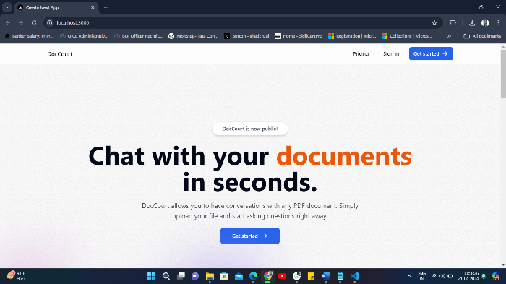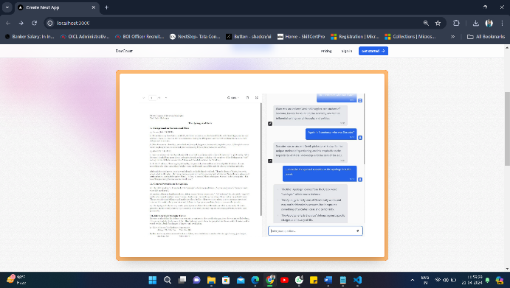

Fig.6.1 Home Page Fig.6.2 After Look of Document Upload

**Sign In / Signup Page:** This is the Project’s Sign Up Page from where users can Sign up or Sign in and access our software and its features.

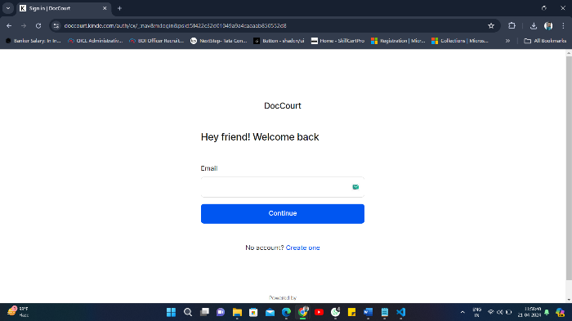

Fig.6.3 Signing Page

# **Conclusion**

The research paper on the "PDF Chat SaaS platform" concludes by offering a full analysis of the application's performance and highlighting its effectiveness, low latency, and real-time communication capabilities. The transformational potential for customer assistance is shown by exploring the deployment of language-model-powered chatbots in the automotive industry. The study addresses workload compatibility issues with SaaS and suggests an offline analysis method. End-to-end encryption is recommended in response to security and privacy issues in chat applications. In summary, the document provides insightful information about the technical and industry-specific features of the PDF Chat SaaS platform, which adds to the current conversations about SaaS applications and their wider outcome.

# **Acknowledgement**

We would like to thank to our Project Guide Mr. Chhiteesh Rai Sir for their guidance and for helping us with our project.

# **References**

[1]. Tsai, W., Bai, X., & Huang, Y. (2014). Software-as-a-service (SaaS): Perspectives and Challenges. Science China Information Sciences, 57, 1–15.

[2]. Ganesan, R., Sarkar, S., Narayan, A., (2012). Analysis of SaaS Business Platform Workloads for Sizing and Collocation. IEEE Fifth International Conference on

Cloud Computing, 868-875.

[3]. KILIÇ, M.B., (2021). Encryption Methods and Comparison of Popular Chat Applications. Advances in Artificial Intelligence Research (AAIR). 1(2), 52-59.

[4]. Bedare, A., Jaiswal, H., Kantule, N. and Kale, S. (2023). Lifeline Messenger Real-Time Chat Application: Using Mern Stack. International Research Journal of Modernization in Engineering Technology and Science, 05(05), 5627-5634.

[5]. Medeiros, T., Medeiros, M., Azevedo, M., Silva, M., Silva, I., & Costa, D. G. (2023). Analysis of Language-Model-Powered Chatbots for Query Resolution in PDF-Based Automotive Manuals. Multidisciplinary Digital Publishing Institute Basel Switzerland, 5(4), 1384-1399.