**Immunopharmacology: Modulation of the Immune System for Therapeutic Interventions**

**1. Abstract-**

In recent years, there has been a tremendous development of biotechnological, pharmacological, and medical techniques which can be implemented in the functional modulation of the immune system components. Immunomodulation has attracted much attention because it offers direct applications in both basic research and clinical therapy. Modulation of a non-adequate, amplified immune response enables to attenuate the clinical course of a disease and restore homeostasis. The potential targets to modulate immunity are as multiple as the components of the immune system, thus creating various possibilities for intervention. However, immunomodulation faces new challenges to design safer and more efficacious therapeutic compounds. This review offers a cross-sectional picture of the currently used and newest pharmacological interventions, genomic editing, and tools for regenerative medicine involving immunomodulation. We reviewed currently available experimental and clinical evidence to prove the efficiency, safety, and feasibility of immunomodulation in vitro and in vivo. We also reviewed the advantages and limitations of the described techniques. Despite its limitations, immunomodulation is considered as therapy itself or as an adjunct with promising results and developing potential.

The development and progression of the inflammatory process is tightly connected with the innate immune system action. The main initial features of inflammation include vasodilation and increased blood flow. This leads to erythema and an increase in the temperature of the inflammation-affected area. Increased vascular permeability allows the inflammatory cells to infiltrate from the blood flow to the tissue, causing tissue edema and swelling. Inflammatory mediators such as bradykinins and prostaglandins increase pain sensitivity and cause hyperalgesia. Cleaning up of the infected area is possible because of the chemotaxis ability of neutrophils triggered by a gradient of chemokines released by the damaged tissue.

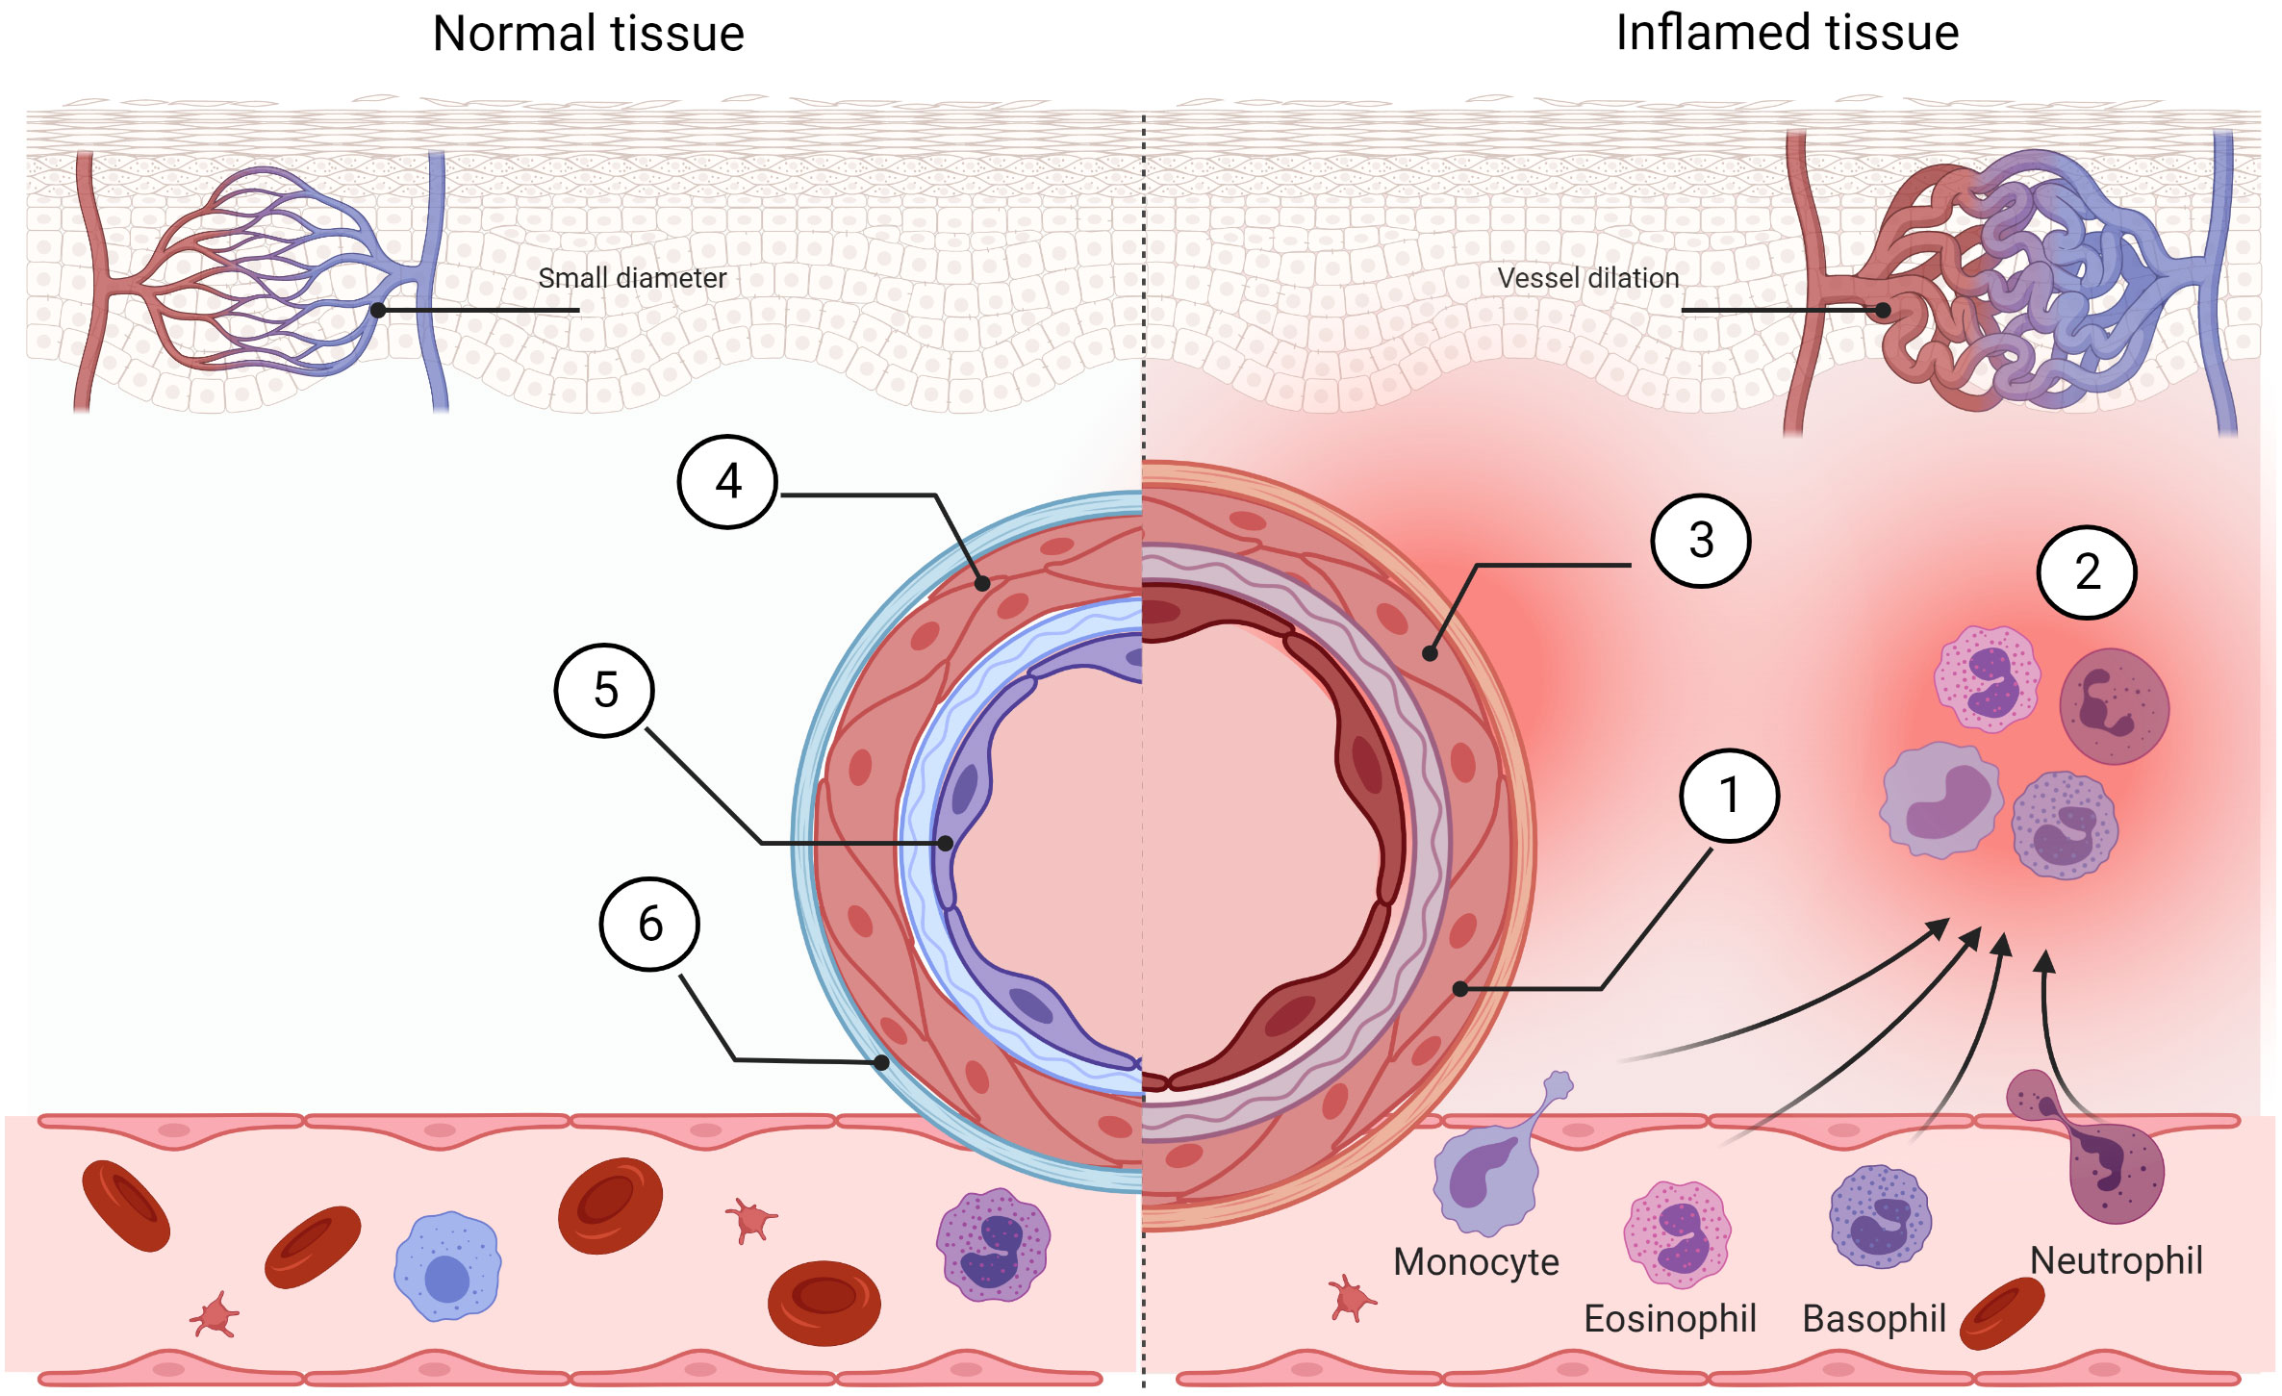Fig.1

Despite the emergence and the clinical success of biologics, several limitations hamper the therapeutic manipulation of the inflammatory networks underlying the multifaceted aetiology of many immune disorders. For instance, agents produced by means of biological processes frequently involving recombinant DNA technology are expensive. More importantly, they lack oral availability and often show inefficient delivery to target tissues in vivo. Another example is the recently recognized rapid onset and short duration of the non-genomic glucocorticoid actions. These new discoveries should help in facilitating the development of new improved strategies for the management of inflammatory and autoimmune diseases. In particular, histamine interacts with four types of GPCRs, designated as H1–H4, and it is a major component of the immune system playing a critical role in inflammation. For more than 70 years, histamine has been one of the most exploited substances in medicine, providing blockbuster drugs acting on H1 and H2 receptors for the treatment of allergies and gastric ulcers respectively. The rapid entry of H4 receptor-targeting compounds into advanced clinical development will benefit patients with poorly treatable chronic diseases. Advances in basic immunology have contributed to the identification of various critical molecules involved in several immune reactions and their respective pathophysiological roles in a variety of immunological diseases.

**2. Keywords**:- Immunomodulators, Immunotherapy, Autoimmune diseases, Inflammatory disease, Cytokines

**3. Introduction -**

The immune system has an invaluable role in the resistance to pathogenic infections and the maintenance of homeostasis. An adequate immune response to an encountered danger is an eligible and a deliberate balance-saving mechanism. However, so far, immunomodulation is successfully applied in the clinic. The immune system is a multiscale system that involves genes, molecules, cells, and organs, organized in complex networks of synergistic interactions and aimed at combating various types of threats to the organism. For example, in oncology, it is possible to enhance the natural ability of human T cells to recognize tumor cells. Monoclonal antibodies can be also used as agonists to imitate immunomodulatory signaling on antigen-presenting cells. We also can inhibit proinflammatory factors by blocking their release. In case of the presence of signals, which indicate infections or death of neighboring cells, phagocytes can intercept pathogen-associated molecular patterns (PAMPs) or damage/danger-associated molecular patterns (DAMPs) by pattern recognition receptors (PRRs) on their surface. The action of NK cells can be modulated by IL-22 secreted by T lymphocytes which indirectly suppress the function of NK cells against cancer cells by modulating CD155 expression on the cancer cells’ surface.

**Cell-mediated immunity:**

Cell-mediated immunity is the term for a specific adaptive immune response activated by Th1 cells, which leads to the activation of APCs and a cytotoxic T-cell response. This immune response fights intracellular infections, including viruses , some bacteria, fungi and protozoans

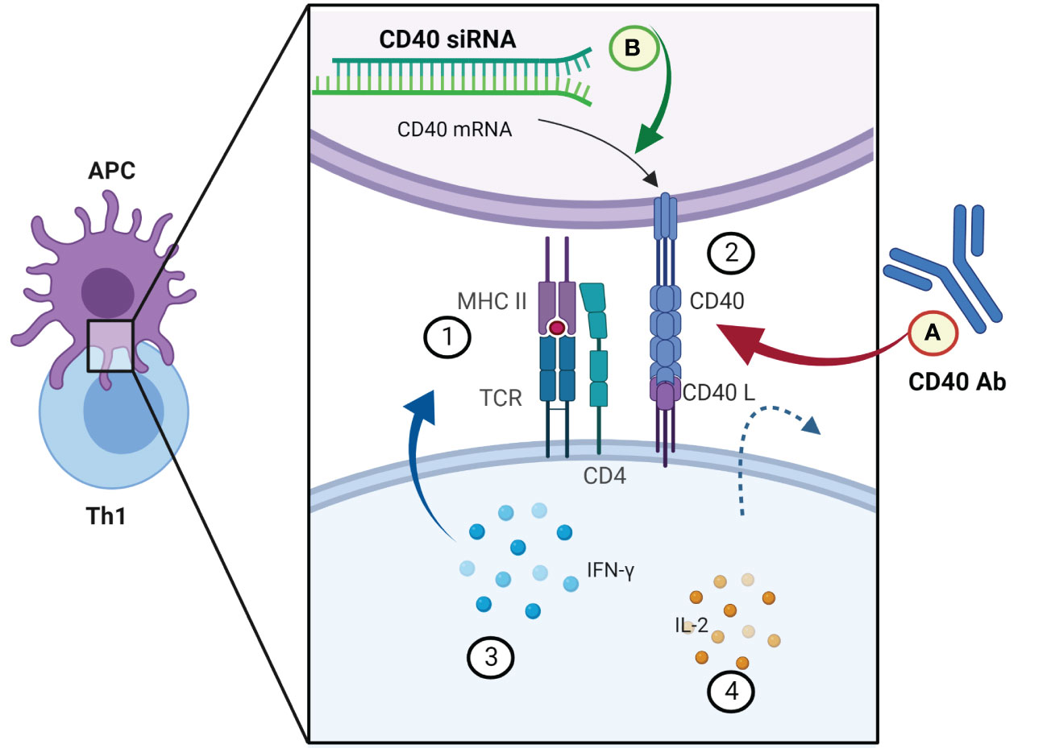Fig.2

Cytotoxic T cells remove infected cells in various ways. They perforate the cell wall of infected cells and release granzymes, granulysin, and perforins, which induce apoptosis and DNA fragmentation. They can also lead to forming a death-inducing signaling complex (DISC) by Fas ligand interactions

**Humoral Immunity:**

Successful vaccination strategies against a number of pathogens including viruses and pathogenic bacteria depend upon the humoral immune response. In addition, neutralising antibodies induced during infection with highly mutating viruses such as HIV, HCV and influenza have shaped current strategies for vaccine design . B cell activation through binding of the B cell receptor (BCR) to a cognate antigen in the context of various additional signals drives both proliferative and differentiation programs. These processes result in expanded populations of both early effector cells that can secrete copious amounts of antibody as well as long-lived populations of B cells that can protect against secondary infections (Figure 1). In recent years, we have made considerable advances in our knowledge of the molecular regulation of the generation, function and maintenance of humoral immune responses induced by immunization. We have a better understanding of the critical interactions between CD4+ T cells and B cells and the key transcriptional regulators that are important for germinal center (GC) responses, and the heterogeneous populations of memory cells that emerge from the GC (both long-lived plasma cells (LLPCs) and memory B cells (MBCs). In an effort to generate better vaccines however, we now need to understand how specific B cell populations can be optimally protective against specific microbial infections, taking into account unique inflammatory signatures, antigen loads, tropisms or immune evasion mechanisms. We propose that the evolution of host-pathogen interactions over time has led to a greater heterogeneity in the development and function of humoral immune responses than perhaps revealed by protein immunization models. Recent studies in this review illuminate both the common mechanisms shared by infection-specific humoral responses as well as highlighting unique characteristics of pathogen-specific responses to counteract immune evasion strategies. Since innate-like CD5+ B1 B-cells are not thought to form memory and their role in infection has recently been extensively reviewed, this review will only focus on B2 B cells.

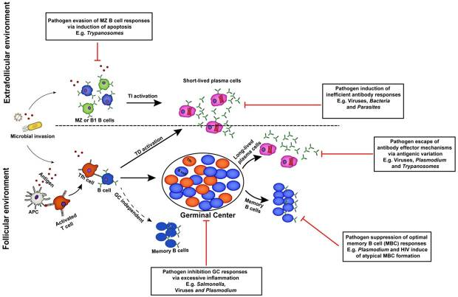Fig.3

Extrafollicular and follicular antibody responses contribute to protection against invading microbial pathogens. B cells activated within the extrafollicular environment in the presence or absence of T cell help differentiate into short-lived antibody secreting cells that mediate early protection against infection. However, the formation of germinal center dependent or independent memory B cells and long-lived plasma cells in the B cell follicles facilitates complete resolution of primary infections and long-term protection against reinfection. For their survival, pathogens have evolved strategies that enable them to evade specific antibody-dependent killing mechanisms.

**Non-steroidal anti-inflammatory drugs:**

The use of the very first NSAID—aspirin—dates back to the 18th–19th centuries, when the antipyretic usage of willow bark gave rise to the isolation of salicin and finally to the synthesis of acetylsalicylic acid. The anti-inflammatory action of NSAIDs is based on the reduction of prostaglandin E2 and prostacyclin levels, preventing from local vasodilation**.** The anti-inflammatory, antipyretic, and analgesic effects are caused by the inhibition of isoform 2-cyclooxygenase (COX-2), and side effects connected with the intake of NSAIDs arise from the inhibition of the constitutive isoform 1-cyclooxygenase (COX-1). This strategy could also be used with coxibs (8). The coxibs such as celecoxib and etoricoxib exhibit higher selectiveness in the inhibition of COX-2; thus, they induce fewer gastrointestinal side effects. To sum up, the pros of NSAIDs are their anti-inflammatory, antipyretic, and analgesic actions and their antineoplastic, antithrombotic, and antiarthritic effects. The cons of NSAIDs are gastrointestinal complications, hepatotoxic problems, renal injury, cardiovascular problems, cerebral complications, respiratory tract issues, and mitochondrial toxicity. Another challenge in designing new NSAIDs is to find highly selective inhibitors of the COX-2 enzyme to increase the benefit/risk profile.

**Properties of Immunomodulatory of mesenchymal stem cell:**

MSCs were discovered in 1970 , and they are multipotent adult cells with self-renewing properties. These cells have immunomodulatory features; therefore, MSCs are potential tools in treating inflammation-related diseases. The common sources of MSCs are the bone marrow (BMMSCs), adipose tissue (ATMSCs), and perinatal tissues, such as Wharton’s jelly (WJMSCs) and amniotic fluid (AFMSCs). The biological role of MSCs is supportive: derivates of MSCs (osteoblasts and fibroblasts) co-create marrow niches for hematopoietic cells. Stromal cells take part in hematopoietic regulation; they secrete growth factors, chemokines, and cytokines (GM-CSF, LIF, SCF, thrombopoietin, IL-8, IL-10, IL-11, IL-14, IL-15). MSCs are involved in tissue regeneration and immunomodulation. They enable the settlement of the marrow environment by transplanted hematopoietic stem cells. MSCs produce components of the extracellular matrix: collagen types I, III, IV, and VI; fibronectin; laminin; hyaluronan; and proteoglycans. They suppress the proliferation of alloT lymphocytes after transplantation. There are no antibody anti-surface proteins of MSCs. In the presence of MSCs, mitogen-stimulated lymphocytes do not proliferate. Transplantation of MSCs does not cause tolerance induction for HLA antigens of given stem cells. The trophic factors secreted by MSCs have beneficial effects on the central nervous system, thus making MSC-based therapies suitable candidates for the treatment of CNS injuries and neurodegenerative diseases. In light of the current scientific data, the MSC secretome was shown to display both direct and indirect influences on neuronal and glial survival and differentiation. Another drug based on MSCs—Alofisel—is based on expanded adipose-derived stem cells and has been approved by the European Medicines Agency as therapy for complex perianal fistulas. Both of these drugs are allogeneic and derived from healthy adult individuals.

**3.Discussion-**

In addition to the classical therapeutic approaches, the novel immunopharmacological concepts and tools and their relevance to human disease offer new options for unmet medical needs including, among others, cancer, inflammatory, autoimmune, metabolic and infectious diseases. The recent developments in immunology and pharmacology emphasize the necessity not only to exploit new classes of drugs, such as cytokines, PKIs and mAbs, but also to improve those that are already in use. Immunomodulation is a challenging branch of medical science, and with the steady improvements in drug design, immunomodulators have become more selective and attenuate the side effects of novel pharmacological treatments. There are limitations in improving manufacturing capabilities: chemical formulation and delivery mechanisms of recently designed highly selective molecules to be safer and more efficacious therapeutic compounds . As in the case of treating diseases in general, these substantive advances need to be combined with a more judicious selection of disease indications and better-validated intervention pathways.

**4.Applications-**

**Cancer Immunotherapy:** Modulating the immune system to target and destroy cancer cells involves harnessing the body's natural defense mechanisms to recognize and eliminate malignant cells. The immune system is a complex network of cells, tissues, and organs that work together to protect the body from harmful invaders, including cancer.

**Autoimmune Diseases:** Suppressing the immune response in autoimmune conditions, such as rheumatoid arthritis, lupus, and multiple sclerosis, is a therapeutic approach aimed at alleviating symptoms and preventing further damage caused by the immune system's attack on the body's own tissues.

**Vaccines and Immunization:** Enhancing the immune response to prevent infectious diseases involves employing various strategies and approaches to strengthen the body's natural defense mechanisms against harmful pathogens. The immune system is a complex network of cells, tissues, and organs that work together to protect the body from infections. By bolstering this system, researchers and healthcare professionals aim to reduce the susceptibility to and severity of infectious diseases.

**Antiviral Immunopharmacology:** Developing drugs to enhance the immune response against viral infections is a critical and dynamic area of biomedical research. This field focuses on designing pharmaceutical interventions that augment the body's natural defense mechanisms, aiming to improve the ability to identify, target, and eliminate viral pathogens. The goal is to develop effective and safe therapeutics that can be used to treat a wide range of viral infections, from common respiratory viruses to emerging and highly pathogenic viruses

**5.Conclusion-**

In conclusion, immunopharmacology plays a pivotal role in modulating the immune system for therapeutic interventions. The intricate interplay between various immune cells, signaling pathways, and immunomodulatory agents offers a diverse array of opportunities for targeted interventions in the treatment of various diseases. The advancements in our understanding of the immune system have led to the development of novel immunotherapies that hold great promise in the fields of oncology, autoimmune disorders, and infectious diseases. Immunomodulatory drugs, such as checkpoint inhibitors, monoclonal antibodies, and small molecule inhibitors, have revolutionized the landscape of cancer treatment by harnessing the body's immune system to target and eliminate cancer cells. Additionally, targeted immunotherapies have shown significant efficacy in managing autoimmune disorders, providing a more precise and tailored approach to immune modulation. The ongoing research in immunopharmacology continues to uncover new targets and therapeutic strategies, expanding our arsenal against diseases with immune system involvement. It is crucial to acknowledge the importance of a balanced immune response. While immunomodulation can be beneficial in treating diseases, an overly suppressed or hyperactive immune system can lead to adverse effects. Therefore, a nuanced understanding of the immune system's intricacies is essential for designing effective and safe immunopharmacological interventions. As we move forward, the integration of personalized medicine approaches, biomarker discovery, and innovative drug delivery systems will further enhance the precision and efficacy of immunotherapies. Collaborative efforts between researchers, clinicians, and pharmaceutical companies will be vital in translating the latest discoveries in immunopharmacology into clinically relevant therapies.

**6.References-**

1. Garofalo S, Cocozza G, Porzia A, Inghilleri M, Raspa M, Scavizzi F, et al. Natural killer cells modulate motor neuron-immune cell cross talk in models of amyotrophic lateral sclerosis. Nat Commun (2020) 11(1):1773. doi: 10.1038/s41467-020-15644-8

2. Subramanian N, Torabi-Parizi P, Gottschalk RA, Germain RN, Dutta B. Network representations of immune system complexity. Wiley Interdiscip Rev Syst Biol Med (2015) 7(1):13–38. doi: 10.1002/wsbm.1288

3. Stadtmauer EA, Fraietta JA, Davis MM, Cohen AD, Weber KL, Lancaster E, et al. CRISPR-engineered T cells in patients with refractory cancer. Science (2020) 367(6481):eaba7365. doi: 10.1126/science.aba7365

4. Moss ML, Sklair-Tavron L, Nudelman R. Drug insight: Tumor necrosis factor-converting enzyme as a pharmaceutical target for rheumatoid arthritis. Nat Clin Pract Rheumatol (2008) 4(6):300–9. doi: 10.1038/ncprheum0797

5. Medzhitov R, Janeway C Jr. Innate immune recognition: mechanisms and pathways. Immunol Rev (2000) 173:89–97. doi: 10.1034/j.1600-065x.2000.917309.x

6. Briukvovetska D, Sauarez-Gosalvez J, Voigt C, Huber S, Endres S, Kobold S. T Cell-derived interleukin-22 drives the expression of CD155 by cancer cells to suppress NK cell function and promote metastasis. Immunity (2023) 56:143–161. doi: 10.1016/j.immuni.2022.12.010

7. Rydyznski Moderbacher C, Ramirez SI, Dan JM, Grifoni A, Hastie KM, Weiskopf D, et al. Antigen-specific adaptive immunity to SARS-CoV-2 in acute COVID-19 and associations with age and disease severity. Cell (2020) 183(4):996–1012.e19. doi: 10.1016/j.cell.2020.09.038

8. Al-Wasaby S, Guerrero-Ochoa P, Ibáñez-Pérez R, Soler R, Conde B, Martínez-Lostao L, et al. In vivo potential of recombinant granulysin against human melanoma. Cancer Treat Res Commun (2021) 27:100355. doi: 10.1016/j.ctarc.2021.100355

9. Costigan M, Scholz J, Woolf CJ. Neuropathic pain: a maladaptive response of the nervous system to damage. Annu Rev Neurosci (2009) 32:1–32. doi: 10.1146/annurev.neuro.051508.135531

10. Chen CJ, Kono H, Golenbock D, Reed G, Akira S, Rock KL. Identification of a key pathway required for the sterile inflammatory response triggered by dying cells. Nat Med (2007) 13(7):851–6. doi: 10.1038/nm1603

11. Kopf M, Bachmann MF, Marsland BJ. Averting inflammation by targeting the cytokine environment. Nat Rev Drug Discov. 2010;9:703–718.

12. Alangari AA. Genomic and non-genomic actions of glucocorticoids in asthma. Ann Thorac Med. 2010;5:133–139.

13. Baumgarth N: B-1 Cell Heterogeneity and the Regulation of Natural and Antigen-Induced IgM Production. Front Immunol 2016, 7:324.

14. Burton DR, Hangartner L: Broadly Neutralizing Antibodies to HIV and Their Role in Vaccine Design. Annu Rev Immunol 2016, 34:635–659.

15. Amanna IJ, Carlson NE, Slifka MK: Duration of humoral immunity to common viral and vaccine antigens. N Engl J Med 2007, 357:1903–1915.

16. Zumla A, Chan JF, Azhar EI, Hui DS, Yuen KY. Coronaviruses - drug discovery and therapeutic options. Nat Rev Drug Discov. 2016 May;15(5):327-47. doi: 10.1038/nrd.2015.37

17. Plotkin SA. Vaccines: past, present and future. Nat Med. 2005 Dec;11(4 Suppl):S5-11. doi: 10.1038/nm1209..

18. McInnes IB, Schett G. The pathogenesis of rheumatoid arthritis. N Engl J Med. 2011 Dec 8;365(23):2205-19. doi: 10.1056/NEJMra1004965.

19. Sharma P, Allison JP. Immune checkpoint targeting in cancer therapy: toward combination strategies with curative potential. Cell. 2015 Apr 23;161(2):205-14. doi: 10.1016/j.cell.2015.03.030.

20. Bindu S, Mazumder S, Bandyopadhyay U. Non-steroidal anti-inflammatory drugs (NSAIDs) and organ damage: A current perspective. Biochem Pharmacol (2020) 180:114147. doi: 10.1016/j.bcp.2020.114147

21. Mellman I, Coukos G, Dranoff G. Cancer immunotherapy comes of age. Nature. 2011;480(7378):480-489.

22. Pardoll DM. The blockade of immune checkpoints in cancer immunotherapy. Nat Rev Cancer. 2012;12(4):252-264.

23. Abbas AK, Lichtman AH, Pillai S. Cellular and Molecular Immunology. 9th edition. Philadelphia: Elsevier; 2017.

24. Smolen JS, Aletaha D, McInnes IB. Rheumatoid arthritis. Lancet. 2016;388(10055):2023-2038.

25. O'Shea JJ, Kontzias A, Yamaoka K, Tanaka Y, Laurence A. Janus kinase inhibitors in autoimmune diseases. Ann Rheum Dis. 2013;72 Suppl 2:ii111-5.