**Environmental Impact Assessment and Remediation Strategies in Sheet Fed Offset Printing Technology**

MEENAKSHI K,

Dept of Printing Technology, Avinashilingam Institute for Home Science & Higher Education for Women, Coimbatore

MIRUTHUBASHINI T,

Prof, Dept of Mechanical Engineering, Kumaraguru College of Technology

ARULMOZHI A,

Prof & Head, Dept of Printing Technology, Avinashilingam Institute for Home Science & Higher Education for Women, Coimbatore

*I. Abstract*— *This paper conducts an environmental impact assessment (EIA) of sheet fed offset printing technology, addressing concerns such as volatile organic compounds (VOCs), energy consumption, and waste generation. The assessment covers prepress, printing, and post-press activities, with proposed remediation strategies focusing on adopting eco-friendly inks, optimizing energy usage, and implementing waste reduction measures. Ultimately, the study aims to promote sustainable printing practices in the industry.*

*Key Words – Sheet fed offset printing, Environmental impact assessment (EIA), Volatile organic compounds (VOCs), Energy Consumption, Waste generation, Remediation strategies, Eco-friendly inks, Workflow management, Waste reduction, Sustainable printing practices.*

II. INTRODUCTION:

Sheetfed offset printing technology has long been a cornerstone of the printing industry, valued for its ability to produce high-quality prints on a wide range of substrates. However, the environmental impact of this widely used printing method has become a growing concern in recent years. The inherent characteristics of sheetfed offset printing, including the use of volatile organic compounds (VOCs), energy-intensive processes, and substantial waste generation, have prompted a re - evaluation of its sustainability.

Environmental Impact Assessment (EIA) plays an important role in modern industrial processes and assesses the potential environmental impacts of proposed projects to ensure sustainable development. A study by Sharma and Arora (2021) shows that the implementation of EIA encourages environmental protection practices in various sectors, including printing technology. Incorporating EIA principles into cost-effective technology represents a powerful way to

improve the efficiency and sustainability of the printing industry. By adopting environmental protection practices, authors can achieve a balance between economic prosperity and ecological conservation, paving the way for greater sustainability. Sharma, R. and Arora, D (2021).

The role of environmental impact assessment to ensure sustainability. By implementing these remediation measures, the printing industry can strive towards achieving a more sustainable and eco-friendly operation, aligning with global initiatives to combat climate change and preserve natural resources. This draws upon the research conducted by Huang et al. (2018), who emphasized the importance of adopting low-VOC or VOC-free inks and coatings to reduce emissions without compromising print quality.

III. LITERATURE REVIEW:

The literature on Environmental Impact Assessment (EIA) and remediation strategies in the technical context of the workshop report provides a comprehensive understanding of the challenges and opportunities for sustainability in the publishing industry. The environmental footprint of general aviation, particularly as it relates to emissions of volatile organic compounds (VOCs). VOCs are released during ink drying, which pollutes the air and poses health risks to workers.

A study by Huang et al. (2018) highlighted the importance of using low or no VOC inks and coatings to reduce emissions without compromising print quality. Lee and Hsu (2019) and Wu et al. (2020) have explored energy-saving measures such as the optimization of printing parameters, equipment upgrades, and the implementation of energy management systems to enhance energy efficiency and reduce carbon emissions throughout the printing process. Efforts to address waste generation in sheetfed offset printing have also been documented in the literature. This includes research on waste reduction strategies such as paper recycling, ink recovery, and the adoption of digital workflows to minimize overruns and setup waste. Additionally, advancements in waste-to-energy technologies offer promising avenues for converting printing waste into renewable energy sources (Li et al., 2021).

Furthermore, the integration of digital technologies and automation in sheetfed offset printing has emerged as a key theme in recent literature. Digitalization enables greater control over printing processes, reduces material waste, and facilitates the adoption of on-demand printing models, thereby enhancing sustainability (Tebas et al., 2020). Overall, the literature underscores the importance of conducting comprehensive EIAs to identify environmental hotspots and implementing remediation strategies that prioritize sustainability without compromising print quality or production efficiency. By leveraging insights from existing research, this study aims to contribute to the ongoing efforts to promote environmental stewardship in the sheetfed offset printing industry.

IV. SYSTEM DESCRIPTION:

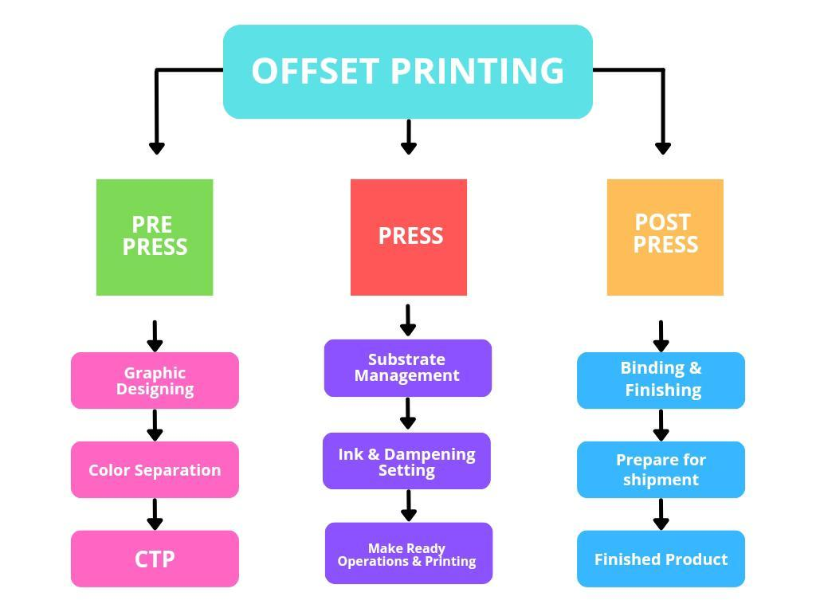

V. METHODOLOGY:

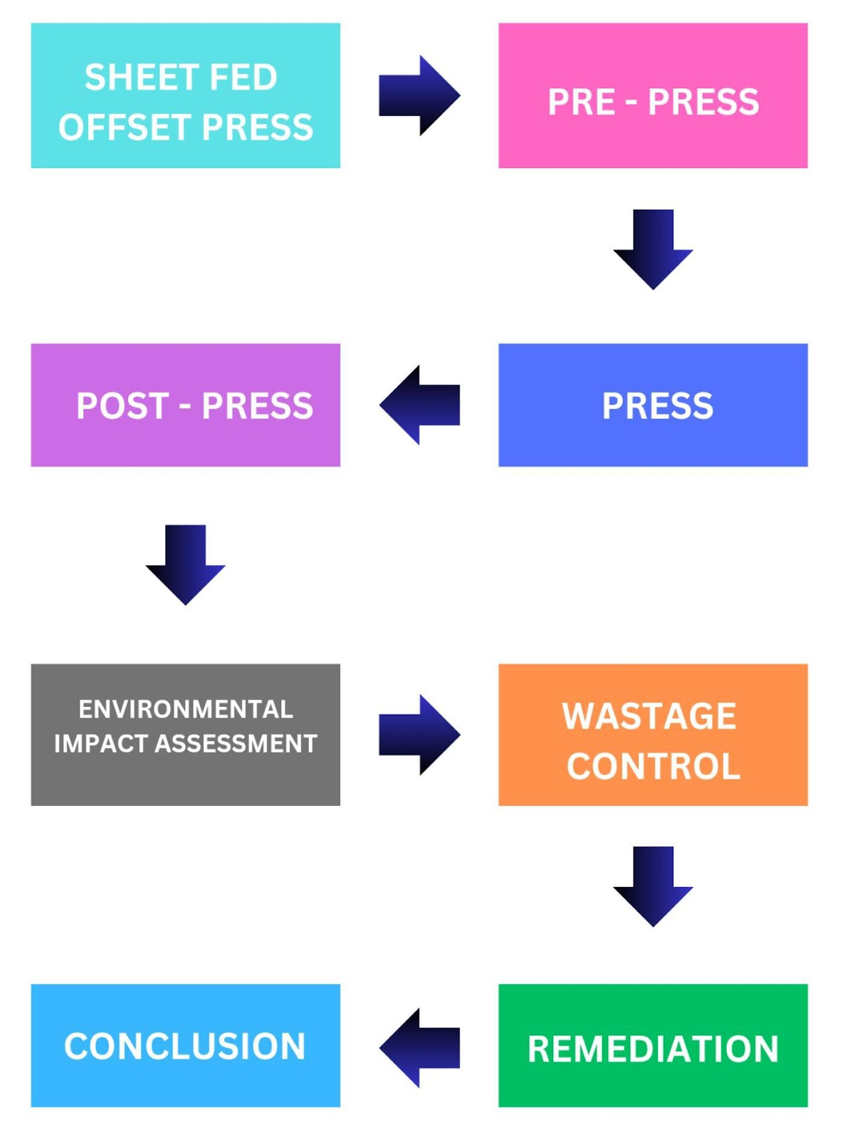

VI. ENVIRONMENTAL IMPACT ASSESSMENT:

1. ***Pre – press section:***

❖ The common factor in many graphic creations, especially in packaging design, is that they are usually printed in large quantities to meet consumer demands. However, amid the focus on reducing packaging material consumption, one crucial aspect seems to have been overlooked.

❖ The environmental impact of printing inks. Often deemed insignificant, the inks used in graphic creations play a more substantial role. We might realize, both in terms of their ecological implications and economic considerations.

❖ Although no significant VOC emissions are generated from the prepress / imaging process, developers and fixers may generate emissions of sulphur compounds, acetic acid, and ammonia from blueprint, as well as odors, particularly in older processes (IFC, 2007).

❖ Computer-to-plate technology (CTP) increased the efficiency of pre-press processes in all printing systems and reduced the use of water significantly. Moreover, other chemicals such as photographic film and photographic developer containing silver and print developer were not used.

❖ Thus, the factors having negative effect on the environment due to the waste film, waste developer and water consumption and causing waste formation were eliminated. Using metal by instead of using acid in preparation print developer for printing, is one of the important measures minimizing the environmental impact of pre-press processes.

❖ Photographic wastes from developing

❖ Holding excessive inventory of pre-press materials

❖ Film and bromide wastes

❖ Damaged or old stock

❖ Old plates and reject plates

❖ Old proofs and test prints

❖ Office paper waste

❖ Over Production

❖ Errors or mistakes in graphic designing

❖ Electronic waste

❖ Material waste

1. ***B. Press Section:***

VOLATILE ORGANIC COMPOUNDS (VOCS): The most common emissions produced by the printing process are gases and emissions of volatile organic compounds (VOCs) from process chemicals and cleaning solutions. Some adhesives, used in post-press operations, also generate VOCs. VOCs released into the atmosphere are toxic and odorous, and also contribute to photochemical smog (ground level ozone).

Photo smog is the white mist seen over cities on warm summer days. VOCs such as xylene, ketones, alcohols, and aliphatics are found in printing inks, solvents, and cleaning products. Cleaning products such as roller, blanket, and press cleaners are petroleum-based products that contain naphtha, mineral water, methanol, and toluene. VOCs also come from volatile solvents that emit fumes and inks from printing and the solvents used in printing High temperature lithography processes. VOCs such as xylene, ketones, alcohols, and aliphatics can be used as printing inks, water-based solvents, and cleaning solvents.

Solvents used for cleaning printing plates, blankets, rubber rollers, metal containers, etc. are naphtha, alcohol and mineral spirits, methanol and toluene, xylene, methanol, MEK (methylethyl ketone, glycol ether, TCA (trichloroethane) Contains oil, etc. VOC and PAH emissions from petroleum based inks: Pollutants and potential emissions of VOCs are used in the production of printing ink in the production of isopropyl alcohol or wet solvent, ink, surface metal, lacquers and detergents, and other printing compounds, blankets and rolls, inks and coatings Isopropyl alcohol (IPA) is used to control irrigation solution processes.

It is a major source of 8- 10% of VOC emissions that pollute the work environment. Other materials used in blankets retain and release coefficients of VOCs and PAHs without any cleaning, coating or coating processes. It is assumed that the emissions of these substances are released into the atmosphere. Conversion to a dryer eliminates VOC emissions from IPA.

***C. Post press section:***

Pastes, adhesives: paraffin wax, isopropanol, toluene, ammonia, amine‚ Paper waste. – Recycled and disposed of in urban waste.pdf Brand powder: copper, zinc, stearic acid. – Adhesives, adhesives and sealants. It can be shipped off-site for use on oil projects. These methods may or may not meet the standards that apply to your facility. It is your responsibility to evaluate your sewer to determine control. Poor cut quality number of excess or wasted energy umber of binding number of improper trimming VOC and PAH emissions from finishing Processes Materials containing VOCs and PAHs used in finishing process pages and Paste, binding and finishing tools and glue used for gluing book covers.

VII. WASTE MANAGEMENT:

* Many writers are beginning to understand the connection between waste reduction and cost savings. The costs of properly managing and disposing of hazardous waste are very high, and reducing the generation of hazardous waste can result in significant cost savings. Lists commercial lithography industry expenditures on various material inputs in 1997.

Many companies are working to increase material efficiency

to reduce material disposal costs and waste. The industry is

paying attention to energy use. The Graphic Arts Information

Network (GAIN) found that while it typically only accounts for 2% of the industry’s total costs, it is making an impact. Solid work (Davis and Kodey).

In 2000, the cost of electricity and other utilities increased an average of 16 percent for all North American consumers, with the largest increases for consumers in the West. One-sixth of respondents to the GAIN survey said that rising energy costs have a “significant negative impact on the bottom line.Furthermore, 9% of respondents said that energy or utility costs are a "big" problem for your company.

In general, planners are focusing more on materials and energy efficiency to reduce costs and improve environmental performance. This coincides with a growing trend in the industry called “eco-efficiency”, which refers to the efficient use of resources. Companies that are committed to the concept of environmental sustainability will see it as a smart business and environmental management strategy.

* Damage due to Improper storage conditions.
* Contamination from wastage
* Waste exposed to weather or improper storage
* Loss of goods or unmarked containers
* Dust collector.

VIII. REMEDIATION:

1. ***Prepress Section***:

Every graphic element, font, shape and color is carefully chosen to convey the message that a large amount of ink is required for reproduction. Using an eco-friendly method called “eco-inking” (an ink saving process), designers can create high-quality graphic designs and control ink consumption at the same time during the printing process. The natural ink approach is best incorporated early in design development, providing an intermediate step in a well-thought-out graphic project.

However, forward thinking designers can consider eco-ink as an important part of the overall design process, even in brand concepts and guidelines. The main goal of eco ink (an ink-saving process) is to optimize ink consumption without compromising the quality and visual impact of your creations. Find the right balance between efficiency and creativity. While changes in ink usage may not be obvious to consumers or readers, successful green ink initiatives have proven to have the potential to strengthen a brand’s commitment to the environment and broadcast positivity to those willing to listen. Also, adopting an eco-design concept for graphics goes beyond reducing ink consumption.

This includes a holistic approach to environmental management. By implementing sustainable practices in the selection and production of materials, designers can reduce the environmental impact of their work. Eco ink is very beneficial for recycling. Graphic paper, widely used in the manufacture and marketing of materials, undergoes a reduction process during recycling to ensure the purity of the resulting paper. By reducing the amount of ink used in printing, eco-friendly inkjet papers remove ink quickly and reduce chemical consumption and the ability to extract ink from recycled materials.

Ultimately, reducing the generation of waste and contributing to a more sustainable circular economy. For brand owners looking to cut costs, “green ink” offers savings. Using cheap ink affects the price, and choosing CMYK (or CMY) can achieve the best results at the lowest price and with the lowest environmental impact. The effectiveness of the eco-friendly ink method has been proven through practical use. Developed 10 years ago, this new technology has been thoroughly tested in France for more than 250 packages of consumer products. The results are surprising. We’ve achieved a 20-25% reduction in average ink consumption while maintaining the visual quality and message effectiveness of the original design.

1. ***Press – Section:***

Use the surface cooling device to keep the ink base solution clean and cold, to reduce evaporation. Keep the cooling system cool‚ If possible, use water-based ink. It can be used in screen printing, flexography, gravure and lithography processes. Some authors point out the disadvantages of printing in water. They say equipment should be cleaned regularly, that ink is more likely to weaken equipment, and that paper curling can cause problems. It can also be used more intensely than other inks.

However, many authors claim that water-based inks save money by maintaining color and viscosity longer during printing and providing more coverage per pound of ink used. Low solvent inks or vegetable inks such as soybean oil or soybean oil inks. Different inks allow you to replace solvent-based cleaners and fountain solutions with water-based products.

Some writers believe that it is better to use linseed oil than soy ink in the writing process or afterburners according to the manufacturer’s instructions. Immediately replace or repair any emission control equipment that is clogged, worn, leaking, or not operating within specifications. Keep empty bags and filters in place. Store solvent-free liquids in a closed container to keep cool and prevent vapor loss. You should be pumping, not pouring‚ Change your writing practice to one that uses less solvent. For example, waterless printing reduces VOC emissions because it uses fewer chemicals.

1. ***Print Equipment Maintenance:***

Keep the ink rollers clean and in good condition. Ink, paper towels, and clean the press immediately after use to prevent dust accumulation. up. How to reduce the use of metals and waste. The use of metals should be avoided. If possible, use soap or detergent, or use an acetic acid based cleaner.

Use only solvents when other cleaning products are ineffective. Switch to a less expensive product. Contact your supplier for information on changing to a non-flammable metal. This has many benefits, including simplifying storage requirements under dangerous goods laws. Install a blanket cleaning system that uses less blanket detergent.

For example, an automatic blanket cleaning system automatically cleans areas affected by ink, such as blankets and ink rollers with cleaning products. Improves the cleaning process and reduces solvent evaporation Uses a solvent recycling system. Using our in-house metal recycling system, gravure and flexographic metals can be recycled and used to clean printing presses. If purchasing metal recovery equipment is too expensive, use a metal recycling company or licensed scrap contractor to dispose of the scrap.

1. ***Post-press area:***

❖ For recycling use, disposed of in municipal waste frying powder for on-site or off-site recycling use. It can be sent off-site to be used for fuel purposes. Suggestions to reduce waste ❖ Too much clipping – give tester feedback

❖ Poor Cover quality – keep knives sharp

❖ Excess or wasted Energy – teach staff to glue less

❖ Bad binding – Correct the load on the machine

❖ Improper cuts – provide clear instructions

Reduce waste by training those employees on cutting techniques, binding techniques, and adhesive. Minimize waste due to over trimming. Ensure proper bobbin operation and trim correct Minimize the need and a correct paper resolution. Sizes.

Consider using liquid adhesives for binding and label VOC and PAH emissions from finishing processes VOC and PAH containing materials used in finishing processes require gluing, gluing and finishing Tools and gluing. The use of water-based adhesives for binding and self adhesive labels reduces the negative impact on the environment.

IX. CONCLUSION:

In conclusion, the adoption of eco-friendly ink not only improves the environmental sustainability of graphic arts, but also provides an opportunity for designers to be pioneers in changing the design environment by continuing to grow with consumer awareness. We can work together to protect our planet’s resources and ensure a greener and better environment for future generations.

Clearly, book presses operate in a multifaceted, ever-changing and sometimes confusing environment regarding many aspects of their operations. In particular, regulations governing VOC emissions remain a challenge.

Historically industry has addressed VOCs and other emissions through waste disposal and pollution control. Industry spending of tens of millions of dollars per year on pollution control equipment demonstrates the economic cost of meeting these requirements.

However, other process technologies have become available in recent years to remove these pollutants at source and eliminate the need for pollution control. The case studies presented here provide evidence of the sustainability of these alternative process technologies for VOC reduction and offers training. These are the companies that implemented this.

We can learn a lot from these and other case studies about the risks and pitfalls of these methods. Usually, the companies selected in the case study will serve as mentors for companies starting in the same direction or as a showcase for technical assistance programs or technology providers. Fortunately, the last ten years have changed for the industry. This is a time when opportunities for legal and technical support increase.

There are many industry or government sponsored programs that offer various services for free. Regulators are beginning to look for ways to simplify regulatory processes, hoping to reduce the regulatory burden on companies and pave the way for economic benefits to achieve emissions reductions. Although there is anecdotal evidence of the success of these programs, there has been no systematic research on their effectiveness, particularly with regard to other organizational and technological issues that continue to shape the industry.

X. REFERENCES:

[1[ Chen, L. Q. (2011, November). Research of Sheet-Fed Offset Damping System Green Printing Technology. *Advanced MaterialsResearch*,*380*,306–310. <https://doi.org/10.4028/www.scientific.net/amr.380.306>

[2]Gnoni, M. G., & Elia, V. (2013). An environmental sustainability analysis in the printing sector. International Journal of Sustainable Engineering, 6(3), 188–197. <https://doi.org/10.1080/19397038.2012.704086>

[3]Kiurski, J. S., Маrić, B., Adamović, D., Mihailović, A., Grujic, S. D., Oros, I., & Krstić, J. (2012). Register of hazardous materials in printing industry as a tool for sustainable development management. Renewable & Sustainable Energy Reviews, 16(1), 660–667. <https://doi.org/10.1016/j.rser.2011.08.030>

[4]Mirković, I. B., Majnarić, I., & Bolanča, S. (2012). Ecological sustainability of the sheetfed offset printing. In Annals of DAAAM for . . . & proceedings of the . . . International DAAAM Symposium (pp. 0947–0952). <https://doi.org/10.2507/23rd.daaam.proceedings.219>

[5]De Brito, J., & Kurda, R. (2021). The past and future of sustainable concrete: A critical review and new strategies on cement-based materials. Journal of Cleaner Production, 281, 123558. <https://doi.org/10.1016/j.jclepro.2020.123558>

[6]Ekezie, F. C., Sun, D., & Cheng, J. (2017). A review on recent advances in cold plasma technology for the food industry: Current applications and future trends. Trends in Food Science & Technology, 69, 46–58. <https://doi.org/10.1016/j.tifs.2017.08.007>

[7]Bruner, J. S. (1991). The narrative construction of reality. Critical Inquiry, 18(1), 1–21. <https://doi.org/10.1086/448619An> environmental sustainability analysis

[8]McDonald, B., De Gouw, J. A., Gilman, J. B., Jathar, S. H., Akherati, A., Cappa, C. D., Jimenez, J. L., Lee-Taylor, J., Hayes, P. L., McKeen, S. A., Cui, Y. Y., Kim, S., Gentner, D. R., Isaacman‐VanWertz, G., Goldstein, A. H., Harley, R. A., Frost, G. J., Roberts, J. M., Ryerson, T. B., & Trainer, M. (2018). Volatile chemical products emerging as largest petrochemical source of urban organic emissions. Science, 359(6377), 760–764. <https://doi.org/10.1126/science.aaq0524>

[9]Lovell, H., & Liverman, D. (2010). Understanding carbon offset technologies. New Political Economy, 15(2), 255–273. <https://doi.org/10.1080/13563460903548699>

[10]Kulčar, R., Friškovec, M., Hauptman, N., Vesel, A., & Gunde, M. K. (2010). Colorimetric properties of reversible thermochromic printing inks. Dyes and Pigments, 86(3), 271–277. <https://doi.org/10.1016/j.dyepig.2010.01.014>

[11]Andrade, L. C., Míguez, C., Gómez, M. T., & Bugallo, P. M. B. (2012). Management strategy for hazardous waste from atomised SME: application to the printing industry. Journal of Cleaner Production, 35, 214–229. <https://doi.org/10.1016/j.jclepro.2012.05.014>

[12]Ramachandraiah, K. (2021). Potential development of sustainable 3D-Printed Meat Analogues: A review. Sustainability, 13(2), 938. <https://doi.org/10.3390/su13020938>

[13] Grimm, M., & Köppel, J. (2019, December 4). Biodiversity Offset Program Design and Implementation. *Sustainability*, *11*(24), 6903. <https://doi.org/10.3390/su11246903>

[14] Yedvav, H., Kordova, S., & Fridkin, S. (2022, September 7). Offset Obligation in Defense Projects: Schedule, Budget, and Performance Implications. *Sustainability*, *14*(18), 11184. <https://doi.org/10.3390/su141811184>

[15] Wadden, R., Scheff, P., Franke, J., Conroy, L., Javor, M., Keil, C., & Milz, S. (1995, April). VOC Emission Rates and Emission Factors for a Sheetfed Offset Printing Shop. *AIHAJ*, *56*(4), 368–376. [http://dx.doi.org/10.1202/0002-8894(1995)056<0368:veraef>2.0.co;2](http://dx.doi.org/10.1202/0002-8894(1995)056%3c0368:veraef%3e2.0.co;2)

[16] Marmo, L. (2008, January). EU strategies and policies on soil and waste management to offset greenhouse gas emissions. *Waste Management*, *28*(4), 685–689. <https://doi.org/10.1016/j.wasman.2007.09.030>

[17] Sip, R. (2015). Workflow of the Management in Printing Production in Condition of Print on-Demand. *INTERNATIONAL JOURNAL OF MANAGEMENT SCIENCE AND BUSINESS ADMINISTRATION*, *2*(10), 25–36. <https://doi.org/10.18775/ijmsba.1849-5664-5419.2014.210.1003>