 

ENERGY MANAGEMENT SYSTEM

**A PROJECT REPORT**

Submitted by

**S.S. VIJAYARAM (913120105044)**

**G.S. MATHESH (913120105301)**

**S. SHREETHARAN (913120105304)**

***In partial fulfilment for the award of the degree of***

## BACHELOR OF ENGINEERING

***in***

**ELECTRICAL AND ELECTRONICS ENGINEERING**

**VELAMMAL COLLEGE OF ENGINEERING AND TECHNOLOGY (AUTONOMOUS)**,

**MADURAI-625 009**

**ANNA UNIVERSITY :: CHENNAI 600 025**

**MAY 2024**

# ANNA UNIVERSITY: CHENNAI 600 025

## BONAFIDE CERTIFICATE

Certified that is report **“ENERGY MANAGEMENT SYSTEM”** is the Bonafide work of **S.S. VIJAYARAM (913120105044), G.S.MATHESH**

**(913120105301)** and **S. SHREETHARAN (913120105304)** who carried out the Project under my supervision.

## SIGNATURE SIGNATURE

**Dr. SHANMUGA LATHA, M.E.,Ph.D., Dr.B.KIRUTHIGA,MBA.,M.E.,Ph.D.**

Dean (Academics) & Head of the Department Assistant Professor - I

Electrical and Electronics Engineering, Electrical and Electronics Engineering, Velammal College of Engineering and Velammal College of Engineering and Technology (Autonomous), Technology (Autonomous),

Madurai – 625 009. Madurai – 625 009.

Certified that the candidate was examined on the Viva-Voce Examination held at Velammal College of Engineering and Technology, Madurai on

.

**INTERNAL EXAMINER EXTERNAL EXAMINER**

## ACKNOWLEDGEMENT

First of all, we thank the Almighty for strengthening us throughout the Mini project and helping us to complete it successfully.

We find immense pleasure to convey our sincere thanks to our honourable Principal **Dr. P. ALLI,** for providing necessary facilities in carrying out our project work in our campus.

We would like to express our hearty thanks to our Dean (Academics) & Head of the Department **Dr. SHANMUGALATHA, M.E., Ph.D.,** for her constant encouragement.

We take this opportunity to express our sincere and heartfelt thanks to our guide, **Dr. B. KIRUTHIGA, MBA, M.E., Ph.D.,** for her patient guidance, timely suggestion technical and moral support and the immense part of her dedication in completing the project work successfully.

We express our special thanks to other staff members of our department, the non-teaching staff and our friends who assisted us, by their support and encouragement.

We also express our special thanks to our Parents who have sacrificed greatly in our education and welfare. We thank all those who have helped directly and indirectly in doing this project and bringing out this successful report.

# TABLE OF CONTENTS

|  |  |  |
| --- | --- | --- |
| **CHAPTER** | **TITLE** | **PAGE NO** |
|  | **ABSTRACT** | 6 |
| **1** | **INTRODUCTION** | 7 |
| 1.1 | **APPLICATIONS** | 8 |
| **2** | **LITERATURE SURVEY** | 12 |
| **3** | **PROBLEM**  **IDENTIFICATION** | 18 |
| 3.1 | Existing System | 18 |
| 3.2 | Objectives | 19 |
| **4** | **PROPOSED SYSTEM** | 20 |
| 4.1 | Introduction | 20 |
| 4.2 | Working Principle | 20 |
| 4.3 | Block Diagram | 22 |
| **5** | **METHODOLOGY** | 23 |

|  |  |  |
| --- | --- | --- |
| **5.1** | System Requirements | 23 |
| 5.1.1 | Hardware Requirements | 23 |
| 5.1.1.1 | Potential Transformer | 23 |
| 5.1.1.2 | Current Transformer | 25 |
| 5.1.1.3 | Load (Bulb) | 27 |
| 5.1.1.4 | Wifi Module | 29 |
| 5.1.1.3 | LCD Display | 30 |
| **5.2** | Software Requirements | 32 |
| 5.2.1 | Arduino Uno | 32 |
| **6** | **RESULTS AND**  **DISCUSSION** | 34 |
| 6.1 | Results | 34 |
| 6.2 | Cost Estimation | 35 |
| 6.3 | Advantages | 36 |
| **7** | **CONCLUSION AND**  **FUTURE SCOPE** | 37 |
| **8** | **REFERENCEs** | 39 |

**ABSTRACT**

Electricity is an important invention without which life on Earth is impossible. So obviously there is a need for measuring the consumed electricity. It is accomplished by the wattmeter. But a person from TNEB has to visit each customer’s house for measuring the power consumption and for calculating the bill amount of customers. So it requires much manual work and consumes time. We have intended to construct an IOT based energy meter to each customer of TNEB. So the proposed energy meter measures the amount of power consumed and uploads it to Thing speak cloud. The concerned person can view the reading.

The power reading is sent to the cloud using ESP 8266, a Wi-Fi module. The power reading from digital wattmeter is read using the opto coupler and transmitted digitally to the Arduino. So it automates the process of measuring the power consumption at homes using IOT and thereby enabling remote access and digitalization for each customer of TNEB.

## CHAPTER 1 INTRODUTION

1. **INTRODUCTION:**

An Energy Management System (EMS) is a sophisticated tool designed to monitor, control, and optimize the performance of various energy-consuming systems within a facility or organization. Enhancing energy efficiency, lowering energy costs, and minimizing environmental effect are its main objectives. An energy management system (EMS) generally consists of a network of sensors and meters that collect data in real time on energy production, consumption, and usage patterns throughout various systems and equipment. This data highlights opportunities for improvement, reveals inefficiencies, and offers insights into patterns in energy usage.

Advanced algorithms and analytics tools are used to analyze the gathered data in order to find areas that can be improved for efficiency and energy savings. To assist stakeholders in tracking their progress toward energy management objectives and understanding energy performance measures, EMS creates detailed reports, dashboards, and visualizations.

Using performance indicators, benchmarking data, and regular feedback, EMS helps to foster a culture of continuous improvement. It makes it possible for businesses to establish goals for reducing their energy use, put efficiency measures into place, and monitor the success of their energy management programs over time. Stakeholders can use these tools to make educated decisions and comprehend the efficacy of energy management techniques.

## 1.1 APPLICATIONS:

Energy Management Systems (EMS) are used in a wide range of sectors and businesses where energy efficiency is essential. The following are some important applications:

* + 1. **Commercial Buildings**

**Office buildings:** Based on occupancy schedules and environmental factors, EMS can improve lighting, HVAC (heating, ventilation, and air conditioning) systems, and other energy-consuming equipment.

**Retail Spaces:** EMS can control lighting, air conditioning, and other

appliances to reduce energy waste and ensure employee and

consumer comfort and safety.

**Hotels:** To ensure energy efficiency without sacrificing visitor

comfort, EMS can regulate the lighting, HVAC, and other amenities

in guest rooms.

**Data centers:** By controlling server loads and cooling systems,

EMS can minimize energy consumption and avoid overheating,

which lowers energy expenses and equipment downtime.

* + 1. **Industrial Establishments:**

**Manufacturing Plants:** To reduce energy consumption and production costs, EMS can optimize the functioning of equipment, production schedules, and energy-intensive processes.

**Chemical Plants:** To minimize energy waste and maintain ideal

conditions for chemical reactions, EMS can control ventilation,

heating, and cooling systems.

**Oil and gas facilities:** To maximize energy use and guarantee

adherence to environmental requirements, EMS can monitor and

regulate compressors, pumps, and other equipment.

* + 1. **Energy and Utilities Providers:**

**Grid Management:** EMS can assist utilities in effectively integrating

renewable energy sources, balancing supply and demand, and

managing grid operations.

**Demand Response Programs:** By encouraging users to use less energy during times of peak demand, EMS allows utilities to lessen the need for expensive infrastructure improvements.

* + 1. **Smart Cities:**

**Public Infrastructure:** To increase efficiency and cut costs, EMS can optimize energy usage in traffic signals, street lighting, public transportation systems, and other municipal infrastructure.

**Urban Planning:** Decisions on the implementation of renewable energy projects, zoning laws, and building energy codes can all be influenced by EMS data.

* + 1. **Medical Facilities:**

**Hospitals:** To maintain comfortable surroundings for patients and

staff while reducing energy waste, EMS can control lights, HVAC

systems, and medical equipment.

**Research Laboratories:** To guarantee adherence to safety regulations

and save energy consumption, EMS can optimize ventilation,

temperature, and equipment functioning in research facilities.

* + 1. **Transportation Sector:**

**Fleet Management:** By controlling charging schedules, streamlining route planning, and improving energy efficiency to lower fuel costs and emissions, EMS can maximize the operation of electric vehicle (EV) fleets.

**Public Transportation:** By controlling vehicle scheduling, streamlining routes, and putting regenerative braking devices in place, EMS can minimize the energy usage of public transportation systems, such buses and trains.

# CHAPTER 2 LITERATURE SURVEY

# A literature survey for an Energy Management System (EMS) would typically encompass a review of various aspects related to energy management, including technologies, methodologies, case studies, and current trends.

1. S.A. Hashmi, C.F. Ali, S. Zafar : “Internet of things and cloud computing‐based energy management system for demand side management in smart grid”: Int. J. Energy Res., 45 (1), pp. 1007-1022. A smart grid is an electricity network, which deals with electronic power conditioning and control of production, transmission, and distribution of electrical power by employing digital communication technologies to monitor and manage local changes in electricity usage. In the traditional power grid, energy consumers remain oblivious to their power consumption patterns, resulting in wasted energy as well as money. (2021)
2. C.K. Rao, S.K. Sahoo, F.F. Yanine :“Demand response for renewable generation in an IoT based intelligent smart energy management system”:2021 Innovations in Power and Advanced Computing Technologies (I-PACT), Kuala Lumpur, Malaysia (2021), pp. 1-7. This paper describes a method to determine a photovoltaic panels state and evaluating its power production. Meteorological data on the rated power of each solar panel was sent to the Cloud, where they were created and stored using Internet of Things, data transmission capabilities, associations and inferences could be further analyzed with alternative to such a large amount of data to create meaningful predictions about the state of each Solar panel as well as to make quick and trustworthy choices Simultaneously.(2021)
3. A. Agüera-Pérez, J.C. Palomares-Salas, J.J. Gonzálezdela Rosa, O. Florencias-Oliveros: “Weather forecasts for microgrid energy management”: Appl. Energy, 228 (2018), pp. 265-278. Meteorological conditions determine the renewable energy generation and, to a lesser extent, the load of microgrids. Weather forecasts are thus necessary to establish optimal plans according to the operational objectives and priorities of each microgid. Weather forecast errors are also responsible for deviations from these plans, thereby being an important source of uncertainty in the scheduling process.(2018)
4. A.U. Rehman, Z. Wadud, R.M. Elavarasan, G. Hafeez, I. Khan, Z. Shafiq, H.H AlhelouAn : “Optimal power usage scheduling in a smart grid integrated with renewable energy sources for energy management” : IEEE Access, 9 (2021), pp. 84619-84638. Existing power grids (PGs) and in-home energy management controllers do not offer its users the choice to maintain comfort and provide a bearable solution in terms of low cost and reduced carbon emission. This work is based on energy usage scheduling and management under electric utility and renewable energy sources i.e., solar energy (SE), controllable heat and power (CHP) and wind energy (WE) together.(2021)
5. S. Sharda, M. Singh, K. Sharma: “ Demand side management through load shifting in IoT based HEMS”: Sustain. Cities Soc., 65 (2021), Article 102517. In smart grid era, demand side management (DSM) plays an indispensable role in development of sustainable cities and societies. This paper presents practical challenges imposed while implementing DSM using load shifting for IoT enabled home energy management systems (HEMS). The main objective of the manuscript is to provide thorough information to the researchers working towards the development of advanced and realistic optimization algorithms for DSM implementation.(2021)
6. S.E. Ahmadi, N. Rezaei, H. Khayyam: “ Energy management system of networked microgrids through optimal reliability-oriented day-ahead self-healing scheduling ”:Sustainable Energy, Grids and Networks, 23 (2020), Article 100387. This paper proposes a day-ahead self-healing scheduling approach in isolated networked microgrid (NMG) systems. The proposed approach is based on a two-level flexible energy management system (EMS). The upper-level EMS is responsible for optimal scheduling of the normal-operated MGs, while the lower-level help the MGs for operating on-fault in self- healing and islanded modes.(2020)
7. F. Terroso-Saenz, A. González-Vidal, A. Ramallo González, A.  Skarmeta: “An open IoT platform for the management and analysis of energy data” : Future Generat. Comput. Syst.,  pp. 1066-1079. Buildings are key players when looking at end-use energy demand. It is for this reason that during the last few years, the Internet of Things (IoT) has been considered as a tool that could bring great opportunities for energy reduction via the accurate monitoring and control of a large variety of energy-related agents in buildings. However, there is a lack of IoT platforms specifically oriented towards the proper processing, management and analysis of such large and diverse data. (2020)
8. M. Wei, S. Hong, M. Alam: “An IoT-based energy-management platform for industrial facilities” :Appl. Energy, 164 pp. 607-619. Interconnectivity and interoperability are very important features in the development of integrated energy management systems for industrial facilities. A simple and common strategy for exchanging energy-related information among the entities in a facility is currently lacking. (2020)
9. LF Grisales-Noreña, OD Montoya : “An energy management system for optimal operation of BSS in DC distributed generation environments based on a parallel PSO algorithm”- Journal of Energy – Elsevier. This paper proposes an [energy management system](https://www.sciencedirect.com/topics/engineering/energy-management-system) (EMS) for the day-ahead dispatch of [battery](https://www.sciencedirect.com/topics/engineering/battery-electrochemical-energy-engineering) storage systems (BSS) under a [distributed generation](https://www.sciencedirect.com/topics/engineering/distributed-power-generation) environment for direct current (DC) networks, with the main objective of reducing the cost of the energy purchased to the utility grid. (2020)
10. D Mariano-Hernández, L Hernández-Callejo: “A review of strategies for building energy management system”: Model predictive control, demand side management, optimization, and fault detect & diagnosis - Journal of Building – Elsevier. Building energy use is expected to grow by more than 40% in the next 20 years. Electricity remains the largest energy source consumed by buildings, and that demand is growing. To mitigate the impact of the growing demand, strategies are needed to improve buildings' energy efficiency. (2021)
11. “A multi-agent reinforcement learning-based data-driven method for home energy management”- X Xu, Y Jia, Y Xu, Z Xu, S Chai - IEEE Transactions on 2020 - ieeexplore.ieee.org. This paper proposes a novel framework for home energy management (HEM) based on reinforcement learning in achieving efficient home-based demand response (DR). The concerned hour-ahead energy consumption scheduling problem is duly formulated as a finite Markov decision process (FMDP) with discrete time steps. (2020)
12. M İnci, M Büyük, MH Demir, G İlbey :”A review and research on fuel cell electric vehicles”: Topologies, power electronic converters, energy management methods, technical challenges, marketing - - Renewable and Sustainable Energy. The implementations of fuel cells (FCs) in the vehicle industry have gained great attention for the last few decades owing to simple utilization, silent operation, high efficiency and modular structure. Technological advancements show that the use of FCs in electric vehicles (EVs) will increase rapidly and cause a revolution, and will be an alternative to traditional vehicles in the future. (2021)

# CHAPTER 3 PROBLEM IDENTIFICATION

## EXISTING SYSTEM:

A centralized system used by buildings or organizations to track, manage, and optimize energy use is referred to as an existing energy management system (EMS). Certain energy management systems (EMS) facilitate demand response initiatives by modifying energy consumption automatically in reaction to market or utility signals. This makes it easier for businesses to take part in demand-side management programs and receive rewards for lowering their peak demand.

The usability of EMS depends on having an intuitive user interface. Accessing historical performance measures, viewing real-time data, adjusting settings, and interacting with the system are all made possible for facility managers and energy analysts. Systems with tools for managing energy procurement, forecasting, and budgeting can help businesses make the best use of their resources and optimize their purchase strategy. EMS should be flexible and scalable to meet changing corporate priorities, technological breakthroughs, and changes in building infrastructure as energy management requirements change.

## OBJECTIVES:

* + - To achieve and maintain optimum energy procurement and utilisation throughout the organization.
    - To optimize energy cost .
    - To minimise energy loss without affecting production and quality.
    - To minimize environmental effects.

# CHAPTER 4 PROPOSED SYSTEM

## INTRODUCTION

By utilizing the most recent technological developments and industry best practices, a suggested energy management system (EMS) could be created to meet certain needs or issues inside a firm. Utilizing advantage analytics and machine learning algorithms to analyse the collected data. This analysis can help identify energy-intensive processes, peak usage times, and potential areas for improvement or efficiency gains. Implementing and meters to monitor energy consumption across various processes and equipment in Real-time. This data collection forms the foundation for understanding usage patterns and identifying opportunities for optimization. Implementing control systems and automation to optimize energy usage, such as adjusting production schedules or machinery settings to minimize energy waste.

## WORKING PRINCIPLE

An energy management system (EMS) revolves around the efficient monitoring, analysis, control, and optimization of energy usage within a facility or organization.

A potential transformer (PT), also called a voltage transformer (VT), is an instrument transformer used to detect high voltages in electrical power circuits. The accuracy of a potential transformer depends on several factors, such as the quality of the magnetic core, the number of turns in the windings, and the accuracy of the measuring instrument connected to the secondary winding. Power transmission and distribution networks frequently employ potential transformers to precisely and securely measure high voltage levels. The main winding, core, and secondary winding make up a current transformer. The secondary winding is connected to a measuring or monitoring device, while the primary winding is connected in series with the circuit carrying the current to be monitored.

The ESP8266 WiFi Module is a self contained SOC with integrated TCP/IP protocol stack that can give any microcontroller access to your WiFi network. The ESP8266 is capable of either hosting an application or offloading all WiFi networking functions from another application processor. Each ESP8266 module comes pre-programmed with an AT command set firmware, meaning, you can simply hook this up to your Arduino device and get about as much WiFi-ability as a WiFi Shield offers. The ESP8266 module is an extremely cost effective board with a huge, and ever growing, community.

## BLOCK DIAGRAM

**Signal Condition circuit**

**Potential Transformer**

**Arduino**

**Uno**

**Mobile**

**Current Transformer**

**Wifi Module**

**Load**

**Fig 4.2: Block diagram**

The primary winding of the potential transformer is connected in parallel to the line whose voltage is to be measured. Current transformers are essential components in power systems for accurate current measurement, monitoring, and protection. They play a critical role in ensuring the safety of personnel and equipment by providing reliable information about current flow and enabling timely responses to abnormal conditions. Functions of Signal Conditioning circuit includes Amplification, filtering, isolation, linearization, conversion & voltage regulation. The heart of the Arduino Uno is the ATmega328P microcontroller, which runs at a clock speed of 16 MHz. This microcontroller has 32 KB of flash memory for storing the program, 2 KB of SRAM, and 1 KB of EEPROM. WiFi modules provide wireless connectivity to devices, allowing them to communicate with routers, access points, and other WiFi-enabled devices within a network. They use the IEEE 802.11 standards for wireless communication.

# CHAPTER 5 METHODOLOGY

## SYSTEM REQUIREMENTS

The hardware and software requirements for the proposed system are presented as follows:

* + 1. **HARDWARE REQUIREMENTS**
* Potential Transformer
* Current Transformer
* LCD Display
* Wifi Module
* Bulb (Load)

## POTENTIAL TRANSFORMER

## 

## Fig 5.1 Potential Transformer

## A potential transformer, also called a PT, is an instrument transformer used in power systems for voltage transformation. It converts higher voltage values to lower voltage values for measurement and protection purposes.

## A transformer is a device used to transfer electrical energy between two or more circuits through electromagnetic induction. It consists of two or more coils of wire, known as windings, that are linked by a magnetic field. Transformers are commonly used to step up or step down voltages in power transmission and distribution systems, as well as in various electronic devices. They play a crucial role in efficiently transmitting electricity over long distances and adjusting voltage levels to meet specific requirements.

## Transformers are commonly used in power distribution systems to step up or step down voltage levels for efficient transmission and distribution of electricity. They play a crucial role in converting high-voltage electricity generated at power plants to lower voltages suitable for household and industrial use.

## It's important to note that the term "transformer" can have other meanings in different domains, such as in mathematics or computer graphics. The context in which you are referring to the term will determine the specific interpretation.

## CURRENT TRANSFORMER

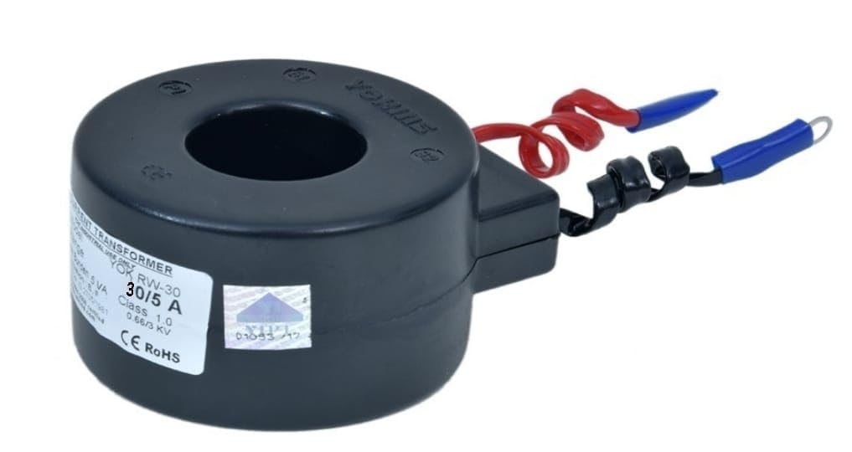

#### Fig 5.1.1.2 Current Transformer

The working principle of a current transformer (CT) is based on electromagnetic induction, a fundamental concept in physics discovered by Michael Faraday. CTs are widely used in electrical systems for measuring alternating current (AC) flowing in a circuit accurately and safely. Current Transformers operate on the principle of electromagnetic induction. When an alternating current flows through the primary winding of the CT, it induces a proportional alternating current in the secondary winding. CTs are typically constructed with a toroidal or ring-shaped core to encircle the conductor carrying the primary current. The primary and secondary windings are insulated and wound around the core to minimize leakage flux and ensure accurate measurement. CTs have a specific turns ratio, which is the ratio of the number of turns in the primary winding to the number of turns in the secondary winding. This ratio determines the magnitude of the current transformation from the primary to the secondary side. Typically, CTs are designed for step-down transformation, where the current in the secondary winding is lower than the current in the primary winding. This allows for safe and manageable measurement of high currents.

CTs have a specified burden, which is the impedance presented to the secondary winding when the CT is connected to a measuring instrument. The burden affects the accuracy and performance of the CT and should be matched to the requirements of the measuring instrument. CTs are available in different accuracy classes, ranging from low accuracy (e.g., Class 5) to high accuracy (e.g., Class 0.2). The accuracy class indicates the maximum permissible error under specified conditions.

CTs are available in various designs and configurations to suit specific applications, such as metering, protection, control, or instrumentation. Specialized CTs may include additional features like transient response, frequency response, or wide dynamic range. Current Transformers play a crucial role in electrical measurement and monitoring, providing accurate and reliable current sensing for a wide range of applications in power systems and industrial environments.

## BULB (LOAD)

## Crompton Greaves GLS Incandescent Filament B22 Light Bulb (Clear) - Pack of 4

Incandescent bulbs are traditional light bulbs that produce light by heating a thin tungsten filament until it becomes hot enough to emit visible light. Here are some key characteristics and features of incandescent bulbs:

The filament of an incandescent bulb is typically made of tungsten, a metal with a high melting point. The filament is coiled or wound into a small spiral shape inside a glass bulb. When an electric current passes through the filament, it heats up and emits light. The filament is housed inside a glass bulb filled with an inert gas, such as argon, to prevent the filament from oxidizing and burning out quickly. The glass bulb also protects the filament from damage and provides insulation. Incandescent bulbs emit a warm, yellowish-white light that closely resembles natural sunlight. This color temperature is typically around 2700-3000 Kelvin, providing a cozy and inviting ambiance in indoor spaces. Incandescent bulbs are inherently dimmable, meaning their brightness can be adjusted by varying the voltage supplied to them. This makes them suitable for use with dimmer switches to create mood lighting or adjust illumination levels as needed. Incandescent bulbs provide instant illumination when turned on, unlike some other types of bulbs that may require a warm-up time to reach full brightness.

Incandescent bulbs are relatively inexpensive to purchase compared to some newer lighting technologies, making them accessible and widely used in many households and commercial settings. Incandescent bulbs have a relatively short lifespan compared to other types of bulbs, typically lasting around 750-2,000 hours, depending on usage patterns. Frequent on-off cycling can further reduce their lifespan. Incandescent bulbs are relatively inexpensive to purchase compared to some newer lighting technologies, making them accessible and widely used in many households and commercial settings.

**5.1.1.4 WIFI MODULE**

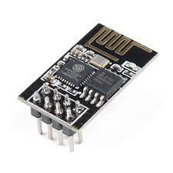

**Fig 5.1.1.4 ESP8266 WIFI Module**

ESP-01WiFimoduleisdeveloped by Ai thinker Team. Core processor ESP8266 in smaller sizes of the module. The module supports standard IEEE802.11b/g/n agreement, complete TCP/IP protocol stack. Users can use the add modules to an existing device networking, or building a separate network controller. ESP8266 is high integration wireless SOCs, designed for space and power constrained mobile platform designers.

It provides un surpassed ability to embed Wi-Fi capabilities within other systems, or to function as a standalone application, with the lowest cost, and minimal space requirement. ESP8266EX offers a complete and self-contained Wi-Fi networking solution; it can be used to host the application or to off load Wi-Fi networking functions from another application processor.

The ESP8266 module can be programmed using various development environments and programming languages, including the Arduino IDE, Espressif's official ESP-IDF framework, and Node MCU (Lua-based firmware). This flexibility enables developers to choose the programming environment that best suits their needs.

The module includes integrated Wi-Fi functionality, allowing it to connect to Wi-Fi networks and communicate over the internet. It supports the 802.11 b/g/n wireless standards and can function as a client or an access point (AP).

**5.1.1.5 LCD DISPLAY**

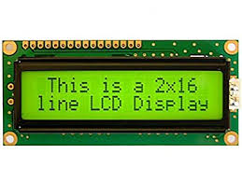

**Fig 5.1.1.2 Liquid crystal display**

Liquid crystal displays (LCDs) have materials which combine the properties of both liquids and crystals. Rather than having a melting point, they have a temperature range within which the molecules are almost as mobile as they would be in a liquid, but are grouped together in an ordered form similar to a crystal.

An LCD consists of two glass panels, with the liquid crystal material sand witched in between them. The inner surface of the glass plates are coated with transparent electrodes which define the character, symbols or patterns to be displayed polymeric layers are present in between the electrodes and the liquid crystal, which makes the liquid crystal molecules to maintain a defined orientation angle.

The LCD’s are lightweight with only a few millimeters thickness. Since the LCD’s consume less power, they are compatible with low power electronic circuits, and can be powered for long durations.

The LCD’s don’t generate light and so light is needed to read the display. By using backlighting, reading is possible in the dark. The LCD’s have long life and a wide operating temperature range.

When sufficient voltage is applied to the electrodes, the liquid crystal molecules would be aligned in a specific direction. The light rays passing through the LCD would be rotated by the polarisers, which would result in activating / highlighting the desired characters.

## SOFTWARE REQUIREMENTS

* Arduino Uno

## ARDUINO UNO

The ATmega328 microcontroller is the MCU used in Arduino UNO R3 as a main controller. ATmega328 is an MCU from the AVR family; it is an 8-bit device, which means that its data-bus architecture and internal registers are designed to handle 8 parallel data signals.

The Arduino Uno is an open-source platform, meaning the hardware design and software libraries are freely available. This fosters a large and active community that contributes libraries, examples, and support, making it easier to find resources and help when working on projects.

ATmega328 has three types of memory:

* **Flash memory:** 32KB nonvolatile memory. This is used for storing application, which explains why you don't need to upload your application every time you unplug arduino from its power source.
* **SRAM memory:** 2KB volatile memory. This is used for storing variables used by the application while it's running.
* **EEPROM memory:** 1KB nonvolatile memory. This can be used to store data that must be available even after the board is powered down and then powered up again.

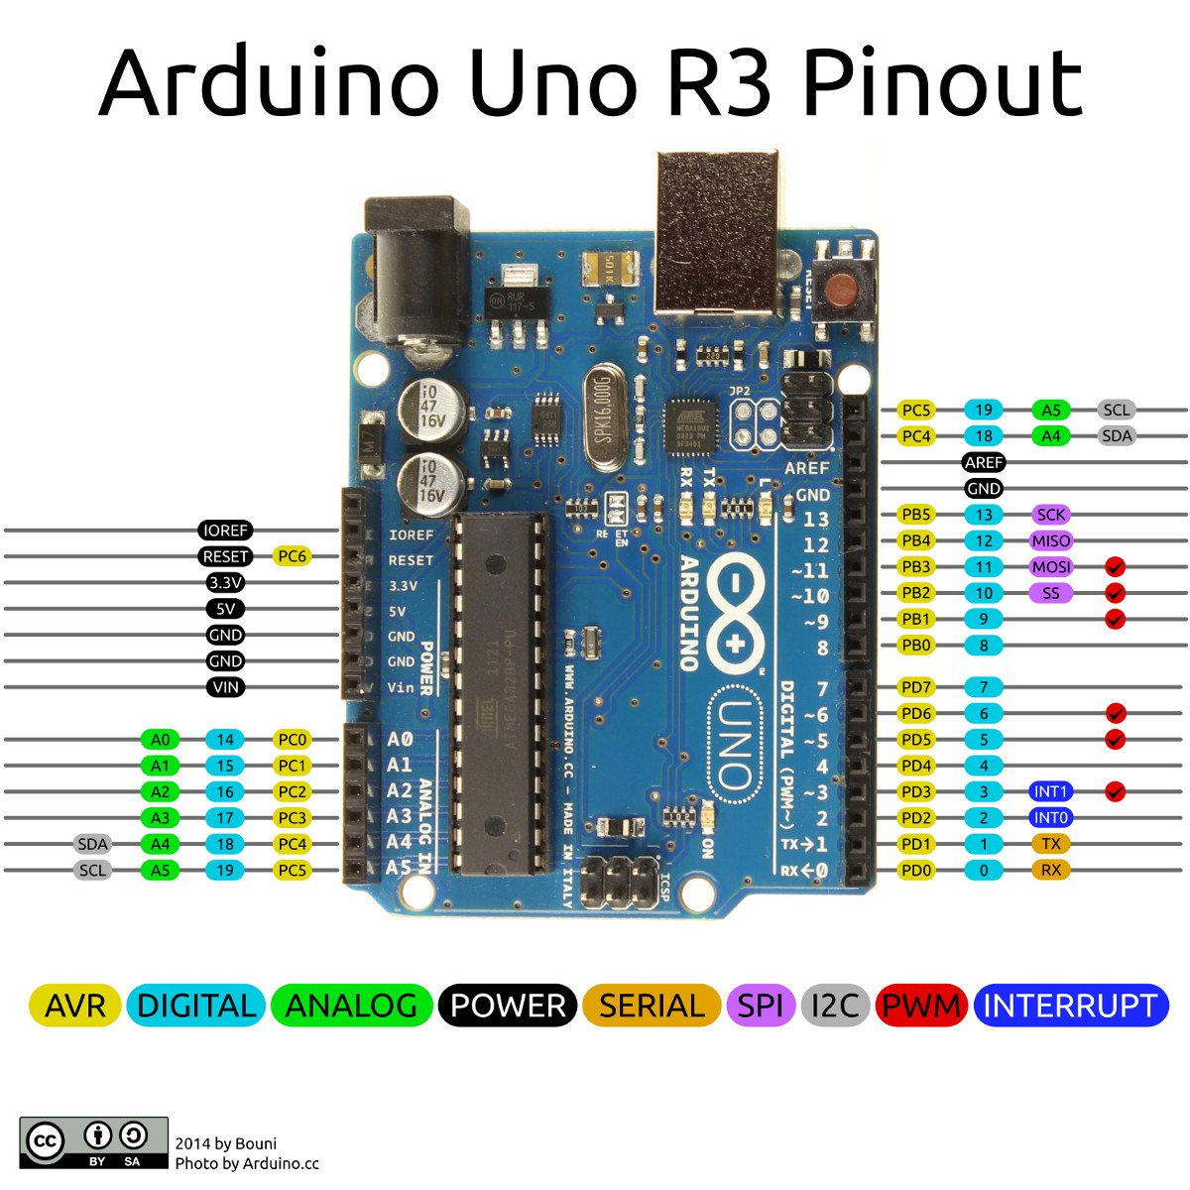

The Arduino Uno is compatible with a wide range of expansion boards called shields. Shields can be plugged into the Uno's headers, providing additional functionality such as motor control, wireless communication, display interfaces, and more.

**ATMEGA 328P (Arduino-uno)**

* AVR 8-bit RISC architecture
* Available in DIP Package
* Up to 20Mhz clock source
* 32KB Flash memory
* 1KB Static ram
* 23 Programmable I/O Channels
* Six 10Bit ADC Inputs
* Three timers/counters
* Six PWM outputs

# CHAPTER 6 RESULTS AND DISCUSSION

## RESULTS

Energy Management System is successfully implemented and explained. This system helps to monitor and control the energy consumption in commercial buildings, Hospitals, Industries, etc. All the details about the working and the making of the model is explained. This model can be used Effortlessly.

Fig 6.1.1 Shows the implemented prototype

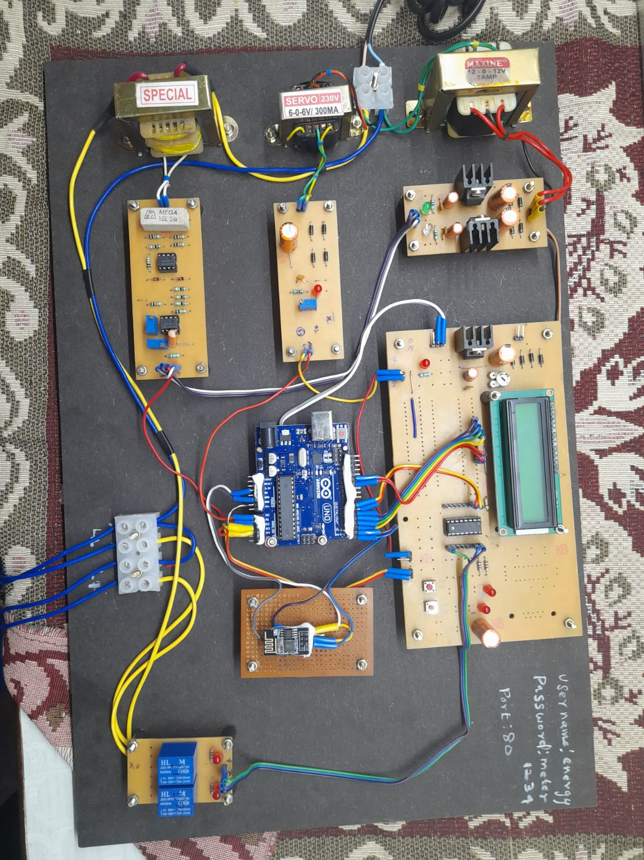

Arduino Uno

LCD Display

WIFI Module

Signal Condition circuit

Current Transformer

Potential Transformer

**Fig 6.1.1 Implemented Prototype**

Fig 6.1.2 shows the output of the system

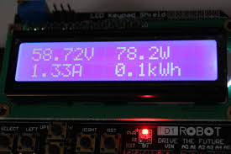

**Fig 6.1.2 Output of the system**

## COST ESTIMATION

|  |  |  |
| --- | --- | --- |
| **SL.NO** | **COMPONENTS** | **COST** |
| 1. | Potential Transformer | 1,000/- |
| 2. | Current Transformer | 600/- |
| 3. | Load | 500/- |
| 4. | Arduino Uno & related components | 2,070/- |
| 5. | Signal Condition Circuit | 1,800/- |
| 5. | Power supply and related components | 1,700/- |
| 6. | Other Expenses | 1,500/- |
|  | TOTAL | 9,170/- |

**Table 6.2 Cost Estimation**

## ADVANTAGES

Energy Management Systems (EMS) offer several advantages for individuals, businesses, and organizations seeking to optimize their energy usage, reduce costs, and improve sustainability. Here are some key advantages of implementing an EMS:

* Improved Energy Efficiency
* Cost Savings
* Environmental Impact Reduction
* Predictive Maintenance
* Demand Response Optimization

# CHAPTER 7 CONCLUSION AND FUTURE SCOPE

In conclusion, Energy Management Systems (EMS) play a crucial role in helping organizations effectively manage their energy consumption, reduce costs, and improve sustainability. By providing real-time monitoring, analysis, and control of energy use, EMS empower organizations to make informed decisions, optimize operations, and achieve their energy efficiency goals.

Key benefits of implementing an EMS include cost savings through energy efficiency improvements, environmental impact reduction by lowering carbon emissions, and compliance with energy regulations and reporting requirements. EMS also enhance operational visibility, enable predictive maintenance, and support participation in demand response programs and integration with renewable energy sources. Furthermore, EMS foster employee engagement by raising awareness about energy conservation practices and encouraging behavior changes that contribute to energy savings. They also offer financial incentives and return on investment opportunities through rebates, tax credits, and incentive programs available for energy efficiency measures.

Moreover, EMS facilitate compliance with energy regulations and reporting requirements, ensuring that organizations meet their legal obligations while also contributing to their corporate social responsibility goals. Additionally, EMS support predictive maintenance strategies, demand response optimization, and integration with renewable energy sources, further enhancing their value and versatility.

Overall, Energy Management Systems are essential tools for businesses, industries, and institutions seeking to optimize energy use, enhance sustainability, and drive operational excellence in today's energy-conscious world. With the continuous advancements in technology and the growing emphasis on energy efficiency and environmental responsibility, EMS will continue to play a vital role in shaping the future of energy management and sustainability initiatives.

# CHAPTER 8 REFERENCES

1. “Distributed Energy Management System for Multi-Microgrid Systems”: Sarah Kim, James Wilson : International Journal of Electrical Power & Energy Systems (2022).
2. "A Comprehensive Review on Energy Management Systems for Smart Grids: Challenges, Solutions, and Future Directions“ : John Doe, Jane Smith : IEEE Transactions on Smart Grid (2023).
3. "Review of energy management systems: From conventional to smart grids" by Mohsen B. J. Rasti, Mohammad Reza Haghifam, and Mohsen Assadi (2021).
4. "Machine Learning-Based Energy Management System for Demand Response in Smart Buildings" : Chen Zhang, Wei Liu : Energies (2023).
5. "Optimal Energy Management System for Electric Vehicles Integrated with Renewable Energy Sources" : Alice Lee, Michael Wang : Applied Energy (2021).
6. “Energy management system for smart grid” : SK Rathor,

D Saxena - International Journal of Energy. (2020).

1. “Specific energy consumption/use (SEC) in energy management for improving energy efficiency in industry”:A Lawrence, P Thollander, M Andrei, M Karlsson. (2019).
2. “Intelligent energy management strategy of hybrid energy storage system for electric vehicle based on driving pattern recognition”:

J Hu, D Liu, C Du, F Yan, C Lv- Elsevier, (2020).

1. “A microgrid energy management system based on non-intrusive load monitoring via multitask learning” : H Çimen, N Çetinkaya, JC Vasquez… ieeexplore.ieee.org – (2020).
2. “Efficient energy management strategy for hybrid electric vehicles” : C Yang, M Zha, W Wang, K LiuTransport Systems, (2020).
3. “ Energy management systems and strategies in buildings sector ” : AM Al-Ghaili, H Kasim, NM Al-Hada- ieeexplore.ieee.org , (2021).
4. **“** Design of a hybrid energy management system using designed rule‐based control strategy and genetic algorithm for the series‐parallel plug‐in hybrid electric vehicle” - N Ding, K Prasad, TT Lie - International Journal of Energy- Wiley Online Library, (2021).
5. “Predictive battery state of charge reference generation using basic route information for optimal energy management of heavy-duty fuel cell vehicles”, S Zendegan, A Ferrara, S Jakubek… - IEEE Transactions on …- ieeexplore.ieee.org – (2021).
6. “Energy management solutions in the Internet of Things applications”: Technical analysis and new research directions, D Wang, D Zhong, A Souri - Cognitive Systems Research, - Elsevier, (2021).
7. “An energy management system design using fuzzy logic control”: Smoothing the grid power profile of a residential electro-thermal microgrid, D Arcos-Aviles, J Pascual, F Guinjoan, L Marroyo… - IEEE …, - ieeexplore.ieee.org, (2021).
8. “Specific energy consumption/use (SEC) in energy management for improving energy efficiency in industry”: Meaning, usage and differences, A Lawrence, P Thollander, M Andrei, M Karlsson - Energies, - mdpi.com, (2019).
9. “Modelling and optimal energy management for battery energy storage systems in renewable energy systems”: Y Yang, S Bremner, C Menictas, M Kay - … and Sustainable Energy Reviews, - Elsevier, (2022).
10. “Modelling of a multi-stage energy management control routine for energy demand forecasting, flexibility, and optimization of smart communities using a Recurrent”. A Petrucci, G Barone, A Buonomano and Management, - Elsevier, (2022).
11. “An artificial intelligence-based solar radiation prophesy model for green energy utilization in energy management system”: F Alassery, A Alzahrani, AI Khan, K Irshad… - Sustainable Energy – (2022).
12. “The architecture optimization and energy management technology of aircraft power systems”: A review and future trends: T Lei, Z Min, Q Gao, L Song, X Zhang, X Zhang - Energies, (2022).