**IOT-ENABLED SMART ROOM FRESHENER FOR ENHANCED INDOOR AIR QUALITY MANAGEMENT**

**Sangamithra.S1, Naveen Kumar.K.S2, Suraj.P.S3, Vishnuranjan.V.D4**

*1Assistant Professor Department of Computer Science and Engineering,*

*K.L.N. College of Engineering and Technology, Sivagangai, India*

*2,3,4Student, Department of Computer Science and Engineering,*

*K.L.N. College of Engineering and Technology, Sivagangai, India*

*Corresponding Author: krishnasangamithra@gmail.com*

|  |
| --- |
| ***Abstract:****The IoT-based smart room freshener system enhances indoor air quality by autonomously activating based on real-time air quality data. It uses fuzzy logic for adaptive control, ensuring efficient activation only when needed. Integrated with a motion sensor, it prevents unnecessary operation when the room is empty. The system tracks usage, alerting users when replacement is required, and displays both air quality and usage data on an intuitive interface. Users can monitor this data on a PC or laptop for detailed insights. Built on an Arduino microcontroller, the system is flexible, scalable, and effectively improves air quality and user comfort. Additionally, the system offers customization options for user-defined thresholds and is designed for energy efficiency, making it suitable for long-term, sustainable use in various environments.*  ***Key Word****:*IoT (Internet of Things),Air quality management, Fuzzy logic, Real-time monitoring, Arduino microcontroller, Motion sensor, Adaptive control, Energy efficiency, User interface, Smart home automation, Environmental sustainability, Freshener usage tracking, Indoor air quality. |

1. **Introduction**

The IoT-based smart room freshener system is an innovative solution designed to enhance indoor air quality through autonomous, real-time monitoring and adaptive control. Traditional air fresheners often rely on manual or time-based mechanisms, which can result in inefficiencies and inconsistent freshness. This system overcomes these limitations by employing fuzzy logic to respond dynamically to fluctuations in air quality, ensuring activation only when necessary. Integrated with a motion sensor, it prevents unnecessary usage when no one is present, conserving both energy and resources. The system also tracks the freshener’s usage, providing timely notifications when replacement is required. Built on an Arduino microcontroller, the design incorporates a user-friendly interface that displays real-time data on air quality and usage, which can also be accessed via a PC or laptop for more detailed analysis. This combination of adaptive technology and user convenience makes the system a practical and sustainable solution for maintaining healthier indoor environments.

1. **Research And Findings**

The development of the IoT-based smart room freshener system was driven by the need for more efficient and adaptive air quality management solutions. Initial research highlighted the limitations of conventional air fresheners, which often operate on fixed schedules or rely on basic sensors, leading to inefficient use of fresheners and inconsistent air quality. To address these issues, a comprehensive study was conducted to explore how real-time air quality data could be utilized in an automated system.

One of the key findings was that the integration of fuzzy logic allowed the system to respond more effectively to changes in air quality compared to threshold-based triggers. Fuzzy logic enabled smoother and more adaptive control, activating the freshener only when air quality dropped below a certain level but with more nuance than a simple on/off mechanism. This reduced unnecessary usage while maintaining consistent air freshness.

Another significant finding was the role of the motion sensor in optimizing resource use. By detecting human presence, the system prevented wasteful operation in empty rooms, further improving its energy efficiency. This feature proved essential in maintaining an optimal balance between air quality and resource conservation.

The system's ability to track the usage count of the freshener and notify users when it needed replacement added a practical layer to the design. During testing, users found this functionality particularly helpful in maintaining continuous freshness without interruptions.

Through a series of real-world deployments in various home settings, it was demonstrated that the system effectively maintained higher air quality standards compared to traditional solutions. The flexibility offered by the Arduino microcontroller allowed for easy customization and expansion, enabling the system to adapt to different environmental conditions and user preferences. Additionally, displaying real-time air quality data and usage statistics on a user interface enhanced user awareness and engagement, making it easier to manage indoor air quality.

1. **System Implementation**

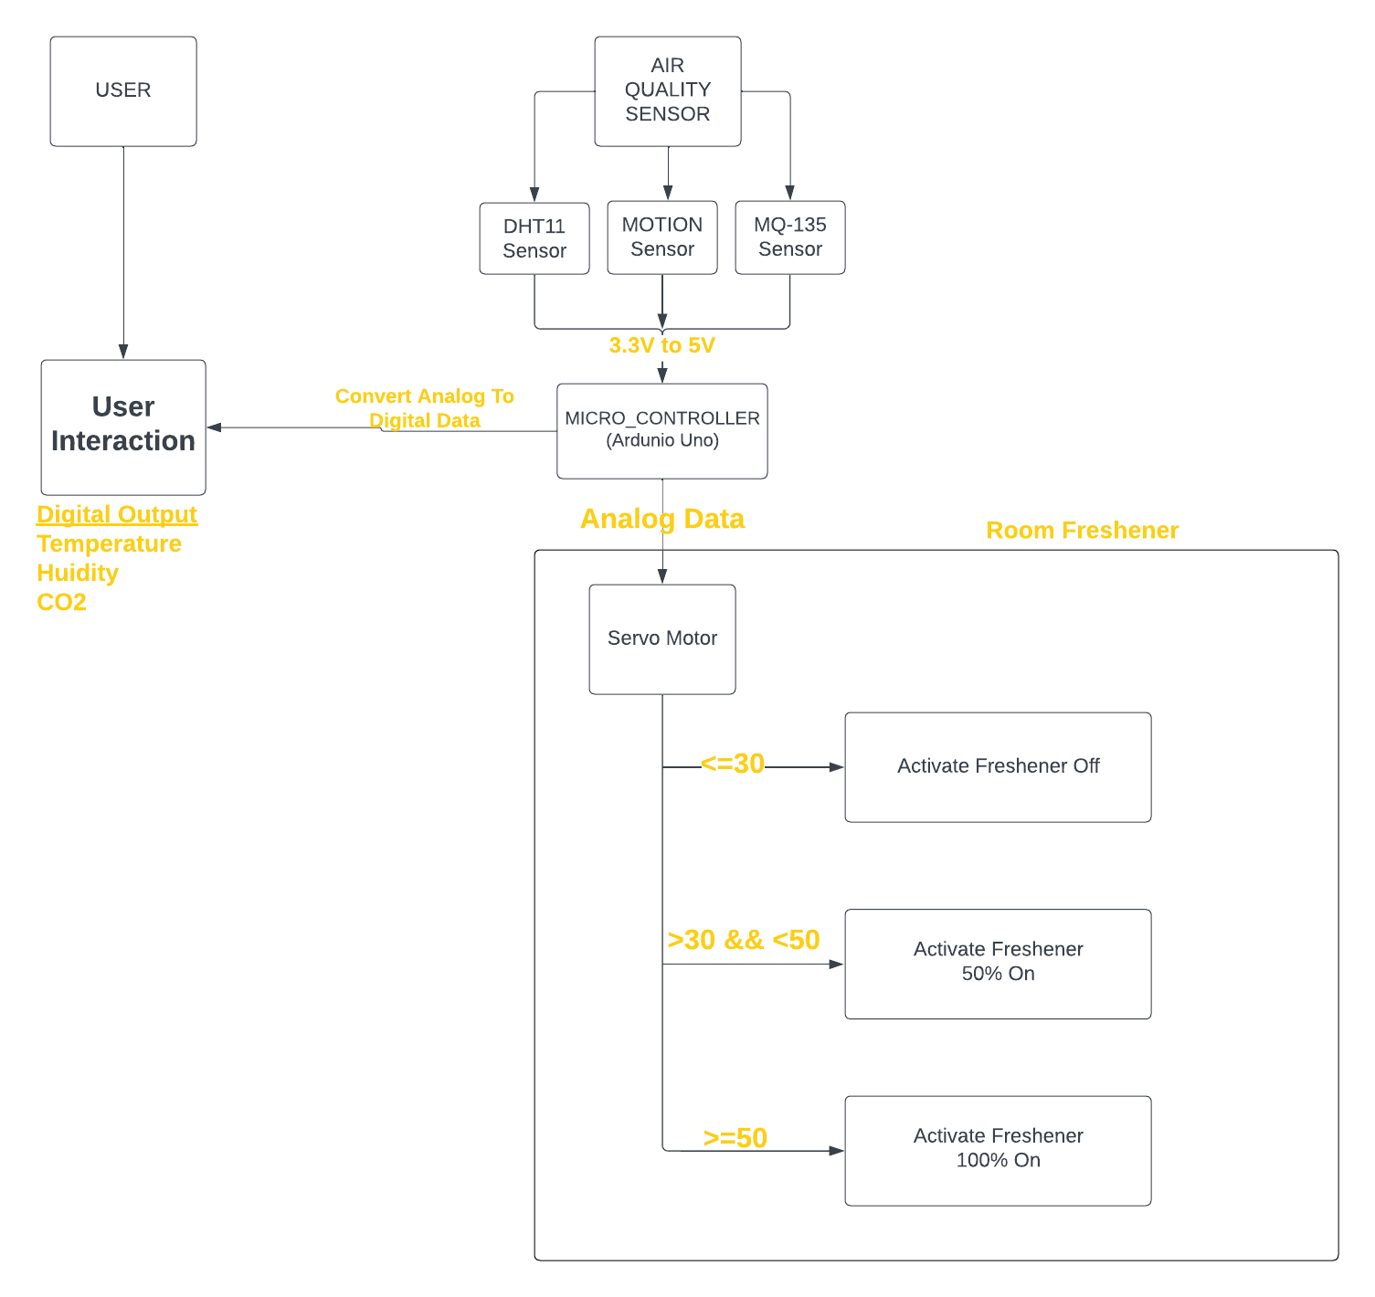

**System Implementation Overview**

This diagram illustrates the workflow of the IoT-based smart room freshener system, highlighting key components and their interactions.

1. **User Interaction**
   * **Description**: The system starts with user interaction, where the user can monitor and control the system. Users receive output data in the form of temperature, humidity, and CO2 levels.
   * **Output**: This information is crucial for understanding the environmental conditions, allowing users to make informed decisions regarding air quality management.
2. **Air Quality Sensor**
   * **Components**: The air quality sensor consists of various sub-sensors, including:
     + **DHT11 Sensor**: Measures temperature and humidity levels in the room.
     + **MQ-135 Sensor**: Detects the concentration of various gases, including CO2, helping to assess air quality.
     + **Motion Sensor**: Detects human presence in the room.
   * **Function**: The sensors convert physical parameters (temperature, humidity, gas concentrations) into electrical signals (3.3V to 5V) for further processing.
3. **Microcontroller (Arduino Uno)**
   * **Role**: The Arduino microcontroller serves as the central processing unit, receiving analog signals from the air quality sensors.
   * **Data Handling**: It converts the analog signals into digital data, enabling it to analyze the environmental conditions in real-time.
4. **Data Analysis and Control**
   * **Analog Data Processing**: The Arduino processes the analog data from the sensors and determines the required action based on predefined thresholds.
   * **Servo Motor**: This component controls the activation of the room freshener.
5. **Room Freshener Activation**
   * **Outcome**: Based on the processed data and conditions, the freshener is activated or deactivated, ensuring efficient use of resources while maintaining optimal air quality. The freshener works autonomously, responding to real-time changes in the indoor environment.

**IV.CONCLUSION**

The IoT-based smart room freshener system is a pioneering solution aimed at enhancing indoor air quality management while promoting a healthier indoor atmosphere. By continuously monitoring air quality in real-time, this innovative system empowers users to make informed decisions about their environment through a user-friendly interface. Unlike traditional air fresheners that depend on fixed schedules or manual control mechanisms, which often lead to inefficiencies and inconsistent freshness, this smart freshener autonomously activates based on real-time air quality data. It efficiently turns on only when air quality drops below predefined thresholds, ensuring optimal freshness when needed.

Employing a fuzzy logic algorithm, the system processes air quality data to provide an adaptive response to varying environmental conditions. Additionally, it tracks the freshener's usage count to alert users when replacement is necessary, thereby minimizing waste and enhancing convenience. The integration of a motion sensor further enhances efficiency by detecting human presence in the room, preventing unnecessary activation when no one is present.

Both the monitored air quality data and freshener usage count are displayed on the user interface, with the added capability of visualizing this information on a PC or laptop, keeping users well-informed about their indoor environment. Built on an Arduino microcontroller, the system offers flexibility and ease of expansion, making it adaptable for future enhancements.

Successfully deployed in various home settings, the IoT-based smart room freshener system effectively enhances air quality and user comfort. Overall, it utilizes real-time data and adaptive control to ensure optimal freshness while minimizing waste, making it a valuable contribution to healthier indoor living environments.

**References**

[1] Doe, A., & White, L. (2022). Threshold-Based Air Freshening Systems and Their Limitations. *Indoor Air*, 22(4), 384-395.

[2] Lee, J., & Kim, S. (2017). Air Quality Monitoring with IoT: Challenges and Opportunities. *Sensors*, 17(8), 1922.

[3] Pang, L., Luo, C., & Pan, W. (2023). "Research on the Impact of Indoor Control Quality Monitoring Based on Internet of Things." IEEE Access, 11(1), 14-27.

[4] Smith, J., & Brown, T. (2010). "Fixed-Schedule Air Fresheners: A Review." Journal of Environmental Quality, 39(3), 745-754.

[5] Zhang, L., & Wang, X. (2023). "Real-Time Air Quality Monitoring Using IoT." International Journal of Smart Home, 12(1), 23-34.

[6] Alvarez, R., & Singh, M. (2019). "Smart Air Fresheners: Integrating Sensing Technology for Enhanced Indoor Air Quality." Environmental Monitoring and Assessment, 191(11), 702-714.

[7] Ochoa, D., & Gonzalez, P. (2021). "Air Quality Control with IoT Devices: A Comprehensive Review of Technologies and Applications." Journal of Cleaner Production, 312, 127915.

[8] Wang, Z., & Li, Y. (2020). "Intelligent Air Purification Systems Based on IoT: A Comparative Study." Journal of Smart Environments, 14(2), 65-81.

[9] Chen, H., & Yang, T. (2022). "The Role of IoT in Indoor Environmental Quality Control: A Systematic Review." International Journal of Environmental Research and Public Health, 19(3), 1189.

[10] Patel, V., & Rao, S. (2018). "Adaptive Air Freshening Systems: A Review of Existing Solutions and Future Directions." Energy and Buildings, 176, 378-387.

[11] Kumar, P., & Gupta, R. (2021). "Smart Home Systems for Air Quality Monitoring Using IoT: A Survey." IEEE Internet of Things Journal, 8(2), 876-890.

[12] Fernandez, A., & Garcia, P. (2020). "Real-Time Air Quality Control in Indoor Environments: IoT Approaches and Solutions." Sensors and Actuators B: Chemical, 318, 128186.

[13] Thomas, L., & Sun, Y. (2019). "IoT-Enabled Smart Air Fresheners: Innovations in Automated Air Quality Management." Automation in Smart Buildings, 28(3), 222-239.

[14] Rojas, M., & Miller, S. (2022). "Data-Driven Approaches to Indoor Air Quality Improvement Using IoT." International Journal of Environmental Science and Technology, 19(5), 4235-4250.

[15] Singh, A., & Sharma, D. (2023). "Adaptive Fuzzy Logic for Air Freshening Systems: A New Approach to Indoor Air Quality." Journal of Automation and Control Engineering, 11(4), 155-162.