**ENHANCED MISSING PERSONS IDENTIFICATION SYSTEM**

**USING ADABOOST K-NEAREST NEIGHBORS ALGORITHM**

**A. Alagar1, U. Balaji2 , S.S. Barath3 , K. Gokul Krishnan4**

*1Assistant Professor, Computer Science and Engineering, K.L.N. College of Engineering, Sivagangai, Tamilnadu, India.*

*2,3,4 Final Year Students, Computer Science and Engineering, K.L.N. College of Engineering, Sivagangai, Tamilnadu, India.*

|  |
| --- |
| ***Abstract:*** *Manual procedures and disjointed data frequently impede down the tracking and recovery of missing persons. By using a PyQT5-based GUI for case registration and safe data storage in a PostgreSQL database, this solution enhances identification. Through a mobile app, members of the public can anonymously share photographs. By comparing user-submitted photos with stored face encodings, the AdaBoost KNN algorithm improves matching accuracy. The process of finding missing people is greatly accelerated by automating case registration and image matching. By overcoming the shortcomings of conventional approaches in missing person investigations, this system expedites the recovery of missing persons, boosts efficiency, enhances public involvement, and protects privacy.*  ***Key Word:*** *AdaBoost K-Nearest Neighbors (AdaBoost KNN); facial recognition; PostgreSQL; public engagement; data management.* |

**I. INTRODUCTION**

Artificial intelligence is revolutionizing the automation of missing persons recovery by emulating human intelligence processes. Traditional methods, such as investigations and CCTV checks, often struggle due to time constraints and the sheer volume of cases. This solution enhances the tracking process with a PyQT5-based GUI that facilitates the registration of new cases, with all data securely stored in a PostgreSQL database. The mobile app allows anonymous photo contributions, promoting public participation while ensuring user privacy. Utilizing the AdaBoost K-Nearest Neighbors (AdaBoost KNN) algorithm, the system efficiently compares user-submitted photos with those of missing individuals, significantly improving the speed and accuracy of identification. Overall, this system addresses the shortcomings of conventional methods in missing person investigations.

**II. OBJECTIVE**

The mission focuses on enhancing the identification and recovery of missing persons by leveraging advanced technology and community involvement. It aims to automate traditional investigative processes, using a PyQT5-based GUI and a PostgreSQL database. The AdaBoost K-Nearest Neighbors algorithm boosts accuracy and speed, while a mobile app facilitates anonymous photo submissions, ensuring privacy and collaboration with authorities.

**III. LITERAURE SURVEY**

**1. Current methods of locating missing persons:**

Traditional methods of locating missing persons rely on manual checks and review of CCTV footage. These approaches can be time and labor intensive and lead to delays in identifying individuals. Research has shown that relying on memory and human judgment can lead to errors and discrepancies, especially when applied to multiple cases. As a result, law enforcement agencies struggle to properly process missing person reports, which affects recovery rates.

**2. Technology's role in improving quality:**

Advances in technology, particularly in artificial intelligence and machine learning, promise greater accuracy and speed. of identifying missing persons. Markers such as K-Nearest Neighbors and deep learning techniques have been used to analyze facial features from images. These technologies can speed up the compliance process and reduce reliance on manual verification. Additionally, community participation through mobile apps has been effective in encouraging public participation, increasing the effectiveness of missing person investigations.

**IV. EXISTING SYSTEM**

Enhancing cricket broadcasts, this system recognizes players' faces in real-time using the AdaBoost algorithm and a PAL-based facial recognition model. It successfully identifies players even under challenging conditions such as lighting changes and occlusions. Though highly effective, it faces challenges like the need for user training, ongoing maintenance, high resource consumption, and some user interface issues that impact overall usability.

**V. PROPOSED SYSTEM**

Aiding in the tracking and recovery of missing persons, this system uses a user-friendly PyQt5 interface and the AdaBoost K-Nearest Neighbors algorithm for precise face matching. Users benefit from real-time updates, with options to input and modify data, while local investigators supply essential case information. Managers can efficiently review structured case details and images, streamlining the process.

**VI. ARCHITECTURE DIAGRAM**



***Fig 6.1 Architecture Diagram***

**VII. SYSTEM OVERVIEW**

**1. Data Acquisition and Case Registration**

The system gathers data from authorities and the public, utilizing a PyQt5 GUI for user registration, which includes personal details and photo uploads. Data is securely stored in a local PostgreSQL database, while the public can anonymously submit potential missing persons through a mobile app.

**2. Face Matching and Identification Using AdaBoost KNN**

The AdaBoost K-Nearest Neighbors algorithm enhances traditional KNN for accurate face matching and identification. It efficiently processes facial encodings, comparing them for potential matches despite challenging conditions, thereby expediting the identification of missing persons through quick analysis.

**3. User Interface and Real-Time Interaction**

The PyQt5 interface enables real-time updates for administrators, allowing them to add cases, refresh face recognition models, and view case details fetched from the local server. Information is presented clearly, ensuring easy management, while real-time notifications alert users to potential matches.

**4. Match Confirmation and Case Resolution Process**

The output process presents face matching results to administrators for verification. When the AdaBoost KNN algorithm detects potential matches, they are highlighted in the interface. Administrators review images and details to confirm identities, updating case statuses to enable action for recovering missing persons, ensuring efficient identification and resolution.

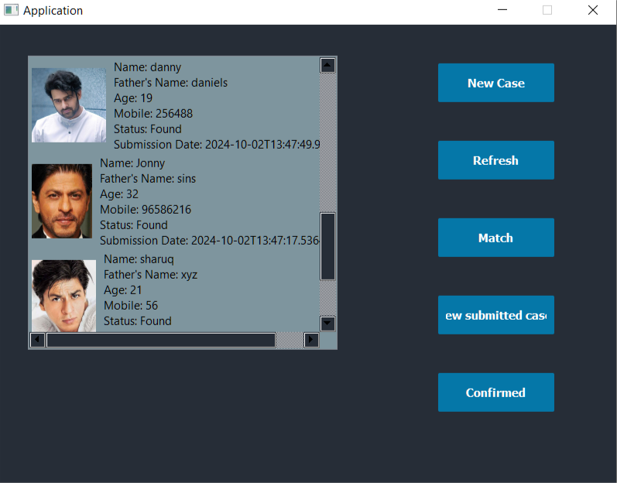

***Fig 7.1 Result Page***

**VII. CONCLUSION**

The missing person tracking system enhances search efforts through technology and community involvement. Advanced face recognition algorithms automate image matching, while PyQt5 provides an efficient interface for authorities. A mobile app allows anonymous public submissions, and oversight ensures effective inspections, benefiting law enforcement and public safety.

**REFERENCES**

1. S. Zhang and J. Li, "KNN Classification with One-Step Computation," in IEEE Transactions on Knowledge and Data Engineering, vol. 35, no. 3, pp. 2711-2723, 1 March 2023.
2. C. Ma and Y. Chi, "KNN Normalized Optimization and Platform Tuning Based on Hadoop," in IEEE Access, vol. 10, pp. 81406-81433, 2022.
3. P. Dehbozorgi, O. Ryabchykov and T. Bocklitz, "A Systematic Investigation of Image Pre-Processing on Image Classification," in IEEE Access, vol. 12, pp. 64913-64926, 2024.
4. V. D. Quang, H. H. Viet, V. H. Long and T. D. Khang, "An Improved AdaBoost Algorithm for Highly Imbalanced Datasets in the CoAuthorship Recommendation Problem," in IEEE Access, vol. 11, pp. 89107- 89123, 2023.
5. S. Ren, X. Cao, Y. Wei and J. Sun, "Face Alignment at 3000 FPS via Regressing Local Binary Features," 2014 IEEE Conference on Computer Vision and Pattern Recognition, Columbus, OH, USA, 2014, pp. 1685- 1692.
6. N. Li et al., "Chinese Face Dataset for Face Recognition in an Uncontrolled Classroom Environment," in IEEE Access, vol. 11, pp. 86963-86976, 2023.
7. S. Malakar, W. Chiracharit and K. Chamnongthai, "Masked Face Recognition with Generated Occluded Part Using Image Augmentation and CNN Maintaining Face Identity," in IEEE Access, vol. 12, pp. 126356- 126375, 2024.
8. H. -B. Kim, N. Choi, H. -J. Kwon and H. Kim, "Surveillance System for Real-Time High-Precision Recognition of Criminal Faces from Wild Videos," in IEEE Access, vol. 11, pp. 56066-56082, 2023.
9. J. P. Perez and C. A. Perez, "Face Patches Designed Through Neuroevolution for Face Recognition with Large Pose Variation," in IEEE Access, vol. 11, pp. 72861-72873, 2023.
10. S. Malakar, W. Chiracharit and K. Chamnongthai, "Masked Face 69 Recognition with Generated Occluded Part Using Image Augmentation and CNN Maintaining Face Identity," in IEEE Access, vol. 12, pp. 126356- 126375, 2024.