ELECTRICAL POWER GENERATION FROM WASTE PRODUCTS

Project guide: Baby Salome Chandra .C

Lecturer

Electrical and Electronics engineering,

Murugappa polytechnic college, Chennai, India.

[babysalomechandra@gmail.com](mailto:babysalomechandra@gmail.com)

Gokul rao.k.

Electrical And Electonics Engineering,

Murugappa polytechnic college,

chennai,india. Mail ID :

[gokulrao7557@gmail.co](mailto:gokulrao7557@gmail.co) m.

Krishna prasath.T Electrical And Electonics Engineering,

Murugappa polytechnic college,

chennai,india. Mail ID :

Krishnaprasath.tb2@gm ail.comBishon.U

Electrical And Electonics Engineering,

Murugappa polytechnic college,

chennai,india. Mail ID :

bishonuresh.ub2@gmail. com

Vijay Kumar.V.S Electrical And Electonics Engineering,

Murugappa polytechnic college,

chennai,india. Mail ID :

vijaykumar.v.sb2@gmail. com

Dhanush.R

Electrical And Electonics Engineering,

Murugappa polytechnic college,

chennai,india. Mail ID :

dhanushrajaeeesw@gm ail.com

Surya.N

Electrical And Electonics Engineering,

Murugappa polytechnic college,

chennai,india. Mail ID :

suryas01234567@gmail. com

ABSTRACT

Electricity generation by burning waste materials, also known as thermal waste-to-energy, is a process that involves converting waste materials into electricity by burning them in a combustion chamber. This process is a sustainable solution for waste management as it reduces the volume of waste sent to landfills while producing renewable energy. The methodology for electricity generation by burning waste materials typically involves waste collection, handling, and preparation, incineration, energy recovery, and ash management. The generated electricity can be used for local communities or industries or fed back into the national grid. The process of electricity generation by burning waste materials provides a reliable source of electricity while reducing greenhouse gas emissions by avoiding the release of methane gas from landfills. Overall, electricity generation by burning waste materials is a promising solution for waste management and renewable energy production. However, it is important to carefully consider the potential benefits and drawbacks of this method and to ensure that appropriate regulations and technologies are in place to minimize any negative environmental impacts.

Keywords - Heating panels, Led Bulbs, zaar box, IN4007, Battery 4.5V, Resistors, and capacitors.

1. INTRODUCTION

Electricity generation from waste material is a rapidly growing field that involves the conversion of various types of waste into usable energy. This process is often referred to as waste-to-energy, and it offers a number of benefits including reducing waste in landfills, reducing greenhouse gas emissions, and providing a source of renewable energy. The process of generating electricity from waste materials typically involves the use of thermal or biological processes. Thermal processes involve the incineration of waste, which is then used to generate steam to power turbines and produce electricity.

One of the main advantages of electricity generation by burning waste materials is that it reduces the volume of waste sent to landfills, which in turn reduces the amount of space required for landfill sites. This can help to mitigate the negative impacts of landfill sites on the environment, such as groundwater contamination and greenhouse gas emissions. Another advantage of electricity generation by burning waste materials is that it produces a reliable source of electricity. This is particularly important in areas where there may be limited access to other sources of electricity, such as remote communities or developing countries. The technology used to generate electricity from these waste materials is constantly evolving, and new innovations are being developed to make the process more efficient and cost-effective. Overall, the generation of electricity from waste material represents an exciting opportunity to reduce waste, lower greenhouse gas emissions, and provide a source of renewable energy for communities around the world

1. Block diagram

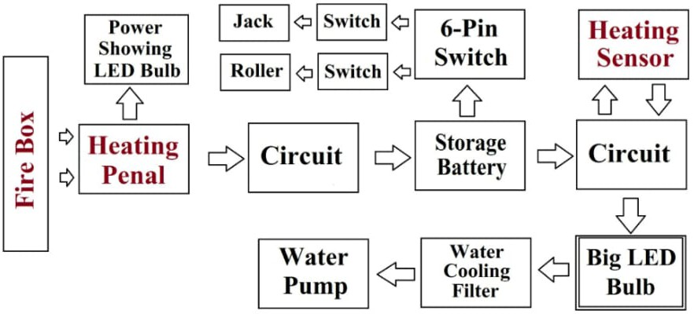

In this Block Diagram you can see when we burn waste materials and fire box then heat generating and heating panel starts to heat convert electricity and after that that electricity we can see by LED Bulb glowing and that electricity go to circuit and after that in battery and start storing power and when electricity store in battery then heating sensor turn on the output power supply and LED Bulb start glowing and smoke go to water tank and filter system start controlling pollution.

1. Components used
   1. Heating Panel

Heating panels can be used in the process of electricity generation from waste material in several ways, depending on the specific technology used.

For example, in thermal waste-to-energy plants, waste material is burned in a combustion chamber to produce high-temperature gases. These gases are then used to heat water and produce steam, which drives a turbine to generate electricity. In this process, heating panels may be used to line the combustion chamber, as well as other areas of the plant where heat is generated or transferred. The heating panels can help to maintain the high temperatures required for efficient combustion and steam production, while also protecting the plant's infrastructure from heat damage.

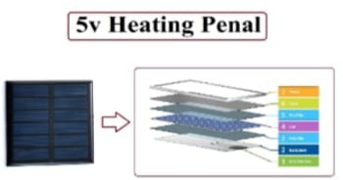

Figure 1 - Heating Penal

* 1. Heating Sensor

Heating sensors are an important component of many waste-to-energy technologies that involve thermal processes, such as incineration and gasification. These sensors are used to measure temperature in various parts of the process, providing valuable information that can be used to optimize the efficiency of the system and prevent damage.

* 1. Capacitor

Capacitors can be used in various ways in the process of electricity generation from waste material. Capacitors are electrical components that store and release electrical energy, and they are commonly used in electrical systems to provide power factor correction, voltage regulation, and energy storage.

In waste-to-energy plants that use thermal processes such as incineration, capacitors may be used in the electrical systems that control the turbines and generators that produce electricity. These capacitors can help to regulate the voltage and power factor of the electrical output, ensuring that the electricity produced is stable and reliable.

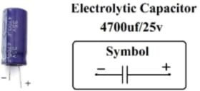

Figure 2 - Capacitor

* 1. Resistor

Resistors can be used in various ways in the process of electricity generation from waste material. Resistors are electrical components that resist the flow of current in a circuit, and they are commonly used in electrical systems to control current, voltage, and power. In waste-to-energy plants that use thermal processes such as incineration, resistors may be used in the electrical control systems that regulate the temperature and flow of gases in the combustion chamber. These resistors can help to control the flow of current to heating elements or other devices that generate heat, ensuring that the temperature is maintained within the desired range for efficient combustion.

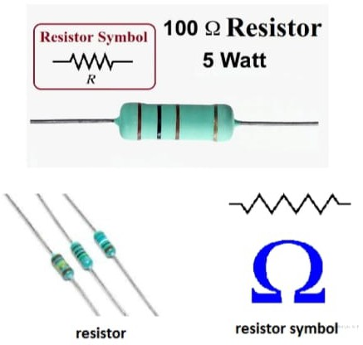

Figure 3 – Resistor

* 1. Battery

Batteries can be used in various ways in the process of electricity generation from waste material. Batteries are devices that store electrical energy chemically and can release it as needed to power electrical devices.

One common use of batteries in waste-to-energy plants is to store excess energy generated by the plant during periods of low demand or low generation. This excess energy can be stored in batteries and used to supplement the plant's output during periods of high demand or low generation, providing a more stable and reliable source of electricity.

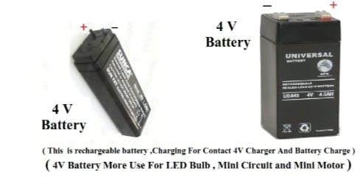

Figure 4 - Battery

* 1. LED Bulbs

LED bulbs can be used in various ways in the process of electricity generation from waste material. LED bulbs are a type of lighting technology that use light-emitting diodes (LEDs) to produce light, and they are known for their energy efficiency, long lifespan, and durability.In waste-to-energy plants, LED bulbs may be used to provide lighting in various areas, including control rooms, storage areas, and maintenance facilities. LED bulbs consume less energy than traditional incandescent bulbs, and they have a longer lifespan, which can help to reduce energy consumption and maintenance costs over time.

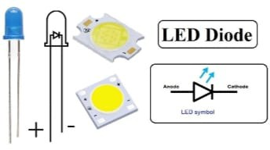

Figure 5 - LED Bulbs

# Working Principle Of Project

This Project Working Depend On Heating Solar. Simply put, a Heating panel works by allowing photons, or particles of light or heat , to knock electrons free from atoms, generating a flow of electricity. Heating panels actually comprise many, smaller units called photovoltaic cells. (Photovoltaic simply means they convert heating or light into electricity.)

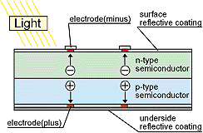

A p-n junction is formed by placing p-type and n-type semiconductors next to one another. The p-type, with one less electron, attracts the surplus electron from the n-type to stabilize itself. Thus the electricity is displaced and generates a flow of electrons, otherwise known as electricity.

When heat hits the semiconductor, an electron springs up and is attracted toward the n- type semiconductor. This causes more negatives in the n-type semiconductors and more positives in the p-type, thus generating a higher flow of electricity. This is the photovoltaic effect.

# Working and Explanation

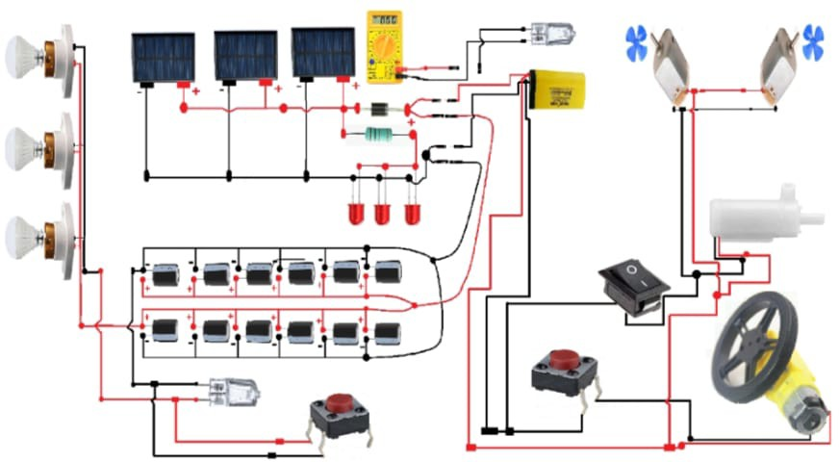

When burning the waste materials in fire box an heat energy is generated. The heating panel starts working which converts heat energy into electricity.

A set of 3 led’s will turn on to indicate the working of heating panel.The generated power goes to inverter circuit and the storage area.In the inverter circuit we can connect loads to consume the energy.The storage area isused to store the energy,in which the energy stores in the battery.Heating sensor turns on the output power supply through which the LED Bulb will start glowing.And the smoke from the burning waste goes to water tank and filter system, which start controlling pollution by using carbon filter.

1. CONCLUSION

Incineration technology is complete combustion of waste (Municipal Solid Wasteor Refuse derived fuel) with the recovery of heat to produce energy that in turn produces power through heating panels. Now from this we can conclude that electricity plays an important role in our life we are made aware of how the generate electricity waste is done.

For technical service provider plant Objectives & Maintenance activities are very important as its service mostly depends on the availability of its equipment. From this we see that how electricity generated successfully. From this we can see how to store the energy in batteries.

1. REFERENCES
   * 1. S. Musorov, D. S. Chertikhina, S. N. Torgaev, T. G. Evtushenko, O. A. Kozhemyak, Control System for Peltier Element Air Dryer-2014, International Conference on

Mechanical Engineering, Automation and Control Systems (MEACS), I Tomsk Polytechnic University, 978-1 -4799- 6221- 1/14/$31.00 ©2014 IEEE.

* + 1. Allwin Jose, Alan D’souza, Sarvesh Dandekar, Jitesh Karamchandani, Pavan Kulkarni, Air Conditioner using Peltier Module, 2015 International Conference on Technologies for Sustainable Development (ICTSD-2015), 978- 1-4799- 8187- 8/15/$31.00 ©2015 IEEE
    2. Takafumi Hatano, Mingcong Deng, and Shin Wakitani, A Cooling and Heat-retention System Actuated by Peltier Device Considering Fan- Saket Kumar, Ashutosh Gupta, Gaurav Yadav, Hemender Pal Singh, Peltier Module for Refrigeration and Heating using Embedded System, 2015 International Conference on Recent Developments in Control, Automation

and power.motor Control, 2014 IEEE International Conference on Automation Science and Engineering (CASE) Taipei, Taiwan, August 18- 22, 2014, 978-1-4799-5283- 0/14/$31.00 ©2014 IEEE