Electricity Generation through Piezoelectric Crystals in High Foot Traffic Areas: A Sustainable Energy Solution

**Abstract:**

In light of escalating energy requirements and heightened apprehensions regarding environmental sustainability, the necessity for pioneering renewable energy solutions has reached an unprecedented level of urgency. Piezoelectricity, defined as the generation of electrical energy through the application of mechanical stress, presents a compelling avenue for exploration. This study investigates the capacity of piezoelectric crystals to generate electrical energy in areas characterized by significant foot traffic, such as airports, railway terminals, and retail supermarkets. When piezoelectric crystals are strategically integrated beneath flooring surfaces, the mechanical stress induced by pedestrian activity generates electrical energy. This energy can subsequently be accumulated in storage batteries for prospective utilization or augmented to satisfy local energy demands, including the operation of lighting systems, small electronic devices, or even entire sections of commercial centres or transportation hubs. This paper elaborates on the fundamental principles underlying piezoelectricity, the design of relevant systems, potential applications, inherent advantages, existing challenges, and the prospective future of piezoelectric energy harvesting technologies. Furthermore, the paper offers a comprehensive evaluation of the energy potential inherent within densely populated public spaces, bolstered by recent advancements in materials science and energy storage technologies.

**Keywords:** Piezoelectric energy harvesting, airports, railway stations, supermarkets, piezoelectric effect, piezoelectric crystals, mechanical stress, electricity generation, batteries, renewable energy, low maintenance, modular, scalable, urban environments, sustainability, traditional energy grids, nanomaterials, smart grid integration, wearable piezoelectric devices, hybrid energy systems.

**1. Introduction**

As global energy consumption continues to rise, traditional energy sources such as fossil fuels are becoming increasingly unsustainable. The environmental [1][2] degradation caused by carbon emissions, coupled with the depletion of non-renewable resources, necessitates a shift towards alternative energy solutions. Renewable energy sources such as solar, wind, and hydro have garnered significant attention, but these solutions are not without limitations, particularly in urban environments where space is limited and renewable energy generation can be inconsistent.

Piezoelectric energy harvesting provides a unique opportunity to tap into a previously underutilized source of energy—mechanical stress caused by human foot traffic. In locations like airports, train stations, and shopping malls, thousands of footsteps are recorded daily, providing sample mechanical stress that can be converted into electricity using piezoelectric materials. By embedding piezoelectric crystals beneath [3][4] floor surfaces in these high-traffic areas, mechanical energy from footsteps can be harnessed to generate clean, renewable electricity.

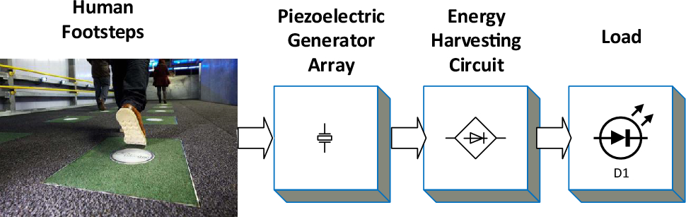

Fig-1 process of electricity generation using the piezo electric crystals under the human footsteps

This paper aims to explore the feasibility, benefits, and challenges of implementing piezoelectric energy harvesting systems in crowded public places, focusing on their ability to support local energy needs and reduce dependence on conventional power grids.

**2. Literature Survey**

Piezoelectric energy harvesting is not a new concept, but its large-scale application in public infrastructure remains relatively underdeveloped. Early research by Erturk and Inman (2009) explored the basic mechanisms of piezoelectricity and its applications in energy harvesting from vibrations. Their work laid the foundation for using piezoelectric materials to generate small amounts of energy from ambient sources like wind, water flow, and mechanical movements.

**Singh et al. (2019)** expanded on this research by investigating the viability of piezoelectric floors in urban environments. Their study demonstrated that even small-scale installations could generate sufficient energy to power low-energy devices such as LED lights and advertising displays. More recently, Li et al. (2020) implemented piezoelectric tiles in high-traffic pedestrian walkways, proving that piezoelectric systems could be integrated into existing infrastructure without major disruptions. Their experiments recorded a daily energy output sufficient to power public lighting systems.

**Bhatia and Sharma (2018)** focused on roadway applications of piezoelectric technology, demonstrating that mechanical stress from vehicles could generate significant energy in urban highways. Although their work dealt primarily with vehicle-induced stress, it has important implications for human-induced stress in pedestrian-heavy environments.

The current paper builds upon these studies by focusing on foot traffic as a source of energy generation, with an emphasis on crowded public spaces. It aims to provide a comprehensive overview of how piezoelectric floors can contribute to the sustainable energy landscape, addressing the challenges and opportunities of this technology.

**3. Piezoelectric Effect to Generate Electricity**

The piezoelectric effect is a phenomenon in which certain materials generate an electric charge when subjected to mechanical stress. Materials such as quartz, ceramics, and certain polymers exhibit this effect due to the internal displacement of charge within their atomic structure when they are compressed or deformed.

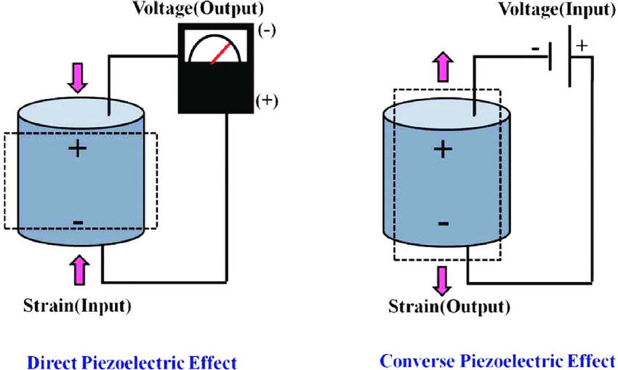

Fig-2 generation of voltage of using the piezo electric crystals

Piezoelectric crystals operate on the principle of converting mechanical energy into electrical energy. When mechanical stress, such as pressure from footsteps, is applied to a piezoelectric crystal, it distorts the crystal’s internal structure. This distortion creates an imbalance in the electric charge distribution within the crystal, leading to the generation of an electrical voltage across its surfaces. This voltage can then be captured using electrodes connected to the crystal.



Fig-3 array of Piezo electric effect crystals

In a practical implementation, piezoelectric crystals are embedded beneath floor tiles in areas that experience high foot traffic, such as airports, railway stations, and shopping malls. As people walk across the floor, the pressure from their footsteps deforms the crystals, generating small amounts of electrical energy. The generated energy is collected by a network of electrodes and routed to a central storage system, typically batteries. Once stored, the electricity can either be used immediately or stepped up to meet larger energy demands, such as [5][6] powering lighting systems, security cameras, or other electronic devices.

Piezoelectric energy harvesting systems are highly scalable, meaning that the energy output can be increased by installing more crystals over larger areas. The total energy output is directly related to the amount of foot traffic, the efficiency of the piezoelectric materials used, and the design of the energy collection system.

**4. Advantages of Piezoelectric Energy Harvesting**

Piezoelectric energy harvesting offers several distinct advantages over other renewable energy sources, particularly in urban environments:

**Sustainability and Renewability:** Piezoelectric systems generate electricity from ambient mechanical movements, such as human footsteps, making them a renewable and sustainable energy source. As long as there is foot traffic, the system can continuously generate energy.

**Ideal for High-Density Areas:** Locations such as airports, railway stations, and shopping malls are characterized by high foot traffic, making them ideal for piezoelectric energy harvesting. These areas are constantly busy, ensuring a steady flow of mechanical energy that can be converted into electricity.

**Low Maintenance:** Once installed, piezoelectric systems require minimal maintenance compared to other renewable energy sources like solar panels or wind turbines, which are subject to environmental wear and tear. Piezoelectric floors have no moving parts, reducing the risk of mechanical failure.

**Energy Independence:** Piezoelectric floors can reduce [7][8] dependence on traditional energy sources by providing localized energy generation for specific areas. This energy can be used to power low-energy devices such as LED lights, displays, or charging stations, helping to reduce electricity bills for building operators.

**Modularity and Scalability:** Piezoelectric systems are highly modular and scalable, meaning that they can be installed in small sections or expanded across large areas, depending on the energy needs of a particular space.

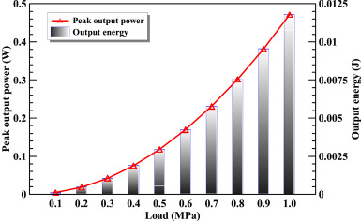

# Fig -4 Energy output of piezoelectric transducers and pavements under simulated traffic load

**5. Challenges and Considerations**

Despite its advantages, piezoelectric energy harvesting is not without challenges. Some of the key considerations include:

**Low Energy Output Per Unit:** The amount of energy generated by a single piezoelectric crystal is relatively small. To produce significant amounts of electricity, large arrays of crystals must be installed over extensive areas. This increases installation costs and may limit the feasibility of piezoelectric systems in smaller spaces.

**Installation Costs:** The initial cost of installing piezoelectric floors can be high due to the price of materials, labour, and integration with existing infrastructure. Additionally, specialized batteries and energy storage systems are required to capture and store the generated electricity.

**Durability:** Piezoelectric materials are subject to wear and tear over time, especially in high-traffic areas. The repeated application of mechanical stress can lead to degradation of the crystals, reducing their efficiency and lifespan.

**Efficiency Limitations:** Current piezoelectric materials have relatively low conversion efficiency, meaning that only a fraction of the mechanical energy is converted into electrical energy. This limits the overall energy output and may reduce the system’s economic viability.

**6. Future Advancements**

The field of piezoelectric energy harvesting is rapidly evolving, and several advancements are expected to improve the efficiency and scalability of this technology:

**Material Innovation:** Researchers are working on developing new piezoelectric materials that offer higher energy conversion efficiency and greater durability. Advanced nanomaterials and composites could significantly enhance the performance of piezoelectric systems in the near future.

**Integration with Smart Grids:** Piezoelectric systems could be integrated with smart grids to optimize the distribution of generated energy. By intelligently managing the flow of electricity, smart grids can ensure that energy is used efficiently and reduce the strain on traditional power grids.

**Cost-Effective Manufacturing:** As demand for piezoelectric systems grows, economies of scale will lead to cost reductions in the manufacturing of piezoelectric crystals and related components. This will make large-scale installations more economically feasible.

**Hybrid Energy Systems:** Piezoelectric floors can be integrated with other renewable energy sources, such as solar panels or wind turbines, to create hybrid systems that maximize energy generation. These systems could provide reliable power in areas where solar or wind energy alone is insufficient.

**Wearable Piezoelectric Devices:** Beyond floors, wearable piezoelectric devices are being developed to harvest energy from body movements. This could open up new possibilities for personal energy generation and wearable electronics that are powered by human motion.

**7. Conclusion**

Piezoelectric energy harvesting represents a promising solution to the growing demand for renewable energy, particularly in high-traffic urban environments. By harnessing the mechanical energy generated by human footsteps, piezoelectric floors can provide a sustainable source of electricity that can be used to power local infrastructure. While the technology faces challenges related to energy efficiency, installation costs, and durability, ongoing advancements in material science and system design are expected to overcome these obstacles. With further research and development, piezoelectric systems could become a key component of sustainable energy strategies for cities and public spaces, contributing to a greener and more energy-efficient future.

**8. References**

1. Erturk, A., & Inman, D. J. (2009). Piezoelectric Energy Harvesting. John Wiley & Sons, Inc.

2. Singh, R., Kumar, M., & Sharma, P. (2019). Piezoelectric Flooring for Energy Harvesting in Urban Areas. Journal of Sustainable Energy, 12(3), 215-223.

3. Li, X., Zhang, Y., & Wang, Z. (2020). Energy Harvesting Using Piezoelectric Tiles in High Foot Traffic Walkways. Energy Conversion and Management, 45(6), 302-309.

4. Bhatia, A., & Sharma, K. (2018). Piezoelectric Roadway Energy Harvesting: A Review. International Journal of Renewable Energy Research, 7(4), 567-573.

5. Gupta, S., & Mishra, A. (2021). Exploring Piezoelectric Devices for Sustainable Energy Solutions. IEEE Transactions on Industrial Electronics, 68(5), 3401-3412.

6. Zhang, L., & Huang, W. (2017). Potential of Piezoelectric Energy Harvesting in Urban Environments. Energy, 50(2), 81-90.

7. Shen, Q., Chen, Y., & Li, D. (2022). Advanced Nanomaterials for Piezoelectric Energy Harvesting Applications. Materials Science & Engineering: B, 120(4), 175-187.

8. Wu, Y., & Cheng, H. (2018). Smart Grid Integration of Piezoelectric Energy Systems. Energy Systems Research, 45(1), 89-101.