**Evaluation A Sitting Position on Public Space Based Ergonomic Approach**

**Julianus Hutabarat1**

1 Faculty of Industrial Engineering, National Institute of Technology Malang, Indonesia

**ABSTRACT**

Public spaces provide infrastructures for the community to carry out diverse activity types in any activities. Downtown of Malang City is a public space that conveys the different intensity of community activities in its place. However, the existing condition shows discrepancy to the ideal condition of a comfortable public open space. This study applies a qualitative approach with data collection gathered from physical and non-physical conditions from respondent’s intellectual understanding and continued by analysis according to related theories. The result of this study are: first; there are quality differences among sub-regions both in the physical and non-physical qualities, second; the sub-area with linear type has better quality compared to the square-type sub-area, third; from responsiveness aspect, sub-areas with mixed functions have better quality than sub-areas with a single function, and fourth; from the democratic aspect, sub-areas with shady vegetations which provide diverse functions have better quality as open public space.

**KEYWORDS:** Malang City, quality of utilization, public open space

# INTRODUCTION

The importance of open space as one significant value must be prioritized in urban planning, which lies particularly in its arrangement. For an ideal ratio, the open space of an urban area must cover one-third of its total area. Where seven percent of it must be designated as city parks or local parks. These parks are open public spaces that completely provide a place for all interactions and activities from community members thus safety and comfort factors need to be applied. This open facility served as an open public space for all community interaction activities regardless of social status or hierarchy of differences between social, educational, or economic levels among them. To achieve security and comfort expectations, one main factor is to create an ergonomic design for public open space.

In the center of Malang, there are many open spaces underutilized by the community which assumed that these spaces have safety and comfort issues because of poor planning and are not well designed according to anthropometric theory.

# MATERIAL AND METHODS

# Definition and typology of public space

According to Konijnendijk [1] park is defined as an open space largely dominated by vegetation and water that generally is reserved for public use. Whereas Carmona et.al [2] divides public space into two characteristics from its scope and function, firstly, according to the scope, there are three types of public spaces namely: 1) *External Public Space*. This type of public space usually has outdoor space format that can be accessed by everyone such as city parks, public squares, pedestrian walks, and so on. 2) *Internal Public Space*. This type of public space is seen in the form of public facilities which generally managed by the government and can be freely accessed by residents without certain restrictions such as post offices, police stations, hospitals, and other public service centers; and 3) *External and Internal "Quasi" Public Space*. This type of public space is a public facility usually managed by a private sector that establishes some restrictions or rules that must be obeyed by residents. Examples are malls, discotheques, restaurants, and so on. Secondly, according to its function, there are four types of public spaces: 1) *Positive Space*. This space has a public space format that can be used for positive intention activities where the majority are managed by the government. 2) *Negative Space*. This is a type of public space that is unable to be optimally utilized for public activities due to a factor that is not following the aspects of safety and comfort for social activities along with its condition that cannot be well managed. Forms of this public space are movement space, service space, or an abandoned space due to poor planning activity. 3) *Ambiguous Space.* This space is a space that is used for transitional activities from the main activities of people. Examples of ambiguous spaces are lounge-like in shops, cafes, religious places, recreational rooms, and so on, and 4) *Private space.* This is a privately-owned space by residents where generally has a form of private open spaces, home yards, and spaces inside their building.

Furthermore, as stated by Carr [3] several factors that must be considered for optimizing public space usage which includes: 1) *Use of space*, where different spaces accommodate many different functions and activities; and 2) *Space form and context*, defined as the physical characteristics of that space. The shape of the space can be identified through the presence of physical boundaries and attractive objects as *focal points*. According to Septariani [4] space is related to access and transition spots. The role of architectural elements of public space is not only affected by the pattern of activity that occurred in the public space itself but also has an influence on the environment around that public space.

Public space is a place that should be easy to access both physically and visually by the public, thus making physical elements play important role in shaping the patterns of activities and the proper usage of the space [5]. In line with this definition, Carr [3] categorizes activities types based on their level of involvement which is *active engagement* (playing, walking) and *passive engagements* (sitting, standing). However, an activity can also consist of various sub-activities related to each other, known as the *system of activity* [6]. This system is closely related to three main elements: 1) street vendors as the activity support that connects this area, 2) parking lot and 3) pedestrian walk related to their circulation pattern. While the pattern of activities associated with the use of existing space is divided into three types, namely *fixed elements*, *semi-fixed elements*, and *non-fixed elements* [7].

# Ergonomics

According to Wignjosoebroto [8], ergonomics is derived from the Greek word “*Ergo”* which means work and “*Nomos”* which means rule or law. By far, ergonomics possesses various limitations of meaning. In Indonesia, it was agreed that Ergonomics is a science that applied to seek a harmonious relationship between work, the environment, and people or vice versa under the purpose of achieving the highest productivity and efficiency through optimal human utilization. Meanwhile, Anthropometry comes from the word "*antro*" meaning as human and "*metri*" meaning as size. Thus, anthropometry can be defined as a study relating to the measurement of the human body dimensions. Basically, human have forms or sizes in height, weight, etc. which differs from one to another. Anthropometry is widely used as ergonomic considerations and requires human interaction in its application [9]. To get anthropometric data, human body dimensions are measured by two types of measurements:

**Dynamic anthropometry**

Related to the measurement of conditions and characteristics of human beings in a state of movement or attention for making movement that may occur when workers carry out their activities. Dynamic anthropometry is also called the measurement of body dimensions (functional body dimension). Within this dimension, there are 3 dynamic assessment classes, namely: a) Measurement of skill level as an approach to understanding the mechanical state of an activity, for example studying the performance of an athlete; b) Measuring the range of the room needed when working, for example: determine the effective range of hand and foot movements while working (by standing or sitting); c) Work variability measurement, for example, kinetics analysis and finger skills of a typist or computer operator.

**Static anthropometry**

Related to the measurement of conditions and the physical characteristics of humans in a state of silence or a standard position (stand up straight). Static anthropometry is also called the measurement of body structure dimensions. Body dimensions are measured by a fixed position include weight or height in a sitting or standing position, head size, knees height or length when standing or sitting, long stretch of hands, and so on. Besides these aforementioned factors, some factors also influence the variability in the size of the human body. The dimensions or sizes of every human body is varied, whereas the factors that affect the human body dimensions are: 1) Randomness; although a person are already in one population group that has the same gender, ethnicity, age group, and occupation, there are still significant differences between individuals. Statistical frequency distribution from the dimensions from a member of community groups can be estimated by using a normal distribution. 2) Gender; in general men tend to have larger body dimensions, except in the chest and hip area. In addition, men are considered to have longer-term body segments than women. 3) Ethnicity; Body dimension variations occur due to ethnic influences. The increasing number of migrations from one country to another will also affect the national anthropometry. 4) Age; In general, the more the age is the bigger the body size of a person. Body size develops from birth to ± 20 years for men and ± 17 years for women. The dimensions of the human body will decrease after the age of 60 years. After reaching adulthood, the height of humans tends to decrease due to reduced spinal elasticity and also from hand and foot movements. 5) Clothing; the occurrence of different seasons make humans must wear certain clothes that change the body dimensions, in winter for example, people are wearing thick clothes which relatively have a larger size. 6) Pregnancy factors in women. This factor has a significant difference put into effect when comparing women who are pregnant with those who are not. 7) Physical bodily disability; An encouraging development lately is prioritizing the facility design for physically disabled people to make them participate and have a similar feeling like others (normal people) for using services as seen from the results of ergonomics application for the service to the community.

Anthropometric data presenting size data from various types of the human body in a particular percentile will be useful because it will be beneficial to the product design or work facility that will be created. thus, the design product can be appropriate with the size of the human body that will be using it. There are three principles in the use of anthropometric data namely as follows:

* + - * Design based on extreme individuals

This principle is applied when we expect facilities designed to be used comfortably by most people. Product design for individuals with extreme sizes is made to meet two product objectives: a. suitable for the size of a human body that follows extreme classifications (too big or too small in comparison to the average person), b. can still be used to meet other body sizes (the majority of the population). In order to meet the product objectives, the size is applied through: 1) For minimum dimensions determination from a design product is based on the largest percentile values such as 90 percentiles, 95 percentiles, and 99 percentiles. 2) The maximum dimensions that must be applied are based on the smallest percentile values such as 1 percentile, 5 percentiles, or 10 percentiles from the existing anthropometric distribution. The example is an application in determining the range of distance from a control mechanism that must be operated by a worker.

* + - * Customizedfacility design

It is a design size that can be adjusted from minimum to maximum size or the smallest percentile to the largest percentile. This principle can only be used to design facilities that can be accommodated or can be used comfortably by those who might use it on adjustable car seats that can be set forward and backward. In relation to get a flexible design, the commonly used anthropometric data is located in a range of 5 percentiles and 95 percentiles. Three facility designs based on average user prices with average body size by 50 percentiles can only be used if these designs based on extreme prices are impossible to create and not feasible when using design principles that can be adjusted.

The anthropometric data measurement on human body consists of:

1. Sitting position. a) The height of the sitting shoulder (TBD) is taken by measuring the vertical distance from the surface of the sitting seat to the tip of the shoulder bone that stands out when the subject is sitting straight, b) High Polipteal (TPO) is the distance that obtained from the floor surface to the bottom of the thigh just behind the knee, c) Polipteal buttocks (PP), is taken by measuring the subject when sitting straight (the horizontal distance) from the outer portion of the buttocks to the inner knee (polipteal) curve. Thighs and lower legs form a right angle.

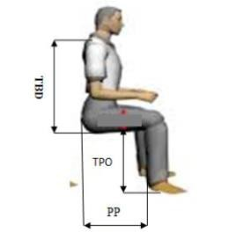

**Figure 1:Measurement of body dimensions in sitting position**

1. Rear Facing Sitting Position. a) The width of the hip (LP) is measured when the subject sits straight, measuring the horizontal distance from the outermost right side of the hip. b) Shoulder width (LB) is measured from the horizontal distance between two upper arms and the subject sitting straight with the upper arm close to the body and the forearm stretched forward.

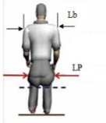

**Figure 2: Measurement of body dimensions in a facing back sitting position**

**Stages after preliminary measurement**

After the preliminary measurements had been conducted there are three consecutive activities in this research:

* + - * Test data uniformity.

Steps in testing the data are as follow:

1. Calculates the average

X = X = Average = the Xth data N = amount of data

1. Calculates the actual standard deviation of the data

Sample standard deviation N = Amount of data = the Xth data X = Average

1. Determines upper control limits (BKA) and lower control limits (BKB) BKA = X + X BKB = X – X
   * + - Calculates the data adequacy test

Where: N = Number of measurements actually needed

N = Amount of data after the data uniformity test was carried out.

* + - * When the number of measurements is insufficient or if the result obtained shows N > N, then additional measurements are needed. If N < N then the preliminary measurement data is sufficient. The calculation of population percentage designed for the entire population is inappropriate because it requires large costs. Therefore, the determination of the range or certain segments of the body size of the population is expected to be following the results of the design, for this reason, the concept of percentiles is used. As for normally distributed data, the percentile value is determined by the formula: X + Zpi

Percentile value of variable X = Average price of sample = Standard deviation of sample = Normal standard value associated with X percentile value

The use of percentile values commonly applied in the calculation of anthropometric data is presented in Figure 3 and in Table 1.

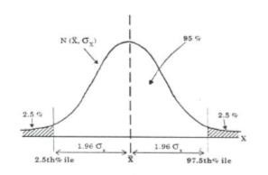

**Figure 3:Normal distribution of anthropometric data**

**Table 1: Types of percentiles and methods of calculation in normal distributions**

|  |  |
| --- | --- |
| PERCENTILE | PERHITUNGAN |
| 1 – st | X – 2.325 σꭕ |
| 2.5 – th | X – 1.96 σꭕ |
| 5 – th | X – 1.645 σꭕ |
| 10 – th | X – 1.28 σꭕ |
| 50 – th | X |
| 90 – th | X – 1.28 σꭕ |
| 95 – th | X – 1.645 σꭕ |
| 97.5 – th | X – 1.96 σꭕ |
| 99 – th | X – 2.325 σꭕ |
|  |  |

# Methodology

This research is quantitative research by descriptive analysis method and applying an approach to the dimensions of seating facilities in public space parks that are associated with the user's body anthropometry. Sample and data analysis of this research is taken from anthropometry data measurement from 100 visitors. The implementation of the study begins with collecting the required data of the user's anthropometric data that sits in the Malang City parks.

The required data for this research are listed below:

* Data tables and park chairs
* Anthropometric data users who come and sit in the park.
* Analyze torque load with pro mannequin software.

The data processing method applied in this research are:

* Data Uniformity Test and the adequacy of data with statistical methods using a 95% confidence level and 5% accuracy level.
* Determine anthropometry sizes to evaluate tables and chairs for the park.

# RESULT AND DISCUSSION

# Community activities users of Malang City Park

Malang City Park is one of many recreational facilities not only for residents of Malang City but also for residents outside Malang City as well as for foreign and domestic tourists. There are many leisure activities carried out by various communities while visiting Malang City Park which requires the government to provide certain facilities such as seating facilities. The result from surveys and interviews of 100 visitors to Malang City Park found that visitors use more than 30 minutes or for more than one hour of seating facilities inside this park and 75 visitors had an opinion or felt body part pain (in their thighs and hips) because of the inappropriate dimension of these seats which do not match the size of the user’s body dimension.

# Types of seating facilities

There are several types of seating facilities provided in Malang City Park which listed below:

**Concrete Chair**

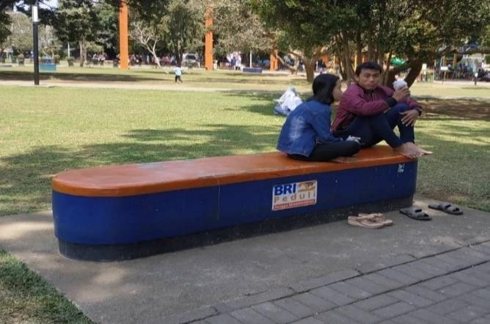

**Figure 4: Concrete chair type**

The elongated concrete chair has dimensions of 50 cm in height, 60 cm in width, and 200 cm in length. Under these large dimensions it is expected to be able to accommodate many people with sitting positions without any consideration of comfort factor while sitting, because it was not in accordance to the size of the user’s human body. If a seating platform is too high then the bottom of the thigh will experience pressure which can cause discomfort and circulatory disorders.

**Backrest iron chair**

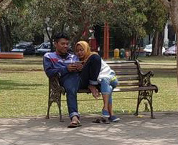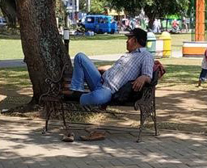

**Figure 5: Iron chair type**

The dimensions of this iron chair are divided into two types, 1) the seat which has 45 cm in height, 40 cm in width and 2) the backrest which has 35 cm in height and 120 cm in length. With a more complete seat design equipped with a backrest or armrest, this type of chair has more concern for the sitting comforts factor.

**Stair chair**

The dimensions of the stair chair are 35 cm in height, 50 cm in width, and 500 cm in length. By these large dimensions, it is expected to accommodate many people with sitting positions without any consideration to the comfort factor, because it was not following the size of the human body of the user.

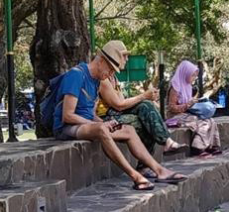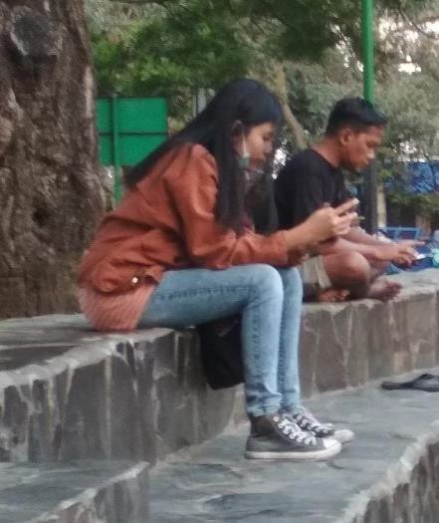

**Figure 6: Stair chair type**

# Ergonomics Analysis

The convenience position when using a seating facility is highly dependent on the proper size of the seating facility measured from the human size as the user. The analysis of user sitting position is using a program what is called Mannequin Pro Software. Mannequin Pro software is used to determine the torque load of a person feels at various positions while sitting.

**Sitting position with hanging legs**

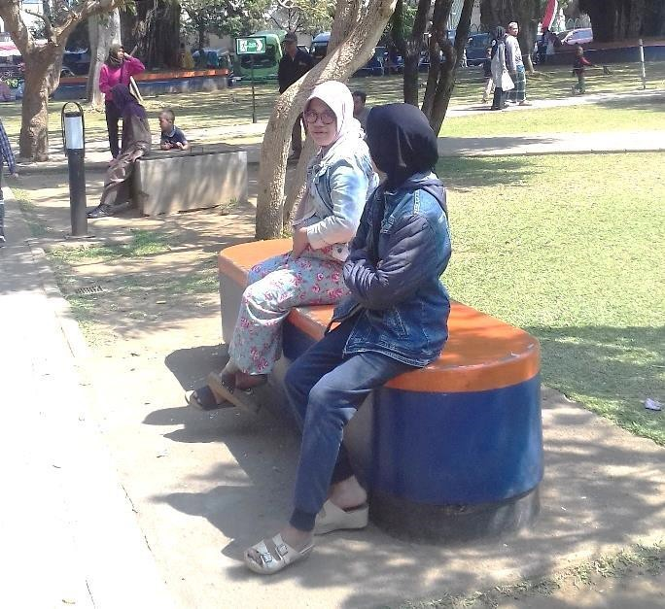

**Figure 7: People sitting with hanging legs**

**Table 2: Analysis of the calculation of people sitting with hanging legs**

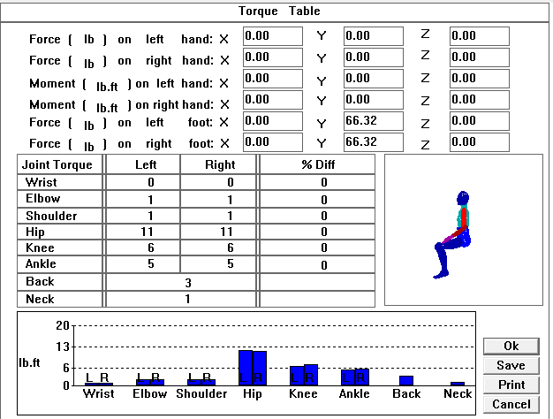

The calculation result of forces and moments that occur on body segments using a Mannequin Pro software is found that there are three (3) parts of the body experiencing torque moments namely; the hip 11 lb. ft = 14.35 Nm, the knee 6 lb. ft = 7.83 Nm, and the ankle 5 lb. ft = 6.5 Nm.

**The position of sitting bent with legs hanging**

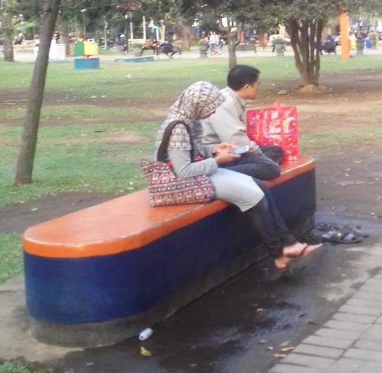

**Figure 8: People sitting bent with hanging legs**

**Table 3: Analysis of the calculation of people sitting bent with hanging legs**

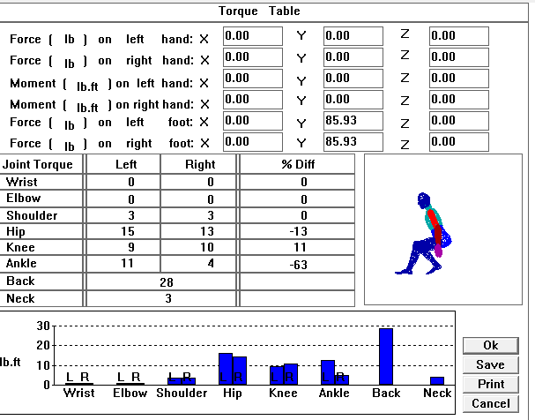

The calculation result of forces and moments that occur in body segments using a Mannequin Pro software is found that there are four (4) body parts that experience torque moments, namely: the back 28 lb. ft = 36.54 Nm, the hip 15 lb. ft = 19.56 Nm, the ankle 11 lb. ft = 14.35 Nm, and the knee 9 lb. ft = 11.75 Nm.

**The sitting position with the feet raised**



**Figure 9: People sitting with feet raised**

**Table 4: Analysis of the calculation of people sitting with the feet raised**

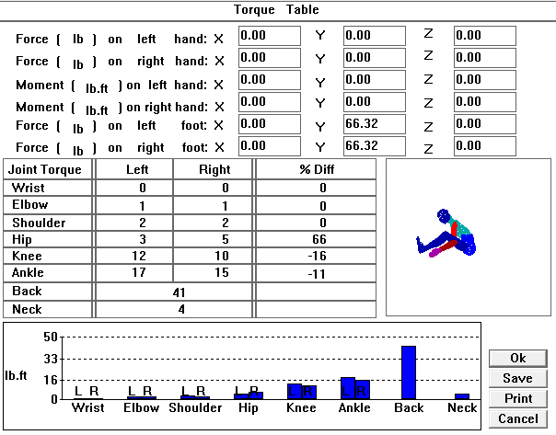

The calculation result of forces and moments that occur on body segments using a Mannequin Pro software is found that there are four (4) parts of the body experiencing torque moments namely: the back 41 lb. ft = 53.5 Nm, the ankle 17 lb. ft = 22.18 Nm, the knee 12 lb. ft = 15.66 Nm, and the hip 3 lb. ft = 3.9 Nm.

**Position sitting with a bow**



**Figure 10: People sitting with a bow**

**Table 5: Analysis of the calculation of people sitting with a bow**

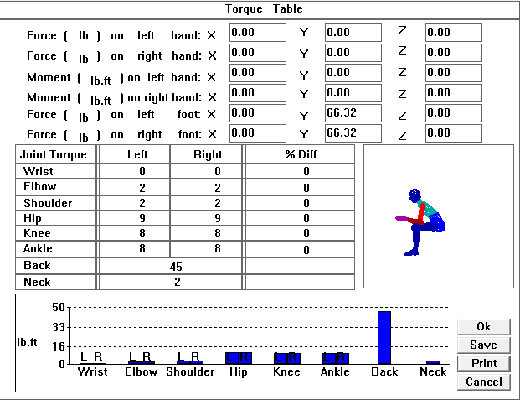

The calculation result of forces and moments that occur on body segments using a Mannequin Pro software is found that there are four (4) parts of the body experiencing torque moments, namely the back 45 lb. ft = 58.73 Nm, the hip 9 lb. ft = 11.75 Nm, the ankle 8 lb. ft = 10.44 Nm, and the knee 8 lb. ft = 10.44 Nm.

**Squat sitting position**

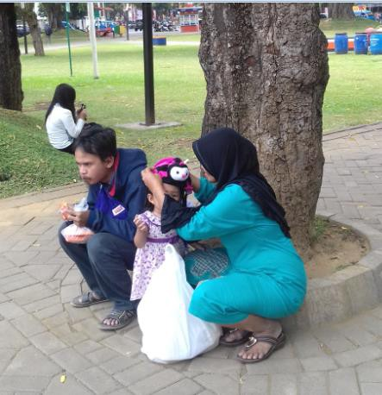

**Figure 11: People sitting with a bow**

**Table 6: Analysis of the calculation of people sitting with squat sitting position**

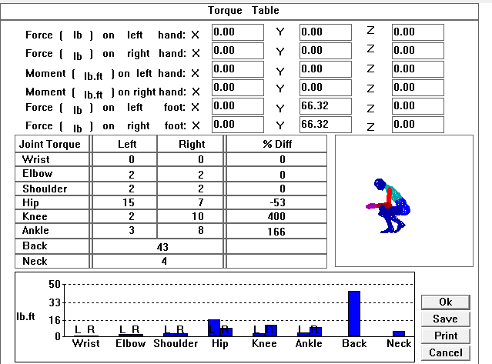

The calculation result of forces and moments that occur in body segments using a Mannequin Pro software is found that there are four (4) parts of the body experiencing torque moments namely: the back 43 lb. ft = 56.12 Nm, the hip 15 lb. ft = 19.57 Nm, the ankle 3 lb. ft = 3.9 Nm, and the knee 2 lb. ft = 2.6 Nm.

# CONCLUSIONS

According to result analysis and evaluation carried out on the seating facilities located at Malang City Parks, the researchers can draw two conclusions as follow:

1. The existing seating facilities are not ergonomically feasible. It is indicated by the incorrect measurement of seating facility size which is not in line with appropriate anthropometric data where the height of the seat is 41 cm and length of the seat is 49 cm, also a seating facility which should also be equipped with 46 cm dimension backrest, backrest angle, and 56 cm long armrest.
2. Analysis and evaluation of biomechanics taken by Mannequin Pro V.10 software on the new design have obtained results in a form of calculation of forces and moments that occur in each segment of the human body which is are smaller when compared to the style and moment of the available (existing) seating facilities.

# REFERENCES

* + - 1. Konijnendijk, C. C., Annerstedt, M., Nielsen, A. B., and Maruthaveeran, S. (2013). Benefit of Urban Parks: A Systematic review. Copenhagen & Alnarp: The International Federation of Park and Recreation Administration.
      2. Carmona, M., Heath, T., Oc, T. and Tiesdell, S. (2003). Public Places Urban Spaces: The Dimensions of Urban Design.Architectural Press.
      3. Carr, Stephen, et al. (1992). Public Space*.* Australia: Press Syndicate of University of Cambridge.
      4. Septariani, D. N. (2010). Peran Elemen Arsitektural Ruang Terbuka Publik Kota pada Taman Bungkul terhadap Interaksi Lingkungan Sekitar [Unpublished Undergraduated Thesis]. University of Brawijaya Malang. <http://repository.ub.ac.id/id/eprint/140463>
      5. Kustianingrum, D., Sukarya, A., Nugraha, R., and Tyagarga, F. (2013). Fungsi dan Aktifitas Taman Ganesha Sebagai Ruang Publik di Kota Bandung. Jurnal Reka Karsa, 1(2), 1-4. ISSN: 2338-6592
      6. Haryadi, and Setiawan, B. (2010). Arsitektur, Lingkungan dan Perilaku. Yogyakarta: GadjahMada University Press.
      7. Rapoport, A. (1982). Human Aspect of Urban Form:Towards a Man Environment Approach to Urban Form and Design. USA: Pergamon Press.
      8. Wignjosoebroto, S. (2008). Ergonomi Studi Gerak dan Waktu.Jakarta: Guna
      9. Wignjosoebroto, S. (2000). Evaluasi Ergonomis dalam Perancangan Produk*.* Surabaya: Institut Teknologi 10 Nopember.

Coressponding Author: Industrial Engineering, Faculty of Industrial Engineering, National Institute of Technology, Sigura – gura Street No. 2, Malang, East Java, 65152, Indonesia.

Email: [julianus1961@lecturer.itn.ac.id](mailto:julianus1961@lecturer.itn.ac.id)