**FACE RECOGNITION**

*Dr Chitra. R Priyadharshini S*

*(Associate Professor) (UG Student)*

*Department of CSE Department of CSE*

*priyadharshini21@karunya.edu.in*

*Karunya Institute of Technology and Sciences Karunya Institute of Technology and Sciences*

*Coimbatore, Tamil Nadu, India. Coimbatore, Tamil Nadu, India.*

**Abstract -**The problem of face recognition is recognizing important facial features from a frontal image of a person, like the mouth, nose, and eyes. To do this, our method entails a number of steps. First, we identify the facial region using a skin-color segmentation method, and then we use morphological techniques to fill in any gaps in the segmentation. We then use skeletonization to create a skeletal model of the face, which makes it possible to identify characteristics within the contour and extract points of the facial contour. To evaluate our approach, we will test it on a variety of face photos. With possible uses in crowd surveillance, video content indexing, personal identification (such as confirming a driver's license), and matching, the main goal is to identify faces within a sizable face database.

.

INTRODUCTION

*Biometric:*

Biometrics is used in the process of authentication of a person by verifying or identifying that a user requesting a network resource is who he, she, or it claims to be, and vice versa. It uses the property that a human trait associated with a person itself like structure of data with the incoming data we can verify the identity of a particular person. There are many types of biometric system like detection and recognition, iris recognition etc., these traits are used for human identification in surveillance system, criminal identification, face details etc. By comparing the existing fingerprint recognition.

*Face recognition:*

Human beings have recognition capabilities that are unparalleled in the modern computing era. These are mainly due to high degree of interconnectivity, adaptive nature, learning skills and generalization capabilities of the nervous system. The human brain possesses a large number of intricately linked organic neurons that, depending on the task at hand, are capable of performing supercomputers. Though it is a laborious operation for a computer, a youngster can recognize a face accurately. Engineering a system that can mimic a child's abilities is therefore the major goal. Over the past few decades, significant progress in processing power has made it possible for these built systems to achieve somewhat similar recognition capabilities. Lately, the field of face recognition algorithms has advanced into a discipline including complex mathematical representations and matching procedures, replacing the earlier usage of basic geometric models. Face recognition technology has gained significant attention due to significant projects and breakthroughs. There are numerous applications for face recognition technology. AI systems capable of identifying and detecting faces might

A crucial component of this technology should be its ability to handle different facial image modifications, such as rotation and expression alterations. Remarkably, picture differences resulting from changes in face identity are nearly never smaller than the mathematical variations resulting from changes in illumination and viewing direction across photographs of the same face. Facial recognition is quite difficult in this.

There are two types of face recognition: Template-based (photometric) and Feature-based (geometric). The eyes, nose, mouth, and chin are among the facial features that are recognized using geometric or feature-based techniques. Face descriptors include attributes and relationships including areas, angles, and separations between features. Despite being cost-effective and efficient, this class of approaches focuses primarily on the extraction and measurement of

facial. Features. Unfortunately, this demand has not been sufficiently met by the feature extraction and measurement methods and algorithms that have been developed to be yet. Conversely, neural techniques and template matching typically work directly with an image-based representation of a face, such as a pixel intensity array. This kind of approach has the advantage that geometric face feature recognition and measurement are not necessary.

situation. For face recognition algorithms to be effective, two fundamental problems must be addressed: First, the selection of facial feature representations. An successful depiction should be able to accommodate for potential changes in viewpoint, illumination, and expression, as images are susceptible to these variations.

ARCHITECTURE

*Dataflow diagram*

A dataflow diagram (DFD) shows how data and information move across systems or processes. They illustrate the data inputs, outputs, storage locations, and system pathways using standardized symbols such as rectangles, circles, arrows, and text labels. DFDs range from straightforward hand-drawn summaries to intricate descriptive diagrams that go deeper into the data flow.

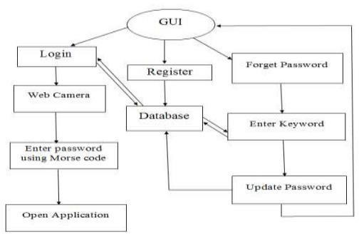

Fig 1 Dataflow diagram of the model

### *Use case Diagram*

It is possible to illustrate the roles of the system's actors.

.

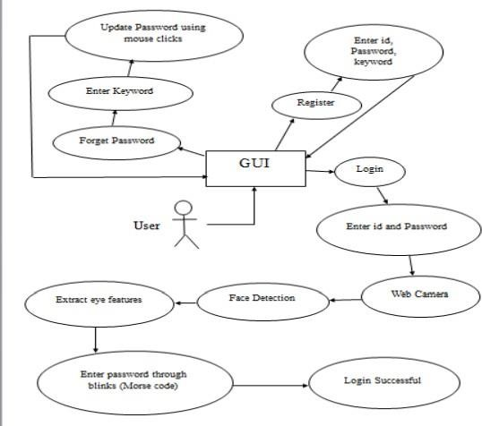

Fig 2 Use Case diagram of the model

### *Sequence Diagram*

A sequence diagram only shows the sequential order—that is, the order in which these events occur—of interactions between objects. Sequence diagrams show the order in which the various components of a system operate. Event diagrams, event situations, and timing diagrams are other names for sequence diagrams.

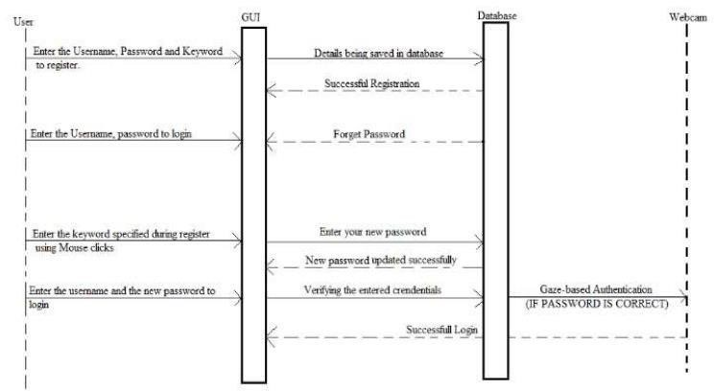

#### Fig 3 Sequence Diagram for the model

IMPLEMENTATION

Techniques

*Traditional*

Some face recognition algorithms work by taking features or landmarks out of face photos, examining the sizes, shapes, and relative positions of the eyes, nose, cheekbones, and jaw, and then comparing these elements to other photographs to see if any similarities exist. Some others compress the data, normalize a gallery of face photos, and compare it with a probe image. These methods can be photometric, which compares image values with templates statistically, or geometric, which concentrates on differentiating features. They can also be classified as feature-based, which breaks the face down into individual parts for analysis, or holistic, which recognizes the face as a whole. Principal component analysis, linear discriminant analysis, neural motivated dynamic link matching, elastic bunch graph matching, hidden Markov models, and multilinear subspace learning are some of the techniques used in recognition. Deep learning in particular, machine learning is being used more and more in modern systems.

*Human Identification at a distance (HID)*

Face hallucination techniques are used to augment low-resolution facial photographs in order to enable human identification at a distance (HID). For facial recognition in CCTV footage, where faces are frequently small, resolution augmentation is essential.

algorithms for recognition, which usually need for photos with higher resolution. Face hallucination algorithms include machine learning techniques based on examples, such as nearest neighbours distribution indexes or pixel replacement, and occasionally incorporate age- and demographic-related facial features. The limitations of super-resolution approaches are overcome by high-resolution algorithms when these techniques are applied before facial recognition. Face hallucination is also used for face preprocessing, which involves precisely mapping the complete face and removing disguises such as sunglasses. However, it might be difficult to capture fleeting facial expressions in low-resolution photos. Datasets are needed to train these algorithms.

with both disguised and undisguised face images.

*3- dimensional recognition*

By using 3D sensors to record facial shape information, the three-dimensional face recognition approach makes it possible to identify individual features like the contours of the chin, nose, and eye sockets. It is not impacted by variations in lighting, unlike other approaches, and can identify faces from different viewing angles, including profiles. 3D data points considerably improve recognition precision. This study is made possible by sophisticated sensors that cast structured light onto the face. Technion researchers used metric geometry tools that treated expressions as isometries to address expression sensitivity. Three tracking cameras are positioned at different angles (front, side, and intermediate) in a unique approach. When these cameras cooperate, real-time tracking, face identification, and recognition are made possible.

*Thermal cameras*

Thermal cameras offer an alternative method for face recognition, detecting only the shape of the head and disregarding accessories like glasses or hats. They excel in low-light and nighttime conditions without revealing the camera's position. However, thermal face recognition databases remain limited, with efforts dating back to 2004 and databases such as the IIITD-PSE and the upcoming Notre Dame thermal face database by 2016. It is difficult for current methods to accurately identify faces in outdoor thermal images. Researchers at the United States Army Research Laboratory (ARL) developed a cross-spectrum synthesis technique in 2018 to compare thermal facial imagery with traditional camera databases. This method maps thermal images to visual ones using an optimization problem and a non-linear regression model, synthesizing a single image by examining different facial regions and details. By merging global and local face traits, ARL's studies show a 30% performance gain over baseline approaches and a 5% improvement over state-of-the-art procedures.

RESULTS OBTAINED

### *Test Environment*

A crucial component of software development is testing. The process of testing ensures that the developed product complies with the standards for which it was intended. Creating test cases is a step in the testing process that the product must pass.   
Combination Module Testing   
The process of combining and testing separate software modules collectively is known as integration testing. It takes place before to validation testing but following unit testing.   
Enrolling   
This module consists of the first page the user sees when submitting his credentials. The supplied username, password, and keyword will be kept on file.   
in a different text document. The project's frontend implementation is used to represent this module.   
Register   
The user or administrator enters their credentials in this module using the information from the register module. In the event that the login process is successful, the user can employ gaze-based authentication to verify the password. The project's back-end implementation is used to illustrate how eye blinks are converted to morse code.   
Lost Your Password?   
In this module, the user can generate a new password by inputting the register keyword in case he forgets his old one.

*Face Encoding*

Face encoding is a vector of values representing the important measurements between distinguishing features of a face like the distance between the eyes, the width of the forehead, etc. We loop through each of the images in our train directory, extract the name of the person in the image, calculate its face encoding vector and store the information in the respective lists. Our test dataset only contains 1 image with all of the persons in it.  
The face recognition library provides a useful method called face locations () which locates the coordinates (left, bottom, right, top) of every face detected in the image. Using those location values, we can easily find the face encodings. We loop through each of the face locations and its encoding found in the image. Then we compare this encoding with the encodings of the faces from the “train” dataset. Then calculate the facial distance meaning that we calculate the similarity between the encoding of the test image and that of the train images.

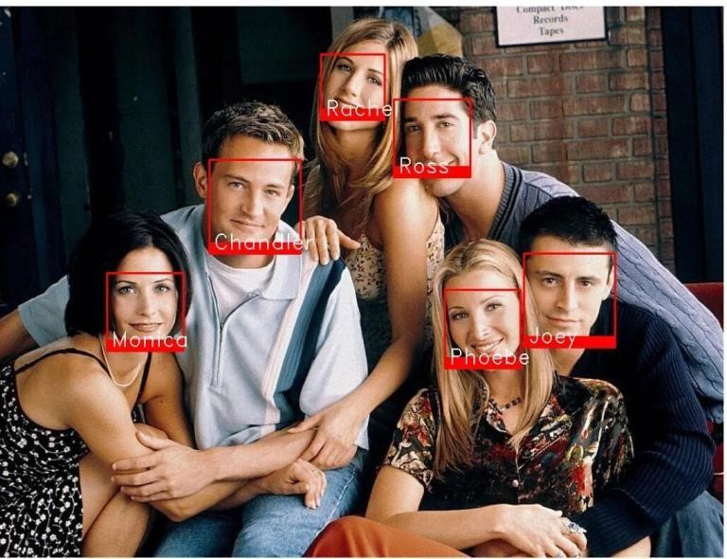

Fig 4 Python Face Recognition Output

FINAL THOUGHTS

Face recognition technology has come a long way in the last twenty years. Today, machines are able to automatically verify identity information for secure transactions, for surveillance and security tasks, and for access control to buildings etc. These applications usually work in controlled environments and recognition algorithms can take advantage of the environmental constraints to obtain high recognition accuracy. However, next generation face recognition systems are going to have widespread application in smart environments where computers and machines are more like helpful assistants. To achieve this goal computers must be able to reliably identify nearby people in a manner that fits naturally within the pattern of normal human interactions. They must not require special interactions and must conform to human intuitions about when recognition is likely. This implies that future smart environments should use the same modalities as humans, and have approximately the same limitations. These goals now appear in reach -- however, substantial research remains to be done in making person recognition technology work reliably, in widely varying conditions using information from single or multiple modalities.

All testing methods that are carried out to get a bug free system. Quality can be achieved by testing the product using different techniques at different phases of the project development. The purpose of testing is to discover errors. Testing is the process of trying to discover every conceivable fault or weakness in a work product. It provides a way to check the functionality of components sub-assemblies and/or a finished product. It is the process of exercising software with the intent of ensuring that the Software system meets its requirements and user expectations and does not fail in an unacceptable manner. There are various types of tests. Each test type addresses a specific testing requirement.

APPLICATIONS

*Social Media*

Platforms like Snapchat utilize Facial Recognition Technology (FRT) for their landmark lenses function, where face detection technology applies 3D mesh masks over users' faces in live videos. Facebook's Deep Face, employing deep learning techniques, accurately identifies human faces in digital images. TikTok's algorithm, though initially stated to not use facial recognition, settled a lawsuit alleging otherwise, indicating its potential use of such technology in user video recommendations.

*ID Verification*

FRT is increasingly used for ID verification services, particularly in banking and e-businesses. Examples include Android's facial recognition feature for device unlocking, Microsoft's Kinect for Xbox 360, and Windows 10's "Windows Hello" platform. Apple's Face ID on the iPhone X utilizes infrared technology for secure facial recognition, surpassing fingerprint-based systems like Touch ID.

*Government and Security*

Facial recognition technology is used by nations like Australia, New Zealand, and Canada to process passports automatically by comparing the faces of visitors with information contained on e-passport microchips. Since 2015, police agencies in the UK have been testing live facial recognition technology at public events, despite criticisms over accuracy and potential abuses of human rights raised by groups such as Big Brother Watch.

ADVANTAGES

#### No more fraud

We are constantly searching for fresh approaches to preventing fraud. Passwords, captures, and PIN codes are insufficient. The development of machine learning and artificial intelligence has made it much simpler to trick security systems.

selfie can be a viable way of authenticating a credit card purchase.

Spending less money   
One of the least expensive biometrics available is face recognition

Simple and quick to use

Face recognition is known for its convenience and social acceptability. It is the only biometric capable of operating without user cooperation. And it works in real time, so what you need to do is look at the camera and in a fewseconds, it knows who you are.

Cut down on product loss

Product loss in stores can be decreased with facial recognition software. It can identify repeat shoplifters and alert security to their presence so they can be escorted out of the establishment. Additionally, it can address the issue of staff stealing. When workers are aware that there is software available to capture them and alert store owners to specific thefts, they are less likely to steal.

.

### FUTURE SCOPE

The future of facial recognition technology is bright. Forecasters opine that this technology is expected to grow at a formidable rate and will generate huge revenues in the coming years. Security and surveillances are the major segments which will be deeply influenced. Other areas that are now welcoming it with open arms are private industries, public buildings, and schools. It is estimated that it will also be adopted by retailers and banking systems in coming years to keep fraud in debit/credit card purchases and payment especially the ones that are online. This technology would fill in the loopholes of largely prevalent inadequate password system. In the long run, robots using facial recognition technology may also come to foray. They can be helpful in completing the tasks that are impractical or difficult for human beings to complete.

*Scope in INDIA*

Indian police are using facial recognition technology (FRT) more often in spite of privacy and accuracy concerns. The National Crime Records Bureau's National Automated Facial Recognition System (AFRS) seeks to establish a nationwide facial recognition database. But worries expressed by groups like the Internet Freedom Foundation draw attention to possible false positives and negatives, which would violate people's right to privacy under Article 21 of the Constitution. While certain states have previously implemented FRT systems, like as Telangana's TSCOP + CCTNS and Punjab's PAIS, the Crime and Criminal Tracking Network and Systems (CCTNS) intends to digitise FIR-related data nationwide. There are privacy problems with the integration of CCTNS and AFRS. The 'RajCop' software from Rajasthan incorporates facial recognition technology for instantaneous suspect identification.

Delhi Police's FRT system reported low accuracy rates, raising concerns about discrimination and biases. The government's collaboration with ISRO for Crime Mapping Analytics and Predictive System (CMAPS) further raises surveillance worries. Attempts to obtain information through Right to Information (RTI) requests have been met with denial, reflecting transparency challenges in FRT deployment.

### REFERENCES

[1] Katie A. Hart, Jennifer Chapin, and Dr. Kyle B. Reed, “Haptics Morse Code Communication for Deaf and Blind Individuals” 38th Annual International Conference of the IEEE Engineering in Medicine and Biology Society (EMBC), 2016.

[2] Cheng-Hong Yang, Ching-Hsing Luo, Yuan-Long Jeang, Gwo-Jia Jon, A novel approach to adaptive Morse code recognition for disabled persons, In Mathematics and Computers in Simulation, Volume 54, Issues 1–3, 2000.

[3] Albano Carrera, Alonso, Ramón de la Rosa and Evaristo J. Abril, “Sensing Performance of a Vibrotactile Glove for Deaf-Blind People”, Optical Communications Group, ETSI de Telecomunicación, Universidad de Valladolid, Paseo Belén, 15, 47011 Valladolid, March 2017, Spain; ejad@tel.uva.es

[4] Shubham Oulkar1, Ram Bamane, Sagar Gulave and Pravin Kothawale, “Voice Controlled Home Automation Using Raspberry Pi 3”,Student, E&TC, Sanjay Ghodawat Institute,Atigre , India

1. TERZOPOULOS, D. AND WATERS, K. 1993. Analysis and synthesis of facial image sequences using physical and anatomical models. IEEE Trans. Patt. Anal. Mach. Intell. 15,

569–579

1. TARR, M. J. AND BULTHOFF, H. H. 1995. Is human object recognition better described by geon structural descriptions or by multiple views— comment on Biederman and Gerhardstein (1993). J. Exp. Psych.: Hum. Percep. Perf. 21, 71– 86.
2. VAPNIK, V. N. 1995. The Nature of Statistical Learning Theory. Springer-Verlag, New York, NY.
3. VIOLA, P. AND JONES, M. 2001. Rapid object detection using a boosted cascade of simple features. In Proceedings, IEEE Conference on Computer Vision and Pattern Recognition.
4. RIKLIN-RAVIV, T. AND SHASHUA, A. 1999. The quotient image: Class based re- rendering and recognition with varying illuminations. In Proceedings, IEEE Conference on Computer Vision and Pattern Recognition. 566–571.
5. ZHOU, S., KRUEGER, V., AND CHELLAPPA, R. 2003. Probabilistic recognition of human faces from video. Comput. Vis. Image Understand. 91, 214– 245.

ACKNOWLEDGEMENT

We are grateful to Karunya Institute of Technology and Sciences in Coimbatore, India for giving us the space and assistance we needed to finish our project successfully.