DETECTING FAKE NEWS ARTICLE AND IMAGES BY USING MACHINE LEARNING ALGORITHM

R. Nivethitha1, V. Sriram2, R. Subash3, D. Sundar Rajan4, K. Vimal Raj5

*1Assistant Professor Department of Computer Science and Engineering, K.L.N. College of Engineering and Technology, Sivagangai, Tamilnadu, India.*

*2,3,4,5 Final Year Students, Department of Computer Science and Engineering, K.L.N. College of Engineering and Technology, Sivagangai, Tamilnadu, India.*

[*Corresponding Author: sundarrajandhamotharan7889@gmail.com*](mailto:alagarcse@gmail.com)

***Abstract:*** *The rampant spread of misinformation on platform like Facebook poses a critical challenge to public discourse. This proposed system focuses on detecting fake news and fake images using machine learning algorithms. To develop a robust machine learning- based system for detecting fake news specifically on Facebook. By leveraging techniques like Logistic Regression and image analysis models, the project aims to identify patterns that distinguish between real and deceptive content. The system processes textual and visual data to flag misinformation, enhancing the reliability of online information. The system utilizes a combination of text-based and image-based machine learning techniques to achieve this goal. For fake news detection, a Logistic Regression algorithm is employed to classify news articles as either real or fake. The model is trained on a label dataset containing various features extracted from the news articles, such as word frequency, sentiment analysis, and metadata. By learning from these features, the model can effectively identify patterns that are common in deceptive or misleading news content. On the image analysis front, the proposed system incorporates advanced image recognition and manipulation detection algorithms. Techniques like Convolutional Neural Networks (CNNs) are used to detect anomalies in images that may indicate forgery or tampering.*

***Key Word:*** *Fake News Detection, Machine Learning, Logistic Regression, Convolutional Neural Networks (CNNs), Error Level Analysis (ELA).*

1. **INTRODUCTION**

In the digital age, the rapid proliferation of information has fundamentally transformed how users engage with content online. Content-based recommender systems have become a cornerstone of this transformation, designed to curate and deliver personalized information to users based on their previous interactions. These systems utilize algorithms to continuously showcase content in users' feeds that closely resembles previously viewed items or those with which the user has engaged, such as through likes or comments. While these algorithms enhance user satisfaction and retention, they inadvertently present a significant opportunity for the dissemination of fake news [1]. Once a user encounters a piece of misleading information, the recommender system perpetuates the cycle of misinformation by suggesting similar content, regardless of its veracity [2].Furthermore, these systems often incorporate mechanisms to diminish the visibility of certain posts, leading to an ecosystem where undesirable content is consistently masked rather than eliminated [3]. This raises critical ethical questions about the responsibility of platform providers in managing the information environment. Historically, the academic focus on fake news detection has predominantly centered on linguistic and compositional characteristics. Researchers have sought to identify fake news by examining various parameters, including the presence of identifiable authorship, the credibility of sources, and the overall length of articles [4], [5], [6], [7].This approach operates under the assumption that clear distinctions exist between the linguistic features of fake and factual news, allowing for the identification of unreliable sources. However, this methodology has significant limitations. It fails to account for the complex characteristics of users who engage with or propagate fake news, as well as the intricate dynamics of the social media networks that facilitate the spread of such information.The rise of sophisticated AI models, such as ChatGPT (Generative Pre-trained Transformer), has further complicated the landscape of fake news detection.

These advanced language models can generate coherent, stylistically appropriate text that closely resembles professional journalism, thereby obscuring the lines between authentic reporting and fabricated narratives [4]. As a result, the traditional reliance on linguistic features for detecting fake news is increasingly inadequate. The ease with which misleading content can now be generated means that users are often unable to distinguish between news articles produced by AI and those crafted by experienced journalists. This shift necessitates a reevaluation of detection methodologies to effectively combat misinformation. In response to these challenges, this study proposes a comprehensive fake news detection model that moves beyond conventional techniques by integrating an analysis of not only the visual characteristics of content but also the nuanced behaviors of users who generate and disseminate fake news.

The sophistication of fake news generation has escalated, particularly with advancements in AI technology that allow for the rapid creation of articles that closely mimic real news. For instance, AI-driven bots deployed on social media platforms like Twitter can create a vast array of user accounts capable of generating support or opposition for specific narratives, effectively obfuscating the authenticity of the information presented [8]. This manipulation of public discourse complicates the landscape of news consumption and amplifies the need for innovative detection strategies.

To effectively address the limitations of existing research, this study aims to enhance the predictive performance of fake news detection by considering the characteristics of information recipients and the specific contexts in which misinformation proliferates. By constructing a detection model that incorporates various content features, user characteristics in social media, and the networks through which fake news is propagated, we seek to offer a more holistic approach to understanding and identifying misinformation. 2 | Page

# OBJECTIVE

The rise of social media has led to an increase in misinformation, prompting various studies on fake news detection. Previous research primarily focused on linguistic features, employing methods such as keyword frequency analysis and sentiment analysis to differentiate between fake and real news articles [1]. For instance, some studies identified fake news based on the presence of sensational language and emotional appeal [3, 4]. Recent advancements in machine learning have shifted the paradigm toward automated detection. Techniques such as Logistic Regression and Random Forest have been widely used, with models achieving notable accuracy in classifying news content [2, 5]. The introduction of deep learning methods, particularly Convolutional Neural Networks (CNNs), has further improved detection capabilities by allowing models to learn intricate patterns in text data [6].

Furthermore, the role of user engagement in the propagation of fake news has gained traction. Studies suggest that user behavior, including likes and shares, can be indicative of content credibility [7]. This user-centric approach provides insights into how misinformation spreads and how it can be mitigated. Despite these advancements, many existing methods still rely heavily on textual features and often overlook the dynamics of social media networks.

# LITERAURE SURVEY

## Current methods of fake news detection:

Traditional fake news detection methods rely on analyzing text patterns, linguistic features, and sentiment. These techniques, including sentiment analysis and syntax parsing, often use natural language processing (NLP) to detect misleading content. Visual methods, such as image manipulation detection, focus on identifying altered images and deepfakes. However, these approaches often struggle to handle complex, multi-modal misinformation and require significant manual intervention, leading to slower detection.

## Technology's role in improving quality:

Advances in machine learning (ML) and deep learning (DL) techniques have significantly improved fake news detection. Algorithms like Support Vector Machines (SVM), Naive Bayes, and deep neural networks can analyze both textual and visual content, increasing detection accuracy. Hybrid models combining text and image analysis are also emerging, allowing for a more comprehensive approach. Moreover, user-centered design in detection systems enhances trust and transparency, offering clearer explanations for classification results and fostering better digital literacy.

# EXISTING SYSTEM

Existing fake news detection systems typically combine traditional techniques such as keyword analysis, sentiment analysis, and rule-based heuristics with machine learning models. While these systems can identify patterns like sensational language or emotional triggers commonly associated with fake news, they face significant limitations. The systems often struggle with high false-positive rates, misclassifying legitimate news, and lack adaptability to keep up with evolving misinformation tactics. Moreover, rule-based methods fail to interpret nuances like sarcasm and irony, and text-only approaches cannot effectively handle multimedia elements such as manipulated images or videos. Additionally, privacy concerns and ethical issues like algorithmic bias and data misuse complicate their adoption, highlighting the need for more innovative, adaptable, and ethical solutions.

# PROPOSED SYSTEM

The Proposed System Consists of a comprehensive fake news detection system to identify and mitigate the spread of misinformation across social media platforms. The system aims to enhance the accuracy of news verification by integrating both text analysis and image recognition techniques, providing a dual-layered approach to content validation. By leveraging advanced machine learning algorithms, the system not only analyzes textual content but also evaluates accompanying images, thereby improving the overall reliability of the detection process.

# ARCHITECTURE DIAGRAM

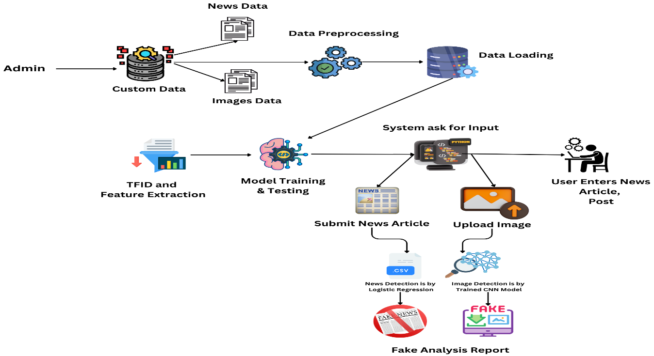

1. **SYSTEM OVERVIEW**

## Data Collection and Input Interface

Users can input text and upload images for analysis. The system retrieves this data and prepares it for processing. The system allows users to submit news articles and upload images for analysis. All content, including text and images, is collected through a user-friendly interface, forming the basis for detecting fake or misleading information.

## Fake news Detection using Logistic regression

The system applies a Logistic Regression algorithm to classify news articles as either real or fake. It extracts features from the articles, including word frequency, sentiment analysis, and metadata, and uses these to train the model on patterns common in deceptive content. This method ensures a reliable classification of fake news based on textual cues.

## Image Forgery Detection using Convolutional Neural Network

To identify potentially manipulated images, the system employs Convolutional Neural Networks (CNNs). These models analyze visual features to detect irregularities, such as pixel inconsistencies and unnatural patterns, that may suggest tampering. This helps in accurately identifying fake images by examining visual anomalies.

## Fake Articles and Image Detection User Interface

A user-friendly interface provides users with real-time feedback on submitted content. Results indicate whether the article or image is classified as real or fake, with explanations based on the analysis process. Administrators can monitor flagged content for review.

3 | Page

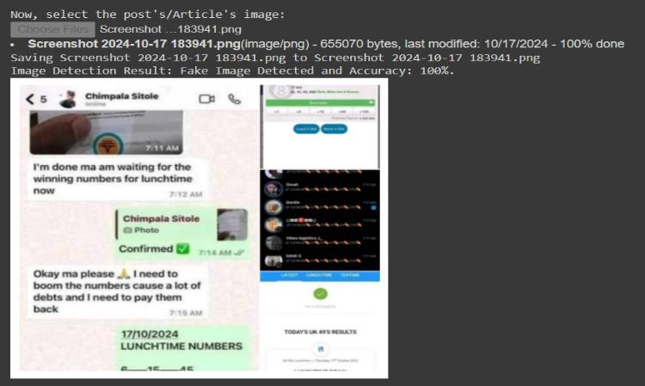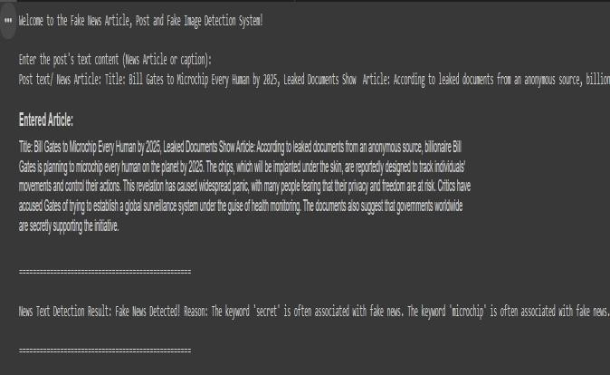

Figure 1: Fake News and Articles Detection System

# IX. CONCLUSION

In today's digital age, the spread of fake news has become a significant challenge, impacting public opinion and trust in media. As misinformation proliferates, it is crucial to develop robust detection systems that can accurately identify and mitigate this issue. Our proposed fake news detection system addresses this need by leveraging advanced text analysis and image recognition techniques. By examining the linguistic features of articles, blog posts, and social media content, along with employing image verification methods, we can effectively classify content as genuine or misleading. This system not only aids in combating misinformation but also promotes a more informed society. With technology at the forefront, our approach provides a proactive solution to an urgent problem, ensuring that users are equipped with the necessary tools to discern the truth in an ever-evolving digital landscape.

4 | Page

# REFERENCES

1. Chaturvedi, S., Saxena, A., Gupta, A., & Alam, F. "Detecting Fake News using Machine Learning Algorithms," 2021 3rd International Conference on Advances in Computing, Communication Control and Networking (ICAC3N), Greater Noida, India, 2021, pp. 212-216, doi: 10.1109/ICAC3N53548.2021.9725560.
2. Durga Lakshmi, V., & Sita Kumari, Ch. "Detection of Fake News using Machine Learning Models," International Journal of Computer Applications, vol. 183, no. 47, Jan. 2022, pp. 22-27, doi: 10.5120/ijca2022921874J.
3. Gururaj, H. L., Lakshmi, H., Soundarya, B. C., Flammini, F., & Janhavi, V. "Machine Learning-Based Approach for Fake News Detection," Journal of ICT Standardization, vol. 10, no. 4, pp. 509-530, 2022, doi: 10.13052/jicts2245-800X.1042.
4. Gupta, V., Mathur, R. S., Bansal, T., & Goyal, A. "Fake News Detection using Machine Learning," 2022 International Conference on Machine Learning, Big Data, Cloud and Parallel Computing (COM-IT-CON), Faridabad, India, 2022, pp. 84-89, doi: 10.1109/COM-ITCON54601.2022.9850560.
5. Jarrah, M., Khalil, A., & Aldwairi, M. "Hybrid Neural Network Models for Detecting Fake News Articles," Hum-Cent Intell Syst, vol. 4, pp. 136–146, 2024, doi: 10.1007/s44230-023-00055-x.
6. Mandical, R. R., Mamatha, N., Shivakumar, N., Monica, R., & Krishna, A. N. "Identification of Fake News Using Machine Learning," 2020 IEEE International Conference on Electronics, Computing and Communication, 2020.
7. Mridha, M. F., Keya, A. J., Hamid, M. A., Monowar, M. M., & Rahman, M. S. "A Comprehensive Review on Fake News Detection with Deep Learning," in IEEE Access, vol. 9, pp. 156151-156170, 2021, doi: 10.1109/ACCESS.2021.3129329.
8. Park, M., & Chai, S. "Constructing a User-Centered Fake News Detection Model by Using Classification Algorithms in Machine Learning Techniques," in IEEE Access, vol. 11, pp. 71517-71527, 2023, doi: 10.1109/ACCESS.2023.3294613.
9. Rahul R., Mandical, et al. “Identification of Fake News Using Machine Learning.” 2020 IEEE International Conference on Electronics, Computing and Communication Technologies (CONECCT), 2020, pp. 1-6.
10. Sharma, D. K., & Garg, S. "Machine Learning Methods to Identify Hindi Fake News within Social Media," 2021 12th International Conference on Computing Communication and Networking Technologies (ICCCNT), Kharagpur, India, 2021, pp. 1-6, doi: 10.1109/ICCCNT51525.2021.9580073.
11. Tanvir, A. A., Mahir, E. M., Akhter, S., & Huq, M. R. "Detecting Fake News using Machine Learning and Deep Learning Algorithms," 2019 7th International Conference on Smart Computing & Communications (ICSCC), Sarawak, Malaysia, 2019, pp. 1-5, doi: 10.1109/ICSCC.2019.8843612.

5 | Page