**FAULT DETECTION IN SUBSURFACE ENVIRONMENT**

**USING LSTM MODEL**

Abirami S Anithra Prabha P Mr Arunkumar R

Computer Science Engineering Computer Science Engineering Computer Science Engineering

Rajalakshmi Institute of Technology, Rajalakshmi Institute of Technology, Rajalakshmi Institute of Technology,

Chennai, Tamil Nadu, India. Chennai, Tamil Nadu, India. Chennai, Tamil Nadu, India.

[abirami.s.2020.cse@ritchennai.edu.in](mailto:abirami.s.2020.cse@ritchennai.edu.in) [anithraprabha.p.2020.cse@ritchennai](mailto:anithraprabha.p.2020.cse@ritchennai).

edu.in

***Abstract-* In the past few years, with the rise of urban dimensions and building of energy infrastructure, more cities construct underground cables to replace power lines in terms of sustainability and safety. Underground cables are susceptible to a variety of problems as a result of underground environments, tear, damage and it also relates to all other factors. This proposed system uses LSTM algorithm and Ohm’s law to identify the specific location of the defect that arises between the consumer and Grid System Environment. Ohm’s Law defines the association between voltage, current, and resistance in a circuit. This technique can be used, together with LSTM algorithms capable of processing data in batches, to examine voltage and current measurements and precisely determine the position of flaws along a connection. The use of LSTM algorithms improves both the precision and the efficacy of fault detection systems by identifying behavioral trends in fault data such as temperature, humidity and the cable status. The aim of the project is to identify the location of faults in centimeters.**

***Keywords-* Sustainability, Grid system, Fault location, Efficacy, Resistance.**

**I. Introduction**

The integrity and reliability of grid systems are fundamental to ensuring the consistent and efficient distribution of electrical power. However, the complex nature of grid infrastructure, combined with environmental factors and operational stresses, can lead to faults and disruptions in service. Timely detection and localization of these faults are critical for maintaining system stability and minimizing downtime [15]. There has been a growing interest in leveraging advanced technologies such as Long Short-Term Memory (LSTM) algorithms in conjunction with fundamental principles like Ohm's Law for fault detection in grid systems. This paper explores the integration of Ohm's Law principles with LSTM algorithms, complemented by MATLAB analytics and ThingSpeak (IoT) platform, for fault detection in grid systems, with a focus on monitoring temperature, humidity, and system status.

Ohm's Law [12], a cornerstone of electrical engineering, establishes the relationship between voltage, current, and resistance in a circuit. By applying Ohm's Law principles to grid systems, it becomes possible to analyze voltage and current measurements to pinpoint faults and anomalies along the grid infrastructure. Additionally, Ohm's Law provides a framework for understanding the behavior of electrical systems under varying conditions, facilitating the detection of abnormalities indicative of potential faults. Integrating LSTM algorithms into the fault detection process enhances the system's capabilities by leveraging the network's ability to analyze temporal dependencies and detect patterns in time-series data. LSTM networks excel at capturing long-term dependencies and learning from historical data, making them well-suited for identifying subtle deviations in grid system parameters that may precede faults. By training LSTM models on historical data, the system can develop predictive capabilities, enabling proactive fault detection and mitigation.

MATLAB [11] analytics serves as a powerful tool for data preprocessing, modeling, and visualization in fault detection applications. With MATLAB, grid operators can analyze temperature, humidity, and system status data collected from sensors deployed throughout the grid infrastructure. MATLAB's extensive suite of functions and toolboxes enables advanced data analysis techniques, facilitating the identification of correlations between environmental variables and fault occurrences.

Moreover, the integration of ThingSpeak provides a scalable and cloud-based platform for data collection, storage, and visualization. ThingSpeak allows for the seamless integration of sensor data from distributed monitoring points within the grid infrastructure, enabling real-time monitoring and analysis of temperature, humidity, and system status. The platform's built-in visualization tools enable grid operators to gain insights into the health and performance of the grid system, facilitating timely decision-making and proactive maintenance. The integration of Ohm's Law ideals, LSTM algorithms, MATLAB analytics, and ThingSpeak offers a comprehensive approach to fault detection in grid systems. By combining fundamental principles with advanced technologies and data analytics capabilities, grid operators can enhance the reliability, resilience, and efficiency of grid infrastructure, ensuring uninterrupted power supply and minimizing service disruptions for consumers.

**II. Literature Review**

(Esha Lohar et al. 2021), Presented Underground Cable Fault Detection Using Arduino Microcontroller [1]. This paper incorporates an Arduino microcontroller and GSM technology to offer real-time fault identification. Possible network problems and delays in reading angle values are disadvantages.

(Pavan Suresh Warade. 2020) Presented Design & Implementation Of Fault Identification In Underground Cables Using IOT [2]. They have designed a system that utilizes an 8051 microcontroller to locate faults and transmit their location information to specialized websites via the Internet.

(N.Badwaik. 2020) Presented Underground Cable Fault Detection System by Using IoT [3].They have utilized basic principles of Ohm's law and current sensing techniques, the system accurately identifies the location faults. This results in Limited Experimental Validation, Low scalability.

(Dr. G. Joga Rao. 2023) Presented Analysis of Underground Cable Fault Distance Locator [5]. By analysing the weaknesses of the current system, they examine a system that employs the 8051 microcontroller to locate the precise location of cable faults.

(R.K.Raghul Mansingh. 2021) Presented Underground Cable Fault Detection using Raspberry Pi and Arduino [4]. In this work, they studied a system that uses Raspberry Pi and Arduino to detect faults in underground cables, especially high voltage primary faults. Since it uses simple concepts from CT (current transfer) theory, the errors are obvious.

(H. Panahi. 2021) Presented “Advances in Transmission Network Fault Location in Modern Power Systems”[18].The main findings emphasize the crucial role of fast and accurate fault location in transmission networks for enhancing system reliability and stability, along with the exploration of various fault location techniques.

(T. S. Kumar et al. 2022) The study focuses on fault diagnosis in power lines using voltage and current information. The methodology involved utilizing data from Kaggle, processing it, and employing two Deep Learning networks (ANN and CNN) for fault classification, with validation using accuracy and loss metrics. CNN was found to outperform ANN in accuracy.

(Y. D. Mamuya. 2020) Presented “Application of Machine Learning for Fault Classification and Location in a Radial Distribution Grid,” [10]. The proposed method using discrete wavelet transforms with machine learning is highly accurate and reliable for fault classification and location in both balanced and unbalanced radial systems.

(A.Abu‐Siada. 2022) Presented “Voltage–current technique to identify fault location within long transmission lines” [19]. The study introduces a new cost-effective technique based on line voltage-current characteristics to predict and identify various abnormal and fault events in real-time. This technique allows for the detection and analysis of changes in the line fingerprint by software in real-time to identify the location, type, and level of abnormal events or emerging faults.

**III. Challenges**

There are some commonly faced challenges:

**Short Circuit Fault:** A short-circuit defect occurs when a pair of conductors of a multi-core cable fall into electrical contact with one another (Fig.1) because of dielectric breakdown. The megger's two terminals can be attached to any two conductors. If the megger reads zero, it indicates a short circuit between these two wires. It can be repeated by using two at once.

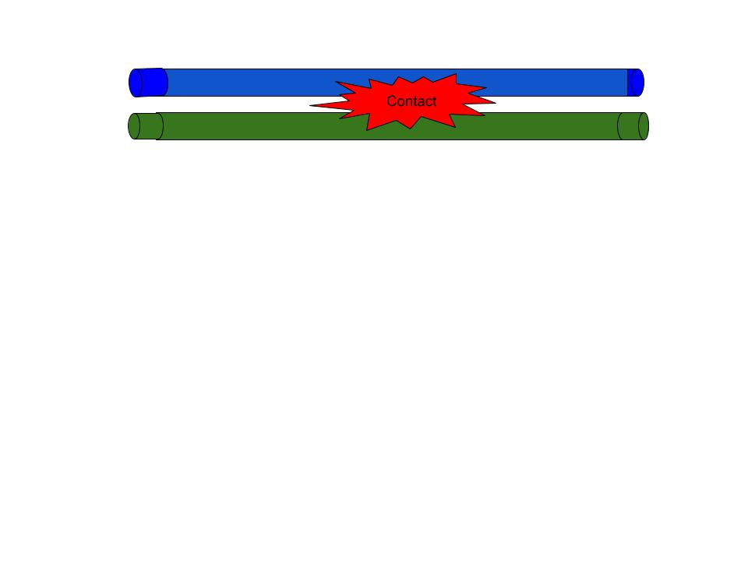

**Fig.1.Short Circuit Fault**

**Open Circuit Fault:** When the cable's conductor breaks, this is referred to as an open circuit fault (Fig.2). Meggers can be used to detect this fault. For this reason, the three conductors of the 3-core wire at the far end are shorted and earthed. The resistance between each conductor and the earth is then measured using a megger. The megger will show 0 resistance in the circuit of the conductor that is not destroyed. However, if the conductor is damaged, the megger will show unlimited resistance in its circuit.

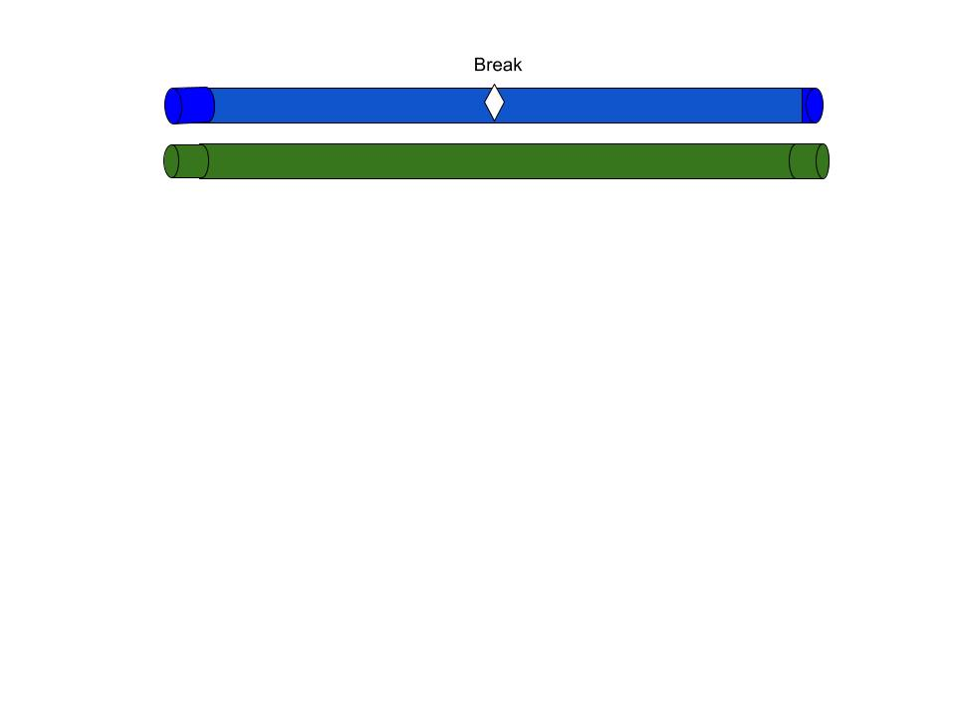

**Fig.2.Open Circuit Fault**

**Earth Fault:** As a cable's conductor comes into touch with the earth, this is known as an earth fault or ground fault (Fig.3). To diagnose this issue, connect one terminal of the megger to the conductor and another to earth.

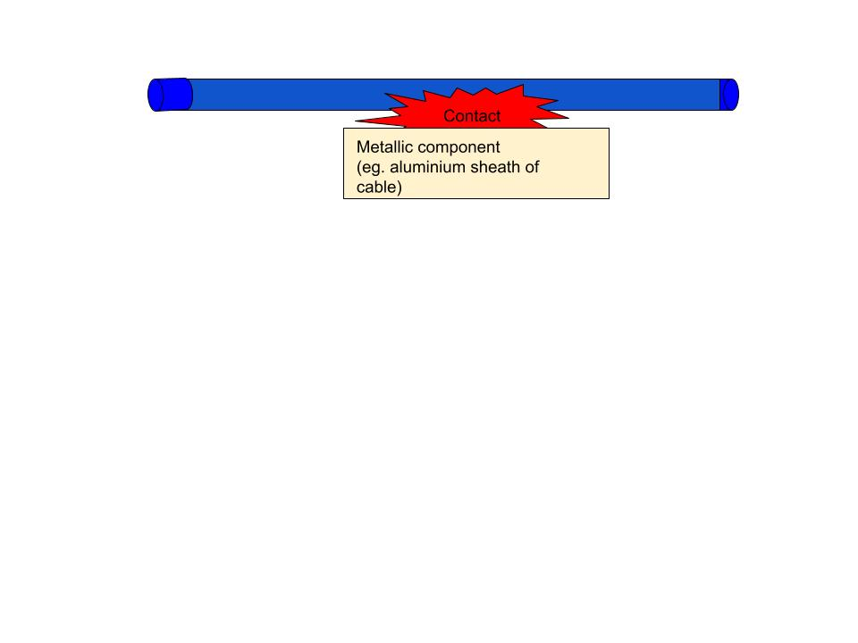

**Fig.3.Earth Fault**

If the megger reads zero, it shows the conductor is earthed. The operation is repeated for the cable's other conductors.

**IV. Motivation**

Urban areas frequently use the digging approach to locate underground cable faults, which takes a very long time to pinpoint the precise site of the fault [13]. A methodology for locating the problem is employed in underground line fault detection. By demonstrating how to locate the issue, this approach lets us avoid having to dig the entire line.

* The main purpose is to provide security.
* To increase safety.
* Helps to take action instantly.
* Reduce human efforts.
* Save time.

**V. Proposed System**

The system's architecture involves preprocessing the raw voltage and current data, applying Ohm's Law principles to compute relevant parameters, and feeding the processed data into the LSTM model for fault detection and localization. Through this approach, the system can automatically identify and pinpoint cable faults, reducing downtime and ensuring the reliability and safety of power systems.

**System Model:** The Working principle of this system model mainly contributes both Software and Hardware implementations.

The below (Fig.4) Architecture Diagram explains the overall description where, the voltage divider is connected to the underground cable to measure the voltage across it. The Node MCU reads the analog voltage values from the voltage divider periodically. By applying Ohm's Law to the measured voltage and current values, we can calculate the resistance of the cable segment between two measurement points. The calculated resistance can be compared with the expected resistance of the cable under normal conditions. If there's a significant deviation, it indicates a fault in the cable segment between the measurement points [16]. Based on the location of the measurement points and the deviation in resistance, we can estimate the location of the fault along the cable. Deploy the trained LSTM model for real-time monitoring of underground cable conditions. Hotspot is connected to Node MCU and ThingSpeak for updation of results which indicates fault location and graphical representation of the Fault. The model continuously analyzes sensor data to detect faults and predict the status of the parameters such as cable distance, temperature and humidity levels.

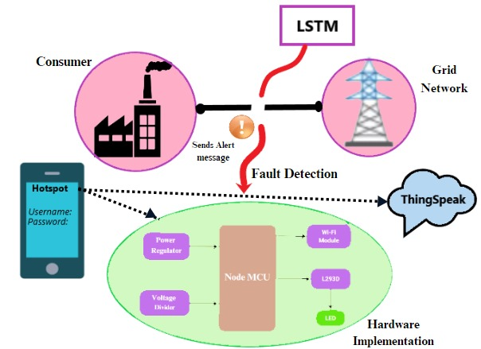

**Fig.4. Architecture Diagram**

**Methodology:** To determine the precise location of a metering terminal, our project utilizes Ohm’s Law and Deep Learning algorithms such as Long Short-Term Memory (LSTM). The below Flowchart (Fig.5) represents two different modules.

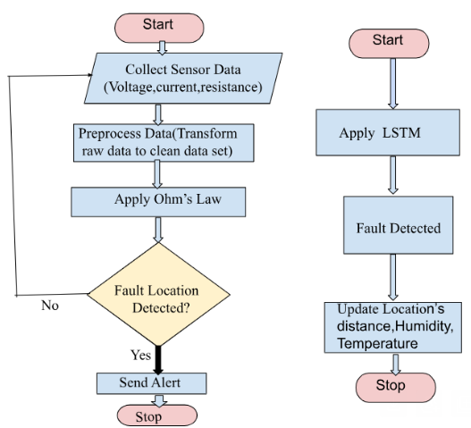

**Fig.5.Modules for detecting cable faults using**

**Ohm’s Law and LSTM**

**MODULE 1: Fault Location Detected**

* **Ohm’s Law**

Ohm’s law states that the current (I) flowing through a conductor between two points is directly proportional to voltage across the two points.

**V=I x R**

Where,

V-voltage in volts (v)

 I-current in ampere (A)

R-resistance in ohms (Ω) (constantly Proportional)

With the help of ohm’s law, we can find the location of fault.

**MODULE 2: Fault Detection**

* **Long Short-Term Memory**

LSTM is a form of Recurrent Neural Network (RNN) that processes sequence data. By analyzing Humidity and Temperature in sensor data, the LSTM can detect anomalies or deviations [5].The key components of an LSTM cell include:

**Cell State (***Ct***)**: The cell state represents the internal memory of the LSTM cell, allowing it to retain information over long sequences.

**Candidate cell state:**

${C'}_{t}$ = tanh( $W_{c}$ ×[$h_{t-1 }$, $x_{t}$]+ $b_{c}$)

**Update Cell State:**

$C_{t}$ = $f_{t}$ × $C_{t-1}$ + $i_{t}$ × ${C'}_{t}$

**Hidden State ($h_{t}$)**: The hidden state carries information forward to the next time step and acts as the output of the LSTM cell.

${ h}_{t}$ = $o_{t}$ × tanh($C_{t}$)

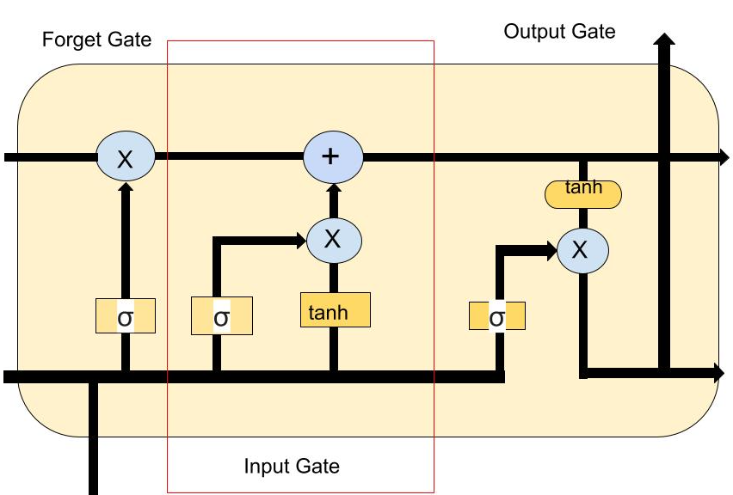

**Fig.6. LSTM model**

**Forget Gate ($f_{t}$**): Controls how much of the previous cell state should be forgotten or retained.

$f_{t}$ = $σ$ ($W_{f}$ × [$h_{t-1}$, $x_{t}$]+ $b_{f}$)

**Input Gate ($i_{t}$)**: Determines how much new information should be added to the cell state.

$i_{t}$ = $σ$ ( $W_{i}$ $×$ [$h_{t-1}$, $x_{t}$]+ $b_{i}$)

**Output Gate ($o_{t}$)**: Regulates how much of the cell state should contribute to the output.

$o_{t}=σ$ ($W_{o}×$ [$h_{t-1}$, $x_{t}$]+ $b_{o}$)

 Where:

* $x_{t}$ is the input at time step *t*,
* $h_{t}$ −1  is the previous hidden state,
* $W_{f}$, $W_{i}$, $W_{c}$, $W_{o}$  are weight matrices for the forget gate, input gate, candidate cell state, and output gate respectively
* $b_{f}$, $b_{i}$, $b_{c}, b$ o are bias vectors,
* *σ* is the sigmoid activation function, and tanh is the hyperbolic tangent activation function.

These mechanisms enable LSTM to capture long term dependencies in the data while avoiding the vanishing gradient problem.

**Algorithm:** FAULT DETECTION IN GRID ENVIRONMENT

**STEP 1**: //Initialisation

**STEP 2:** //Collect voltage, current, resistance data from sensors

**STEP 3:** //Preprocessing of data

def Voltage, Current, Resistance (V,I,R)

def Expected_Resistance (ER)

**STEP 4:** //Implement OHM’S law for Fault location detection

**Input:** V, I, R

**Output:** Fault detection

//Apply OHM’S Law

***R*=V/I**

if (R!=ER) then

    return Fault

else

     return Normal

**STEP 5:** //Integration of Long Short Term Memory (LSTM) algorithm

//Fault Detected

if Fault then

       return Humidity, Temperature

else

       return Normal

**Experimental Analysis:**

Analyzing the behavior of each components includes the success ratio after detecting the disconnected line of execution path.

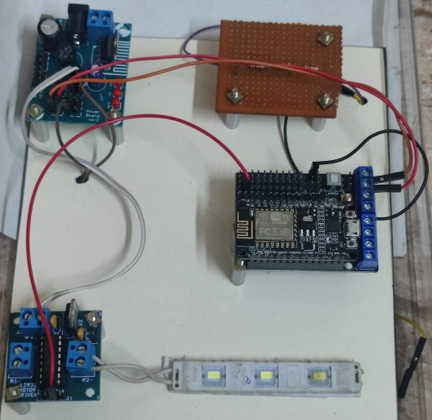

**Fig.7.Hardware Implementation**

**Hardware Used:** The power supply unit provides the necessary electrical power to the entire system. It ensures that all components receive stable and sufficient voltage to operate reliably. The voltage divider is used to measure the voltage across the underground cable. It divides the voltage to a level that can be safely read by the Node MCU's analog input pins.

The Node MCU is a microcontroller development board based on the ESP8266 Wi-Fi module. It serves as the main controller of the system, responsible for collecting data from sensors, processing information, and communicating with the cloud or a monitoring station via Wi-Fi.

The Wi-Fi module integrated into the Node MCU allows the system to connect to a local Wi-Fi network or act as an access point for data transmission. It enables the system to send data to remote servers or receive commands from external sources.

The L293D is a motor driver IC commonly used for driving the DC motors. In this application, it can be used to control actuators or relay switches that disconnect faulty cable sections from the power grid when a fault is detected. The PC serves as a monitoring and control interface for the system. It can display real-time data collected by the Node MCU, visualize fault detection alerts, and provide a user-friendly interface for system configuration and management.

By utilizing Ohm's Law to the acquired voltage and current measurements, we may determine the resistance of the cable section between two measurement sites [17]. The computed resistance can be compared to the cable's expected resistance in normal operating conditions. If there is a large deviation, it indicates a defect in the cable segment connecting the measuring stations with the trained LSTM model to monitor real-time underground cable conditions. The model continuously analyzes sensor data to detect defects and predict parameter statuses such as cable, temperature, and humidity levels.

**VI. Result**

The result indicates that the effectively learned patterns within the data, allowing it to differentiate the normal conditions and the fault conditions with higher degree of accuracy. Through the analysis of voltage, current and resistance, the data collected (i.e. distance in cm, plotted chart) from underground cable is executed in MATLAB with such parameters.

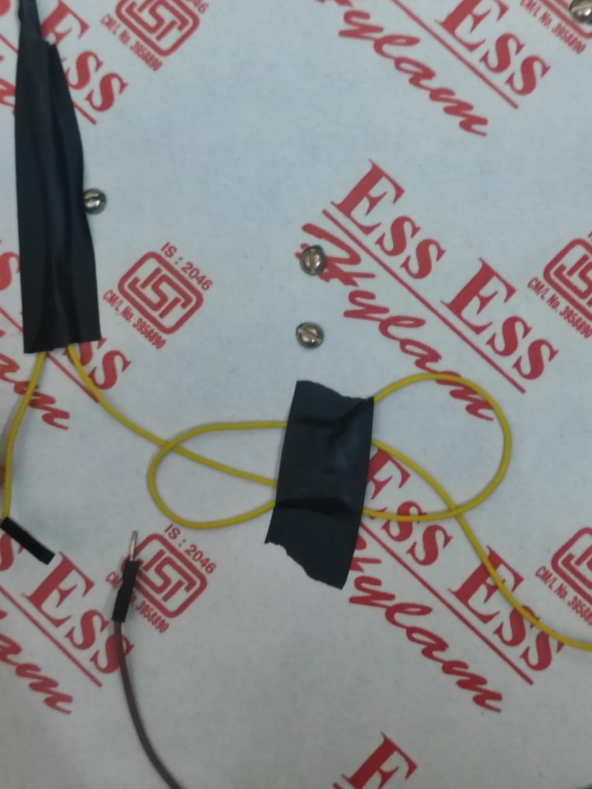

**Fig.8.Wire disconnected**

This below Diagram (Fig.9) represents the cable Fault detection in centimeters

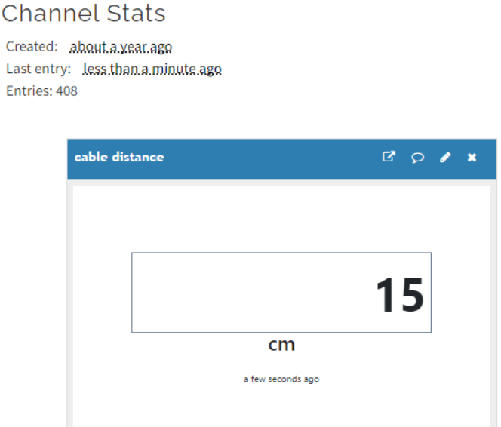

**Fig.9.Fault Location in cm**

Finally, We are able to identify the fault of the cable connection by integrating MATLAB (Fig.10) which displays Temperature, Humidity, Cable distance and Status of the process.

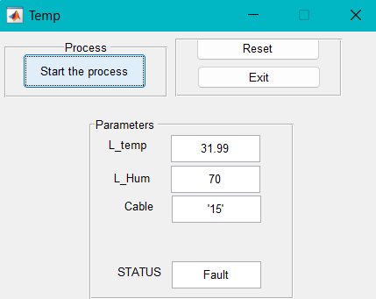

**Fig.10.Analytics of measured values**

Here, the only two paramaters are calculated based on the high and low temperatures the cable can get disconnected, and also in rainy seasons the cable is incorporated with lot of water inside it, may break the wirelines that causes damage.

**VII. Conclusion**

Our goal in this project, "Fault Detection in Grid Environment using LSTM," is to verify the places where fault is occurred in underground cable fault detection systems. The advantage of our approach as compared to the other measurement technique is the additional dataset we used in the LSTM model to predict the exact location of the fiber cable cut on the earth’s surface.

By boosting the system's accuracy, adaptability, and efficiency, this integrated approach raises its overall reliability. The major benefits acquired by using this Algorithms when system enables rapid response to cable faults by alerting operators or automated systems as soon as anomalies are detected.

We presented the process, which made the predicted data more comprehensive and more accurate. The result of this study has given an improved fault tracing process of hard failure in fiber cable.

***Future Work:*** In the upcoming years, Self-Healing Systems can have a significant impact on autonomously detecting and addressing power transmission issues by rerouting them without the need for human participation but at present we are not able to implement this kind of System.

**VIII. References**

[1]EshaLohar, Dadasaheb Patil, Amanat Mujawar,"Underground Cable Fault Detection Using  
Arduino Microcontroller"International Journal of Advances in Engineering and Management (IJAEM)  
Volume 5, Issue 2 Feb. 2023. [www.ijaem.net](http://www.ijaem.net/) ISSN: 2395-5252

[2] RoshaniShingrut, DakshataMokal, Shubham Shelar, Shekar Mhatre, “Arduino Based Underground Transmission Cable Fault Location System” IJERT, Vol.9 Issue 02, February 2020.

[3] Neha N. Badwaik, Achal J. Wakade, Sudha Shrikanth, “Underground Cable Fault Detection System by Using IoT”, International Journal of Scientific Research in Network Security and Communication, Vol.8, Issue.1, pp.25-28, 2020.

[4] Dr. G. Joga Rao, S. Sharmilla, M. Mohan Avinash, N. Dileep Kumar, S. Mohan Swamy, B. Ranjith Kumar “Underground Cable Fault Detection Using Arduino Microcontroller ” , International Journal of Advances in Engineering and Management (IJAEM) Volume 5, Issue 2 , Feb -2023.

[5] Li, W., Dou, Z., & Qi, L. (2020). *Communication Protocol Classification Based on LSTM and DBN. IEEE Access, 8, 91818-91828.*

doi:10.1109/access.2020.2979768

[6] N. Murugan, J. S. Senthil Kumar, T. Thandapani, S. Jaganathan, and N. Ameer, “Underground Cable Fault Detection Using Internet of Things (IoT),”Journal of Computational and Theoretical Nanoscience, vol. 17, no. 8. American Scientific Publishers, pp. 3684–3688, Aug. 01, 2020. doi: 10.1166/jctn.2020.9261.

[7] A. Said, S. Hashima, M. M. Fouda, and M. H. Saad, “Deep Learning-Based Fault Classification and Location for Underground Power Cable of Nuclear Facilities,” IEEE Access, vol. 10. Institute of Electrical and Electronics Engineers (IEEE), pp. 70126–70142, 2022. doi: 10.1109/access.2022.3187026.

[8] J. P. Melanta, Y. R. Kotian, M. S, S. Pb, and Ms. Pavanalaxmi, “IoT Based Underground Cable Fault Detector,” 2023 IEEE International Conference on Distributed Computing, VLSI, Electrical Circuits and Robotics (DISCOVER). IEEE, Oct. 13, 2023. doi: 10.1109/discover58830.2023.10316705.

[9] A.Abbas and M. Al-Tak, “A Review of methodologies for Fault Location Techniques in Distribution Power System,” Iraqi Journal for Electrical and Electronic Engineering, vol. 17, no. 2. University of Basrah - College of Engineering, pp. 27–37, Jul. 30, 2021. doi: 10.37917/ijeee.17.2.4.

[10] Y. D. Mamuya, Y.-D. Lee, J.-W. Shen, M. Shafiullah, and C.-C. Kuo, “Application of Machine Learning for Fault Classification and Location in a Radial Distribution Grid,” Applied Sciences, vol. 10, no. 14. MDPI AG, p. 4965, Jul. 19, 2020. doi: 10.3390/app10144965.

[11] A. Nag, A. Yadav, A. Y. Abdelaziz, and M. Pazoki, “Fault Location in Underground Cable System Using optimization Technique,” 2020 First International Conference on Power, Control and Computing Technologies (ICPC2T). IEEE, Jan. 2020. doi: 10.1109/icpc2t48082.2020.9071462.

[12] L. Goswami, M. K. Kaushik, R. Sikka, V. Anand, K. Prasad Sharma, and M. Singh Solanki, “IOT Based Fault Detection of Underground Cables through Node MCU Module,” 2020 International Conference on Computer Science, Engineering and Applications (ICCSEA). IEEE, Mar. 2020. doi: 10.1109/iccsea49143.2020.9132893

[13] Roshani Shingrut, Shubham Shelar, Dakshata Mokal, Shekar Mhatre, and Dr. Sharvari Sane, “Underground Cable Fault Detection,” International Journal of Engineering Research and, vol. V9, no. 02. ESRSA Publications Pvt. Ltd., Feb. 22, 2020. doi: 10.17577/ijertv9is020147

[14] P. Chi, Z. Zhang, R. Liang, Y. Hu, K. Ni, and W. Li, “A fault diagnosis method of double-layer LSTM for 10 kV single-core cable based on multiple observable electrical quantities,” Electrical Engineering, vol. 104, no. 2. Springer Science and Business Media LLC, pp. 603–614, Jun. 05, 2021. doi: 10.1007/s00202-021-01324-3.

[15] R. Tariq et al., “An Optimized Solution for Fault Detection and Location in Underground Cables Based on Traveling Waves,” Energies, vol. 15, no. 17. MDPI AG, p. 6468, Sep. 05, 2022. doi: 10.3390/en15176468.

[16] B. V and R. G, “Effective Automatic Fault Detection in Transmission Lines by Hybrid Model of Authorization and Distance Calculation through Impedance Variation,” March 2021, vol. 3, no. 1. Inventive Research Organization, pp. 36–48, Mar. 27, 2021. doi: 10.36548/jei.2021.1.004.

[17] F. Md Arifin, M. Hasan, I. Mahyudin, and S. Arshad, “Development of fault distance locator for underground cable detection,” Journal of Physics: Conference Series, vol. 1432, no. 1. IOP Publishing, p. 012014, Jan. 01, 2020. doi: 10.1088/1742-6596/1432/1/012014.

[18] H. Panahi, R. Zamani, M. Sanaye-Pasand, and H. Mehrjerdi, “Advances in Transmission Network Fault Location in Modern Power Systems: Review, Outlook and Future Works,” IEEE Access, vol. 9. Institute of Electrical and Electronics Engineers (IEEE), pp. 158599–158615, 2021. doi:10.1109/access.2021.3129838.

[19] A. Abu‐Siada, M. I. Mosaad, and S. Mir, “Voltage–current technique to identify fault location within long transmission lines,” IET Generation, Transmission &amp; Distribution, vol. 14, no. 23. Institution of Engineering and Technology (IET), pp. 5588–5596, Oct. 19, 2020. doi: 10.1049/iet-gtd.2020.1012.