# **World Electricity Analysis: Trends, Challenges, and Future Prospects**

Shweta Shukla1, Noorul Islam2,Avinash Kumar3, Vaibhav Yadav4, Megha Saraf5

*1-5Department of Electrical Engineering, Meerut Institute of Engineering and Technology, Meerut, India*

|  |  |
| --- | --- |
|  | ***Abstract: Electricity is a fundamental driver of economic growth, technological advancement, and societal progress. Understanding electricity generation, consumption, and losses on a global scale is crucial for improving energy efficiency, promoting sustainability, and forecasting future trends. This paper presents a comprehensive analysis of global electricity generation, distribution, and consumption patterns using diverse datasets. The study covers various aspects, including electricity production from renewable and non-renewable sources, energy losses during transmission and distribution, urban-rural electricity accessibility, and emerging global energy trends. The findings underscore significant disparities in electricity access, the gradual but essential transition toward renewable energy, and the persistent challenges in achieving global energy sustainability.***  ***Key Word****:* ***Electricity Generation, Renewable Energy, Power Consumption, Energy Losses, Sustainability.*** |

1. **Introduction**

Electricity plays an essential role in the development and sustainability of modern societies. As a cornerstone of technological advancement, economic growth, and quality of life, its availability and distribution are critical to various sectors, from industrial production to healthcare and education. Over the years, global electricity consumption has surged, driven by rapid urbanization, technological innovations, and the increasing digitalization of economies. According to the International Energy Agency (IEA), global electricity demand is expected to grow by 2.1% per year on average between 2019 and 2040, outpacing overall energy demand [1]. This trend highlights both the expanding reliance on electricity and the pressing need for sustainable energy solutions.

However, the world’s electricity sector faces several challenges that hinder its ability to meet growing demands while reducing environmental impact. Traditional energy sources, such as coal, natural gas, and oil, have dominated electricity generation for decades, contributing to air pollution and climate change. In response to these issues, there has been a global shift toward renewable energy sources, including solar, wind, hydro, and geothermal power, which are seen as vital components in achieving long-term sustainability. According to the IEA (2021), renewable now account for almost 29% of global electricity generation, and this share is projected to grow as nations transition to low-carbon economies.

Despite the significant advancements in renewable energy technologies, challenges remain [3]. These include issues related to the intermittency of renewable sources, the need for improved energy storage solutions, and the economic and technical barriers to transitioning away from fossil fuels in some regions[4-7]. Additionally, the rapid growth in electricity demand, combined with geopolitical uncertainties and infrastructure limitations, further complicates the global electricity landscape[8-13]. As countries strive to balance the need for reliable electricity supply with the imperative of minimizing environmental impacts, understanding the key trends, challenges, and future prospects of global electricity systems becomes crucial [14-19].

This paper aims to provide an in-depth analysis of the global electricity landscape, identifying current trends in electricity generation, distribution, and consumption, as well as the challenges that the sector faces in achieving sustainability. Furthermore, it will explore future prospects and innovations in the electricity industry, focusing on emerging technologies and policy frameworks that may shape the future of global electricity systems.

1. **Data And Methodology**

The study utilizes datasets from multiple sources, including:

* **World Bank & IEA**: Global electricity production and consumption statistics
* **IRENA (International Renewable Energy Agency)**: Renewable energy share and trends
* **National Grid Data**: Country-specific electricity distribution and losses
* **Urban-Rural Electricity Reports**: Access to electricity across different regions

### a. Data Cleaning and Preprocessing

The collected datasets were processed using Python (Pandas, NumPy) and visualized using Power BI for interactive dashboards. Missing values were handled using interpolation techniques, and anomalies were identified using statistical analysis.

### b. Analytical Approach

* **Trend Analysis**: Year-wise electricity generation and consumption patterns
* **Geospatial Analysis**: Electricity access across urban and rural areas
* **Efficiency Metrics**: Energy loss in transmission and distribution
* **Comparative Analysis**: Renewable vs. non-renewable energy share

1. **Results And Discussion**

### Global Electricity Generation and Consumption Trends

* Europe & Central Asia have the highest energy production, followed by Sub-Saharan Africa and Latin America & the Caribbean.
* North America and South Asia exhibit significantly lower energy production levels.
* Differences in energy output are influenced by infrastructure, resource availability, and investments in power generation.

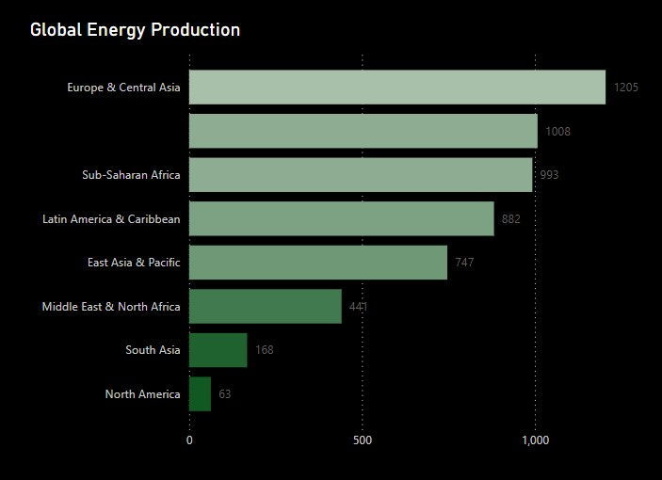

Figure 1: Energy production across regions

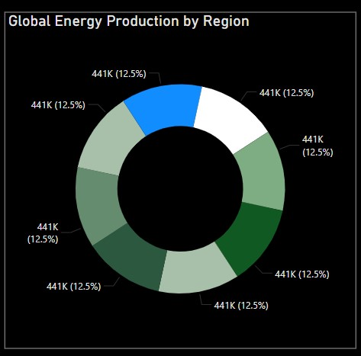

Figure 2: Regional Energy Distribution

* The donut chart shows an equal proportional representation (12.5%) of energy production across regions.
* However, the bar chart reveals actual disparities, with certain regions contributing far more than others
* Variations in energy output highlight the impact of regional energy policies, industrial demands, and renewable energy adoption.

### b. Renewable vs. Non-Renewable Energy Transition

* **Renewable Energy Growth:** Solar and wind energy are growing at an annual rate of 12-15%, with Europe leading the adoption.
* **Coal and Gas Dependence:** Despite the push for renewable energy, fossil fuels still contribute around 60% of global electricity production.
* **Hydroelectric Power:** Large-scale hydropower projects continue to provide substantial electricity generation, particularly in South America and Asia.
* **Nuclear Energy:** While some countries phase out nuclear power, others expand their nuclear capacity to meet carbon neutrality goals.

### c. Urban vs. Rural Electricity Access

* **Urban Electrification:** Nearly 100% access in most developed regions, but reliability issues persist.
* **Rural Electrification Challenges:** In Sub-Saharan Africa and parts of South Asia, nearly 20% of the population still lacks access to electricity.
* **Decentralized Energy Solutions:** Off-grid solar, microgrids, and hybrid energy systems are emerging as viable solutions for remote areas.

### d. Energy Losses and Efficiency

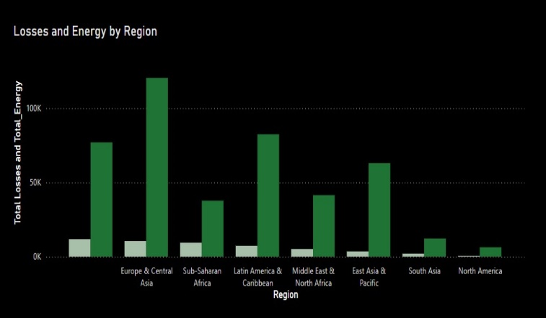

Figure 3: Total Losses and Energy Generation

The above figure shows the Total Losses and Energy Generation

* **Europe & Central Asia** and **Latin America & the Caribbean** exhibit relatively high total energy production but moderate losses.
* **Sub-Saharan Africa** and **East Asia & Pacific** display significant energy production with corresponding high losses.
* **North America** records the lowest losses and total energy values, indicating a highly efficient power transmission system.
* **Middle East & North Africa** and **South Asia** show moderate energy production with noticeable losses.

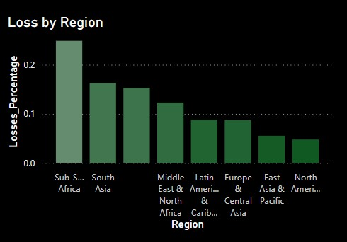

Figure 3: **Loss Percentage by Region**

**In the above figure we have Loss Percentage by Region**

* **Sub-Saharan Africa** has the highest loss percentage, exceeding 20%, signifying critical inefficiencies likely due to inadequate infrastructure and high levels of electricity theft.
* **South Asia** also demonstrates significant losses, estimated at 15-20%.
* **Middle East & North Africa, Latin America & the Caribbean** regions experience moderate losses in the range of 10-15%.
* **Europe & Central Asia, and East Asia & Pacific** have relatively lower losses.
* **North America** reports the lowest loss percentage, indicative of a robust and technologically advanced grid infrastructure.

Transmission and distribution losses vary across regions:

* **Developed nations**: Losses are around **5-8%** due to advanced grid infrastructure.
* **Developing nations**: Losses exceed **15-20%**, often due to outdated transmission networks and theft.

## IV. Future Prospects and Recommendations

1. **Investment in Renewable Energy:** Governments should enhance policies to promote large-scale solar, wind, and hydroelectric power projects.
2. **Smart Grid Implementation:** AI and IoT-driven smart grids can optimize energy distribution, reduce losses, and enhance demand-response management.
3. **Rural Electrification Programs:** Expanding off-grid renewable energy solutions can bridge the electricity access gap in developing regions.
4. **Energy Storage Innovations:** Battery storage technologies, such as lithium-ion and solid-state batteries, are critical for stabilizing renewable energy supply.
5. **Carbon Capture and Storage (CCS):** Implementing CCS technology can mitigate the environmental impact of fossil fuel power plants.
6. **Policy and International Collaboration:** Cross-border energy trade and collaborative research can drive sustainable energy transitions worldwide.

## V. Conclusion

This research provides a detailed analysis of global electricity trends, highlighting the urgent need for sustainable energy transitions. While renewable energy adoption is increasing, disparities in electricity access and grid inefficiencies persist. Addressing these challenges requires technological advancements, policy reforms, and international collaboration. Future work will focus on predictive modeling of energy demand and integration of AI-driven energy management systems.

## Acknowledgment

The authors acknowledge the support of data sources such as the International Energy Agency, World Bank, National Renewable Energy Laboratory, and the International Renewable Energy Agency for providing valuable datasets that contributed to this research.

**References**

[1] International Energy Agency (IEA). (2020). *World Energy Outlook 2020*. International Energy Agency.

[2] International Energy Agency (IEA). (2021). *Renewables 2021: Analysis and Forecast to 2026*. International Energy Agency.

[3] International Energy Agency, “World Energy Outlook 2023”.  
[4] World Bank, “Global Electricity Access Report.”  
[5] International Renewable Energy Agency, “Renewable Energy Statistics 2023.”  
[6] U.S. Energy Information Administration, “Electricity Generation and Consumption Trends.”

[7] Harish V, Kumar A. A review on modeling and simulation of build-ing energy systems. Renewable Sustainable Energy Rev 2016; 56:1272–92.doi: 10.1016/j.rser.2015.12.040.

[8] Wei Y, Zhang X, Shi Y, Xia L, Pan S, Wu J, et al. A review of data-driven approachesfor prediction and classification of building energy consumption. Renewable Sustainable Energy Rev 2018; 82:1027–47. doi: 10.1016/j.rser.2017.09.108.

[9] Yildiz B, Bilbao JI, Dore J, Sproul AB. Recent advances in the analysis of residential electricity consumption and applications of smart meter data. Appl Energy2017; 208:402–27. doi:10.1016/j.apenergy.2017.10.014.

[10] Zhou K, Yang S. Understanding household energy consumption behavior: thecontribution of energy big data analytics. Renewable Sustainable Energy Rev2016; 56:810–19. doi: 10.1016/j.rser.2015.12.001.

[11] Hong T, Pinson P, Fan S, Zareipour H, Troccoli A, Hyndman RJ. Probabilistic energyforecasting: global energy forecasting competition 2014 and beyond. Int J Forecast2016;32(3):896–913. doi: 10.1016/j.ijforecast.2016.02.001.

[12] Hong T, Fan S. Probabilistic electric load forecasting: a tutorial review. Int J Forecast 2016;32(3):914–38. doi: 10.1016/j.ijforecast.2015.11.011.

[13] Kalogirou S. Artificial neural networks in renewable energy systems applications:a review. Appl Energy 2001.

[14] Kalogirou S. Applications of artifcial neural-networks for energy systems. Appl Energy 2000:17–35.

[15] Kalogirou S. Applications of artifcial neural networks in energy systems - a review.Energy Convers Manage 1998:1073–87.

[16] Hippert HS, Pedreira CE, Souza RC. Neural networks for short-term load forecasting: a review and evaluation. IEEE Trans Power Syst 2001;16(1):44–55.doi:10.1109/59.910780.

[17] Weron R. Modeling and forecasting electricity loads and prices: a statistical approach. Chichester England and Hoboken NJ: John Wiley & Sons; 2006.

[18] Liu Y, Yu S, Zhu Y, Wang D, Liu J. Modeling, planning, application and management

of energy systems for isolated areas: a review. Renewable Sustainable Energy Rev 2018; 82:460–70. doi: 10.1016/j.rser.2017.09.063.

[18] Chicco G. Overview and performance assessment of the clustering methods for electrical load pattern grouping. Energy 2012;42(1):68–80.doi: 10.1016/j.energy.2011.12.031.

[19] Suganthi L, Samuel AA. Energy models for demand forecastingareview. Renewable Sustainable Energy Rev 2012;16(2):1223–40.doi: 10.1016/j.rser.2011.08.014.