**FarmAssist – Comprehensive Scheme Recommendation System For Enhanced Farming**

Prof . Yogita Fatangare1

Assistant Professor, Dept. of I.T., P.E.S Modern College of Engineering, Savitribai Phule Pune University, Maharashtra,India.

Chandrakesh Ram2 ,Sanskruti Magdum3 , Shubham Panchal4 , Darshan Deshmukh5

*2,3,4,*5Dept. of I.T., P.E.S Modern College of Engineering, Savitribai Phule Pune University, Maharashtra, India.

*Corresponding Author:* [*sanskruti_magdum@moderncoe.edu.in*](sanskruti_magdum@moderncoe.edu.in)

|  |
| --- |
| ***Abstract:*India’s economy and employment are heavily reliant on agriculture. FarmAssist emerges as a groundbreaking digital platform, reshaping how farmers access and leverage agricultural support. This web-based tool stands at the forefront of facilitating farmers with custom-tailored recommendations for agricultural programs and real-time updates on farming news. At its essence, FarmAssist harnesses the power of advanced data processing techniques, including machine learning, to sift through and interpret a diverse range of data specific to each farmer, such as crop varieties, land extent, and local climatic conditions. This approach ensures the delivery of highly relevant and practical scheme suggestions directly applicable to each farmer’s unique situation. The interface of FarmAssist is crafted for simplicity and ease of use, ensuring that farmers of varying digital literacy can navigate and utilize the platform effectively. This aspect is crucial in diminishing the digital barriers commonly encountered in rural farming sectors. Moreover, FarmAssist incorporates a constantly updating feed of agricultural news, equipping farmers with cutting-edge knowledge and practices in the agricultural realm, thus fostering well-informed agricultural decisions and modern cultivation techniques.**    ***Key Word****:***FarmAssist, Web-based Dashboard, Scheme Recommendation System, Crop Prediction, Precision Agriculture, Real Time Farming News, Weather Forecast.** |

1. **Introduction**

Agriculture is the back bone of Indian economy. To insulate farmers against risks in agriculture, government has launched several schemes. But their coverage seems to be limited among the farmers primarily due to lack of full information [1]. Agriculture is undergoing perceptible changes as it gets transformed from traditional to modern economy which is an important step towards economic development. The traditional farming of agriculture is followed in the academic year and the organic farming of cultivation is good agriculture practices focusing on environment for production of food grains are gaining momentum in the modern agriculture. The State Government is promoting environment friendly sustainable agriculture and encouraging farmers to adopt such practices with an objective to meet the demands put forth by the growing population in the food segment as well as the raw materials for agro-based industries in an eco-friendly sustainable way. Agriculture is the main profession of the India. So that the India’s annual GDP is always dependent on the agricultural productivity [2]. The progress of our nation is impossible without the development of the agriculture. Farmers have great importance in our society. They are the one who provide us food. Governments have employed various measures to maintain farm prices and incomes above what the market would otherwise have yielded [3].Government introduced several schemes in this regard that will enhance the productivity monetary status of the farmer's agricultural infrastructure and so on. Central and State governments have been initiating different schemes time to time for the upliftment of agricultural field and welfare of farmers related to it. So Government of India has considered the welfare of farmers as its importance to improve the economic status of the farmers. This research study identifies the awareness, level of satisfaction, opinion of farmers and issues of farmers towards schemes provided by government [3].

*Objectives:*

1. Providing financial support to farmers suffering crop loss/ damage arising out of unforeseen events.

2. Stabilizing the income of farmers to ensure their continuance in farming.

3. Encouraging farmers to adopt innovative and modern agricultural practices.

4. Ensuring flow of credit to the agriculture sector which will contribute to food security, crop diversification and enhancing growth and competitiveness of agriculture sector besides protecting farmers from production risks [4].

1. **Related Works**

The welfare of farmers has always been the top priority of the Government of India. Government plays an important role in order to achieve the goals, benefits of farmers and economic development by providing various schemes [3].

*1. Shagun* ***(2022),*** Cash-based agricultural schemes received almost 79 per cent of allocations in the Union Budget 2022-23, leaving only about 21 per cent expenditure for ‘core schemes’. Budgetary allocations were heavily skewed towards cash-based schemes or direct monetary benefits in the last two fiscals as well. Investment to improve agriculture infrastructure was paltry. The trend, experts said, only addresses the symptoms of the agrarian crisis and not the cause.In the Union budget 2022-23, Rs 1.04 lakh crore has been allocated to just five schemes: Pradhan Mantri Kisan Samman Nidhi (PM-KISAN), Pradhan Mantri Fasal Bima Yojana (PMFBY), Modified Interest Subvention Scheme, Market Intervention Scheme and Price Support Scheme; and Pradhan Mantri Kisan Man Dhan Yojana. All these schemes provide cash benefits to individual farmers.The highest share (51 per cent) among these is of PM-KISAN (Rs 68,000 crore), which provides income support by way of cash benefits to all land-holding farmers.The kind of long-term perspective you get when you look at the schematic approach of the budget is that the Union government is more focused on individualistic solutions.”

*2 Mahesh K.M, P.S.Aithal and Sharma K.R.S* ***(2021***) The foremost intent of this research article is to create awareness about various schemes for the productive sector of agriculture. Through this study, the level of performance of these agricultural schemes and programmes were analysed that will be helpful for the attainment of financial inclusion. Here it is necessary to know about various schemes and their making to connect beneficiaries. Agriculture is the basic source of food supply, processing, promotion and distribution. Agricultural products contribute to GROSS DOMESTIC PRODUCT (G.D.P) and generate employment in rural areas. The government of india has introduced Minimum Support Price (MPS), MIF, PMKSY, PMFBY, e-NAM, PM-KISAN, PMJDY, PM-KUSUM, PKVY, NAMS and MGNREGS. The mobile app Kisansuvidha and innovative programmes like Kisan economy ,crop insurance ,dairy,forestry, beekeeping and with the support of SHGs which will directly impact productivity, profitability, financial inclusion and the welfare of farmers in the 21st century and development of the country's economy.

*3. The Indian Express* ***(2020)*** The Tamilnadu Government has launched the 'Uzhavar-Aluvalar Thodarbu Thittam' in an attempt to bridge the gap between farmers and officials in all village Panchayats. A government order was issued to this effect on Tuesday. The primary aim is to help in the dissemination of crop technology to farmers. Under the scheme, in each village panchayats, ten farmers would be identified, out of whom at least two will belong to SC/ST communities, to be trained the technology and other aspects of agriculture. These farmers will be those who have already adopted new technologies or those with the inclination to learn, and will act as a 'bridge' between the agriculture and horticulture departments and other farmers in the Panchayat. The inclination to learn, and will act as a 'bridge' between the agriculture and horticulture departments and other farmers in the Panchayat.

1. **Methodology**

The research has conducted the study and has considered the farmers to collect the samples. The objective of the study is to analyze the farmers perception towards the benefits of agricultural schemes to encourage them to do agriculture. Descriptive Research design is adopted by the researcher. The sample size consider for the study is 140. Data is collected from the farmers. Respondents have been chosen for study from the study area according to the convenience of the researcher, Convenience sampling and non-parametric- Direct interview method is adopted to take survey from 140 respondents. The researcher has analyzed the data of percentage analysis and a survey for significant is used to understand the farmers perception towards the agricultural schemes [4]. The methodology for FarmAssist's development and implementation revolves around several key stages aimed at realizing its objectives effectively.

*1.* Requirement Analysis and Design Planning:

- The process begins with a comprehensive analysis of the requirements gathered from stakeholders, including farmers, agricultural experts, and policymakers.

- Detailed design planning involves outlining the functionalities, user interfaces, and data processing requirements of FarmAssist.

*2.* Technology Selection and Architecture Design:

- Based on the identified requirements, appropriate technologies are selected, considering factors such as scalability, performance, and ease of integration.

- The system architecture is designed to ensure seamless communication between frontend and backend components, incorporating technologies such as React for the frontend and Node.js with Express.js for the backend.

*3.* Data Collection and Preprocessing:

- Data specific to each farmer, including crop varieties, land extent, water availability and local climatic conditions, is collected from various sources such as surveys, satellite imagery, and weather stations.

- Data preprocessing techniques are applied to clean, transform, and standardize the collected data, making it suitable for analysis and machine learning algorithms.

*4*. Machine Learning Model Development:

- Machine learning algorithms are developed to analyze farmer data and generate personalized recommendations for agricultural programs.

- Various machine learning techniques, such as supervised learning for classification and regression, are explored to interpret diverse datasets and predict scheme suggestions tailored to each farmer's unique situation.

*5.* Frontend and Backend Development:

- Frontend development involves implementing user interfaces using HTML, CSS, and JavaScript frameworks like Handlebar template engine. The interfaces are designed for simplicity and ease of use, catering to farmers with varying levels of digital literacy.

- Backend development focuses on building server-side logic using Node.js with Express.js, handling data processing, user authentication, and interaction with the MongoDB database.

*6*. Integration of Real-Time Updates and News Feed:

- Real-time updates on farming news are integrated into FarmAssist using JavaScript libraries and frameworks to fetch and display news articles dynamically within the application interface.

- The news feed is sourced from reliable agricultural sources and updated continuously to provide farmers with cutting-edge knowledge and practices in the agricultural realm.

*7*. Testing and Evaluation:

- Comprehensive testing procedures, including unit testing, integration testing, and user acceptance testing, are conducted to ensure the functionality, reliability, and usability of FarmAssist.

- Feedback from farmers and stakeholders is collected and incorporated into iterative development cycles to address any identified issues or enhancements.

*8*. Deployment and Maintenance**:**

- FarmAssist is deployed to a web-based platform, ensuring accessibility to farmers across different regions and devices.

- Ongoing maintenance and support activities are carried out to address any software updates, security patches, or performance optimizations required to keep FarmAssist operational and effective.

By following this methodology, FarmAssist can be developed and implemented as a groundbreaking digital platform, reshaping how farmers access and leverage agricultural support in a manner that is both effective and sustainable.

1. **System Architecture**

There are two main modules such as Scheme Recommendation Model, Crop Recommendation Model in this system. Frontend development is done by using HTML, CSS, JavaScript. For backend we have used ExpressJS and NodeJS. Additionally Handlebar template engine is used to make development quite easy.

Step-by-step guide to implementing a content-based recommendation algorithm for FarmAssist:

Data Collection:

- Gather relevant data sources such as agricultural databases, sensor data, weather information, soil characteristics, crop types, historical farming practices, etc.

- Ensure the data is representative and covers a wide range of farming scenarios.

Data Preprocessing:

- Clean the data to remove noise, missing values, and inconsistencies.

- Normalize or scale the features to ensure they are on a similar scale.

- Perform feature extraction to identify relevant attributes for recommendation (e.g., crop type, soil pH, temperature, humidity).

Content Representation:

- Convert the preprocessed data into a suitable format for content-based recommendation.

- Represent each farm or farming situation as a vector of features, where each feature corresponds to a characteristic of the farm (e.g., soil type, climate, crop rotation history).

Similarity Calculation:

- Define a similarity measure (e.g., cosine similarity, Euclidean distance) to quantify the similarity between farms based on their feature vectors.

- Calculate the similarity between each pair of farms in the dataset.

Recommendation Generation:

- For a given farm or user profile, identify the most similar farms based on their feature vectors.

- Rank the similar farms based on their similarity scores.

- Select the top-N most similar farms as recommendations for the target farm.

Integration with FarmAssist:

- Integrate the content-based recommendation algorithm into the FarmAssist system architecture.

- Ensure seamless interaction between the recommendation engine and other components of FarmAssist, such as data collection, preprocessing, and user interface.

Testing and Evaluation:

- Evaluate the performance of the content-based recommendation algorithm using appropriate metrics (e.g., precision, recall, F1-score).

- Test the algorithm on a representative dataset to assess its accuracy and effectiveness in providing relevant recommendations to farmers.

Optimization and Refinement:

- Fine-tune the algorithm parameters (e.g., feature weights, similarity threshold) to optimize its performance.

- Gather feedback from users and stakeholders to identify areas for improvement and refine the recommendation engine accordingly.

Documentation and Reporting:

- Document the implementation details, including algorithms, data preprocessing steps, and evaluation results.

- Prepare a detailed report or research paper outlining the design and implementation of the content-based recommendation algorithm for FarmAssist.

Deployment:

- Deploy the FarmAssist system with the integrated recommendation engine in real-world farming environments.

- Monitor the performance of the recommendation system and make necessary updates or enhancements as needed.

By following these steps, you can design and implement a content-based recommendation algorithm for FarmAssist to provide personalized recommendations for enhanced farming practices.

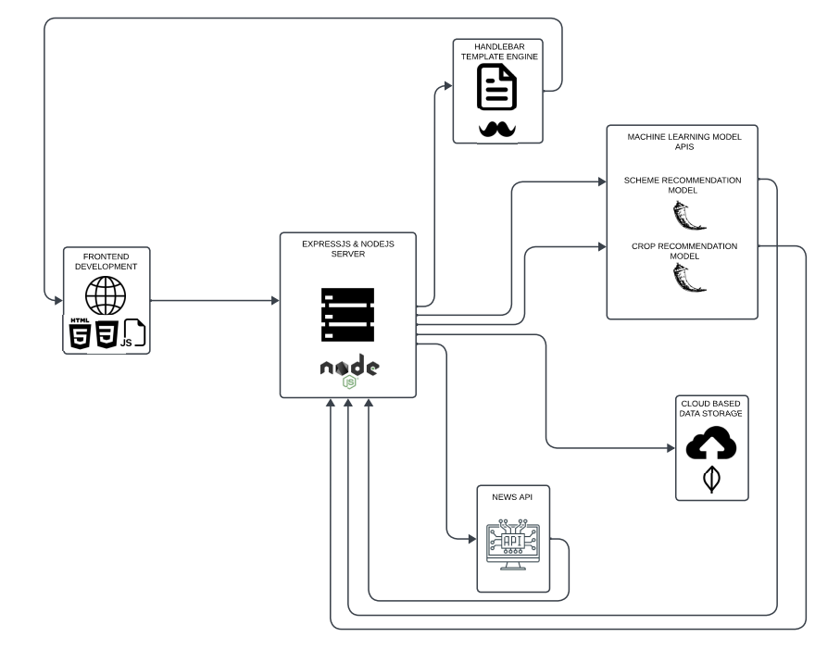

1. **Result and Discussion**

Farmers are not have enough source to aware of the schemes provided by government [3].In the opinion of farmers, schemes are announced by government but subsidies of the schemes are not reached. The majority of farmers facing hard to approach the schemes and difficult to get benefits from it. The State and Central government should look for effective ways to announce the schemes in a right time and make all the farmers obtain all the schemes in a higher satisfactory level. This study concluded that every farmers have to know about the schemes provided by government and government should make more efficiency to make aware and make the farmers to benefits from the schemes [3].FarmAssist represents a significant stride in the realm of digital agriculture, effectively bridging the gap between complex agricultural policies and the everyday farmer. By delivering a user-friendly platform that offers personalized agricultural scheme recommendations and real-time news updates, FarmAssist stands as a testament to the transformative power of technology in the agricultural sector.

1. **Future Scope**

In the realm of agricultural technology, FarmAssist represents a pioneering digital platform that has the potential to revolutionize how farmers access and utilize agricultural support. As described, FarmAssist offers farmers bespoke recommendations for agricultural schemes and provides real-time updates on farming news, thereby enhancing their decision-making processes and fostering modern cultivation techniques. One avenue for future research and development lies in the continued refinement and enhancement of FarmAssist's recommendation system. By leveraging advanced data processing techniques, including machine learning, FarmAssist can further optimize its algorithms to sift through and interpret a diverse range of data specific to each farmer's unique circumstances. This iterative process ensures the delivery of highly relevant and practical scheme suggestions tailored to individual farmers, thereby maximizing the platform's efficiency and impact. Furthermore, as the agricultural landscape continues to evolve, FarmAssist can explore opportunities to expand its functionality and scope. For instance, the integration of predictive analytics models could enable FarmAssist to forecast crop yields, predict pest infestations, and anticipate market trends, empowering farmers to make proactive decisions and mitigate risks associated with farming operations. In conclusion, by embracing these future research directions and continually innovating, FarmAssist can further solidify its position as a transformative tool in the agricultural sector. Through ongoing refinement of its recommendation system, improvement of its user interface and accessibility features, and exploration of new functionalities and capabilities, FarmAssist can continue to empower farmers with the knowledge, resources, and support they need to thrive in an ever-changing agricultural landscape.

1. **Conclusion**

In this study, discovered that the impact and awareness level of farmers regarding government schemes. Farmers are not have enough source to aware of the schemes provided by government [3].In the opinion of farmers, schemes are announced by government but subsidies of the schemes are not reached. The majority of farmers facing hard to approach the schemes and difficult to get benefits from it. The State and Central government should look for effective ways to announce the schemes in a right time and make all the farmers obtain all the schemes in a higher satisfactory level. This study concluded that every farmers have to know about the schemes provided by government and government should make more efficiency to make aware and make the farmers to benefits from the schemes [3].FarmAssist represents a significant stride in the realm of digital agriculture, effectively bridging the gap between complex agricultural policies and the everyday farmer. By delivering a user-friendly platform that offers personalized agricultural scheme recommendations and real-time news updates, FarmAssist stands as a testament to the transformative power of technology in the agricultural sector. The integration of machine learning algorithms for tailored scheme suggestions and the provision of a dynamic news feed are key features that enhance the decision-making process for farmers. The application’s design prioritizes accessibility and simplicity, ensuring that it caters to farmers with varied levels of digital literacy. Throughout its development and implementation, FarmAssist has adhered to high standards of data security, user experience, and system functionality, making it a reliable and valuable resource for the farming community.

**References**

# Ajith, V., & Kalai Lakshmi, T.R. (2021). A Study on Farmers Perception Towards the Benefits of Agricultural Schemes of Govt. of Tamil Nadu. International Journal of Creative Research Thoughts.

# Jiao, Y., Zhang, S., & Lv, H. (Year). Research on Recommendation System of Agricultural Product Logistics Scale Control Based on Consumer Behavior.

# Kumar, M. M., & Gnanamani, D. (2022). A Study on Awareness and Impact of Government Schemes for Farmers in Coimbatore City. International Journal of Research Publication and Reviews

# Gaikwad, S. R., Thorat, K. S., Deshmukh, J. M., & Samrit, V. B. (2021). Awareness of Farmers about Schemes for Doubling Farm Income. International Journal of Current Microbiology and Applied Sciences.

# Naik, A., Amruthamala, Kavya, Kumara, V., Kanchan, H., & Shetty, V. (2023). Empowering Farmers, Enriching Lives: The One Stop Solution for Agricultural Assistance. Journal of Advanced Zoology.

# Davis, K., et al. (2012). Digital Green: Participatory Video and Mediated Instruction for Agricultural Extension. In Proceedings of the Fifth International Conference on Information and Communication Technologies and Development (ICTD).

# Khan, S., et al. (2019). AgriNet: An IoT Based Agriculture Assistance System. In 2019 20th International Conference on Parallel and Distributed Computing, Applications and Technologies (PDCAT).

# Ranveer, C., et al. (2018). FarmBeats: An IoT Platform for Data-Driven Agriculture. In Proceedings of the ACM on Interactive, Mobile, Wearable and Ubiquitous Technologies.

1. citeseerx.ist.psu.edu/document?repid=rep1&type=pdf&d oi=c9f96d22422953625f1f8d9dbee221cba38e6c08

# Liu, H., et al. (2016). Review of Recent Advances in Precision Agriculture Technology. International Journal of Agricultural and Biological Engineering, 9(5), 1-9