**A Convolution Neural Network Approach for Predicting the Age of Mango Trees**

**Kriyanshi Thakkar1, Jayasree Ravi2\***

1 Research Scholar, Department of Computer Science, SVKM’s Mithibai College of Arts, Chauhan Institute of Science & Amrutben Jivanlal College of Commerce And Economics, Vile Parle, Mumbai, 400056, Maharashtra, India

2 Assistant Professor, Department of Computer Science, SVKM’s Mithibai College of Arts, Chauhan Institute of Science & Amrutben Jivanlal College of Commerce And Economics, Vile Parle, Mumbai, 400056, Maharashtra, India

**Abstract**

Predicting the age of specific plant categories holds a major task in agriculture because it is useful for many things like agri-business, healthcare of the plants etc. Nowadays, Google lens is used to identify plants, text, animals that is also a computer vision tool. Predicting the age of specific trees and plants has emerged as a challenging and time-consuming task, prompting the need for innovative approaches to tackle this issue. To address this, the research is currently conducting experiments using a dataset focused on mango trees.

The aim is to develop methodologies or models that can accurately estimate the age of these trees based on various factors such as growth patterns and their size. By delving into this dataset and employing techniques from deep learning, the goal is to create a predictive framework that could streamline and enhance the accuracy of determining the age of mango trees. Convolutional Neural Network, which is a deep learning algorithm primarily used for analyzing visual imagery. With an impressive accuracy of 97.33%, a CNN Sequential model outperformed other deep learning architectures for plant recognition. There are many different mango tree species worldwide; this research is experimented on particularly Kesar Mango tree saplings, which gets sell in plant nurseries. The dataset exclusively originates from a plant nursery, aligning with the research's emphasis on agricultural practices beneficial to both farmers and plant nurseries.

**Keywords**: Age prediction, CNN, Image classification, Keras and Tensorflow

1. **Introduction**

The manual way to predict the age of a tree is by counting the annual growth rings, which are seen after cutting down the tree. We have used a CNN approach using many images of trees and training them accordingly to predict the age. A vision is needed to develop an unconscious mind therefore Images are a rich source of information and knowledge. Computer vision allows us to replicate this power of understanding to machines and help them to create such models to learn. We can solve many business problems using image datasets. For image processing the data is given in the form of image which is an unstructured form of data. To make it understandable to machines we convert them in the form of vectors or numbers. Just as humans can recognize a long-lost friend at a glance, farmers possess a similar intuition enabling them to gauge the approximate age of a plant or tree without constant observation, relying on distinctive features and recurring patterns for swift recall.

Numerous studies exist that can accurately predict diseases affecting various types of leaves, a task fraught with challenges. Similarly, when it comes to tree trunks, despite differences in age, the patterns remain remarkably consistent, presenting a comparable challenge. However, the features like width of the trunk, colour difference, height and gaps between the patterns makes a difference, which is helpful for predicting the age. As patterns of tree stems are very similar to one another, it leads to a challenge to identify and classify them as per a particular age.

Although convolutional neural networks have significantly advanced image analysis in various fields, surprisingly, there has been little to no research conducted on utilizing them to determine the age of plants. A research study proposed a mathematical approach utilising Convolutional Neural Networks (ConvNet/CNN) for recognizing patterns in facial images to predict age and gender. ConvNet, as a deep learning algorithm, serves as a feature extractor, capable of distinguishing various aspects and objects within images. Unlike primitive methods, ConvNet requires less preprocessing and can learn filters and features through training. They successfully trained ConvNet with over 20,000 facial images annotated with age, gender, and ethnicity. Images encompassed a wide range of poses, facial expressions, lighting conditions, occlusions, and resolutions. Their results showed that ConvNet achieved high rates of success in predicting age and gender [1]. Another study addressed the importance of age-related analysis, particularly in facial age prediction, for vital applications despite time-consuming techniques. They proposed a deep age estimation model achieving 85.7% accuracy using inceptionV4, showcasing superior efficiency compared to other approaches and evaluated four pre-trained models (ResNet50, ResNet101, SqueezeNet, and InceptionV4), emphasising advancements in deep age evaluation and leveraging common datasets for validation [2]. A study reported, weed segmentation method Based on BlendMask was proposed to accurately identify leaf age and plant centre, crucial for understanding weed morphology and guiding targeted spraying. Images from various angles of three weed types were collected, and different datasets and backbone networks were evaluated to enhance model performance. Their results showed that data enhancement and ResNet101 as the backbone network improved segmentation performance, with high F1 and recognition accuracy values, demonstrating the effectiveness of deep learning for weed phenotypic information extraction and variable spraying applications [3]. Age and gender identification are integral in network security, childcare, and targeted advertising on social media. One of the reported studies proposed leveraging deep CNNs to enhance age and gender prediction, thereby improving tasks like face recognition. A simple convolutional network architecture achieved significant advancements, with age and gender accuracy reaching 79%, surpassing HAAR Feature- based Cascade Classifiers proposed by Viola and Jones. These classifiers, employing machine learning, are trained with positive and negative images to detect objects effectively in various images [4]. There are two global features to quantify stems of tree saplings on the basis of just images which are pattern and width. You will be able to differentiate looking at the below images.

Two primary global features for quantifying tree sapling stems solely based on images are their patterns and width. You can easily distinguish between them by examining the images provided below.

Figure 1: Representation of Age Categories

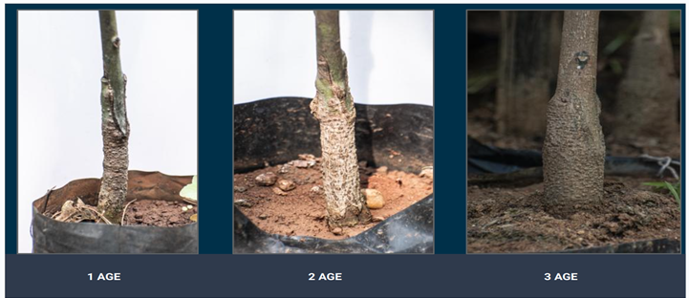

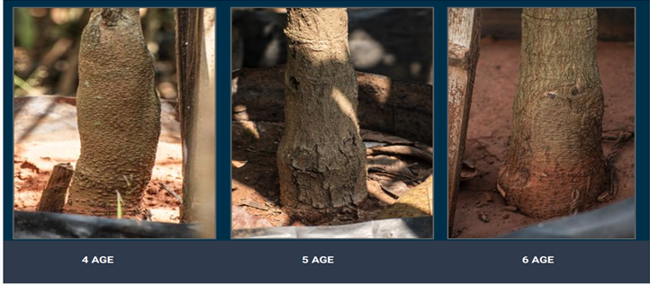

1. **Review of Literature**

There are many papers published on the highlighting the remarkable advancements achieved through deep learning and its various components such as Convolutional Neural Networks (CNNs), Recurrent Neural Networks (RNNs), image classification, age prediction, and more. Deep learning stands as a potent tool capable of processing vast amounts of data and producing remarkable outcomes akin to human vision, albeit through algorithms specifically trained for distinct tasks. Among the plethora of deep neural networks, CNNs particularly stand out as highly effective for numerous tasks. CNN have multiple layers including convolutional layer, non-linearity layer, pooling layer and fully connected layer. CNN is able to solve complex task and get better results for pattern recognition to video detection [5]. The table below summarizes the research articles pertinent to the domain discussed in this study.

Table 1: Research Articles

|  |  |  |  |  |  |
| --- | --- | --- | --- | --- | --- |
| **No.** | **Name/Year** | **Title** | **Purpose** | **Method Used** | **Result** |
| **1.** | I.Gogul, V.Sathiesh Kumar  (2017) [15] | Flower Species Recognition System using Convolution Neural Networks and Transfer Learning | The authors propose a method to recognize flower species with high accuracy using CNN and transfer learning. | * CNN * Transfer Learning * VGG, ResNet, and Inception | Accuracies of 73.05%, 93.41% and 90.60% using OverFeat, Inception-v3 and Xception architectures, respectively as Feature Extractors on FLOWERS102 dataset |
| **2.** | Rahul Barman, Sharvari Deshpande, Shruti Agarwal, Unzela Inamdar  (2019) [16] | Transfer Learning for Small Dataset | How can we increase the accuracy of the small dataset using transfer learning and make good use of different pretrained models. | * Transfer learning * CNN | With only simple machine learning algorithm the accuracy achieved was only 50%. But with Transfer Learning it went straight up to 95% when trained for 40 epochs. |
| **3.** | Insha Rafique,Awais Hamid, Sheraz Naseer, Muhammad Asad, Muhammad Awais,,Talha Yasir  (2019) [4] | Age and Gender Prediction using Deep Convolutional Neural Networks | This paper purpose a scheme to fill the gap between automatic face recognition and age and gender prediction. | * CNN * DeepCNN | The ConvNet achieved high rates of success in predicting age and gender.  The best they could receive was 79.5% accuracy using HAAR cascading. |
| **4.** | HOUSSAM BENBRAHIM, HANAÂ HACHIMI,  AND AOUATIF AMINE  (2020) [17] | Deep Convolution Neural network with tensorflow and keras to classify skin cancer images. | The paper explores the use of deep learning techniques to classify skin, especially cancer images using TensorFlow and Keras frameworks. | * Keras * Tensorflow * CNN | It was seem that an accuracy in order of 94.06% in the validation set and 93.93% in the test set was achieved. |
| **5.** | Anirudh Ghildiyal,  Sachin Sharma,  Ishita Verma,Urvi Marhatta  (2020) [1] | Age and Gender Predictions using Artificial  Intelligence Algorithm | The aim is to predict the age of individuals using image datasets and solve the  problem of recognition  patterns using a mathematical approach. | * CNN * ConvNet * Tensorflow * keras | This paper says there  program was not sufficiently accurate to achieve high  recognition accuracy. |
| **6.** | Nguyen Van Hieu 1 and Ngo Le Huy Hien  (2020) [6] | Recognition of Plant Species using Deep Convolutional Feature Extraction | A CNN system was proposed to perform feature extraction using different deep learning models in large-scale plant classification methods. | * Resnet50V2   Inception,  Resnet V2, MobilenetV2, and VGG16,  A comparative study using SVN and KNN. | With the highest accuracy of 95.6%, MobilenetV2 performed  betterfor plant recognition in both SVM and KNN classification  methods. |
| **7.** | Sai Kumar T S, Prabha Lakshmi A, Arunaggiri Pandian K and S. Alagammal  (2021) [8] | A Comparative Study on Plant Classification  Performance using Deep Learning Optimizers | This research mainly focuses on classifying the medicinal plants that are available in rural areas. | * CNN * Pretrained models: * Dense121, InceptionV3,   VGG16, Xception, VGG19, and MobileNet, | The MobileNet architecture trained through the SGD optimizer, that achieved a validation accuracy, F1-  score and validation loss of 0.9625, 0.9673 and 0.4996 is  proposed as the best-suited architecture. |
| **8.** | Aditya,  Chakraborty,  Debarun Kumer,  and Deeba K  (2021) [7] | Plant leaf disease recognition using Fastal IMage classification. | This paper presents a study on the application of Fastai image classification method for the  detection of plant foliar diseases. The authors use Fastai, a deep learning library built by PyTorch, to train a convolutional neural network (CNN) model to detect various diseases affecting plant leaves. | * CNN * DenseNet(12) * Pytorch | A classification accuracy of 92.5% was achieved. This can significantly contribute to agricultural practices and crop  management. |
| **9** | Longzhe Quan,  Bing Wu,  Shouren Mao,  Chunjie Yang,  and Hengda Li [3] | An Instance Segmentation-Based Method to Obtain the Leaf Age and Plant Centre of Weeds in Complex Field Environments | In this work, a weed  segmentation method based on BlendMask is proposed to obtain the phenotypic information of  weeds under complex field conditions. | * (ResNet50 and ResNet101) | The results indicated that data enhancement and ResNet101 as the backbone  network could enhance the model performance. |
| **10** | Abdullah M. Abu Nada,  Eman Alajrami,  Ahemd A. Al-Saqqa and  Samy S.  Abu-Naser  (2020) [9] | Age and Gender Prediction and Validation Through Single User Images Using CNN. | In this paper, they suggest a new approach to validate the user’s gender and age range that is reflected from his photo correctly. | * CNN | They evaluated this solution using’ custom dataset and it has achieved a good result in gender prediction and has challenges in age prediction. |
| **11.** | Md Taimur Ahad a, Yan Li b ,  Bo Song c and Touhid Bhuiyan  (2023) [10] | Comparison of CNN-based deep learning architectures for rice diseases classification | In this study, a rice disease classification comparison of six CNN-based deep-learning architectures (DenseNet121, Inceptionv3, MobileNetV2, resNext101, Resnet 152, and Seresnext101) was conducted using a database of nine of the most epidemic rice diseases in Bangladesh. | * DenseNet121, * Inceptionv3, * MobileNetV2, * resNext101, * Resnet152V, * Seresnext101 * Transfer learnning | The results suggest that the framework provides the best accuracy of 98%, and transfer learning can increase the accuracy by 17% from the results obtained by Seresnext101 in detecting and localizing rice leaf diseases.  The deep CNN model is promising in the plant disease detection domain and can significantly impact the detection of diseases in real-time agricultural systems. |
| **12.** | [Xiangrong Zhang](https://ieeexplore.ieee.org/author/37421977400); [Yujia Sun](https://ieeexplore.ieee.org/author/37086503226); [Kai Jiang](https://ieeexplore.ieee.org/author/37085888023); [Chen Li](https://ieeexplore.ieee.org/author/37291258800); [Licheng Jiao](https://ieeexplore.ieee.org/author/37276095000); [Huiyu Zhou](https://ieeexplore.ieee.org/author/37405366100)  (2018) [11] | Spatial Sequential Recurrent Neural Network for Hyperspectral Image Classification. | The paper proposes a novel local spatial sequential (LSS) method, which is used in a recurrent neural network (RNN). | * RNN * LSS | The experimental results on three publicly accessible datasets show that our proposed method can obtain competitive performance compared with several state-of-the-art classifiers. |
| **13.** | Pin Wang,En Fan,  and Peng Wang.  (2020) [12] | Comparative analysis of image classification algorithms based on traditional machine learning and deep learning. | This paper compares and analyses the traditional machine learning and [deep learning](https://www.sciencedirect.com/topics/engineering/deep-learning) image classification algorithms. | * CNN * SVM | This study found that when using a large sample mnist dataset, the accuracy of [SVM](https://www.sciencedirect.com/topics/computer-science/support-vector-machine) is 0.88 and the accuracy of [CNN](https://www.sciencedirect.com/topics/computer-science/convolutional-neural-network) is 0.98; when using a small sample COREL1000 dataset, the accuracy of SVM is 0.86 and the accuracy of CNN is 0.83. |
| **14.** | Ananda S. Paymode,  Vandana B. Malode  (2021) [13] | Transfer learning for Multi crop Leaf Disease Image Classification using Convolutional Neural Network VGG | The research is on disease detection and classification of different crops, especially tomatoes and [grapes](https://www.sciencedirect.com/topics/agricultural-and-biological-sciences/vitis-vinifera). | * VGG model | The designed model classifies disease-affected leaves with greater accuracy. In the experiment, proposed research has achieved an accuracy of 98.40% of grapes and 95.71% of tomatoes. |
| **15.** | Adesh V. Panchal Subhash Chandra Patel,  K. Bagyalakshmi, Pankaj Kumar, Ihtiram Raza Khan,  Mukesh Soni  (2021) [14] | Image-based Plant Diseases Detection using Deep learning. | The motive of the paper is to identify the deceased plats through automatic system that can identify these diseases and help farmers to take appropriate steps to get rid of crop loss | * CNN | As per the performance of the model, the accuracy is 90.4%. |

1. **Models and methodologies**

The proposed model underwent training and testing using 800 images exclusively sourced from a plant nursery in Maharashtra for this research endeavour. These images were specifically captured to study Kesar mango trees and their saplings, which are available for sale at the nursery. The dataset is categorized into three classes, delineating age ranges of 1-2, 3-4, and 5-6 years respectively. Initially captured at dimensions of 300x400 pixels, the images were resized to 250x300 pixels to mitigate the proliferation of parameters associated with larger image sizes. Given that all images were in RGB format, the resulting dimensions became 250x300x3. Generating your own dataset presents a significant challenge, as it demands extensive processing, diligent effort, and consistent capturing conditions, ensuring uniformity in distance for each image acquired.

**1) Pre-processing:** The dataset where 740 images were splitted into 80-20 % of training and validation data. Firstly, when I captured all the images they were 300x400 size but then resized into 250 x 300-image size. The ImageDataGenerator class from TensorFlow's Keras API was used for loading and augmenting images. Then done rescaling where pixel values of images were rescaled to the range

[0, 1].

**2) Model Architecture**:Convolutional Neural Network (CNN): A sequential CNN architecture was employed for plant recognition. The model consisted of convolutional layers with ReLU activation followed by max-pooling layers for feature extraction. Extracted features were flattened and passed through fully connected dense layers. The output layer utilised a softmax activation function for multiclass classification.

**3) Training configuration:** The model was optimised using the Adam optimizer. Categorical cross-entropy loss was utilised for training the model. Metrics: Model performance was evaluated based on accuracy.

**4)** **Training Process:** Training was conducted for 20 epochs. A batch size of 16 was utilised for training and validation. Early stopping was employed with a patience of 3 to prevent overfitting. Model check pointing was used to save the best performing model based on validation loss.

**5)** **Model Evaluation:** During training, the model demonstrated a consistent improvement in accuracy and reduction in loss across epochs. The entire implementation was carried out using the TensorFlow framework and its high-level API, Keras.

Below is the pseudo code and the plot of training of training and validation accuracy.

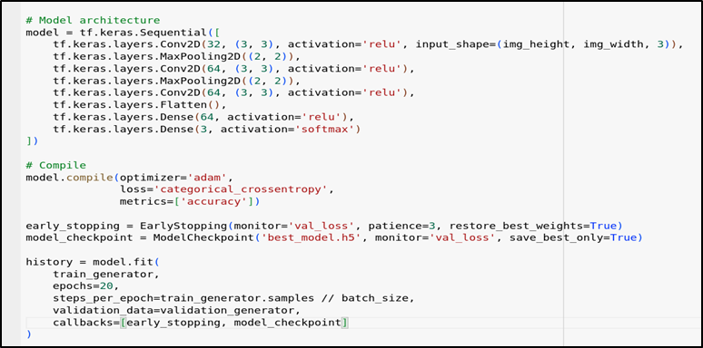

Figure 2. Pseudo code illustrates the sequential construction of a CNN model comprising convolutional layers, pooling layers, flattening operations, and fully connected layers.

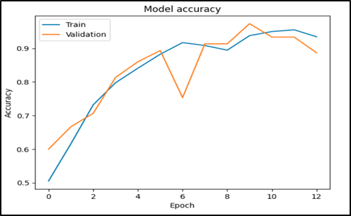

Figure 3. Training and Validation Accuracy of CNN model.

1. **Results and Conclusion:**

The training accuracy steadily increased from an initial value of 91.70% to 95.50% by the end of epoch 12. Similarly, the validation accuracy exhibited a positive trend, reaching a peak of 97.33% at epoch 10. The training loss decreased progressively from 0.2366 to 0.1244 during the training process. The validation loss also decreased over epochs, indicating improved generalisation performance, with the lowest recorded value of 0.0949 at epoch 10.

These results demonstrate the effectiveness of the CNN model in accurately classifying plant images. The observed high accuracy on both the training and validation datasets suggests the model's ability to generalise well to unseen data, thereby validating its suitability for plant recognition tasks. Furthermore, the utilization of early stopping and model check pointing techniques helped prevent overfitting and ensured that the best-performing model was retained based on validation loss. Overall, the experimental results underscore the efficacy of the proposed CNN-based approach for plant recognition, achieving a validation accuracy of 97.33% and showcasing its potential for real-world applications in agriculture and botanical research.Before trying from sequential CNN model the model went through some pre-trained models but the validation accuracy was not generating above 30%.

As this research mainly focuses on classifying the age range of kesar mango tree sampling. The age ranges were the three classes (age1-2, age 3-4 and age 5-6). In this work we tried many pre-trained weights to train my model but received only 30% validation accuracy. So, the better option to this was building a model from scratch using sequential CNN, Keras and Tensorflow. The model trained from Adam optimizer achieved validation accuracy of 97.33%. The dataset has achieved a relatively higher validation accuracy and lower loss when compared to the other networks with an excellent minimum training time for each epoch.The performance of the architectures is explicitly shown in Figure 3.

The outcomes of this study open up new avenues for future research and can serve as a great source for future plant identification systems. Further research should focus on a large-scale dataset with more numbers of different species and with MobileNetV2 to classify different plants on a large scale. As this research only focussed on kesar Mango plant which was too limited for an extent.

**References**

1. A. Ghildiyal, S. Sharma, I. Verma and U. Marhatta, "Age and Gender Predictions using Artificial Intelligence Algorithm," *2020 3rd International Conference on Intelligent Sustainable Systems (ICISS)*, Thoothukudi, India, 2020, pp. 371-375, doi: 10.1109/ICISS49785.2020.9316053.
2. A. E. Ba Alawi and A. Y. A. Saeed, "Facial Age Estimation Using Convolution Neural Networks," *2021 International Congress of Advanced Technology and Engineering (ICOTEN)*, Taiz, Yemen, 2021, pp. 1-4, doi: 10.1109/ICOTEN52080.2021.9493508.
3. Quan, L., Wu, B., Mao, S., Yang, C. and Li, H., 2021. An instance segmentation-based method to obtain the leaf age and plant centre of weeds in complex field environments. *Sensors*, *21*(10), p.3389.
4. I. Rafique, A. Hamid, S. Naseer, M. Asad, M. Awais and T. Yasir, "Age and Gender Prediction using Deep Convolutional Neural Networks," 2019 International Conference on Innovative Computing (ICIC), Lahore, Pakistan, 2019, pp. 1-6.
5. S. Albawi, T. A. Mohammed and S. Al-Zawi, "Understanding of a convolutional neural network," 2017 International Conference on Engineering and Technology (ICET), Antalya, Turkey, 2017, pp. 1-6, doi: 10.1109/ICEngTechnol.2017.8308186.
6. Van Hieu, N. and Hien, N.L.H., 2020. Recognition of plant species using deep convolutional feature extraction. *Int J Emerg Technol*.
7. A. Chakraborty, D. Kumer and K. Deeba, "Plant Leaf Disease Recognition Using Fastai Image Classification," *2021 5th International Conference on Computing Methodologies and Communication (ICCMC)*, Erode, India, 2021, pp. 1624-1630, doi: 10.1109/ICCMC51019.2021.9418042.
8. S. K. T. S, P. A, A. P. K and S. Alagammal, "A Comparative Study on Plant Classification Performance using Deep Learning Optimizers," 2021 Emerging Trends in Industry 4.0 (ETI 4.0), Raigarh, India, 2021, pp. 1-9, doi: 10.1109/ETI4.051663.2021.9619238.
9. Nada, AM Abu, et al. "Age and gender prediction and validation through single user images using CNN." *Int. J. Acad. Eng. Res.(IJAER)* 4 (2020): 21-24.
10. Md Taimur Ahad, Yan Li, Bo Song, Touhid Bhuiyan, Comparison of CNN-based deep learning architectures for rice diseases classification, Artificial Intelligence in Agriculture, Volume 9, 2023, Pages 22-35, ISSN 2589-7217.
11. X. Zhang, Y. Sun, K. Jiang, C. Li, L. Jiao and H. Zhou, "Spatial Sequential Recurrent Neural Network for Hyperspectral Image Classification," in *IEEE Journal of Selected Topics in Applied Earth Observations and Remote Sensing*, vol. 11, no. 11, pp. 4141-4155, Nov. 2018, doi: 10.1109/JSTARS.2018.2844873.
12. Pin Wang, En Fan, Peng Wang, Comparative analysis of image classification algorithms based on traditional machine learning and deep learning,Pattern Recognition Letters,Volume 141,2021,Pages 61-67,ISSN 0167-8655, <https://doi.org/10.1016/j.patrec.2020.07.042>.
13. Ananda S. Paymode, Vandana B. Malode,Transfer Learning for Multi-Crop Leaf Disease Image Classification using Convolutional Neural Network VGG, Artificial Intelligence in Agriculture, Volume 6, 2022, Pages 23-33, ISSN 2589-7217, <https://doi.org/10.1016/j.aiia.2021.12.002>.
14. Adesh V. Panchal, Subhash Chandra Patel, K. Bagyalakshmi, Pankaj Kumar, Ihtiram Raza Khan, Mukesh Soni, Image-based Plant Diseases Detection using Deep Learning, Materials Today: Proceedings, Volume 80, Part 3, 2023, Pages 3500-3506, ISSN 2214-7853, <https://doi.org/10.1016/j.matpr.2021.07.281>.
15. I. Gogul and V. S. Kumar, "Flower species recognition system using convolution neural networks and transfer learning," *2017 Fourth International Conference on Signal Processing, Communication and Networking (ICSCN)*, Chennai, India, 2017, pp. 1-6, doi: 10.1109/ICSCN.2017.8085675.
16. Barman, Rahul, et al. "Transfer learning for small dataset." *Proceedings of the National Conference on Machine Learning*. Vol. 26. Berlin, Germany: ResearchGate, 2019.
17. Benbrahim, Houssam, Hanaâ Hachimi, and Aouatif Amine. "Deep convolutional neural network with tensorflow and keras to classify skin cancer images." *Scalable Computing: Practice and Experience* 21.3 (2020): 379-390.