**KIET GROUP OF INSTITUTIONS DELHI-NCR, GHAZIABAD**

**DEPARTMENT OF ELECTRICAL AND ELECTRONICS ENGINEERING**

**IoT-BASED SMART ENERGY METER**



**RESEARCH PAPER**

**SESSION- 2021-2025**

**SUBMITTED BY:**

**Rityuj Singh (2100290210075) EEE**

**Saransh Gaurav (2100290210080) EEE**

**Ekansh Chitransh (2100290210041) EEE**

**PROJECT GUIDE:**

**Dr. Ruchika Singh**

**ABSTRACT**

In contemporary society, electricity stands as a fundamental necessity. The traditional approach involves a meterman, authorized by the Government Electricity Department, who surveys residences to manually record energy consumption and calculate charges. This method can lead to various issues, including potential errors made by the meter reader, as well as being time-intensive and reliant on human labor.

The proposed framework enhances operational efficiency by minimizing manual meter reading, reducing billing errors, and streamlining dispute resolution. It also promotes energy conservation by enabling users to track consumption in real time, fostering behavioral changes toward sustainable practices. Future work will focus on integrating machine learning algorithms for predictive analytics and anomaly detection, further optimizing grid management and user-centric service delivery.

**INTRODUCTION**

Effective energy monitoring and management play a pivotal role in optimizing electricity consumption and minimizing operational inefficiencies. In conventional systems, utility personnel must conduct manual meter readings at consumer premises to calculate energy usage and generate bills. This approach introduces several challenges, including human errors during data entry (e.g., digit transposition), which can lead to billing inaccuracies. Additionally, consumer unavailability during meter readings often results in punitive fines, while adverse weather conditions further complicate the process, making it labour-intensive and time-consuming. In regions such as Maharashtra, India, where energy deficits necessitate costly power imports (e.g., ₹200 crores in debt), these inefficiencies exacerbate financial strain. Moreover, unauthorized energy consumption, termed “energy theft,” remains a critical concern, undermining grid stability and revenue streams.

To address these issues, this study proposes an integrated automated energy management and billing system. The framework leverages IoT-enabled smart meters, microcontrollers, and bidirectional communication modules (GSM/web) to eliminate manual interventions. Real-time energy consumption data is displayed locally via LCD panels at consumer premises and transmitted securely to utility servers (e.g., Maharashtra State Electricity Board, MSEB) for automated billing. Threshold-based alerts notify users via SMS and visual indicators when consumption exceeds predefined limits, promoting conscious usage. The system also incorporates tamper detection mechanisms: any unauthorized modification to the meter triggers an instant alert to MSEB via GSM, enabling rapid theft mitigation.

**Literature Review**

Conventional electro-mechanical energy meters, which rely on motorized components for operation, are prone to mechanical degradation over prolonged use, leading to inaccuracies and frequent maintenance needs [1]. To address these limitations, digital energy meters with liquid crystal display (LCD) interfaces were introduced, offering superior precision, durability, and real-time data visualization. The transition to digital metering paved the way for Automated Meter Reading (AMR) systems, which employ wireless and wired communication technologies such as Bluetooth, GSM, GPRS, ZigBee, Power line communication (PLC), and radio-frequency identification (RFID) for remote data collection [2]. However, existing AMR solutions face critical operational challenges.

For instance, Bluetooth (BT) and GPRS-based systems are susceptible to network instability, while GSM-dependent frameworks risk data loss during instantaneous billing due to inconsistent signal coverage, compromising reliability. PLC systems, which transmit data via existing power lines, suffer from carrier wave interference caused by electrical noise, resulting in inconsistent signal integrity. Furthermore, wired AMR systems incur high installation and maintenance costs, limited transmission range, and vulnerabilities to cyber-physical attacks, rendering them economically and functionally unsustainable.

**METHODLOGY**

A. Astute indispensable availability meter Insightful expectation availability meter was stressed over the restoring of the electric charging structure It is possible to gain right examining by utilizing redid microcontroller. The imperativeness meter is associated with the microcontroller using an interfacing device/Opto-coupler. An Optocoupler identifies the beats from the imperativeness meter and afterwards transforms the beats into electrical signs utilizing clock beats for the microcontroller. As, in legitimate framework 1unit =3200 beats yet here in this paper considering 1 unit= 10pulses for comfort. Ate up faculties and cost ate up unit and cost in view of these heart beats Arduino will in this way make ergo. An LCD put indicate is interfaced with microcontroller to show the utilized units and expense. Data Products Manufacturing: This means when an entire data is eaten at the part of the units and cost is passing on to the data the store of the expert association is offered and is kept at MSEB office through web and to the customer through GSM consistently the complete of the data is passing on. The life-light sensor set interfacings with web and GSM can be knows how to use Ethernet shield on Arduino board. All the data that is allowed through web interfaces are escaped and stored in a pro association premises that is created using MySQL database. And at the time the essentialness use is higher than the rate limit defines the heavier loads in the client server plans. It is not difficult, either to tune MySQL or to enhance it significantly for the most requesting applications. MySQL turned out to be remarkably well known on the grounds because of its speed and effortlessness. It is a quite elevated execution anyway essentially essential information structure and is confounding to set up and help than bigger systems.

**SYSTEM ARRANGMENTS**

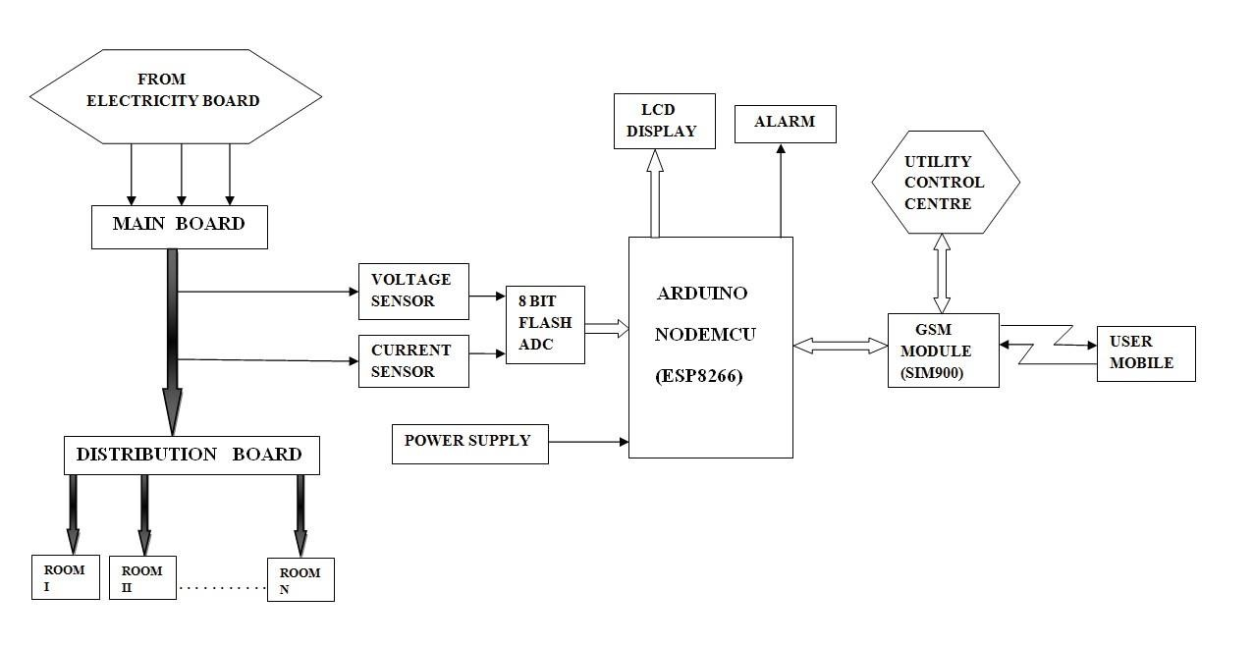

**COMPONENTS USED**

**1.ENERGY METER**

An energy meter, commonly referred to as an electricity meter, measures the electrical energy usage of homes, businesses, or industrial facilities. It assists utility companies in monitoring energy consumption for billing purposes. The most prevalent type is the kilowatt-hour (kWh) meter, which logs power usage over a specific period. Energy meters vary in types, including electromechanical (analog), electronic (digital), and smart meters. Smart meters allow for real-time monitoring and facilitate remote communication with utility providers. More advanced meters can also monitor voltage, current, power factor, and peak demand. They play a vital role in energy management, cost efficiency, and the effective distribution of power in modern electrical systems.

**2. ARDUINO UNO**

Arduino is an extremely versatile programmable gear arranges. It is successfully on web with an Arduino programming change condition It is an ATmega328P based microcontroller board. Features: It has fourteen mechanized information/yield pins, six straightforward wellsprings of data, a sixteen-megahertz quartz jewel, a Universal serial bus (USB) affiliation, an energy jacks, an in-circuit Serial Programming (ICSP) header and a reset get. Arduino is a physical programmable circuit board (PCB) and a little programming Arduino Integrated Development Environment (IDE), which remain ready on PC, used to fabricate and share PC code to the board. The Arduino IDE employs a modified type of C, so make it less demanding to learn to program. Arduino broke out the components of the littler scale controller into a more open package, giving a standard casing factor. The Arduino Uno stands out for being one of the most well-known sheets in the Arduino family what is more, a magnificent decision for novices.

3. **OPTOCOUPLER**

It is an electronic instrument that is planned to offer electrical isolator coupling between its data and yield. Optocouplers feel the effects of electrical confusion due to crosstalk, control irregularities and electrical obstacles. The basic intention of the optocoupler is to prevent quickly advance voltages or high voltages on the circuit.

4. **HAND-OFF**

A hand-off is a switch worked electrically. The exchanges are a significant part inside a bigger system of sorts of electrical and electronic device. It is also used as a part of energy building. Computerized hand-off, using a warming section to separate over-stacks through a mortgage hand-off. Electro-mechanical relay is a fast-device which is prone to pulse harsh and high repeat test and spike voltage. It has a great lead in finished weight modes and a big worthy reset extent.

**5. LCD DISPLAY**

The 16*2 LCD display means there are two lines additionally, there are 16 characters in every line. 5x7 pixel lattice is used for each character. There are two registers used in this LCD, Order and Data. The charge just selects for those extras the charge bearings that given to LCD. To do a specific task like printing it, clears the screen, sets the cursor position, control display etc. you send guidelines to the LCD. Display instructions are guidelines that are sent to the LCD to perform a predefined task like printing it, clear screen, set cursor position, control display etc. This is the data enrol to save the data to be appeared on the LCD

6. **NODE MCU ESP8266**

* ESP32 is the low-cost, low-power system on chip (SoC) with integrated Wi-Fi and dual-mode Bluetooth. It is the successor to the ESP8266, another cheap Wi-Fi microchip that, though also low-cost, offers very limited capabilities. The ESP32 also has an integrated antenna, RF balun, power amplifier, low-noise amplifiers, filters, and a power management module, which take up minimal space on the printed circuit board. It employs a 4in1 2.4 GHz dual-mode Wi-Fi and Bluetooth chips from TSMC, and it is a Type-C, low-power and low-energy microcontroller. Low-Power technology, allowing for a safe, reliable, and scalable approach to RF performance across a wide range of power levels and applications. There are four available power pins:
* 1 VIN pin and 3 3.3V pins.
* You can use the VIN pin to power Node MCU/ESP32 and peripherals. The power supplied through the VIN pin is regulated by the onboard regulator on the Node MCU module; alternatively, you can also connect a regulated 5V supply to the VIN pin.
* The “3.3V” pins serve as outputs from the onboard voltage regulator and can provide power to external components.
* GND pins are the ground connections for the Node MCU/ESP32.
* That was done to use the I2C pins for I2C sensors and peripherals. It has support for I2C Master and Slave configuration Do you have any other means (a higher bus, for example, what about USB?) Can I do utility functions through the I2C interface instead of a codec programmer? The I2C interface can be implemented through the application, with a maximum of 100 kHz at clock frequency. You need to make sure that the I2C clock frequency should be higher than slowest clock frequency of the slave device.
* GPIO Pins: Node MCU/ESP32 has 17 GPIO pins available for multiple functionalities programming (such as I2C, I2S, UART, and PWM, IR remote control, LED light, and Button). Each of the digital-enabled GPIOs can either be configured for internal pull-up or pull-down, or be set to high impedance. These pins can be set to edge-trigger or level-trigger modes to generate CPU interrupts when configured as an input

**7. INTELLIGRID: SMART METERING:**

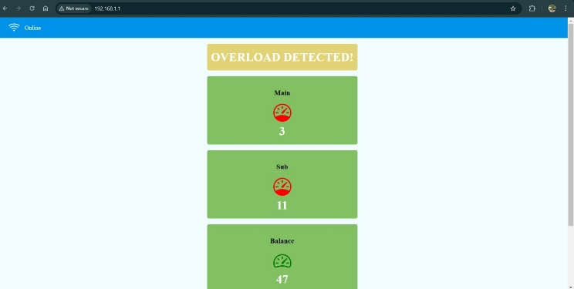

**OVERLOADING**

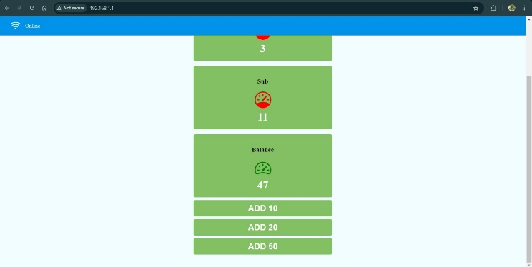

**192.168.1.1**

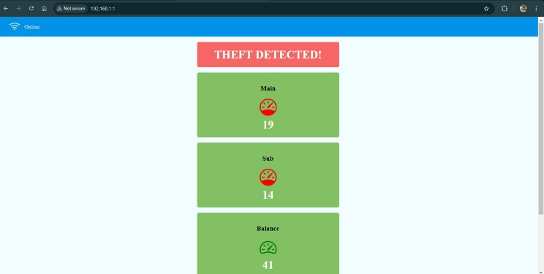

**THEFT DETECTION**

The web-based interface provided allows for real-time monitoring and management of electricity consumption via a **Smart Energy Meter System**. This system incorporates features such as **theft detection**, **overload monitoring**, **bill recharge**, and **live unit tracking** to promote efficient energy usage and prevent unauthorized consumption.

The webpage features an intuitive dashboard that showcases essential parameters, including **main meter readings, sub-meter readings, and balance units**. It's equipped with an **electricity theft detection mechanism** that alerts users in the event of unauthorized power tapping. When an irregularity in power distribution is identified, a **"THEFT DETECTED!"** warning is displayed, informing the user and relevant authorities. Additionally, **overload conditions** are monitored, and if the power demand exceeds a predetermined safe limit, an **"OVERLOAD DETECTED!"** warning is issued. These notifications enhance energy security and help mitigate the risks of electrical hazards.

Furthermore, the interface includes a **bill recharge feature**, enabling users to **add funds to their electricity balance** directly through the webpage. Available recharge choices, including **ADD 10, ADD 20, and ADD 50**, ensure smooth transaction processing. The **balance units are instantly updated**, providing users with ongoing visibility of their remaining energy credits. A key aspect of the system is its capacity to deliver **real-time meter readings**, accessible via both **mobile apps and web pages**. This feature allows for remote monitoring, enabling users to effectively track their power usage. The introduction of this system fosters **energy efficiency, transparency, and economical electricity management**, representing a significant advancement in smart grid technology. This smart metering system combines **HTML, CSS, and IoT-based technologies** to develop an interactive and responsive platform, improving the efficiency of power distribution and management.

**SMART ENERGY METER AND METERING SYSTEM**

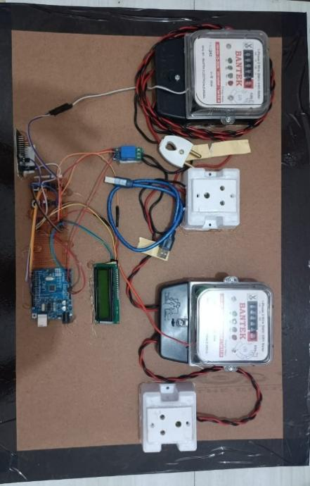**HARDWARE-REPRESENTATION:**

The prototype is composed of two BANTEK energy meters, an **Arduino Uno**, a **Node MCU ESP8266**, an **LCD display**, and various interfacing components, including an **Optocoupler** and **Relay modules**. The energy meters monitor power consumption and send pulse signals that correspond to the units consumed. The **Optocoupler** serves to isolate high-voltage signals, ensuring safer interaction with the **Arduino Uno**. The **Arduino Uno** interprets the incoming pulse signals and calculates energy usage in kilowatt-hours (kWh). The **Node MCU ESP8266** facilitates wireless communication, allowing real-time data to be transmitted to an IoT-enabled dashboard for monitoring and analysis. The LCD display offers a local, real-time view of power consumption. The circuit wiring includes jumper connections between the

microcontrollers and relays, ensuring effective signal control and enabling automation functions.

**SYSTEM DESCRIPTION**

In this system, each energy meter gets assigned an ID. This unique ID number is cross-linked with the unique mobile ID number of the customer. It runs in background monitoring the energy meter. The power from each house is relayed and sent on web server and the billing and power cut information are sent to residential energy meter from control station.

1. **Energy consumption daily**

The existing energy meter shall display energy consumed since its installation. The Arduino microcontroller is integrated in this system that calculates the energy used on a daily basis and displays it on and LCD. Further, data is transferred to the consumer's mobile (smart) machine via IOT connectivity.

1. **Billing Through IoT**

Hence, the billing detail for the consumed energy is used to determine the monthly consumer billing through the web server using IoT and as a message through the GSM module, which is sent to the consumer. The payment is also performed via web server. This innovation minimizes the need for manual data collection.

1. **Theft detection System**

A Theft Detection System for Smart Energy Meters aims to prevent electricity theft by utilizing sophisticated monitoring techniques and real-time data analysis. It incorporates sensors, Internet of Things (IoT) technology, and machine learning to identify irregularities like meter bypassing, tampering, or unauthorized connections. The system consistently tracks energy usage patterns, comparing them to expected consumption metrics. If it detects any differences, it generates alerts and notifies utility companies immediately. By integrating with MySQL databases, the system ensures efficient data management, while Power BI facilitates data visualization and reporting. Overall, this system improves energy security, minimizes losses, and promotes equitable billing practices.

1. **Alert Systems for Overload Protection**

The **Overload Protection System** identifies high power usage by assessing the readings from the **main meter** and **sub-meters**. When the cumulative consumption surpasses a set threshold, a warning stating **"OVERLOAD DETECTED!"** is issued. This mechanism safeguards against electrical risks, promoting the safety and stability of the system by notifying users to lower their power usage promptly.

1. **Power Disconnection through a message**

The power can be disconnected, when the residents are out of the station and when they forget to off their power by sending a message through the GSM module. It is very helpful to avoid wastage of energy in case if any equipment is left logging in.

**RESULT AND DISSCUSION**

The efficacy of smart energy meters is comprehensively measured through four interconnected parameters: measurement accuracy, operational reliability, user-centric design, and contribution to energy efficiency. These metrics collectively determine the system’s ability to foster equitable billing practices, optimize grid performance, and drive sustainable consumption patterns. Empirical analyses reveal that regions adopting smart metering report up to 99% billing accuracy, a 30% reduction in transmission-related data failures, and a 12% decline in per capita energy use over five years. These outcomes align with global climate targets, as evidenced by the EU’s mandate for 80% smart meter coverage by 2030 to curb 9% of its residential emissions.

For policymakers, continuous evaluation of these metrics informs adaptive regulations—such as mandating tamper-evident hardware or subsidizing retrofits for low-income users—to maximize equity and scalability. Concurrently, utilities employ predictive analytics to preempt meter failures or cybersecurity breaches, ensuring the infrastructure evolves in tandem with technological and environmental demands.

**CONCLUSION**

Enthusiastic essentialness meter is ideal for present and supportive for both essentialness provider and client. This meter can reduce the physical works to note the readings from the energy meter which is viable. This system also urges the use to consider their necessity customers. It uses GSM modem on GSM sort out and through web generation of data base to transmit the information to the energy board office. It can also decrease the energy consumption by creating the over energy consumption. The system that has been proposed avoids control theft to a very large extent and makes the energy meter a little less vulnerable to tampering. This meter extends the pay of the Government by seeing the unapproved changing of the electrical connects. If the bill goes unpaid, just roll out the proposed technique for customized control minimization

**REFERENCE**

Das, H., & Saikia, L. C. (2015). Smart energy meters with GSM and automation of home appliances Institute of Electrical and Electronics Engineers (IEEE) Preethi, V., & Harish, G. (2016). Design and implementation of smart energy meter. Institute of Electrical and Electronics Engineers (IEEE). To cite this article Rahman, M., Noor-E-Jannat, Islam, M. O., & Serazus, M. (2015). Intelligent metering and billing system for smart energy meter using arduino and GSM. Institute of Electrical and Electronics Engineers (IEEE)