**Seismic analysis of double-decker elevated water tank**

Bilal Naeem Sheikh

*(P.G) Student Civil Engineering department, Gondwana, University, Maharashtra*

*Corresponding Mail:* [*bilalnaeemsk@gmail.com*](mailto:bilalnaeemsk@gmail.com)

Prof. Ganesh Mahalle

*Professor of civil engineering department*

*Ballarpur Institute of technology bamni*

*Email: ganeshmahalle@gmail.com*

***Abstract:*** Double-Decker Elevated Water tank is used for storage of large quantity of water. Direct

source of water in water tank is from the rainfall. Taking water from tank for drinking, household & etc purpose is economical in that place where construction of well ,bore well ,etc is costly and area is less . Elevated water tanks are integrated part of lifeline facilities elevated water tank is storage container construction for the purpose of holding water supply. A large number of water tank is damage during past earthquake. So, there is need to focus on seismic safety.

The aim of this paper to propose a seismic response of double-decker elevated water \tank in different zone and comparison with single elevated water tank . To study different types of load acting on it, bending moment an shear force and its displacement if any after seismic load is applied on water tank by using staad-pro software.

*.****Key Word:***Double-decker Elevated Water tank, Comparison , Seismic analysis

# Introduction

Double-decker elevated water tank it will allow more storage capacity than single water tank and the area needed for construction of both the tanks approximately same .The water pressure will be consistent in any type of situation so no more need for extra pressure machine for pumping water "With increasing concerns over earthquake resilience, this review explores the latest advancements in seismic analysis techniques applied to double elevated water tanks, aiming to identify critical factors influencing their structural response under seismic loading and propose effective design strategies for enhanced safety." Several studies have investigated the seismic analysis of elevated water tanks, including single and double-decker tanks. However, there is a need for a comprehensive review of the existing literature to identify the current state of knowledge, research gaps, and future research directions.

This review paper aims to provide a comprehensive overview of the seismic analysis of double-decker elevated water tanks and their comparison with single elevated water tanks. The paper reviews the existing literature on the seismic behavior of elevated water tanks, including their dynamic response, fluid-structure interaction, and seismic design guidelines. The paper also identifies research gaps and provides recommendations for future research directions. in this paper we will discuss the comparison between single elevated and double-decker elevated water tank as well as we going to find bending moment and shear force that going to acting on it and will find out the displacement happens if any.

# Literature Review:

**JAY PATIDAR** -.( Seismic Analysis of RC Elevated Rectangular Water Tank Using STAAD Pro)Aug 2021 In this investigation different Length/width ratios considered are (1.0, 1.2, 1.4, 1.6, 1.8, 2.0, 2.5, 3.0 and 4.0). The water tank is designed for 10000 liters capacity for 2.5m depth for all the L/B ratios. The height of RCC elevated water tank is 18 m. .Using Staad pro software the analysis of RCC water tank has been carried out for different seismic zone ( Zone III, Zone IV & Zone V). Result parameters compare from this analysis are lateral displacement, base shear & Axial Force. After analysis all the models of water tank the value of displacement & base shear decreases for lower seismic zone & increases for higher seismic zone. 2. When length by width ration increases the value of displacement decreases up to length by width ratio is 2.5 in Zone II, Zone III & Zone IV. 3. When Length by width ratio 3.0 and 4.0 forZone II, Zone III, Zone IVwater tanks the maximum value of displacement achieved. 4. When Length by width ratio 3.0 the minimum base shear is value is achieved and for Length by width ratio 4.0 maximum value of base shear is achieved for Zone II, Zone III, Zone IV.

.**Ayush Kumar Tomar**-( Seismic Analysis And Comparative Study Of Esr For Earthquake Zone V In India) 2022

.In this study author have compared Elevated Service Reservoir (E.S.R) of Rectangular & Circular shape of 5lakh

capacity and total height of 18m with 3m staging in Earthquake Zone V by Equivalent static analysis using

STAAD.PRO software referring GSDMA guidelines for design of tank and IS 1893 PART2-2014 code. It can

be observed that Circular water tank is more economical and preferable. 1) Rectangular Water Tanks

a) Rectangular tanks are mostly in square plan for economy purpose.

b) It is also notable that longer side not be greater than twice the smaller side.

c) Moments are caused in both the way/direction of wall i.e. vertical and horizontal.

d) For small capacities, circular tank is undesirable because of curved shuttering’s. therefore

rectangular tank is more preferable

2) Circular Water Tanks

a) Mainly circular water tank possess or show the properties of the cylinder.

b) The base of circular water tank has a flexible joint.

c) On account of circular shape, it can be made water tight easily as there are no sharp corners

Circular water tank are found to be more economical than rectangular water tank.

base shear for circular tank is less than rectangular tank.

overturning moment for circular tank is less than rectangular tank.

**Pradnya V. Sambary**-( Seismic Analysis of RC Elevated Water Tanks) (2015), . In this paper manual seismic analysis of elevated circular water tank is carried out in accordance with IS: 1893-1984 (i.e. lumped mass model) and IS: 1893-2002 (Part-2) draft code (i.e. two mass model). The tank is located in zones III and V and on two different soil types i.e. hard rock and soft soil. Hence there are total four cases. Further comparison between the framed type and shaft type staging is done as per manually calculated responses such as base shear and base moment. Analysis is carried out for two different tank fill conditions i.e. tank full and tank empty conditions. In the analysis, response spectrum method has been used for seismic analysis of structures. Seismic responses such as base shear, base moment and hydrodynamic pressure are evaluated and compared. The results of this study show that the current practice (as per IS: 1893-2002) predicts the response of elevated tanks with reasonable accuracy carried out manual seismic analysis of elevated circular water tank in accordance with IS: 1893-1984 (i.e. lumped mass model) and IS: 1893-2002 (Part-2) draft code (i.e. two mass model).The tank is located in zones III and V and on two different soil types i.e. hard rock and soft soil. Hence there are total four cases. Further comparison between the framed type and shaft type staging is done as per manually calculated responses such as base shear and base moment. The water tanks are been analyzed for tank full and tank empty conditions for which response spectrum method is used. Seismic responses such as base shear, base moment and hydrodynamic pressure are evaluated and compared.

convective pressures play a major role in seismic analysis of the elevated water tank. 4) Base shear and base moment values obtained from two mass idealization are far greater than that in lumped mass model. Hence idealization of water tank as single degree of freedom system is not appropriate for seismic analysis of water tanks. Hence two mass idealization should be used for dynamic analysis of water tanks.

**Neha Pol-**( SEISMIC ANALYSIS OF ELEVATED WATER TANK)September 2023

The design is for an elevated /overhead tank with strengthened concrete liquid holding structure using seismic evaluation and wind analysis for the liquid holding structure, in addition Indian standard standards like IS:3370(1965) and IS:1398. It uses IS: 875, IS: 1893 part-3 and IS: 1398. After the earthquake, the water storage tank is absolutely necessary The design of tank is dependent on whether they are above or below the earth. For direct water distribution by gravity, the overhead tanks are often built at a particular height above the ground using columns and braces., however there is very little study done on water tank design and analysis. This study’s primary objective is to develop a raised water tank for earthquake.

### Gaikwad madhukar -(REVIEW ON SEISMIC ANALYSIS OF ELEVATED WATER TANK) April 2013

The main purpose of this paper is to study the response of elevated water tank to dynamic forces by both equivalents Static method as well as Dynamic method and to find basic design parameters. It is also necessary to find out the effect of sloshing of water on roof slab of tank container during the earthquake. For seismic analysis, it is necessary to consider the effect of hydrodynamic pressure on sides of container as well as base slab of container. It is also necessary to consider the effect of pressure due to wall inertia & effect of vertical ground acceleration in the seismic analysis of elevated water tank. Analysis & design of elevated water tanks against earthquake effect is of considerable importance. These structures must remain functional even after an earthquake. Elevated water tanks, which typically consist of a large mass supported on the top of a slender staging, are particularly susceptible to earthquake damage. During the earthquake, water in the tank get vibrates. Due to this vibration water exerts impulsive & convective hydrodynamic pressure on the tank wall and the tank base in addition to the hydrostatic pressure. The effect of impulsive & convective hydrodynamic pressure should consider in the analysis of tanks. For small capacity tanks, the impulsive pressure is always greater than the convective pressure, but it is vice-versa for tanks with large capacity. Magnitudes of both the pressure are different.

**George W. Housner** [1963] The basic plot behind this paper was the Chilean Earthquake, took place in 1960. In this earthquake most of the elevated water tanks are totally collapse or badly distorted. This paper was clearly speaks about the relation between the motion of water in the tank with respect to tank and motion of whole structure with respect to ground. He has considered three basic conditions for this analysis. He said that if water tank is fully filled i.e. without free board then the sloshing effect of water is neglected, if the tank is empty then no sloshing as water is absent. In above two cases water tower will behave as one-mass structure. But in third case i.e. water tank is partially filled, the effect of sloshing must be considered. In that case the water tower will behave as two-mass structure. Finally he concluded that the tank fully filled is compared with the partially filled tank then it is seen that the maximum force to which the half-full tank is subjected may be significantly less than half the force to which the full tank is subjected. The actual forces may be as little as 1/3 of the forces anticipated on the basic of a completely full tank.

**Gareane A. I. Algreane, S. A. Osman & O. A. Karim** [2008] This paper is related with the soil & water behavior of elevated concrete water tank under seismic load. An artificial seismic excitation has been generated according to Gasparini and Vanmarcke approach, at the bedrock, and then consideration of the seismic excitation based on one dimension nonlinear local site has been carried out. Author has chosen seven cases to make comparisons with direct nonlinear dynamic analysis, mechanical models with and without soil structure interaction (SSI) for single degree of freedom (SDOF), two degree of freedom (2DOF), and finite element method (FEM) models. The analysis is based on superposition model dynamic analysis. Soil structure interaction (SSI) and fluid structure interaction (FSI) have been accounted using direct approach and added mass approach respectively. The result shows that a significant effect obtained in shear force, overturning moment and axial force at the base of elevated tank.

**Dr. Suchita Hirde & Dr. Manoj Hedaoo** [2011] This paper presents the study of seismic performance of the elevated water tank for various seismic zones of India for various heights and capacity of elevated water tanks for different soil conditions. The effect of height of water tank, earthquake zones and soil conditions on earthquake forces have been presented in this paper with the help of analysis of 240 models of various parameters. In this paper, the study is carried out on RCC circular elevated water tank with M-20 grade of concrete and Fe-415 grade of steel & SMRF are considered for analysis. Elevated water tank having 50,000 liters and 100,000 liters capacity with staging height 12 m. 16 m, 20 m, 24 m, 28 m considering 4 m height of each panels are considered for the study. Author has given following conclusions from his analysis – (1) Seismic forces are directly proportional to the Seismic Zones. (2) Seismic forces are inversely proportional to the height of supporting system. (3) Seismic forces are directly proportional to the capacity of water tank. (4) Seismic forces are higher in soft soil than medium soil, higher in medium soil than hard soil. Earthquake forces for soft soil is about 40-41% greater than that of hard soil for all earthquake zones and tank full and tank empty condition.

**Vrushali Gujjar**-(Review on Seismic Analysis of Elevated Water Tank with Different Staging Configuration)December 2019

In this review paper author study intz tank for different type of staging i.e. Frame staging & shaft staging. The aim of design of this tank to have seismic resistance propose . Comparative study of frame staging &shaft staging will be done . In this paper author will show the behaviors of different staging under different loading condition, this can be done using Staad-Pro software. Analysis and Design of elevated water tank against earthquake using Staad-pro V8i is considerable importance .This is done to remain structure functional even after earthquake. After detailed study of all paper following point are to be considered at the of time of seismic analysis of elevated water tank.

1. Slossing effect must be considered.

2. Study of seismic tank behavior for different geometry.

3. Study of seismic tank behavior for different staging.

4. Dynamic and Static response on water tank studied.

**Conclusion from literature review**-

Analysis of elevated water tank against earthquake using Staad-pro V8i is considerable importance .This is done to remain structure functional even after earthquake. After detailed study of all paper following point are to be considered at the of time of seismic analysis of elevated water tank. 1. For all the models displacement values and base shear are less for lower zones and it goes on increases for higher zones. 2. Study of seismic tank behavior for different geometry. 3. Dynamic and Static response on water tank studied. 4. In all the zones tanks having L/B ratio 3.0 and 4.0 experiences maximum displacement values. 5. Shear force& bending moment in empty tank slightly less than full tank condition due to the absence of hydro static pressure.

**OBJECTIVE-**

1. To develop finite element models of double-decker and single elevated water tanks.

2. To perform seismic analysis of both types of tanks using response spectrum analysis .

3. To compare the seismic performance of double-decker and single elevated water tanks in terms of displacement, stress, shear force and bending moment.

4.Solving and creating the model with linear method.

5.To analyze seismic condition of different zone.

**Methodology-**

**T**his methodology includes the comparison between single elevated & double-decker elevated water tank. Analyzing it with linear dynamic analysis to get exact analysis of elevated double-decker tank. to use response spectrum analysis within a structural analysis software like STAAD Pro, analyzing both tank configurations under different seismic zone conditions, while focusing on key parameters like bending moment and shear force.

Modeling:

Create detailed 3D models of both single and double elevated water tanks, accurately representing their geometry, support condition.

Consider the different zone of seismic analysis and different forces that can damage the structure.

Seismic Analysis:

Utilize the response spectrum method to analyze the tanks under different seismic zones, using design response spectra specific to each zone.

Comparison **:**

Calculate and compare the following key structural responses between the single and double tank configurations:

Base shear

Bending moment at critical sections

Shear force at critical sections

Maximum displacement

Code Compliance:

Ensure that the analysis is conducted according to relevant seismic design codes applicable to the region of study.

Use of Software:

Analysis is conducted on staad-pro and all the results will and analysis will be achived by this software.

**Modeling**-

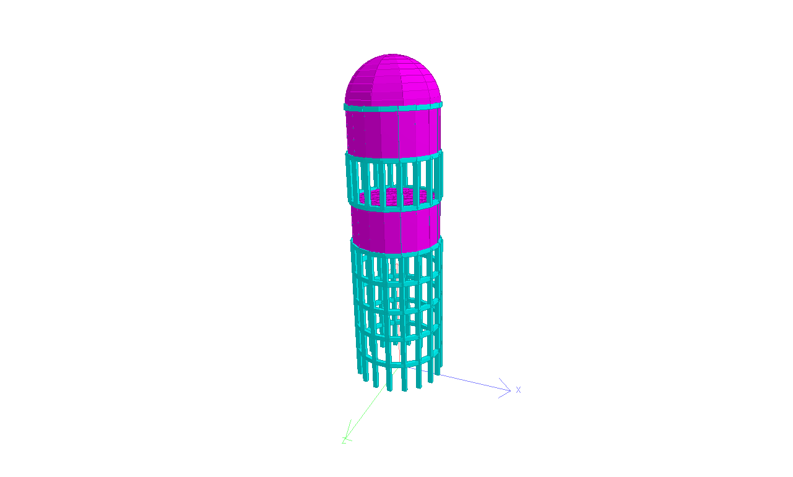

# References

# 1.Gaikwad madhukar (REVIEW ON SEISMIC ANALYSIS OF ELEVATED WATER TANK)

# 2. Neha Pol-( SEISMIC ANALYSIS OF ELEVATED WATER TANK)

3.Vrushali Gujar (JAN 2020) Review on Seismic Analysis of Elevated Water Tank with Different Staging Configuration.

4.Dr. K. B. Prakash - September-(2023 )SEISMIC ANALYSIS OF ELEVATED WATER TANK.

5.Pradnya V. Sambary , D.M. Joshi-. February 2023 seismic analysis of RC elevated water tank

6.Manali Ugemuge june (2023) seismic analysis and design of circular elevated water tank for variation of H/D ratio and

bracing patterns.

7. L.Raghava Naidu (February 2019) seismic analysis of elevated water tank in different seismic zone.

8.Arjun Butala (2022) seismic analysis and design of elevated water tank for different stanging condition.

9.Sanket Nimbekar. A. (2020) Seismic response control of elevated water tank using base isolation.

10.Raoglu and A. Dogangun, “Effect of foundation embedment on seismic behavior of elevated tanks considering fluid- structure –soil interaction”, Soil dynamics and earthquake engineering- ELSEVIER, (2007), (855-863).

11.HalilSezen and Livaoglu et al. “Dynamic analysis and seismic performance evaluation of above ground liquid- containing tanks”, Engineering structures- ELSEVIER, (2008), (794- 803)   
12.A.I Gareane and Algreane et al, “Behavior of elevated concrete water tank subjected to artificial ground motion”, Electronic journal of geotechnical engineering, (2008), Vol.16, (387- 406)., F. & Johnston, E. - Discusses buckling and slenderness in materials, providing foundational knowledge.

13.IS:456-2000 : Code of practice for plain and reinforced concrete.

14. IS:875-1987(PART-2) : Design loads for buildings and structure.

15. IS:1893-1984 : Criteria for earthquake resistant design of structures.

16. IS:11682 : Criteria for design of RCC staging for overhead water tanks.

17.Double-decker elevated water tank is Designed and constructed by Gammon India in 1990 for Andheri Sports complex.

18.NMC(Nagpur Municipal corporation) the civic body has come up with first-of-its-kind proposal of constructing a double-decker ESRs having 2.2 MLD capacity each.