**FOOTWEAR-BASED ASSISTIVE TECHNOLOGY FOR LOWER LIMB AMPUTEES**

*Mrs. M. Nila Nandhini,

Assistant professor, Biomedical Instrumentation Engineering,

Avinashilingam Institute for home science and higher education for women, Coimbatore, Tamilnadu.

nilanandhini_bmie@avinuty.ac.in

C.P. Bertilla Madonna

madonnabertilla@gmail.com

P.S. Supraja

suprajaps02@gmail.com

1. Vasantha Varshini

vasanthavarshini06@gmail.com

**Abstract:** Men and women with lower limb amputations struggle with managing the balance between prosthesis alignment and shoe heel rise. A novel prosthetic ankle-feet system is being developed to support a wider range of footwear options for men and women with lower limb amputations. Each rigid foot is customized to fit the footwear of choice and can be rapidly attached to (or released from) an ankle unit which remains attached to the prosthesis. The proposed system consists of two key components: a transmitter shoe and a receiver shoe. The transmitter shoe is worn on the intact limb and is equipped with sensors, including accelerometers and gyroscopes to capture the wearer's ankle movements accurately. These sensor data are wirelessly transmitted to the receiver shoe worn on the amputated limb, which houses actuators, such as stepper motors, to replicate the natural ankle movements.

The hypothesis was that the orientation of the roll-over shapes of these systems would be altered with even small changes in shoe heel height. Seven prosthetic ankle-foot systems were mechanically loaded to determine their roll-over shapes while using a no-heel shoe and a low-heel shoe. This system was developed specifically to allow users the ability to switch between shoes of different heel heights (i.e., it is a heel-height-adjustable system). Additional loading trials were performed with the heel-height-adjustable system in which the ankle alignment was altered to accommodate the change in heel height between shoes.

***Keywords: Foot wear; Technology; Lower limb; Ankle alignment; Sensors.***

**INTRODUCTION**

Lower limb amputees face significant challenges in regaining the mobility and achieving a natural gait. Traditional prosthetic solutions often fall short in providing a seamless and comfortable walking experience. This project presents a novel approach to address this issue through the development of footwear-based assistive technology tailored to lower limb amputees. The core concept involves integrating sensor-equipped footwear with a wireless communication system to enable real-time monitoring and control of ankle movements.

Prosthetists are keenly aware of how their patients often struggle to find footwear that can work with their prosthetic foot. According to Kapp and Fergason, “Heel height is the single most important factor in shoe fit related to [prosthetic] foot function.”. These struggles affect both men and women with lower limb amputation, impacting individuals who wish to wear stiletto heels and cowboy boots alike. Understanding the barriers this population faces requires an understanding of the able-bodied biomechanics of adaptation to footwear heel rise and a clear picture of the ability of current prosthetic components to adapt to footwear with different heel rises.

The heel height of a shoe is the measurement from the floor to the top of the heel platform (underside of the shoe upper at the heel). Many shoe styles also have a thickness of shoe sole beneath the forefoot, thus the more relevant metric for human biomechanics is heel rise, the difference between the height of the heel and the height of the forefoot. Healthy able-bodied persons primarily accommodate the heel rise of their footwear at the ankle, increasing plantar flexion at the ankle as the heel rise increases. Wearing shoes with higher heel rise moves the plantar pressure anterior from the heel and mid-foot to the forefoot and toe region. Furthermore, the toes counter rotate as the ankle plantar flexes to provide a firm base that is generally parallel to the sole of the shoe. For persons with lower limb amputations, these biomechanical adaptations are not available. Traditional prosthetic ankle-foot systems are non-adaptive. Accommodation to footwear is achieved through modification of the prosthesis alignment by a certified prosthetist. This alignment is sensitive to the heel rise of footwear. Some modern prosthetic ankle-foot systems possess a passive range of motion, generally achieved through hydraulic damping that allows for a limited accommodation. The accommodation range of motion is usually only a few degrees of plantar flexion and/or dorsiflexion, allowing for accommodation of minor slopes or limited tolerance of footwear with different heel rises. One challenge of these products is that the hydraulic damping range of motion results in an inherent loss of energy because that displacement is not recovered during unloading leading to reduced energy return relative to traditional non-accommodating feet of similar design.

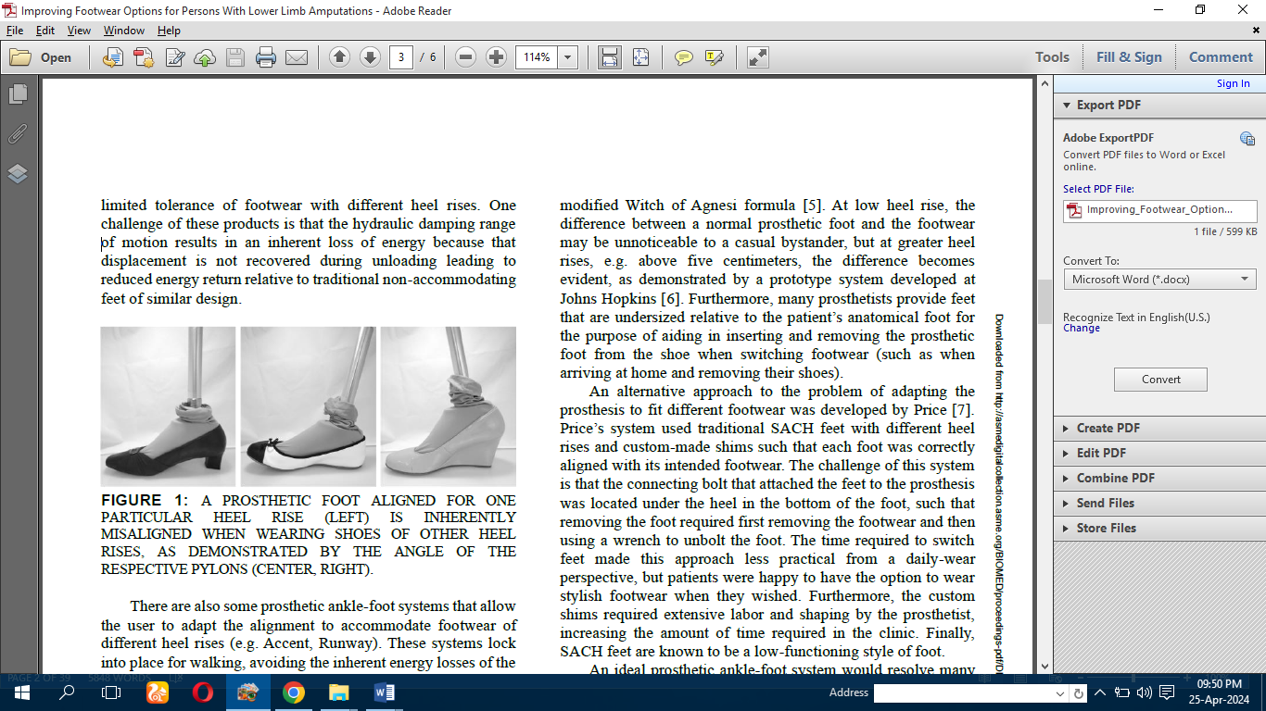

Fig 1. A Prosthetic foot aligned for One Particular Heel Rise (Left) is inherently misaligned when wearing shoes of other Heel Rises, As Demonstrated By The angle of the respective Pylons (Center, Right).

**LITERATURE REVIEW**

**Nur Azah Hamzaid. et.al.,** proposed Micro-processor controlled prosthetic legs (MPCPL) offer better functionality than conventional prosthetic legs as they use actuators to replace missing joint function. This potentially reduces the user’s metabolic energy consumption and normal walking gait can be mimicked as closely as possible. However, MPCPL require a good control system to perform efficiently, and one of the essential components is the system of sensors. The sensory system must satisfy two important criteria; the practicality in donning and doffing the prosthesis, i.e. the process of putting on and taking off the prosthesis by the amputee user, and the quality in the information provided. The articles were classified into three main categories: prosthetic- device oriented, user’s-biological-input oriented and neuro-mechanical fusion sensory system. Types of sensors used and their application to the prosthetic system were analysed. Hence, a sensory system that eases the don and doff process of the prosthesis [1].

**He Huang. et.al.,** developed an algorithm based on neuromuscular–mechanical fusion to continuously recognize a variety of locomotion modes performed by patients with transfemoral amputations. Electromyography signals recorded from gluteal and residual thigh muscles and ground reaction forces/moments measured from the prosthetic pylon were used as inputs to a phase-dependent pattern classifier for continuous locomotion-mode identification. The algorithm was evaluated using data collected from five patients with transfemoral amputations. The results showed that neuromuscular–mechanical fusion outperformed methods that used only EMG signals or mechanical information. For continuous performance of one walking mode the interface based on neuromuscular–mechanical fusion and a support vector machine (SVM) algorithm produced higher accuracy in the stance phase and in the swing phase for locomotion-mode recognition. During mode transitions, the fusion-based SVM method correctly recognized all transitions with a sufficient predication time [2].

**Dongfang Xu, et.al.,** proposed a multi-level real-time on-board system to recognize continuous locomotion modes. A cascaded classification strategy is designed for the recognition of six steady locomotion modes and ten transitions. On-board signals of the robotic prosthesis include two inertial measurement Units and one load-cell. The prediction decision time of the real-time on-board cascaded classification system is very short time. It is easy to recognize the standing and ambulation in the first-level classification. In the second-level classification, threshold method is adopted to divide one stride into swing and stance phases with five steady modes are recognized besides, for transitions the proposed system could recognize all transitions rightly. The designed system is feasible and effective to realize real-time on-board recognition of continuous locomotion modes [3].

**Muhammad Jawad Khan, et.al.,** developed a model asintegration of a Series Damping Actuator (SDA) in prosthetic leg design. It addresses the challenges posed by traditional passive prostheses and lack of natural motion and the high cost and energy consumption associated with active prostheses. Semi-active prostheses, exemplified by SDA, demonstrate the potential to control knee movement and emulate natural gait patterns. The research encompasses kinematics analysis, control system design, and the successful adaptation of gait patterns, offering a promising avenue for enhanced prosthetic limb functionality [4].

**Kyle R. Embry, et.al.,** enhanced prosthetic leg control the limitations of current control methods using finite state machines and proposes a continuous parameterization model for joint kinematics. The authors conducted a pilot experiment to evaluate the accuracy of speed and incline measurements and simulated phase measurements. The analysis reveals that the continuous parameterization model offers more accurate predictions of knee and ankle kinematics compared to a finite state machine. However, subject-specific differences continue to be a significant source of error. The paper emphasizes the importance of subject-specific tuning for improved results [5].

**PROPOSED METHODOLOGY**

In the present work is propose to follow in the spirit of the system developed by Price in developing an ankle-feet system where a single ankle unit containing the majority of the ankle-foot function is easily inserted into, and removed from, custom-shaped prosthetic foot structural keels designed to fit individual shoes. The prosthetics can align the ankle unit in any of the feet (with appropriate shoes) and that alignment should transfer to all other feet with their respective shoes. With the mechanical and manufacturing complexity contained within the ankle unit (retained with the prosthesis), the foot structure can be low cost and be purchased with the appropriate plantar configuration for each pair of shoes. The requisite foot (sans ankle unit) is inserted into the appropriate shoe and, once settled in place, can remain there as long as desired. When the wearer wishes to don or doff the shoe, they also don or doff the custom-fit foot, with an accessible connector.

The need for the proposed system arises from the limitations of the existing system, which is a manual one. In the previous system, customer can make a call and book the car for travelling from one place to another. Updation in the details is a tedious task. But a new system was proposed to overcome the above drawbacks developed in web application. To develop user friendly software that meets the user needs any time. Customer can easily book the available car at a time. Information can be created and altered by administrator.

In terms of prosthetic feet, the geometry of the foot must be customized to the shape of the shoe, but the walking function must remain constant. The roll-over function of the human ankle-foot complex remains invariant under a wide array of conditions including load carriage, walking speed, and changes in heel height (albeit at a different neutral angle at the ankle). Many high-heeled shoes have inflexible keel structures that preclude generating a roll-over through flexing of a keel structure throughout the foot length (as is the case with traditional carbon-fibre energy-storage-and-return prosthetic feet), thus a system suitable for use over a broad array of heel heights should incorporate the ankle-foot roll-over mechanics primarily at the ankle.

The proposed method provides assistive technology for lower limb amputees who create an actuation mechanism for natural ankle flexion and extension. Walking speed can be adjusted by the users. The proposed system consists of two key components: a transmitter shoe and a receiver shoe. The transmitter shoe is worn on the intact limb and is equipped with sensors, including accelerometers and gyroscopes to capture the wearer's ankle movements accurately. These sensor data are wirelessly transmitted to the receiver shoe worn on the amputated limb, which houses actuators, such as stepper motors, to replicate the natural ankle movements. The receiver shoe's actuators are controlled in real-time based on the sensor data received from the transmitter shoe, allowing for precise and adaptive ankle movement mimicry. The system can be customized to the individual needs of the wearer, providing a tailored and comfortable user experience.

**Features:**

* The proposed method provides assistive technology for lower limb a amputee who creates an actuation mechanism for natural flexion and extension.
* It consists of two key components: a transmitter shoe and a receiver shoe.
* The transmitter shoe is worn on the intact limb and it is equipped with sensors.
* The receiver shoe is controlled and monitored based on the sensor data received from the transmitter shoe.
* The system can be customized to the individual needs of the wearer, providing a tailored and comfortable user experience.

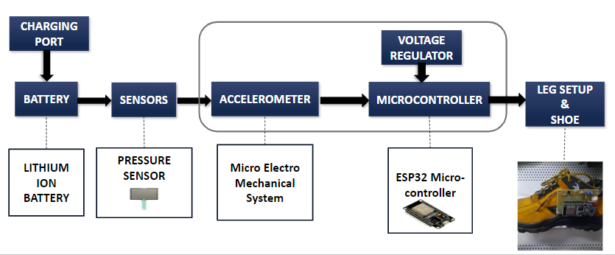

***Fig. 2. Transmitting Shoe work flow***

The ankle design volume was the common (intersection) space between the two extreme foot heel rises of 22cm SACH prosthetic feet (10mm heel rise and 89 mm heel rise). Use of 22cm feet to define the design volume supports developing feet for shoes as small as women’s size 5 (US). The feet were scanned and overlaid in Geomagic Freeform (3dsystems, Rock Hill, SC). The intersecting volume was used as the design volume. Using the available design volume as a hard constraint, a single axis ankle element was designed to fit in a housing that could be dropped into a mating cavity in the rigid prosthetic foot element.

The housing was machined out of aluminium alloy to minimize weight at a reasonable cost point. The ankle system housing was designed with drafted exterior surfaces on all sides to allow for easy insertion and release from the prosthetic foot. The ankle housing is widest at the anterior surface to distribute forefoot loads into as wide an area as possible. The total mass of the ankle system is 318 g. To keep the system within the volumetric design constraints, the elastomeric bumpers were oriented horizontally, in a wiper style design. The cross section view shows the internal features of the ankle system. The pyramid adapter was built into a wiper element to reduce weight and part count. Titanium, 6AL-4V, was chosen for the wiper element due to the high cyclic loading that the wiper is exposed to. The dorsiflexion bumper is smaller than the plantar flexion bumper due to the higher stiffness requirement during dorsiflexion and the greater range of motion desired during plantar flexion. This design provides over 20 degrees of plantar flexion rotation and 15 degrees of dorsiflexion rotation from neutral. The housing has a two-part construction, allowing access to the bumpers from underneath the unit, with a single screw to hold the housing assembly together.

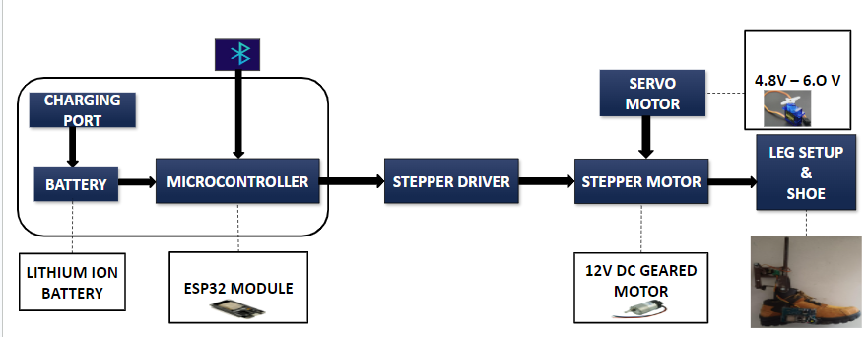

***Fig. 3. Receiving shoe with Bionic leg***

The customized feet were printed on a Stratasys Fortus 400mc 3d printer and were made of Nylon 12. The foot was designed in Solid Works (Dessault Systemes Solidworks Corporation, Waltham MA) as a Boolean merging of multiple bodies: a plantar plate, internal structure, external shell, and ankle receiver socket. This foot had a mass of 446g when printed. The internal structure included a central oval, centered approximately 25% of the foot length from the heel, that provided a solid volume from which to subtract the ankle receiver socket and radiating ribs that extended to the external shell. One main rib extended from the anterior aspect of the central oval toward the big toe, providing reinforcement for the full length of the foot. Other anterior ribs described arcs that joined with the main rib to further support the forefoot against medio- lateral loading. The external shell was 1mm in thickness to provide a smooth surface for cosmetic purposes but was not intended to provide structural support. The ankle receiver socket was subtracted from the central oval of the internal structure and was designed to match the external geometry of the ankle unit with a small amount of clearance to avoid binding.

The worst-case foot for structural testing is the “flattie”, a foot with essentially zero heel rise, because the moments are maximized in late stance phase with this heel rise. Structural strength was assessed by subjecting a printed foot to external loads based on the ISO 10328 ultimate strength test. The foot withstood a peak load of 4584N without failing, at which point our test machine was unable to apply further load due to limited facility air pressure, maintaining that force for more than 10s. This force exceeds the lower threshold of the ultimate strength test for the load level ( applicable for persons with a body mass up to 175kg) and exceeds the upper threshold of the ultimate strength test for the load level (4480N, applicable for persons with a body mass up to 100kg). The structure exhibited limited flexion and no permanent deformation during testing, indicating further loading is possible.

**STEPPER MOTOR**

* Size: 42.3 mm square × 48 mm
* Weight: 350 g (13 oz)
* Shaft diameter: 5 mm “D”
* Steps per revolution: 200
* Current rating: 1.2 A per coil
* Voltage rating: 4 V
* Resistance: 3.3 Ω per coil
* Holding torque: 3.2 kg-cm (44 oz-in)

***Table 1: Difference between different power volts.***

|  |  |
| --- | --- |
| **at 4.8V** | **at 6.0V** |
| Operating Speed: 0.20sec/60° at no load | Operating Speed:  0.17sec/60° at no load |
| Running Current:~ 0.2A | Running Current: ~ 0.25A |
| Stall Torque:  ≥ 3.2kgf.cm (44.44 oz/in) | Stall Torque:  ≥ 3.5kgf.cm (48.6 oz/in) |

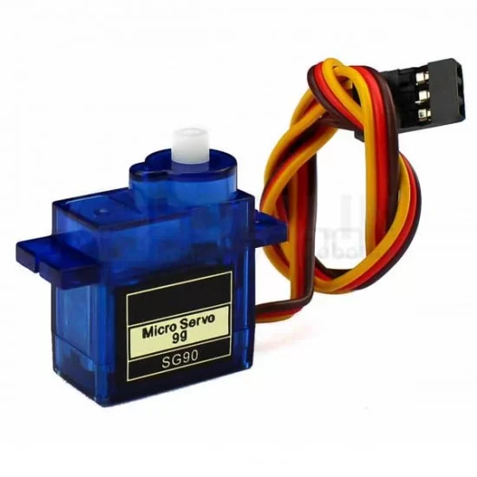

***Fig. 5. Gear material (Resin)***

* Gear Material: Resin
* Size : 40.6*20.0*38.9mm (106*0.79*1.53 in)
* Weight: 37g (1.30 oz)

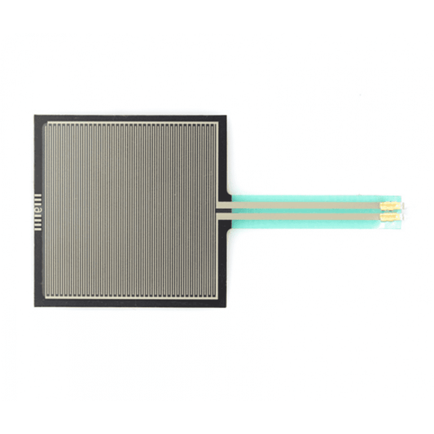

***Fig. 6. Force pressure sensor***

* Easily customizable to a wide range of sizes
* Cost-effective
* Ultra-thin: 0.45 mm
* Robust: up to 10 million actuations
* Simple and easy to Integrate
* Overall length: 3.5″
* Overall width: 1.75″
* Sensing area: 1.75 x 1.5″

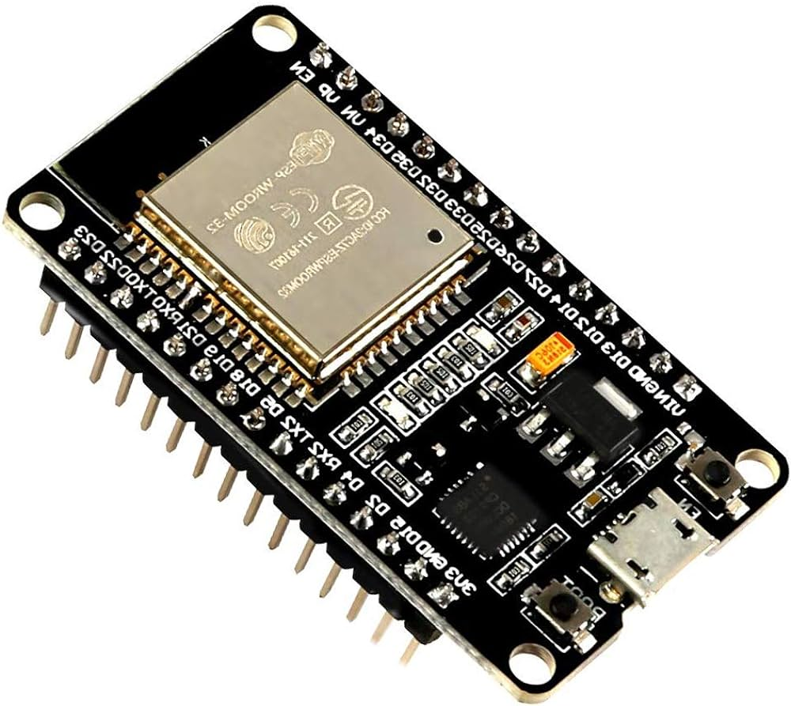

***Fig. 7. ESP32 micro-controller***

* **ESP32** is a series of low-cost, low-power system on a chip microcontroller with integrated Wi-Fi and dual-mode Bluetooth.
* Memory: 520 kB RAM, 448 kB ROM
* Wireless connectivity:
* Wi-Fi
* Bluetooth
* Xtensa single-/dual-core 32-bit LX6 microprocessor(s)
* Supports single-precision Floating Point Unit
* 34 × programmable GPIOs
* 12-bit SAR ADC up to 18 channels
* 2 x 8-bit DAC

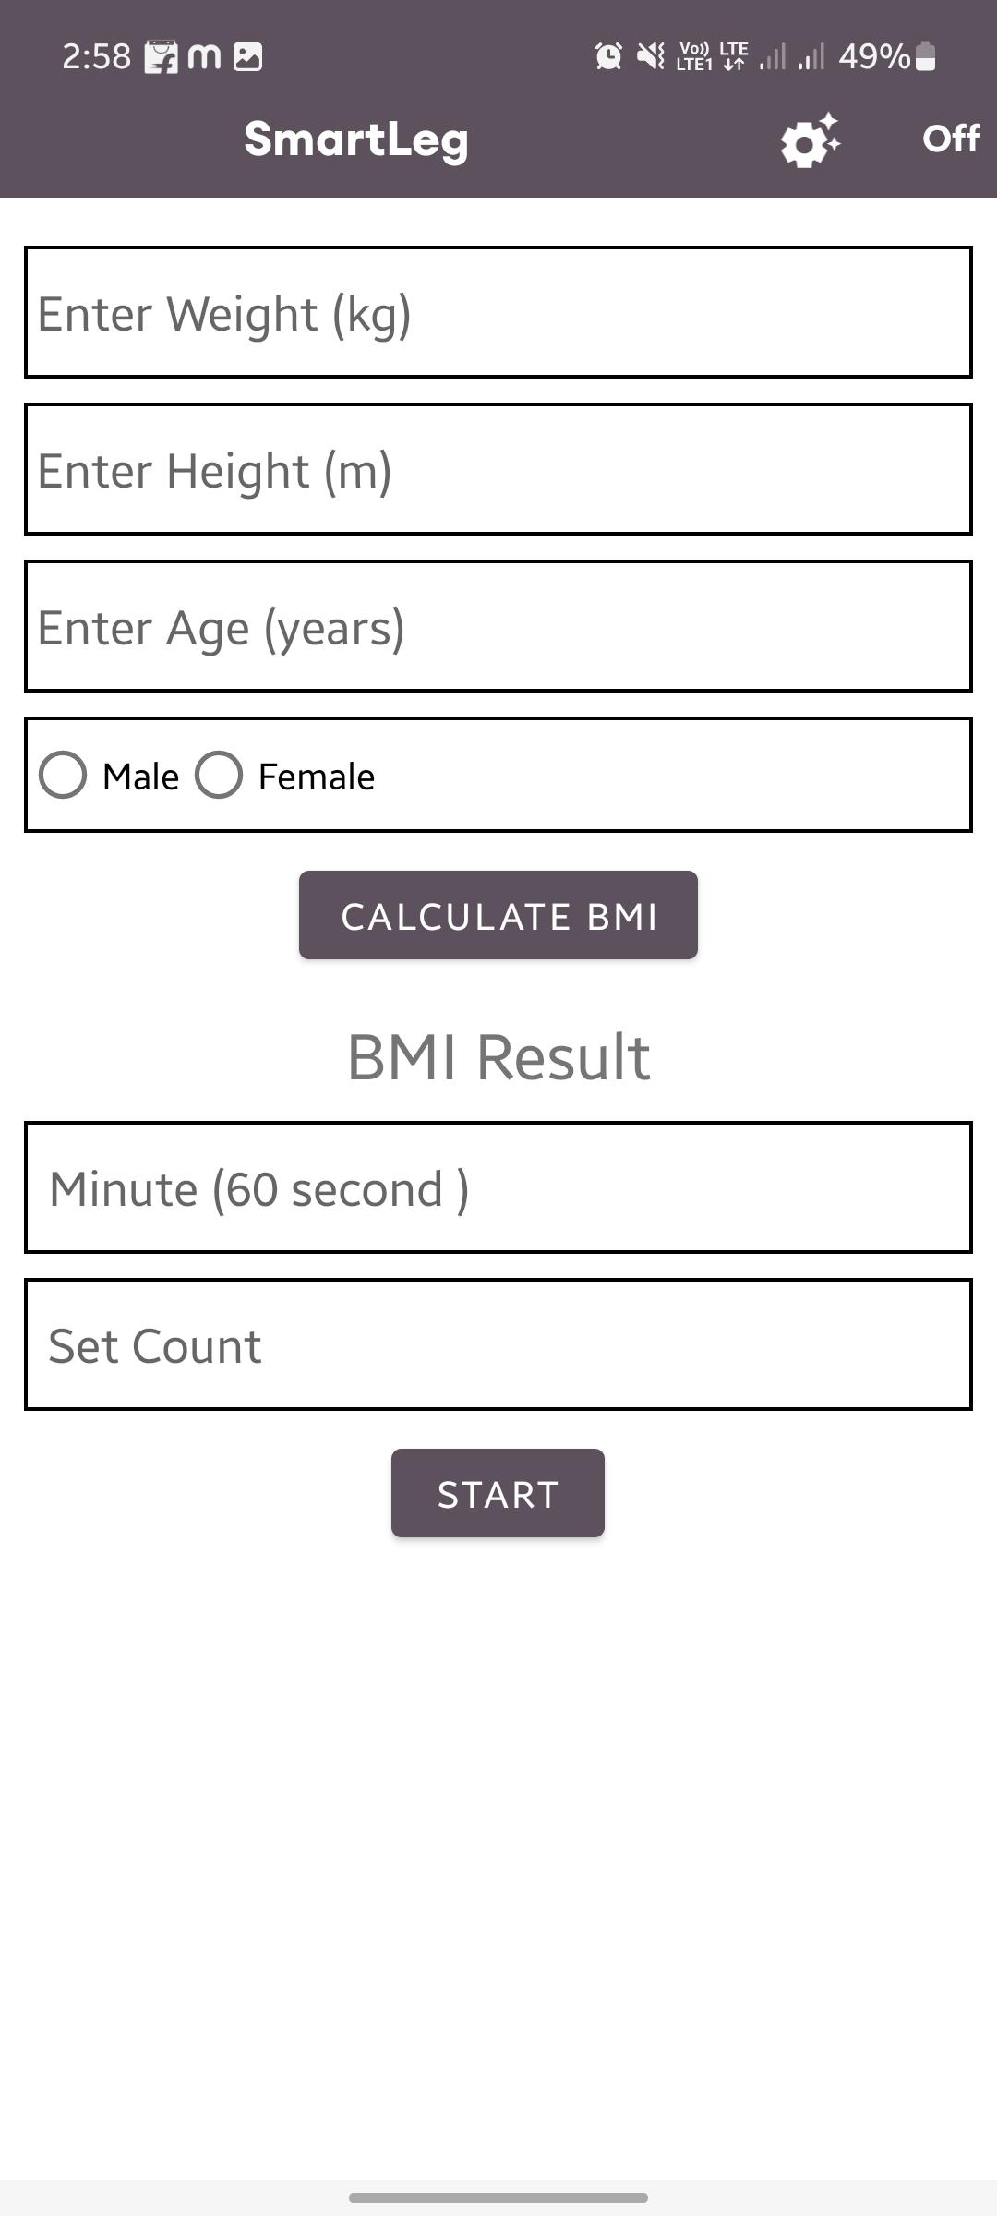

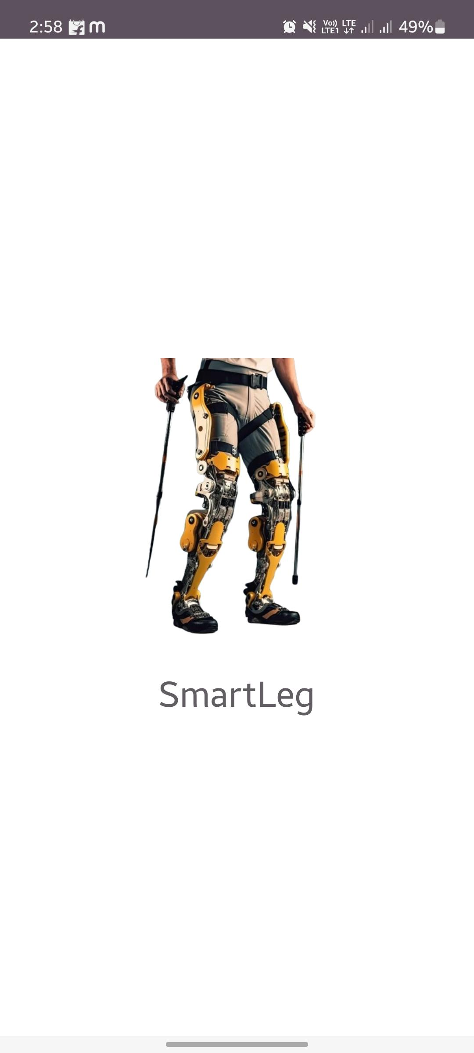

***Fig. 4. Smart leg with descriptions of BMI***

* The mobile application is developed and it is named as **Smart Leg**.
* The app is connected via Bluetooth with the shoes.
* The application give the details about step count with timer, day-to-day target and also a voice assistance is incorporated.
* This application provides BMI (Body Mass Index) of an person can be calculated by providing informations such as weight (kg), height (m), age and gender of the person.
* The embedded C is programmed in the micro-controllers

**CONCLUSION**

In conclusion, the development of lower limb prosthesis helps to revive the gait cycle and revolutionize healthcare by providing accessible, and comprehensive monitoring for the amputees. This finding along with previous findings suggest invariance of shapes to walking speed, proposes an underlying importance of maintaining proper rollover characteristics for walking. The study of lower limb system provides an understanding of human walking and assist in the development of the system. In the future, this work can be made into a customized wearable system in respective to the individuals.

**FUTURE WORK**

In the future, this work can be made into a customized wearable system with respective to the individuals. Using PCB designing components are made and incorporated inside the shoes. The system can be incorporate with machine learning algorithms to adaptively adjust ankle movement with walking patterns.

**REFERENCES:**

1. Nur Azah Hamzaid.Et:al., “Sensory Systems in Micro-Processor Controlled Prosthetic Leg” Institute of Electrical and Electronics Engineers (IEEE), Issue.September 2019.
2. He Huang.Et.al.,“Continuous Locomotion-Mode Identification for Prosthetic Legs Based on Neuromuscular–Mechanical Fusion” Institute of Electrical and Electronics Engineers (IEEE), Issue. July 2011.
3. Dongfang Xu.Et.al.,”Real-Time On-Board Recognition of Continuous Locomotion Modes for Amputees With Robotic Transtibial Prostheses” Institute of Electrical and Electronics Engineers (IEEE), Issue. September 2018.
4. Muhammad Jawad Khan.Et.al., “Control system design for a prosthetic leg using series damping actuator” Institute of Electrical and Electronics Engineers (IEEE), Issue. October 2012.
5. Kyle R. Embry.Et.al., “Analysis of Continuously Varying Kinematics for Prosthetic Leg Control Applications” Institute of Electrical and Electronics Engineers (IEEE), Issue. December 2020.
6. Control system design for a prosthetic leg using series damping actuator Publisher: IEEE (2012) Muhammad Jawad Khan; Muhammad Raheel Afzal; Noman Naseer; Zafar Ullah Koreshi.
7. Analysis of Continuously Varying Kinematics for Prosthetic Leg Control Applications Publisher: IEEE (2020) Kyle R. Embry; Robert D. Gregg.
8. Continuous Locomotion-Mode Identification for Prosthetic Legs Based on Neuromuscular–Mechanical Fusion Publisher: IEEE (2011 ) He Huang; Fan Zhang; Levi J. Hargrove; Zhi Dou; Daniel R. Rogers; Kevin B. Englehart.
9. Real-Time On-Board Recognition of Continuous Locomotion Modes for Amputees With Robotic Transtibial Prostheses Publisher: IEEE (2018) Dongfang Xu; Yanggang Feng; Jingeng Mai; Qining Wang.
10. Sensory Systems in Microprocessor Controlled Prosthetic Leg Publisher: IEEE(2019) Nur Azah Hamzaid; Nur Hidayah Mohd Yusof; Farahiyah Jasni.
11. Foot/ankle roll-over characteristics in different heel heights during level walking .World Congress on Medical Physics and Biomedical Engineering 2006, Choi, H.S., Kim, Y.H., 2007.
12. High heels on human stability and plantar pressure distribution: Effects of heel height and shoe wearing experience. Hapsari, V. D., Xiong, S., Yang, S., 2014.
13. Johns Hopkins students create high-heeled prosthetic. Washington Post, August 9, 2016, McDaniels, A.K., 2016.
14. Effects of adding weight to the torso on roll-over characteristics of walking, Hansen, A. H., Childress, D. S., 2005.
15. Roll-over shapes of human locomotor systems: Effects of walking speed. Hansen, A. H., Childress, D. S., Knox, E. H., 2004.