**FORM PERFECTOR**

Prof.Pallavi N.Shejwal

Assistant professor

Modern College of Engineering,Pune

Aryan Takle, Aditya Joshi, Nikhil Koshti, Pratik Jaiswal

UG Student, Dept. of I.T., P.E.S Modern College of Engineering, Savitribai Phule Pune University, Maharashtra, India

**ABSTRACT**: Home-based workouts are known to have significant health and fitness benefits, but it could be dangerous if not performed with proper posture. This could be due to a lack of sufficient training and bad habits, or the inability to afford a personal trainer to fix the individual's posture. With the current Artificial Intelligence technology, we are now able to achieve workout analysis by using computer vision approach without any involvement of personal trainer. This report discussed the approach of keypoint detection, human pose estimation and pose analysis that will be utilized to produce the proposed project through Rapid Application Development (RAD) methodology, which will monitor these procedures phase by phase. Pretrained model from MediaPipe was chosen as the main human key point detection, and various machine learning algorithms such as Linear Regression and Random Forest were studied to find the suitable algorithm to be implemented in detecting and analyze home workout postures. Furthermore, this research also studies on geometrical approach to determining proper and improper posture for analysis. These approaches were then compared to see which will produce the best results and user experience. Since machine learning approach does not produce the best result due to lack of training data and variety of other factors, the geometrical approach was chosen as the final approach before implementing it into desktop application.

**KEYWORDS**: ***Personal Trainer, Keypoint Detection, MediaPipe, Rapid Application Development***

# 

# 

# 

# **I.** **Introduction**

# **1.1 Introduction**

In the realm of physical fitness, the correct execution of exercises is paramount for both efficacy and safety. An improper posture during gym and yoga sessions not only diminishes the potential benefits of the workout but also poses a risk of injury. Recognizing the importance of addressing this issue, our project endeavors to perfect the form of gym and yoga exercises through the integration of cutting-edge technology.

The foundation of our approach lies in the utilization of the Pose model from the Mediapipe library, a powerful tool capable of detecting the intricate landmarks or joints of the human body and the connections between them. These landmarks serve as crucial indicators of body parts such as hands, legs, elbows, shoulders, and hips. By accurately capturing the spatial relationships between these landmarks, we can calculate the angles formed by the connections, providing us with a comprehensive understanding of the user's body posture.

This project aims to develop software that focuses on assisting people in properly performing workout such as bicep curl, sit-up and various exercise using Artificial Intelligence with Computer Vision technique. The goal of this project is to help prevent injuries and improve the quality of individual's workout by providing personalized feedback on their posture using only a computer and a webcam. Artificial Intelligence has always been discussed nowadays due to its ability to assist human with their daily activities. The capabilities of Artificial Intelligence giving humans hope to develop machines with human intelligence. One of the common Artificial Intelligence technologies is called Computer Vision, where machines can recognize photographs and videos in the same way that humans do.

**1.2 Purpose**

The primary purpose of our project is to develop a system that acts as a vigilant guide, assisting users in maintaining correct exercise postures. Aiming to enhance the overall exercise experience, our system employs a proactive approach by setting threshold values for key angles involved in various exercises. These threshold values are determined through a meticulous study of ideal exercise angles, ensuring that users receive immediate alerts when deviating from the prescribed form.

**1.3 Aim**

The overarching aim of our project is to contribute to the creation of a safer and more effective exercise environment. The specific objectives include:

• Implementing the Pose model to detect body landmarks and connections.

• Calculating relevant angles between body connections for various exercises.

• Establishing threshold values based on ideal exercise angles.

• Providing real-time alerts to users when their posture exceeds the defined thresholds.

• Empowering users to correct their form and reduce the risk of injuries.

**1.4** **Objective**

The goal of this project is to develop an Artificial Intelligence-based system that assists people in performing home workouts such as bicep curl and sit-up by combining computer vision technology with human pose estimation technique, along with deep learning and machine learning approaches. Following are the objectives of this project in order to achieve the mentioned goals:

• To investigate how computer vision can assist in detecting human exercise posture and incorrect posture.

• To develop an artificial intelligence-based software that uses camera to detect user’s workout posture and provides personalized feedback on improving their exercise posture.

• To help preventing injuries and breaking the bad habits of exercising with incorrect posture.

• To evaluate the effectiveness of implementing this software in individual’s health.

**1.5 Scope**

While our current focus is on perfecting exercise form through real-time feedback, the scope of our project extends beyond its immediate applications. In the future, we envision integrating an exercise and diet planner into the system, providing users with a comprehensive tool for optimizing their fitness routines.

As we delve into the subsequent sections, we will explore the technological and methodological aspects of our project, detailing the steps taken to transform this vision into a functional and user-friendly solution. Through this initiative, we aspire to contribute to the advancement of fitness technology and promote safer, more effective workout practices.

# **II.** **Existing System**

FlexifyMe emerges as a beacon of hope in the realm of chronic pain management, boasting a comprehensive platform that addresses a multitude of afflictions such as back pain, cervical pain, spondylosis, and more. Its innovative approach integrates online physiotherapy, yoga therapy, and cutting-edge artificial intelligence (AI) technology, offering patients a holistic solution for their persistent discomfort. Through personalized treatment plans and remote guidance, FlexifyMe has successfully alleviated the suffering of countless individuals spanning over 26 countries, garnering acclaim for its efficacy and reach. At the heart of FlexifyMe's success lies a team of over 40 physiotherapists, yoga therapists, and orthopedic doctors, each equipped with the expertise to provide tailored care and support. Backed by prominent investors such as Flipkart, GSF, and Ivy Cap, FlexifyMe stands as a testament to its credibility and potential for growth in the healthcare industry.

# 

# **III.** **PROBLEMS IN EXISTING SYSTEM**

In terms of price and affordability, FlexifyMe faces challenges in making its services accessible to a broader demographic. The cost associated with online physiotherapy, yoga therapy, and AI-based treatments may be prohibitive for individuals lacking sufficient insurance coverage or financial resources. Furthermore, if FlexifyMe operates on a subscription-based model or incurs additional costs for equipment and supplementary treatments, affordability could become a barrier for many potential users. Methodological Constraints: Itrely on qualitative methods and surveys, respectively. While useful, these methods might not capture the entire spectrum of factors influencing e-ticketing systems' effectiveness, potentially missing nuanced aspects or broader societal implications.

Technology and Accessibility Challenges: It propose technologically advanced systems. However, literature often discusses challenges related to technology adoption, such as infrastructure limitations, digital literacy, or affordability, which could hinder widespread implementation or access.

Environmental Impact Consideration: It highlights the issue of paper wastage due to traditional ticketing systems. However, while emphasizing the environmental benefits of e-tickets, the literature might not extensively address the ecological implications of the required electronic infrastructure or disposal of outdated tech components.

# **IV.** **Technology**

a. Python

Python is a programming language that was created by Guido van Rossum in 1991 and has a simple syntax like the English language.



b. Jupyter Notebook

The Jupyter Notebook is the original web application for creating and sharing computational documents. It offers a simple, streamlined, document-centric experience.



**Mediapipe pose landmarker**

The MediaPipe Pose Landmarker task lets you detect landmarks of human bodies in an image or video. You can use this task to identify key body locations, analyze posture, and categorize movements. This task uses machine learning (ML) models that work with single images or video. The task outputs body pose landmarks in image coordinates and in 3-dimensional world coordinates.

The pose landmarker model tracks 33 body landmark locations, representing the approximate location of the following body parts:

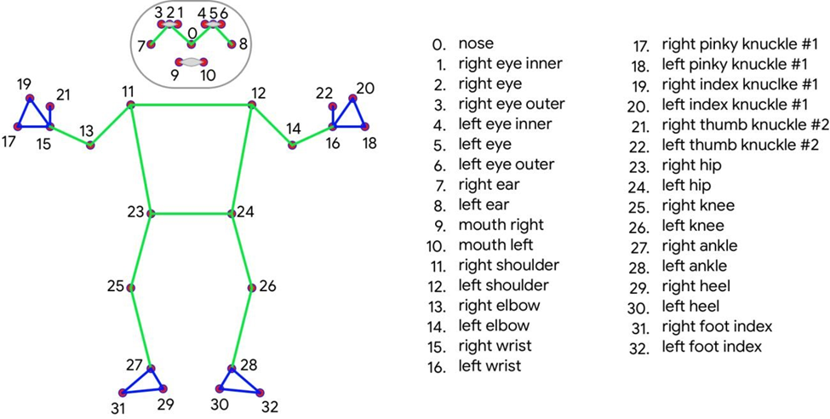

1. MediaPipe

MediaPipe is a Framework for building machine learning pipelines for processing time-series data like video, audio, etc. This cross-platform Framework works on Desktop/Server, Android, iOS, and embedded devices like Raspberry Pi and Jetson Nano.

b) OpenCV

OpenCV (Open-Source Computer Vision Library) is an open-source computer vision and machine learning software library. OpenCV was built to provide a common infrastructure for computer vision applications and to accelerate the use of machine perception in the commercial products. Being an Apache 2 licensed product, OpenCV makes it easy for businesses to utilize and modify the code.



c) NumPy

NumPy (pronounced NUM-py) is a library for the Python programming language, adding support for large, multi-dimensional arrays and matrices, along with a large collection of high level mathematical functions to operate on these arrays. We are mainly using this library to calculate the angle between connections.



**Working**

In this Python script, we've orchestrated a sequence of steps to create a real-time pose detection system using the user's camera feed. Firstly, we acquire access to the camera using OpenCV's VideoCapture module. This allows us to continuously capture frames from the camera feed. Then, we utilize the MediaPipe library, specifically its Pose model, to process each frame and identify the joint points and connections corresponding to the human pose. These key points provide us with the necessary data to calculate angles using the NumPy library. By employing mathematical calculations, we can determine angles between specific joints, which are crucial for assessing the user's pose. The subsequent step involves setting threshold values for these angles, defining ranges within which the angles should ideally fall. Finally, based on these threshold values, we implement a mechanism to alert the user if their pose deviates beyond acceptable limits. This alerting mechanism could take various forms, such as visual indicators on the screen, auditory alerts, or even haptic feedback, depending on the application's requirements. By integrating these components seamlessly, we create a holistic system capable of real-time pose detection and providing timely feedback to the user, fostering better posture awareness or aiding in physical therapy exercises, among other potential applications. Through the synergy of OpenCV, MediaPipe, NumPy, and threshold-based alerting, this system empowers users to monitor and improve their posture or perform exercises with greater precision and effectiveness, thereby promoting overall well-being and health.

**Procedure**

Step 1: Get access to the user's camera

Step 2: Capture the video feed using OpenCV Library

Step 3: Process the video feed using a mediapipe pose model and detect the joint points and connections

Step 4: Calculate the desired angles using the numpy library.

Step 5: Give threshold values to the desired angles.

Step 6: As per the threshold values give alerts to the user.

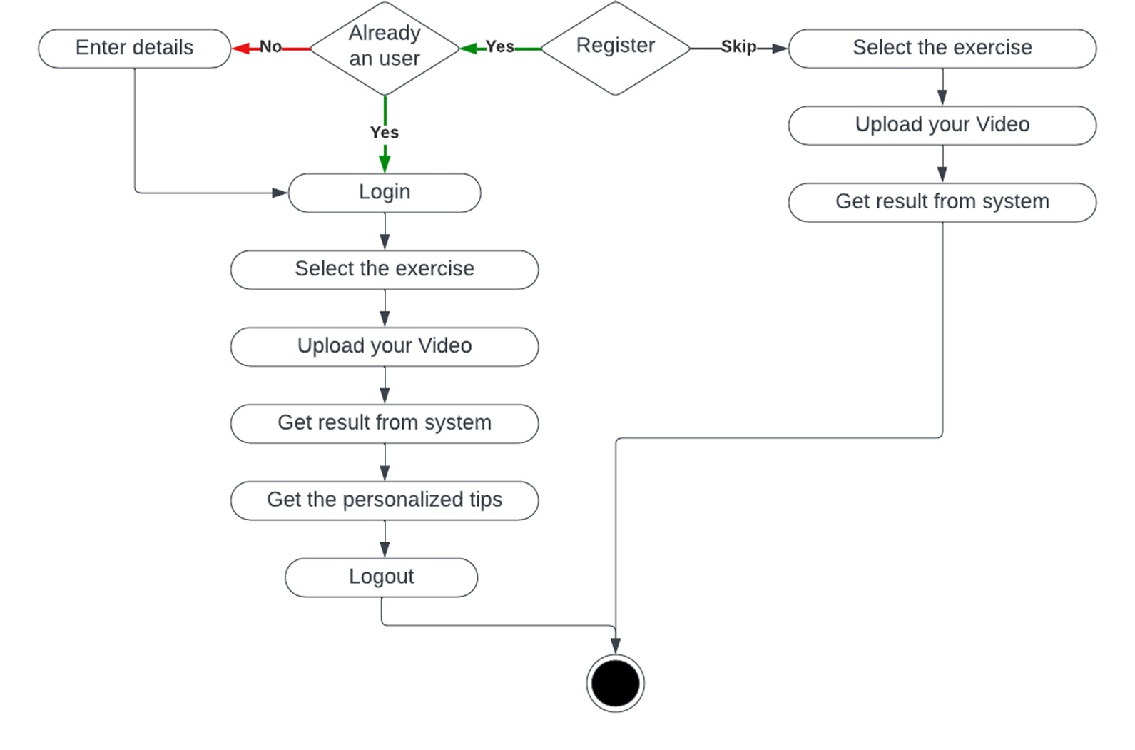

# **RESULTS**

Here we are going to share some result screenshots in which we have shown we are going to give alerts and information about the angles on which users have to focus.

In our example of biceps exercise there are two angles: elbow and hip. We do display the measure of angle to the user as shown in the following diagrams.

In the section there are 4 sections as follows,

1. Both angles are right

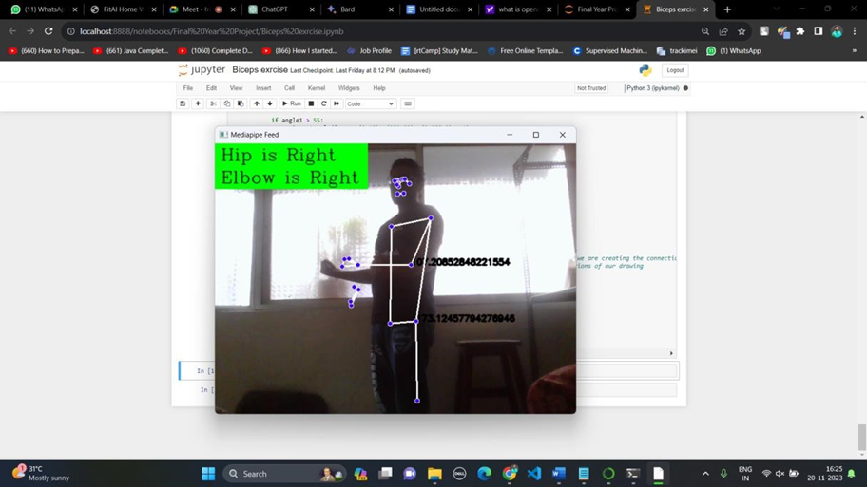

2. One of the angles is wrong 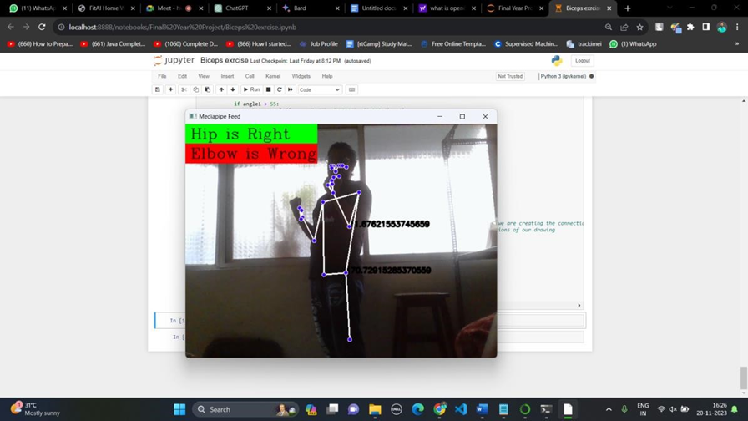

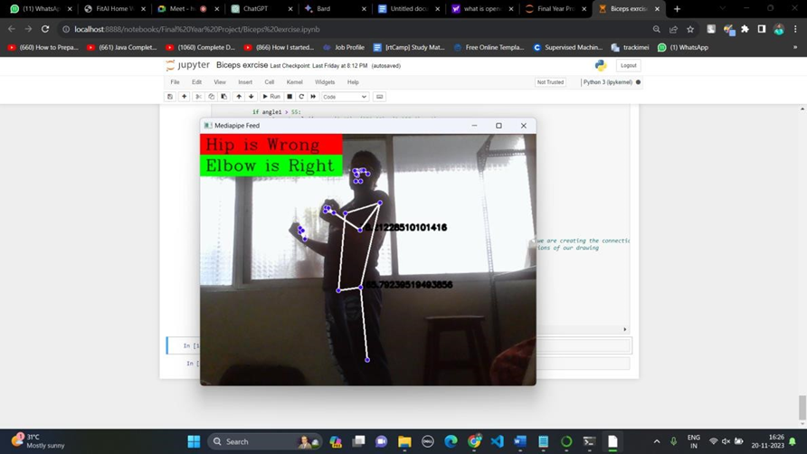

3. Both angles are wrong 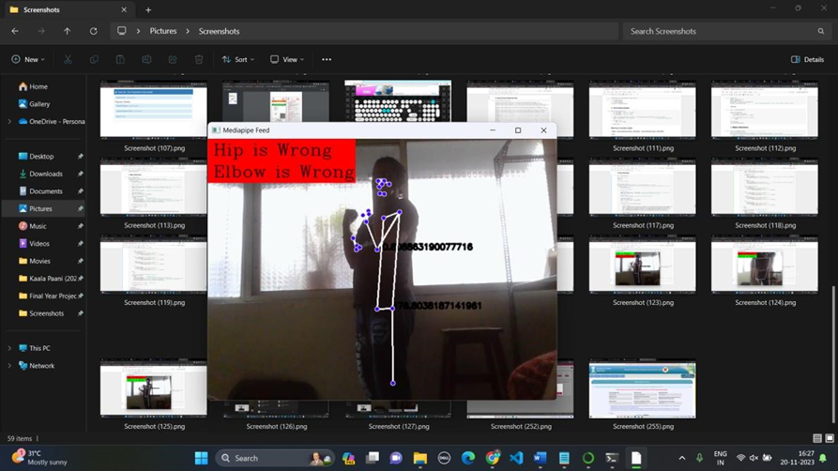

**Conclusion**

In conclusion, our research has revealed the Form Perfector as a groundbreaking innovation in tackling the challenge of incorrect exercise form. Through its real-time feedback and guidance features, it enables users to enhance their workout effectiveness while minimizing the likelihood of injuries. Its incorporation of advanced technology alongside a user-friendly design position it as a potential game-changer in the fitness industry. By empowering individuals to exercise with precision and safety, the Form Perfector has the capacity to significantly impact fitness practices and promote healthier lifestyles.

**References**

<https://www.irjet.net/archives/V7/i3/IRJET-V7I3295.pdf>

<https://www.irjmets.com/uploadedfiles/paper/issue_5_may_2022/22939/final/fin_irjmets1652552307.pdf>

<https://www.irjmets.com/uploadedfiles/paper//issue_5_may_2022/24574/final/fin_irjmets1654075370.pdf>