**FORM PERFECTOR**

Prof.Pallavi N. Shejwal

Assistant Professor

Modern College of Engineering, Pune

Aditya Joshi, Nikhil Koshti, Pratik Jaiswal, Aryan Takle

UG Student, Dept. of I.T., P.E.S Modern College of Engineering, Savitribai Phule Pune University, Maharashtra, India

**ABSTRACT**: At-home workouts are widely known for their significant health and fitness benefits, but improper posture poses a risk of injury. However, traditional solutions such as personal trainers may not always be accessible or affordable. This project introduces an innovative approach utilizing AI technology for workout analysis, eliminating the need for a personal trainer through computer vision techniques. The methodology revolves around keypoint detection, human pose estimation, and posture analysis, all integrated within a Rapid Application Development (RAD) framework. Using pre-trained models from MediaPipe, the project focuses on detecting key points and analyzing home workout postures. Various machine learning algorithms, including Linear Regression and Random Forest, are evaluated for their effectiveness in posture detection. Also, a mathematical approach is explored to differentiate between proper and improper posture. Given constraints such as limited training data, the mathematical approach emerges as the preferred method for integration into a desktop application. To ensure accessibility, a user-friendly web application is developed using Flask, HTML, CSS, and JavaScript. This platform caters to gym enthusiasts and beginners, providing seamless access to posture analysis and corrective guidance. Ultimately, this solution aims to enhance safety and effectiveness during home workouts without a personal trainer.

**KEYWORDS**: **Personal Trainer, Keypoint Detection, MediaPipe, Rapid Application Development, Flask**

**I.** **Introduction**

# **1.1 Introduction**

# In the realm of physical fitness, executing exercises with precision is essential for maximizing effectiveness and ensuring safety. Improper posture during gym and yoga sessions not only undermines the potential benefits of workouts but also increases the risk of injury. Recognizing the significance of this issue, our project aims to refine the execution of gym and yoga exercises through the integration of advanced technology.

# At the core of our approach is implementing the Pose model from the Mediapipe library, a robust tool renowned for detecting the intricate landmarks or joints of the human body and the connections between them. These landmarks, encompassing body parts such as hands, legs, elbows, shoulders, and hips, serve as vital indicators for assessing body posture. By accurately capturing the spatial relationships between these landmarks, we can derive precise angles formed by the connections, thereby gaining a comprehensive insight into the user's posture.

# Our project is dedicated to developing software tailored to assist individuals in correctly performing a variety of workouts, including bicep curls, sit-ups, and various exercises, utilizing Artificial Intelligence with Computer Vision techniques. The primary objective is to mitigate the risk of injuries and enhance the quality of each individual's workout experience by delivering personalized feedback on their posture, leveraging only a computer and a webcam.

# In recent times, Artificial Intelligence has emerged as a transformative force, offering unprecedented assistance to humans in their daily activities. Its potential to replicate human intelligence instills hope in developing machines capable of mimicking human cognition. Among the myriad applications of Artificial Intelligence, Computer Vision stands out, enabling machines to discern and interpret images and videos akin to human perception.

# Transitioning from this conceptual foundation, we aim to leverage these cutting-edge technologies to develop a user-friendly web application using Flask. This application will be a seamless platform for users, offering real-time posture analysis and personalized feedback to optimize their workout routines. Through this integration, we aspire to empower individuals to achieve their fitness goals safely and effectively, fostering a culture of informed and mindful exercise practices.

**1.2 Purpose**

As our primary purpose of the project, which is to build an AI system to correct posture during workouts, has been successfully achieved, our next aim is to develop a Flask web application to broaden accessibility to the system. This application will be a user-friendly interface, enabling individuals of all levels to easily access and utilize the posture correction system during their workout routines.

**1.3 Aim**

The overarching aim of our project is to contribute to the creation of a safer and more effective exercise environment using a user-friendly web application. The specific objectives include:

* Installing all the dependencies such as, Flask==3.0.0, Jinja2==3.1.2, OpenCV-python, Mediapipe, numpy. (Note: Versions may vary)
* Create the appropriate structure for Flask (templates, static files i.e. HTML, CSS, JS files)
* Create a Python file to write a flask code.
* Create routes in Python files and render the appropriate templates.

**1.4** **Objective**

To extend the capabilities of our project, our objective is to create a Flask web application that integrates the Artificial Intelligence-based posture correction system. This application will serve multiple purposes:

* Provide users with a user-friendly interface to interact with the posture correction system.
* Enable users to easily access personalized feedback on their workout posture in real time.
* Facilitate the prevention of injuries and correct poor exercise habits by offering immediate guidance on proper posture.
* Evaluate the impact and effectiveness of implementing this software on individuals' overall health and fitness journey.

**1.5 Scope**

While our current emphasis lies in refining exercise form through real-time feedback, the scope of our project extends to encompass broader enhancements within the Flask web application. In the future, we envision implementing improvements in the user interface (UI) and user experience (UX), aiming to provide users with a more intuitive and seamless interaction with the system. Additionally, we seek to enhance the performance of the application, optimizing its responsiveness and efficiency to ensure a smoother user experience. As we progress through subsequent phases, we will delve into the technical and methodological aspects of these enhancements, detailing the steps taken to elevate the functionality and usability of the application. Through these endeavors, we aim to contribute to the evolution of fitness technology, fostering safer and more impactful workout practices for users.

# **II.** **Existing System**

# An existing system in the context of developing a Flask web application is "PainRelief360". PainRelief360 offers a comprehensive online platform for managing chronic pain conditions, including back pain, cervical pain, spondylosis, and more. It integrates online physiotherapy, yoga therapy, and AI technology to provide patients with personalized treatment plans and remote guidance, fostering holistic pain management solutions. With a global reach spanning multiple countries, PainRelief360 has successfully helped numerous individuals find relief from chronic pain, earning recognition for its effectiveness and accessibility. The platform is supported by a team of experienced physiotherapists, yoga therapists, and orthopedic doctors who collaborate to deliver tailored care and support to each patient.

# **III.** **PROBLEMS IN THE EXISTING SYSTEM**

# In developing a Flask web application for PainRelief360, several challenges and areas for improvement emerge. Firstly, there is a need to simplify the user interface to avoid overwhelming users, especially those seeking pain relief who may be dealing with physical discomfort. Ensuring accessibility for users with disabilities and robust data security measures to protect sensitive health information are paramount. Additionally, scalability concerns must be addressed to accommodate a growing user base, while seamless integration with existing healthcare systems is crucial for effective data sharing and collaboration. Continuous improvement, driven by advancements in pain management and healthcare technology, is essential to maintain relevance and competitiveness in the market. By tackling these challenges through strategic planning and iterative development, the Flask web application can enhance its effectiveness and usability for pain relief management.

# **IV.** **Technology**

a. Python

Python, a programming language conceived by Guido van Rossum in 1991, is renowned for its simplicity and readability, akin to the English language.

b. Jupyter Notebook

The Jupyter Notebook stands as the pioneering web application designed for crafting and disseminating computational documents. It provides users with a straightforward, document-focused interface, streamlining the process of creating and sharing content.



**Mediapipe pose landmarker**

The MediaPipe Pose Landmarker task facilitates the detection of landmarks on human bodies within images or videos. By utilizing this task, users can pinpoint essential body locations, analyze posture, and classify movements effectively. Employing machine learning (ML) models, this task operates seamlessly with both single images and video inputs. The output comprises body pose landmarks represented in image coordinates as well as 3-dimensional world coordinates.

The pose landmarker model tracks 33 body landmark locations, representing the approximate location of the following body parts:

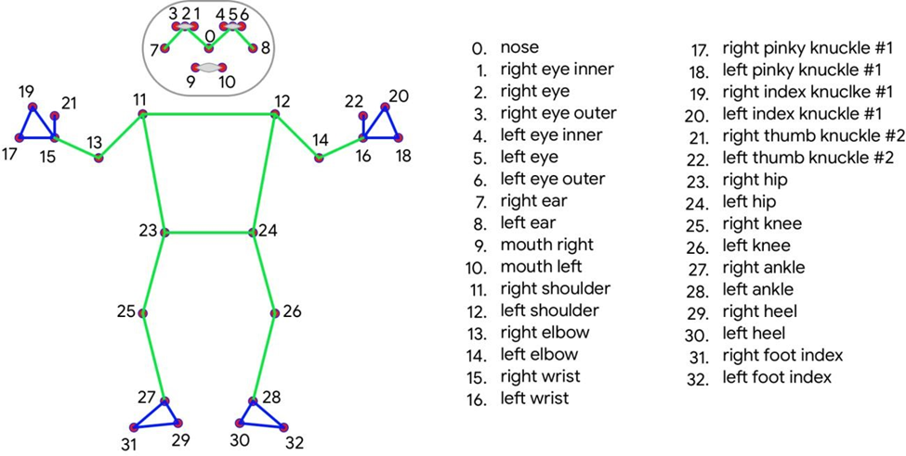

MediaPipe: MediaPipe serves as a versatile framework tailored for constructing machine learning pipelines designed to process time-series data such as video and audio. This cross-platform framework seamlessly operates across various environments, including Desktop/Server setups, Android, and iOS devices, as well as embedded platforms like Raspberry Pi and Jetson Nano.

OpenCV: OpenCV, short for Open-Source Computer Vision Library, stands as an open-source software library focused on computer vision and machine learning tasks. It was conceived to establish a standardized infrastructure for computer vision applications and promote the integration of machine perception into commercial products. Operating under the Apache 2 license, OpenCV facilitates seamless utilization and modification of its codebase, thereby offering businesses an accessible and adaptable solution for their computer vision needs.



NumPy: NumPy pronounced as NUM-py, represents a Python library tailored for handling large, multi-dimensional arrays and matrices, coupled with an extensive suite of high-level mathematical functions designed to operate on these arrays. Primarily utilized for its array manipulation capabilities, NumPy finds significant application in various computational tasks, including the calculation of angles between connections in data structures.



**Web Technologies**

**Flask:** Flask is a lightweight and versatile web framework for Python, designed to facilitate the development of web applications with simplicity and flexibility. It provides the essential tools and libraries necessary to build web applications quickly and efficiently, offering features such as URL routing, template rendering, and HTTP request handling. Flask follows a minimalist philosophy, allowing developers to choose and integrate additional components as needed, making it ideal for projects of all sizes. With its ease of use and extensive documentation, Flask has become a popular choice among developers for creating web applications ranging from simple prototypes to complex, production-ready systems.

**Jinja Template**: Jinja Template is a popular templating engine used with Flask for building dynamic web applications in Python. It allows developers to embed Python-like expressions directly into HTML templates, making it easy to generate dynamic content. Jinja Template promotes clean code by separating presentation logic from application logic, and its intuitive syntax includes variables, loops, conditionals, and template inheritance. With Jinja Template, developers can efficiently create dynamic web pages and render content based on data from the application.

The above technologies are used on the server side and for the client-side interface we have used HTML, CSS & JavaScript. HTML to structure the element, CSS to design and align the elements, and JavaScript for some redirection purposes

**Working**

The Form Perfector project utilizes OpenCV, MediaPipe, and numpy to process webcam frames, analyzing posture in real time. OpenCV captures webcam frames, while MediaPipe detects human body landmarks for posture evaluation, leveraging numpy for angle calculations. Using the 'yield' keyword, results are efficiently generated, enabling immediate feedback without program blockage. Flask renders these results in the browser, providing users with interactive feedback on their posture during exercises or activities. By integrating these libraries, the project offers a seamless and effective posture correction system accessible through a web browser interface, enhancing form and reducing injury risk.

**Procedure**

Step 1: Click on the application URL

Step 2: Explore the home page

Step 3: Click on the 'Let's Try' button of the desired exercise after reading the instructions.

Step 4: Video camera will start

Step 5: Start doing the exercise.

Step 6: After completing the exercise click on the 'Back to home' button to redirect to the Home page.

# **RESULTS**

Here we are going to share some result screenshots in which we have shown the Index page of the website and the exercise webpage on which the user is going to perform exercise. We are going to give alerts and information about the angles on which users must focus.

In our example of biceps exercise, there are two angles: elbow and hip. We do display the measure of angle to the user as shown in the following diagrams.

1. Index Page

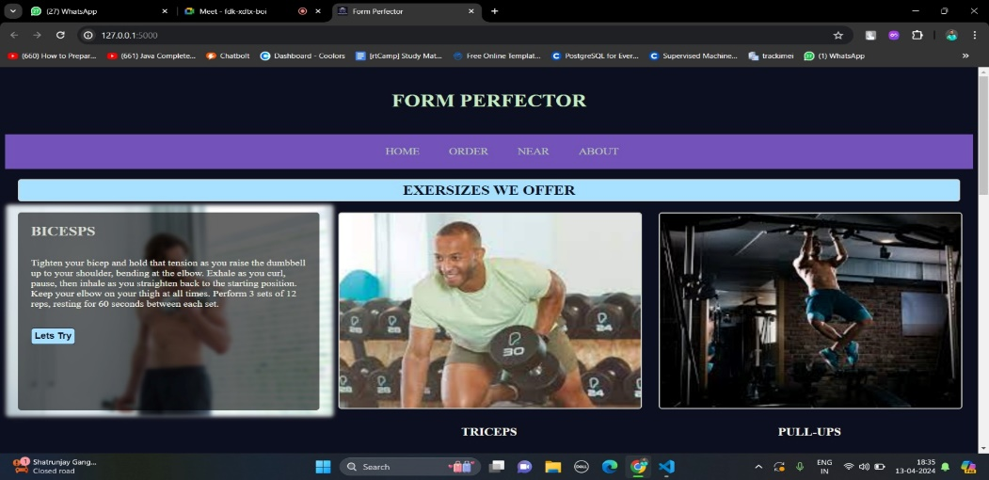

2. Exercise page in which there are multiple possibilities 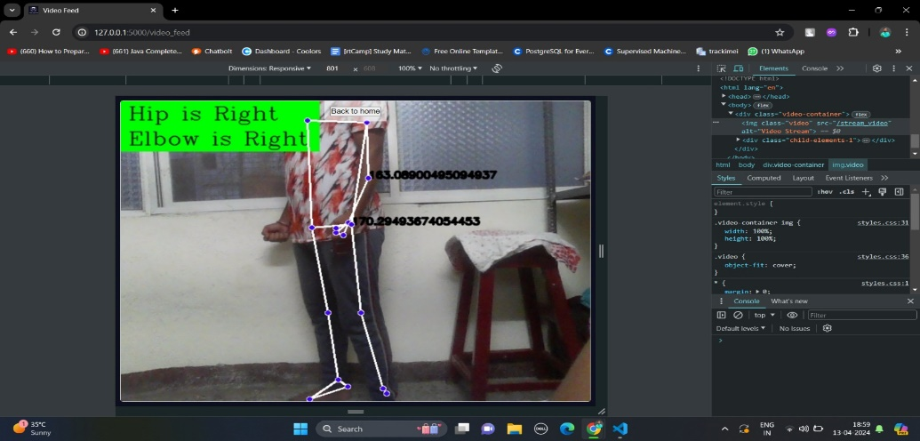

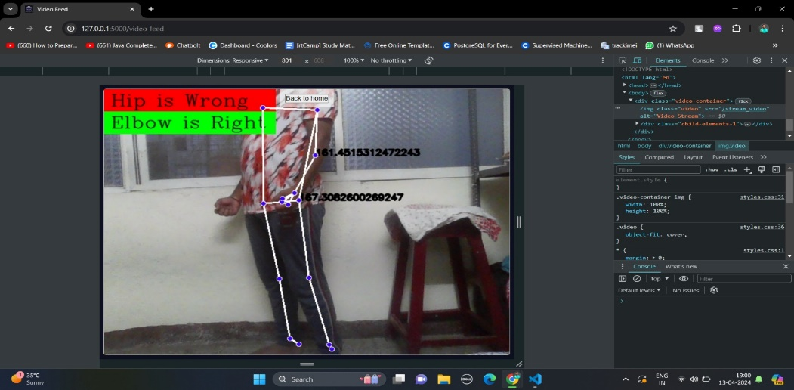

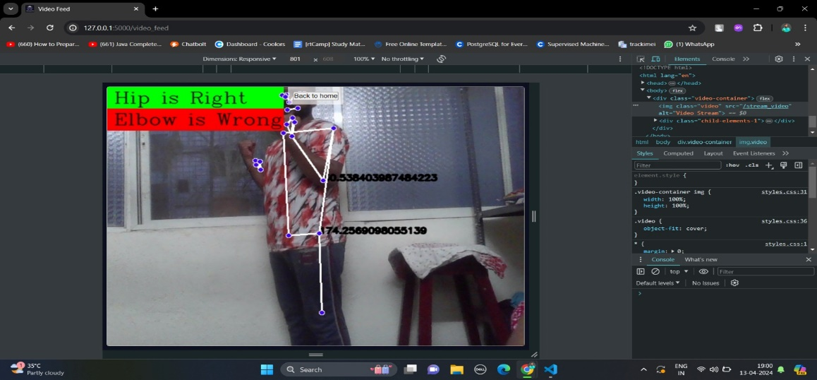

**Conclusion**

In summary, the development of our Flask web application, Form Perfector, marks a significant advancement in addressing the issue of incorrect exercise form. By providing real-time feedback and guidance, our application empowers users to optimize their workout effectiveness while reducing the risk of injuries. Its integration of advanced technology within a user-friendly interface position it as a promising innovation in the fitness industry. Through the provision of precise and safe exercise assistance, Form Perfector has the potential to revolutionize fitness practices and foster healthier lifestyles among individuals.

**References**

<https://stackoverflow.com/questions/30988033/sending-live-video-frame-over-network-in-python-opencv>

<https://learnopencv.com/ai-fitness-trainer-using-mediapipe/>

<https://github.com/AlessandroDiPatria/GymAI>

<https://flask.palletsprojects.com/en/2.3.x/patterns/streaming/>