**Induction Motor Parameter Monitoring as Text File**

Sanjeevani S. Jagtap, Shweta M. Jugale, Bhakti B. Kadam, Gayatri A. Rajgole, Neha S. Kulkarni, Dr. V. Jayashree

Student, Dept. Of Electrical Engineering, D.K.T.E Society’s Textile and Engineering Institute, Ichalkaranji, India

Asst. Prof. Dept. Of Electrical Engineering, D.K.T.E Society’s Textile and Engineering Institute, Ichalkaranji, India

Abstract— Monitoring induction motor parameters is essential for ensuring reliable operation, maximizing efficiency, and minimizing risks associated with motor failure. It allows for proactive maintenance strategies that ultimately save time, money, and resources. In this project we have connected an ADC and the data from ADC is transferred through serial port by using Python program to the System laptop. The real time monitored data is displayed on LCD display and the same data with time stamp is transferred to the System laptop at where it forms text file in internal memory location. The idea behind this project is generating large datasets required for AI&ML projects.

Keywords— Monitoring, Induction Motor, Python.

# ***Introduction***

The monitoring of induction motor parameters can reduce the major concern of safety and fault. By using continuous monitoring, we can optimize the working of device as well as can detect fault in device. For finding accurate method for implementation of predictive maintenance various researchers used various methodologies but some of them have failed to create large datasets and some of them can monitor only limited parameters. By using ATMega328p we can monitor up to eight parameters of Induction motor and with aid of Python program this monitored parameters are transferred to system laptop at higher rate with time stamp.

##### ***Literature Review***

Table 1: Literature Review

|  |  |  |  |  |
| --- | --- | --- | --- | --- |
| **Sr. No** | **Research paper title/journal/author** | **Method** **/Algorithm** **used/Software** | **Results** | **Limitation/Gap** |
| **1** | Ramazan BAYINDR Mehmet Sen,GUJ Sci24(4) | Zigbee protocol is used /Borland Delphi 7.0 package | The data stored in database is compatible to Ms office excel and graphical results also accessible for voltage, current, temperature and speed. | It has very low data transmittion rate |

|  |  |  |  |  |
| --- | --- | --- | --- | --- |
| **2** | Ridho Syawli, SelamatMeliala.IJREEC,vol 3, no.1. | IOT/Blynk IOT platform | The result of each phase current and phase voltage is shown on LCD and table showing monitoring results on Blynk application. | Large data can’t be exported from Blynk platform and limited number of devices can be connected to Blynk |
| **3** | Ashwini B.Kaule,  Mrs.M.R.Bachawad,IJERA, Vol 10,is 11 | IOT/Thing speak cloud | The value of per phase voltage and current and temperature and speed is shown on LCD and parameters are monitored in graphical method on thing speakk cloud | Only 8 fields can be monitored and data is not secure. |
| **4** | E.Noyjeen, Chattapon Tanita  M.Panthasarh,Pakpoom Chansri. | IOT/Thing speak cloud and MIT app | When the parameters will overload the proposed system alerts on smartphone. | The time required for getting notification is more. |
| **5** | Khichada BhavinA,  K.J.Chudashma,Vyas Darshan, Shiyal Jignesh. | FFT power spectrum using LABVIEW and Ni 6008DAQ card. | The three-phase current and waveforms are obtained. | It has limited visualizing element. |

# ***METHODOLOGY***

Induction motor is a machine which converts electrical energy into mechanical energy. Various properties of induction motor attract towards them like self-starting, easy construction, simple working principle and cost effectiveness. Although the induction motors are robust & flexible it leads to fatal accidents in some cases. So identification and correction of those faults should be done otherwise they may lead to early degradation of motor and because of that financial loss also occurs. There are mainly three types of faults viz.; Mechanical faults, Electrical faults, and environmental faults and the sub category of the faults are as shown in Figure.1.

Fig 1: Types of Faults in Induction Motor

Previously, the induction motors were monitored by manually taking readings or by visually inspecting the parts of machine.

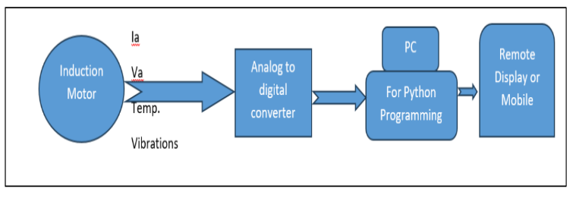

Fig 2: Implemented Hardware Block Diagram

Figure 2 shows the actual implemented block diagram to monitor the parameters of induction under various conditions. In this project we have used a python program which is used to transfer whatever data available at ADC port of ATmega328p. the same data is saved to the internal memory location of system laptop.

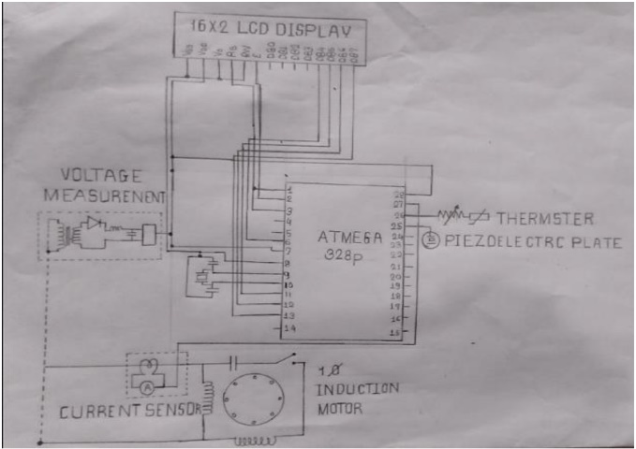

Fig 3: Circuit Diagram

Figure 3 shows the circuit diagram of the monitoring system used. As an ADC microcontroller is used. By programming serial port, the data is transferred to system laptop. Python program is used to configure the serial port because python is simple and small program is sized.

# ***Experimental Procedure***

Fig 4: Steps of Experimentation

# ***Observations & Results***

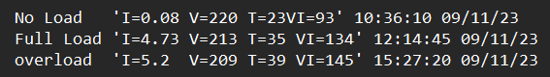In this project we have observed that, this model gives us accurate readings for every condition after the delay of 1 min. For various fault conditions we can reduce this delay for maximum readings. Here is a snippet of No Load, Full Load and Overload condition shown in fig.4.

Fig 5: Selective Text Format Results

The results of hardware were in text format as shown in above snippet with respect to time. We also displayed these results on LCD Display which are as follows:

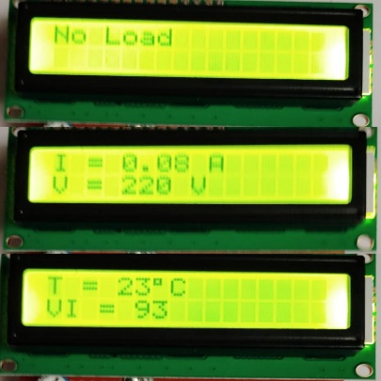

Fig 6: No load LCD Display Results

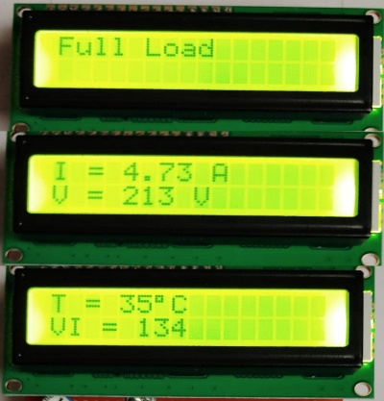

Fig 7: Full load LCD Display Results

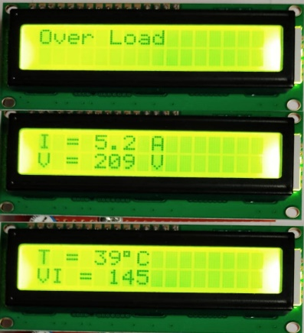

Fig 8: Over load LCD Display Results

# ***CONCLUSION***

Hence, by using this project we can monitor the induction motor parameters continuously. We can also collect various readings under various loading conditions as well as fault conditions. These readings can be used for induction motor fault diagnosis purpose as well as for predictive maintenance also. In this project we have saved the data in form of text format also we can save this data in excel sheet by using proper version of Microsoft Excel.

# ***Acknowledgement***

We would like to thank our guide Dr. V. Jayashree and our project co ordinator Prof. D. A. Patil for their valuable guidance and support throughout this project. We are also grateful to our Department of Electrical Engineering, DKTE.

##### **References**

1. <https://media.springernature.com/lw685/springerstatic/image/art%3A10.1007%2Fs42417-020-00253y/MediaObjects/42417_2020_25_Fig1_HTML.png>
2. E.Noyjeen, Chattapon Tanita M.Panthasarh,Pakpoom Chansri *“Monitoring Parameters of Three Phase Induction Motor Using IoT”* , Ieecon2021.
3. G. Mamatha, A. H. Thejaswi, *“Induction Motor Condition Monitoring and Controlling Based on IoT”* published at IJRESM, Volume 4, Issue 9, 2021.
4. Ramazan BAYINDIR, Mehmet SEN, “A Parameter Monitoring System for Induction Motors Based on Zigbee Protocol”, Gazi University Journal of Science, Vol 24, Issue 4, 2011.