**Green and Clean Energy-Waste to Energy: A Review**

**Mrs. K.S. Bhattad1 Mr. R.N Dongare2**

**Department of Computer Technology**

**SKBP Polytechnic, Kopargaon**

***Abstract***

**The fast depleting fossil fuels and their everincreasing demand further reinforce the importance of energy from alternate sources. Prominent among problems of developing nations are access to affordable and reliable energy as well as clean and lovable environment. Adopting waste-to-energy system could leverage on the possibility of reducing the adverse environmental impact occasioned by waste generation and ensuring production of renewable and sustainable energy while achieving circular economy. Solid waste management becomes a major challenge in a country with increasing population and simultaneously striving for economic development. Many studies indicate that solid waste generation rate is influenced to a large extent by the level of industrialisation, habits of public and climatic conditions.**

1. **Introduction**

Energy is significant to societal development and is the main driver of global technology. It plays a pivotal role in virtually every aspect of human endeavour. Energy is a factor of production and is therefore a nexus for sustainable development (Mapako and Stafford, 2020). The current means of meeting energy demands has been dominated by burning fossil fuels which is found to be unsustainable and environmentally unfriendly Alao et al., 2022. Over the years, fossil fuels such as coal, natural gas and oil have been exploited to meet several energy services such as electricity, transportation, heating and cooking purposes. Gaseous emissions from exploration and exploitation of fossil fuels have caused unprecedented environmental havoc. Unfortunately, the reserves of these fossil resources are limited; and with its current spate of exploitation, they may be completely used up in no distant time. There is a steady growth rate in global population with an accompanied increase in waste generation due to increased consumption of goods and services. This has culminated into increase in energy demand. So, an increase in population and municipal solid waste (MSW) generation as well as unprecedented growth rate in energy demands are critical and challenging issues in the world; but seriously affected are the developing countries. There have been national and international outcries for sustainable energy generation and waste management systems to meet an ever-increasing energy demand. The conventional methods of MSW treatment (i.e., open dumping and burning) and power supply (i.e., from fossil fuels) pose a serious threat to the environment due to the emission of dangerous gases and fluids that are capable of contaminating the land, air and water. MSW is non-hazardous mixed (heterogeneous) garbage (trash) produced from domestic, commercial and industrial activities. MSW consists of biodegradable, recyclables and inert materials. Waste generation has a positive correlation with the rate of urbanization, economic development, and population growth of a nation.

1. **Incineration**

Incineration is a conventional thermal treatment method whereby the feedstock (MSW) is directly burnt in an excess supply of oxygen in a furnace with temperature in the range of 800°C–1000 °C and minimum residence time of 2 s leading to the production of heat and ash (bottom and fly ash) (DEFRA, 2013). It is the most mature and widely used technology for waste management worldwide. The main advantage of incineration is its capability to reduce the volume of waste by 80–90% and mass by 70–80% (Lombardi et al., 2015) leading to a significant reduction in the land space needed for landfilling and eventual elongation of the lifespan of the existing landfill sites. For instance, incinerating 1 million tonnes of MSW per year requires land area of less than 100,000 m2 for an average of 30 years whereas landfilling 30 million tonnes of MSW requires a land of 300,000 m2 (Arena, 2012) in a year. With this process, the working lifespan of landfill can be elongated for an average of 30 years. For a typical incineration plant with 300 tonnes per day (tpd), an approximately 0.8 hectares of land is required (Yap and Nixon, 2015). Apart from waste mass and volume minimization, the high temperature involved in the incineration process also helps in hazardous material destruction (Tsui and Wong, 2019). Incineration technology can also treat any type of waste and requires a low level of technology and human resource skills. The hot flue gas produced in an incineration plant can be harvested as a useful product by cooling it in a high-pressure feed-water boiler to raise steam. The produced steam in supersaturated form can be made to turn a condensing steam turbine for power only application or a backpressure steam turbine or an extraction-condensing steam turbine for combined heat and power (CHP) production through the conventional steam Rankine cycle. The steam produced can also be recovered for thermal energy application in district heating system or for industrial processes. Up to 80–90% of the energy contained in the waste can be recovered as heat in the boiler.

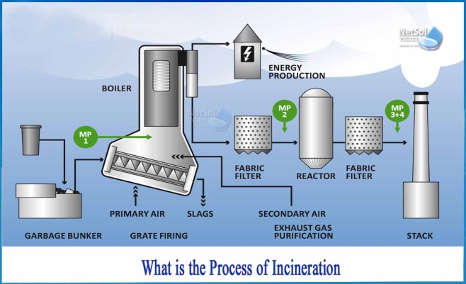

1. **Gasification**

Gasification is an advanced thermal treatment process which involves decomposition of carbon enriched fuels such as coal or MSW at high temperature in the range of 550–1600°C in an insufficient and controlled supply of oxidant lower in amount than that required for the stoichiometric combustion (Arena, 2012). Depending on the source of heat for combustion of feedstock, gasification can be classified as auto thermal and allo-thermal. An auto-thermal gasification is that in which the heat required to gasify the feedstock is provided by a part of the input feedstock (i.e., fuel). Example of an auto-thermal gasification is air gasification. In the case of an allo-thermal gasification, an external source of heat energy such as plasma torch is provided to gasify the feedstock. A typical example of this is the case of plasma arc gasification (Arena, 2012). In both cases, the product of gasification is a combustible gas called syngas or producer gas. The syngas is a combination of a variety of gases such as hydrogen, carbon monoxide and little amount of methane as well as some impurities. The chemical composition, heating value, quality and yield of the syngas depend mainly on the operating temperature and gasifying agents such as air, oxygen-enriched air and steam (Qazi et al., 2018b). With air as the gasifying agent, the syngas produced has a higher concentration of non-combustible atmospheric nitrogen gas. The presence of this non-combustible gas in the syngas is responsible for the smaller lower heating value (LHV) ranging between 4 and 7 MJ/Nm3. For pure oxygen as the gasifying agent, a syngas free of atmospheric nitrogen gas is generated with a higher LHV ranging between 10 and 15 MJ/Nm3 and lastly for the steam gasification the syngas generated is nitrogen-free with a high concentration of hydrogen and lower heating value of 15–20 MJ/Nm3 (Arena, 2012). It can also be turned into higher value products such as transportation fuels, chemicals, fertilizers, and even as a substitute for natural gas (Soni and Naik, 2016). The raw syngas contains a variety of impurities such as particulate, tar, alkali metals, chloride and sulfide (Lombardi et al., 2015) which makes it unsuitable for any downstream applications such as electrical power or heat energy generation (Luz et al., 2015). It is therefore essential to purify the syngas before utilization in any downstream application to prevent damage to equipment and emission limitation. Depending on the conversion technology, the syngas could be directly used in a boiler to produce heat energy at an efficiency ranging from 20–40% or for electricity generation, in a conventional Rankine Cycle steam turbine of efficiency 17–28%, in a gas turbine at efficiency 24–33%, in an internal combustion engine (ICE) with efficiency 25–37% or in a solid oxide fuel cell (SOFC) 41– 60% (Luz et al., 2015). Syngas clean-up could be achieved by dry or wet process. In dry gas cleaning system there is no usage of water and consists of equipment such as cyclone, fabric filters, sand bed filters, thermal cracking of tars. Whereas, in wet gas cleaning system the utilization of water is required and the equipment involved are wet electrostatic precipitators, wet scrubbers and wet cyclones. For a typical gasification plant a combination of both wet and dry cleaning processes could be adopted where a cyclone or baghouse filter can be attached to the gasifier for dust particle removal; wet scrubbing for heavy tar removal, catalytic adsorption for NOx removal and activated carbon for absorbing CO2 (Kumar and Samadder, 2017)

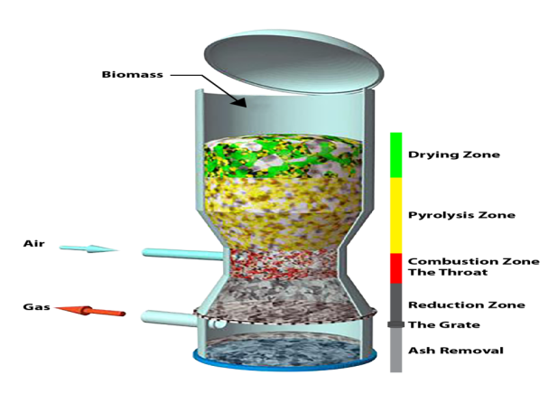

1. **Pyrolysis**

Pyrolysis involves decomposition of solid waste in an environment totally deficient in air (oxygen) at high temperatures in the range of 300– 900 °C (Chen et al., 2014) to produce different forms of energy carriers including char, pyrolysis oil and combustible gases (syngas). Pyrolysis is the only thermal process that produces fuels in all three states of matter (i.e., solid, liquid and gaseous fuels). Pyrolysis is an old technology as it has been used to produce charcoal from wood for thousands of years (Chen et al., 2014). The quantity and quality of pyrolysis products depend largely on the heating rate, process temperature, residence time, feedstock composition and characteristics, type of reactor (Hasan et al., 2021) as well as addition of catalysts (Sharuddin et al., 2016). Raw MSW is usually not appropriate for pyrolysis and typically would require some pre-treatment by removing the glass, metals and inert materials (such as rubble) prior to processing the remaining waste. Wastes with high moisture content such as food wastes are not suitable for pyrolysis and if it were to be used, additional energy is required for drying which may increase the operating costs and perhaps reduce the overall system efficiency. For good quality pyrolysis products, specific and homogenous waste types such as plastic, tire, paper, wood waste, etc. are more appropriate. Plastic wastes produce oil as the main product while wood and woody biomass give syngas and char as their main product (Chen et al., 2014). Plastic waste contains different types of polymers such as Polystyrene (PS), Polypropylene (PP), Polyethylene (PE) (including low-density and high-density polyethylene (LDPE and HDPE)), Polyvinyl chloride (PVC) and Polyethylene terephthalate (PET). It has been reported that PP and PE form the largest portion of the waste plastics stream in MSW in China (Wang et al., 2013), Nigeria (Ayodele et al., 2018a), South Africa (Ayeleru et al., 2016) and also worldwide (Chen et al., 2014). Among the plastic types, PVC is not suitable for pyrolysis due to production of toxic chlorinated compounds such as dioxins and furans (Sharuddin et al., 2016). Pyrolysis can be classified into slow, fast and flash pyrolysis depending on the heating rate of feedstock, temperature and residence time (Vaish et al., 2019). Slow pyrolysis (conventional pyrolysis) involves low heating rates ranging from 0.1–2 °C/s, residence time from 450–550 s and low temperature 277–677°C with the main products formed being char and tar. The fast pyrolysis operates at moderate temperature 577–977 °C, heating rates above 2°C/s and residence time from 0.5–10 s, with the key products formed being tar and bio-oil. Flash pyrolysis involves temperatures from 777–1027 °C, high heating rates of 200–105 °C/s and very short solid residence time less than 5 s, with gases rich in ethylene being the main product formed (Qazi et al., 2018b). The pyrolytic oil/gas produced can be used for electricity generation through appropriate energy conversion devices such as gas engine, internal combustion engine and diesel engine. Type of pyrolysis reactors are fixed-bed reactors, rotary kilns and fluidized bed reactors (Chen et al., 2014). Fluidized- bed reactors are widely used for the pyrolysis of plastic waste due to low thermal conductivity and high viscosity of polymers. Fixed-bed reactor is seldom used in commercial scale due to its inefficiency while rotary kilns and tubular reactors are applied to the scale-up facilities (Chen et al., 2014). The rotary kiln is the only type of reactor that has successfully achieved industrialscale implementation (Dong et al., 2019). Pyrolysis is more environmentally friendly than conventional incineration due to its lower toxic pollutant emission tendencies because oxygen-deficient atmosphere in a pyrolysis reactor does not provide the environment needed for dioxins and furans to form or reform. Pyrolysis plant also produces less noise pollution than a typical incineration plant.

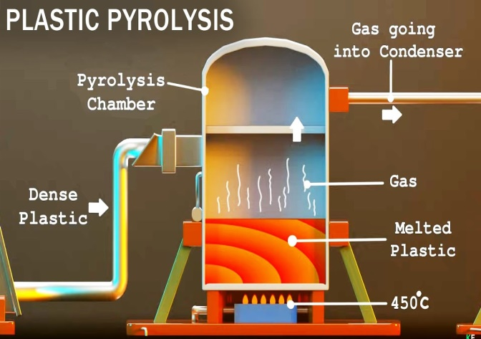

1. **Biochemical conversion process**

The biochemical conversion process involves decomposition of biodegradable organic components of the waste under the influence of bacterial. The microbial action can take place either in the presence or absence of oxidant (oxygen) leading to the production of different products (compost or biogas). The biochemical conversion processes are preferred for wastes that have high percentage of bio-degradable organic matter and high level of moisture/water content, which aids microbial activity. The main technological pathways for biochemical process are anaerobic digestion, composting and landfilling.

**5.1 Dark fermentation and Photo-fermentation producing bio-hydrogen**

Dark fermentation and photo-fermentation are techniques that can convert organic substrates into hydrogen with the absence or presence of light, respectively. This is possible because of the processing activity of diverse groups of bacteria. These technologies can be interesting when it comes to researching valuable options for waste water treatment (Angenent et al., 2004)

**5.2 Microbial fuel cell**

A microbial fuel cell is a device that is able to produce electricity by converting the chemical energy content of organic matter. This is done through catalytic reaction of microorganisms and bacteria that are present in nature. This technology could be used for power generation in combination with a waste water treatment facility (Min B., Cheng S. & Logan B.E., 2005).

**6. Anaerobic Digestion**

Anaerobic digestion is another attractive technology to create energy from waste. In this process, bacteria decompose materials in the absence of air. Owing to this process, a combination of Methane and Carbon di oxide, Biogas is produced which is again a form of Renewable energy and can be used as a fuel. In anaerobic digestion reduced carbon di oxide emissions, possible valorization of ecofriendly waste for soil conditioners and lower odour emissions can be achieved.

1. **Global status of waste‐to‐energy generation**

Globally, 216 million tonnes of collected Municipal Solid Waste (MSW) is incinerated each year, of which 15 per cent is incinerated with energy recovery. Thermal WtE accounts for 29 per cent and 25 per cent of MSW incinerated in Asia Pacific and Europe respectively. Global Waste to energy Market size was valued at USD 35.82 Billion in 2021 and is poised to grow from USD 38.51 Billion in 2022 to USD 68.68 Billion by 2030, at a CAGR of 7.5% during the forecast period (2023-2030). Globally, municipal solid waste (MSW) generation has been rising over time because of rapid urbanization, population growth and globalization. It has been evaluated to be approximately 2 billion tons per year and by 2030, it is estimated to reach 2.59 billion tons

**7. Challenges, policy and incentive drive for waste‐to‐energy implementation**

8 Key Challenges Faced by Every Waste Management Business

* Collection and disposal infrastructure. ...
* Financial constraints. ...
* Lack of support from localities. ...
* Ineffective recycling or composting. ...
* Ever-changing climate. ...
* Lack of technological advances. ...
* Changing consumer preferences. ...
* Unclear regulations.

These key challenges are:

Instability, such as conflict between nations.

Implementation, such as ensuring programmes fit the local context.

Governance, such as political will to transform development programmes into sustainable long-term practices.

Management of Municipal Solid Waste (MSW) is one of the major challenges worldwide. Inadequate collection, recycling or treatment and uncontrolled disposal of waste in dumps lead to severe hazards, such as health risks and environmental pollution. This situation is especially serious in low and mid- income countries.

The long-recognized hierarchy of management of wastes, in order of preference consists of prevention, minimization, recycling and reuse, biological treatment, incineration, and landfill disposal

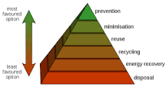

1. **Green Country**

Albania, Iceland, and Paraguay obtain essentially all of their electricity from renewable sources (Albania and Paraguay 100% from hydroelectricity, Iceland 72% hydro and 28% geothermal).

Only 1% of Sweden's trash is sent to landfills. By burning trash, another 52% is converted into energy and the remaining 47% gets recycled. The amount of energy generated from waste alone provides heating to one million homes and electricity to 250,000. There are more than 1,000 incinerators in Japan and more than 500 in European countries like Germany, Sweden and Denmark, burning thousands of tons of municipal waste every year and using that heat to generate up to 4.2 gigawatts in Japan and 10.5 GW in Europe.

Renewable energy accounted for only 12.3% of total energy. India's total renewable energy capacity, excluding large hydro and nuclear plants, reached 122 gigawatts in February 2023, the latest monthly report by the Central Electricity Authority (CEA) showed. India has finished at the bottom of the Environment Performance Index-2022 released by the World Bank. This means India is among those countries in the world that have the worst environmental health. Out of 180 countries that have been ranked, India is in the bottom five with a score of 18.9.

**9. Conclusion-**

This paper presents a review of different WtE technologies as a potential source of renewable energy and waste management strategy for developing as well as developed countries**.**

MSW has many unique and challenging characteristics and often presents a disposal problem to municipalities and other relevant entities. The assessment reported here finds that the technology for production of electricity from MSW needs to be more cost competitive with other power options in the market. Electricity production from MSW is cost competitive with other electricity generation options only in specific niche situations.

R&D opportunities exist to further increase the resource recovery potential, and accompanying revenues, by targeting biofuel and bio product markets. These R&D opportunities represent technologies that could be implemented in next generation MSW processing facilities, but they require further development or risk reduction before being adopted by industry. These R&D opportunities include development of MSW gasification systems, approaches to decrease the capital intensity of anaerobic digesters, and processes for direct conversion of MSW to biofuels and bio products. Production of biofuels and bio products from these MSW feed stocks are both promising and at a much earlier stage of technological development than bio power.

However, existing basic and applied research on producing biofuels and bio products from cellulosic materials, algae and other feed stocks can be leveraged to make MSW processes more cost effective.

Based on the literature reviewed, implementation of waste-to-energy systems either in developing or developed nations has the potential to contribute to the energy generation mix, mitigate environmental impact, reduce health risks and create jobs for the local populace

**10. Future research perspective**

It is hoped that the current study will certainly provide a platform for technocrats and researchers to explore more possibilities for converting waste into useful energy. In the present scenario, the challenge of society is to ensure safekeeping of sustainable renewable energy and waste management as well. Waste to energy technologies would provide a sustainable renewable solution for the generation of clean energy to elude these challenges. Green House Gas emissions can be lower down significantly by promoting WTE technologies for solid waste management. WTE technologies have been promoted and used comprehensively in the developed nations for efficient management of MSW. In most of the developing countries, these facilities are stepped down due to improper infrastructure, ineffective pollution control system, and negligence in maintenance. Further, number of economic, technical, political, institutional and social issues may shackle the implementation of these technologies. Therefore, a special attention is needed from all stake holders, especially government, technocrats, businessmen to support the execution of future sustainable energy resources.

**11. References**

Angelidaki I. & Batstone D.J. (2011) “Anaerobic digestion: process” in Solid waste technology & management

Angenent, L.T., Karim, K., Al-Dahhan, M.H., Wrenn, B.A., Domíguez-Espinosa, R., 2004. Production of bioenergy and biochemicals from industrial and agricultural wastewater. “Trends in Biotechnology” 22, 477-85.

Astrup T. (2011). “Pyrolysis and Gasification” in Solid waste technology & management

Beigl P. & S. Salhofer (2004). Comparison of ecological effects and costs of communal waste management systems. Resources, Conservation and Recycling, 41, 83-102.

Cherubini, F., Bargigli, S., & Ulgiati, S. (2009) Life cycle assessment (LCA) of waste management strategies: Landfilling, sorting plant and incineration. Energy, 34, 2116-2123 Christensen, T.H., G. Bhander, H. Lindvall, A.W. Larsen, T. Fruergaard, Anders Damgaard, S. Manfredi, A. Boldrin.

C. Riber and M. Hauschild, 2007. Experience with the use of LCA-modelling (EASEWASTE) in waste management, Waste Management and Resea

EPA. 2016. "Municipal Solid Waste." https://archive.epa.gov/epawaste/nonhaz/municipal/web/html/. Accessed June 6, 2018.

EPA. n.d. "Landfill Methane Outreach Program." https://www.epa.gov/lmop/landfill-gas-energyproject-data-and-landfill-technical-data. Accessed January 2018.

EIA. 2018. "Total MSW generation in the United States by type of waste, 2015." https://www.eia.gov/energyexplained/images/charts/total_msw_generation_by_material-large.gif. Accessed April 18, 2018.

DOE. 2016. "Municipal Solid Waste Resources." https://www.energy.gov/sites/prod/files/2016/07/f33/municipal_solid_waste_factsheet_bt16.pdf. Accessed August 2018.

Valkenburg, C., C.W. Walton, B.L. Thompson, M.A. Gerber, S.B. Jones, and D.J. Stevens. 2008. Municipal Solid Waste (MSW) to Liquid Fuels Synthesis, Volume 1: Availability of Feedstock and Technology. PNNL-18144. Richland, WA: Pacific Northwest National Laboratory. <https://www.energy.gov/sites/prod/files/2014/03/f14/PNNL-18144_0.pdf>.

Environmental Research & Education Foundation. 2016. MSW Management in the U. S.: 2010 & 2013. Raleigh, NC: Environmental Resarch & Education Foundation.

Energy Policy Act of 2005, Pub. L. No. 109-58, 119 Stat. 594 (2005).

Center for Sustainable Systems. 2018. Municipal Solid Waste Factsheet. Ann Arbor, MI: Center for Sustainable Systems.

EPA. 2018. "Advancing Sustainable Materials Management: 2015 Fact Sheet.

https://www.epa.gov/sites/production/files/201807/documents/2015_smm_msw_factsheet_07242018_fnl_508_002.pdf. Accessed October 17, 2018.

<http://www.worldbank.org/en/topic/urbandevelopment/brief/solid-waste-management>.

Parvez N.,2019, Recycling2019, 4, 28; doi:10.3390/recycling4030028.

Perrot JF et al, 2018, Sustainability, 10, 3114; doi:10.3390/su10093114.