DIGITAL NOTICE BOARD USING ARDUNIO AND GSM TECHNOLOGY

1. **Akunoori Varun Kumar,** B. tech, Department of Information Technology,

**CMR Engineering College,** Hyderabad

1. **Asians Prathiba,** B. tech, Department of Information Technology**,**

**CMR Engineering College,** Hyderabad

1. **Arraram Ashritha,** B. tech, Department of Information Technology,

**CMR Engineering College,** Hyderabad

1. **Nyalankanti Harish Reddy,** B. tech, Department of Information Technology,

**CMR Engineering College,** Hyderabad

1. **Dr. Madhavi pingili**, Professor & HOD, Department of Information Technology,

**CMR Engineering College,** Hyderabad

***Abstract*—** The digital notice board system has become an essential communication tool in various institutions, such as schools, colleges, offices, and public places. This project presents an advanced digital notice board utilizing Arduino and GSM technology to provide a dynamic, efficient, and user-friendly solution for disseminating information. The system is designed to replace traditional notice boards with a digital display that can be updated remotely through SMS or web-based applications. Key innovations and features include remote updating via a GSM module, which allows authorized personnel to send updates to the digital notice board from anywhere, ensuring timely and efficient communication. Additionally, a web-based interface allows users to manage and schedule announcements, providing a versatile approach to managing content. The integration of a real-time clock (RTC) module facilitates scheduling messages and ensures the accurate display of time-sensitive information. The notice board supports multiple languages, making it suitable for diverse user groups, and it is designed for energy efficiency and eco-friendliness, incorporating low-power consumption components and an automatic dimming feature based on ambient light conditions. Furthermore, a quick alert feature allows for the immediate dissemination of urgent messages, enhancing safety and responsiveness in critical situations. Optional interactive features, such as a touch interface for interaction and feedback collection from users, add to the system's versatility. Robust security measures, including authorized user access, encrypted message transmission, and message approval processes, are incorporated to prevent unauthorized use. Designed for scalability, the system can be easily expanded or customized to suit different environments or requirements. Users can schedule different content types, such as text, images, and videos, to be displayed at specified times, enhancing the utility and engagement of the notice board. The proposed system’s flexibility, security, and convenience make it an ideal choice for various organizational and public communication needs.

**Keywords—** **Digital Notice Board, GSM Technology, Remote Updating, Real-time Clock (RTC), Security Measures.**

**INTRODUCTION**

The evolution of digital technology has transformed the way information is shared and communicated across various sectors, including education, business, and public administration. Traditional notice boards, which have long served as a medium for information dissemination, are often limited by their static nature and the manual effort required to update them. In response to these limitations, digital notice boards have emerged as a modern solution that provides a more dynamic and efficient means of communication. This project focuses on the development of an advanced digital notice board system using Arduino and GSM technology, aiming to enhance the way information is conveyed in institutions such as schools, colleges, offices, and public places.

The proposed digital notice board system leverages the capabilities of Arduino, a popular open-source electronics platform, combined with GSM technology to enable remote updates via SMS or web-based interfaces. This innovation allows authorized personnel to update the display in real time from any location, ensuring that important announcements are communicated promptly. The integration of a real-time clock (RTC) module ensures the accurate timing of scheduled messages, while multi-language support makes the system accessible to a wider audience. This introduction outlines the motivation behind the project and highlights the key features and benefits of the proposed digital notice board system. By embracing modern technology and focusing on user-centric design, this project aims to significantly improve the traditional methods of information dissemination, making it more efficient, flexible, and responsive to the needs of today’s fast-paced world. the system can display emergency alerts or other critical messages instantly, improving communication speed and accuracy. Because the setup involves relatively simple hardware (Arduino, GSM module, RTC, LED matrix), it is scalable and can be adapted to various environments.

**OBJECTIVE**

The objective of this project to develop a dynamic Digital Notice Board System Using Arduino and GSM Technology to enable remote, real time information updates. It aims to support multiple languages, enhance energy efficiency, and include a quick alert feature for emergencies. The system will offer interactive features and robust security measures to ensure authorized use and user engagement. Designed for scalability and customization, it will adapt to various environments, providing efficient content management and display capabilities, LED screen message displays should be updated every time the user sends new data only author authenticated people should be able to access the server.

**METHODOLOGY**

This section outlines the methodology for developing a Digital Notice Board System utilizing Arduino and GSM technology. The process includes system design, component selection, implementation, and testing.

1. System Design

Requirement Analysis: Identify user needs and system requirements, including features like remote updates, multi-language support, and emergency alerts.

Architecture Design: Develop a block diagram representing the system architecture, illustrating the interaction between the Arduino, GSM module, RTC module, and display unit.

2. Component Selection

Arduino Board: Choose an appropriate Arduino board (e.g., Arduino Mega 2560) for its processing power and input/output capabilities.

GSM Module: Select a GSM module (e.g., SIM900A) to enable SMS communication for remote updates.

Display Unit: opt for an LED (e.g., 16x2) or LED matrix display to visualize the messages.

RTC Module: Integrate a real-time clock module (e.g., DS3231) for accurate timing of messages.

Power Supply: Ensure a reliable power supply suitable for the chosen components.

3. Circuit Design

Wiring Diagram: Create a wiring diagram that illustrates how to connect the Arduino, GSM module, RTC module, and display.

Component Connections: Detail the connections among components, ensuring proper pin configuration for data transmission and power supply.

4. Software Development

Programming Environment: Use Arduino IDE for coding the Arduino board.

Code Development:

Implement the logic to receive SMS messages and display them on the notice board.

Develop functions for time-stamped messages using the RTC module.

Include user authentication protocols to restrict access to authorized personnel.

Multi-Language Support: Utilize libraries or functions to support multiple languages for message display.

5. Testing and Validation

Unit Testing: Test individual components (GSM, RTC, display) to ensure functionality.

Integration Testing: Test the integrated system to verify that all components work together seamlessly.

User Acceptance Testing: Conduct testing with potential users to gather feedback and make necessary adjustments.

6. Deployment

Installation: Set up the digital notice board in the target environment (e.g., school, office).

Training: Provide training sessions for authorized personnel on how to use the system for updates and emergency alerts.

**HARDWARE COMPONENTS**

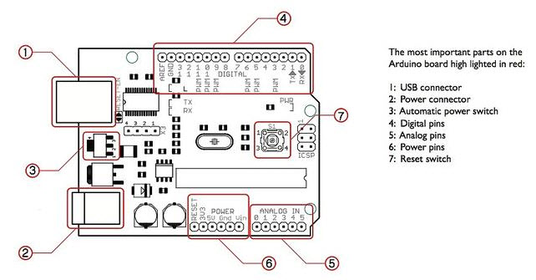

ARDUNIO UNO

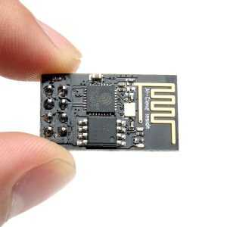

IOT ESP8266 Module

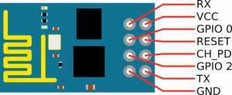

Module Pin

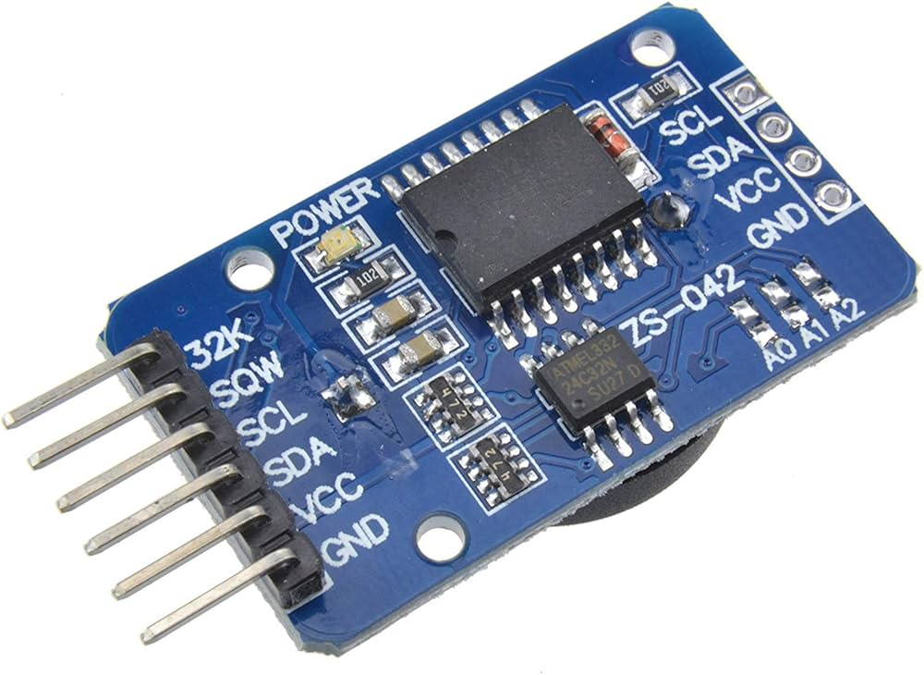Real Time Clock (RTC)

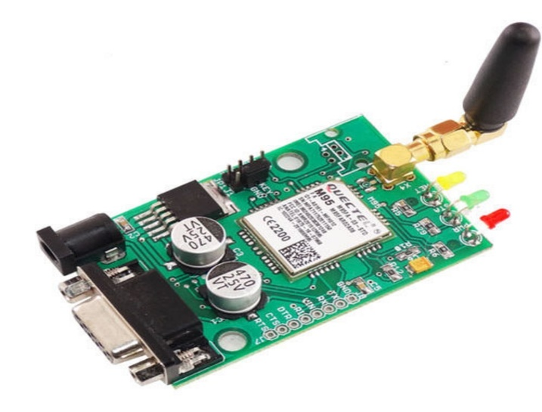

GSM Module

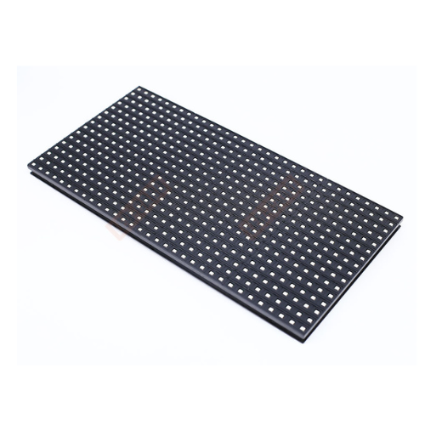

P10 LED Display

**EXISTING SYSTEM**

The **Digital Notice Board using Arduino and GSM Technology** typically involves the use of an **Arduino microcontroller** to control the display and manage incoming SMS messages via a **GSM module**. Authorized users can send messages to the system, which are then displayed on an **LED matrix or screen**. A **Real-Time Clock (RTC)** module is often included to handle scheduled or time-sensitive updates. This system allows remote updates and provides dynamic, real-time information dissemination, making it useful for schools, offices, and public places. In an advanced **Digital Notice Board system** using **Arduino** and **GSM technology**, the core setup is designed to replace traditional manual notice boards with a dynamic digital solution. The system leverages the **Arduino** microcontroller to receive and process SMS messages via a **GSM module**, allowing remote updates from authorized personnel. These updates are displayed on an **LED matrix** in real-time. Additionally, a **Real-Time Clock (RTC)** module is integrated to support scheduling and time-sensitive messages, making the system efficient for schools, offices, and public spaces. The system ensures flexibility, allowing for real-time, remote updates and scheduling of content. Furthermore, it is energy-efficient, incorporating auto-dimming features based on ambient light, making it eco-friendly. This solution modernizes communication by eliminating physical postings and allowing instantaneous updates, which is particularly useful for sharing important announcements, emergency alerts, or event schedules remotely.

**PROPOSED SYSTEM**

The proposed system utilizes an Arduino to manage the entire process, a GSM module (SIM900A) to receive messages from an authenticated mobile device, and an LED to display the received SMS. The block diagram below outlines the structure of this wireless notice board, powered by GSM technology. The use of GSM for message display in this project offers an efficient, reliable, and fast solution with minimal errors. It is a cost-effective system that requires minimal maintenance and is user-friendly. This digital notice board replaces traditional paper-based systems, eliminating the time-consuming and labor-intensive task of manually updating notices. With its wireless functionality, this modern solution is particularly useful in institutions and organizations of all sizes. Its popularity is growing as it provides a faster, more efficient way to communicate information while reducing the need for physical resources.

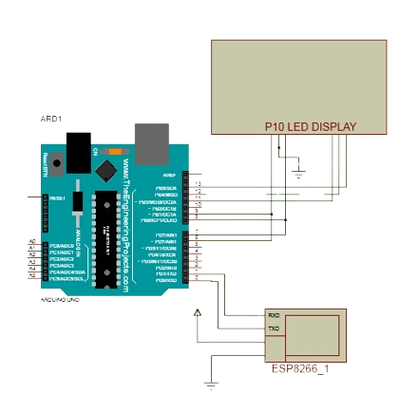

**System architecture**

**RESULT**

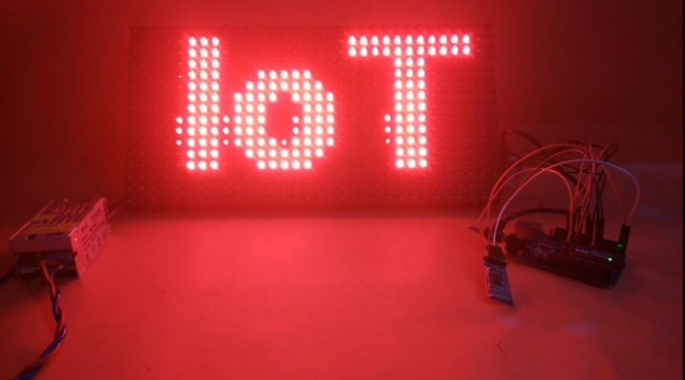

##### **ACKNOWLEDGEMENT**

**1.** We are extremely grateful to **Dr. A. Srinivasula Reddy**, Principal and **Dr. Madhavi Pingili,** HOD & Professor, **Department of Information Technology, CMR Engineering College** for their constant support.

**2.** We are extremely thankful **to Dr. Madhavi Pingili,** Professor & HOD, Internal Guide, Department of Information Technology, for her constant guidance, encouragement and moral support throughout the project.

**3.** We express our thanks to all staff members and friends for all the help and co-ordination extended in bringing out this project successfully in time.

**CONCLUSION**

The prototype of a GSM-based electronic notice board has been successfully designed. It allows remote display of messages via SMS, storing and validating them before display if sent by an authorized user. The system currently supports one message at a time, but this can be improved with better hardware. This technology offers quick and efficient message updates for use in places like campuses, railway stations, or public centers without the need for physical connection to a computer. It is particularly useful for urgent messaging by police or military. The system eliminates the limitations of manual updates and opens up new possibilities in embedded systems and telecommunication.

##### **REFERENCES**

1. Shyam Kishore, M. Sudhakar: Wireless Digital Notice Board Using GSM Technology, International Journal of Engineering Research and Applications, Volume 5, Issue 4 (2024), pp. 75-80.
2. K. Anusha, K. Chandramohan, K. Mounika: Wireless Electronic Notice Board Using GSM Technology, International Journal of Electronics and Communication Engineering & Technology (IJECET), Volume 6, Issue 6 (2024), pp. 59-65.
3. Padmaraja Yedamale: Interfacing GSM Module with PIC Microcontrollers, Microchip Technology Inc., 2024.
4. Priya C. Jadhav, Prof. S.A. Shinde: Wireless Digital Notice Board using GSM Technology, International Journal of Advanced Research in Computer Science and Software Engineering, Volume 6, Issue 2 (2024), pp. 354-358.
5. Hemant Ghayvat, et al.: Smart Electronic Notice Board using GSM and Bluetooth, Journal of Telecommunication, Switching Systems, and Networks (2023), pp. 81-85.
6. S. Vijayalakshmi, K. Sripriya: GSM Based Wireless Notice Board Display using Arduino, International Journal of Advanced Research in Electrical, Electronics and Instrumentation Engineering, Volume 5, Issue 3 (2023), pp. 116-122.
7. Deepak Kumar Nayak, T. Uday Kumar, M. Praveen Kumar: SMS Based Wireless Notice Board using GSM Modem, International Journal of Emerging Technology and Advanced Engineering, Volume 5, Issue 3 (2023), pp. 532-535.
8. Tejas M. Naik, Pradeep R. Mane: GSM Based Digital Notice Board with Arduino, International Journal of Innovative Research in Electrical, Electronics, Instrumentation and Control Engineering, Volume 4, Issue 4 (2023), pp. 231-235
9. J. Kavitha, R. Valarmathi: GSM Based LED Scrolling Display, International Journal of Advanced Research in Computer and Communication Engineering, Volume 2, Issue 3 (2022), pp. 1353-1356.
10. Vikas J. Kadam, Akshay M. Thakur, Amruta P. Naik: GSM Based Wireless Notice Board Using Arduino, International Journal of Scientific Research and Engineering Development, Volume 1, Issue 1 (2022), pp. 49-55.
11. Maninder Pal Singh, Mohit Jain: Wireless Notice Board using GSM, International Journal of Advanced Research in Computer and Communication Engineering, Volume 3, Issue 5 (2022), pp. 6855-6861.
12. G.H. Gupta, D.G. Rathod: GSM Based Electronic Notice Board, International Journal of Engineering Research and Applications, Volume 3, Issue 1 (2021), pp. 39-42.
13. Himani Mittal, Neha Mahajan: Wireless Notice Board using GSM, International Journal of Electronics and Communication Engineering, Volume 2, Issue 4 (2021), pp. 32-35.
14. A. K. Shrivastava, S. G. Upadhyay: Design of GSM-based Wireless Notice Board System, International Journal of Electronics, Communication and Instrumentation Engineering Research and Development, Volume 3, Issue 2 (2021), pp. 45-50.
15. Mukesh Kumar, Anshu Singh: GSM Based Wireless Digital Notice Board, International Journal of Scientific Research and Review, Volume 8, Issue 7 (2020), pp. 214-220.