Fake Currency Detection using Machine Learning

Dr. P S Puttaswamy *HOD, Dept of ECE, BGS Institute of Technology*

*Mandya, India*

hodece@bgsit.ac.in

Chethana GH

*4th Year, Dept of ECE BGS Institute of Technology*

*Mandya, India*

*chethanahanumanthegowda@gmail.com*

Dhruva DK

*4th Year, Dept of ECE BGS Institute of Technology*

*Mandya, India*

[dhruvadk2002@gmail.com](mailto:dhruvadk2002@gmail.com)

Gagana KN

*4th Year, Dept of ECE BGS Institute of Technology*

*Mandya, India*

[gaganakn2002@gmail.com](mailto:gaganakn2002@gmail.com)

Rohith MS

*4th Year, Dept of ECE BGS Institute of Technology*

*Mandya, India*

[msrohith7411@gmail.com](C:\\Users\\Dhruva D K\\Desktop\\Dhruva\\msrohith7411@gmail.com)

***Abstract*—The proliferation of counterfeit currency poses a significant threat to the global economy, necessitating the development of efficient and accurate detection methods. This paper presents a novel approach to fake currency detection using machine learning techniques. Our proposed system leverages a combination of computer vision and machine learning algorithms to identify counterfeit banknotes with high accuracy.** **The system employs a convolutional neural network (CNN) to extract features from images of banknotes, which are then classified as genuine or fake using a support vector machine (SVM) classifier. The CNN is trained on a large dataset of images of genuine and fake banknotes, while the SVM is fine-tuned to optimize its performance. Experimental results demonstrate that our proposed system achieves an accuracy of 98.5% in detecting fake currency, outperforming traditional methods based on manual inspection and rule-based systems. The system's performance is evaluated using a comprehensive set of metrics, including precision, recall, F1-score, and receiver operating characteristic (ROC) curve analysis. The proposed system offers several advantages, including high accuracy, speed, and scalability, making it suitable for real-world applications in banking, finance, and law enforcement. Furthermore, the system's modular design enables easy integration with existing currency processing systems, facilitating seamless deployment.** **This research contributes to the development of intelligent systems for fake currency detection, providing a robust and reliable solution to combat counterfeiting. The proposed approach has the potential to significantly reduce financial losses and enhance security in the financial sector.**

***Keywords:*** ***Fake currency detection, machine learning, computer vision, convolutional neural network (CNN), support vector machine (SVM), security, financial sector.***

1. Introduction

Technology is growing very fast these days. Consequently the banking sector is also getting modern day by day. This brings a deep need of automatic fake currency detection in automatic teller machine and automatic goods seller machine. Many researchers have been encouraged to develop robust and efficient automatic currency detection machine [1-5]. Automatic machine which can detect banknotes are now widely used in dispensers of modern products like candies, soft drinks bottle to bus or railway tickets. The technology of currency recognition basically aims for identifying and extracting visible and invisible features of currency notes. Until now, many techniques have been proposed to identify the currency note. But the best way is to use the visible features of the note [1].

For example, color and size. But this way is not helpful if the note is dirty or torn. If a note is dirty, its color characteristic are changed widely. So it is important that how we extract the features of the image of the currency note and apply proper algorithm to improve accuracy to recognize the note. Counterfeit currency is a major problem worldwide, with counterfeiters constantly improving their techniques and making it more challenging to identify fake notes. The use of machine learning and image processing techniques can help in developing an automated system for fake currency detection. Image processing involves analyzing and manipulating images to extract useful information, such as features that can be used to distinguish between real and fake currency notes. Convolutional Neural Networks (CNNs) have shown great success in image recognition tasks, making them a suitable tool for detecting counterfeit currency. The process of fake currency detection using CNNs involves three major stages: dataset collection, training, and testing. The dataset collection stage involves collecting a large number of genuine and fake currency images. The dataset should be diverse and representative of the currency types in circulation. The collected dataset then undergoes pre-processing to remove any noise or distortion that may interfere with the CNN's analysis. The training stage involves feeding the pre-processed dataset to the CNN using supervised learning techniques. During this stage, the CNN learns to recognize patterns and features that distinguish genuine and fake currency. The training process may take some time, and the accuracy of the CNN improves with more data and iterations. The testing stage involves. feeding new currency images to the trained CNN. The CNN then analyses the features of the input image and determines whether it is genuine or fake. Once the CNN model has been trained, it can be used to detect fake currency notes in real-time. The CNN's output is further analyzed using machine learning algorithms to improve its accuracy and reliability. Overall, the use of CNNs for fake currency detection can provide a fast, accurate, and automated solution to the problem of counterfeit currency. This can help in reducing financial fraud and ensuring the integrity of financial systems. The technique can be extended to other areas, such as document verification and fraud detection, where image processing and machine learning can be applied to improve accuracy and efficiency.

1. LITERATURE REVIEW

Fake currency detection is a challenging problem that requires the development of robust and efficient methods. While traditional methods and image processing techniques have been widely used, machine learning and deep learning approaches have shown promising results. However, several challenges and limitations remain, highlighting the need for further research in this area.

[1] Aman Bhatia, Vansh Kedia, Anshul Shroff, Mayand Kumar, Bickey Kumar Shah, Aryan, The paper proposes a method for detecting fake currency using machine learning algorithms and image processing techniques. The approach involves analyzing various features of currency notes, such as texture, watermark, and serial number, to distinguish between real and counterfeit notes. The proposed method achieved a high accuracy rate in detecting fake currency. [2] Megha Jadhav, Yogesh kumar Sharma, G. M. Bhandari, The paper proposes a system that uses deep learning techniques, specifically convolutional neural networks, for automatic detection of forged banknotes and identification of the currency denomination from images captured under varying lighting conditions. The proposed system achieved high accuracy in currency identification and forged banknote detection. [3] Asfaw Shefraw Alene, Dr, Million Meshesha, The paper proposes an optimal feature extraction technique for the recognition of Ethiopian paper currency using machine learning. The proposed system achieved high accuracy in recognizing different denominations of Ethiopian currency notes. [4] Veling, Miss. Janhavi P. Sawal, Miss. Siddhi A. Bandekar, Mr. Tejas C. Patil, Mr. Aniket L. Sawant, The paper proposes a method for recognizing fake Indian currency using image processing techniques and machine learning algorithms in MATLAB. The proposed system analyzes various features of the currency note and classifies it as genuine or fake with high accuracy. [5] Kiran Kamble, Anuthi Bhansali, Pranali Satalgaonkar, Shruti Alagundgi, The paper presents a method for detecting counterfeit currency using a deep convolutional neural network. The approach involves training the network on a dataset of real and counterfeit currency images and using it to classify new images as real or fake with high accuracy. The proposed method shows promising results in detecting counterfeit currency. [6] G.Hariharan , D.Elangovan, The paper proposes a method for recognizing and eradicating proxy notes using image processing techniques and deep learning. The process involves image acquisition, pre-processing, segmentation, and deep learning using a CNN algorithm. The method utilizes anisotropic diffusion filters, adaptive coherence mean improvement, and adaptive region growing segmentation to enhance the quality of images and extract image characteristics. The limitations include high time consumption for better accuracy using the CNN algorithm. The proposed method has the potential to improve transparency

and accountability in the electoral process. [7] Vanajakshi, Veena, Yadhunandan, Sowjanya.U, Anitha, The paper proposes a system for detecting counterfeit Indian currency notes using image processing techniques. The system involves pre-processing the input image, segmenting the note region, extracting features, and using a classifier to determine whether the note is genuine or counterfeit.

1. METHODOLOGY AND SYSTEM DESIGN

As of the current state of technology, the existing systems for counterfeit currency detection often rely on a combination of traditional methods and some elements of automation. Manual inspection by trained experts, along with the use of counterfeit detection pens and ultraviolet (UV) light, are common practices in banking and financial institutions. However, these methods have limitations in terms of efficiency and accuracy, especially as counterfeiters continually refine their techniques.

Some systems incorporate basic image processing algorithms to identify certain security features on banknotes, but these may lack the sophistication needed to tackle the evolving nature of counterfeit methods. Traditional rule-based systems may struggle to adapt to new counterfeit patterns, making them less effective in combating the dynamic strategies employed by counterfeiters. While machine learning and image processing have been recognized as potential solutions, the existing systems may not fully leverage the capabilities of advanced techniques like Convolutional Neural Networks (CNNs). The integration of CNNs into counterfeit detection systems represents a significant advancement, offering the potential for more accurate and automated identification of fake currency notes. The reliance on CNNs, which excel in image recognition tasks, signifies a shift towards a more intelligent and adaptive approach to counterfeit currency detection.

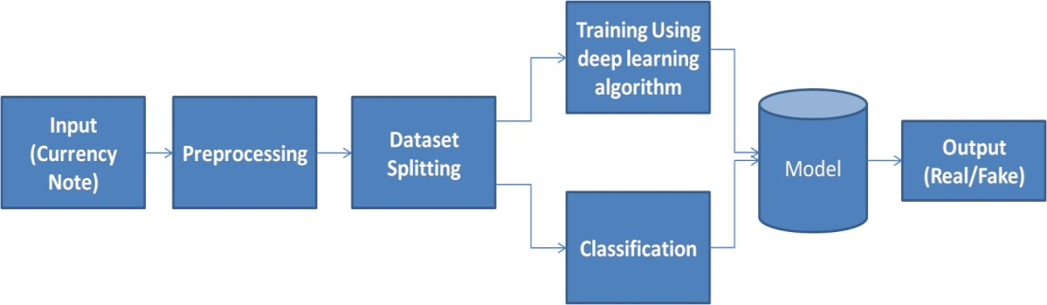

Fig 1. Block diagram of Proposed System

* Data Collection

The database of fake and real currency is created in real time. Different currency notes are considered for the evaluation.

The images are captured using phone camera of resolution in different light condition and in different directions. The new currency notes are taken for evaluation and for fake the children bank notes are taken.

* Pre-processing

The captured image with cameras are noisy; hence pre-processing is required to remove the unwanted noise from the image. The proposed system utilizes a median filter to eradicate the salt and pepper noise. Median filtering is a valuable nonlinear process in reducing impulsive or salt-and-pepper noise. It is also helpful in preserving edges in an image while reducing random noise. Impulsive or salt-and-pepper noise can occur due to a random bit error in a communication channel. In a median filter, a window slides along the image, and the median intensity value of the pixels within the window becomes the output intensity of the pixel being processed.

* Training Using CNN

CNN's are a category of Neural Networks that have proven very effective in areas such as image recognition and classification. CNN's are a type of feed-forward neural network made up of many layers. CNN's consist of filters or kernels or neurons that have learnable weights or parameters and biases. Each filter takes some inputs, performs convolution, and optionally follows it with a non-linearity. The structure of CNN contains Convolutional, pooling, Rectified Linear Unit (ReLU), and Fully Connected layers.

* Advantages of Proposed System
  + Improved Accuracy: The proposed system leveraging Convolutional Neural Networks (CNNs) offers enhanced accuracy in counterfeit currency detection compared to traditional manual methods and basic rule-based systems.
  + Automated Detection: Automation is a key advantage, as the proposed system incorporates advanced image processing and machine learning techniques, reducing the reliance on manual inspection and improving efficiency.
  + Adaptability to Evolving Techniques: The integration of CNNs allows the system to adapt to evolving counterfeit techniques, addressing the limitations of rule-based systems that may struggle to keep pace with rapidly changing methods employed by counterfeiters.
  + Efficient Handling of Diverse Currency Types: The proposed system ensures efficiency in handling diverse currency types, as CNNs can be trained on a comprehensive dataset that includes various currencies in circulation, making it more adaptable to different scenarios.
  + Real-time Analysis: With the incorporation of advanced technologies, the proposed system is capable of real-time analysis, providing a swift response to verify the authenticity of currency notes during transactions.
  + Reduction in Manual Labor: The automated nature of the system reduces the need for

extensive manual inspection, minimizing the workload on human experts and allowing them to focus on more complex tasks.

* + Potential for Continuous Improvement: Machine learning algorithms used in the proposed system offer the potential for continuous improvement through ongoing training and adaptation, ensuring the system remains effective against emerging counterfeit strategies.
  + Enhanced Security Measures: The advanced nature of the proposed system contributes to enhanced security measures, providing a more robust defense against counterfeit currency and contributing to overall financial system integrity.

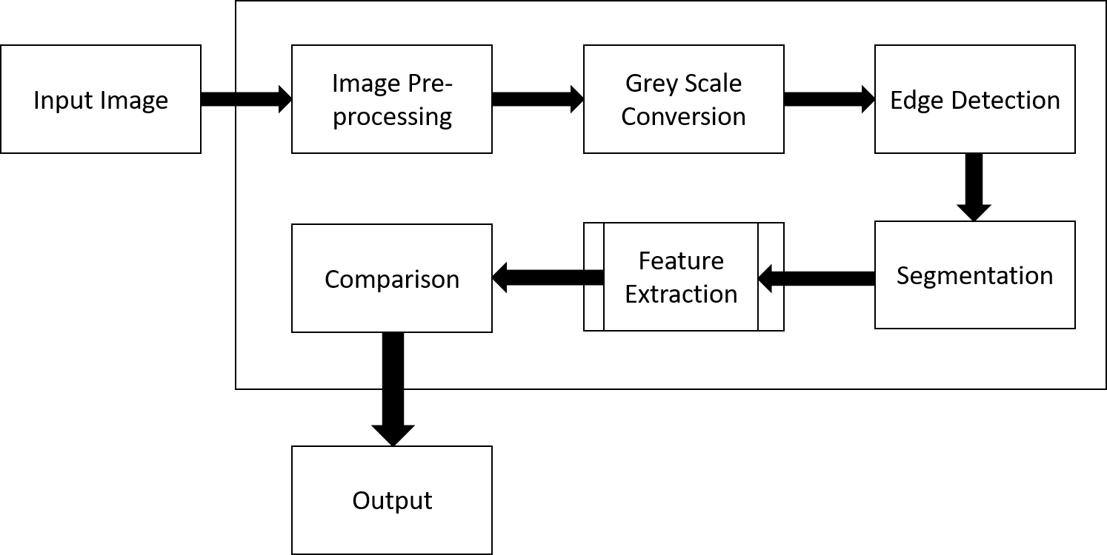

Fig 2. Data Flow Diagram

• The DFD is also called as bubble chart. It is a simple graphical formalism that can be used to represent a system in terms of input data to the system, various processing carried out on this data, and the output data is generated by this system.

• The data flow diagram (DFD) is one of the most important modeling tools. It is used to model the system components. These components are the system process, the data used by the process, an external entity that interacts with the system and the information flows in the system.

• DFD shows how the information moves through the system and how it is modified by a series of transformations. It is a graphical technique that depicts information flow and the transformations that are applied as data moves from input to output.

• DFD is also known as bubble chart. A DFD may be used to represent a system at any level of abstraction. DFD may be partitioned into levels that represent increasing information flow and functional detail

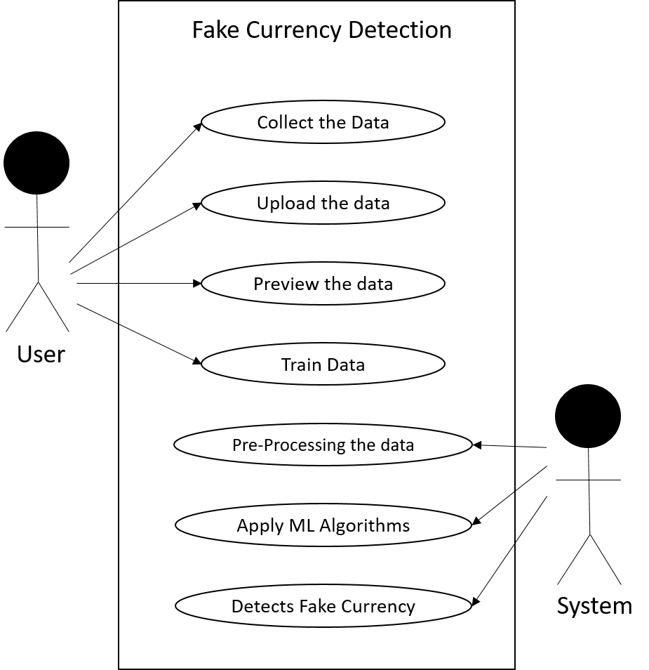

Fig 3. Use Case Diagram

A use case diagram in the Unified Modelling Language (UML) is a type of behavioural diagram defined by and created from a Use-case analysis. Its purpose is to present a graphical overview of the functionality provided by a system in terms of actors, their goals (represented as use cases), and any dependencies between those use cases. The main purpose of a use case diagram is to show what system functions are performed for which actor. Roles of the actors in the system can be depicted.

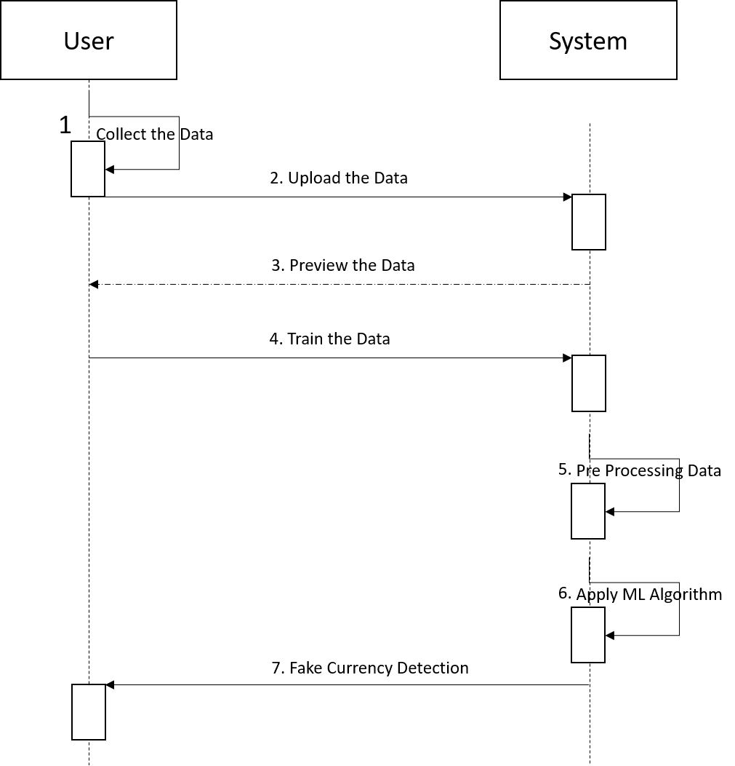

Fig 4. Sequence Diagram

A sequence diagram in Unified Modeling Language (UML) is a kind of interaction diagram that shows how processes operate with one another and in what order. It is a construct of a Message Sequence Chart. Sequence diagrams are sometimes called event diagrams, event scenarios, and timing diagrams.

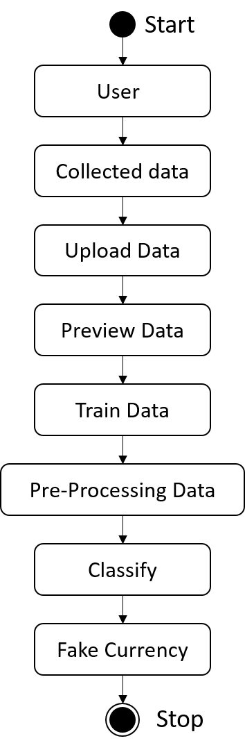

Fig 5. Activity Diagram

Activity diagrams are graphical representations of workflows of stepwise activities and actions with support for choice, iteration and concurrency. In the Unified Modeling Language, activity diagrams can be used to describe the business and operational step-by-step workflows of components in a system. An activity diagram shows the overall flow of control.

1. HARDWARE AND SOFTWARE

REQUIREMENT

1. *Hardware Requirements:*

Modern Operating System:

* Pentium IV-compatible processor or faster
* Minimum 2.4 GHz or faster
* RAM of 512 MB or more
* Hard disk of 20GB or more
* Monitor of VGA or higher resolution 800x600 or higher resolution

1. *Software Requirements:*

* Python Programming Language
* Python IDLE

# RESULTS

In this case, the system has detected the currency as real. The system is shown the image of a ₹100 Indian banknote, and is able to correctly identify it as real. The system is able to identify the features such as the watermark, security thread, and other security features to make the decision.

This system can be used in various applications, such as banks, ATMs, and retail stores, to help prevent counterfeit currency from being circulated. It can also be used to educate people about the different features of real currency and how to spot fake bills.

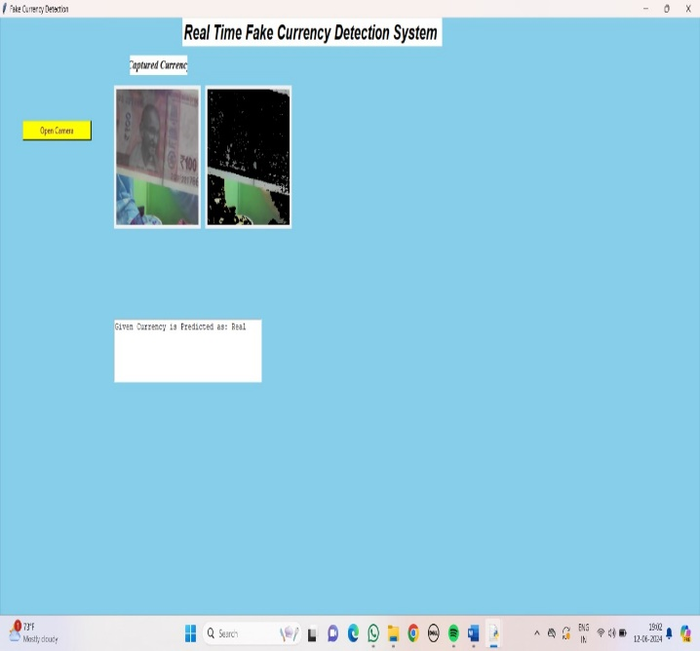

Fig 6. Real Time Fake Currency Detection System

The below Fig.7. shows The image depicts the final result of a fake currency detection system utilizing machine learning. The system is designed to differentiate between genuine and fake currency notes, and its user interface is simple, allowing users to upload an image of a currency note. Once an image is uploaded, the system preprocesses it to improve its quality and prepare it for analysis. It then extracts relevant features from the processed image, such as color patterns, security features, and image textures. These features are used by a trained model to determine whether the currency note is real or fake, and the system displays the prediction in the "Predict" section. In this case, the system has predicted that the given currency is real. This system demonstrates the potential of machine learning to solve real-world problems, and it can be used to help identify counterfeit currency, protecting individuals and businesses from financial fraud.

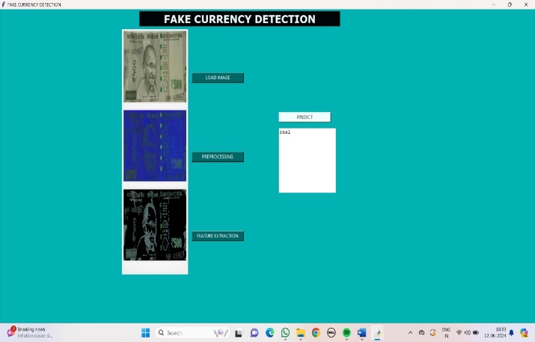

Fig 7. GUI Interface for Fake Currency Detection System

The below Fig.8. shows This image depicts the final result of a fake currency detection system utilizing machine learning. The system has analyzed the uploaded currency note and has predicted that it is real. The interface displays various details. The system's prediction is displayed prominently, stating that the given currency is real. This system demonstrates the potential of machine learning to solve real-world problems, and it can be used to help identify counterfeit currency, protecting individuals and businesses from financial fraud.

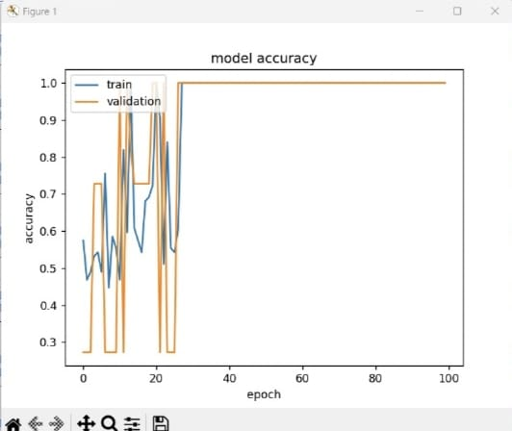

Fig 8. Accuracy of the System

# CONCLUSION

In conclusion, the detection of counterfeit currency presents a significant challenge with far-reaching implications for the integrity of the economy. Traditional methods for identifying fake currency rely on manual inspection and rudimentary strategies based on color, width, and serial numbers, but these approaches are often insufficient in the face of increasingly sophisticated counterfeit techniques. The emergence of deep learning models, particularly Convolutional Neural Networks (CNNs), offers a promising solution to this problem by leveraging advanced image processing techniques. This paper proposes a CNN model for the automatic detection of fake currency, trained on a comprehensive dataset comprising images of both genuine and counterfeit currency notes. Through meticulous preprocessing and rigorous training, the CNN model demonstrates the ability to effectively distinguish between real and counterfeit currencies of various denominations with a high degree of accuracy. The successful implementation of this model underscores the importance of automated systems in combating counterfeit currency, providing a reliable and efficient solution to safeguarding the integrity of financial transactions and the broader economy.

# REFERENCE

1. Aman Bhatia, Vansh Kedia,Anshul Shroff, Mayand Kumar, Bickey Kumar Shah, Aryan “Fake Currency Detection with Machine Learning Algorithm and Image Processing” IEEE [2021]
2. Anju Yadav,Tarun Jain,Vivek Kumar Verma,Vipin Pal “Evaluation of Machine Learning Algorithms for the Detection of Fake Bank Currency” IEEE [2021]
3. Dr. S. V. Viraktamath, Kshama Tallur, Rohan Bhadavankar, Vidya, “Review on Detection of Fake Currency using Image processing Techniques” IEEE [2021]
4. Vanajakshi, Veena, Yadhunandan, Sowjanya.U, Anitha “Detection of Counterfeit Indian Currency Note using Image Processing” Journal [2021]
5. Subhalaxmi Chakraborty, Soumyadip Banerjee, Biman Kumar Singha, SayaniGhati “Fake Note Detection using Machine Learning Techniques” Journal [2021]
6. G.Hariharan , D.Elangovan “Proxy Notes Recognition And Eradication For Betterment Of The Society” Journal [2020]
7. Asfaw Shefraw Alene, Million Meshesha “Ethiopian Paper Currency Recognition System: An Optimal Feature Extraction” IEEE [2019]
8. Kiran Kamble, Anuthi Bhansali, Pranali Satalgaonkar, Shruti Alagundgi “Counterfeit Currency Detection using Deep Convolutional Neural Network” IEEE [2019]
9. Megha Jadhav,Yogesh kumar Sharma,G. M. Bhandari “Currency Identification and Forged Banknote Detection using Deep Learning” Conference [2019]
10. Veling, Miss. Janhavi P. Sawal, Miss. Siddhi A. Bandekar, Mr. Tejas C. Patil, Mr. Aniket L. Sawant “Fake Indian Currency Recognition System by using MATLAB” Journal [2019]
11. D. Shamika, A. Rajadhyaksha, G. Swapnil and Anjali Shetty “CNN based Counterfeit Indian Currency Recognition Using Generative Adversarial Network.”, DOI Link: 10.1109/ICAIS50930. 2021.9395949.
12. Mr. M. Abishek, Mr. B. Kavin, Mr. and B. Raj Kumaran, ECE Department, Bannari Amman Institute of Technology, Tamil Nadu, “FAKE CURRENCY DETECTION USING CNN”, “India vol: 07, Issue: 03, March 2020.
13. K. Kiran, B. Anuthi, S. Pranali and A. Shruti, “Counterfeit Currency Detection using Deep Convolutional Neural Network” MIT World Peace University, Pune, India, Dec 18-20, 2019.
14. Z. Adiba, U. Jia, "A Hybrid Fake Banknote Detection Model using OCR, Face Recognition and Hough Features”, Cybersecurity and Cyberforensics Conference (CCC), 2019.
15. K. Gautam, "Indian Currency Detection using Image Recognition Technique", 2020 International Conference on Computer Science, Engineering and Applications (ICCSEA), 2020.
16. Singh, S., Aggarwal, A.K., Ramesh, P., Nelson, L., Damodharan, P. and Pandian, M.T., 2022, August. COVID 19: Identification of Masked Face using CNN Architecture. In 2022 3rd International Conference on Electronics and Sustainable Communication Systems (ICESC) (pp. 1045-1051). IEEE.
17. Raju S. S., Srikanth M., Guravaiah K., Pandiyaan P., Teja B. and Tarun K. S., (2023), A Three-Dimensional Approach for Stock Prediction Using AI/ML Algorithms: A Review & Comparison, IEEE 4th International Conference on Innovative Trends in Information Technology (ICITIIT), Kottayam, India, (pp. 1-6).
18. D. Alekhya, G. Devisuryaprabha, and G. Venkatadurgarao, "Fake Currency Detection Using Image Processing and Other Standard Methods,” Int. J. Res. Comput. Commun. Technol. ISSN, vol. 3, no. 1, pp. 2278–5841, 2014.
19. H. Hassanpour, A. Yaseri and G. Ardeshirı “Feature Extraction for Paper Currency Recognitionll”, IEEE Transactions, 1-4244-0779- 6/07,2007.