Four Axis Solar Tracking System using ESP32

|  |  |  |  |
| --- | --- | --- | --- |
| Vivekanandan. P *Department of Mechatronics Engineering*  *SNS College of Technology, Coimbatore, India*  [vp.academics@snsct.org](mailto:vp.academics@snsct.org) | Kirubasagar. V  *Department of Mechatronics Engineering*  *SNS College of Technology, Coimbatore, India*  [Kiruba.v.mct.2020@snsct.org](mailto:Kiruba.v.mct.2020@snsct.org) | Pragatheeshwaran. M *Department of Mechatronics Engineering*  *SNS College of Technology, Coimbatore, India*  [pragathe.m.mct.2020@snsct.org](mailto:pragathe.m.mct.2020@snsct.org) | Sanjay. G  *Department of Mechatronics Engineering*  *SNS College of Technology, Coimbatore, India*  [sanjay.g.mct.2020@snsct.org](mailto:sanjay.g.mct.2020@snsct.org) |

**ABSTRACT:** This Project aimed to create a practical model of a solar tracking system for commercial, with the purpose of optimizing the performance of photovoltaic modules in solar energy setups. The main idea behind the device is to consistently align the photovoltaic modules with sunlight, maximizing the exposure to the Sun’s radiation and consequently increasing the output power of the solar panel. The project encompassed the design and implementation of hardware, along with programming the microcontroller unit responsible for the solar tracker. For motion control, an ESP32 microcontroller was employed to manage two servo motors, facilitating the rotation of the solar panel along two axes. The microcontroller determined the degree of rotation based on inputs received from four photo sensors positioned next to the solar panel. The outcome of the project was a fully operational solar tracking system that effectively kept the solar panel aligned with the sun or any light source, showcasing the efficiency of the hybrid control system. The solar tracker designed in this project serves as a valuable reference and starting point for the development of more advanced systems in the future.

**KEYWORDS:** Solar energy, ESP32 microcontroller, solar tracking system, servo motors, hybrid control system, Design Thinking.

# INTRODUCTION:

Solar energy, renowned for its cleanliness and abundance, stands as a multifaceted resource powering technologies that harness the sun for heat, light, and electricity. Beyond the widespread use of solar panels for artificial and domestic purposes, solar tracking systems have emerged as pivotal tools to amplify the energy output of photovoltaic modules. In India, where solar initiatives are gaining traction, recent statistics indicate a significant surge in solar installations, with an annual growth rate of approximately 40%. Binary axis trackers, recognized for their efficacy in renewable energy investment, prove especially advantageous in regions where consistent sunlight is not guaranteed. The Indian government's commitment to promoting renewable energy is reflected in the ambitious National Solar Mission, aiming to achieve 100 GW of solar capacity by 2022. This mission has spurred investments in advanced solar technologies, including tracking systems, to optimize energy generation. While conventional energy sources like petroleum, coal, and natural gas have dominated in the past, the transition to binary trackers, monitoring the sun along two axes, signifies a paradigm shift towards cleaner and more sustainable energy solutions.

Despite the seemingly boundless solar resource, effective harvesting remains a puzzle, necessitating a closer examination of factors such as shadowing systems and rainfall patterns. In India, where diverse climatic conditions prevail, innovative approaches to overcome these challenges are crucial for the success of solar projects. Efficiency in commercially available solar cells typically ranges from 10 to 20 percent, prompting ongoing efforts to perfect shadowing systems and overcome limitations in array effectiveness. In India, advancements in solar cell technologies are evident, with increased efficiency rates observed in projects across the country.

Approximately 85 percent of the global energy supply is still dominated by conservative powers, a figure that underscores the urgency to shift towards cleaner alternatives. Fossil energy resources are finite, and their utilization contributes significantly to global warming through the emission of greenhouse gases.

Solar panels, as pioneers in the renewable energy landscape, directly convert solar radiation into electrical energy. Mainly crafted from semiconductor materials, particularly silicon, these panels exhibit an efficiency rate of 24.5 percent. In India, solar panel manufacturing is on the rise, supported by government incentives and policies. Enhancements in

solar panel efficiency hinge on a triad of strategies: refining cell effectiveness, maximizing power output, and deploying sophisticated shadowing systems.

Maximum Power Point Tracking (MPPT) stands out as a technology optimizing solar panel performance by ensuring operation at the knee point of the P-V characteristics. However, it remains contingent on the sun's alignment with the system. Solar shadowing, an automated system that dynamically tracks the sun's position, elevates power output by 30 to 60 percent compared to stationary systems. The landscape of emerging energy types extends beyond solar, encompassing hydroelectricity, bioenergy, wind, geothermal, tidal, and swell power. In India, the focus on renewable energy is underscored by ambitious targets and strategic initiatives. Solar photovoltaic (PV) energy emerges as a frontrunner in the country's energy transition, with key metrics showcasing substantial growth in solar capacity and a positive impact on the environment.

# Problem statement:

International Energy Agency (IEA), worldwide PV capacity has grown at 49% per year on average since early 2000s. Solar PV energy is highly expected to become a major source of power in the future

Challenge to maximize power output of PV systems in areas that do not admit a large quantum of solar radiation. We still need A solar tracker is used in various systems for the improvement of harnessing of solar radiation. The problem that is posed is the implementation of a system which is capable of enhancing production of power by 30-40%. The control circuit is implemented by the microcontroller. The control circuit then positions the motor that is used to orient the solar panel optimally.

# Project justification:

The design was accepted to ensure the shafts of the sun are falling perpendicularly on the solar panel to give it maximum solar energy. This is exercised into electrical power.

* + - Maximum energy is attained between 1200 hrs.’ and 1400 hrs, with the peak being around noon.
    - At this time, the sun is directly over. At the same time, the least energy will be demanded to move the panel, commodity that will further increase effectiveness of the system.
    - The design was designed to address the challenge of low power, accurate and provident microcontroller predicated shadowing system which is in order to save power, it's supposed to sleep during the is also written into C- program on Adriano IDE.

# Methodology:

The circuit of the solar shamus system is divided into three sections. There's the input stage that's composed of detectors and potentiometers, a program in bedded software in the microcontroller and incipiently the driving circuit that has the servo motor. The input stage has two LDRs that are so arranged to form a voltage separator circuit. A C program loaded into the ESP 32 forms the bedded software. There's a metallic frame that houses the factors.

The three stages are designed singly before being joined into one system. This approach, analogous to accretive refinement in modular programming, has been employed as it ensures an accurate and logical approach which is straight forward and readily to understand. This also ensures that if there are any crimes, they’re singly considered and corrected the solar design was enforced using a servo motor.

The choice was informed by the fact that the motor is presto, can sustain high necklace, has precise gyration within limited angle and doesn't produce any noise. There's the bedded software section where the ESP 32 is programmed using the C language before the chip removed from the Adriano board. The Adriano IDE was used for the coding. It’s also used as a standalone unit on a PCB during fabrication and display. The design is limited to Single Axis shadowing because the use of a dual axis tracking system would not add much value challenge to maximize power output of PV systems in areas that do not admit a large quantum of solar radiation. We still need more advanced technologies from manufacturers to ameliorate the capability of PV accoutrements, but enhancement of system design and module construction is a doable approach to make solar PV power more effective, therefore being a dependable choice for guests. Aiming for Tracks the daily east to west movement of the sun and the seasonal declination movement of the sun. Concentrates solar power systems use lenses or mirrors and tracking systems to focus a large area of sunlight into

a small beam. PV converts light into electric current using the photoelectric effect. Solar power is the conversion of sunlight into electricity.

Test results indicate that the increase in power efficiency of tracking solar plate in normal days is 26 to 38% compared to fixed plate. And during cloudy or rainy days it’s varies at any level that purpose, this design had been carried out to support the development of similar promising technology.

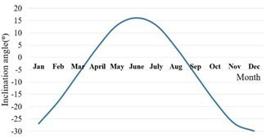

Fig. 1. Cosine variation of Seasonal Inclination Angle

In order to save power, it's supposed to sleep during the is also written into C- program on Adriano IDE. equals of1.2833

⁰ S,36.8167 ⁰ E and thus the position of the sun won't vary in a significant way during the time. In the tropics, the sun position varies vastly during certain seasons. There's the design of an input stage that facilitates conversion of light into a voltage by the light dependent resistors, LDRs. There's comparison of the two voltages, also the microcontroller uses the difference as the error.

The servo motor uses this error to rotate through a corresponding angle for the adaptation of the position of the solar panel until such a time that the voltage labours in the LDRs are equal. The difference between the voltages of the LDRs is gotten as analogy readings. The difference is transmitted to the servo motor and it therefore moves to insure the two LDRs are an equal inclination. This means they will be entering the same quantum of light. The procedure is repeated throughout the day in sun rise the solar panel pop-up the devices at night time solar panel rise down the processing.

# CHAPTER-2

* 1. **Literature Survey:**

# K. Vidanapathi rana; KAHS Kuma rap Eli; MADD Marasinghe; DP Amarasinghe; JR Lucas -2021.

The Performance Evaluation of a Hybrid Dual-Axis Solar Tracking System demonstrates its effectiveness in enhancing the power output of photovoltaic (PV) panels. Compared to fixed-mount PV panels, this system can increase power output by up to 35%. Additionally, it is noteworthy that this enhancement comes with cost-effectiveness and ease of implementation. This indicates that not only does the system offer substantial benefits in terms of energy generation, but it also presents a practical and accessible solution for adopting advanced solar tracking technology.

# M. Karthik; R. Vishnu; M. Vigneshwar; M. Loga Eshwar

ICAIS Conference 2023.

In the Arduino-based Dual Axis Smart Solar Tracking System (DAST), the implementation of this technology results in a notable increase in energy output. This enhancement establishes the DAST system as a valuable asset for a wide range of solar energy applications. With its ability to significantly boost energy production, the DAST system proves to be an invaluable addition to the realm of solar energy, offering promising solutions for optimizing energy generation in various settings.

# Agustin Orro; Noriel Correa; Álvaro Matur ell; Marciano Santamaría ICAIS 2023

In the preliminary results of the 100W Solar Tracker with Arduino MKR1000, initial findings indicate that the tracker demonstrates effectiveness in monitoring the sun's movement and adjusting accordingly. This capability results in a noticeable increase in energy output, rendering it a promising solution for a diverse range of solar energy applications. With its ability to accurately track the sun's position, the tracker optimizes energy capture by ensuring that solar panels

are consistently aligned with the sun's rays. This feature underscores its potential to significantly enhance energy generation in various solar-powered systems.

# Introduction:

A solar tracker is a device used for orienting a photovoltaic array solar panel or for concentrating solar reflector or lens toward the sun. The position of the sun moves across the sky. Solar powered equipment works best when they are pointed at the sun. Therefore, a solar tracker increases how efficient such equipment are over any fixed position at the cost of additional complexity to the system. There are different types of trackers. The photovoltaic cell is the basic building block of a photovoltaic system. The individual cells can vary from 0.5 inches to 4 inches across. One cell can however produce only 1 or 2 watts that is not enough for most appliances. Performance of a photovoltaic array depends on sunlight.

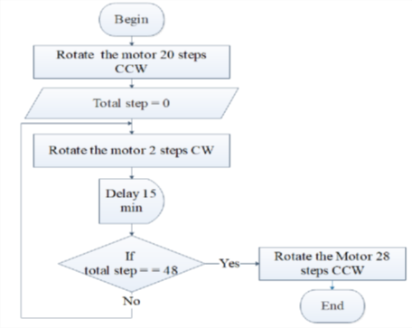Climatic conditions like clouds and fog significantly affect the amount of solar energy that is received by the array and therefore its performance. Most of the PV modules are between 10 and 20 percent efficient.

Fig.2. Time-Based Chronological Tracking Algorithm

# The Earth:

Gyration and Revolution The earth is a earth of the sun and revolves around it. Besides that, it also rotates around its own axis. There are thus two movements of the earth, rotation and revolution. The earth rotates on its axis from west to east. The axis of the earth is an imaginary line that passes through the northern and southern poles of the earth. The earth completes its rotation in 24 hours. This stir is responsible for circumstance of day and night. The solar day is a 7 the movement of the earth round the sun is known as revolution. It also happens from west to east and takes a period of 365 days.

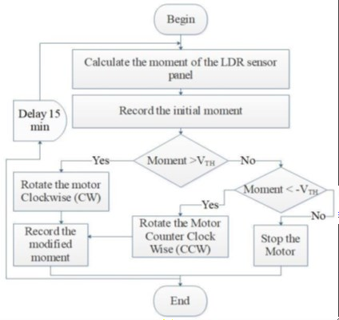The route of the earth is elliptical. Because of this the distance between the earth and the sun keeps changing. The apparent periodic track of the sun via the fixed stars in the celestial sphere is known as the ecliptic. The earth’s axis makes an angle of 66.5 degrees to the ecliptic airplane. Because of this, the earth attains Four critical positions with reference to the sun in coming sun rays. The control algorithm is given in Figure 3.

Fig. 3. LDR Based Active Tracking Algorithm

# Revolution and rotation Solar Irradiation:

Sunlight and the Solar Constant delivers energy by means of electromagnetic radiation. There is solar fusion that results from the intense temperature and pressure at the core of the sun. Protons get converted into helium atoms at 600 million tons per second. Because the output of the process has lower energy than the protons which began, fusion gives rise to lots of energy in form of gamma rays that are absorbed by particles in the sun and re-emitted. The total power of the sun can be estimated by the law of Stefan and Boltzmann.

P=4πr2 σ ϵ T 4 W, T is the temperature that is about 5800K, r is the radius of the sun which is 695800 km and σ is the Boltzmann constant which is 1.3806488 × 10-23 m 2 kg s-2 K-1.

The emissivity of the surface is denoted by ϵ. Because of Einstein’s famous law E=mc2 about millions of tons of matter are converted to energy each second. The solar energy that is irradiated to the earth is 5.1024 Joules per year. This is 10000 times the present worldwide energy consumption per year. Solar radiation from the sun is received in three ways: direct, diffuse and reflected.

# Sunlight:

Photometry enables us to determine the quantum of light given off by the Sun in terms of brilliance perceived by the mortal eye. In photometry, a refulgence function is used for the radiant power at each wavelength to give a different weight to a particular wavelength that models mortal brilliance perceptivity. Photometric measures began as beforehand as the end of the 18th century performing in numerous different units of dimension, some of which cannot indeed be converted owing to the relative meaning of brilliance.

still, the luminous flux (or lux) is generally used and is the measure of the perceived power of light. Its unit, the lumen, is compactly defined as the luminous flux of light produced by a light source that emits one candela of luminous intensity over a solid angle of one steradian. The candela is the SI unit of luminous intensity and it's the power emitted by a light source in a particular direction, ladened by a refulgence function lux and roughly 130000 lux, as epitomized in the table below.

Table2.1 Range of the brilliance of sun (lux) Time of day Luminous flux(lux) Sunrise or evening on a clear day 400 heavy day 1000 Full day (not direct sun) 10000 to 25000 Direct sun 32000 to 130000 nearly equal to the tracking system power towards mid-day.

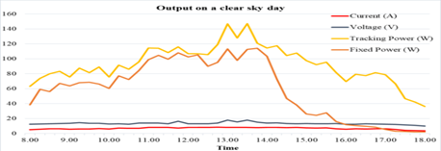

Fig. 4. Output of the solar tracker on a clear sky day

The output of the designed tracker on a rainy day and on a cloudy day was also considered and was found to have improvements of 31.5% and 22.3% respectively. A Summary of average Weather data for the Clear sky day, Rainy day and Cloudy day considered in the study taken from the nearest weather station (Ratmalana) are indicated in Table

TABLE II. Average weather data for clear sky day, rainy day, and cloudy day

|  |  |  |  |  |  |  |
| --- | --- | --- | --- | --- | --- | --- |
| Date | Avg. Temp. (ºC) | Prec. (mm) | S.L.Press./ Gheopot.  (hPa) | Wind direction | Wind  speed (Km/h) | Cloud cover |
| 25/12/2020  Clear Sky | 28.2 | 0.0 | 1009.2 | 356º(N) | 6 | 4/8 |
| 01/01/2021  Rainy Day | 26.8 | 65.0 | 1010.1 | 37º(NE) | 3 | 7/8 |
| 22/12/2020  Cloudy Day | 26.9 | 0.0 | 1010.2 | 24º(NE) | 6 | 7/8 |

Table III shows the energy produced by Tracking and Fixed systems at different time intervals of a clear sky day together with the efficiency improvement of the tracking system compared to fixed system.

TABLE III. Energy produced at different time intervals

|  |  |  |  |  |  |  |
| --- | --- | --- | --- | --- | --- | --- |
| Time | 8.00 – 12.00 | | 12.00 – 16.00 | | 16.00 – 18.00 | |
| Fixed | Tracking | Fixed | Tracking | Fixed | Tracking |
| Energy (Wh) | 305.9 | 364.3 | 285.1 | 443.2 | 12.2 | 131.2 |
| Efficiency |  | 16% |  | 35.6% |  | 90.6% |

The proposed solar tracker has been developed aiming high-capacity solar power consumers and for implementation on ground-mounted solar systems.

# Sun Angles:

1. **Elevation Angle:** The elevation angle is used interchangeably with altitude angle and is the angular height of the sun in the sky measured from the vertical. Both altitude and elevation are used for description of the height in measures above the ocean position. The elevation is 0 degrees at daylight and 90 degrees when the sun is directly above. The angle of elevation varies throughout the day and also depends on latitude of the particular position and the day of the time.
2. **Zenith Angle:** This is the angle between the sun and the vertical. It is similar to the angle of elevation but is measured from the vertical rather than from the horizon 10
3. **Azimuth Angle:** Compass direction from which the sun is coming. At solar noon, the sun is directly south in the northern semicircle and directly north in the southern semicircle. The azimuth angle varies throughout the day. At the equinoxes, the sun rises directly east and sets directly west anyhow of the latitude. thus, the azimuth photovoltaic collectors but works just fine 1200h and 1400h.

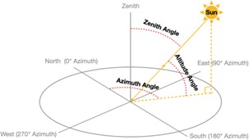

Fig. 5. Sun Angles

# Types of solar trackers and tracking technologies:

There are various categories of modern solar tracking technologies.

# Active Tracker:

Active trackers make use of motors and gear trains for direction of the shamus as commanded by the regulator responding outside this range, the collectors are diagonally acquainted to the sun in response to gusts of wind. and thus, only a bit reaches the face of immersion to the solar direction. The position of the sun is covered throughout the day. When the shamus is subordinated to darkness, it either sleeps or stops depending on the design. This is done using

detectors that are sensitive to light similar as LDRs. Their voltage affair is put into a microcontroller that also drives selectors to acclimate the position of the solar panel

# Passive solar tracking:

Passive trackers use a low boiling point compressed gas fluid driven to one side or the other to beget the shamus to move in response to an imbalance. Because it's an on-precision exposure it isn't suitable for some types of concentrating Their bracket is grounded on exposure of their primary axes with respect to the ground.

# Chronological solar tracking:

A chronological shamus counteracts the gyration of the at the same speed as the earth relative to the sun The Fixed Collector For collectors that are fixed, the around an axis that's resemblant to the earths. To achieve this, a simple gyration medium is cooked which enables the system to protuberance area on the area that's perpendicularly acquainted to the angles are 90 degrees at daylight and 270 degrees at evening.

The axis of gyration of single axis trackers is aligned along the peak of the true North. With advanced shadowing algorithms, it's possible to align them in any cardinal direction. Common executions of single axis trackers include vertical single axis trackers (HSAT), vertical single axis shamus with listed modules (HTSAT), perpendicular single axis trackers (VSAT), listed single axis trackers (TSAT) and polar aligned single axis trackers (PSAT).

# Dual axis trackers:

Dual axis trackers have two degrees of freedom that act as axes of rotation. These axes are typically normal to each other. The primary axis is the one that is fixed with respect to the ground. The secondary axis is the one referenced to the primary axis. There are various common implementations of dual trackers.

# Single axis trackers:

The Fixed Collector For collectors that are fixed, the projection area on the area that is perpendicularly oriented to the d direction of radiation is given by S = So cos 0, where & changes in the interval during the day. The angular velocity of the 72 suns as it moves across the sky is given by σ = 7.27×10-5 rad/s with the differential of the falling energy given by dw = IS dt

# Fixed and tracking collectors:

solar energy can be harnessed using either fixed or movable collectors.

# Fixed collectors:

Fixed collectors are mounted on places that have maximum sun and are at fairly good angle in relation to the sun. These include rooftops. The main end is to expose the panel for maximum hours in a day without the need for tracking technologies. There's thus a considerable reduction in the cost of conservation and installation. utmost collectors are of the fixed type. When using these collectors, it's important to know the position of the sun at colourful seasons and times of the time so that there's optimum exposure of the collector when it's being installed. This gives maximum solar energy through the time. The sun map for Nairobi is shown below. Sun path illustration for Nairobi Key 13 Through the use of the map, it's possible to ascertain the position of the sun at different times and seasons so that the panel can be fixed for maximum affair. Fixed trackers are cheaper in tropical countries like Kenya. For countries beyond 10 degrees North and-10 degrees south of the ambit, there's need for serious shadowing. This is because the position of the noon sun varies significantly.

# Case I (Fixed Collector):

The projection area perpendicularly oriented to the direction of radiation is represented as S = So cos θ, where θ varies from -π/2 to +π/2 during the day. The angular velocity of the sun's movement across the sky is denoted by ω

= 2π/T, where T is the rotation period, equivalent to 7.27×10-5 rad/s. The differential of falling energy is expressed as dw = IS dt.

# Case II (Moving Collector):

The efficiency improvement is calculated by assuming a maximum radiation intensity (I) of 1100W/m2 falling on the area perpendicularly oriented to the direction of radiation. A comparison is drawn between the intensity on the tracking collector and the fixed one, revealing that more energy is obtained from the tracking collector.

In the second scenario (CASE II) with tracking collectors, neglecting atmospheric influence, the energy per unit area for an entire day is given by W = ISt = 4.75 × 10Ws, equivalent to 13.2 kWh/m2 per day. Comparing the theoretical results for the two cases, more energy is obtained from the tracking collector. However, it's important to note that as the sun's rays travel towards the Earth in both cases, they pass through thick layers of the atmosphere. Despite this, the tracking collector still has greater exposure to the sun's energy at any given time.

# Effect of light intensity:

Because graces are further than the faults, the use of Change of the light intensity incident on a solar cell solar power is considered as a clean and feasible source of changes all the parameters, including the open circuit voltage, energy. The colourful limitations can be reduced through short circuit current the filler factor, effectiveness and impact of series colour full ways and shunt resistances. thus, the increase or drop.

# Efficiency of solar panels:

Resistance of LDR depends on intensity of the light and the effectiveness is the parameter most generally used to compare it varies according to it. The advanced is the intensity of performance of one solar cell to another. It's the rate of energy light, lower will be the LDR resistance and due to this affair from the solar panel to input energy from the sun. In the affair voltage lowers and when the light intensity is addition to reflecting on the performance of solar cells, it'll downward, advanced will be the LDR resistance and therefore advanced depend on the diapason and intensity of the incident sun and affair voltage is attained. the temperature of the solar cell.

As a result, conditions under an implicit separator circuit are used to get the affair which effectiveness is to be measured must be controlled precisely to voltage from the detectors (LDRs). The circuit is shown compare performance of the colourful bias. The effectiveness of then solar cells is determined as the bit of incident power that's converted to electricity. It's defined as were Vo Type equation here. c is the open circuit voltage; Isac is the short circuit current FF is the filler factor η is the effectiveness. The input power for effectiveness computations is 1 kW/ m2 or 100 mW/ cm2. therefore, the input power for a 100 × 100 mm2 cell is 10 W

# Advantages of Solar Power:

* + - * Solar energy is a clean and renewable energy source.
      * Once a solar panel is installed, the energy is produced at reduced costs.
      * Whereas the reserves of oil of the world are estimated to depleted in future, solar energy will last forever.
      * It is pollution free.
      * Solar cells are free of any noise. On the other hand, various machines used for pumping oil or for power generation are noisy.
      * Once solar cells have been installed and running, minimal maintenance is required. Some solar panels have no moving parts, making them to last even longer with no maintenance.
      * On average, it is possible to have a high return on investment because of the free energy solar panels produce.
      * Solar energy can be used in very remote areas where extension of the electricity power grid is costly.

# Disadvantages of solar power:

* + - * Solar panels can be costly to install resulting in a time lag of many years for savings on energy bills to match initial investments.
      * Generation of electricity from solar is dependent on the country’s exposure to sunlight. This means some countries are slightly disadvantaged.
      * Solar power stations do not match the power output of conventional power stations of similar size.
      * Furthermore, they may be expensive to build.
      * Solar power is used for charging large batteries so that solar powered devices can be used in the night. to 5 volts and provides a digital number at the
      * Output which generally ranges from 0 to 1023 Now this will give feedback to the microcontroller using the arguing software (IDE) The servo motor position can be controlled by this mechanism which is discussed later in the hardware model

# CHAPTER 3

* 1. **Design and Working Principle:**

The resistance of the Light Dependent Resistor (LDR) is contingent on the intensity of light, and it fluctuates accordingly. When the light intensity is high, the LDR resistance decreases, leading to a lower output voltage. Conversely, in low light conditions, the LDR resistance increases, resulting in a higher output voltage.

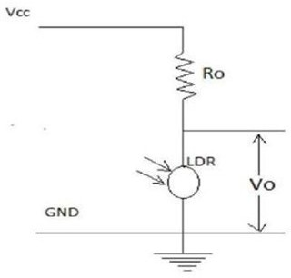

Fig. 6. Symbol Circuit Diagram

To obtain the output voltage from the LDR sensors, a potential divider circuit is employed. The LDR senses analog input voltages ranging from 0 to 5 volts and outputs a digital number typically ranging from 0 to 1023. This numerical data serves as feedback to the microcontroller through the integrated development environment (IDE) software.

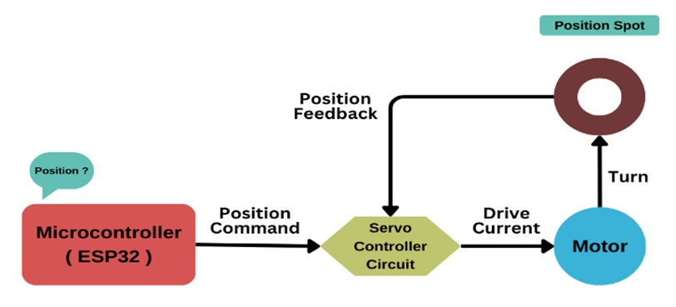

Fig. 7. Process Flow Diagram

The servo motor's position can be manipulated by this feedback mechanism, a concept elaborated on in the hardware model. The solar tracker, using this information, adjusts its position by sensing the maximum intensity of light falling perpendicularly onto it and remains in that position until it detects any subsequent changes.

It's worth noting that the sensitivity of the LDR is influenced by a point source of light and has minimal impact under diffuse lighting conditions. This design ensures efficient tracking by responding to variations in light intensity, allowing the solar tracker to optimize its position for maximum exposure to sunlight.

# Basic Circuit Diagram:

An overview of the required circuit for the Dual-axes solar tracker is shown here. The 5V supply is fed from an USB 5V dc voltage source through Adriano Board Servo X: Rot**a**tes solar panel along X direction

Servo Y: Rotates solar panel along Y direction

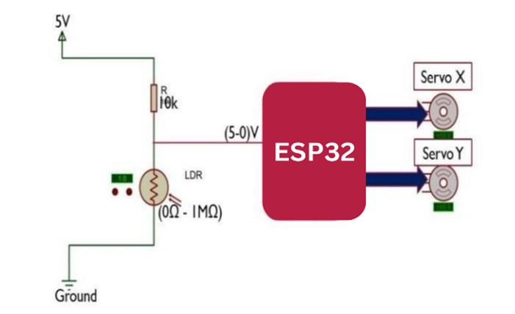

Fig. 8. Basic Circuit Diagram

Light Sensor Theory and Circuit of Sensor Used Light detecting sensor that maybe used to build solar tracker include; phototransistors, photodiodes, LDR and LLS05. A suitable, inexpensive, simple and easy to interface Thus illumination in lamberts/m2 on a normal plane= Candle power/ (Distance in meters) 2.

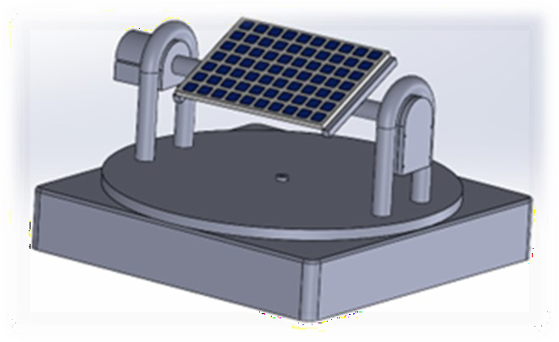

Fig. 9. 3D Design of Solar Tracking System

# CHAPTER-4

* 1. **Mathematical Model Mathematical Equations Required Inverse Square Law:**

When light shines onto a surface, the amount of illumination it receives decreases as the distance from the light source increases. This decrease follows a specific pattern: if the illumination at a surface located 1 meter away from the source is represented as "I" units, then at a distance of 2 meters, the illumination will be one-fourth of "I," at 3 meters it will be one-ninth of "I," and so forth.

This phenomenon, known as the inverse square law, applies when light rays originate from a single point source and strike the surface perpendicularly. Essentially, it means that the intensity of light diminishes rapidly as the distance from the source increases. To quantify this relationship, we can measure illumination in lamberts per square meter (lamberts/m2) on a surface perpendicular to the light source. This can be calculated by dividing the candle power of the source by the square of the distance in meters from the source to the surface.

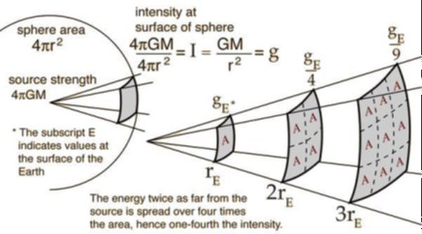

Fig 10. Inverse Square Law

# Lambert’s Cosine Law:

The amount of light received by a surface depends on the angle between the incoming light rays and the surface's normal direction at the point where they meet. This relationship is primarily influenced by the reduction in the area of the surface that the light can reach as the angle of incidence increases.

In simpler terms, when light hits a surface at an angle, less of it is actually landing on the surface compared to when the light hits the surface straight on. This phenomenon is described by the equation:

# Eθ = Ecosθ = IcosθD2

Where,

* + - Eθ represents the illumination on a horizontal plane
    - E is the illumination from light that hits the surface normally (straight on)
    - θ is the angle of incidence
    - D is the distance.

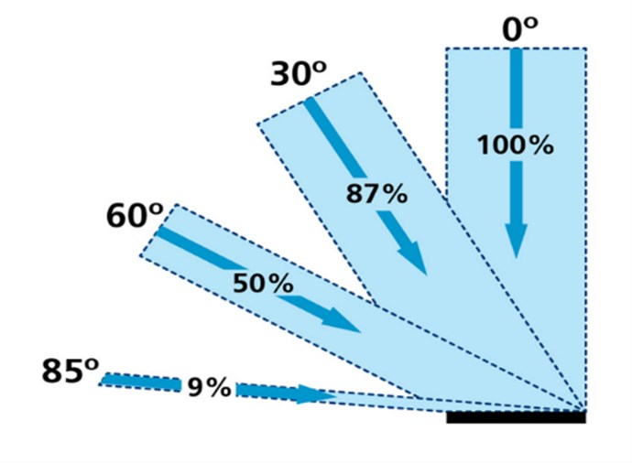

Fig. 11. Cosine Law Diagram

# CHAPTER-5

**5.1 Hardware Model:**

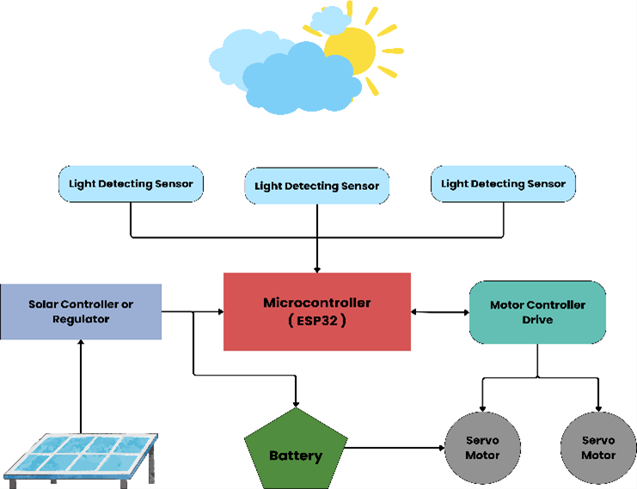

In the block diagram, we notice three Light Dependent Resistors (LDRs) placed alongside a solar panel on a common plate. These LDRs receive varying amounts of light from a source, leading to differences in their resistance levels. This occurs because LDRs naturally decrease resistance as light intensity increases—a property known as photoconductivity. Consequently, each LDR sends a signal corresponding to its resistance value to the Microcontroller, which is programmed accordingly.

The Microcontroller compares these resistance values, using one LDR’s value as a reference point. One of the servo motors is mechanically linked to the driving axle of the other, causing it to move in sync. The first servo motor’s axle is connected to the solar panel, allowing for movement along both the X and Y axes. Based on the input from the LDRs, the Microcontroller sends signals to the servo motors to adjust the solar panel’s position. One servo motor control tracking along the x-axis, while the other handles y-axis tracking. This setup forms the basis of the solar tracking system, ensuring optimal alignment with the sun’s position throughout the day.

# CHAPTER 6

* 1. **Hybrid Control System:**

Hybrid control systems seamlessly blend the strengths of both open-loop and closed-loop control strategies. We dissect the components, from sensors and actuators to computational algorithms, that form the backbone of these systems. The ability to harness real-time data while maintaining the stability of closed-loop control proves instrumental in the intricate task of solar panel positioning.

# The Essence of Four-Axis Solar Panel Tracking:

Four-axis solar panel tracking transcends traditional systems by incorporating additional degrees of freedom. We explore how this dynamic approach optimally aligns solar panels with the sun's position, maximizing energy absorption throughout the day. The demand for precise control prompts the integration of hybrid control systems, ushering in a new era of responsiveness and adaptability.

# Enhancing Sustainability with Energy Storage Integration:

The synergy between hybrid control systems and energy storage solutions adds a layer of sustainability. We discuss how excess energy generated during peak sunlight hours can be stored for later use, ensuring a consistent and reliable power supply even during periods of low or no sunlight.

5.3Navigating Challenges and Future Trajectories:

While advancements abound, challenges persist. The article discusses complexities such as system maintenance, standardization, and the evolving landscape of communication protocols. Looking forward, glimpses into self-healing algorithms and advanced materials paint a picture of a future where four-axis solar panel tracking becomes even more efficient and accessible.

# CHAPTER 7

* 1. **Outcome and Conclusion:**
     + The goal of the project is to enhance the efficiency of solar photovoltaic panels by ensuring they remain perpendicular to the sun's rays throughout the year.
     + This is achieved through a dual-axis solar photovoltaic panel that utilizes astronomical data for reference. The tracking system is designed to constantly orient the solar array toward the sun, making it adaptable for installation in different regions with minimal adjustments required.
     + To achieve vertical and horizontal motion of the panel, altitude and azimuth angles are used as reference points. The system employs a fuzzy controller to regulate the position of the servo motor, ensuring precise alignment with the sun's position for optimal energy generation.

# References:

1. What is U.S. Electricity Generation by Energy Source? -FAQ-U.S. Energy Information Administration (EIA). (n.d.).U.S.Energy Information Administration (EIA).RetrievedAugust 29, 2013, [http://www.eia.gov/tools/faqs/faq.cfm?id=](http://www.eia.gov/tools/faqs/faq.cfm?id) 427&t=3

Kothari, D. P., and Nagrath, I. J. Modern Power System Analysis (3rd ed.). New Delhi: Tata McGraw-Hill Pub. Co., 2003

1. Watson, A., Giudice, L., Lisell, L., Doris, L., and Watson, S. B., "Solar Ready: An Overview of Implementation [3]Practices". Contract Volume: 303 (2012-01-01) ISSN:

1530-6224

[4]."Solar Angle Calculator." Solar Electricity Handbook. N.p., n.d. Web. 25 Sept. 2013. <http://solarelectricityhandbook.com/solar->angle calculator. html.

1. Kelly-Detwiler, Peter. "As Solar Panel Efficiencies Keep Improving, It's Time To Adopt Some New Metrics." Forbes. Forbes Magazine, 16 July 2013. Web. 15 Sept.
2. What is U.S. Electricity Generation by Energy Source? -FAQ-U.S. Energy Information Administration (EIA). (n.d.).

U.S. Energy Information Administration (EIA). Retrieved August 29, 2013, http:// [www.eia.gov/tools/faqs/faq.cfm?id=](http://www.eia.gov/tools/faqs/faq.cfm?id) 427&t=3 Kothari, D. P., and Nagrath, I. J. Modern Power System Analysis (3rd ed.). New Delhi: Tata McGraw-Hill Pub. Co., 2003.

1. Chandler, Nathan. "How Does Solar Power Help the Environment?" 29 August 2012. HowStuffWorks.com. <http://science.howstuffworks.com/environmental/energy/solar-power-help-environment.htm>29 August 2013.
2. Solar Technologies | Photovoltaic Solar Panels | Thin Film Solar Panels | Solar Thermal. (n.d.). Solar Panels, Photovoltaic Systems, Solar Solutions for Home, Business &Utility-Scale - SunPower. Retrieved August 29, 2013, <http://us.sunpowercorp.com/solar-resources/howsolar->works/solar-technologies
3. Journal of Solar Energy Engineering, Vol.133 ] studied and investigated maximization of collected energy from an onboard PV array, Hossein Mousa Zadeh et Al.,[ (2011),
4. International Journal of Scientific & Engineering Research vol. 3, 2229–5518, states that a single axis tracker tracks the sun east to west, K.S. Madhu et al., (2012)
5. Solar Tracking Hardware and Software by Gerro J Prinsloo
6. Design and Implementation of a Sun Tracker with a Dual Axis Single Motor “Jing-Min Wang and Chia-Liang Lu’’

Sensors and Transducers...Second Edition...’’Daryanani’s” https://[www.rcciit.org/students_projects/projects/ee/2018/GR](http://www.rcciit.org/students_projects/projects/ee/2018/GR) 1.pdf, https://[www.slideshare.net/sweetswetansh/solar-](http://www.slideshare.net/sweetswetansh/solar-) trackerreport-swetansh

[14]H. Mousazadeh; A. Kahani; A. Javadi; H. Mobi; K. Abronia and A. Sharifi; "A Review of Principle and Sun Tracking Methods for Maximizing Solar System's Output"; Renewable and Sustainable Energy Reviews,2009.

1. Solar Technologies | Photovoltaic Solar Panels | Thin Film Solar Panels | Solar Thermal. (n.d.).Solar Panels, Photovoltaic Systems, Solar Solutions for Home, Business &Utility-Scale - SunPower. Retrieved August 29, 2013, <http://us.sunpowercorp.com/solar-resources/howsolar->works/solar-technologies
2. Watson, A., Giudice, L., Lisell, L., Doris, L., and Watson, S. B., "Solar Ready: An Overview of Implementation Practices". Contract Volume: 303 (2012-01-01) ISSN: 1530-6224
3. Kelly-Detwiler, Peter. "As Solar Panel Efficiencies Keep Improving, It's Time To Adopt Some New Metrics." Forbes. Forbes Magazine, 16 July 2013. Web. 15 Sept. 2013. <http://www.forbes.com/sites/peterdetwiler/> 2013/07/16/as-solar-panel-efficiencies-keep-improving-its-time-toadopt- some-new-metrics/.
4. "The Kyocera KD135GX-LPU 135-Watt Solar Panel's New Technology Allows for End Mounting under 2400 Pa (50 Psf) and Traditional Mounting under 5400 Pa (113 Psf)." Kyocera KD135SX-LPU 135 Watt Solar Module. N.p.,

n.d. Web. 11 Oct. 2013. [http://www.](http://www/) wholesalesolar.com/products.folder/module-folder/ kyocera/KD135GXLPU. html

1. "Solar Angle Calculator." Solar Electricity Handbook. N.p., n.d. Web. 25 Sept. 2013. <http://solarelectricityhandbook.com/solar->anglecalculator. html.
2. Koutroulis, E., Kalaitzakis, K., Voulgaris, N.C., "Development of a Microcontroller-based, Photovoltaic Maximum Power Point Tracking Control System," Power Electronics, IEEE Transactions on, vol.16, no.1, pp.46,54,

Jan 2001

1. Journal of Solar Energy Engineering, Vol.133 studied and investigated maximization of collected energy from an onboard PV array, Hossein Mousa Zadeh et Al., [ (2011),
2. International Journal of Scientific & Engineering Research vol. 3, 2229–5518, states that a single axis tracker tracks the sun east to west, K.S. Madhu et al., (2012)
3. Solar Tracking Hardware and Software by Gerro J Prinsloo
4. Design and Implementation of a Sun Tracker with a DualAxis Single Motor “Jing-Min Wang and Chia-Liang Lu’’
5. Sensors and Transducers...Second Edition...’’D. Patra Nabis”