**International Journal of Innovative Research in Engineering**

Volume 3, Issue 4 (July-August 2022), PP: 33-37.

www.theijire.com***ISSN No: 2582-8746***

**Power Factor Regulation in BLDC Motor Using Landsman Converter**

**Baby Salome Chandra C**

*Lecturer, Department of EEE, Murugappa Polytechnic College, Chennai, India.*

|  |  |
| --- | --- |
| **How to cite this paper:** Baby Salome Chandra C , “Power Factor Regulation in BLDC Motor Using Landsman Converter”, IJIRE-V3I04-33-37.  Copyright © 2022 by author(s) and5th Dimension  Research Publication.  This work is licensed under the Creative Commons Attribution International License (CC BY 4.0). <http://creativecommons.org/licenses/by/4.0/> | ***Abstract:*** *This paper deals with a highly reliable electrical drive utilizing the Brushless DC Motor. The Motor is fed by Voltage Source Inverter (VSI) with a dc–dc converter Power Factor correction circuit (PFC) as the VSI’s predecessor. The Performance of dc-dc converters is analysed and the results are discussed to arrive at the best suited converter. PID Logic Controller is used as the Intelligent Controller for the BLDC Motor. Reliable, low cost arrangement is thus provided to achieve unity Power Factor and speed regulation with accuracy. The Landsman Converter performs Power factor correction and dc voltage control in single stage using only one controller.*  ***Key Word****:Landsman Converter, PID Logic, VSI, dc-dc converter, BLDC Motor.* |

## INTRODUCTION

The air-conditioning is energy intensive application which normally uses single phase induction motors for driving its compressor and fans. The efficiency of these motors is between 70-80%. Moreover,theon-offcontrolemployedforthetemperaturecontrolisnotenergyefficientandintroducesmany disturbance sin the distribution system along with increased wear and tear of the motor and reduces power factor. The use of PMBLDCM for driving the compressor results in energy efficiency improvement of the Air-Con. Moreover, the temperature in the air-conditioned zone canbe maintained at the set references moothly while operating the Air-Con.underspeedcontrol.This paper presents to improve the power factor using Landsman Converterfor PMBLDC motor application. Mainly in air conditioning systems it is used to improve the power factor. Smooth start-up of air conditioning systems without fluctuations is difficult in conventional system. Achieve the study and smooth speed control to maintain the constant room temperature. Avoid the Harmonics in the power system due to the continuous switching and mainly to provide higher efficiency.

1. **SYSTEM TECHNIQUES**

In the existing system permanent magnet brushless DC motor is replacing single phase induction motor used in air conditioners for driving compressor and fan for its low power consumption. BLDCMs are fed from a single-phase AC mains through a diode bridge rectifier (DBR) and a smoothening DC link capacitor, which results in a pulsed current from AC mains having various power quality (PQ) disturbances such as poor power factor (PF), increased total harmonic distortion (THD),harmonics which reduces the power quality and causes unwanted electromagnetic interference.

In order to improve the power factor bridgeless SEPICconverter is used for BLDC motor application. The bridgeless SEPIC converter is configured from a buck controller that drives a high-side PMOSFET. It uses the LANDSMAN converter topology provides a positive outputfrom an input voltage.The LANDSMAN converter also needs two inductors and a series capacitor, sometimes called a flying capacitor. Unlike the SEPIC converter, which is configured with standard boost converter, the LANDSMAN converter is configured from a buck controller that drives a high-side PMOSFET.

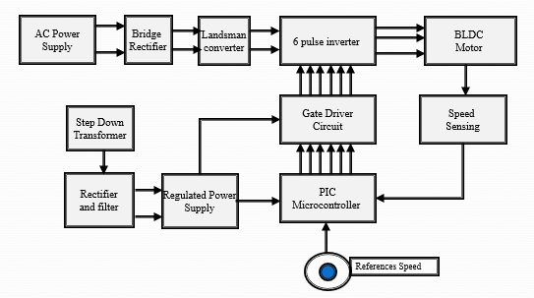

**III.BLDC MOTOR**

Brushless Direct Current motors (BLDC motors) also known as ECM (electronically commutated motors)are synchronous electric motors generated by Direct Current electricity and having electronic commutation systems, rather than mechanical commutators and brushes. It is uses a permanent magnet external rotor**,** three phases of driving coils, one or more Hall Effect devices to sense the position of the rotor, and the associated drive electronics. They act as three-phase synchronous motors containing their own variable frequency drive electronics where the coils are activated, one phase after the other, by the drive electronics as cued by the signals from the Hall Effect sensors. BLDC motors have many advantages over brushed DC motors and induction motors. Low cost of maintenance due to absence of brushes, simple and inexpensive control, and noiseless operation are some of the advantages.

BLDC motors are synchronous motor because of magnetic field generated by the stator and the magnetic field generated by the rotor rotates at the same frequency.

The stator of a BLDC motor consists of stacked steel laminations with windings placed in the slots that are axially cut along the inner side-line. They have three stator windings with star connection in most of BLDC motor. Each of these winding is built with plentiful of coils interconnected to form a winding and many coils are placed in the slots and they are interconnected to make a winding where they are distributed even numbers of poles. There are two types of stator windings alternatives, trapezoidal and sinusoidal motors. Advantages of using sinusoidal motors, the torque output smoother than that of a trapezoidal motor. However, this comes with an extra cost, as the sinusoidal motors take extra winding interconnections because of the coils distribution on the stator periphery, thereby increasing the copper intake by the stator windings. That will make trapezoidal more cheaply than sinusoidal motors.

Since the rotor is made of permanent magnet, it can vary from two to eight pole pairs with alternate North (N) and South (S) poles. There are two types of magnetic material use in BLDC motor, there are Ferrite Magnets and Alloy Magnets. The ferrite magnets are inexpensive but they have the disadvantage of low flux density for a given volume. Compare to the alloy material has high magnetic density per volume and enables the rotor to compress further for the same torque. In addition, these alloy magnets improve the size-to-weight ratio and give higher torque for the same size motor using ferrite magnets.

Stator windings should be energized in a sequence. It is important to know the rotor position in order to understand which winding will be energized following the energizing sequence. Rotor position is sensed using Hall effect sensors embedded into the stator. Most BLDC motors have three Hall sensors embedded into the stator on the non-driving end of the motor. Whenever the rotor magnetic poles pass near the Hall sensors, they give a high or low sign.

**IV.MODELING OF BLDC MOTOR**

The Modeling of BLDC motor drive system is based on the following assumptions.

1. All the stator phase windings have equal resistance per phase and constant self and mutual inductances.
2. Power semiconductor devices are ideal.
3. Iron losses are negligible and the motor is unsaturated.

Based on the above assumptions, the three phase input voltages are expressed as follows.







The electromagnetic torque is expressed as



The electromagnetic torque can be expressed in terms of

Mechanical parameters as



where TL is the load torque, J is inertia, ω is angular speed, B is viscous damping coefficient.

**V.PRINCIPLE OF OPERATION**

Stator windings should be energized in a sequence in order to rotate the BLDC motor. Identify the rotor position in order to understand which winding will be energized following the energizing sequence is very importance. Rotor position is sensed using Hall Effect sensors. Whenever the rotor magnetic poles pass near the Hall sensors, they give a high or low signal (1 or 0), indicating the N or S pole is passing near the sensors. The sequence of commutation can bedetermined based on the combination of three Hall sensor signals. There have two type of phase shift of the Hall Sensors, 60° or 120° phase shift to each other. Each commutation sequence has one of the windings energized to positive power where current enters into the winding and exits as negative on the second winding while the third is in a no energized condition. The interaction between the magnetic field generated by the stator coils and the permanent magnets (rotor) will produce torque.

The motor can be loaded up to the rated torque during continuous operation. The torque will remain constant for a speed range until the rated speed. After that the torque will start dropping in order to run up the motor to 150% of the rated speed (maximum speed). The motor need more torque than the rated for application acceleration and deceleration. During acceleration and motor starts from standstill, extra torque is required to overcome the inertia of the load and the rotor itself.

It is implemented by a 3 Phase full bridge inverter topology with six switches in order to drive the BLDC Motor. The 3-phase full bridge arrangement was chosen for the power interface between the motor and controller. The full bridge was chosen for it higher torque output capability over a half bridge arrangement. The purpose of the bridge circuit is to enable each of the three motor phases to be switched on as required by the motor. And another new implementation of this project is RF-link, which is used to drive the motor from remote.

A device that converts dc power to ac power at desired output voltage and frequency is called an inverter. Inverters can broadly classify into two types: VSI and CSI. A VSI, is one in which the dc source has small or negligible impedance. In other words, a voltage source inverter has stiff dc voltage source at its input terminals. A CSI is fed with an adjustable current from a dc source of high impedance, i.e. from a stiff dc current source. In a CSI fed with stiff current source, output current waves are not affected by the load. In VSIs using THYRISTORS, some type of forced commutation is usually required. In case VSIs are made up of using power MOSFETs self-commutation with gate drive signals is employed for their turn-on and turn-off.

Landsman converter-based PFR is designed to operate in DICM for natural PF regulation at AC mains. The current in input inductor (Li) becomes discontinuous during switching period (Ts) in DICM operation. There are three operating stages of a PFR Landsman converter.

1. **Modes Of Operation**

**Mode – 1**

When switch (S) is on, an energy from the supply and stored energy in the intermediate capacitor (C1) are transferred to input inductor (Li). The output inductor (Lo) starts discharging and the voltage of intermediate capacitor (vC1) starts reducing while DC-link voltage (Vdc) starts increasing. The value ofintermediate capacitor is large enough to store required energy such that the voltage across the capacitor does not become discontinuous.

**Mode – 2**

In this mode of converter operation, switch is turned-off. An intermediate capacitor (C1) and DC-link side inductor (Lo) are charging through the supply current while output inductor (Li) starts discharging. Hence, vC1 starts increasing in this mode. Moreover, the voltage across the DC capacitor (Vdc) decreases.

**Mode – 3**

This is the DCM for converter operation as the input inductor (Li) is discharged completely and currentbecomes zero. The current of DC bus side inductor starts increasing and the voltage of intermediary capacitor (vC1) continues to decrease in this mode.

The line voltage waveforms represent a balanced set of three phase alternating voltages. During six intervals, these voltages are well defined. Therefore these voltages are independent of the nature of the load circuit which may consist of any combination of resistance, inductance and capacitance and the load may be balanced or unbalanced, linear or non-linear.

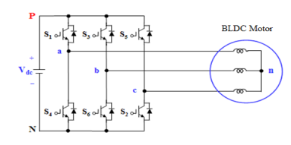

*Fig.2 Three Phase Voltage Source Inverter*

V1 = 2/3VaN - 1/3VbN - 1/3VcN……… (4.1)

V2 = -1/3VaN + 2/3VbN - 1/3VcN……. (4.2)

V3 = -1/3VaN - 1/3VbN + 2/3VcN……. (4.3)

The operation of a 120° mode inverter the power circuit diagram is similar to that of a 180° mode inverter. In the 120 °mode inverter each IGBT conducts for 120° of a cycle. Similar to a 180° mode inverter this also requires six steps, each of 60° duration, for completing one cycle of the output ac voltage.

The line voltages, however, have six steps per cycle of output alternating voltage. voltagesat the output terminals a, b and c of the inverter.

**VI.SIMULATION RESULTS**

The following simulation results have been observed and analyzed.

In order to verify the effectiveness of the proposed system the variations in i/p voltage, rectified voltage, speed and torque, power factor wave forms are analysed.

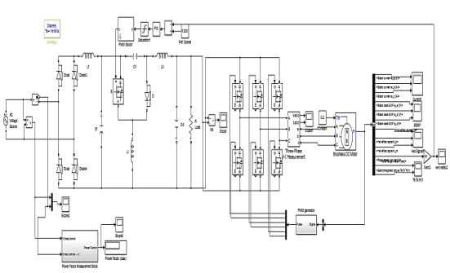

**Input Voltage**

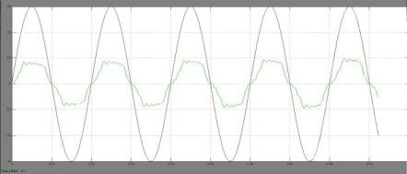

**4.2 Motor Torque**

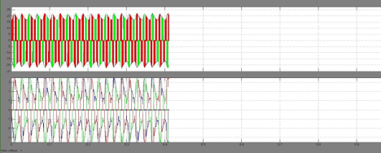

**VII.CONCLUSION**

The power factor correction has been successfully implemented using the Landsman Converter. It shows a much-improved result as it not only provides better power quality, but also the converter removes the necessity to smooth out the dc output from ripples. The PID controller widely increases application range of the motor by increasing the reliability. The motor is presently used in areas such as aerospace, aircraft and mining applications because of the enhanced reliability that the motor offers. This is further enhanced by the usage of NFLC and the PFC converters. The NFLC is used to control the motor speed and the Landsman Converter is used for the power factorimprovement. It is found that the Landsman Converter is found to provide better power quality.

**References**

[*1] R.Shanmugasundaram, K. Muhammad Zakariah and N. Yadaiah, “Implementation and Performance Analysis of Digital Controllers for Brushless DC Motor Drives,” IEEE/ASME Trans. Mechatronics, vol. 19, no. 1, Feb. 2014.*

*[2] T. Kenjo and S. Nagamori, Permanent MagnetBrushless DC Motors.Oxford, U.K.: Clarendon Press, 1985.*

*[3] Sanjeev Singh and Bhim Singh, “A Voltage-Controlled PFC Cuk Converter-Based PMBLDCM Drive for Air-Conditioners,” IEEE Trans. Ind. Appl. vol. 48, no. 2, Mar. /Apr. 2012.*

*[4] VashistBist and Bhim Singh, “PFC CUK Converter-Fed BLDC Motor Drive,” IEEE Trans. Power Electron., vol. 30, no 2, Feb. 2015.*

*[5] A. Rubaai, D. Ricketts, and M. D. Kankam, “Laboratory implementation of a microprocessor-based fuzzy logic tracking controller for motion controls and drives,” IEEE Trans. Ind.Appl., vol. 38, no. 2, pp. 448–456, Mar./Apr. 2002.*

*[6] Pierre Guillemin, “Fuzzy logic applied to motor control,” IEEE Trans. Ind. Appl., vol. 32, no. 1, pp. 51–56, Jan./Feb. 1996.*

*[7] M. A. Akcayol, A. Cetin, and C. Elmas, “An educational tool for fuzzy logic-controlled BDCM,” IEEE Trans. Edu., vol. 45, no. 1, pp. 33–42, Feb. 2002.*

*[8] Zengshi Chen, “PI and Sliding Mode Control of a Cuk Converter”, IEEE Trans. Ind. Electron., vol. 27, no. 8, Aug. 2012*

*[9] Ahmed Rubaai and Paul Young, “Hardware / Software Implementation of Fuzzy-Neural-Network Self-Learning Control Methods for Brushless DC Motor Drives”, IEEE Trans. Ind. Appl., DOI 10.1109/TIA.2015.2468191.*

*[10] Harmonic Current Emissions Guidelines, European Power Supply Manufactures Association Standard EN 61000-3–2 Nov. 2010.*