**INTELLIGENT FALL DETECTION FOR ELDERS**

Vijith P R1, Aromal K R2, Aswin T M3, Nihal Navas K M4

*1Assistant Professor, Department of Electronics and Communication Engineering, Universal Engineering College*

*Vallivattom, Thrissur, Kerala, India.*

*2,3,4Department of Electronics and Communication Engineering, Universal Engineering College Vallivattom, Thrissur,*

*Kerala, India.*

*Aromal K R2 : aromal0480@gmail.com*

|  |
| --- |
| ***Abstract:*** *In today's fast-paced world, many elderly individuals live alone, increasing their risk of falls without immediate help. To address this, we propose a system with wall-mounted cameras and mmWave sensors in the home to detect falls quickly and accurately. When a fall is detected, the system alerts medical services and caregivers for prompt assistance. All fall-related data is securely stored on a website, accessible to medical professionals and family members for real-time monitoring. This system ensures the safety of the elderly and provides peace of mind for their loved ones by bridging technology and caregiving.*  ***Key Word****:**Elderly individuals, wall-mounted cameras, mmWave sensors, falls, secure website, monitoring, alert* |

1. **INTRODUCTION**

Falls are a significant public health concern, especially among the elderly, leading to serious injuries and fatalities, with 684,000 fatal falls occurring globally each year and adults aged 60 and older at the highest risk. Approximately 28-35% of individuals aged 65 and over, and 32-42% of those aged 70 and above, experience falls annually. To address this, automatic fall detection systems are essential, providing timely alerts that reduce the fear and complications associated with falls, such as hypothermia and dehydration. Current technologies include wearable devices, ambience sensors, and vision-based systems, each with strengths and limitations. Our project proposes a comprehensive fall detection system that integrates vision-based and ambience sensors throughout a home, ensuring accurate fall detection and swift intervention, thereby enhancing safety and peace of mind for the elderly and their caregivers.

1. **SYSTEM ARCHITECTURE & WORKING**

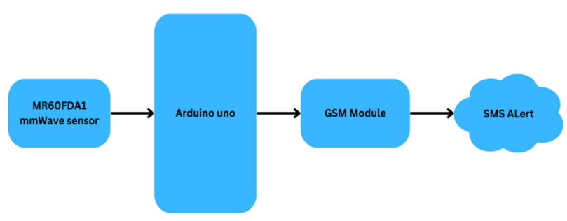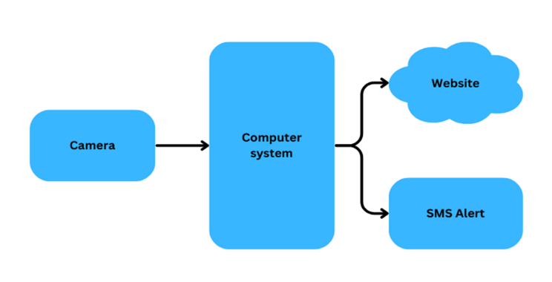



* mm Wave Sensor (Millimeter Wave Sensor): Detects falls in real-time using millimeter wave technology, monitors movements and presence in the environment specifically for fall detection, and connects to the Arduino Uno for data processing and transmission.
* Arduino Uno: Acts as a microcontroller for sensor interfacing and data processing, receives data from the mmWave sensor, processes it, sends instructions to other components, and interfaces with the mmWave sensor and GSM module.
* Camera: Provides visual input for fall detection using computer vision algorithms, captures video footage of the environment for processing by the computer system, and connects to the computer system for video input and processing.
* Computer System: Performs data processing and analysis for fall detection, runs computer vision algorithms (e.g., YOLOv7) to analyze video footage from the camera, detects falls, and sends alerts.
* Website: Provides a user interface for remote monitoring and management of the fall detection system, allowing users to easily access the real-time monitoring system.
* GSM Module: Responsible for sending SMS notifications to designated contacts in case of fall detection, ensuring timely notification of fall incidents without relying on internet connectivity.
* SMS Alert System: Sends SMS notifications to designated contacts in case of fall detection.

**Software Used:**

1. Visual Studio Code: Visual Studio Code, or VS Code, is a beloved code editor known for its sleek design and extensive features. Its rich ecosystem of extensions enhances productivity across various programming languages, from web development to data science. With built-in Git integration, developers can collaborate seamlessly and manage code changes efficiently. VS Code's performance, extensibility, and community support make it an indispensable tool for developers, enabling cleaner code and innovative solutions with ease.
2. YOLOv7: YOLO (You Only Look Once) is a renowned object detection model known for its speed and precision, conceived by Joseph Redmon in 2016 and reaching its pinnacle with YOLO v7. Redmon's groundbreaking contributions and continuous enhancements have solidified YOLO's prominent role in advancing object detection technologies. YOLO v7 exemplifies the model's enduring relevance and capacity to adapt to evolving computational requirements, setting new standards for real-time object detection and establishing itself as an exemplary model in computer vision.
3. Pytorch: PyTorch, developed by Facebook’s AI Research lab (FAIR), is a powerful open-source machine learning library known for its ease of use and dynamic computational graph. Its flexibility makes it ideal for tasks like natural language processing, computer vision, and reinforcement learning. With a wide range of tools and modules for building and training neural networks, PyTorch's Pythonic syntax and intuitive API cater to both beginners and experienced researchers. Supported by a vibrant community and extensive documentation, PyTorch offers distributed training and deployment on various platforms, making it a favorite among machine learning practitioners for its versatility and extensive capabilities in deep learning.
4. Arduino IDE: The Arduino IDE is a user-friendly software tool for programming Arduino microcontrollers, offering features like syntax highlighting and code completion. It's used to program the Arduino Uno microcontroller in the fall detection system, interfacing with sensors and controlling components. Its accessibility and library of pre-written code examples make it suitable for users with varying levels of programming experience, simplifying development.

**Proposed System:**

In this integrated surveillance system, a wall-mounted camera captures video feed, which is transmitted to a dedicated computer system. The video undergoes real-time processing through YOLOv7, a Convolutional Neural Network (CNN), for motion analysis, primarily classifying motions as indicative of a fall or non-fall event. Simultaneously, the processed video stream is securely sent to a private website accessible exclusively through a designated link, ensuring restricted access for authorized users. Additionally, in private areas like bathrooms, upon detecting a fall event, the Arduino, with the assistance of the MM-Wave sensor, triggers the GSM module to send SMS alerts. The MM-Wave sensor continuously monitors motion patterns and detects falls in real-time. This alert mechanism involves sending notifications via email and SMS through the GSM module to designated individuals, such as medical assistants or close relatives, providing them with pertinent information. The email notification includes a secure link to the live footage hosted on the private website, allowing concerned parties to assess the situation in real-time. The integration of these technologies facilitates rapid fall detection and ensures a timely response to ensure the safety and wellbeing of the monitored individuals.

1. **DISCUSSION AND FUTURE SCOPE**

The integrated fall detection and surveillance system is a significant advancement in healthcare technology, addressing the critical need for ensuring the safety of monitored individuals. Looking ahead, advancements in machine learning and computer vision algorithms could enhance accuracy and efficiency, reducing false alarms and improving fall detection precision. Moreover, integrating wearable sensors and IoT devices could enable continuous monitoring of health and activity levels, providing valuable insights and early detection of potential health issues. The system's potential applications extend beyond healthcare to smart homes and assisted living facilities, enhancing safety and security for elderly individuals and people with disabilities. By leveraging cloud computing and edge computing technologies, the system could achieve broader deployment and accessibility. Overall, the system presents promising opportunities for future research and development, revolutionizing elderly care and healthcare monitoring by embracing innovation and adapting to evolving societal needs.

1. **RESULT**

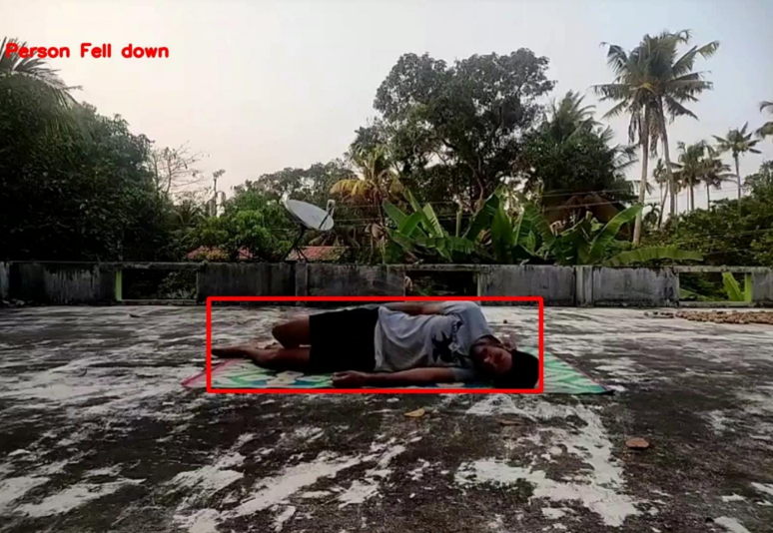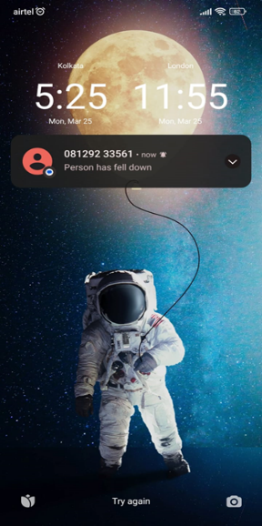





Fig 3 : Working of proposed system

1. **CONCLUSION**

The proposed wall-mounted camera system is designed to precisely detect falls and monitor seniors' overall health. Using advanced computer vision and machine learning, specifically YOLOv7, the system ensures real-time fall detection and activity recognition, reducing false alarms. It also includes millimeter wave-based fall detection for privacy-sensitive areas like bathrooms. When a fall is detected, designated individuals receive SMS alerts with secure links to live footage for quick response. Ultimately, the system aims to empower seniors to live independently while prioritizing their safety, enhancing their quality of life, and providing peace of mind to caregivers.

**REFERENCES**

1. WHO-website: https://www.who.int/news-room/fact-sheets/detail/falls
2. R. Heilym Ramirez, Sergio A. Velastin, Ignacio Meza, Ernesto Fabregas, Dimitrios Makris and Gonzalo Farias,“Fall detection and activity recognition using human skeleton features”0.1109/ACCESS.2021.306162 March 3,2021Bener A, Zirie M, Janahi IM, Al-Hamaq AOAA, Musallam M, Wareham NJ.Prevalence of diagnosed and undiagnosed diabetes mellitus and its risk factorsin a population-based study of Qatar. Diabetes Research and Clinical Practice. 2009;84(1):99–106.
3. Chalavadi Vishnu, Rajeshreddy Datla, Debaditya Roy, Shobhan Babu and C Krishna Mohan,“Human fall detection in surveillance videos using fall motion vector modelling”.DOI 10.1109/JSEN.2021.3082180, IEEE Sensor, Oct,2021
4. Rabia Hasib, Kaleem Nawaz Khan, Miao Yu and Muhammad Salam Khan,“Vison-based human posture classification and fall detection using convolutional neural networks”.2021 International Conference on Artificial Intelligence (ICAI) — 978-1-6654-3293-1/202021 IEEE, Apr 5,2021
5. Ayush Chandak, Nitin Chaturvedi and Dhiraj, “Machine-learningbased human fall detection using contact and non-contact based sensors”.Volume 2022, Article ID 9626170.
6. A. Murad and J.-Y. Pyun, “Deep recurrent neural networks for human activity recognition,” Sensors, vol. 17, no. 11, p. 2556, Nov. 2017.
7. Jia-Wei Lin, Ming-Hung Lu andYuan-Hsiang Lin,“A thermal camera based continuous body temperature measurement system”. Feb 10,2021
8. B. S. Daga, A. A. Ghatol, and V. M. Thakare, “Silhouette based human fall detection using multimodal classif i ers for content based video retrieval systems,” in Proc. Int. Conf. Intell. Comput., Instrum. Control Technol.(ICICICT), Jul. 2017, pp. 1409–1416.
9. P. Bet, P. C. Castro, and M. A. Ponti, “Fall detection and fall risk assessment in older person using wearable sensors: A systematic review,” Int.J. Med. Informat., vol. 130, Oct. 2019, Art. no. 103946.
10. S. C. Agrawal, R. K. Tripathi, and A. S. Jalal, “Human-fall detection from an indoor video surveillance,” in Proc. 8th Int. Conf. Comput., Commun.Netw. Technol. (ICCCNT), Jul. 2017, pp. 1–5.
11. J. Wang, Y. Chen, S. Hao, X. Peng, and L. Hu, “Deep learning for sensorbased activity recognition: A survey,” Pattern Recognit. Lett., vol. 119,pp. 3–11, Mar. 2019.
12. S. Yu, H. Chen, and R. A. Brown, “Hidden markov model-based fall detection with motion sensor orientation calibration: A case for real-life home monitoring,” IEEE Journal of Biomedical and Health Informatics,vol. 22, no. 6, pp. 1847–1853, 2018.
13. Z. Liu, M. Yang, Y. Yuan, and K. Y. Chan, “Fall detection and personnel tracking system using infrared array sensors,” IEEE Sensors Journal, vol. 20, no. 16, pp. 9558–9566, 2020.
14. N. Lu, Y. Wu, L. Feng, and J. Song, “Deep learning for fall detection: Three-dimensional CNN combined with LSTM on video kinematic data,” IEEE Journal of Biomedical and Health Informatics, vol. 23, no.1, pp. 314–323, 2019.
15. J. Maitre, K. Bouchard, and S. Gaboury, “Fall detection with UWB radars and CNN-LSTM architecture,” IEEE Journal of Biomedical and Health Informatics, pp. 1–1, 2020.