**A Study on employee satisfaction at apollo pharmacies ltd**

Bhavana R1Muthumani S2and Bethel Erastus-0bilo3

MBA Student, Jerusalem College of Engineering, Chennai, Tamil Nadu, India

2Professor And Head MBA, Jerusalem College of Engineering, Chennai, Tamil Nadu, India

Vice President of Academic Affairs & Professor of Criminal Justice, University of Atlanta, Atlanta, GA

**Abstract:**

The research project entitled ‘A STUDY ON EMPLOYEE SATISFACTION AT APOLLO PHARMACY LTD’ is an attempt to understand how effectively technology has improved and holds the strength and weakness. The sample size of the study is 105. The research design carried out of this study is descriptive research. Primary data are collected from the Workers, secondary data are gathered from published by someone else for a different purpose than your current research. The findings of the study were arrived at based on the analysis conducted.

**Key Words**: Analysis, Research

**Introduction:**

Human resource is considered to be the most valuable asset in any organization. It is the sum-total of inherent abilities, acquired knowledge and skills represented by the talents and aptitudes of the employed persons who comprise executives, supervisors and the rank-and-file employees. It may be noted here that human resource should be utilized to the maximum possible extent, in order to achieve individual and organizational goals. It is thus the employee's performance, which ultimately decides, and attainment of goals Employee satisfaction is the terminology used to describe whether employees are happy and contented and fulfilling their desires and needs at work. Many measures purport that employee satisfaction is a factor in employee motivation, employee goal achievement, and positive employee morale in the workplace. Employee satisfaction, while generally a positive in your organization, can also be a downer if mediocre employees stay because they are satisfied with your work environment. The term relates to the total relationship between an individual and the employer for which he is paid. Satisfaction does mean the simple feeling state accompanying the attainment of any goal; the end state is feeling accompanying the attainment by an impulse of its objective. This project report mainly focused on a study on employee's satisfaction on APOLLO PHARMACY Ltd. Employee satisfaction is an important factor which will influence the growth and profitability of the firm. Employee satisfaction is terminology used to describe whether employees fulfilling their desire and need at work many measures purport that employee motivation, employees goal achievement and positive employee morale in the work place.

**REVIEW OF LITERATURE:**

Ekta Sinha2019 ,Findings of this study focused on three factors namely Behavioral, organizational and environmental factors. These factors attempted to find the relation between these factors and employee job satisfaction and it was found that all the three factors have a positive impact on job satisfaction. The study concluded that organizational factors are the most important aspect for job satisfaction of the employees in a company i.e. if the employees are treated equally and fairly and they are properly supervised, their level of satisfaction can be increased towards their job. The research design used in the research was descriptive. This research was used because it is a good structured instrument for collection of data. The research method used was survey method. The research technique used was Questionnaire. In all the above research, Researchers have found that for the growth of any organization employee satisfaction is very important. A few factors that were prominent to the employee satisfaction in the researches before were income, promotion, feeling of fulfillment, work environment, relations with superior. Muhammad Rizwan,Waqas Mehmood Khan2020. Workplace, facets of employees and job discipline are related to working situations. Organization tasks and job activities training, capabilities, utilization, health, secure and working period is deal in it. Employees want relax and ease surroundings and these factors regulate on employee satisfaction. Organization gains employee satisfaction by supplied this environment. Physical job conditions primarily ascribed on low job satisfaction levels.Caterina C. Bulgarella2021.The empirical literature summarized the criticality of the relationship between employee attitudes and customer satisfaction. . Employees can strongly contribute to an organization’s success by having a customer-centric approach in their work and in their work-related interactions. However, they are more likely to do so if they are satisfied with their job. Employee satisfaction is the result of a holistic approach that involves strategic steps such as: Service Climate ,Supportive Management Work Effort, Job Satisfaction, Employee Service Quality.

Dr. L.W Poter2022.While employee satisfaction and employee engagement are both critical to maintaining a happy and productive workforce, achieving satisfaction without engagement will have significantly less impact on business results. After all, engaged employees are emotionally committed to working hard, demonstrating initiative, and expending extra discretionary effort — and doing so in alignment with strategic priorities to move the organization forward. It’s no wonder that employee engagement has been associated with higher workforce productivity and customer satisfaction as well as lower absenteeism and turnover. To start reaping bottom-line benefits that a truly engaged workforce promises, organizations must adopt a more dynamic approach to both satisfaction and engagement that incorporates more frequent measurements — not just a once a-year snapshot to identify trends and create effective change. By taking the satisfaction and engagement pulse of employees periodically throughout the year, HR leaders can develop and implement engagement initiatives and management strategies that take into account not only employees’ present perceptions, but also their past experiences and future expectations. The end result is a more sustained increase in employee engagement that drives competitive success and bottom-line results.

**METHODOLOGY**

This study based on both primary and secondary data. The primary data were collected from public sector and college students using questionnaire form. Data was collected using a questionnaire. The questionnaire was distributed among the all through a Google form. The questionnaire included mainly the questions based on the use of mobile payment system. one hundred one respondents were selected for the present study. The secondary data were collected from various books, journals, research articles, magazines, and websites. Primary Objective of the study is to find the relationship towards the impact of mobile payments with special references among them. Secondary Objectives to study the relationship between to understand the awareness level and mobile payments is to understand the usage acceptance. To satisfaction of e-payment among student. The total population of 101 respondents was taken in consideration. The respondents were the among all. Efforts were made to include equal number of respondents from each category.Limitations of the study:The result is based only on the sample which is collected using convenient sampling method. A sample size of only 105 respondents was taken in consideration. The findings will differ with largersample size. were made to include equal number of respondents from each category.The study is focused on use of online payment methods among Jerusalem college students

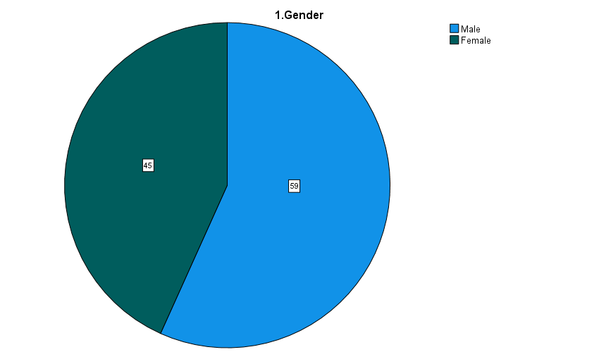**ANALYSIS**

**TABLE 1. Gender**

|  |  |  |
| --- | --- | --- |
| **GENDER** | **NO. OF**  **RESPONDENTS** | **PERCENTAGE** |
| Male | 56.7 | 56.7 |
| Female | 43.3 | 43.3 |
| Total | 100 | 100 |

**INFERENCE:** From the above table it is interpreted that 56.7% are male and 43.3% of respondents are female. Majority (56.7%) are male.

**2. AGE FOR RESPONDENTS :**

**TABLE 2.AGE**

|  |  |
| --- | --- |
| **AGE** | **NO. OF RESPONDENTS** |
| Below-25 | 58.7 |
| 25-30 | 22.1 |
| 31-40 | 18 |
| 41-50 | 2 |
| Total | 100 |

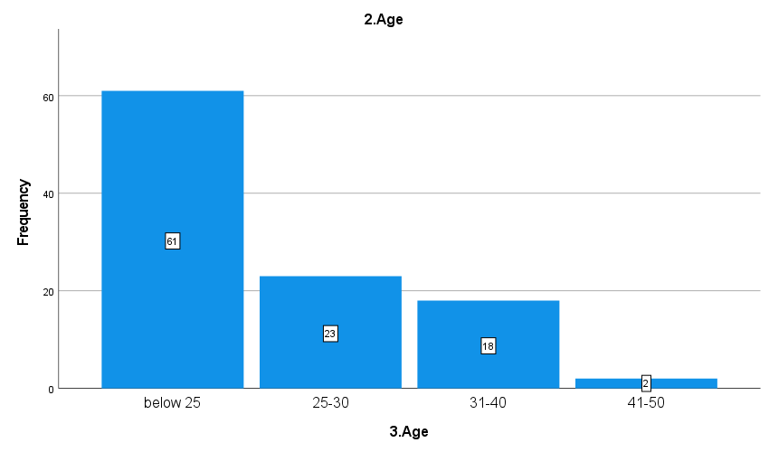

**INTERPRETATION**: From the above table it is interpreted that 58.7 are Below 25 years, 22.1 are

25- 30 years, 17.3 are 31 - 40 years and 1.9 are 41-50 and above. Majority (58.7) are Below 25 years.

**3. EDUCATIONAL QUALIFICATION:**

**TABLE 3.**

|  |  |
| --- | --- |
| **EDUCATIONAL QUALIFICATION** | **NO. OF RESPONDENTS** |
| SSLC | 4.8 |
| HSC | 16.3 |
| UNDERGRADUATE | 77.9 |
| POSTGRADUATE | 1.0 |
| TOTAL | 100 |

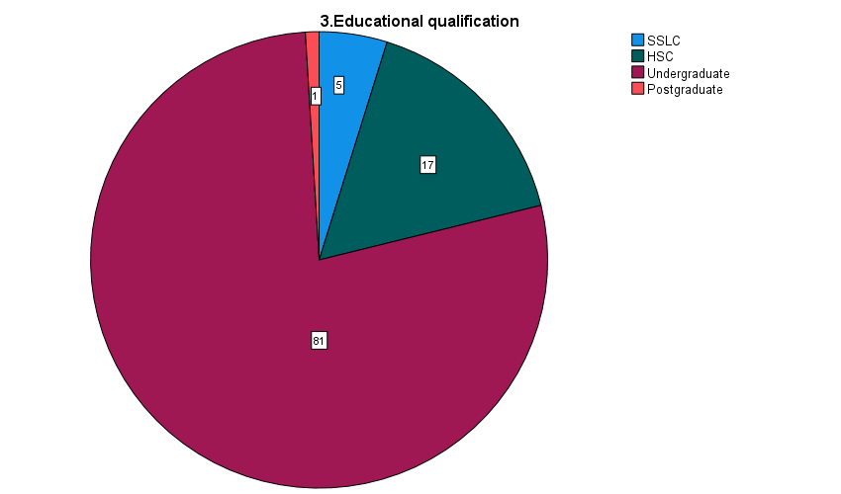

**INTERPRETATION:** From the above table it is interpreted that 5% are SSLC,17% are HSC,81% are Undergraduate,1% are Postgraduate. Majority are (81%) Undergraduate.

**4.DESIGNATION:**

**TABLE 4:**

|  |  |
| --- | --- |
| **DESIGNATION** | **NO. OF RESPONDENTS** |
| Trainee pharmacist | 14.4 |
| Pharmacy aide | 32.7 |
| Pharmacy trainee | 6.7 |
| Senior recrutier | 6.7 |
| Junior recrutier | 7.7 |
| Recruiter | 13.5 |
| HR department | 18.3 |
| Total | 100 |

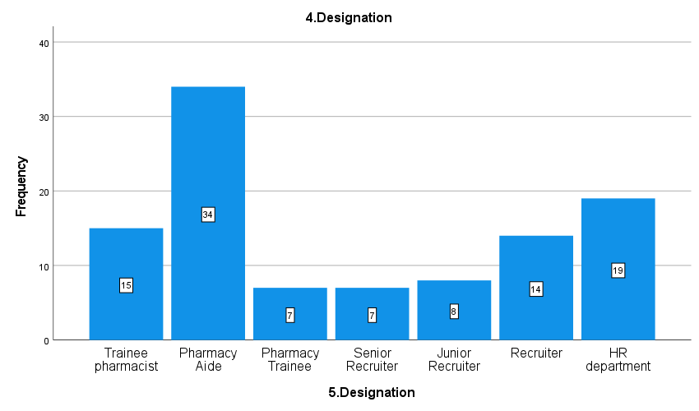**INTERPRETATION:** From the above table it is interpreted that 15 % are trainee pharmacist,34% are pharmacy aide,7% are pharmacy trainee,7% are senior recruiter,8% are junior recruiter, 14% are recruiter, 19% are HR department. Majority are (34%) pharmacy aide

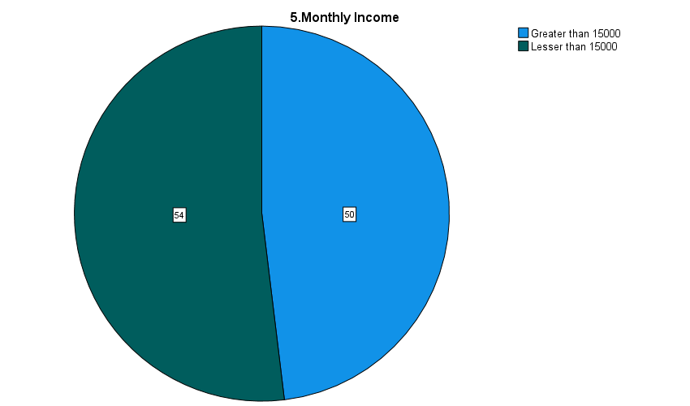**5. MONTHLY INCOME:**

|  |  |
| --- | --- |
| **MONTHLY INCOME** | **NO.0F RESPONDENTS** |
| Greater than 15000 | 48.1 |
| Lesser than 15000 | 51.9 |
| Total | 100 |

**TABLE 5:**

**INTERPRETATION:** From the above table it is interpreted that 50% are greater than 150000 and 54% lesser than 150000. Majority are (54%) lesser than 150000.

|  |  |  |  |  |  |
| --- | --- | --- | --- | --- | --- |
| **ANOVA**  To identify the factors that motivates the employees.  **NULL HYPOTHESIS (H0):** There is a significance difference to identify the factors that motivates the employees  **ALTERNATIVE HYPOTHESIS (H1):** There is no significance to identify the factors that motivates the employees | | | | | |
| What is the primary factor that motivates you at work? | | | | | |
|  | Sum of Squares | df | Mean Square | F | Sig. |
| Between Groups | 5.295 | 3 | 1.765 | 2.304 | .082 |
| Within Groups | 76.618 | 100 | .766 |  |  |
| Total | 81.913 | 103 |  |  |  |

**INFERENCE:** The significant value 0.001 is less than the table significant value (0.082<0.05).

H0 is rejected and H1 is accepted. Therefore, there is significance difference to identify the factors that motivates the employees.

|  |
| --- |
| **Correlations**  To measure the satisfaction level of the employees.  **NULL HYPOTHESIS (H0):** There is a significance difference to measure the satisfaction level of the employees.  **ALTERNATIVE HYPOTHESIS (H1):** There is no significance to measure the satisfaction level of the employees. |

|  |  |  |  |
| --- | --- | --- | --- |
|  | | What aspects of your job do you find most fulfilling? | How satisfied are you with your relationship with your immediate supervisor? |
| What aspects of your job do you find most fulfilling? | Pearson Correlation | 1 | -.065 |
| Sig. (2-tailed) |  | .515 |
| N | 104 | 104 |
| How satisfied are you with your relationship with your immediate supervisor? | Pearson Correlation | -.065 | 1 |
| Sig. (2-tailed) | .515 |  |
| N | 104 | 104 |

**INFERENCE:** The significant value 0.001 is less than the table significant value (0.515<0.05).

H0 is rejected and H1 is accepted.

Therefore, there is significance difference to measure the satisfaction level of the employees

**CHI-SQUARE**

To appraise the employees and understand factors which plays an important role in their job satisfaction.

**NULL HYPOTHESIS (H0):** There is no significance difference of appraise the employees and understand factors which plays an important role in their job satisfaction.

|  |  |  |
| --- | --- | --- |
| **Test Statistics** | | |
|  | How satisfied are you with the level of collaboration within your team in rate scale of 1 to 5? | How long to you get bonus as a part of your performance appraisal ? |
| Chi-Square | 29.212a | 5.846a |
| df | 2 | 2 |
| Asymp. Sig. | .000 | .054 |
| a. 0 cells (0.0%) have expected frequencies less than 5. The minimum expected cell frequency is 34.7.  **INFERENCE:** The significant value 0.000 is less than the table significant value (0.000<0.05).  H0 is rejected and H1 is accepted.  Therefore, there is significance difference of various activities involved in the recruitment process. | | |
|  | | |
| **FINDINGS**  From the above table it is interpreted that 56.7% are male and 43.3% of respondents are female. Majority (56.7%) are male. From the above table it is interpreted that 58.7 are Below 25 years, 22.1 are 25- 30 years, 17.3 are 31 - 40 years and 1.9 are 41-50 and above. Majority (58.7) are Below 25 years. From the above table it is interpreted that 5% are SSLC,17% are HSC,81% are Undergraduate,1% are Postgraduate. Majority are (81%) Undergraduate. From the above table it is interpreted that 15 % are trainee pharmacist,34% are pharmacy aide,7% are pharmacy trainee,7% are senior recruiter,8% are junior recruiter, 14% are recruiter, 19% are HR department. Majority are (34%) pharmacy aide. From the above table it is interpreted that 50% are greater than 150000 and 54% lesser than 150000. Majority are (54%) lesser than 150000. | | |

**SUGGESTION**

Provide actionable recommendations for Apollo Pharmacy Ltd to enhance collaborative satisfaction among employees.

Offer specific strategies for improving salary and benefits structures to positively impact employee satisfaction and collaboration.

Insights into particular areas that Apollo Pharmacies Ltd. needs to focus on and develop in order to promote a more cooperative and satisfying work environment.

**REFERENCE**

**Ekta Sinha 2019 ,**Findings of this study focused on three factors namely Behavioral, organizational and environmental factors.

**Manoj Verghese & Dalvinder Singh Wadhwa 2020** Study concluded that the overall employees with special reference to KRIBHCO,found that with respect to experience the satisfaction level of the employees differ significantly regarding salary.

**Muhammad Rizwan,Waqas Mehmood Khan 2021.** Workplace, facets of employees and job discipline are related to working situations.

**Caterina C. Bulgarella 2022.**The empirical literature summarized the criticality of the relationship between employee attitudes and customer satisfaction**Dr. L.W Poter2022 .**While employee satisfaction and employee engagement are both critical to maintaining a happy and productive workforce, achieving satisfaction without engagement will have significantly less impact on business results.

**Ekta Sinha 2019 ,**Findings of this study focused on three factors namely Behavioral, organizational and environmental factors. **Ekta Sinha 2019 ,**Findings of this study focused on three factors namely Behavioral, organizational and environmental factors. **Ekta Sinha 2019 ,**Findings of this study focused on three factors namely Behavioral, organizational and environmental factors. **Ekta Sinha 2019 ,**Findings of this study focused on three factors namely Behavioral, organizational and environmental factors. **Ekta Sinha 2019 ,**Findings of this study focused on three factors namely Behavioral, organizational and environmental factors. **Ekta Sinha 2019 ,**Findings of this study focused on three factors namely Behavioral, organizational and environmental factors. **Ekta Sinha 2019 ,**Findings of this study focused on three factors namely Behavioral, organizational and environmental factors. **Ekta Sinha 2019 ,**Findings of this study focused on three factors namely Behavioral, organizational and environmental factors. **Ekta Sinha 2019 ,**Findings of this study focused on three factors namely Behavioral, organizational and environmental factors. Throughout the following sections, this study will explore the theoretical foundations of mobile payment adoption, review relevant literature, and detail the research methodology employed to uncover the perceptions, motivations, and behaviors of college students regarding mobile payments. The findings of this investigation promise to broaden our understanding of how technology intersects with finance in the lives of young adults, offering insights that can guide the development of effective strategies for fostering responsible and informed mobile payment usage. As the world hurtles toward an increasingly cashless and digitally interconnected future, comprehending the intricacies of mobile payment adoption among college students becomes an essential endeavor with far-reaching implications.Top of Form