**Inventory Processing and Query Management using Data Visualization**

**USHARANI.K1, Karthikeyan.S2, Vivekan.O.P3, Amesh.J4, Anand.R.M5,**

*1Assistant Professor Department of Computer Science and Engineering,*

*K.L.N. College of Engineering and Technology, Sivagangai, India*

*2,3,4,5Student, Department of Computer Science and Engineering,*

*K.L.N. College of Engineering and Technology, Sivagangai, India*

*Corresponding Author: usharanibe@gmail.com*

|  |
| --- |
| ***Abstract:****This project focuses on enhancing model management efficiency and customer engagement through the development of a Django-based web application. The system is designed to streamline workflows for Main Admin by optimizing tasks such as customer communication and model support. It also provides Secondary Admin with detailed data visualizations, including charts and graphs, that offer insights into sales, leads, and customer behavior. The application further enhances query management by ensuring prompt handling and resolution of customer and business requests. Ultimately, the integration of comprehensive data analytics improves decision-making and project outcomes, contributing to more efficient model management.*  ***Key Word****:*Django Web Application, Data Visualizations, Sales Insights, , Query Management, Decision-Making, Project Outcomes, Workflow Optimization, , Customer Communication. |

**I. Introduction**

This project aims to develop a sophisticated web application designed to enhance model management and improve organizational efficiency. The system includes specialized tools for Main Admin, enabling them to manage key tasks such as customer interactions and model support. On the other hand, Secondary Admin benefits from a comprehensive view of system performance through detailed data visualizations, including charts and graphs, which transform complex data into clear, actionable insights. The application is also designed to streamline the resolution of customer and business queries, ensuring prompt responses that enhance both satisfaction and operational efficiency. By integrating advanced analytics with efficient management processes, the system ultimately seeks to improve decision-making and drive better project outcomes.

**II. Research And Findings**

This project focuses on enhancing model management and customer engagement through the development of a web application using Django. The research reveals several important findings. First, the Main Admin workflow has been significantly streamlined with tools for managing customer communication and model support. This has led to more efficient administrative processes, reducing the time taken to complete tasks and improving customer satisfaction through quicker responses.

For Secondary Admin, the introduction of detailed data visualizations, such as charts and graphs, has provided a clearer understanding of system performance. These visualizations cover key metrics like sales, leads, and customer insights, enabling better decision-making. By converting complex data into easily interpretable formats, Secondary Admin can identify trends and take strategic actions, though ensuring that the visualizations remain user-friendly without overwhelming users is an ongoing challenge.

The system also features a robust query management tool that facilitates effective handling of customer and business requests. This has resulted in smoother communication and faster query resolution, thereby increasing operational efficiency. However, as the volume of queries increases, maintaining the system’s responsiveness and stability will require additional improvements.

Finally, the integration of comprehensive data analytics has proven to be a crucial asset, aiding both Main Admin and Secondary Admin in making more informed, data-driven decisions. While the system performs well, challenges such as ensuring data accuracy, scaling to meet future demands, and enhancing security will be key areas for future development to further optimize the system’s performance and impact.

**III. System Implementation**

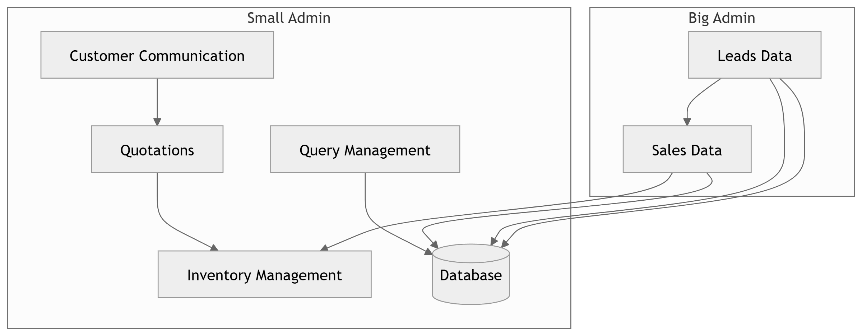

The system architecture depicted in the diagram is structured to streamline business operations across two administrative layers: Main Admin and Secondary Admin, with clear roles for each. The Main Admin is responsible for handling customer-facing processes, while Secondary Admin manages sales and lead data.

1) Customer Communication

This module initiates the system by capturing all interactions with customers. The Customer Communication module gathers inquiries and requests from customers, directing them to relevant areas such as Query Management within the Main Admin domain. This ensures that customer needs are addressed promptly and efficiently.

2)Query Management

The Query Management module is housed within the Main Admin, where it tracks and addresses customer queries. It ensures that all customer inquiries are resolved efficiently and escalates issues when necessary. This module plays a key role in maintaining customer satisfaction and seamless communication.

3)Inventory Management

The Inventory Management module is integral to ensuring the Main Admin can provide accurate information to customers. It interacts with the Database to track stock levels, ensuring that commitments reflect the actual availability of items. Inventory updates occur in real time to avoid discrepancies between stock and customer commitments.

4)Database

At the heart of the system, the centralized Database integrates all critical data, from customer communications to sales and lead data. It ensures seamless data flow and synchronization across all modules. This real-time access to data allows both Main Admin and Secondary Admin to operate efficiently without overlaps or delays.

5)Sales Data & Leads Data (Secondary Admin)

The Secondary Admin is primarily responsible for viewing and analyzing Sales Data and Leads Data. These modules provide insights into business performance, trends, and potential leads. The Secondary Admin can only view this data through reports, charts, and dashboards, and they have no capability to manage or alter the data. This ensures that the Secondary Admin has a purely observational and analytical role, leaving the operational and customer-facing responsibilities entirely to the Main Admin.

**IV.CONCLUSION**

The proposed system effectively optimizes and streamlines business operations by integrating key modules within two distinct administrative layers: Main Admin and Secondary Admin. The Main Admin handles critical tasks such as customer communication, managing queries, and overseeing inventory. These processes are directly tied to real-time data from the Database, ensuring that all customer-facing activities are efficient and accurate.

In contrast, the Secondary Admin is designed solely for observational purposes, where it can view Sales Data and Leads Data in visual formats like charts and reports. This layer has no active role in the management or alteration of system data, allowing for clear separation of responsibilities and ensuring that operational decisions remain within the Main Admin's domain.

Through this architecture, the system enhances overall business efficiency by automating and centralizing data flow, enabling informed decision-making, and fostering better coordination between departments. The integration of the Database ensures that all modules remain updated in real-time, further improving the system's reliability and performance. Ultimately, the project demonstrates the power of a well-structured, role-specific administrative system in driving business success and operational improvement.

**References**

* Juanjuan Li, Rui Qin, and Fei-Yue Wang, “The Future of Management: DAO to Smart Organizations and Intelligent Operations”, in IEEE Access, vol. 53, pp. 3389-3399, 2023
* S. Sakri et al., “A Comprehensive State-of-the-Art Survey on Data Visualization Tools: Research Developments, Challenges and Future Domain Specific Visualization Framework”, in IEEE Access, vol. 10, pp. 96581 - 96601, 2022
* M. Koschi and M. Althoff, “Set-based prediction of traffic participants considering occlusions and traffic rules,” IEEE Trans. Intell. Veh., vol. 6, no. 2, pp. 249–265, Jun. 2021.
* T. A. Stewart, Intellectual Capital: The New Wealth of Organization. New York, NY, USA: Crown Business, 1997.
* P. Vanhulst, F. Evequoz, R. Tuor, and D. Lalanne, ‘‘A descriptive attribute976 based framework for annotations in data visualization,’’ in Proc. Int. Joint 977 Conf. Comput. Vis., Imag. Comput. Graph. Cham, Switzerland: Springer, 978 2018, pp. 143–166