**Title: Effect of varying stiffness of top foil on the performance of Air foil thrust bearing (AFTB)**

**Authors:**

1. Abhishek H E, MTech Student (Machine Design), Department of Mechanical Engineering, B. M. S. COLLEGE OF ENGINEERING, Bengaluru-560019, India

2. Dr. R. N. Ravikumar, Associate Professor, Department of Mechanical Engineering, B. M. S. COLLEGE OF ENGINEERING, Bengaluru-560019, India

**Abstract**

Air foil thrust bearings (AFTB) are essential components in various rotating machinery, such as gas turbines and turbochargers, designed to support higher loads while minimizing friction and wear. The project aims to investigate the effect of varying stiffness of the top foil on the performance of air foil thrust bearings. The stiffness of the top foil is a critical parameter that influences the bearing's load-carrying capacity, stability, and overall efficiency. The geometric parameters like foil geometry, sector angle of top foil, initial angle of top foil and thickness of top foil and operating parameters like runner speed, gap between top foil and runner, will affect the load carrying capacity of the thrust bearing.

The study involves both static analysis and dynamic analysis to comprehensively evaluate how changes in top foil stiffness affect the bearing's operational characteristics. The geometric parameters like foil geometry, sector angle of top foil, initial angle of top foil and thickness of top foil are considered for the study.

The results of these analyses will be used to validate how the varying geometrical parameters impact the stiffness of the Air foil thrust bearing. This will provide practical insights into the real-world performance of air foil thrust bearings with varying top foil stiffness.

The findings of this research will have significant implications for the design and optimization of air foil thrust bearings in various industrial applications. By understanding how changes in top foil stiffness affect the bearing's performance, engineers and researchers can enhance the efficiency and reliability of rotating machinery, ultimately contributing to improved energy efficiency and reduced maintenance costs.

#### Chapter 1

# Introduction

## 1.1 Introduction to Bearing

Bearings are the machine elements that allow the relative movement of components with respect to each other, and they play a very essential role in turbo-machinery systems. An important function of the bearing is to support the shaft in the axial or radial direction due to loading from compressor, turbine and other components connected to the shaft. Since ancient times, bearings have been used for various applications in various forms. Recently, however, their importance has increased as the machines have been driven to greater speeds and higher power.

## 1.2 Air Foil Thrust Bearing

Air foil thrust bearings (AFTB) are the self-acting type of bearing which utilizes gas (usually air as its lubricating medium). At less rotational speed, the air foil bearing will operate in dry friction conditions. Above the limit speed, a gas film forms in the air gap and the journal of the bearing is lifted-off. Due to the utilization of gas or air as a lubricant, air foil bearings have very low friction losses and can operate at greater rotational speed. On the other hand, they also have some important drawbacks as well. The important drawback includes low load carrying capacity and higher frictional torque during the startup. Despite these disadvantages or drawbacks, the air foil thrust bearings (AFTB) have found applications in high-speed turbomachinery like air cycle machines or industrial blowers and compressors. Currently many research facilities around the world are developing new air foil thrust bearing concepts for automotive turbochargers and small jet engines. The main goal of these research programs is to increase the load carrying capacity of the bearing and develop a durable coating layer that has a low coefficient of friction and can withstand the high temperatures, which is especially important in the field of gas turbine solutions.

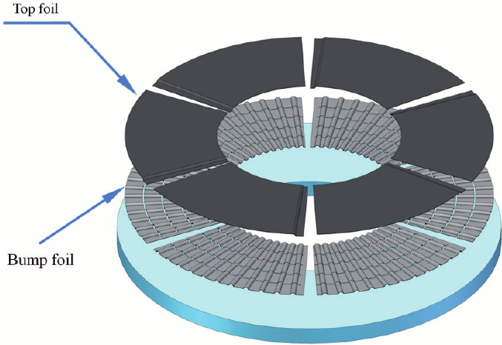

Fig 1.2: Fundamental structure of an Air foil thrust bearing (AFTB)

Air foil thrust bearing (AFTB) also represent an enabling technology for advanced oil-free turbomachinery applications. Operating at high speeds and temperatures, the next-generation turbo machines will present tribological challenges that conventional oil lubricated rolling element bearings may be unable to meet, including shaft speeds and bearing temperatures which is excess of 400° C. Therefore, continued advancement of foil bearing technology will allow more widespread adoption of oil-free shaft supports in high speed rotating systems or equipments.

## 1.3 Literature Gap

While research on air foil thrust bearing (AFTB) and their components is extensive, there exists a notable gap in the study concerning the specific impact of varying the stiffness of the top foil on the overall performance of air foil thrust bearing. Although there are numerous studies focusing on the performance and design of air foil thrust bearings, few studies systematically investigate the effects of changing the stiffness of the top foil. So in our project we are conducting systematic study of the effect of varying stiffness on the performance of air foil thrust bearing (AFTB).

Stiffness of the top foil has the potential to influence key performance metrics of air foil thrust bearings, such as load-carrying capacity, friction, and stability. The stiffness of a top foil depends on its thickness, number of foils, the initial angle of a top foil and sector angle of a top foil. Understanding these relationships is crucial for optimizing bearing performance in high-speed rotating machinery. Addressing this gap is essential for optimizing the design of air foil thrust bearing in various applications and ensuring that they perform optimally under different operating conditions.

#### Chapter 2

# Problem Definition and Methodology

## 2.1 Problem Statement

Modeling and analysis of the top foil of Air foil thrust bearing (AFTB) for varying stiffness and to determine the load carrying capacity of bearing under different configurations.

## 

## 2.2 Objectives

The objectives of the project are as follows:

* To model the top foil of AFTB by varying geometrical parameters.
* To conduct static structural analysis to determine the stiffness and load carrying capacity of AFTB under different foil configurations.
* To conduct dynamic structural analysis to determine the stiffness and load carrying capacity of AFTB at different operating conditions.
* To understand the effect of varying stiffness of top foil on the performance of AFTB.

#### 

#### Chapter 3

# Modeling and Analysis of Air Foil Thrust Bearing

Air foil thrust bearing (AFTB) is usually composed of three major components:

* The thrust bearing backing plate.
* Top foil to provide the stationary boundary for the hydrodynamic gas film.
* Bump foil structure which provides compliant support for the top foil.

But in our study, we are considering a bearing with bearing backing plate and top foil.

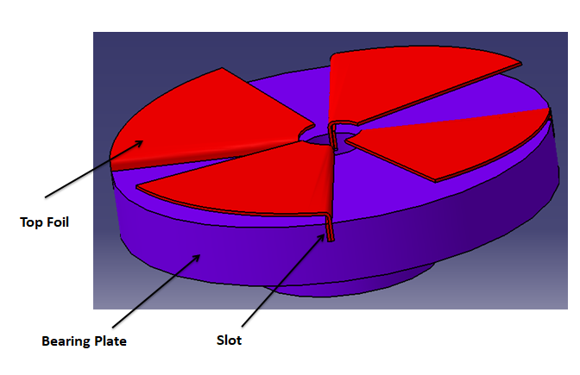

Fig 3.1: Components of Air foil thrust bearing

## 3.1 Design of Bearing Plate

The design and features of the bearing plate can vary based on the specific application and operating conditions. The geometrical parameters considered for the modelling of the bearing plate are as per the work done by Ravikumar, R.N., Rathanraj, K.J. and Kumar, V.A [6]

1. Outer diameter of the Bearing Plate: 60 mm
2. Inner diameter of the Bearing Plate: 10 mm

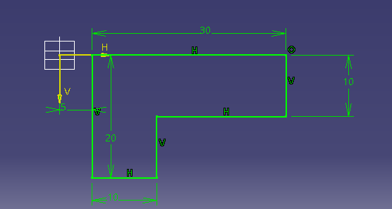

Fig 3.2: Dimensions of the bearing plate

## 3.2 Top Foil

The top foil is one of the key or critical components of Air foil thrust bearing, which plays a crucial role in maintaining a stable, thin film of air between the rotor and the bearing surface. A fundamental aspect of top foil design is its geometry. Studies have also investigated the impact of factors like foil thickness and width on load-carrying capacity and stiffness.

The air film formed on the top foil is crucial for reducing friction and ensuring stable operation at high speeds. The stiffness of top foil depends on its thickness, the number of foils, initial angle of the top foil and sector angle of the top foil. The backing plate is slotted to allow the top foils to be easily installed and removed.

The geometrical parameters considered for the modeling of the top foil are as follows:

|  |  |  |
| --- | --- | --- |
| **Sl No** | **Geometrical parameters** | **Dimensions** |
| 1 | Thickness of the top foil | 0.1 mm, 0.3 mm, 0.5 mm |
| 2 | Variable thickness of the top foil | 0.2 mm to 0.5 mm |
| 3 | Sector angle of the top foil | 45°, 60°, 90° |
| 4 | Initial angle of the top foil | 3°, 6°, 9° |

Table 5.1: Geometrical parameters of top foil

#### Chapter 6

# Results and Conclusion

## 6.1 Static Structural Analysis

### Static structural analysis in ANSYS refers to a type of finite element analysis (FEA) that focuses on studying the behaviour of a structure or component under static, steady-state loading conditions. In this analysis, the primary goal is to understand how a structure responds to applied forces or constraints without considering dynamic effects, such as acceleration or changes in load over time.

Static structural analysis in ANSYS typically involves:

* **Steady-State Loads:** Static structural analysis deals with loads that do not change over time. These can include forces, pressures, moments, and constraints applied to the structure.
* **Equilibrium:** The analysis is based on the assumption that the structure is in static equilibrium, meaning that all forces and moments are balanced, and there is no net acceleration.
* **Linear Material Behavior:** In many cases, linear material behavior is assumed, meaning that the relationship between stress and strain remains linear within the analyzed load range.
* **Boundary Conditions:** One can define boundary conditions, including constraints that restrict the degrees of freedom at specific locations to simulate how the structure is supported or restrained.

The specific aspects considered for the analysis of the bearing are as follows:

|  |  |  |
| --- | --- | --- |
| 1 | Material | Structural Steel |
| 2 | Meshing | Default meshing |
| 3 | Boundary conditions | Inner diameter and base of the bearing plate is made fixed support. |
| 4 | Static load | 100 N |

Table 6.1: Aspects considered for static analysis

## 6.2 Results of Static Analysis

### 6.2.1 Results obtained from varying the thickness of the top foil

In this case, the top foil with 90° sector angle and initial angle of 3° has been considered to study the effect of varying thickness of top foil on the stiffness of the bearing. The following tables indicate how the deformation, stress and strain of top foil vary as the thickness of the foil changes.

**Deformation:**

|  |  |  |  |
| --- | --- | --- | --- |
| **Thickness of top foil [mm]** | **Minimum Deformation [mm]** | **Maximum Deformation [mm]** | **Average Deformation [mm]** |
| 0.1 | 0 | 43.58 | 5.7295 |
| 0.3 | 0 | 3.3599 | 0.39248 |
| 0.5 | 0 | 0.12787 | 1.32e-002 |

Table 6.2: Deformation of 0.1 mm, 0.3 mm, 0.5 mm top foil

**Equivalent Stress:**

|  |  |  |  |
| --- | --- | --- | --- |
| **Thickness of top foil [mm]** | **Minimum Stress [MPa]** | **Maximum Stress [MPa]** | **Average Stress [MPa]** |
| 0.1 | 2.013e-002 | 10871 | 802.35 |
| 0.3 | 1.0506e-003 | 972.98 | 126.73 |
| 0.5 | 1.2875e-003 | 52.348 | 5.7185 |

Table 6.3: Equivalent stress of 0.1 mm, 0.3 mm, 0.5 mm top foil

**Equivalent Strain:**

|  |  |  |  |
| --- | --- | --- | --- |
| **Thickness of top foil [mm]** | **Minimum Strain** | **Maximum Strain** | **Average Strain** |
| 0.1 | 1.6183e-007 | 5.4475e-002 | 6.1421e-003 |
| 0.3 | 7.7005e-009 | 5.0834e-003 | 8.7604e-004 |
| 0.5 | 1.0993e-008 | 2.6872e-004 | 3.9888e-005 |

Table 6.4: Equivalent strain of 0.1 mm, 0.3 mm, 0.5 mm top foil

### From the following data, we can conclude that 0.5mm thick top foil is more stable compared to the other 2 profiles and hence, we conclude that top foil with 0.5mm thickness has minimum deformation & can handle the load conditions better.

### 6.2.2 Results comparison between 0.5 mm thick top foil and variable thickness of the top foil (0.2-0.5 mm)

In this case also, the top foil with 90° sector angle and initial angle of 3° has been considered to study the effect of varying thickness of top foil on the stiffness of the bearing. The term "variable thickness of top foil" refers to the design feature where the thickness of the top foil can vary across its surface. In this design, 0.2mm thickness is towards the slot and 0.5 mm thickness is towards trailing edge. The following tables compare how the deformation, stress and strain of top foil vary as the thickness of the foil changes.

**Deformation:**

|  |  |  |  |
| --- | --- | --- | --- |
| **Thickness of top foil [mm]** | **Minimum Deformation [mm]** | **Maximum Deformation [mm]** | **Average Deformation [mm]** |
| 0.5 | 0 | 0.12787 | 1.32e-002 |
| 0.2 to 0.5 | 0 | 2.6391 | 0.2994 |

Table 6.5: Deformation of top foil having 0.5 mm thickness and 0.2-0.5 mm variable thickness

**Equivalent Stress:**

|  |  |  |  |
| --- | --- | --- | --- |
| **Thickness of top foil [mm]** | **Minimum Stress [MPa]** | **Maximum Stress [MPa]** | **Average Stress [MPa]** |
| 0.5 | 1.2875e-003 | 52.348 | 5.7185 |
| 0.2 to 0.5 | 1.2499e-002 | 1300.5 | 170.71 |

Table 6.6: Equivalent stress of top foil having 0.5 mm thickness and 0.2-0.5 mm variable thickness

**Equivalent Strain:**

|  |  |  |  |
| --- | --- | --- | --- |
| **Thickness of top foil [mm]** | **Minimum Strain** | **Maximum Strain** | **Average Strain** |
| 0.5 | 1.0993e-008 | 2.6872e-004 | 3.9888e-005 |
| 0.2 to 0.5 | 9.6146e-008 | 6.5311e-003 | 1.2284e-003 |

Table 6.7: Equivalent strain of top foil having 0.5 mm thickness and 0.2-0.5 mm variable thickness

### The results between the 0.5 mm thick top foil and variable thickness foil (0.2-0.5 mm) are compared. 0.5 mm thick top foil shows much more stabilization compared to the variable thickness top foil because of many factors:

* **Load Distribution:** The load distribution across the bearing surface plays a crucial role. In variable thickness foil, the load is uneven or concentrated more towards the inner side as inner side foil has less thickness. A uniform thickness foil of 0.5 mm distributes the load more evenly, resulting in less deformation.

### Stiffness Distribution: The variable thickness design introduces varying stiffness across the top foil surface. The inner side with 0.2 mm thickness may have lower stiffness compared to the outer side with 0.5 mm thickness. This stiffness variation can affect the deformation characteristics.

### Rotational Speed and Centrifugal Effects: The rotational speed of the shaft and the resulting centrifugal effects can impact the deformation of the top foil. The variable thickness design may interact differently with centrifugal forces, leading to variations in deformation.

### So we can conclude that 0.5 mm Thick foil is much more stable & can handle the uniform loads much better compared to variable thickness foil.

### 6.2.3 Results obtained from different sector angle of top foil

In this case, the top foil with 0.5 mm thickness and initial angle 3° has been considered to study the effect of varying sector angle on stiffness of the bearing.   
The sector angle of the top foil in an air foil thrust bearing refers to the angular span of the bearing surface covered by the top foil. This angle is often specified in degrees and defines the portion of the circumference around the bearing plate where the top foil is present. The sector angle is typically defined in relation to a full 360-degree circle, where 360 degrees would represent a complete circular top foil. The following tables indicate how the deformation, stress and strain of top foil vary as the sector angle of the foil changes.

**Deformation:**

|  |  |  |  |
| --- | --- | --- | --- |
| **Sector angle of top foil [°]** | **Minimum Deformation [mm]** | **Maximum Deformation [mm]** | **Average Deformation [mm]** |
| 45° | 0 | 0.5287 | 3.7553e-002 |
| 60° | 0 | 0.78657 | 6.1322e-002 |
| 90° | 0 | 0.12787 | 1.32e-002 |

Table 6.8: Deformation of top foil having 45°, 60° and 90° sector angle

**Equivalent Stress:**

|  |  |  |  |
| --- | --- | --- | --- |
| **Sector angle of top foil [°]** | **Minimum Stress [MPa]** | **Maximum Stress [MPa]** | **Average Stress [MPa]** |
| 45° | 1.7317e-002 | 208.38 | 41.423 |
| 60° | 9.0975e-003 | 303.38 | 49.956 |
| 90° | 1.2875e-003 | 52.348 | 5.7185 |

Table 6.9: Equivalent stress of top foil having 45°, 60° and 90° sector angle

**Equivalent Strain:**

|  |  |  |  |
| --- | --- | --- | --- |
| **Sector angle of top foil [°]** | **Minimum Strain** | **Maximum Strain** | **Average Strain** |
| 45° | 1.6903e-007 | 1.0475e-003 | 2.8394e-004 |
| 60° | 1.5156e-007 | 1.5182e-003 | 3.4501e-004 |
| 90° | 1.0993e-008 | 2.6872e-004 | 3.9888e-005 |

Table 6.10: Equivalent strain of top foil having 45°, 60° and 90° sector angle

From the following analysis with different sector angles, we can observe that the top foil having sector angle of 90° has much better stiffness considered to the other angles and can handle stress better. It's important to note that the specific sector angle chosen for a given application is part of the overall design process, and it may vary depending on factors such as the type of machinery, operating conditions, and performance requirements. Engineers carefully consider these factors to optimize the design of air foil thrust bearings for specific applications. In air foil thrust bearings, the top foil is designed to generate a thin film of air that supports the axial load. The sector angle influences the shape and size of the air film, which, in turn, affects the bearing's ability to carry loads and maintain stability during operation. A larger sector angle generally provides a larger bearing surface, potentially increasing load capacity, but it may also affect other aspects of performance.

Hence we can conclude that top foil with sector angle of 90° with 5 mm thickness is comparatively better than other variations conducted so far.

### 6.2.4 Results obtained from varying the initial angle of the top foil

In this case, the top foil with 90° sector angle and thickness of 5 mm has been considered to study the effect of varying initial angle of top foil on the stiffness of the bearing. The "initial angle" of the top foil in an air foil thrust bearing refers to the inner angle between the top foil and the top foil at horizontal position when the bearing is at rest or not subjected to any external loads. The following tables indicate how the deformation, stress and strain of top foil vary as the initial angle of the foil changes.

**Deformation:**

|  |  |  |  |
| --- | --- | --- | --- |
| **Initial angle of top foil [°]** | **Minimum Deformation [mm]** | **Maximum Deformation [mm]** | **Average Deformation [mm]** |
| 3° | 0 | 0.12787 | 1.32e-002 |
| 6° | 0 | 1.3493 | 0.14992 |
| 9° | 0 | 1.3129 | 0.1689 |

Table 6.11: Deformation of top foil having 3°, 6° and 9° initial angle

**Equivalent Stress:**

|  |  |  |  |
| --- | --- | --- | --- |
| **Initial angle of top foil [°]** | **Minimum Stress [MPa]** | **Maximum Stress [MPa]** | **Average Stress [MPa]** |
| 3° | 1.2875e-003 | 52.348 | 5.7185 |
| 6° | 1.5439e-002 | 456.41 | 58.886 |
| 9° | 1.385e-002 | 417.49 | 58.15 |

Table 6.12: Equivalent stress of top foil having 3°, 6° and 9° initial angle

**Equivalent Strain:**

|  |  |  |  |
| --- | --- | --- | --- |
| **Initial angle of top foil [°]** | **Minimum Strain** | **Maximum Strain** | **Average Strain** |
| 3° | 1.0993e-008 | 2.6872e-004 | 3.9888e-005 |
| 6° | 1.1563e-007 | 2.3387e-003 | 4.0697e-004 |
| 9° | 1.1588e-007 | 2.0906e-003 | 3.9971e-004 |

Table 6.13: Equivalent strain of top foil having 3°, 6° and 9° initial angle

### From the following data, we can conclude that top foil having 3° initial angle is more stable compared to the other two initial angles. So we can conclude that top foil having 3° initial angle is found to be more stable with respect to deformation and stress factors because of following factors:

* **Load Distribution:** The initial angle can affect how the load is distributed across the top foil. 3° initial angle of top foil may distribute the load more evenly, resulting in less deformation compared to 6° and 9° initial angle.

### Stiffness Distribution: The initial angle contributes to the overall stiffness of the top foil. A larger initial angle might introduce variations in stiffness across the bearing surface, affecting how it responds to applied loads.

* **Contact Area:** The initial angle influences the contact area between the top foil and the rotating shaft. Changes in the contact area can impact both the deformation and stiffness of the bearing. 3° initial angle of top foil have more contact area between top foil and rotating shaft compared to 6° and 9° initial angle.
* **Operating Conditions:** The behaviour of the bearing, including deformation and stiffness, can be influenced by the specific operating conditions such as rotational speed, temperature etc.

### 6.2.5 Summary of Static Analysis

### Considering the geometrical parameters of top foil design, we can conclude that the top foil having 0.5 mm thickness, 90° sector angle and 3° initial angle is more stable compared to the other profiles and hence, we conclude that top foil having 0.5 mm thickness, 90° sector angle and 3° initial angle have minimum deformation & can handle the load conditions better.

**Deformation:**

The top foil of Air foil thrust bearing acts as cantilever beam and the maximum deflection or deformation is at the end of the foil towards trailing edge.

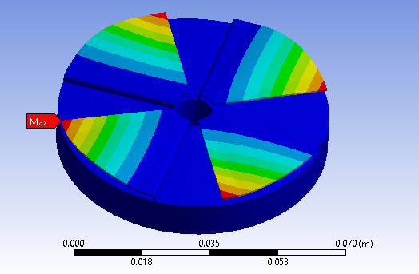

Fig 6.1: Deformation of 0.5 mm thick top foil

**Stress:**

The stress distribution in the top foil of an air foil thrust bearing is influenced by the operating conditions, load distribution, and the design of the bearing itself. The stress is often higher towards the slot region due to several factors:

* **Load Concentration:** The slot region is where the more axial load is often applied to the top foil. The concentration of load in this area leads to higher stress compared to other regions of the top foil. The load is typically applied near the leading edge of the top foil, and this is where the pressure distribution within the air film is significant.
* **Contact Area:** The contact area between the top foil and the rotating shaft is crucial for load transfer. The slot region is where the contact area is often maximized, leading to increased stress in that specific region.
* **Geometry and Boundary Conditions:** The specific design of the bearing, including the geometry of the top foil and the boundary conditions, can contribute to stress concentrations. The presence of the slot and the attachment points can influence the stress distribution.
* **Material Properties:** The material properties of the top foil also play a role. If the material has variations in stiffness or if it exhibits non-uniform behavior, this can result in stress concentrations in certain areas, such as the slot region.

To address the potential issues related to stress concentration, one can employ various strategies; including optimizing the design, adjusting the material properties, and considering different load distribution scenarios. Finite element analysis and other engineering tools are often used to simulate and analyze the stress distribution in the top foil and optimize its design for better performance and durability.

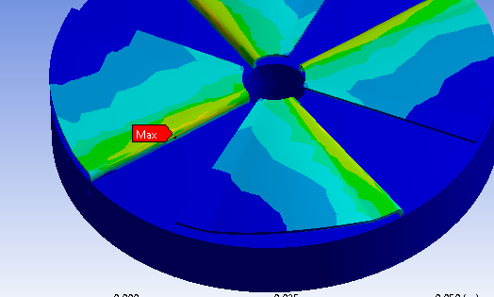

Fig 6.2: Stress distribution of 0.5 mm thick top foil

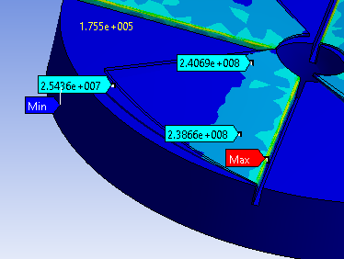

Fig 6.3: Stress distribution of variable thickness top foil

The stiffness of the top foil refers to its structural rigidity or resistance to deformation under load. A stiffer top foil has a higher stiffness, which means it deforms less under load. Conversely, a more flexible or less stiffer top foil will exhibit greater deflection when subjected to the same load. Hence, from the static analysis the top foil having 0.5 mm thickness, 90° sector angle and 3° initial angle have lesser deformation, higher stiffness, and high load carrying capacity compared to all other parameters considered.

## 6.3 Dynamic Structural Analysis

## Dynamic analysis in ANSYS involves simulating and studying the structural response of a structure or component to time-varying loads or dynamic forces. This analysis is particularly important for components or structures that experience changing conditions, such as those subjected to varying operating speeds. In this case, dynamic analysis of AFTB at different operating speeds has been evaluated which helps us to assess the bearing's response to rotational variations.

The specific aspects considered for the dynamic analysis of the bearing at different operating speed are as follows:

|  |  |  |
| --- | --- | --- |
| 1 | Material | Structural Steel |
| 2 | Meshing | Default meshing |
| 3 | Boundary conditions | Inner diameter and base of the bearing plate is made fixed support. |
| 4 | Rotational velocity applied on thrust runner | 10000, 20000, 30000, 40000 rpm |

Table 6.14: Aspects considered for dynamic analysis

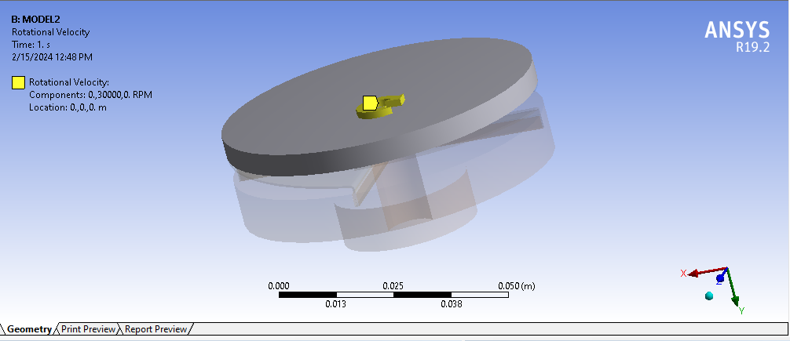

Fig 6.4: Application of operating speed of 30000 rpm on thrust runner

## 6.4 Results of Dynamic Analysis

### 6.4.1 Top foil having different sector angles with same thickness and same initial angle

In this case, one model of top foil with 90° sector angle, 0.5 mm thickness and initial angle of 3° and another model of top foil with 45° sector angle, 0.5 mm thickness and initial angle of 3° has been considered to study the effect of varying operating speeds on top foil of the bearing. The following table indicates how the stress of top foil changes according to the varying operating speeds.

**Equivalent Stress:**

|  |  |  |  |  |
| --- | --- | --- | --- | --- |
| **Model/Speed** | **10000 rpm** | **20000 rpm** | **30000 rpm** | **40000 rpm** |
| **Model 1** (4 foils; 90° Sector angle; 0.5 mm thickness; 3° initial angle) | 24.36 MPa | 33.59 MPa | 51.19 MPa | 90.18 MPa |
| **Model 2** (4 foils; 45° Sector angle; 0.5 mm thickness; 3° initial angle) | 14.68 MPa | 24.16 MPa | 39.31 MPa | 69.87 MPa |

Table 6.15: Maximum equivalent stress vs operating speed of Model 1 and Model 2

As the rotational speed of the thrust runner on the top foil of an air foil thrust bearing increases, the stress in the top foil also increases. The change in stress level of top foil can be attributed to several factors.

* **Centrifugal Effects:** Increased rotational speed leads to higher centrifugal forces acting on the top foil. This can result in increased stresses, especially at the inner edges of the foil.
* **Temperature Rise:** Higher rotational speeds can generate more heat due to friction and other factors. Elevated temperatures can influence the material properties, potentially affecting stress levels.
* **Dynamic Effects:** Increased rotational speed may introduce dynamic effects, such as vibrations and oscillations, which can impact the stress distribution in the top foil.
* **Material Fatigue:** Higher rotational speeds can lead to increased fatigue loading on the top foil material. It's crucial to consider the material's fatigue strength and design the bearing accordingly to ensure durability under dynamic conditions.
* **Frictional Effects:** The friction between the top foil and thrust runner can influence the stress distribution.

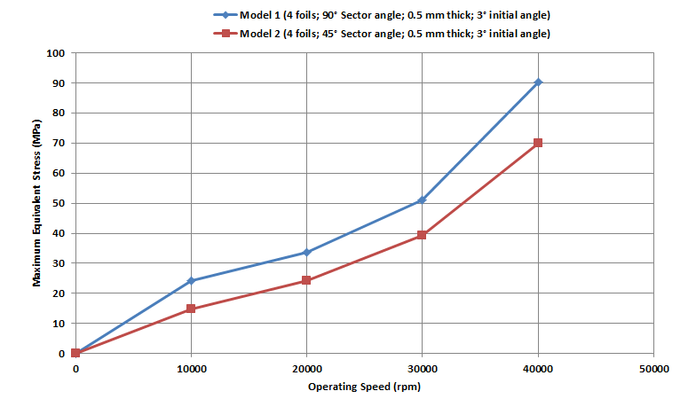

Fig 6.5: Maximum equivalent stress vs operating speed of Model 1 and Model 2

Figure 6.5 shows the variation of maximum equivalent stress of top foil as a function of operating speed for model 1 and model 2. As the rotational speed of the thrust runner on the top foil of an air foil thrust bearing increases, the stress value also increases. Comparing the results from the figure 6.5, we can observe that under dynamic load conditions 45° sector angle top foil have better load carrying capacity compared to 90° sector angle top foil.

The difference in load carrying capacity between a 45° sector angle top foil and a 90° sector angle top foil in an air foil thrust bearing can be attributed to various factors related to the bearing's design and operational conditions.

### Here are some potential reasons why a 45° sector angle top foil might show better load carrying capacity compared to a 90° sector angle top foil:

### Load Distribution: A 45° sector angle distributes the load over a smaller portion of the bearing's circumference. This can lead to a more uniform load distribution, reducing stress concentrations and improving load carrying capacity.

### Edge Effects: Smaller sector angles may help mitigate stress concentrations at the edges of the top foil. A 45° sector angle typically results in less abrupt changes in loading at the foil edges compared to a 90° sector angle.

### Stiffness: The geometry of the 45° sector angle top foil may provide better stiffness and resistance to deformation, contributing to enhanced load carrying capacity.

### Friction and Lubrication: The contact and sliding conditions between the top foil and thrust runner can influence the load carrying capacity. The frictional effects may favor the 45° sector angle configuration.

### Dynamic Stability: The dynamic behaviour of the bearing, including the response to varying operating speeds, may influence load carrying capacity. The 45° sector angle top foil might exhibit better dynamic stability under certain conditions.

### 6.4.2 Top foil having different thickness with same sector angle and same initial angle

In this case, one model of top foil with 90° sector angle, 0.5 mm thickness and initial angle of 3° and another model of top foil with 90° sector angle, 0.2 to 0.5 mm variable thickness and initial angle of 3° has been considered to study the effect of varying operating speeds on top foil of the bearing. The following table indicates how the stress of top foil changes according to the varying operating speeds.

**Equivalent Stress:**

|  |  |  |  |  |
| --- | --- | --- | --- | --- |
| **Model/Speed** | **10000 rpm** | **20000 rpm** | **30000 rpm** | **40000 rpm** |
| **Model 1** (4 foils; 90° Sector angle; 0.5 mm thickness; 3° initial angle) | 24.36 MPa | 33.59 MPa | 51.19 MPa | 90.18 MPa |
| **Model 3** (4 foils; 90° Sector angle; 0.2 to 0.5 mm variable thickness; 3° initial angle) | 40.26 MPa | 89.36 MPa | 107.25 MPa | 190.14 MPa |

Table 6.16: Maximum equivalent stress vs operating speed of Model 1 and Model 3

As the rotational speed of the thrust runner on the top foil of an air foil thrust bearing increases, the stress in the top foil also increases.

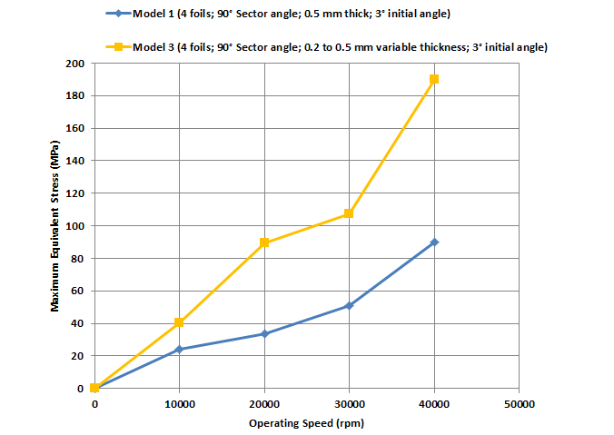

Fig 6.6: Maximum equivalent stress vs operating speed of Model 1 and Model 3

Figure 6.6 shows the variation of maximum equivalent stress of top foil as a function of operating speed for model 1 and model 3. As the rotational speed of the thrust runner on the top foil of an air foil thrust bearing increases, the stress value also increases. Comparing the results from the figure 6.6, we can observe that under dynamic load conditions top foil with 0.5 mm thickness have better load carrying capacity compared to top foil with 0.2 to 0.5 mm variable thickness. 0.5 mm thickness provides uniform load distribution and has comparatively less induced stresses.

### 6.4.3 Top foil having different initial angle with same sector angle and same thickness

In this analysis, two different cases are considered. In first case, one model of top foil with 90° sector angle, 0.5 mm thickness and initial angle of 3° and another model of top foil with 90° sector angle, 0.5 mm thickness and initial angle of 6° has been considered to study the effect of varying operating speeds on top foil of the bearing.

In second case, one model of top foil with 45° sector angle, 0.5 mm thickness and initial angle of 3° and another model of top foil with 45° sector angle, 0.5 mm thickness and initial angle of 6° has been considered to study the effect of varying operating speeds on top foil of the bearing.

The following table indicates how the stress of top foil changes according to the varying operating speeds.

**Equivalent Stress for first case:**

|  |  |  |  |  |
| --- | --- | --- | --- | --- |
| **Model/Speed** | **10000 rpm** | **20000 rpm** | **30000 rpm** | **40000 rpm** |
| **Model 1** (4 foils; 90° Sector angle; 0.5 mm thickness; 3° initial angle) | 24.36 MPa | 33.59 MPa | 51.19 MPa | 90.18 MPa |
| **Model 4** (4 foils; 90° Sector angle; 0.5 mm thickness; 6° initial angle) | 29.56 Mpa | 40.26 MPa | 52.76 MPa | 91.17 MPa |

Table 6.17: Maximum equivalent stress vs operating speed of Model 1 and Model 4

**Equivalent Stress for second case:**

|  |  |  |  |  |
| --- | --- | --- | --- | --- |
| **Model/Speed** | **10000 rpm** | **20000 rpm** | **30000 rpm** | **40000 rpm** |
| **Model 2** (4 foils; 45° Sector angle; 0.5 mm thickness; 3° initial angle) | 14.68 MPa | 24.16 MPa | 39.31 MPa | 69.87 MPa |
| **Model 5** (4 foils; 45° Sector angle; 0.5 mm thickness; 6° initial angle) | 17.13 MPa | 26.42 MPa | 39.50 MPa | 70.233 MPa |

Table 6.18: Maximum equivalent stress vs operating speed of Model 2 and Model 5

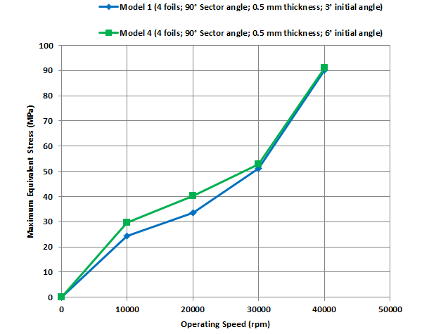

Fig 6.7: Maximum equivalent stress vs operating speed of Model 1 and Model 4

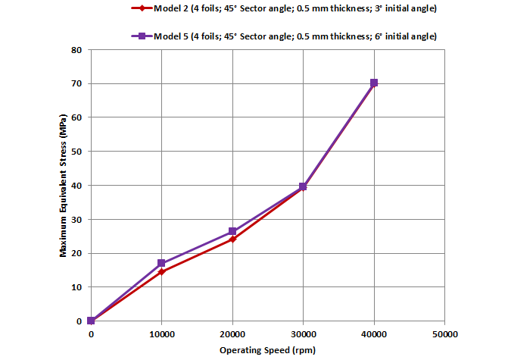 Fig 6.8: Maximum equivalent stress vs operating speed of Model 2 and Model 5

Figure 6.7 shows the variation of maximum equivalent stress of top foil as a function of operating speed for model 1 and model 4. Figure 6.8 shows the variation of maximum equivalent stress of top foil as a function of operating speed for model 2 and model 5. As the rotational speed of the thrust runner on the top foil of an air foil thrust bearing increases, the stress value also increases. Comparing the results from the figure 6.7 and 6.8, we can observe that under dynamic load conditions top foil with 3° initial angle have better load carrying capacity compared to top foil with 6° initial angle. However, as the rotational speed of thrust runner increases, the effect of initial angle on the load carrying capacity becomes negligible.

### 

### 6.4.4 Summary of Dynamic Analysis

### Considering the geometrical parameters of top foil design and operating parameters, we can conclude that under dynamic analysis the top foil having 0.5 mm thickness, 45° sector angle and 3° initial angle is more stable compared to the other profiles and hence, we conclude that top foil having 0.5 mm thickness, 45° sector angle and 3° initial angle have comparatively less induced stress & can handle the load conditions better.

**Deformation:**

During dynamic analysis, the bearing experiences varying loads and forces as the rotor rotates. The top foil of the bearing is often subjected to the rotational velocity, leading to deformation or deflection. The specific location of maximum deflection can depend on factors such as the bearing geometry, material properties, and the nature of the dynamic forces. In our analyses, the maximum deflection or deformation is at the end of the foil towards trailing edge.

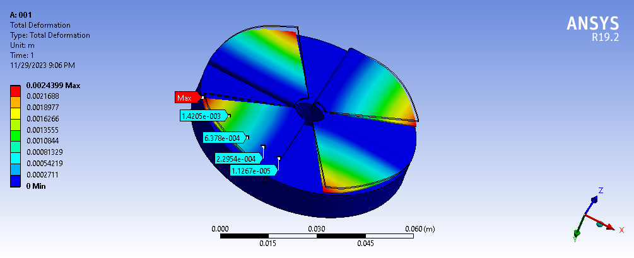

Fig 6.9: Deformation of model 2 under dynamic analysis

**Stress:**

In dynamic analysis, the stress distribution within the top foil of an air foil thrust bearing undergoes dynamic variations influenced by diverse factors, including operating conditions, load distribution, and the inherent design of the bearing. The slot region frequently experiences elevated stress levels due to several key considerations:

* **Dynamic Load Concentration:** The slot region is prone to a higher concentration of load during dynamic operation. This concentration of load in the slot area induces increased stress levels when compared to other sections of the top foil. Typically, the load is applied in proximity to the leading edge of the top foil, aligning with significant pressure variations within the air film.
* **Contact Area Dynamics:** Effective load transfer is contingent upon the contact area between the top foil and the rotating shaft. The slot region tends to maximize the contact area, contributing to an augmented stress profile within this specific region.
* **Geometry and Boundary Conditions:** The intricacies of the bearing's design, encompassing the geometric attributes of the top foil and the imposed boundary conditions, actively shape the stress distribution. The presence of the slot, coupled with the location of attachment points, exerts a discernible influence on stress concentrations throughout the top foil.
* **Material Property Dynamics:** The material properties of the top foil play a pivotal role in the dynamic stress distribution. Variations in material stiffness or non-uniform material behaviour can lead to stress concentrations, especially in areas such as the slot region.

Understanding and addressing these dynamic stress factors are essential for optimizing the design and performance of air foil thrust bearings under varying operational conditions. Dynamic analysis enables engineers to comprehensively assess the behaviour of the bearing, ensuring its reliability and longevity in dynamic applications.

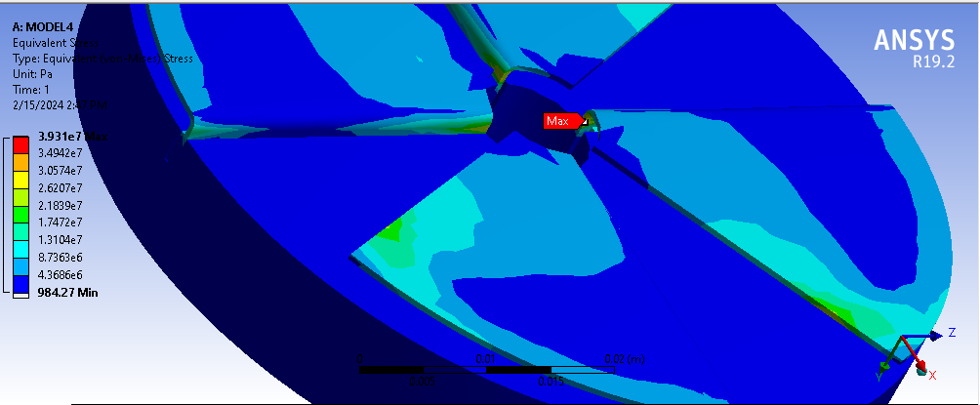

Fig 6.10: Stress distribution of 45° sector angle, 0.5 mm thick top foil under dynamic analysis

# References

1. DellaCorte, C. and Valco, M.J., 2000. Load capacity estimation of foil air journal bearings for oil- free turbomachinery applications. Tribology Transactions, 43(4), pp.795-801.
2. Heshmat, H., Hryniewicz, P., Walton Ii, J.F., Willis, J.P., Jahanmir, S. and DellaCorte, C., 2005. Low-friction wear-resistant coatings for high-temperature foil bearings. Tribology International, 38(11-12), pp.1059-1075.
3. Dykas, B.D., 2006. Factors influencing the performance of foil gas thrust bearings for oil-free turbomachinery applications (Doctoral dissertation, Case Western Reserve University).
4. Lee, D. and Kim, D., 2011. Design and performance prediction of hybrid air foil thrust bearings. Journal of Engineering for Gas Turbines and Power, 133(4).
5. Iordanoff, I., 1999. Analysis of an aerodynamic compliant foil thrust bearing: method for a rapid design.
6. Ravikumar, R.N., Rathanraj, K.J. and Kumar, V.A., 2016. Comparative experimental analysis of load carrying capability of air foil thrust bearing for different configuration of foil assembly. Procedia Technology, 25, pp.1096-1105.
7. Dykas, B., Bruckner, R., DellaCorte, C., Edmonds, B. and Prahl, J., 2009. Design, fabrication, and performance of foil gas thrust bearings for microturbomachinery applications. Journal of Engineering for Gas Turbines and Power, 131(1).
8. Arora, V., Van Der Hoogt, P.J.M., Aarts, R.G. and de Boer, A., 2011. Identification of stiffness and damping characteristics of axial air-foil bearings. International journal of mechanics and materials in design, 7(3), pp.231-243.
9. Bauman, S., 2005, March. An oil-free thrust foil bearing facility design, calibration, and operation. In 58th Annual Meeting (No. NASA/TM-2005-213568).
10. Kozanecki, Z., Łagodziński, J., Tkacz, E. and Miazga, K., 2018. Performance of thrust airfoil bearing for oil-free turbomachinery. Journal of Vibration Engineering & Technologies, 6(1), pp.1-6.