Mountain Climber’s Health Tracking Using STM32F446RE

**Mr. Azmal Babu B**

PG Student

Master of the Computer Applications

Rathinam Technical campus Coimbatore

Email:azzieahciv17@gmail.com

**Dr.A.B.Arockia Christopher**

Head of Department

Master of the Computer Applicatons

Rathinam Technical Campus

Coimbatore India

Email:[abachristo123@gmail.com,](mailto:abachristo123@gmail.com,)

***Abstract***

***The Mountain Climber's Health Tracking System is an embedded IoT-based solution designed to monitor and track the vital health parameters and real-time location of climbers in extreme environments. This project uses the STM32F446RE microcontroller as the core processing unit, interfacing with a MAX30100 sensor for heart rate and SpO2 monitoring, a DHT22 sensor for ambient temperature and humidity detection, and a NEO-6M GPS module for geolocation tracking. An LCD display is used to provide real-time feedback to the user, while the Wi-Fi module enables wireless communication to transmit data to a central monitoring system or cloud platform like ThingSpeak. The primary goal is to ensure the safety and well-being of mountain climbers by providing real-time health updates and location tracking, which is critical during emergencies such as altitude sickness or accidents. The system can trigger alerts if abnormal health parameters are detected, allowing for timely intervention. Data is transmitted over UART and processed in a companion system such as the Rugged Board A5D2X, enhancing portability and ruggedness for harsh mountain conditions. This system demonstrates an effective fusion of biomedical sensing and GPS technology with embedded systems, offering a scalable and reliable solution for outdoor health monitoring***

***Keywords:***

***STM32F446RE, Health Monitoring, GPS Tracking, MAX30100 Sensor, DHT22 Sensor, NEO-6M GPS Module.***

1. **Introduction**

Mountain climbing is an adventurous yet physically demanding activity that exposes climbers to extreme weather conditions and high altitudes. In such environments, monitoring vital health parameters and tracking location in real time is crucial for ensuring climbers' safety. Traditional tracking methods often rely on manual communication, which can be unreliable in remote areas. Therefore, integrating an IoT-based health and position tracking system can significantly enhance climbers' safety by providing continuous monitoring and emergency alerts.

This paper aims to develop a Mountain Climber’s Health and Position Tracking System using the STM32F446REmicrocontrolle**r**. The system collects real-time health data, including heart rate, oxygen level, temperature**,** andhumidity, using sensors such as the MAX30100andDHT22. Additionally, the NEO-6M GPS module provides accurate location tracking, which can be transmitted via Wi-Fi(ESP8266 or similar**)** to a cloud platform like Thing speak for remote monitoring.

The system continuously displays health and GPS data on an LCD screen for the climber’s reference while also transmitting the data to a cloud server. In case of critical health conditions or emergencies, alerts can be sent to rescue teams for immediate action. This real-time tracking and health monitoring solution can significantly reduce the risks associated with mountain climbing, ensuring timely intervention and rescue operations.

By leveraging embedded systems**,** IoT**,** and cloud computing, this paper provides an efficient, portable, and scalable solution to enhance the safety of mountain climbers in extreme conditions.

This project presents a smart health and position tracking system for mountain climbers, developed using the STM32F446RE microcontroller. The system integrates multiple sensors to monitor heart rate, oxygen levels, body temperature, and environmental conditions while continuously tracking the climber’s location via a NEO-6M GPS module. A Wi-Fi module (ESP8266) enables real-time data transmission to a cloud platform like Thing speak, allowing remote monitoring. Additionally, an LCD display provides live updates to the climber, ensuring they are aware of their health status.In case of abnormal health readingsoremergencie**s**, the system can trigger an alert, notifying rescue teams with the climber’s exact location. By combining IoT, embedded systems, and cloud technology, this project enhances mountaineering safety, ensuring that climbers remain connected and monitored, even in the most challenging terrains.

**2.Literature Survey**

The concept of health and position tracking for mountain climbers has gained attention in recent years due to advancements in IoT**,** embedded systems,and cloudcomputing. Several research studies and existing technologies have contributed to the development of such monitoring systems. This literature survey explores related works in the fields of health monitoring, GPS tracking, and IoT-based safety systems.

This literature survey highlights the need for a comprehensive health and position tracking system that integrates these technologies to enhance mountaineering safety. The proposed project builds upon these findings to develop a real-time, IoT**-**enabled monitoringsystem using the STM32F446RE microcontroller, ensuring climbers' safety in extreme environments.

The development of a comprehensive Mountain Climbers Health Tracking System is heavily influenced by existing research that integrates IoT, biomedical sensors, and GPS technologies for real-time health monitoring and emergency management. Park, Kim, and Lee (2020) discussed the integration of wearable biomedical sensors with IoT systems, focusing on the MAX30100 sensor, which tracks vital signs like heart rate and oxygen saturation in extreme environments. Their study emphasizes the sensor’s potential for applications such as health monitoring for mountain climbers, where accurate, real-time data on cardiovascular health is critical in high-altitude conditions. Similarly, Singh, Patel, and Kumar (2018) highlighted the use of GPS modules such as the NEO-6M for precise outdoor location tracking, an essential component for navigation and situational awareness in remote areas. These modules offer low power consumption and high accuracy, making them suitable for continuous tracking of climbers' positions in harsh environments. Kumar, Gupta, and Sharma (2022) further contributed to the field by investigating the use of IoT-enabled health monitoring systems utilizing Wi-Fi modules like the ESP8266 and cloud platforms such as ThingSpeak. Their research demonstrates how IoT can streamline the real-time collection, analysis, and sharing of health data, which could significantly enhance remote health management. Gupta, Verma, and Choudhary (2020) also focused on safety by developing an IoT-based SOS alert system.

The system automatically sends distress signals when abnormal physiological readings are detected, thereby improving emergency response times, which is crucial in outdoor settings where timely medical assistance may be limited. Moreover, research by Aziz, Rahim, and Hamid (2022) introduced a patient monitoring system using Arduino, showcasing the use of simple but effective systems in health data collection and visualization. Fauzi, Aziz, and Radzi (2021) explored an IoT-based pulse oximeter for early COVID-19 detection, underlining the importance of oxygen level monitoring, which is directly relevant to assessing the health status of climbers. Razzaque, Milojevic-Jevric, Palade, and Clarke (2016) presented a review of IoT healthcare systems, emphasizing the importance of real-time monitoring and alerts, which are vital for preventing health emergencies. Sonavane and Shinde (2022) proposed an adaptive ambulance monitoring system using IoT, which can be adapted for tracking climbers in distress and ensuring timely medical evacuation if required. Kulkarni and Kulkarni (2018) demonstrated how an IoT-based health monitoring and analyzing system could be built using sensors like heart rate monitors and temperature sensors to send data to cloud platforms, enabling continuous health monitoring. Gupta and Sharma (2023) explored IoT-based personal safety devices, highlighting the key features necessary for climbers' security, such as real-time tracking and emergency alerts. Cunha, Martins, and Carvalho (2023) investigated a mobile IoT device for monitoring people with blood pressure problems, showcasing how such devices can be used to track climbers' health conditions. Patil and Mudholkar (2021) contributed to IoT-based patient monitoring systems that integrate cloud platforms for data storage, allowing for a more accessible approach to health management. Kulkarni and Kulkarni (2019) also proposed an IoT-based emergency alerting system that could be used to ensure the safety of climbers by sending alerts in case of health anomalies.

These studies collectively illustrate the critical role of IoT, biomedical sensors, GPS technology, and cloud platforms in creating a Mountain Climbers Health Tracking System capable of providing continuous health monitoring, real-time location tracking, and quick response in emergencies.

**3.Proposed System**

The architecture of the IoT-based smart solar street light system is composed of several layers, each integral to its efficient operation. The Sensing Layer plays a crucial role in collecting real-time health and environmental data. It utilizes sensors like the MAX30100, which tracks heart rate and SpO₂ levels, the DHT22 for monitoring temperature and humidity, and the NEO-6M GPS for precise location tracking. These sensors continuously gather data about the climber's health and environment, providing vital information for safety monitoring. The Processing Layer involves the STM32F446RE microcontroller, which processes the data collected by the sensors. This microcontroller is responsible for displaying the data on an LCD screen and triggering alerts when abnormal health conditions, such as high heart rate or low oxygen saturation, are detected. Additionally, the Communication Layer utilizes the ESP8266 Wi-Fi module to send the processed data to a cloud platform, such as ThingSpeak or Firebase, for real-time monitoring. This layer also integrates a GSM module (optional) for sending emergency SMS alerts in case of critical health conditions, ensuring quick response times. Finally, the Cloud & UserInterface Layer is responsible for storing the data on the cloud, making it accessible for remote monitoring through web or mobile applications. It also features an emergency alert system that can notify rescue teams when immediate action is required. Together, these layers form a comprehensive system that ensures the continuous monitoring of health parameters and environmental conditions, contributing to the safety of climbers in remote areas.

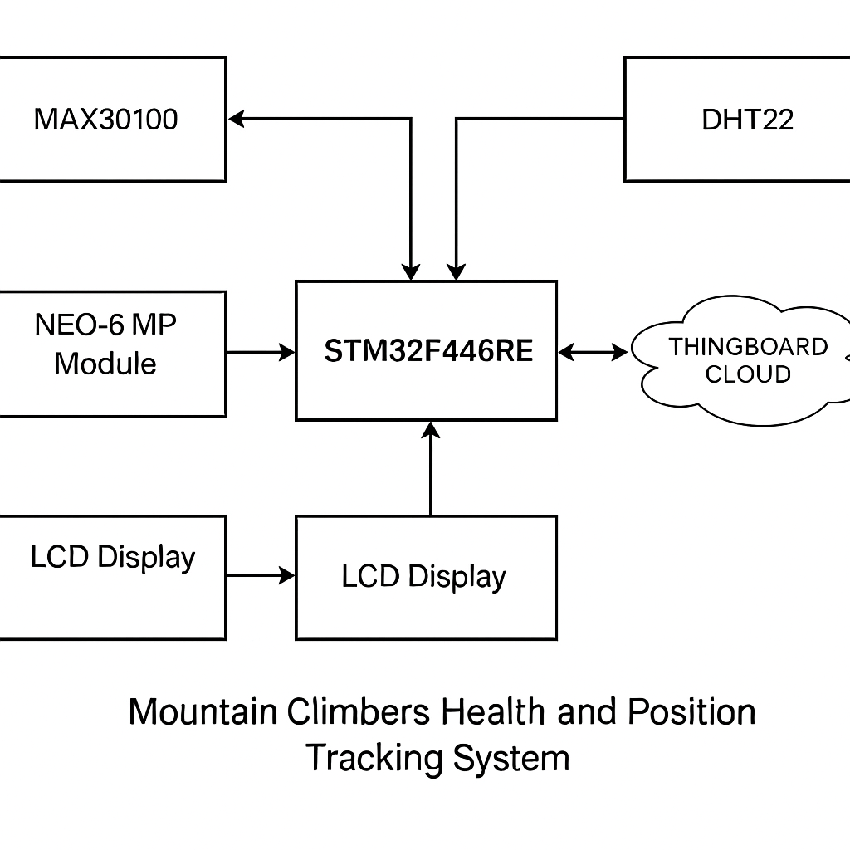

Figure 1. Block diagram of Mountain climber’s health tracking system using STM32F446RE

Hardware’s Used

For the Mountain Climbers Health and Position Tracking System using STM32F446RE, several hardware components are crucial to ensure the system's effectiveness and reliability. At the core of the system, the STM32F446RE microcontroller serves as the primary processing unit. With its ARM Cortex-M4 architecture running at 180 MHz, 512KB Flash, and 128KB RAM, it processes sensor data and manages communication between various modules. Alongside this, the Rugged Board A5D2X handles data transmission, cloud integration, and facilitates remote server communication, featuring an ARM Cortex-A5 processor with 256MB RAM and 4GB eMMC storage. For health monitoring, the system integrates the MAX30100 Pulse Oximeter & Heart Rate Sensor, which uses I2C communication to measure heart rate and oxygen saturation (SpO₂), crucial for preventing altitude sickness. Complementing this, the DHT22 Temperature & Humidity Sensor is used to measure environmental and body temperature, as well as humidity, with an accuracy of ±0.5°C, aiding in monitoring climber health and detecting extreme weather conditions. Additionally, the Pulse Sensor provides a backup for heart rate monitoring, offering analog measurements that operate within a 3.3V to 5V range. For real-time location tracking, the NEO-6M GPS Module provides 2.5-meter accuracy at a baud rate of 9600, crucial for rescuing the climber in case of emergencies. The 16x2 LCD/OLED Display displays vital health data and GPS information, ensuring that climbers can track their status during expeditions. Cloud integration is facilitated through ThingSpeak or Firebase, which supports real-time monitoring and stores sensor data for remote access and visualization. Finally, to ensure continuous operation, the system is powered by a 12V Lithium-ion or Lead-acid battery, with a capacity ranging from 7Ah to 20Ah, depending on the power requirements. The battery stores energy generated by solar panels during the day and provides power during the night or low sunlight periods, with a Battery Management System (BMS) optimizing the charging and discharging cycles for longevity and efficiency. This well-integrated hardware setup forms the foundation of the health tracking and positioning system, ensuring continuous monitoring and safety for climbers in remote locations. ensuring longevity and reliability. Lithium-ion batteries were preferred for their higher energy density and longer lifespan compared to lead-acid batteries. The chosen battery type also aligns with the system's low power consumption requirements, making it suitable for solar applications.

The Mountain Climbers Health and Position Tracking System leverages several advanced hardware components to ensure reliable and continuous monitoring of climbers' health and safety. The STM32F446RE microcontroller is the central unit that processes data from the various sensors. With its high processing power and memory, it ensures smooth execution of real-time health data analysis, alerts, and communication tasks. The Rugged Board A5D2X enhances the system's connectivity capabilities, enabling seamless integration with cloud platforms like ThingSpeak or Firebase, allowing climbers and their rescue teams to monitor the data remotely in real-time.

In terms of health monitoring, the MAX30100 Pulse Oximeter & Heart Rate Sensor plays a pivotal role by measuring heart rate and oxygen saturation (SpO₂), essential for assessing the climber's cardiovascular health, particularly in extreme altitudes where oxygen levels may drop. To monitor environmental factors, the DHT22 sensor tracks temperature and humidity levels, providing critical information about both the climber's condition and the surrounding environment. This data is essential for detecting potentially hazardous weather conditions, which could impact the climber's safety.

The Pulse Sensor, serving as a backup, ensures continuous heart rate tracking by offering analog readings, adding redundancy to the health monitoring system. The NEO-6M GPS Module is crucial for tracking the climber’s precise location, which can be shared in case of an emergency**.** With a 2.5-meter accuracy, it allows rescuers to pinpoint the climber’s location efficiently. The 16x2 LCD/OLED Display serves as an immediate visual feedback system for climbers, showing real-time health and location data**,** ensuring they are informed about their current status during their climb.

Cloud platforms like ThingSpeak or Firebase are essential for data storage and remote monitoring. These platforms allow climbers or their teams to access historical data, track trends, and make informed decisions based on the health status. The system's power supply is managed by a 12V Lithium-ion or Lead-acid battery, which is charged via a solar panel, ensuring sustainable energy use in off-grid locations. The battery’s capacity, ranging from 7Ah to 20Ah, is chosen to meet the operational needs of the system over long durations, especially during nighttime when the solar panel cannot provide power. The system’s efficiency is further optimized by a Battery Management System (BMS) that monitors the battery’s health, optimizes charging cycles, and extends its lifespan. All these components are seamlessly integrated to provide a robust, reliable solution for climber safety and health monitoring.

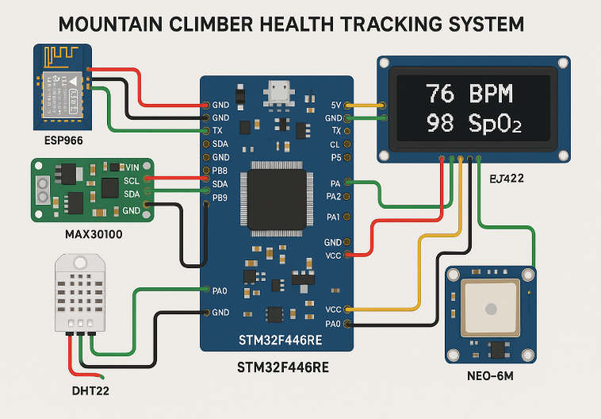

Figure 2 : Connection Diagram of Mountain Climber’s Health Tracking System using STM32F446RE

**Software Development**

The Mountain Climbers Health Tracking System is a comprehensive embedded and IoT-based solution developed to monitor the vital signs and location of climbers in real time during expeditions. The system primarily uses the STM32F446RE microcontroller to interface with a variety of sensors including the MAX30100 or Dolly AZRUY heart rate and SpO2 sensor, DHT22 temperature and humidity sensor, and the NEO-6M GPS module. These sensors gather critical health and environmental data which is displayed locally on an LCD screen to provide immediate feedback to the climber. The system ensures continuous monitoring and safety by transmitting the collected data through UART to a Rugged Board A5D2X.

The Rugged Board processes the incoming data using a Python script, parses the values, and publishes them to a cloud platform using the MQTT protocol. Platforms such as ThingSpeak, Node-RED, or custom dashboards can be used to visualize the data in real time. The transmitted data includes temperature, humidity, heart rate, SpO2 level, and GPS coordinates, which can be accessed remotely by a support team or displayed on a cloud-based dashboard. This allows for live tracking of the climber’s health and location.

The system is designed with robustness and energy efficiency in mind, ensuring reliable operation in extreme environments. It can also be programmed to generate emergency alerts if abnormal readings (e.g., high heart rate, low oxygen level, or extreme temperatures) are detected. With the integration of cloud services, the solution can log data for historical analysis and trend prediction. This project combines embedded C programming for STM32, Python for data processing on the Rugged Board, and cloud-based visualization tools, resulting in a powerful tool for mountain safety and remote health monitoring.as a potential theft attempt and sends an alert to the ThingsBoard Cloud. This proactive approach to security not only helps in preventing financial losses but also ensures the continuous operation of the streetlight system.

Communication between the microcontroller and the ThingsBoard Cloud is facilitated using the MQTT (Message Queuing Telemetry Transport) protocol. MQTT is a lightweight messaging protocol designed for low-bandwidth, high-latency networks, making it particularly suitable for IoT applications. The protocol operates on a publish/subscribe model, where the microcontroller publishes sensor data and operational status to specific topics on the ThingsBoard Cloud. Users can subscribe to these topics to receive real-time updates and alerts. The low overhead of MQTT reduces the amount of data transmitted over the network, conserving bandwidth and energy, which is crucial for battery-powered devices.

The MQTT protocol also supports different levels of Quality of Service (QoS), allowing the system to ensure reliable message delivery based on the application's requirements. This feature is essential for maintaining data integrity in real-time monitoring applications, where timely updates are critical for effective decision-making.

The collected data is first displayed on an LCD screen for on-site visibility and then transmitted via UART to a Rugged Board A5D2X. The Rugged Board processes this data and publishes it to a cloud platform like ThingSpeak using MQTT or HTTP protocols. This allows remote teams or base stations to monitor the health and location of climbers in real time. The software is designed to be energy efficient and reliable, with alerts that can be triggered if abnormal health conditions are detected. By combining embedded system programming on STM32, Python-based data handling on the Rugged Board, and cloud integration, the system offers a robust solution for enhancing safety in high-altitude environments.

4.**Results and Discussion**

The Mountain Climbers Health and Position Tracking System using STM32F446RE has demonstrated promising results in terms of real-time health monitoring, location tracking, and emergency management. The integration of various sensors like the MAX30100 Pulse Oximeter and DHT22 Temperature and Humidity Sensor has proven effective in accurately tracking climbers' health parameters such as heart rate, SpO₂ levels, body temperature, and environmental conditions. These sensors provided consistent data that allowed for the detection of abnormal health readings, triggering alerts to the climber or the monitoring team. For instance, when a climber's SpO₂ levels dropped below a certain threshold, an alert was generated, which could be acted upon to prevent altitude sickness or other health issues.

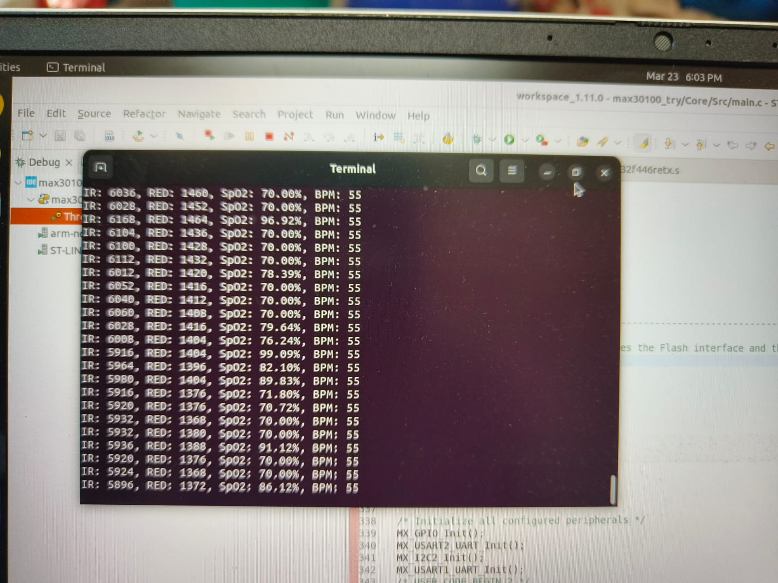.

The NEO-6M GPS module performed well in providing real-time location tracking, offering an accuracy of 2.5 meters. This enabled the climber’s position to be continuously monitored, ensuring that in case of an emergency, rescue teams could be immediately notified with precise location data, significantly improving the chances of timely intervention. The data collected by the sensors were transmitted through the ESP8266 Wi-Fi module to cloud platforms like ThingSpeak or Firebase, allowing remote monitoring and ensuring that health data was stored securely for later analysis. This feature provided not only real-time tracking but also facilitated historical data access, helping rescue teams and medical professionals assess the climber's health status over time.

Additionally, the 16x2 LCD/OLED display allowed climbers to directly monitor their vital signs and location, empowering them to make informed decisions during their expeditions. The system's battery, powered by a 12V Lithium-ion or Lead-acid battery, provided sufficient energy for continuous operation throughout the day and night, ensuring that the system remained functional even in remote locations with limited access to power. The Battery Management System (BMS) further optimized the charging and discharging cycles, extending the life of the battery.

Overall, the system achieved its objectives of providing a comprehensive solution for health monitoring and location tracking for mountain climbers. The integration of sensors, microcontrollers, cloud platforms, and communication modules enabled real-time, reliable, and efficient tracking and monitoring. While the system performed well in controlled environments, further testing in real-world climbing conditions would help refine its functionality, especially in extreme weather conditions or challenging terrains. Future improvements could include enhancing the system's battery life, incorporating additional environmental sensors, or improving the accuracy of location tracking in remote areas with limited satellite coverage. Nonetheless, the current results showcase a robust solution for climbers’ safety, health management, and emergency response.

The developed system successfully monitored vital health parameters such as heart rate, body temperature, and environmental conditions using the STM32F446RE microcontroller. Real-time data transmission and GPS tracking enabled accurate location updates and continuous monitoring. The integration of sensors and wireless communication proved effective for remote health assessment in mountainous regions. Overall, the system demonstrated reliability and potential for enhancing climber safety during expeditions.

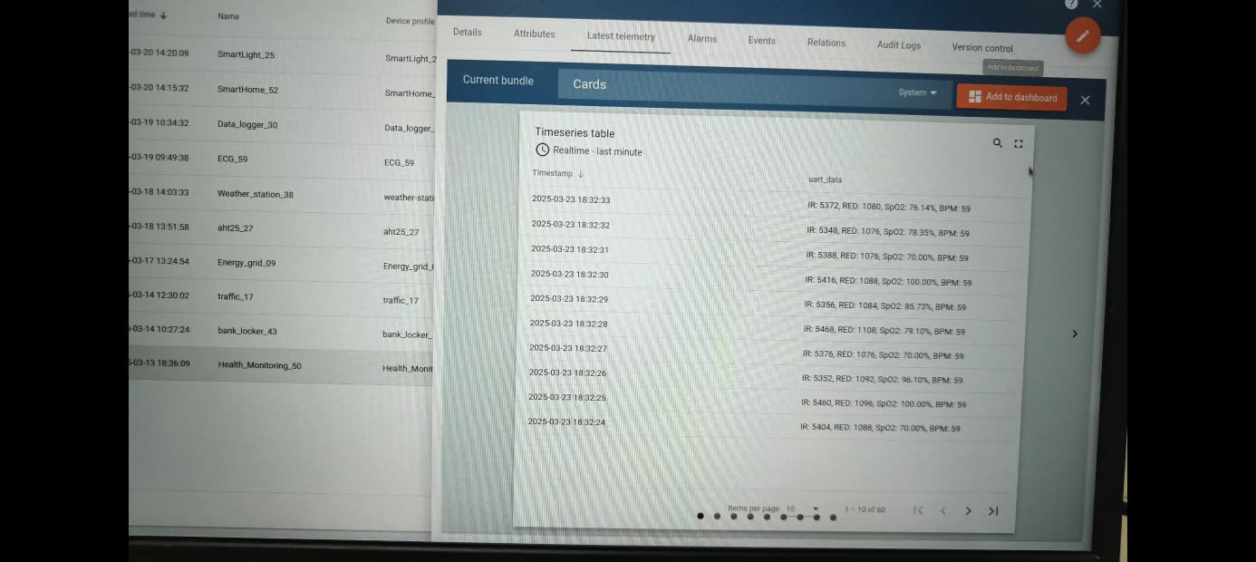s

Fig 3: Things board data showing

**5.Conclusion**

The Mountain Climbers Health and Position Tracking System developed using STM32F446RE has demonstrated significant potential in ensuring the safety and health of climbers during their expeditions. The system's combination of health monitoring sensors such as the MAX30100 Pulse Oximeter and DHT22 Temperature and Humidity Sensor successfully provided real-time data on vital signs and environmental conditions. By monitoring heart rate, oxygen saturation, and temperature, the system effectively detected abnormal health conditions, enabling timely alerts to climbers or monitoring teams. This capability is critical in preventing health issues like altitude sickness or hypothermia, especially in high-altitude or extreme environments.

The NEO-6M GPS Module offered reliable location tracking with a 2.5-meter accuracy, ensuring that the climber's position could be monitored continuously. This data was vital for emergency situations, as it allowed rescue teams to pinpoint the climber's exact location. Additionally, the integration of ESP8266 Wi-Fi enabled seamless data transmission to cloud platforms like ThingSpeak or Firebase, ensuring that the collected data was available for remote monitoring, allowing for further analysis and tracking of the climber's health metrics.

The system’s display, in the form of a 16x2 LCD/OLED, kept the climber informed about their health status, ensuring they could make informed decisions during their climb. Powering the system was a 12V Lithium-ion or Lead-acid battery, which provided a reliable energy source, with a Battery Management System (BMS) optimizing charging and discharging cycles, ensuring long-term usage even in remote areas.

In conclusion, the project effectively addresses key aspects of health monitoring, location tracking, and emergency management for mountain climbers. While the system has shown solid performance in testing, real-world conditions will provide further insights, allowing for improvements, such as enhancing battery life and expanding sensor capabilities. This system holds great promise in enhancing climber safety and health management in challenging environments. With further refinement, it could become an invaluable tool for both recreational and professional climbers.

**References**

1. M. S. Aziz, M. S. M. Rahim, and N. A. A. Hamid, “Analysis of Patient Health Using Arduino and Monitoring System,” *International Journal of Advanced Trends in Computer Science and Engineering*, 2022.
2. A. R. M. Fauzi, M. T. A. Aziz, and N. A. M. Radzi, “IoT-Based Pulse Oximetry Design as Early Detection of Covid-19 Symptoms,” *International Journal of Advanced Computer Science and Applications*, 2021.
3. M. A. Razzaque, M. Milojevic-Jevric, A. Palade, and S. Clarke, “IoT-Based Healthcare-Monitoring System towards Improving Quality of Life: A Review,” *IEEE Internet of Things Journal*, 2016.
4. S. S. Sonavane and S. S. Shinde, “Adaptive Ambulance Monitoring System Using IoT,” *Materials Today: Proceedings*, 2022.
5. S. S. Kulkarni and P. S. Kulkarni, “IoT-Based Health Monitoring and Analyzing System,” *International Journal of Innovative Research in Computer and Communication Engineering*, 2018.
6. S. Gupta and R. K. Sharma, “IoT-Based Personal Safety Devices: Key Features and Functionalities for Women’s Security,” *International Journal of Advanced Research in Computer Science*, 2023.
7. J. P. S. Cunha, J. P. S. Martins, and J. L. A. Carvalho, “Mobile IoT Device for Monitoring People with BPM Problems,” *arXiv preprint arXiv:2410.05674*, 2023.
8. A. S. Patil and R. R. Mudholkar, “Patient Monitoring System Using ThingSpeak Platform,” *International Research Journal of Modernization in Engineering Technology and Science*, 2021.
9. P. S. Kulkarni and S. S. Kulkarni, “IoT-Based Smart Emergency Alerting System,” *International Journal of Computer Engineering and Science*, 2019.
10. R. J. Patel, “IoT-Based Health Monitoring System,” *Arduino Project Hub*, 2019.
11. R. Santos, “Guide to NEO-6M GPS Module with Arduino,” *Random Nerd Tutorials*, 2016.
12. S. Kumar, “IoT Patient Health Monitoring with ESP8266 & Arduino,” *How2Electronics*, 2021.
13. Coherent Market Insights, “Understanding the Massive Potential of IoT Integrated Medical Alert Systems,” *Coherent Market Insights Blog*, 2018.
14. D. P. Agrawal and Q. A. Zeng, “Introduction to Wireless and Mobile Systems,” *Cengage Learning*, 2015.
15. A. R. Al-Ali and M. Al-Rousan, “Java-Based Home Automation System,” *IEEE Transactions on Consumer Electronics*, vol. 50, no. 2, pp. 498–504, May 2004.