**Sustainable Transportation in the Gurugram-Manesar Urban Complex**

Kavita Chananiya

ABRC, Department of Education (SSA),

Mahendergarh, Haryana, India

E-mail- kavita.chananiya1082@gmail.com

**Abstract**

*In today's world, more than half of the global population resides in urban areas, a significant shift from the past. In 1950, only 30% lived in cities, but by 2050, its projected to reach 66%. Despite rapid urbanization in India, one standout is the cyber town of Gurugram in Haryana, which has embraced sustainable urban growth. Maruti Industry was established with assistance from Suzuki Company of Japan, heralding a period of significant growth. This urban complex, often lauded as India's only city with a rapid metro network, modern commercial hubs, towering cyber parks, stands as a beacon of sustainable urbanization. The nomenclature of this complex was proposed in the district development plan. The establishment of the Maruti Industry in 1972 marked the onset of Gurugram's substantial development. Renowned for its quick metro network, modern malls, and cyber parks, Gurugram- Manesar Urban Complex stands as a model of sustainable urban development. Serving as Haryana's financial and industrial hub, Gurugram has witnessed the third-largest increase in per capita income in India, contributing significantly to the state's revenue. Its strategic location along National Highway Number 48 and proximity to Indira Gandhi International Airport have fueled its rapid expansion. This paper examines its transport system and connections to nearby towns and the national capital, Delhi.*

Keywords: Collaboration, Network, Transport, Real Estate, Sustainable Urbanization.

**Introduction**

The Gurugram-Manesar Urban Complex (GMUC) is striving to craft an integrated land use and transportation plan aligned with the objectives of the National Urban Transport Policy (NUTP). The Integrated Mobility Plan (IMP) endeavors to guide investments towards the overarching mobility vision, prioritizing public transportation and non-motorized modes to emphasize efficient movement of people and goods over reliance on motor vehicles. With a projected population of 43 lakhs by 2031, nearly three times the current figure, the GMUC anticipates substantial employment opportunities from proposed Special Economic Zones (SEZs) in the vicinity. Various organizations overseeing transportation initiatives for GMUC have laid out plans and commenced several projects. The IMP aims to coordinate and streamline efforts across multiple agencies, enhancing Gurugram's transportation infrastructure through an integrated approach. Furthermore, this report not only outlines a roadmap for future transportation enhancements but also proposes a comprehensive transportation investment program for GMUC, encompassing short-, medium-, and long-term initiatives aligned with the mobility plan.

**Objectives of the study**

The objective of this study is;

* To develop a transportation vision, set goals based on the defined vision for the Gurugram- Manesar Urban Complex.
* To study benefits of the master plan of GMUC.

**Data-Base & Methodology**

Secondary data have been collected from the published sources and internet search.

The methodology of the paper includes -

1. Documentation /Literature Review

2. Study area map has been prepared by using ARC GIS Software version 10.7.1.

**Introduction to the study area**

Gurugram district, situated in the southern part of Haryana, covers an area of 124,039 hectares. Its climate is characterized as hot, semi-arid, tropical steppe, with air predominantly dry except during the monsoon season. The region features alluvial plains intersected by long ridges of Delhi quartzite. Administrative divisions include Gurugram, Sohna, Farukh Nagar, Manesar, and Pataudi. Groundwater depth ranges from 2.13 meters below ground level (mbgl) in Dharampur village to 79 mbgl in Dundahera village. Over the last decade (2000–2010), the groundwater table in the study area has been declining at a rate of 73 cm per year pre-monsoon and 70 cm per year post-monsoon.

**Fig. 1.1:** *Study area map of Gurugram District, Haryana.*

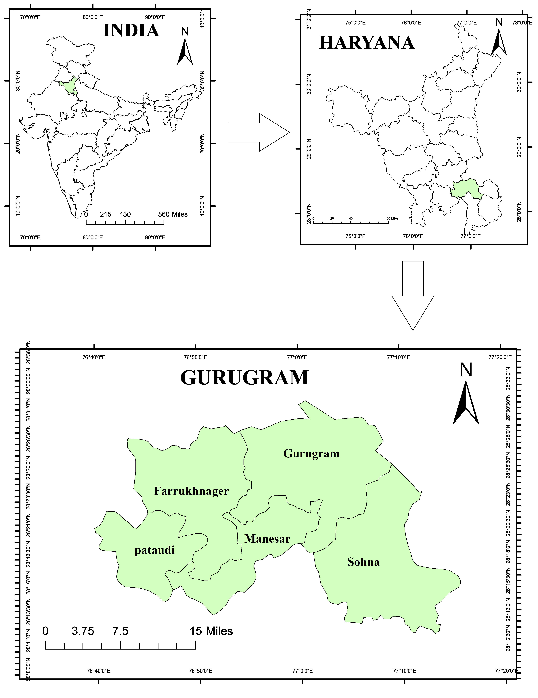

Source: Prepared by researcher with the help of ARC GIS,10.7.1.

**Result and Discussions**

Gurugram has developed as an industrial, IT, BPO and commercial hub. Large corporate organisations, multinational corporations, foreign investors, and Non-Resident Indians (NRI) continue to invest in Gurugram. The region is experiencing rapid urbanisation, population growth, economic growth, and the emergence of new employment prospects, which has created a huge demand for high-quality transportation infrastructure. Even with vehicles with superior technology, this will rise to 18 tonnes by 2031 if the current trend continues. Real estate investors have hinted to the Gurugram real estate market's imminent growth. The price of land and plots will increase to unimaginable heights as a result of the construction of the New Gurugram and the Dwarka Expressway. These experts claim that the prices being demanded at the moment are extremely low. They believe that these places would become the heart of Gurugram once the construction is finished. The acquisition of property is the result of the brand-new Gurugram Master Plan 2031. In accordance with the new plan, 58 new sectors will be introduced together with an allocation of land for residential developments of around 14900 hectares. In view of the global Master Plan 2031 includes some of the most innovative ideology themes ever created because to its multinational and inventive concept.Manesar is developing into a mega-city as it now serves as the home to numerous international industrial facilities and is a fully integrated part of the Millennium City. In the National Capital Region, the entire district is anticipated to outperform Noida thanks to Gurugram's commercial and residential hub and Manesar's industrial foundation.

The 5,000-acre industrial area is run by the Haryana State Industrial and Infrastructural Development Corporation (HSIIDC). Manesar is particularly well connected to both Delhi and Gurugram because it is situated at the crossroads of NH-48 and the planned Kundli- Manesar-Palwal Expressway. To enable the personnel to dwell close to the industrial units and be able to access them, Manesar's residential sectors have risen from one to four under the integrated development plan. Manesar has developed into a popular site for developers as well. The Haryana Government has launched a number of efforts to support the economic development of the area, including the Integrated Mobility Plan for Gurugram- Manesar Urban Complex.

**Fig. 1.2:** *Gurugram Manesar Master Plan, 2031*

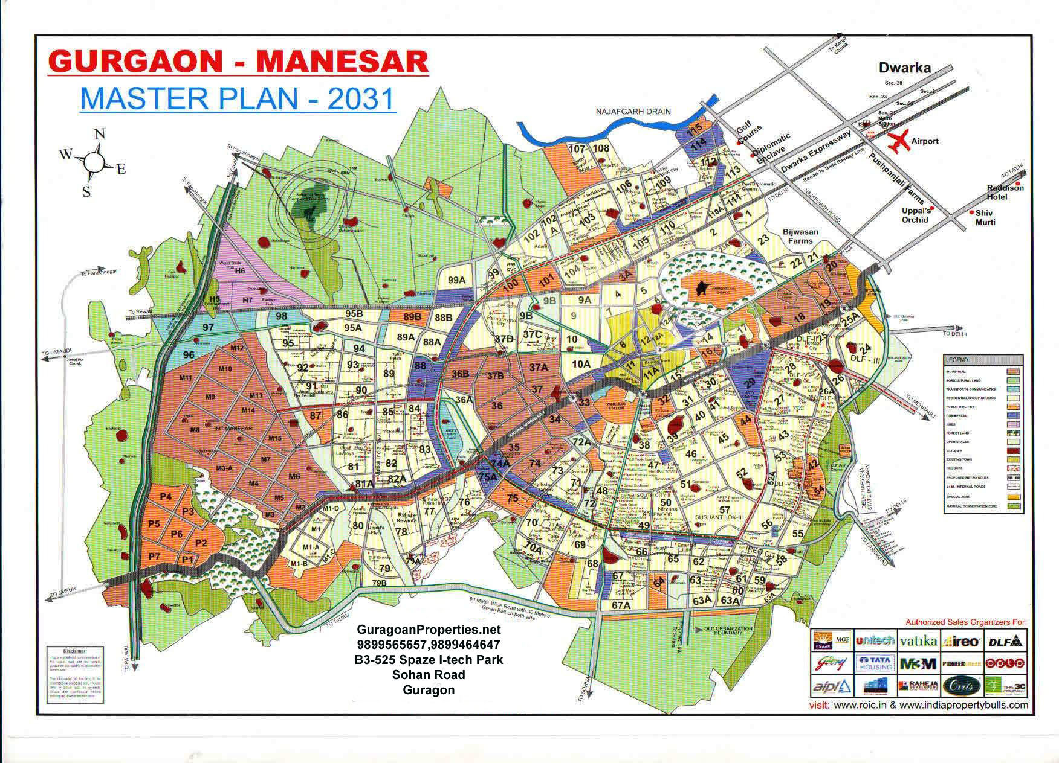

Source: Town and Country Planning Department, Gurugram, Haryana Government.

**Development Plan Transport Proposals**

The Government's Development Plan-2021 for the Gurugram-Manesar Urban Complex includes a variety of transportation ideas to address the rising demand for transportation. The suggestions comprise: Vasant Kunj in Delhi and Mehrauli Road in Gurugram are connected by a 90 m wide road. Through Mandi and GualPaheri, a 90 m wide road connects Delhi's AndheriaMor to Gurugram's Faridabad Road. Density Graph Integrated Mobility Plan for the Gurugram-Manesar Urban Complex for 2021 17 Road connecting Dwaraka and Palam Vihar in Gurugram is 150 metres wide.

* Extension of DMRC metro lines:

(1) Sushant Lok Phase I and

(2) Dwarka line to Manesar and up to the KMP corridor.

* 150m wide northern peripheral road and
* 90m wide southern peripheral road

**Traffic Management Traffic Engineering and Management** must be given high priority in Gurugram- Manesar Urban Complex. The strategies are intended to improve the traffic situation without extensive investments. Key measures include:

1. Intersection redesign
2. Traffic control devices
3. Traffic signs and markings

**Intersection redesign**

Intersection re-design present not only safety problems as accident rates are usually higher at intersections than at other sections of the road. However, intersections control the network's capacity and effectiveness. Redesigning the intersections with suitable channelization, turning limits, and phasing might significantly increase capacity. It is essential to optimise and maintain optimal throughput levels at all intersections. After the Gurugram-Manesar Urban Complex Integrated Mobility Plan.

**Traffic control devices**

Installation of Traffic Control Devices The following benefits of traffic signals: Ensure the efficient flow of traffic. Increase the intersection's capacity to handle traffic. Reduce the number and severity of specific accident types, particularly right-angle collisions. are employed to periodically stop heavy traffic to allow pedestrians to cross the road. Every significant intersection in GMUC needs to have traffic signals installed as a plan.

**Traffic signs and markings**

Traffic Markings and Signs must be put up in the right locations. According to the recommendations made in IRC document 67-2001, "Code of Practice for Road Signs," all traffic signs should be installed. The lack of road markers is one of the main issues with GMUC roads. Road markings are an essential safety feature as well as an aesthetic addition to the road. There are also benches, bollards, phone boxes, post boxes, streetlights, traffic signals, stop signs, bus stops, trash cans, taxi stands, public restrooms, fountains, and memorials.

**Facilitating Mobility for Transport Management**

**Walking and cycling**

Develop and execute a footpath network design on all roads compliant with the amended code of the Indian Road Congress (IRC). Gradually construct footpaths covering the entire city, prioritizing wide sidewalks and cycle lanes on selected roads based on people-friendly street design principles. Enhance secondary street networks and un-gated streets to offer direct, efficient paths for pedestrians and cyclists, while implementing traffic calming measures citywide.

1. To alleviate congestion, redirect traffic from busy intersections through alternative routes, minimizing the use of signal-free corridors to avoid hindering pedestrian and public transportation flow. Ensure safe pedestrian crossings at all traffic intersections, prioritizing at-grade crossings equipped with pedestrian signals and signage. Employ micro-mapping to identify business hubs and areas with high pedestrian traffic for pedestrianization and implement local safety access solutions. Synchronize traffic signals with an integrated IT-based management system for efficient signal crossings.
2. Expand bicycle sharing programs citywide in collaboration with the private sector, promoting and supporting bike sharing initiatives. Mandate safety and walkability audits for walking and cycling infrastructure, amending laws to penalize encroachments, especially parking violations on walking and cycling lanes.
3. Enhance bus services by increasing the bus fleet to achieve a ratio of 100 buses per lakh people, including a variety of air-conditioned buses. Rationalize bus routes to ensure every home is within 200 meters of a bus stop. Implement IT-based systems for monitoring, electronic ticketing, and passenger information services, equipped with hand-held ticket vending machines and GPS tracking devices for reliability. Construct sufficient parking spaces and depots to prevent buses from parking on streets, incorporating multi-level parking and multi-modal amenities in integrated passenger terminals. Integrate common ticketing and fare systems with ETVMs in neighborhood buses, and facilitate effective use of auto-rickshaws and e-rickshaws as feeder systems for door-to-door connectivity.

**Parking**

Implement parking regulations as a way to manage transport demand.  Through approaches like parking district management, the introduction of evidence of parking, etc., this strategy will attempt to address concerns with parking supply and enforcement, pricing of parking places, and administration of parking at the neighborhood level.

1. Enforce strict penalties for parking violations and encroachments on walkways in accordance with the Delhi Municipal Corporation Act of 1957 and the Police Act of 1978. Declare parking on footways a punishable offence and fine individuals who park their vehicles in non-designated areas. Implement penalties for parking violations that are ten times the parking price, with repeated violations resulting in vehicle impoundment.
2. Enhance variable time-based pricing strategies based on market demand. Coordinate off-street and on-street pricing in both commercial and residential areas, and introduce parking permits for residential zones. Parking fees should vary based on factors such as duration of parking, location within the city, and vehicle size.
3. Revise parking lease terms to increase revenue for neighborhood improvements and public transportation. Integrate assessment and control of parking and traffic impacts on buildings as a mandatory component of the building permit process.

**Road safety**

A systematic auditing system for all important highways and intersections will be established, and audits will be performed at regular intervals. Solutions must be put into practise in a timely manner. To guarantee that roadways are safe for women, children, and the elderly, specific audits for vulnerable groups in society will be done alongside road safety inspections.

1. Road designs will be altered in response to audit findings. While letting traffic to flow safely at grade, traffic calming techniques should be used to lower vehicle speeds.
2. In order to improve road safety, a spatial database of traffic collisions will be kept up to date. strict adherence to the law when it comes to driving in lanes, etc.

**Conclusion**

At the conclusion of this paper, I can state that the Gurugram and Manesar Urban Complex is a south-eastern Haryana region that is still in development. also develop into a smart city in this regard in the future. Many policies were made for this aim by the Haryana government, and now it is our turn to contribute to the effort. The government has decided on a number of projects for sustainable development up until 2021 and 2031 for this region. The government's Development Plan-2021 for the Gurugram-Manesar Urban Complex includes a variety of transportation ideas to address the rising demand for transportation. The acquisition of property is the result of the brand-new Gurugram Master Plan 2031. In accordance with the new plan, 58 new sectors will be introduced together with an allocation of land for residential developments of around 14900 hectares.  The Master Plan 2031 contains some of the most inventive themes ever with its worldwide and innovation ideology.

**References**

* Haryana Government Town and country Planning Department Notification, Panchkula.
* Anon, 2010, Integrated Mobility Plan for Gurugram Manesar Urban Complex, Department of Town and Country Planning (DTCP), Government of Haryana, http://www.wricitieshub.
* Gurugram First, 2017, “Issues and Solutions in Smart Mobility” for Workshop on Smart Mobility Solutions for NCR.
* Anon, 2012 “Gurugram Development Plan 2031”, Town and Country Planning Department, Haryana Government. Found at: https://www.tcpharyana.gov.in/Notification/1662016Mangar%20 Bani%20notification.
* <http://www.Gurugramproperties.net/Gurugram-map/Gurugram-master-plan-2031.aspx>
* [https://tcpharyana.gov.in/CIM/Doc/Gurugram%20mobility%20plan.pdf](https://tcpharyana.gov.in/CIM/Doc/gurgaon%20mobility%20plan.pdf)
* <http://www.cseindia.org/userfiles/gurugram-a-framework-for-sustainable-development-update.pdf>
* [https://tcpharyana.gov.in/Development_Plan/Gurugram/Gurugram/FDP_2031/FDP_2031_GMUC.pdf](https://tcpharyana.gov.in/Development_Plan/Gurgaon/Gurgaon/FDP_2031/FDP_2031_GMUC.pdf)