**Kernel Paradigms: A Comprehensive Analysis, Applications, and Future Directions in Computer Science**

Dr.Shashank Singh1 , Dr. Dhirendra Pratap Singh2, Mr.Kaushal Chandra3

1Proctor and Professor, Department of Computer Science and Engineering, S R Institute of Management and Technology, Bakshi Ka Talab, Affiliated to AKTU, Lucknow, Uttar Pradesh. 226201. [shashankjssit@gmail.com](mailto:shashankjssit@gmail.com).

2Professors and Director, S R Institute of Management and Technology, BakshiKaTalab, Affiliated to AKTU, Lucknow, Uttar Pradesh. 226201. [dirsrgi485@gmail.com](mailto:dirsrgi485@gmail.com)

3Director Corporate Relations, S R Institute of Management and Technology, BakshiKaTalab, Affiliated to AKTU, Lucknow, Uttar Pradesh.226201. [kaushalkamann@gmail.com](mailto:kaushalkamann@gmail.com)

**Abstract:** This research paper conducts a comprehensive analysis of kernel paradigms in computer science, focusing on their structure, applications, and potential future directions. Kernels, as pivotal components in operating systems, profoundly impact system functionality, performance, and security. This paper delves into the foundations of kernels, explores diverse architectures, discusses real-world applications, addresses performance and optimization strategies, highlights security implications, and envisions future trends in kernel development. By providing a thorough examination of kernel paradigms, this research contributes to the understanding of their critical role in contemporary computing, catering to both practitioners and researchers in the field.

**Keywords:** Kernels, contemporary computing, architectures.

**I.INTRODUCTION**

The introduction serves as a gateway to the comprehensive analysis of kernel paradigms, emphasizing their pivotal role in computer science.[1] Kernels, being the fundamental components of operating systems, are the linchpin connecting hardware and software, shaping the very foundation of computational systems. As technology continues to advance at a rapid pace, the intricacies of kernel architectures become increasingly significant for practitioners and researchers alike.[2,3] This research embarks on a journey to unravel the layers of kernel paradigms, aiming to provide a thorough exploration of their historical evolution, fundamental principles, real-world applications, performance metrics, and security considerations. The historical context is vital for understanding how kernel paradigms have evolved over time, marking key milestones that have contributed to their current state.[4] By tracing this evolutionary path, we gain insights into the motivations and innovations that have shaped the development of kernels. Furthermore, the foundational principles of kernels, deeply rooted in mathematical concepts, form the basis of their design and functionality.[5,6] A closer examination of these principles allows for a more nuanced understanding of the theoretical underpinnings that govern kernel development.[7] Real-world applications represent the tangible impact of kernel paradigms across diverse domains, from traditional operating systems to emerging technologies like the Internet of Things (IoT) and edge computing.[7,8] Through case studies and examples, we uncover the versatility of kernels, showcasing their adaptability and relevance in various computing environments.[8,9] Performance metrics are critical in assessing the efficiency of kernel architectures. By identifying key metrics such as throughput, latency, and resource utilization, we can evaluate the impact of different kernel designs on overall system performance. Strategies for optimizing kernel performance, including load balancing and parallel processing, are explored to provide practical insights for system developers and administrators.[10] Security implications form a crucial aspect of our analysis, acknowledging the vulnerabilities and risks associated with kernel design. Understanding these challenges is essential for implementing robust security measures and safeguarding systems against potential threats. Looking towards the future, the introduction sets the stage for envisioning potential advancements in kernel technology.[11] By exploring current research trends and anticipating future developments, we aim to contribute to the ongoing dialogue surrounding the trajectory of kernel paradigms and their profound implications for the future of computer science[12,13]. In essence, this research paper endeavors to provide a comprehensive and forward-looking perspective on kernel paradigms, catering to the dynamic landscape of contemporary computing.[14]

**II. FOUNDATIONS OF KERNELS**

The foundations of kernels form the bedrock upon which the intricate structures of operating systems are built. In this section, we delve into the essence of kernels by defining and categorizing them, tracing their historical development, and exploring the mathematical foundations that underpin their design.

**Definition and Types:** Kernels, in the context of operating systems, are the core components responsible for managing hardware resources and facilitating communication between software and hardware layers. This subsection provides a clear definition of kernels and classifies them into different types based on their design and functionality. It delineates the distinctions between monolithic and microkernel architectures, shedding light on the fundamental characteristics that define each type.

**Historical Development:** The historical evolution of kernels is a journey through the annals of computing, marked by significant milestones and paradigm shifts. This subsection traces the development of kernel architectures, from early monolithic designs to the emergence of microkernels. By examining key advancements, technological breakthroughs, and the motivations behind different design choices, we gain a holistic understanding of how kernels have evolved into their contemporary forms.

**Mathematical Foundations:** At the core of every kernel lies a foundation built upon mathematical principles. This subsection explores the mathematical underpinnings of kernel design, offering insights into the theoretical aspects that govern their functionality. It delves into concepts such as algorithms, data structures, and computational complexity, providing a deeper appreciation for the mathematical rigor that shapes the development of kernels.

**III. KERNEL ARCHITECTURES**

Kernel architectures represent the fundamental design principles governing the structure and organization of operating system kernels. In this section, we delve into the dichotomy between monolithic and microkernel architectures, providing a comparative analysis of their characteristics and exploring the design considerations that shape their implementations.

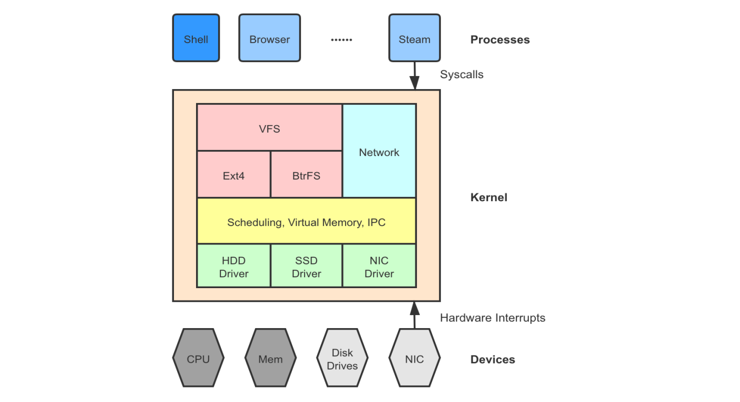

Figure 1 Architecture of Kernel

**Monolithic vs. Microkernel Architectures:** At the heart of kernel architectures lies a fundamental dichotomy between monolithic and microkernel designs. This subsection elucidates the distinctions between these two paradigms. Monolithic kernels encapsulate all essential operating system functionalities within a single, cohesive unit, while microkernels distribute these functionalities across separate, modular components. By highlighting the advantages and disadvantages of each architecture, we provide readers with a nuanced understanding of the trade-offs inherent in choosing between monolithic and microkernel structures.

**Comparative Analysis:** This subsection offers an in-depth comparative analysis of popular kernel architectures, examining their design philosophies, performance characteristics, and suitability for various applications. By dissecting well-known examples of both monolithic and microkernel designs, we aim to provide readers with insights into the practical implications of these architectural choices. Case studies and real-world examples illuminate the impact of architecture on system behavior, robustness, and ease of maintenance.

**Design Considerations:** Beyond the overarching classifications, kernel design considerations play a pivotal role in shaping the architecture of operating systems. This subsection delves into essential considerations such as modularity, scalability, and ease of maintenance. It explores how these considerations influence the decision-making process when designing kernels, shedding light on the factors that contribute to the overall efficiency and adaptability of the system

**IV. APPLICATIONS OF KERNELS**

The applications of kernels extend across a diverse spectrum of computing domains, showcasing their versatility and indispensable role in modern technology. In this section, we explore how kernels are integrated into operating systems, examine real-world examples spanning various domains, and identify emerging trends that highlight the expanding applications of kernel technology.

**Operating Systems Integration:** Kernels serve as the core component in the integration of operating systems, playing a central role in managing hardware resources, facilitating communication between software layers, and providing a foundation for system functionality. This subsection delves into the intricacies of how kernels are seamlessly integrated into operating systems, influencing the user experience, system responsiveness, and overall stability.

**Real-World Examples:** This subsection presents a series of real-world examples that illustrate the broad applications of kernels across different domains. From traditional desktop and server environments to specialized systems like embedded devices, mobile platforms, and cloud computing, kernels play a critical role in shaping the behavior and performance of diverse computing systems. Case studies and examples highlight the adaptability of kernels to meet the unique requirements of each application.

**Emerging Trends:** The landscape of kernel applications is continually evolving, with emerging trends reflecting the dynamic nature of computing. This subsection explores current trends, such as the integration of kernels in Internet of Things (IoT) devices and edge computing environments. The discussion delves into how kernels are adapting to the challenges posed by these emerging technologies, providing a glimpse into the future of kernel applications.

**V. SECURITY IMPLICATIONS**

Kernel-level security implications are a critical aspect of understanding the robustness and vulnerability of a computer system. In this section, we delve into the specific security risks associated with kernel design, explore approaches to enhance kernel security, and analyze real-world case studies to illustrate the potential consequences of kernel vulnerabilities.

**Kernel-Level Security Risks:** Understanding the risks inherent in kernel design is paramount for developing secure computing environments. This subsection identifies and analyzes kernel-level security risks, including potential exploits such as privilege escalation, unauthorized access, and denial-of-service attacks. By dissecting these risks, readers gain insights into the potential weak points that adversaries may exploit to compromise system security.

**Enhancing Kernel Security:** This subsection explores various approaches to enhancing kernel security. From secure coding practices to access control mechanisms, we delve into the strategies employed to fortify kernel architectures against potential threats. Understanding how security measures are integrated into kernel design allows developers and system administrators to implement proactive measures to mitigate vulnerabilities and strengthen the overall security posture of a system.

**VI. FUTURE DIRECTIONS**

As we peer into the future, the trajectory of kernel paradigms suggests several promising directions that will shape the landscape of computer science. This section outlines potential future directions in kernel development, considering ongoing research trends, emerging technologies, and the evolving needs of computing systems.

**Microservices and Containerization:** The future of kernel development may witness a deeper integration with microservices architectures and containerization technologies. As organizations increasingly adopt containerized applications and microservices for scalability and efficiency, kernels may evolve to provide enhanced support for these paradigms, optimizing resource utilization and improving orchestration capabilities.

**Security by Design:** Security will continue to be a paramount concern in future kernel development. The integration of security features directly into the kernel design, such as hardware-based security mechanisms and advanced encryption protocols, will be crucial. A proactive approach to security by design will become standard practice to mitigate emerging threats.

**Edge Computing and IoT Integration:** The proliferation of edge computing and the Internet of Things (IoT) will drive kernels to adapt to the unique challenges posed by distributed computing environments. Future kernels may prioritize optimizations for edge devices, ensuring efficient communication, reduced latency, and enhanced support for real-time processing in IoT ecosystems.

**Quantum Computing Integration:** The advent of quantum computing presents both challenges and opportunities for kernel development. Future kernels may need to adapt to the unique characteristics of quantum processors, potentially opening avenues for hybrid computing models that combine classical and quantum processing capabilities.

**Machine Learning Integration:** Machine learning (ML) and artificial intelligence (AI) are becoming integral parts of computing applications. Future kernels may incorporate specialized support for ML workloads, optimizing hardware-accelerated processing for neural networks and deep learning tasks. This integration could lead to more efficient and tailored computing solutions for data-intensive applications.

**Enhanced Performance and Optimization Techniques:** Future kernels will likely continue to explore innovative performance optimization techniques. This may include advancements in parallel processing, improved load balancing strategies, and efficient resource management to meet the increasing demands of high-performance computing environments.

**CONCLUSION**

The comprehensive analysis of kernel paradigms presented in this research paper has illuminated the fundamental components that underpin operating systems and shape the landscape of modern computing. From the foundational definitions and historical evolution to the nuanced discussions on diverse architectures, real-world applications, performance considerations, and security implications, this exploration has provided a holistic perspective on the critical role that kernels play in the realm of computer science. The foundations of kernels, deeply rooted in mathematical principles, serve as the theoretical bedrock guiding their design and functionality. The dichotomy between monolithic and microkernel architectures, as discussed in the section on kernel architectures, showcases the trade-offs and considerations that influence the structural paradigms of operating system kernels. The applications of kernels, as explored in this research, demonstrate their adaptability and ubiquity across various computing domains. From the integration into operating systems to real-world examples spanning desktops, mobile devices, and the cloud, kernels emerge as the linchpin enabling the functionality of diverse computing environments. Emerging trends, particularly in the Internet of Things (IoT) and edge computing, hint at the continual evolution of kernel applications. Security implications at the kernel level underscore the imperative of addressing vulnerabilities to fortify the overall security posture of computer systems. Understanding and mitigating risks such as privilege escalation and unauthorized access are critical steps in ensuring the integrity and confidentiality of data. As we peer into the future, the research paper envisions potential advancements in kernel technology and their broader implications for the field of computer science. Ongoing research trends, coupled with emerging technologies, hint at a dynamic landscape where kernels will continue to evolve to meet the demands of an ever-changing computing paradigm.

**REFERENCES**

[1]. Stallings W, Paul GK. Operating systems: internals and design principles. Pearson New York. 2012;9.

[2]. Hwang D, Yang M, Jeon S, Lee Y, Kwon D, Paek Y. Riskim: Toward complete kernel protection with hardware support. in 2019 Design, Automation & Test in Europe Conference & Exhibition (DATE), 2019, pp. 740-745.

[3]. Ageed ZS, Zeebaree SR, Sadeeq MM, Kak SF, Rashid ZN, Salih AA, et al. A survey of data mining implementation in smart city applications. Qubahan Academic Journal. 2021;1:91-99.

[4]. Dino HI, Zeebaree SR, Ahmad OM, Shukur HM, Zebari RR, Haji LM. Impact of Load sharing on performance of distributed systems computations. International Journal of Multidisciplinary Research and Publications (IJMRAP). 2020;3:30-37.

[5]. Haji L, Zebari R, Zeebaree S, Abduallah W, Shukur H, Ahmed O. GPUs impact on parallel shared memory systems performance. Int. J. Psychosoc. Rehabil. 2019;24:8030-8038.

[6]. Jiang H, Gao W, Wang M, See S, Yang Y, Liu W, et al. Research of an architecture of operating system kernel based on modularity concept. Mathematical and Computer Modelling. 2010;51:1421-1427.

[7]. Jijo BT, Zeebaree SR, Zebari RR, Sadeeq MA, Sallow AB, Mohsin S, et al. A comprehensive survey of 5G mm-wave technology design challenges. Asian Journal of Research in Computer Science. 2021;1-20.

[8]. Dino HI, Zeebaree SR, Salih AA, Zebari RR, Ageed ZS, Shukur HM, et al. Impact of Malallah et al.; AJRCOS, 8(3): 16-31, 2021; Article no.AJRCOS.68517 28 process execution and physical memoryspaces on os performance.

[9]. Zaidenberg NJ, Khen E. Detecting kernel vulnerabilities during the development phase. in 2015 IEEE 2nd International Conference on Cyber Security and Cloud Computing. 2015;224-230.

[10]. Fernandes A, Tribolet J. Enterprise operating system: the enterprise (self) governing system. Procedia Computer Science. 2019;164:149-158.

[11]. Zeebaree S, Salim B, Zebari R, Shukur H, Abdulraheem A, Abdulla A, et al. Enterprise resource planning systems and challenges. Technol. Rep. Kansai Univ. 2020;62:1885-1894.

[12]. Sharif KH, Zeebaree SR, Haji LM, Zebari RR. Performance measurement of processes and threads controlling, tracking and monitoring based on shared-memory parallel processing approach. in 2020 3rd International Conference on Engineering Technology and its Applications (IICETA), 2020;62-67.

[13]. Salih AA, Zeebaree SR, Abdulraheem AS, Zebari RR, Sadeeq MA, Ahmed OM. Evolution of mobile wireless communication to 5G revolution. Technology Reports of Kansai University. 2020;62:2139-2151.

[14]. Baccelli E, Gündoğan C, Hahm O, Kietzmann P, Lenders MS, Petersen H., et al. RIOT: An open source operating system for low-end embedded devices in the IoT. IEEE Internet of Things Journal. 2018;5:4428-4440.