 

**LPG GAS ANALYSIS SYSTEM**

**A PROJECT REPORT**

Submitted by

## ADEEB RAAFEH S (913120105001)

## HAREESHANGAR M (913120105010)

***In partial fulfillment for the award of the degree of***

## BACHELOR OF ENGINEERING

***In***

**ELECTRICAL AND ELECTRONICS ENGINEERING**

**VELAMMAL COLLEGE OF ENGINEERING AND TECHNOLOGY,**

**MADURAI-625009**

**ANNA UNIVERSITY: CHENNAI 600025**

**MAY 2024**

# **ANNA UNIVERSITY: CHENNAI 600025**

## BONAFIDE CERTIFICATE

Certified that is report **“LPG GAS ANALYSIS SYSTEM”** is the bonafide work of **ADEEB RAAFEH S (913120105001), HAREE SHANGAR M (913120105010)** who carried out the project under my supervision.

## SIGNATURE SIGNATURE

**Dr.A.SHUNMUGALATHA, M.E., Ph.D., Mrs. M.DEVAKI, B.E., M.E.**

Dean (Academics) & Head of the Department Assistant Professor

Electrical and Electronics Engineering, Electrical and Electronics Engineering, Velammal College of Engineering and Velammal College of Engineering Technology, and Technology,

Madurai–625009. Madurai–625009.

Certified that the candidate was examined on the Viva Voce Examination held at Velammal College of Engineering and Technology, Madurai on\_\_\_\_\_\_\_\_\_\_

**INTERNALEXAMINER EXTERNALEXAMINER**

## ACKNOWLEDGEMENT

First of all we thank the Almighty for strengthening us throughout the project and helping us to complete it successfully.

We find immense pleasure to convey our sincere thanks to our honorable Principal **Dr.P.ALLI,** for providing necessary facilities in carrying out our project work in our campus.

We would like to express our hearty thanks to our Dean (Academics) & Head of the Department **Dr.A.SHUNMUGALATHA, M.E., Ph.D.,** for her constant encouragement.

We take this opportunity to express our sincere and heartfelt thanks to our guide, **Mrs. M.DEVAKI, B.E., M.E.** for her patient guidance, timely suggestion technical and moral support and the immense part of her dedication in completing the project work successfully.

We express our special thanks to other staff members of our department, the non-teaching staff and our friends who assisted us, by their support and encouragement.

We also express our special thanks to our Parents who have sacrificed greatly in our education and welfare. We thank all those who have helped directly and indirectly in doing this project and bringing out this successful report.

# **ABSTRACT**

Recent trend is the development of Smart homes all around the world. Home automation has become very affordable and many people, industries has started to automate daily routines like light, fans, setting the temperature, etc,. A gas detector is a device that detects the presence of gases in an area, often as part of a safety system. This type of equipment is used to detect a gas leak or other emissions and can interface with a control system so a process can be automatically fan ON. A gas detector can sound an alarm to operators in the area where the leak is occurring, giving them the opportunity to leave. In this connection we fix Gas sensor to identity gas leakage. This type of device is important because there are many gases that can be harmful to organic life, such as humans or animals. Gas detectors can be used to detect combustible, flammable and toxic gases, and oxygen depletion. This type of device is used widely in industry and can be found in locations, such as on oil rigs, to monitor manufacture processes and emerging technologies such as photovoltaic. They may be used in firefighting. Gas leak detection is the process of identifying potentially hazardous gas leaks by sensors. These sensors usually employ an audible alarm to alert people when a dangerous gas has been detected. The main objective of the project is to build a Gas leakage detector and monitoring using LPG gas sensor and also connect it with IoT using ESP module for safety and security. ESP32 is used as the main controller. The final output of the project is used to detect leakage if gas from cylinders and also notify the user by connecting via IoT software using Blynk app and turn off LPG valve using Relay.

Keywords: ESP32 Module, Relay, LCD 2\*16, Internet of things (IoT), MQ2 sensor, Gas sensor, Security System, Home Security, Blynk app.

**TABLE OF CONTENTS**

|  |  |  |
| --- | --- | --- |
| **CHAPTER NO.** | **TITLE** | **PAGE**  **NO.** |
|  | **ACKNOWLEDGEMENT** | **3** |
|  | **ABSTRACT** | **4** |
|  | **TABLE OF CONTENTS** | **5** |
|  | **LIST OF FIGURES** | **7** |
|  | **LIST OF ABBREVATION** | **8** |
| **1** | **INTRODUCTION** | **9** |
|  | 1.1 GENERAL | 9 |
|  | 1.2 OBJECTIVE | 11 |
|  | 1.3 EXISTING METHOD | 12 |
| **2** | **LITERATURE SURVEY** | **13** |
|  | 2.1. Liquid Problem Gas Detection | 13 |
|  | 2.2. Classification of Leakages Detection | 13 |
|  | 2.3. FPGA-GSM Based Gas Leakage Detection | 13 |
|  | 2.4. Embedded Real-Time System For Gas Leakage Detection | 13 |
|  | 2.5. Wireless modularization of gas safety devices. | 14 |
|  | 2.6. Automatic Safety Gas Stove and liquefied petroleum gas booking and monitoring PATIENTS AT HOME | 14 |
| **3** | **PROPOSED SYSTEM** | **15** |
|  | 3.1 DESCRIPTION | 15 |
|  | 3.2 BLOCK DIAGRAM DESCRIPTION | 15 |
| **4** | **MODULE DESCRIPTION** | 16 |
|  | 4.1 IOT | 16 |
|  | 4.2 Blynk | 18 |
|  | 4.3. ESP32 | 19 |
|  | 4.4. Arduino IDE | 21 |
|  | 4.5. LCD DISPLAY | 33 |
|  | 4.6. MQ2 GAS SENSOR | 35 |
|  | 4.7. Relay | 37 |
|  | 4.8. 5V Adaptor: | 38 |
|  | 4.9. Pneumatic valve | 39 |
|  | 4.10. Procedure | 40 |
|  | 4.11. Program | 41 |
| **5** | **RESULTS AND DISCUSSION** | **46** |
|  | 5.1 RESULTS | **46** |
|  | 5.2 COST ESTIMATION | 48 |
| **6** | **CONCLUSION** | **49** |
| **7** | **FUTURE DIRECTION AND ENHANCEMENTS** | **50** |
| **8** | **REFERENCES** | **51** |

**LIST OF FIGURES**

|  |  |  |
| --- | --- | --- |
| **FIGURE**  **NO.** | **DESCRIPTION** | **PAGE**  **NO.** |
| 3.1.1 | Gas analysis | 15 |
| 4.1.1 | IOT | 17 |
| 4.3.1 | ESP32 | 19 |
| 4.3.2 | Pin connections of ESP32 | 20 |
| 4.4.1 | Arduino IDE | 21 |
| 4.4.2 | Toolbar Button | 22 |
| 4.4.3 | Serial Monitor | 23 |
| 4.4.4 | File | 24 |
| 4.4.5 | Page Setup | 26 |
| 4.4.6 | Edit Button | 26 |
| 4.4.7 | Find Button | 28 |
| 4.4.8 | Sketch Button | 29 |
| 4.4.9 | Add File | 30 |
| 4.4.10 | Tools Button | 31 |
| 4.4.11 | Help Button | 33 |
| 4.5.1 | LCD | 33 |
| 4.5.2 | Pin connections of LCD | 35 |
| 4.6.1 | MQ2 Gas Sensor | 36 |
| 4.7.1 | Relay | 37 |
| 4.8.1 | Adpator | 38 |
| 4.9.1 | Pneumatic valve | 39 |
| 5.1.1 | Implemented Prototypes | 47 |
| 5.1.2 | LCD Display showing gas detection | 47 |

**LIST OF ABBREVATION**

* **LPG -** Liquid Petroleum Gas
* **IDE -** Integrated Development Environment
* **LCD -** Liquid Crystal Display
* **ESP32 -** Express if System on Chip
* **MQ2 -** Methane/CH4 Quality Sensor
* **MQTT -** Message Queuing Telemetry Transport
* **CPU -** Central Processing Unit

**CHAPTER - 1**

**INTRODUCTION**

**1.1 INTRODUCTION**

            An LPG leakage analyzer is an essential device used to detect and measure the presence of LPG gas leaks in a given area. The analyzer works by using different techniques such as gas sensors, thermal imaging, and infrared spectroscopy to identify and quantify the amount of LPG gas present in the air. The detection of LPG gas leaks is crucial to prevent potential fire hazards, explosions, and health hazards. LPG leakage analyzers have a wide range of applications in various industries such as petroleum, chemical, and gas processing plants. The recent advances in LPG leakage analyzer technology have led to the development of portable, wireless, and real-time analyzers that can be used in field applications. However, it is important to ensure that LPG leakage analyzers meet the required specifications and compliance requirements set by various standards and regulations. Conducting a literature survey is essential to understand the different types of LPG leakage analyzers, their working principles, applications, recent advances, and compliance requirements.

          An LPG analyzer is an important analytical instrument used to measure the composition and properties of liquefied petroleum gas (LPG). The analyzer works by utilizing various techniques such as infrared spectroscopy, gas chromatography, and mass spectrometry to identify and quantify the different components of LPG. LPG analyzers have a wide range of applications in the petroleum industry, gas processing, petrochemicals, and gas pipelines. Recent advances in LPG analyzer technology have led to the development of portable and real-time analyzers that can be used in field applications. However, it is important to ensure that LPG analyzers meet the required specifications and compliance requirements set by various standards and regulations. Conducting a literature survey is essential to understand the different types of LPG analyzers, their working principles, applications, recent advances, and compliance requirements.

           Most of LPG explosions are caused by undetected gas leakage in the pre-detection condition. So that, LPG detection system is needed. The purpose of this system is to detect gas leakage, neutralize it, and prevent the explosion. Gas leakage could happen due to improper regulator installation or the hose is broken. This detection should not work in just one location because gas can leak at the gas regulator and its hose. Therefore, Wireless Sensor Network (WSN) is one of the methods that suitable for detecting gas leakage in the wider area. This method uses two or more gas sensors to detect leakage in two or more locations around the gas tube and its distribution line. WSN system works based on gas sensor MQ-6 and wireless module Bluetooth HC-05. Explosion prevention system works based on alarm/buzzer, exhaust fan, and automatic gas regulator. If the gas leaks, the sensor will send its data wirelessly to Arduino. Then, explosion prevention system will be activated. The system will turn the alarm/buzzer on, automatically releases gas regulator, and neutralizes the air with the exhaust fan. Both systems will be fully controlled by Arduino platform.

         As we know, security has been major issue in today’s scenario. Accidents are on increasing day by day. Here, we are talking about those accidents that are being occurred due to combustible gases, i.e., LPG, CNG. Frequently we hear, explosion in cylinder of household and vehicles.Several people have been injured and some got dead. So we are making this project for security purpose that will detect combustible gases and alert candidates. Now a day’s, LPG Gas leakage detector’s comes in the market with the LPG sensor that only senses any gas leakage and sends a SMS to the emergency no. provided to it and alerts the user via audio or visual indications while we are on a project in which we are using a stepper motor also in addition to the normal LPG Gas leakage detectors which helps in turning off the switch when there an emergency in our absence. In this paper, we are reviewing on the use of LPG Gas leakage detector along with the stepper motor instead of using other simple Gas leakage detector. The sensor we are using here has excellent sensitivity combined with a quick response time. The sensor can also sense is obutane, propane, LNG and cigarette smoke.

**1.2 OBJECTIVE**

To ensure to avoid the leakage of gas in big industries and etc.

➢ A gas detector is a device that detects the presence of gases in an area, often as part of a safety system

➢To detect a gas leak or other emissions and can interface with a control system so a process can be automatically fan ON

➢ To detect combustible, flammable and toxic gases, and oxygen depletion.

**1.3 EXISTING METHOD**

The existing system utilizes advanced technology to create comprehensive gas leakage detection and monitoring solution. At its core is the ESP32 module, serving as the main controller to orchestrate the various functionalities of the system. The system incorporates MQ2 gas sensors, specifically designed to detect a wide range of gases including combustible, flammable, and toxic gases commonly found in household environments.

Upon detecting a gas leak, the system activates an audible alarm to alert individuals in the vicinity, providing crucial time for evacuation. Simultaneously, the system communicates with the Blynk app via the Internet of Things (IoT) connectivity, enabling real-time monitoring and notifications on the user's Smartphone or other connected devices. This feature ensures that users are promptly informed of potential hazards, even when they are not physically present at home.

Moreover, the system includes a safety mechanism whereby a relay is utilized to automatically shut off the LPG valve upon detecting a gas leak. This proactive approach helps prevent the escalation of the situation and minimizes the risk of fire or explosion.

In addition to the functional aspects, the system incorporates a user-friendly interface with a 2x16 LCD display, providing essential information such as gas levels and system status at a glance. This enhances user experience and facilitates quick decision-making in emergency situations.

Overall, the integration of these components results in a robust home security system focused on gas leak detection and prevention, providing peace of mind to homeowners and ensuring the safety of their families and property.

**CHAPTER - 2**

**LITERATURE SURVEY**

**2.1. Liquid Problem Gas Detection:**

Liquid problem gas is a flammable mixture of hydrocarbon gases used as fuel in heating appliances, cooking equipment, and specifically as a vehicle fuel (it is often referred to as autogas). It is an odorless gas due to ethyl mercaptan is added as an odorant to be easily detected when leakage occurs for safety precaution. LPG is made by refining petroleum or wet natural gas and is almost entirely derived from fossil fuels sources being manufactured during the refining of crude oil as theory emerged from the natural state. It was classified as a hazardous material because of its explosive potentials when under pressure, due to this hazardous property leading to fire explosion. The gas detection process was made by the chemically infused paper that change its color when it’s been exposed to gas before the development of the electronics gas detector. The electronics leakage detector was an active approach to initial fault detection in other to achieve the utmost safety of humanity and properties as a whole they introduced an android base automatic gas detection).different approaches have been used alongside several research in the detection of leakage and were also implemented alongside some incident toward some decades. The existing leakage detection is optical sensor method, cable sensor, negative pressure, vapor sampling, signal processing, mass volume, and pressure point analysis, in which have been implemented using a different framework. Some groups of researchers have classified the technology as two fitting categories, which are software and hardware method but research continues and to technical nature research effort which led them to three group methods

**2.2. Classification of Leakages Detection:**

There are different classes of leakage detection which have been used to monitor the leakage, several criteria are classified into their classification, some of which are critical principles and abilities needed from humans. The detection is classified into three, which are automated detection, manual detection, and semi-automated detection. Automated Detection involves monitoring of detecting leakage without the help of the operator, once the detector device is installed and been connected to the display of the personnel in charge and can be automatically shut down from the display unit. (SCADA); Manual Detection - These are methods in which the device can only be operated by humans. Like thermal imager or light detection and ranging (Lidar) devices; Semi-automated detection – solutions that necessitate a certain amount of input or assistance in carrying out certain tasks (e.g. statistical or digital signal processing methods) (Batzias et al., 2011). The technology used in leakages detection can be classified into two categories which are, Direct method and the Indirect method The direct method is making use of a handheld detector by the patrol team along the pipeline and in the aspect of the very long pipeline, the airplane mounted optical imaging device is used along the pipeline for measuring gas emanation for fast result .

**2.3. FPGA-GSM Based Gas Leakage Detection:**

In the work entitled FPGA-GSM Based Gas Leakage Detection Method by [7]. They investigated a simple FPGA-based system that detected LPG leakages using the MQ6 sensor. In the event of gas leakage, an automatic warning call is sent to the first response team via GSM to avoid any delays. There is no remote monitoring or any mechanism for mitigating gas leaks, such as automatic shut-off of the gas supply.

**2.4. Embedded Real-Time System For Gas Leakage Detection:**

A domestic applications in residential buildings for an Embedded real-time system for gas leakage detection in which sensor nodes are installed in various households and communicate with a single central node. An alarm is triggered in the event of gas leakage. The concerned personnel is identified and alerted via text messages using the assigned MAC address of the RF module in each sensor unit. The use of exhaust fans is a commonly proposed solution for gas-related accidents, however, this system is only capable of mitigating a possible disaster and not completely averting it, since this approach reduces the risk by expelling gas leakage instead of shutting down the supply .

**2.5. Wireless modularization of gas safety devices:**

Smart home gas safety management system based on wireless modularization of gas safety devices was designed to allow safety in the homes in other to reduce damages. The system is based on the commercially available intelligent Micom meters, which have enhanced standard gas meters with a built-in microcontroller and a cutoff valve. The system is primarily concerned with detecting fire breakouts, and the existing gas meter has been upgraded to communicate with an external smoke and CO detecting sensor, as well as fire extinguishing modules, which are used to extinguish the fire when the temperature exceeds the threshold. The requirement for an existing Micom meter to construct the enhanced gas and fire safety method is a disadvantage of this system, as it lacks independent application. [10] developed a gas leakage detection and location system based on wireless sensor networks. They used wireless sensor networks to detect gas leakages and ensure product safety in the petrochemical industry. The system emphasizes the importance of developing centralized location software by collecting data from wireless RF sensors in order to precisely pinpoint the location of gas leakage and aid in the response time reduction In spite of the absence of remote monitoring and automatic shutoff, the study emphasizes the importance of inter-node communication in developing a dependable leakage detection system .

**2.6. Automatic Safety Gas Stove and liquefied petroleum gas booking and monitoring:**

An automatic safety gas stove that uses Infrared (IR) sensors to detect the presence of utensils on the stove. In the absence of utensils, the system relies on motors to turn the stove knob to turn off the gas supply. The system presumes that the gas leak is limited to the stove burner and ignores the possibility of a leakage in the gas supply pipe. Its ability to detect gas leaks is limited due to the absence of any sensing units. The disadvantage of this approach is that it does not take into account scenarios such as gas pipe leakage [12]. Automated Unified System For LPG Using Microcontroller And GSM Module: This was a very cost-effective

4 automated liquified petroleum gas booking and monitoring, which the gas leakage is detected through the weight sensor to detect the level of the gas in the cylinder and an MQ series sensor to monitor leakage through the SMS received by the user and automatically book the cylinder. It also involves an exhaust fan that is switched on and a solenoid valve fitted to the cylinder to close once there is leakage [13].

**CHAPTER – 3**

**PROPOSED SYSTEM**

**3.1 DESCRIPTION**

* The LPG gas analysis system effectively monitors and analyzes the composition of LPG, ensuring safety and efficiency.

* Its accurate measurements allow for timely detection of any anomalies or leaks, promoting safer usage and minimizing risks associated with LPG.

* Implement a robust data processing unit to analyze sensor data in real-time. This unit can use algorithms to identify patterns associated with gas leaks and differentiate them from normal variations in gas levels.

**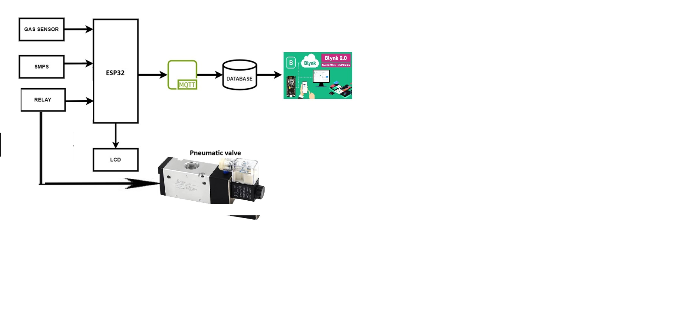**

**Figure 3.1.1 Gas analysis**

**3.2 Block Diagram Description**

An LPG gas analysis system comprises several key components essential for accurate gas detection and analysis. At the core are gas sensors tasked with detecting the presence and concentration of LPG gas. These sensors feed their signals to signal conditioning circuits, which enhance the raw data through processes like amplification and filtering to prepare it for further processing. A microcontroller or processor acts as the system's brain, receiving and interpreting the conditioned signals using data processing algorithms to determine LPG gas concentrations. Communication modules facilitate the transmission of this data to external devices or systems, allowing for remote monitoring and control. Additionally, a display or interface provides users with a means to interact with the system, conveying information such as gas concentrations or system status. Power supply components ensure that all system elements receive the necessary power to operate reliably, with power management circuits regulating voltage and current levels as required. Together, these components form a comprehensive LPG gas analysis system capable of detecting and analyzing gas concentrations in diverse settings.

**CHAPTER – 4**

**MODULE DESCRIPTION**

**4.1 IOT:**

The Internet of Things (IOT) is a system of interconnected computing devices, mechanical and digital machines, objects, animals or humans, each with a unique identifier (UID) and the ability to transmit data over a network without human intervention – Manual connection is required, provided. Human-Computer Interaction or Human- Computer Interaction. Things on the Internet of Things could be people implanted with heart monitors, farm animals with biochip transponders, cars with built-in sensors that warn drivers when tire pressure is too low, or any other natural or Man-made objects can be assigned Internet Protocol (IP) addresses and can transmit data over a network.

The web of things helps individuals live and work more astute, as well as deal with their lives. As well as offering savvy gadgets to robotize homes, IOT is fundamental for business. IOT furnishes organisations with

a continuous investigation of how their frameworks truly work, conveying bits of knowledge into everything from the exhibition of machines to inventory network and strategies tasks. A few advantages are industry-explicit, and some are relevant across different enterprises. A portion of the normal advantages of IOT empower organised

* Screen their general business processes
* Further develop the client experience (CX)
* Set aside time and cash
* Improve representative usefulness

In a developing United States like India, where the populace and cars are developing rapidly, the implementation of an advanced parking system is critical. despite the fact that vehicle utilisation is soaring, there are not enough parking spaces to accommodate them, which means that they have to make do with seldom-determined spaces. which strain the driving force to park a vehicle on the roads, it's the reason heavy,congestion the roads sluggish movement of web page traffic. Despite the fact that, lot of time is wasted in searching for parking whilst looking by chance it outcomes the environment via emission dangerous vehicles. This emission adulterated the air with the resource of CO2 and other gases thru combustion of fuel. In addition, even looking at parking slots, the motion of traffic turns sluggish. to triumph over all the troubles stated above, we need an green parking tool which would possibly help to lessen site travellers congestion and enhance air at crucial places wherein website site visitors rushmore.

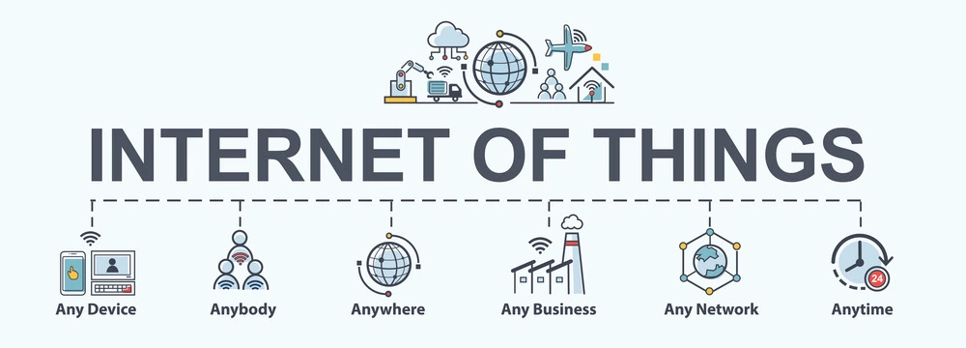

Fig 4.1.1 IOT

According to the definition of IOT, it's the manner to interconnect with the help of the net gadgets that can be embedded to put in force the capability in normal objects by permitting them to send and acquire data. Connectivity

* Intelligence and identity
* Scalability
* Protection

The **Internet of things** (**IOT**) describes physical objects (or groups of such objects) with sensors, processing ability, software and other technologies that connect and exchange data with other devices and systems over the Internet or other communications networks. Internet of things has been considered a misnomer because devices do not need to be connected to the public internet, they only need to be connected to a network, and be individually addressable.

The field has evolved due to the convergence of multiple technologies, including ubiquitous computing, commodity sensors, increasingly powerful embedded systems, as well as machine learning. Traditional fields of embedded systems, wireless sensor networks, control systems, automation (including home and building automation), independently and collectively enable the Internet of things. In the consumer market, IOT technology is most synonymous with products pertaining to the concept of the "smart home", including devices and appliances (such as lighting fixtures, thermostats, home security systems, cameras, and other home appliances) that support one or more common ecosystems, and can be controlled via devices associated with that ecosystem, such as smartphones and smart speakers. IoT is also used in healthcare systems.

There are a number of concerns about the risks in the growth of IOT technologies and products, especially in the areas of privacy and security, and consequently, industry and governmental moves to address these concerns have begun, including the development of international and local standards, guidelines, and regulatory frameworks.

* 1. **Blynk**

Blynk (pronounced "blink") is a powerful platform designed for building IoT applications quickly and easily. Let's explore how Blynk compares to MQTT and its components:

**Blynk Overview Protocol**: Blynk provides a user-friendly platform and mobile app for IoT development, offering drag-and-drop tools and customizable widgets to create IoT interfaces without complex coding. Blynk Components: Dashboard: The Blynk dashboard is where users can create and customize their IoT projects. It provides a visual interface for adding devices, arranging widgets, and monitoring data. Widgets: Blynk offers a variety of widgets such as buttons, sliders, graphs, and displays, which can be added to the dashboard to interact with connected devices and visualize data.

**Cloud Connectivity:** Blynk connects devices to its cloud servers, facilitating communication between the user's mobile app and the IoT devices.

**Blynk in IoT:** Blynk simplifies the development of IoT projects by providing a user-friendly interface and cloud connectivity. It allows users to quickly prototype and deploy IoT applications without extensive programming knowledge. Security Considerations: Similar to MQTT, security is important when using Blynk for IoT applications. Blynk offers features such as encrypted communication and user authentication to ensure the security of IoT devices and data.

**Comparing BLynk to MQTT:** While both Blynk and MQTT are used in IoT applications, they serve different purposes and cater to different user needs. Blynk focuses on providing a user-friendly platform for building IoT projects without extensive coding, making it ideal for hobbyists, makers, and small-scale projects. MQTT, on the other hand, is a lightweight messaging protocol designed for efficient communication between IoT devices, particularly in large-scale deployments where low bandwidth and high reliability are essential. In summary, Blynk simplifies IoT development with its user-friendly interface and cloud connectivity, while MQTT is optimized for efficient messaging in IoT systems. The choice between the two depends on the specific requirements and preferences of the project.

**4.3. ESP32:**

The MCU ( MicroController Unit) is an open-source software and hardware development environment built around an inexpensive System-on-a-Chip (SoC) called the ESP32. The ESP32, designed and manufactured by Espressif Systems, contains the crucial elements of a computer: CPU, RAM, networking (WiFi), and Bluetooth even a modern operating system and SDK. That makes it an excellent choice for Internet of Things (IOT) projects of all kinds.

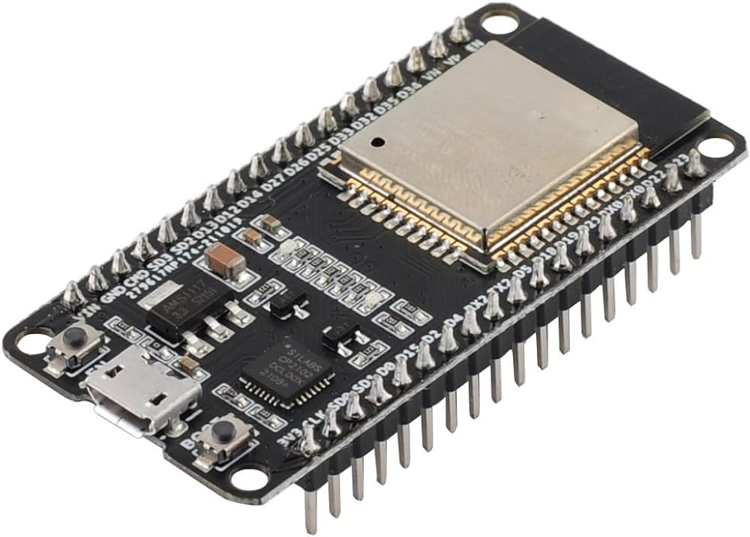

Fig 4.3.1 ESP32

However, as a chip, the ESP32 is also hard to access and use. You must solder wires, with the appropriate analog voltage, to its pins for the simplest tasks such as powering it on or sending a keystroke to the “computer” on the chip. You also have to program it in low-level machine instructions that can be interpreted by the chip hardware. This level of integration is not a problem using the ESP32 as an embedded controller chip in mass-produced electronics. It is a huge burden for hobbyists, hackers, or students who want to experiment with it in their own IoT projects.

But, what about Arduino? The Arduino project created an open-source hardware design and software SDK for their versatile IoT controller. Similar to ESP32, the Arduino hardware is a microcontroller board with a USB connector, LED lights, and standard data pins. It also defines standard interfaces to interact with sensors or other boards. But unlike ESP32, the Arduino board can have different types of CPU chips (typically an ARM or Intel x86 chip) with memory chips, and a variety of programming environments. There is an Arduino reference design for the ESP32 chip as well. However, the flexibility of Arduino also means significant variations across different vendors. For example, most Arduino boards do not have WiFi capabilities, and some even have a serial data port instead of a USB port.

The ESP32 is available in various package styles. Common to all the designs is the base ESP32 core. Designs based on the architecture have maintained the standard 30-pin layout. Some designs use the more common narrow (0.9″) footprint, while others use a wide (1.1″) footprint – an important consideration to be aware of.

The most common models of the MCU are the Amica (based on the standard narrow pin-spacing) and the LoLin which has the wider pin spacing and larger board. The open-source design of the base ESP8266 enables the market to design new variants of the MCU continually.

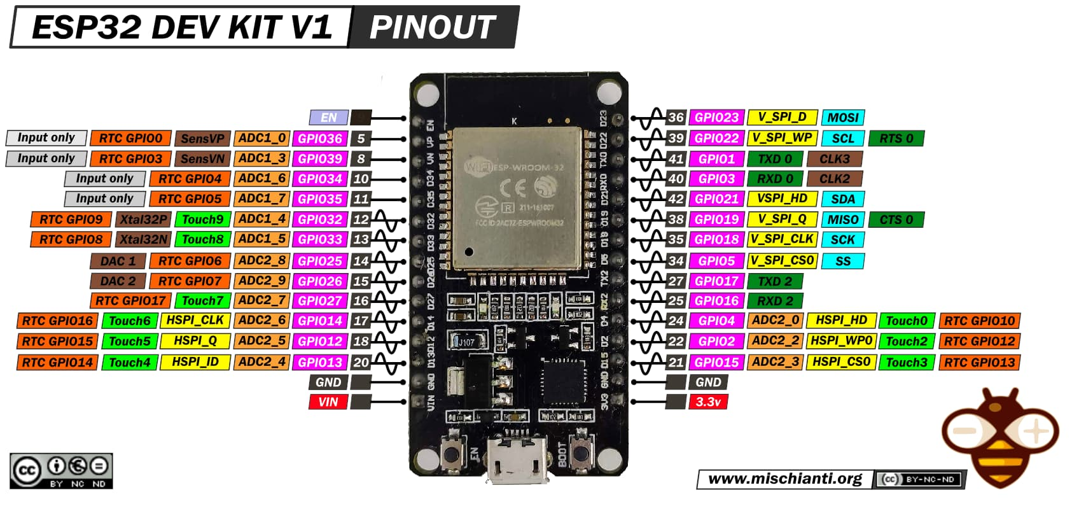

Fig.4.3.2 Pin connections of ESP32

**ESP32 Specifications & Features**

* Microcontroller: Tensilica 32-bit RISC CPU Xtensa LX106
* Operating Voltage: 3.3V
* Input Voltage: 7-12V
* Digital I/O Pins (DIO): 24
* Analog Input Pins (ADC): 16
* UARTs: 2
* SPIs: 2
* I2Cs: 1
* Flash Memory: 4 MB
* SRAM: 64 KB
* Clock Speed: 80 MHz
* USB-TTL based on CP2102 is included onboard, Enabling Plug n Play
* PCB Antenna
* Small Sized module to fit smartly inside your IoT project

**Programming ESP32 with Arduino IDE**

The ESP32 Development Board can be easily programmed with Arduino IDE since it is easy to use.

Programming ESP32 with the Arduino IDE will hardly take 5-10 minutes. All you need is the Arduino IDE, a USB cable and the ESP32board itself. You can check this Getting Started Tutorial for ESP32 to prepare your Arduino IDE for ESP32.

**4.4. Arduino IDE**

The Arduino IDE is an open-source software, which is used to write and upload code to the Arduino boards. The IDE application is suitable for different operating systems such as **Windows, Mac OS X, and Linux**. It supports the programming languages C and C++. Here, IDE stands for **Integrated Development Environment**.The program or code written in the Arduino IDE is often called sketching. We need to connect the Genuino and Arduino board with the IDE to upload the sketch written in the Arduino IDE software. The sketch is saved with the extension '.into. 'The Arduino IDE will appear as:

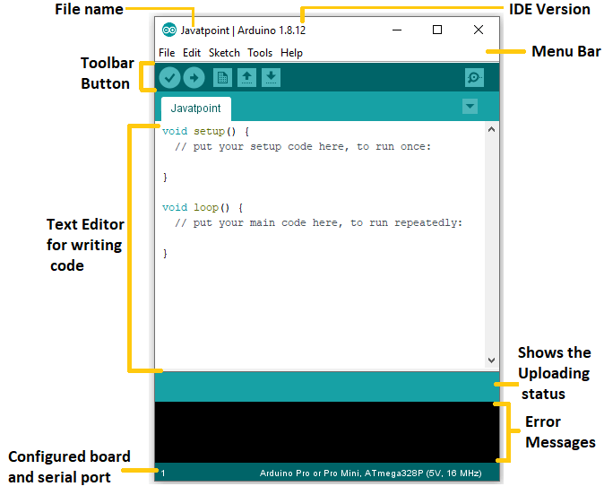

Fig 4.4.1. Arduino IDE

**Toolbar Button**

The icons displayed on the toolbar are **New, Open, Save, Upload,** and **Verify**.

It is shown below:

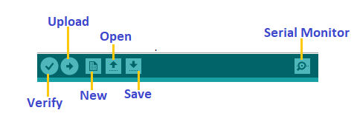

Fig.4.4.2 – Toolbar Button

### Upload

The Upload button compiles and runs our code written on the screen. It further uploads the code to the connected board. Before uploading the sketch, we need to make sure that the correct board and ports are selected.

We also need a USB connection to connect the board and the computer. Once all the above measures are done, click on the Upload button present on the toolbar.

The latest Arduino boards can be reset automatically before beginning with Upload. In the older boards, we needed to press the Reset button present on it. As soon as the uploading is done successfully, we can notice the blink of the Tx and Rx LED.

If the uploading fails, it will display the message in the error window.

We do not require any additional hardware to upload our sketch using the Arduino Bootloader. A **Bootloader** is defined as a small program, which is loaded in the microcontroller present on the board. The LED will blink on PIN 13.

### Open

The Open button is used to open the already created file. The selected file will be opened in the current window.

### Save

The save button is used to save the current sketch or code.

### New

It is used to create a new sketch or open a new window.

### Verify

The Verify button is used to check the compilation error of the sketch or the written code.

### Serial Monitor

The serial monitor button is present on the right corner of the toolbar. It opens the serial monitor.

It is shown below:

IMG_256

Fig.4.4.3-Serial Monitor

When we connect the serial monitor, the board will reset on the operating system Windows, Linux, and Mac OS X. If we want to process the control characters in our sketch, we need to use an external terminal program. The terminal program should be connected to the COM port, which will be assigned when we connect the board to the computer.

## Menu Bar

* **File**

When we click on the File button on the Menu bar, a drop-down list will appear. It is shown below:



Fig.4.4.4-File

Let's discuss each option in detail.

**New**

The New button opens the new window. It does not remove the sketch which is already present.

**Open**

It allows opening the sketch, which can be browsed from the folders and computer drivers.

**Open Recent**

The Open Recent button contains the list of the recent sketches.

**Sketchbook**

It stores the current sketches created in the Arduino IDE software. It opens the selected sketch or code in a new editor at an instance.

**Examples**

It shows the different examples of small projects for a better understanding of the IDE and the board. The IDE provides examples of self-practice.

**Close**

The Close button closes the window from which the button is clicked.

**Save**

The save button is used to save the current sketch. It also saves the changes made to the current sketch. If we have not specified the name of the file, it will open the '**Save As...'** window.

**Save As...**

We can save the sketch with a different name using the '**Save As...'** button. We can also change the name accordingly.

**Page Setup**

It allows setting the page margins, orientation, and size for printing. The '**Page Setup**' window will appear as:



Fig 4.4.5– Page Setup

**Print**

According to the settings specified in the 'Page Setup', it prepares the current sketch for printing.

**Preferences**

It allows the customization settings of the Arduino IDE.

**Quit**

The Quit button is used to close all the IDE windows. The same closed sketch will be reopened when we open the Arduino IDE.

* **Edit**

When we click on the Edit button on the Menu bar, a drop-down list appears. It is shown below:

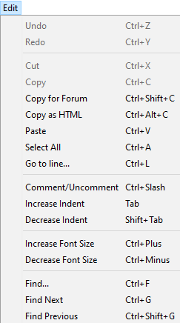

Fig 4.4.6 – Edit Button

Let's discuss each option in detail.

**Undo**

The Undo button is used to reverse the last modification done to the sketch while editing.

**Redo**

The Redo button is used to repeat the last modification done to the sketch while editing.

**Cut**

It allows us to remove the selected text from the written code. The text is further placed to the clipboard. We can also paste that text anywhere in our sketch.

**Copy**

It creates a duplicate copy of the selected text. The text is further placed on the clipboard.

**Copy for Forum**

The 'Copy for Forum' button is used to copy the selected text to the clipboard, which is also suitable for posting to the forum.

**Copy as HTML**

The 'Copy for Forum' button is used to copy the selected text as HTML to the clipboard. It is desirable for embedding in web pages.

**Paste**

The Paste button is used to paste the selected text of the clipboard to the specified position of the cursor.

**Select All**

It selects all the text of the sketch.

**Go to line...**

It moves the cursor to the specified line number.

The window will appear as:

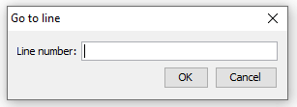

**Comment/Uncomment**

The Comment/ Decomment button is used to put or remove the comment mark (**//**) at the beginning of the specified line.

**Increase Indent**

It is used to add the space at the starting of the specified line. The spacing moves the text towards the right.

**Decrease Indent**

It is used to subtract or remove the space at the starting of the specified line. The spacing moves the text towards the left.

**Increase Font Size**

It increases the font size of the written text.

**Decrease Font Size**

It decreases the font size of the written text.

**Find...**

It is used to find the specified text. We can also replace the text. It highlights the text in the sketch.

The window will appear as:

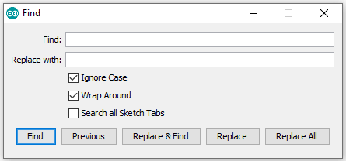

Fig 4.4.7– Find Button

**Find Next**

It highlights the next word, which has been specified in the '**Find...'** window. If there is no such word, it will not show any highlighted text.

**Find Previous**

It highlights the previous word, which has been specified in the '**Find...'** window. If there is no such word, it will not show any highlighted text.

* **Sketch**

When we click on the Sketch button on the Menu bar, a drop-down list appears. It is shown below:

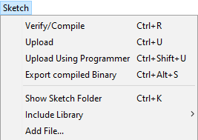

Fig 4.4.8– Sketch Button

Let's discuss each option in detail.

**Verify/Compile**

It will check for the errors in the code while compiling. The memory in the console area is also reported by the IDE.

**Upload**

The Upload button is used to configure the code to the specified board through the port.

**Upload Using Programmer**

It is used to override the Bootloader that is present on the board. We can utilize the full capacity of the Flash memory using the '**Upload Using Programmer**' option. To implement this, we need to restore the Bootloader using the **Tools**-> **Burn Bootloader** option to upload it to the USB serial port.

**Export compiled Binary**

It allows saving a .**hex** file and can be kept archived. Using other tools, .hex file can also be sent to the board.

**Show Sketch Folder**

It opens the folder of the current code written or sketch.

**Include Library**

Include Library includes various Arduino libraries. The libraries are inserted into our code at the beginning of the code starting with the #. We can also import the libraries from .zip file.

**Add File...**

The Add File... button is used to add the created file in a new tab on the existing file.

For example, let's add '**Blink**' file to the '**Java point**' file. The tab will now appear as:

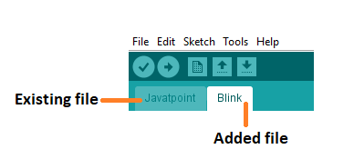

Fig 4.4.9– Add File

We can also delete the corresponding file from the tab by clicking on the **small triangle** -> **Delete** option.

### Tools

### When we click on the Tools button on the Menu bar, a drop-down list appears. It is shown below:

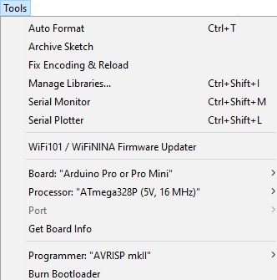

Fig 4.4.10– Tools Button

Let's discuss each option in detail.

**Auto Format**

The Auto Format button is used to format the written code. For example, lining the open and closed curly brackets in the code.

**Archive Sketch**

The copy of the current sketch or code is archived in the .zip format. The directory of the archived is same as the sketch.

**Fix Encoding and Reload**

This button is used to fix the inconsistency between the operating system char maps and editor char map encoding.

**Manage Libraries** It shows the updated list of all the installed libraries. We can also use this option to install a new library into the Arduino IDE.

**Serial Monitor**

It allows the exchange of data with the connected board on the port.

**Serial Plotter**

The Serial Plotter button is used to display the serial data in a plot. It comes preinstalled in the Arduino IDE.

**WiFi101/WIFI NINA Firmware Updater**

It is used to check and update the Wi-Fi Firmware of the connected board.

**Board**

We are required to select the board from the list of boards. The selected board must be similar to the board connected to the computer**.**

**Processor**

It displays the processor according to the selected board. It refreshes every time during the selection of the board.

**Port**

It consists of the virtual and real serial devices present on our machine.

**Get Board Info**

It gives the information about the selected board. We need to select the appropriate port before getting information about the board.

**Programmer**

We need to select the hardware programmer while programming the board. It is required when we are not using the onboard USB serial connection. It is also required during the burning of the Bootloader.

**Burn Bootloader**

The Bootloader is present on the board onto the microcontroller. The option is useful when we have purchased the microcontroller without the bootloader. Before burning the bootloader, we need to make sure about the correct selected board and port.

### Help

When we click on the Help button on the Menu bar, a drop-down list will appear. It is shown below:

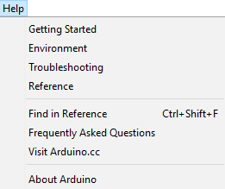

Fig 4.4.11 – Help Button

The Help section includes several documents that are easy to access, which comes along with the Arduino IDE. It consists of the number of options such as Getting Started, Environment, Troubleshooting, Reference, etc. We can also consider the image shown above, which includes all the options under the Help section. Some documents like Getting started, Reference, etc., can be accessed without the internet connection as well. It will directly link us to the official website of Arduino.

**4.5. LCD DISPLAY**

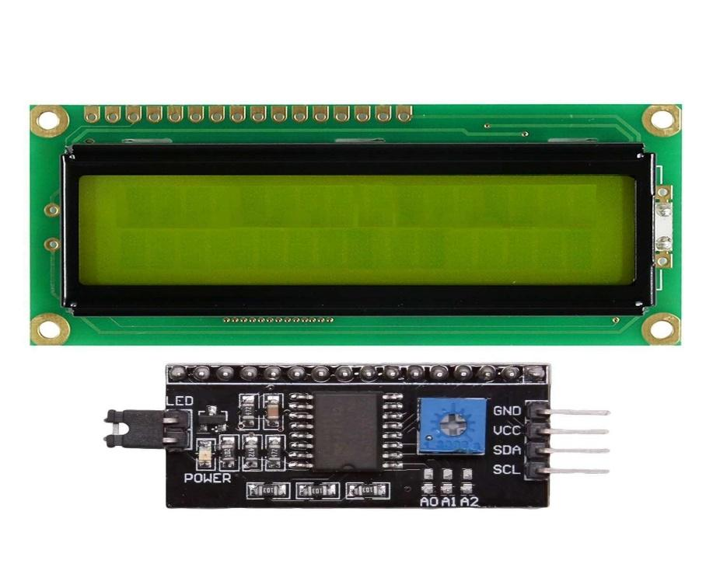

Fig 4.5.1 LCD

This is LCD 1602 Parallel LCD Display that provides a simple and cost-effective solution for adding a 16×2 White on Liquid Crystal Display into your project. The display is 16 character by 2 line display has a very clear and high contrast white text upon a blue background/backlight. This is great blue backlight LCD display. It is fantastic for Arduino based project. This LCD1602 LCD Display is very easy to interface with Arduino or Other Microcontrollers. This display overcomes the drawback of LCD 1602 Parallel LCD Display in which you’ll waste about 8 Pins on your Arduino for the display to get working., which shows a good library and little of coding. The usage voltages are standard as 5V and 3.3V.

**LCD 16×2 Pin Diagram**

The 16×2 LCD pinout is shown below.

* Pin1 (Ground/Source Pin): This is a GND pin of display, used to connect the GND terminal of the microcontroller unit or power source.
* Pin2 (VCC/Source Pin): This is the voltage supply pin of the display, used to connect the supply pin of the power source.
* Pin3 (V0/VEE/Control Pin): This pin regulates the difference of the display, used to connect a changeable POT that can supply 0 to 5V.
* Pin4 (Register Select/Control Pin): This pin toggles among command or data register, used to connect a microcontroller unit pin and obtains either 0 or 1(0 = data mode, and 1 = command mode).
* Pin5 (Read/Write/Control Pin): This pin toggles the display among the read or writes operation, and it is connected to a microcontroller unit pin to get either 0 or 1 (0 = Write Operation, and 1 = Read Operation).
* Pin 6 (Enable/Control Pin): This pin should be held high to execute Read/Write process, and it is connected to the microcontroller unit & constantly held high.
* Pins 7-14 (Data Pins): These pins are used to send data to the display. These pins are connected in two-wire modes like 4-wire mode and 8-wire mode. In 4-wire mode, only four pins are connected to the microcontroller unit like 0 to 3, whereas in 8-wire mode, 8-pins are connected to microcontroller unit like 0 to 7.
* Pin15 (+ve pin of the LED): This pin is connected to +5V
* Pin 16 (-ve pin of the LED): This pin is connected to GND.

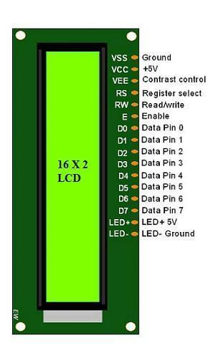

Fig 4.5.2 Pin connections of LCD

## 16×2 LCD Applications

In most of the applications that have only small values to show, use the LCD.

* Most of the commercial meters use this module to represent the data output.
* In the toys and developing projects, it is still vastly in use.
* In black and white printers, it helps to show the printer settings and status.

**4.6. MQ2 GAS SENSOR**

MQ2 gas sensor is an electronic sensor used for sensing the concentration of gases in the air such as LPG, propane, methane, hydrogen, alcohol, smoke and carbon monoxide.

MQ2 gas sensor is also known as chemiresistor. It contains a sensing material whose resistance changes when it comes in contact with the gas. This change in the value of resistance is used for the detection of gas.

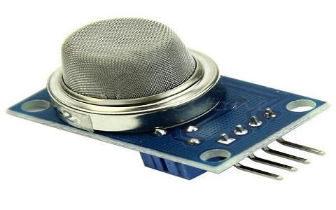

                                                       Fig 4.6.1 MQ2 Gas Sensor

MQ2 is a [metal oxide semiconductor](https://www.elprocus.com/cmos-working-principle-and-applications/) type gas sensor. Concentrations of gas in the gas is measured using a [voltage divider](https://www.elprocus.com/voltage-divider-rule-with-examples/) network present in the sensor. This sensor works on 5V DC voltage. It can detect gases in the concentration of range 200 to 10000ppm.

### Working Principle

This sensor contains a sensing element, mainly aluminium-oxide based ceramic, coated with Tin dioxide, enclosed in a stainless steel mesh. Sensing element has six connecting legs attached to it. Two leads are responsible for heating the sensing element, the other four are used for output signals.

Oxygen gets adsorbed on the surface of sensing material when it is heated in air at high temperature. Then donor electrons present in tin oxide are attracted towards this oxygen, thus preventing the current flow.

When reducing gases are present, these oxygen atoms react with the reducing gases thereby decreasing the surface density of the adsorbed oxygen. Now current can flow through the sensor, which generated analog voltage values.

These voltage values are measured to know the concentration of gas. Voltage values are higher when the concentration of gas is high.

## Applications

These sensors are used to detect the presence of gases in the air such as methane, butane, LPG and smoke but they are unable to distinguish between gases. Thus, they cannot tell which gas it is.

Module version of this sensor can be used without interfacing to any [microcontroller](https://www.elprocus.com/different-microcontrollers-used-in-automobiles/) and is useful when detecting only one particular gas. This can only detect the gas. But if ppm has to be calculated then the sensor should be used without module.

This sensor is also used for Air quality monitoring, Gas leak alarm and for maintaining environmental standards in hospitals. In industries, these are used to detect the leakage of harmful gases.

Some of the alternatives of the MQ2 [gas sensor](https://en.wikipedia.org/wiki/Gas_detector) are MQ-6, M-306A, AQ-3 sensors. To detect which gas

have you used the MQ2 Gas sensor.

**4.7. Relay**

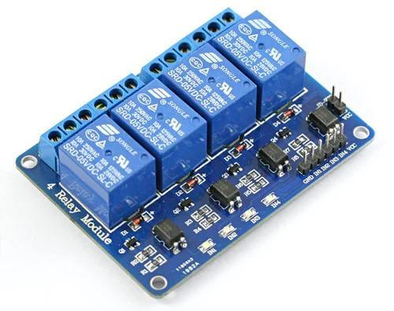

Fig 4.7.1 Relay

A relay is an electrical switch that operates through an electromagnet to control a high-powered circuit using a low-powered input signal. It consists of a coil, contacts, and an armature. When the coil is energized, it creates a magnetic field that attracts the armature, which in turn closes or opens the contacts, allowing or blocking the flow of current to the load.

Relays are used in a wide range of applications, including industrial control systems, automation, robotics, automotive, and telecommunications. They provide isolation between the input and output circuits, allowing low-level control signals to safely switch high-power loads. They can also provide signal amplification, signal conversion, and signal protection functions.

There are various types of relays, including electromagnetic relays, solid-state relays, thermal relays, and reed relays. Electromagnetic relays are the most common type and are available in different configurations such as single-pole single-throw (SPST), single-pole double-throw (SPDT), and double-pole double-throw (DPDT). Solid-state relays use semiconductor devices to switch the load, providing faster switching speeds, longer life, and no mechanical noise. Thermal relays protect motors from overheating and can be used as overload protection devices. Reed relays are low-power, high-speed relays that use a magnetic field to close and open the contacts. The choice of relay depends on the specific application requirements, including voltage and current ratings, switching speed, reliability, and cost.

Relay modules are simply circuit boards that house one or more relays. They come in a variety of shapes and sizes, but are most commonly rectangular with 2, 4, or 8 relays mounted on them, sometimes even up to a 16 relays.

Relay modules contain other components than the relay unit. These include [indicator LEDs](https://en.wikipedia.org/wiki/Light-emitting_diode%22%20/l%20%22:~:text=Modern%20indicator%20LEDs%20are%20packed,dissipation%20in%20high-power%20LEDs.), [protection diodes](https://www.elprocus.com/protection-diode-ciruit-working-and-its-application/), transistors, resistors, and other parts. But what is the module relay, which makes the bulk of the device? You may ask. Here are facts to note about it:

* A relay is an electrical switch that can be used to control devices and systems that use higher voltages. In the case of module relay, the mechanism is typically an [electromagnet](https://science.howstuffworks.com/electromagnet.htm).
* The relay module input voltage is usually DC. However, the electrical load that a relay will control can be either AC or DC, but essentially within the limit levels that the relay is designed for.
* A relay module is available in an array of input voltage ratings: It can be a 3.2V or 5V relay module for low power switching, or it can be a 12 or 24V relay module for heavy-duty systems.
* The relay module information is normally printed on the surface of the device for ready reference. This includes the input voltage rating, switch voltage, and current limit.

**4.8. 5V Adaptor:**

This 5V 2A Power Adapter is a high quality power supply manufactured specifically for electronics. These are switch mode power supplies which means the output is regulated to 5V and the capable output current is much higher (2000mA).



Fig.4.8.1 Adpator

**Specification:**

* Voltage Input: AC 100-240V
* Frequency Response: 50/60Hz
* Voltage Output: DC 5V
* Electric Current: Max. 2A
* Power: 24W
* Length of the cable: approx. 86.36 cm (34 inch)
* Internal diameter of the connector: 2.1 - 2.5 mm (0.1 inch)
* External diameter of the connector: 5.5 mm (0.21 inch)

**4.9. Pneumatic valve**

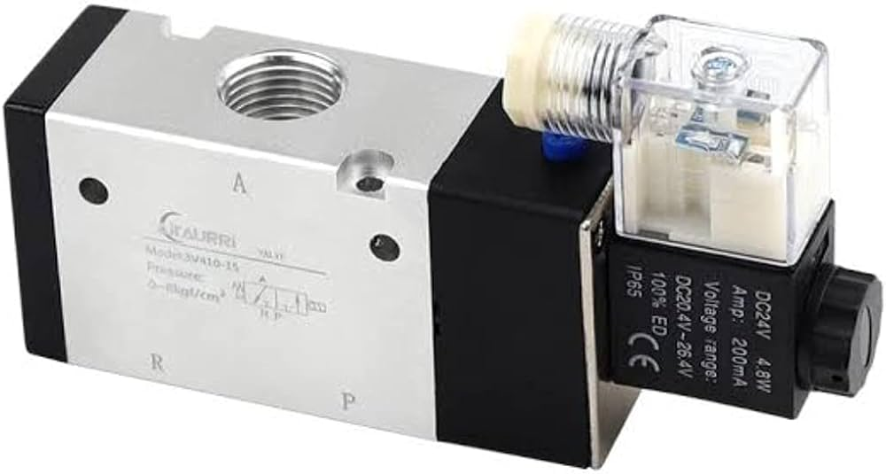

Fig. 4.9.1 Pneumatic valve

Pneumatic valves play an important role in a pneumatic system. They determine how much air passes through and in which direction. This means that they can be used as control valves, but also as safety valves that shut off the air supply in dangerous situations or that depressurise the system.

Features:

Adjustable start gas rate for quick/slow opening.

Option for restricted flow rate.

Robust and compact valve design for long-term operation.

Suitable for high-duty cycling.

No pressure difference required.

Sealing in a reliable and sturdy material.

Long-term availability of spare parts.

Comes with a signal feedback

The liquid petroleum gas on-off solenoid valve is a device positioned between the tank and the regulator to stop the LPG flow during petrol-fuelled operation and while the engine is off.

**4.10**. **Procedure**

1. ESP32 and Gas Sensor Wiring:

            Connect the Gas Sensor with VCC to 3.3V on the ESP32 and the GND to ground.

Connect the data pin to an analog pin 35 on the ESP32**.**

1. ESP32 Programming:

Use the Arduino IDE to program the ESP32. You'll need the Arduino core for ESP32 installed. Write a program to read the analog value from the Gas sensor, send it to an Blynk with the help of inbuilt wifi in esp32.Use a library like Blynk to publish data to the Blynk Cloud**.** Select the board ESP32 Dev Kit and select the  port.

      3. Blynk Setup:

1. Create a template and datastreams i.e Virtual Pin or Direct Pin.
2. Set the Datatype and Minimum and Maximum value.
3. Fill in the necessary details such as name of data source, unit, Design the Web dashboard to establish the connection. Save and Apply.
4. Design the Mobile App.

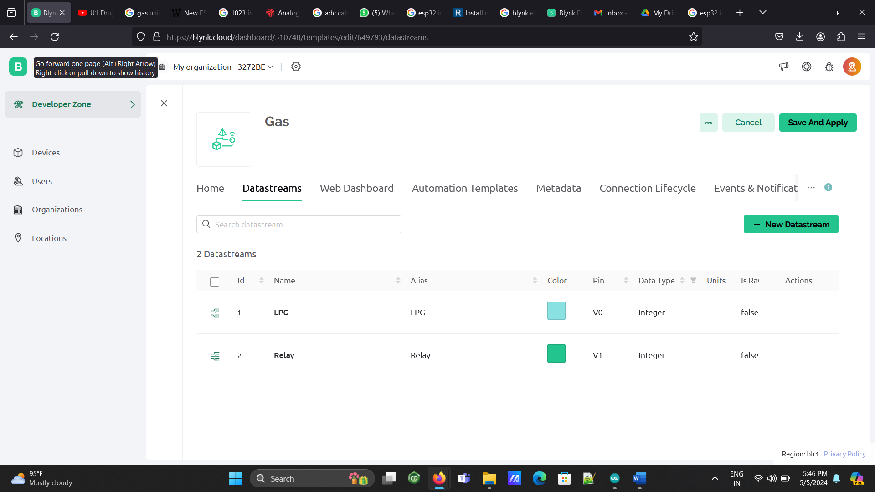

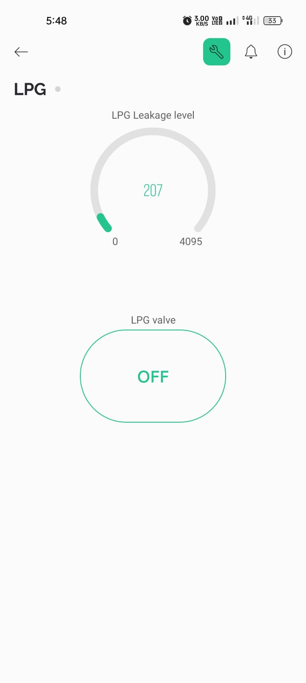

**5** Test:

Upload the modified ESP32 program to your device.

Monitor the Blynk data for incoming data.

**4.11. Program**

#include <LiquidCrystal.h>

LiquidCrystal lcd(13, 12, 14, 27, 26, 25);

#define BLYNK\_TEMPLATE\_ID "TMPL328IlKX7z"

#define BLYNK\_TEMPLATE\_NAME "Gas"

#define BLYNK\_AUTH\_TOKEN "lnk9izmH-QyGmCak\_AjOeOhonnWaQpl4"

/\* Comment this out to disable prints and save space \*/

#define BLYNK\_PRINT Serial

#include <WiFi.h>

#include <WiFiClient.h>

#include <BlynkSimpleEsp32.h>

#define gas 35

#define relay 4

#define buzzer 2

int a = 0;

int b = 0;

char ssid[] = "AGF";

char pass[] = "09876543211";

BlynkTimer timer;

BLYNK\_WRITE(V1)

{

int pinValue = param.asInt(); // assigning incoming value from pin V1 to a variable

if (pinValue == 1)

{

digitalWrite(relay, LOW);

}

if (pinValue == 0)

{

digitalWrite(relay, HIGH);

}

}

void myTimerEvent()

{

if (a > 199 ) {

// int lpg = map(0,4095,0,100);

Blynk.virtualWrite(V0, a);

if (a > 300)

{

digitalWrite(relay, LOW);

digitalWrite(buzzer, HIGH);

}

if (a < 300 )

{

lcd.clear();

digitalWrite(relay, HIGH);

digitalWrite(buzzer, LOW);

b = 0;

}

}

else{

int c= 0;

Blynk.virtualWrite(V0, c);

}

}

void setup() {

// put your setup code here, to run once:

pinMode(relay, OUTPUT);

pinMode(buzzer, OUTPUT);

digitalWrite(buzzer, LOW);

digitalWrite(relay, HIGH);

Serial.begin(115200);

Blynk.begin(BLYNK\_AUTH\_TOKEN, ssid, pass);

timer.setInterval(1000L, myTimerEvent);

lcd.begin(16, 2);

lcd.setCursor(0, 0);

lcd.print("LPG ANALYZER");

}

void loop() {

// put your main code here, to run repeatedly:

lcd.setCursor(0, 0);

lcd.print("LPG ANALYZER");

a = analogRead(gas);

Serial.print("MQ2 : ");

Serial.println(a);

Blynk.run();

timer.run();

delay(100);

}

**CIRCUIT DIAGRAM**

**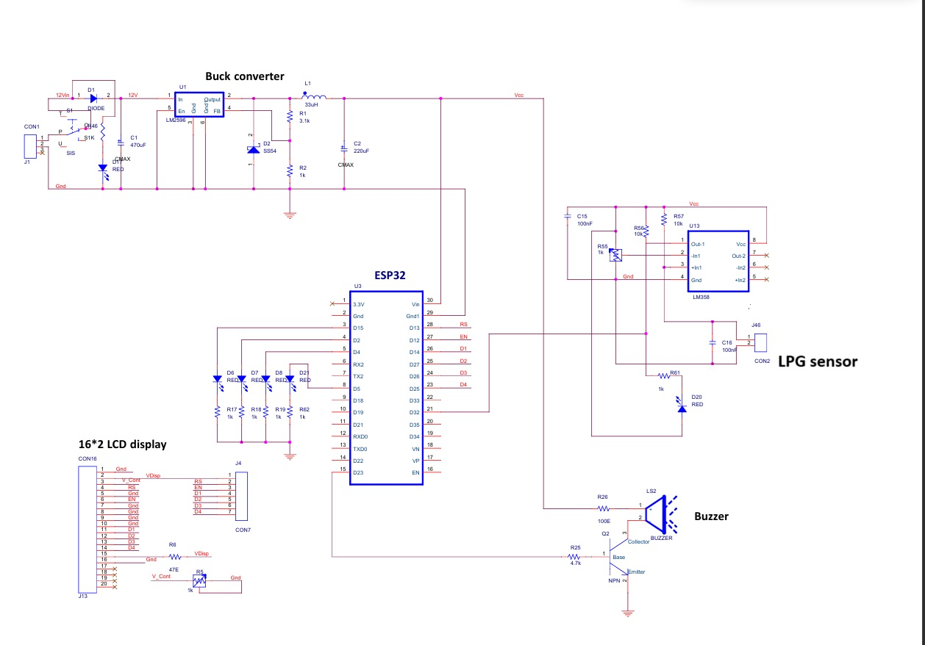**

**CHAPTER – 5**

**RESULT AND DISCUSSION**

**5.1 RESULT**

When employing an ESP32 microcontroller for LPG gas analysis, the system is typically designed to provide comprehensive monitoring capabilities. The ESP32 interfaces with gas sensors, like the MQ-2 sensor, to gather data on LPG concentration levels in the surrounding environment.

Once collected, the ESP32 processes this data using its onboard computational capabilities. This processing might involve calibration, noise filtering, and other algorithms to ensure accurate and reliable results.

Following data processing, the ESP32 utilizes its built-in Wi-Fi capabilities to transmit the analyzed data to a designated endpoint. This endpoint could be a server hosted on the internet, a local computer, or a mobile device such as a smartphone or tablet.

The transmitted results typically include not only the LPG concentration levels but also relevant metadata such as timestamps and potentially the device's location if GPS capabilities are integrated. This additional information enables users to track changes over time, identify trends, and correlate gas levels with specific events or conditions.

By leveraging the ESP32's capabilities for real-time monitoring and wireless communication, the system provides a flexible and scalable solution for monitoring LPG levels in various environments. This setup facilitates proactive decision-making, allowing users to respond promptly to any fluctuations or safety concerns related to LPG gas levels.

**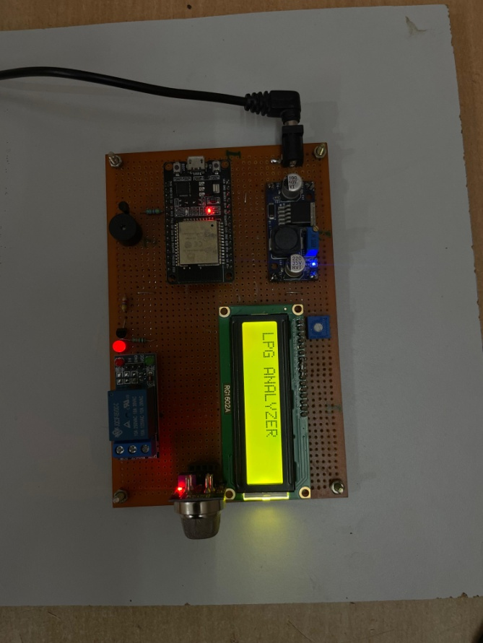**

**Fig. 5.1.1 Implemented Prototypes**

**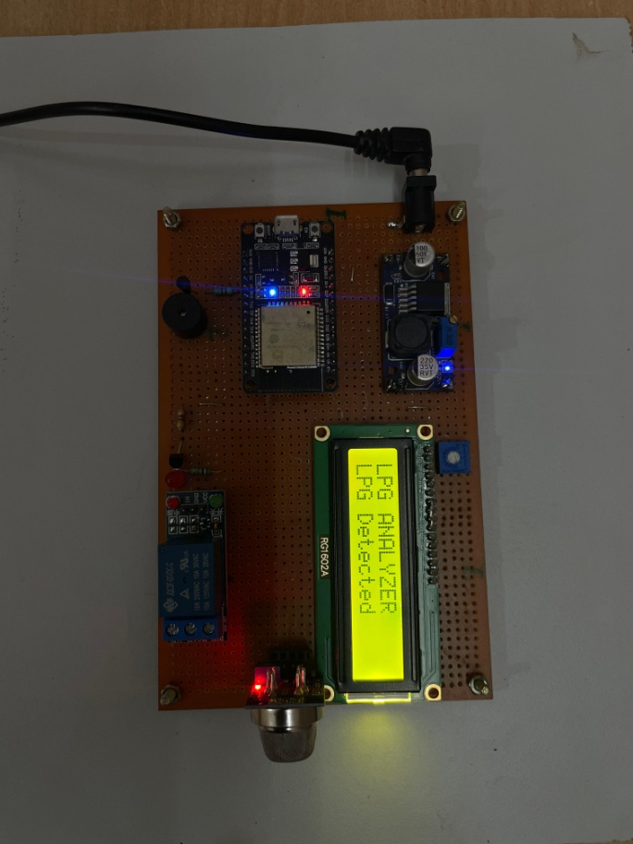**

**Fig. 5.1.2 LCD Display showing gas detection**

**5.2 COST ESTIMATION**

|  |  |
| --- | --- |
| **COMPONENTS** | **COST** |
| **Power Supply Adaptor** | **500** |
| **Buck Converter** | **1,000** |
| **Wi-Fi module** | **1,000** |
| **LCD Display** | **500** |
| **MQ-2 Sensor** | **2,000** |
| **Relay** | **1,000** |
| **Buzzer** | **100** |
| **LED Light** | **100** |
| **Pneumatic Valve** | **20,000** |
| **Total** | **26,200** |

**TABLE 5.2.1 Cost Estimation**

**CHAPTER – 6**

**CONCLUSION**

In recent days, the Internet of Things has acquired its broad prominence. Thanks to its diverse sources of applications that have paved the way for human beings to live in a smooth, healthy and simpler way. The suggested detector of gas leakage in the area of security seems promising. The goal to make this model has always been to introduce a revolution on safety to reduce and therefore eliminate any large or little risk that may arise from the leaking of toxic and hazardous gases. One such application area is monitoring of gas reservations and gas leakages for both household and industrial applications. While the identification of gas leak has been one of the main problems, while there are numerous ways. This study therefore provided a new approach, depending on microcontroller, for gas reservation and gas detectors. The sensor employed in this version is capable to monitor, identify and inform the client to the remainder of the pressurized gas, and to also take certain actions without obstructing the prebooking of the new cylinder. This device may be easily placed into an alert device or an LPG display indicator for extra advantages. It is a low cost but extremely efficient device for detecting gas leakage and may play a key role in avoiding LP Gas leakage exploration. The major aim of this effort is to maintain security and to make it simpler to reserve gasses and detect leaks to prevent tragedies caused by carelessness.

**CHAPTER – 7**

**FUTURE DIRECTION AND ENHANCEMENTS**

* Implement advanced gas detection (e.g.,  carbon monoxide, lead, nitrogen oxides) to ensure more safety.
* Design the system with redundancy in critical components (e.g., dual sensors, redundant control channels) to enhance reliability and ensure safe operation in the event of sensor or hardware failures.

**CHAPTER – 8**

**REFERENCE**

[1.] A., L. (2017). Wireless gas leak detection improves employee protection, environs, and production

value.

[2.] Arpitha, T. K. (2016). FPGA-GSM-based gas leakage detection system. Bangalore. IEEE Annual India

Conference (INDICON), 1-4.

[3.] Chengjun, D. X. (2011). Development of gas leak detection and location system based on wireless

sensor networks. Shanghai. Third International Conference on Measuring Technology and

Mechatronics Automation, 1067–1070.

[4.] Kareem, H. (2019). Embedded real‐time system for detecting leakage of the gas used in Iraqi kitchens.

Indonesia J. Elect Eng Comp Sci .vol 14, 1171-1176.

[5.] Loth, J. M. (2003). Technology Assessment of online Acoustic monitoring Leak In fragment in the

underground, natural gas Transmission Lines. USA: West Virginia University.

[6.] Manohar, R. a. (2018). Android Introduction to Detection. Hindu: Nwebweze, O. (December 2015)

vanguard News .com .

[7.] Murvaya, P. (2011). A survey in Gas leak Detection and localization technology. Journal of loss

prevention in the Process Industries, 11-25.

[8.] Park, G. L. (2013). Development of gas safety management system for smart‐home services. Distributor

Sensor Network, 9-10.

[9.] Sonkar, B. S. (2015). Microcontroller-based LPG Leakage Detector using GSM Module. International

Journal of Electrical and Electronics Research, Vol .111, 264-269.

[10.] Sperl, J. (2005). System pinpoints Leak s on point Arguello Offshore Lines. Oil and Gas Journal. vol

.99, no 36, 47-55.

[11.] Yalmar, A. P. (2015). Implementation of automatic safety gas stove. Ann IEEE India Conference (pp. 1-

6). New Delhi: INDICON.

[12.] Zhang, X. (2006). Statistical Leak Detection in Gas and Pipelines. pipes and pipelines international ,vol

68 .no 4, 20-30

 [13.] Suma V, Ramya R Shekar, Akshay Kumar A, “Gas Leakage Detection Based on IOT,” Proceedings of the Third International Conference on Electronics Communication and Aerospace Technology [ICECA 2019] IEEE Conference Record # 45616; pp.no 1312 – 1315.

[14.] M Athish Subramanian, Naveen Selvam, Rajkumar S, R Mahalakshmi, J Ramprabhakar , “Gas Leakage Detection System using IoT with integrated notifications using Pushbullet-A Review”, Proceedings of the Fourth International Conference on Inventive Systems and Control (ICISC 2020) IEEE Xplore Part Number: CFP20J06-ARTI; pp.no 359 – 363.

[15.] Ravi Kishore Kodali, Greeshma, R.N.V, Kusuma Priya Nimmanapalli, Yatish Krishna Yogi Borra, “IOT Based Industrial Plant Safety Gas Leakage Detection System”, International Conference on Computing Communication and Automation (ICCCA), pp.no, 1-5, published in 2018.

[16.] Nagib Mahfuz, Shawan Karmokar, Md. Ismail Hossain Rana, “A Smart Approach of LPG Monitoring and Detection System Using IoT”, 11th International Conference on Computing Communication and Networking Technologies (ICCCNT), published in 2020