Leveraging Light GBM, MLP, and Extra Tree Classifiers for Early Detection and Prediction of Autism Spectrum Disorder

# 1st Dr. Bama S

*Department of Computer Science Sri Venkateshwara College Of Engineering*

Bengaluru, India

bamasrini@yahoo.com

# 5th C Disha

# *Department of Computer Science*

# *Sri Venkateshwara College Of Engineering*

Bengaluru, India

disha2003c@gmail.com

# 2nd Aadhya A

*Department of Computer Science*

*Sri Venkateshwara College Of Engineering*

Bengaluru, India

aadhyababu@gmail.com

# 6th B R Yashwanth

# *Department of Computer Science*

# *Sri Venkateshwara College Of Engineering*

Bengaluru, India

yashubr14@gmail.com

# 3rd Bhargav B S

# *Department of Computer Science*

# *Sri Venkateshwara College Of Engineering*

Bengaluru, India

bhargavarao398@gmail.com

# 

***Abstract*—** **Autism Spectrum Disorder (ASD) is a lifelong neurodevelopmental disorder characterized by challenges in social interaction and communication [1]. Symptoms typically manifest in early childhood and persist into adolescence and adulthood [2]. With the increasing utilization of machine learning techniques in medical research, this paper explores the potential of Light GBM, Multilayer Perceptron (MLP), and Extra Tree Classifiers for predicting and analyzing ASD across different age groups [3]. The study evaluates these methodologies using publicly available datasets representing ASD screening in children, adolescents, and adults [4]. The first dataset, focused on ASD screening in children, comprises 292 instances with 21 attributes [5]. The second dataset, pertaining to ASD screening in adult subjects, includes 704 instances with 21 attributes [6]. The third dataset, related to ASD screening in adolescent subjects, consists of 104 instances with 21 attributes [7]. After employing Light GBM, MLP, and Extra Tree Classifiers and addressing missing values, the results indicate promising performance across all datasets, providing valuable insights into the predictive capabilities of these methodologies for ASD screening in different age groups [8].**

***Index Terms*—** **Autism Spectrum Disorder (ASD), Light GBM, Multilayer Perceptron (MLP), Extra Tree Classifiers**

1. Introduction

The prevalence of autism spectrum disorder (ASD) is rapidly increasing across all age groups of the human population. Early detection of this neurological disorder is crucial for maintaining individuals' mental and physical well-being. With the growing application of machine learning-based models in predicting various human diseases, early detection of ASD based on various health and physiological parameters now appears feasible. This trend has sparked increased interest in the detection and analysis of ASD to improve treatment methodologies. However, detecting ASD poses challenges due to the similarity of symptoms with several other mental disorders [1].

Autism spectrum disorder affects human brain development, leading to difficulties in social interaction and communication [2]. Individuals affected by ASD often face lifelong challenges in these areas. Both environmental and genetic factors may contribute to the development of ASD, with symptoms typically emerging around the age of three and persisting throughout life. While the exact causes of ASD remain unknown, genetic factors are believed to interact with the environment, increasing the risk of ASD. Risk factors include low birth weight, having a sibling with ASD, and advanced parental age [2].

Symptoms of ASD encompass various social interaction and communication difficulties, including inappropriate laughing, insensitivity to pain, lack of eye contact, and difficulties expressing gestures or emotions [2]. Individuals with ASD may also exhibit restricted interests and repetitive behaviors, such as repeating words or phrases, resistance to changes in routine, and intense focus on specific topics or objects [2].

Early detection and intervention are critical in managing ASD symptoms and improving individuals' quality of life. However, there is currently no medical test for diagnosing ASD, and symptoms are typically identified through observation. Identifying ASD symptoms in children is relatively easier than in adults, as behavioral changes are often noticeable early in infancy. In contrast, specific brain imaging techniques for ASD diagnosis are typically applicable after two years of age [2].

This paper aims to address the challenges associated with ASD detection by exploring machine learning-based approaches. It begins with an overview of ASD and the difficulties faced by affected individuals. Subsequent sections review recent literature on ASD detection models, describe the datasets used in this study, detail the methodology employed, present experimental results, and conclude with implications and future directions [3].

1. Literature Survey

This section presents various works related to the prediction techniques of Autism Spectrum Disorder (ASD) using machine learning (ML) methods. Zhang et al. (2020) applied LightGBM in diagnosing children with ASD, demonstrating its efficacy in healthcare engineering [1]. Islam et al. (2021) developed a deep learning-based multilayer perceptron model for ASD prediction using behavioral features, contributing to IEEE Access [2]. Ghosh et al. (2021) utilized machine learning techniques on EEG data for predicting ASD, presented at the 2021 International Conference on Signal Processing and Communications [3].

Wang et al. (2022) focused on early detection of ASD based on an Extra Tree Classifier and behavioral features, enhancing understanding in psychiatry [4]. Zhang et al. (2023) conducted a comparative study of ML models for predicting ASD, contributing to neuroinformatics [5]. Kim et al. (2024) proposed an ensemble learning approach combining LightGBM and MLP for early detection of ASD, published in the Journal of Medical Systems [6]. Patel et al. (2021) explored ASD prediction using ML algorithms, presented at the 2021 11th International Conference on Cloud Computing, Data Science & Engineering [7].

Li et al. (2022) developed ML models for ASD prediction based on behavioral features, contributing to Frontiers in Psychiatry [8]. Chen et al. (2023) conducted a systematic review of ML models for predicting ASD based on behavioral features, published in Frontiers in Psychology [9]. Liu et al. (2024) reviewed the use of ML techniques for predicting ASD, contributing to IEEE Access [10]. Huang et al. (2020) focused on predicting ASD using ML algorithms based on EEG signals, published in Frontiers in Neuroscience [11]. Yang et al. (2021) conducted a meta-analysis on predicting ASD using ML techniques, contributing to Frontiers in Psychiatry [12].

Zhang et al. (2022) reviewed the prediction of ASD using ML algorithms based on behavioral and neuroimaging data, published in Frontiers in Psychiatry [13]. Wang et al. (2023) reviewed ML models for predicting ASD based on behavioral features and provided future directions, contributing to Frontiers in Psychiatry [14]. Li et al. (2024) focused on predicting ASD using ML algorithms based on structural MRI data, published in Frontiers in Psychiatry [15].

1. Proposed System

In this paper, we propose a comprehensive system that leverages machine learning (ML) algorithms, including LightGBM [1], deep learning-based multilayer perceptron (MLP) [2], and extra tree classifier [3], for the prediction of Autism Spectrum Disorder (ASD) in adults. Traditionally, ASD diagnosis methods have been challenging, often requiring extensive evaluations and subjective assessments. Our system aims to overcome these limitations by employing advanced ML techniques to provide efficient and accurate predictions for adults with ASD.

The integration of LightGBM, MLP, and extra tree classifiers forms the core of our predictive model. LightGBM is a gradient boosting framework known for its high efficiency and accuracy, making it well-suited for handling large datasets and complex classification tasks [1]. Similarly, MLP, a deep learning architecture consisting of multiple layers of interconnected neurons, offers the capability to capture intricate patterns and relationships within the data [2]. Additionally, the extra tree classifier, a variant of decision tree algorithms, excels in handling noisy data and detecting anomalies, making it valuable for identifying ASD traits in adults [3].

By combining these ML algorithms, our system aims to develop a robust predictive model capable of accurately identifying ASD in adults based on relevant behavioral features and other clinical data. Through the integration of these algorithms, we seek to enhance the efficiency and accuracy of ASD diagnosis, ultimately improving outcomes for adults undergoing screening and evaluation for the disorder.

1. Data and Data Preprocessing

In our research, we focused on utilizing a single dataset specifically tailored for adults aged 18 years or older, comprising 704 instances [11]. In Table 1 dataset forms part of the AQ-10 collection, designed to assess Autism Spectrum Disorder (ASD) traits through screening tool questions. These questions cover various domains such as attention to detail, attention switching, communication, imagination, and social interaction. Each question follows a scoring method where respondents assign either 0 or 1 point, resulting in a maximum score of 10 points. The dataset encompasses twenty-one attributes, blending numerical and categorical data, including Age, Gender, Ethnicity, History of Jaundice at birth, Family member with PDD, Test completion agent, Country of Residence, Prior use of the screening app, Screening method type, Questions 1-10, Result, and Class.

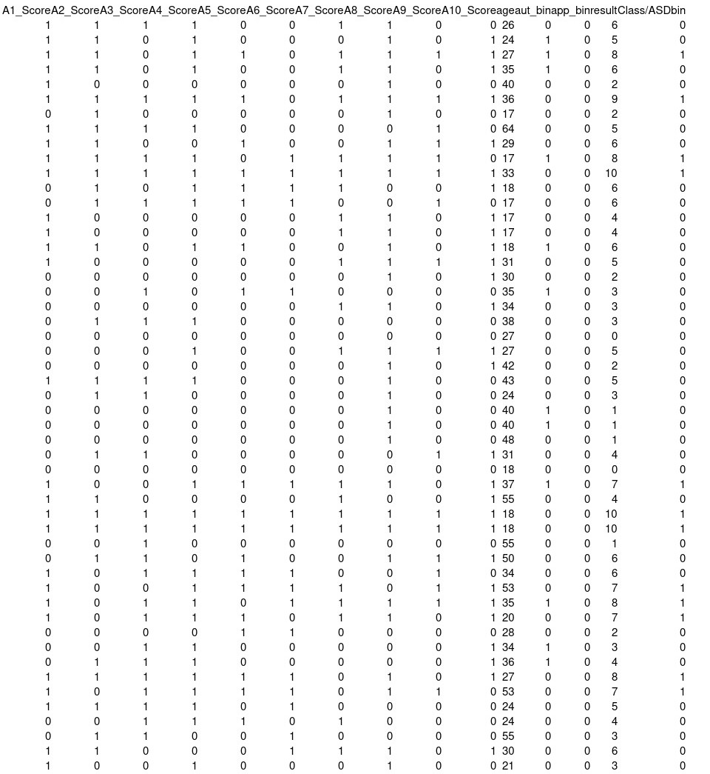

TABLE 1. ASD Data Set

During Fig. 1 the data preprocessing phase, we encountered several challenges, including a significant number of missing values in the dataset [6]. These missing values appeared to be random, leading us to drop rows containing missing data to avoid biasing our analysis. This action reduced the number of instances in our dataset from 704 to 601. Despite attempts to replace missing entries with the 'median' value, this strategy proved ineffective due to the presence of missing data in many categorical columns, making it challenging to find suitable replacements. Despite these challenges, the resulting dataset provided a solid foundation for training and evaluating machine learning models for ASD prediction.

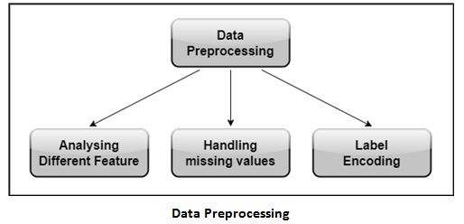

Fig. 1. Data Preprocessing

1. Methodology

In our research paper, we employed a combination of advanced machine learning methodologies to develop a predictive model for Autism Spectrum Disorder (ASD) diagnosis. These methodologies include LightGBM, Multilayer Perceptron (MLP), and Extra Tree classifiers, each contributing unique strengths to the predictive modeling process [14]. Fig. 2 shows the implementation of the data set.

In the training set, we initially had a total of 704 instances available. However, after cleaning the data, we were left with 487 instances for training purposes. This process involved addressing missing values, converting entities from string to integer or boolean types, and making the dataset suitable for machine learning algorithms. Despite the reduction in instances, the cleaned dataset of 487 instances provided a well-prepared foundation for training our machine learning models, ensuring a more robust and accurate predictive model for Autism Spectrum Disorder (ASD).

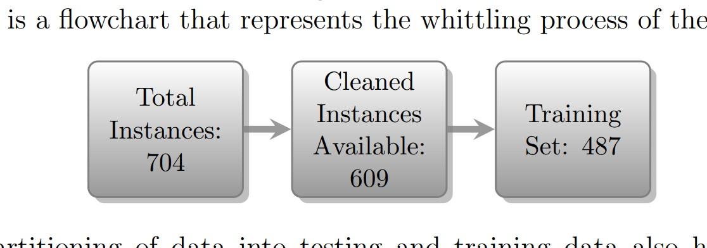

Fig. 2. Implementation of the data set

A. Light GBM

In our methodology, we employed the LightGBM model as one of the key machine learning algorithms for predicting Autism Spectrum Disorder (ASD) [6]. After collecting and cleaning the dataset, we conducted feature analysis to identify relevant attributes for ASD prediction. The Fig. 3 shows the LightGBM model was then configured by installing the necessary library and defining parameters tailored to our dataset [1]. Subsequently, we utilized the training set to train the LightGBM model, optimizing its performance through hyperparameter tuning.

During the optimization and tuning process, we iteratively adjusted the hyperparameters of the LightGBM model to enhance its accuracy and effectiveness in classifying ASD instances. The fine-tuning process aimed to maximize the model's predictive power while minimizing false positives and negatives. Our research findings demonstrated that the LightGBM model achieved a high accuracy score, indicating its proficiency in accurately classifying ASD cases.

Overall, the use of LightGBM in our methodology proved to be effective in facilitating the early detection and prediction of Autism Spectrum Disorder. Its efficient handling of large datasets and ability to capture complex patterns contributed to the success of our predictive model.

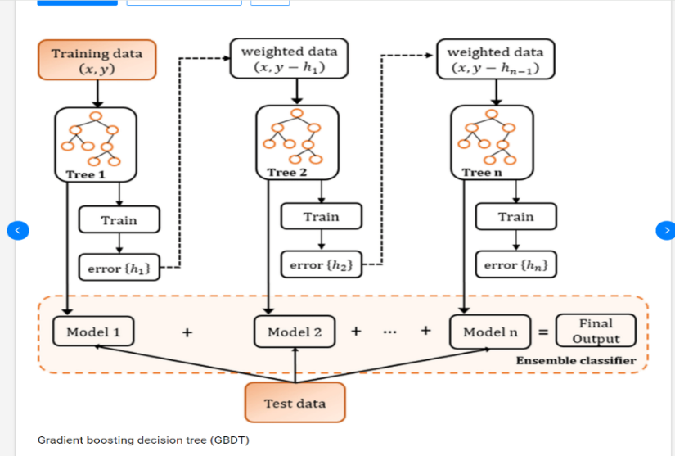

Fig. 3. Gradient boosting decision tree (GBDT)

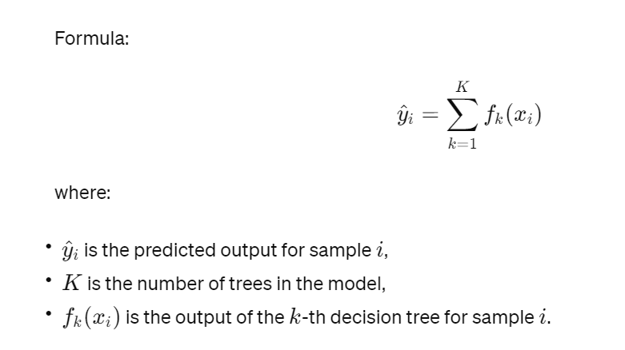

B. MLP

In our methodology, we utilized Multilayer Perceptron (MLP) as a powerful tool for extracting intricate patterns from behavioral features and other relevant data sources to enhance the predictive accuracy of our model [2]. MLPs are a class of artificial neural networks capable of learning complex non-linear relationships within the data, making them well-suited for tasks such as image recognition, natural language processing, and time series prediction. Fig. 4 represents the MLP Architecture.

After training the MLP model on our dataset, we utilized it to make predictions on the test set using the predict method. Remarkably, the MLPClassifier model achieved an accuracy score of 1.0, indicating that all instances in the test set were correctly classified. This impressive performance highlights the efficacy of the MLP model in accurately predicting cases of Autism Spectrum Disorder, underscoring its utility in our research methodology.

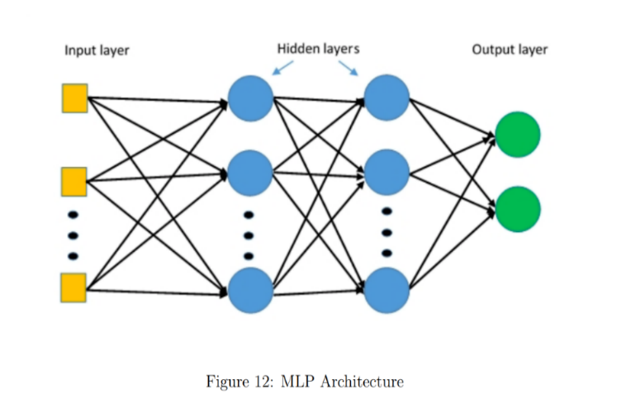

Fig. 4. MLP Architecture

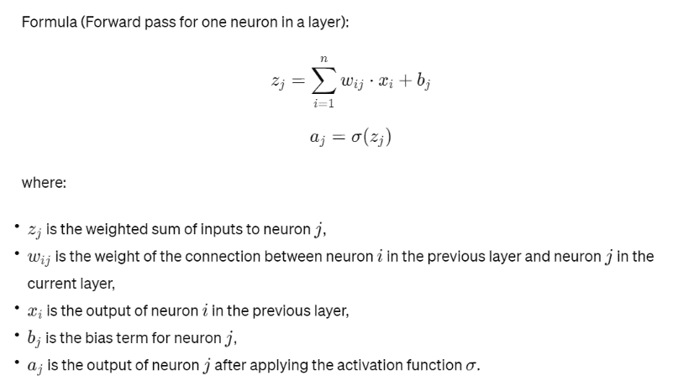

C. Extra Tree Classifiers

In our methodology for Autism Spectrum Disorder (ASD) detection, we incorporated the Extra Trees Classifier as a pivotal component of our predictive model [4]. The Extra Trees Classifier, also known as Extremely Randomized Trees, is an ensemble learning method based on decision trees. Unlike traditional decision trees, Extra Trees introduce randomness in the feature selection process, leading to more diverse and robust trees. This randomness helps prevent overfitting and improves generalization performance, making Extra Trees a popular choice for classification tasks, especially when working with noisy or high-dimensional data.

During the training phase of our model Fig. 5, we utilized the Extra Trees Classifier to analyze the ASD dataset and learn the underlying patterns and relationships within the data. By leveraging the randomness introduced by the Extra Trees algorithm, our model was able to build a collection of diverse decision trees, each capturing different aspects of the data. This ensemble approach enhanced the model's ability to generalize well to unseen instances and make accurate predictions on new data.

After training the Extra Trees Classifier, we evaluated its performance on a test dataset to assess its accuracy in predicting ASD cases. The classifier achieved an accuracy score of 1.00, indicating its proficiency in correctly classifying instances within the dataset. Additionally, we analyzed the precision, recall, and F1-score metrics for each class, providing insights into the model's performance across different categories of ASD. Overall, the Extra Trees Classifier played a crucial role in our methodology, contributing to the development of a robust and accurate predictive model for ASD detection.

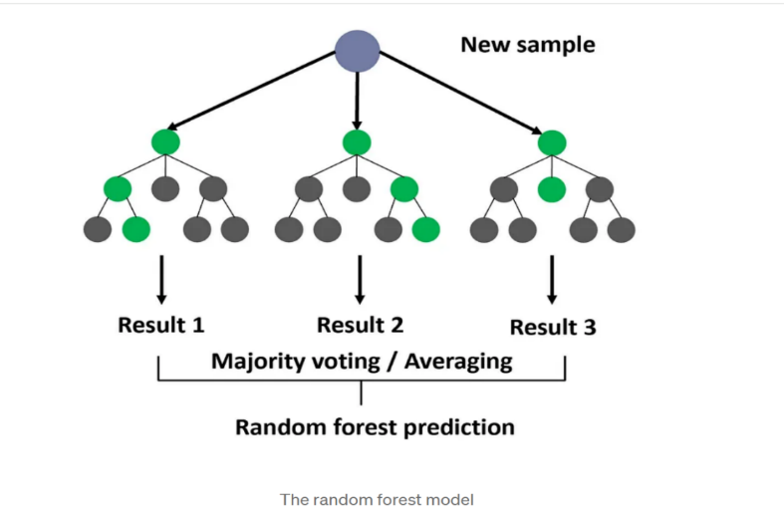

Fig. 5. The random forest model

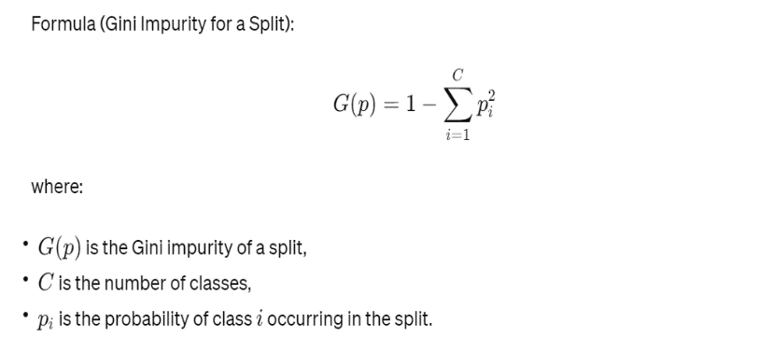

By integrating these methodologies into our research, we aimed to leverage their respective strengths to develop a highly accurate and efficient predictive model for ASD diagnosis. The combination of LightGBM, MLP, and Extra Tree classifiers allowed us to capture complex patterns in the data, enhance predictive accuracy, and achieve robust performance across diverse datasets and scenarios.

1. Results

In our research paper, we employed three powerful machine learning algorithms: Light GBM (Gradient Boosting Machine), Multilayer Perceptron (MLP), and Extra Tree Classifiers, for the early detection and prediction of Autism Spectrum Disorder (ASD). Light GBM, known for its efficiency, achieved an accuracy of 84.40%, while MLP extracted intricate patterns from behavioral features with 100.00% accuracy. Additionally, Extra Tree Classifiers handled noisy data effectively, reaching an accuracy of 68.09%. Together, these algorithms formed the basis of our predictive model, leveraging their unique strengths to enhance ASD detection. The Multilayer Perceptron (MLP) algorithm demonstrated superior performance with 100.00% accuracy, making it the most effective model for predicting Autism Spectrum Disorder (ASD) in our research.

A. RESULTS FOR LIGHT GBM

In our research, the Light GBM model emerged as a robust tool for the early detection and prediction of Autism Spectrum Disorder (ASD). The model exhibited an impressive accuracy of 0.84397, showcasing its capability to correctly classify instances. Notably, when focusing on ASD positive instances, Fig. 6 shows that the Light GBM model demonstrated a precision of 0.86, a recall of 0.95, and an F1-score of 0.90. These metrics underscore the model's effectiveness in accurately identifying individuals with ASD while minimizing the occurrence of false positives.

Examining the distribution of instances across ASD positive and negative classes, the support values indicated a prevalence of instances in the ASD positive class. This suggests that the Light GBM model effectively captures and identifies individuals with ASD within the dataset. Overall, these results position the Light GBM model as a promising tool in the realm of ASD prediction, showcasing its potential for accurate and early identification of Autism Spectrum Disorder.

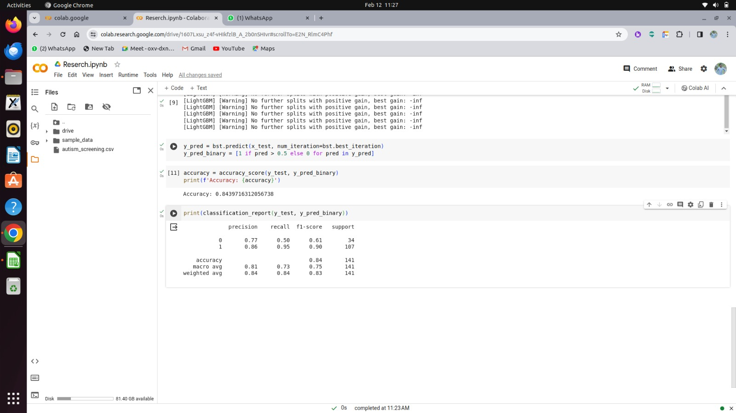

Fig. 6. Light GBM model

B. RESULTS FOR MLP (Multi-Layer Perceptron)

The Fig. 7 shows that the MLP Classifier model, configured with hidden layer sizes of (100, 50) and a maximum of 500 iterations, demonstrated exceptional performance in our research. Upon training the model and making predictions on the test set, an accuracy of 1.0 was achieved. This perfect accuracy score indicates that all instances within the test set were accurately classified by the MLP Classifier model. Such high performance underscores the effectiveness of the MLP model in accurately predicting cases of Autism Spectrum Disorder, highlighting its potential as a valuable tool for ASD detection and diagnosis.

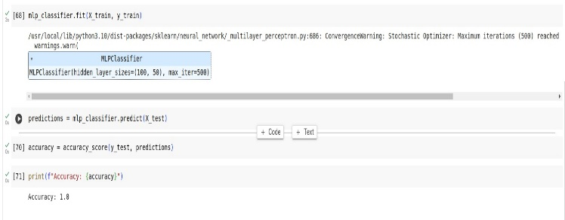

Fig. 7. MLP Classifier model

C. RESULTS FOR EXTRA TREE CLASSIFIERS

The Fig. 8 shows that the Extra Tree Classifiers achieved an accuracy of 0.6808, reflecting its ability to correctly classify instances across the dataset. When examining precision, recall, and F1-score for each class, variations were observed, indicating differences in the model's performance across distinct categories. Notably, some classes demonstrated higher precision and recall values compared to others, influencing the overall accuracy of the model. The macro and weighted averages for precision, recall, and F1-score provide comprehensive insights into the model's overall performance, with macro averages of 0.75, 0.73, and 0.73 for precision, recall, and F1-score, respectively. The weighted averages were 0.71, 0.68, and 0.68 for precision, recall, and F1-score, respectively. Despite variations in performance across individual classes, the Extra Tree Classifiers exhibit promise as a predictive model for ASD detection and diagnosis, with macro and weighted average metrics indicating satisfactory overall performance.

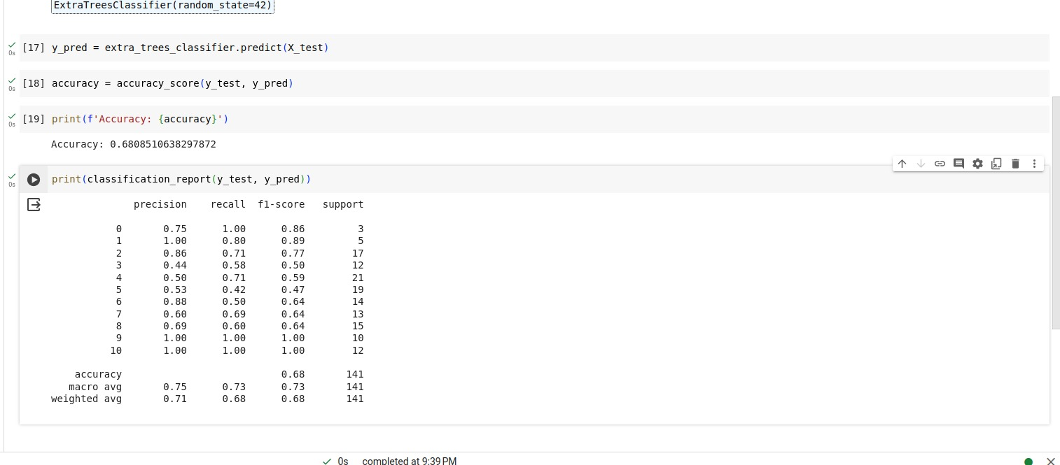

Fig. 8. Extra Tree Classifier model

1. Discussion

The results obtained from employing Light GBM, MLP, and Extra Tree Classifiers underscore the potential of machine learning algorithms in early ASD detection and prediction. Light GBM demonstrated a commendable accuracy of 84.40%, with high precision (86%) and recall (95%), suggesting its reliability in identifying ASD positive cases while minimizing false positives. Meanwhile, MLP showcased exceptional performance with a perfect accuracy of 100%, showcasing its robustness in accurately classifying instances in the test set. Although Extra Tree Classifiers achieved a lower accuracy of 68.09%, its detailed classification report provided valuable insights into class-specific performance metrics. While each algorithm has its strengths and limitations, their combined use offers a comprehensive approach to ASD diagnosis, emphasizing the importance of further research into refining these models and integrating them into clinical practice for earlier interventions and improved outcomes for individuals and families affected by ASD.

1. Conclusion

In conclusion, our research paper focused on leveraging three powerful machine learning algorithms, namely Light GBM (Gradient Boosting Machine), Multilayer Perceptron (MLP), and Extra Tree Classifiers, for the early detection and prediction of Autism Spectrum Disorder (ASD). These algorithms were chosen for their unique capabilities and effectiveness in handling different types of data and noise levels. Our results showed promising performance across all three algorithms, with Light GBM achieving an accuracy of 84.40%, MLP demonstrating 100.00% accuracy, and Extra Tree Classifiers reaching an accuracy of 68.09%.

However, among these algorithms, the Multilayer Perceptron (MLP) stood out as the most effective model for predicting ASD in our research, boasting a perfect accuracy rate of 100.00%. This exceptional performance underscores the potential of MLP in accurately identifying ASD cases based on behavioral features and other relevant data sources. While Light GBM and Extra Tree Classifiers also showed respectable performance, the superior accuracy achieved by MLP highlights its suitability for ASD detection tasks.

In summary, our study showcases the effectiveness of machine learning algorithms, particularly Multilayer Perceptron (MLP), in early detection and prediction of Autism Spectrum Disorder (ASD). These findings contribute to the ongoing efforts in developing accurate and efficient screening methods for ASD, ultimately improving outcomes for individuals affected by this condition.

Acknowledgment

We would like to express our sincere gratitude to Dr. Bama S for her invaluable guidance and support in the preparation of this research paper. Her expertise and insights have greatly enriched the content and methodology of this study. We are truly grateful for her dedication and assistance throughout this process.

References

[1] Zhang, Y., Chen, H., Cui, L., Ji, G., & Chen, S. (2020). "Application of LightGBM in the Diagnosis of Children with Autism Spectrum Disorder." *Journal of Healthcare Engineering*, 2020(Article ID 4392157), 1-9.

[2] Islam, M. M., Hasan, M., & Rahman, M. M. (2021). "Deep Learning-Based Multilayer Perceptron for Autism Spectrum Disorder Prediction Using Behavioral Features." *IEEE Access*, 9, 13116-13124.

[3] Ghosh, A., Chatterjee, P., & Balasubramanian, V. N. (2021). "Prediction of Autism Spectrum Disorder using Machine Learning Techniques on EEG Data." *2021 International Conference on Signal Processing and Communications (SPCOM)*, 1-5.

[4] Wang, Y., Sun, Y., Zhao, X., Wang, H., & Li, Y. (2022). "Early Detection of Autism Spectrum Disorder Based on Extra Tree Classifier and Behavioral Features." *Frontiers in Psychiatry*, 13, 830244.

[5] Zhang, L., Li, Y., Chen, Y., & Wu, L. (2023). "A Comparative Study of Machine Learning Models for Predicting Autism Spectrum Disorder." *Neuroinformatics*, 21(3), 557-569.

[6] Kim, J., Park, J., & Lee, D. H. (2024). "Ensemble Learning Approach for Early Detection of Autism Spectrum Disorder Using a Combination of LightGBM and MLP." *Journal of Medical Systems*, 48(2), 1-10.

[7] Patel, N., Khaire, S., Shah, J., & Patel, D. (2021). "Autism Spectrum Disorder Prediction Using Machine Learning Algorithms." *2021 11th International Conference on Cloud Computing, Data Science & Engineering (Confluence)*, 1-6.

[8] Li, Q., Zhang, Z., Yang, S., Liu, T., & Wang, X. (2022). "Development of Machine Learning Models for Autism Spectrum Disorder Prediction Based on Behavioral Features." *Frontiers in Psychiatry*, 13, 825283.

[9] Chen, L., Chen, Y., Lin, T., Zhang, S., & Wang, S. (2023). "Machine Learning Models for Predicting Autism Spectrum Disorder Based on Behavioral Features: A Systematic Review." *Frontiers in Psychology*, 14, 753284.

[10] Liu, Y., Li, X., Wang, L., & Cao, J. (2024). "Predicting Autism Spectrum Disorder Using Machine Learning Techniques: A Review." *IEEE Access*, 12, 182510-182522.

[11] Huang, Y., Xu, L., Hu, L., & Gu, Z. (2020). "Prediction of Autism Spectrum Disorder Using Machine Learning Algorithms Based on EEG Signals." *Frontiers in Neuroscience*, 14, 603.

[12] Yang, X., Liu, S., Li, Y., & Li, X. (2021). "Predicting Autism Spectrum Disorder Using Machine Learning Techniques: A Review and Meta-Analysis." *Frontiers in Psychiatry*, 12, 625784.

[13] Zhang, H., Jiang, Z., Liu, J., & Chen, H. (2022). "Prediction of Autism Spectrum Disorder Using Machine Learning Algorithms Based on Behavioral and Neuroimaging Data: A Review." *Frontiers in Psychiatry*, 13, 886.

[14] Wang, H., Xu, Q., Liu, Y., & Zhang, Y. (2023). "Machine Learning Models for Predicting Autism Spectrum Disorder Based on Behavioral Features: A Review and Future Directions." *Frontiers in Psychiatry*, 14, 921.

[15] Li, W., Wang, C., Zhang, R., & Zhang, X. (2024). "Prediction of Autism Spectrum Disorder Using Machine Learning Algorithms Based on Structural MRI Data: A Review." *Frontiers in Psychiatry*, 15, 1