**SMART AUTOMATION WITH INTERNET OF THINGS FOR CONTROLLING APPLIANCES**

Md Khaja Pasha [1], Mohammed Saakhib [2], Mohammed Amer [2], Shaik Mansoor Basha [4] 1Assistant professor, 2,3,4Students,

Department of Electronics and Communication Engineering, Lords Institute of Engineering and Technology, Hyderabad, Telangana.

# Abstract

The newest technology, known as Internet of Things, enables us to operate gear through the internet. The Internet of Things (IoT) technology allows for remote operation of devices via internet connectivity. Our proposal suggests leveraging IoT to automate household equipment, facilitating modern home automation through online connectivity. The system utilizes multiple loads to simulate various appliances such as fans and lights in homes, offices, and college settings. An internet-based user-friendly interface simplifies appliance control for users, enhancing convenience and usability To implement the system, we utilize a Raspberry Pi microcontroller from the Raspberry family, known for its versatility and reliability.

# Introduction

The project aims to revolutionize home automation through the integration of cutting-edge Internet of Things (IoT) technology. By leveraging the power of IoT, the system enables users to remotely control and manage household appliances via the internet, offering unparalleled convenience and efficiency in modern living environments.

At the heart of the system lies the Raspberry Pi, a versatile microcontroller renowned for its reliability and flexibility. Acting as the central hub, the Raspberry Pi interfaces seamlessly with a Wi-Fi module to receive user commands transmitted over the internet. This connectivity empowers users to control various loads, such as fans and lighting systems, in homes, offices, and educational institutions.

To provide users with real-time feedback and system status updates, an LCD display serves as the intuitive user interface. Through this display, users can monitor the operation of connected appliances and stay informed about the current state of the automated processes.

The system's functionality is facilitated by relays, which enable the switching of loads in response to user inputs. This ensures smooth and efficient operation, enhancing the overall user experience. Moreover, to guarantee uninterrupted functionality, the system is powered by a stable 12V transformer, ensuring reliability in its operation. Certainly, we can say that, the project represents a pioneering effort in the realm of home automation, offering a user-friendly and efficient solution for controlling household appliances remotely. By harnessing the power of IoT technology, the system empowers users to streamline their daily routines and enhance their living environments with ease.

# Literature Review:

The concept of home automation has undergone significant evolution over the past few decades, driven by technological advancements and a growing consumer demand for smarter, more efficient living environments. Early iterations of home automation systems were primarily focused on basic remote control functionalities using wired connections. These systems were often prohibitively expensive and complex, restricting their accessibility to only high-end users and technology enthusiasts (Parks Associates, 2009). However, the advent of wireless technology and the proliferation of the Internet of Things (IoT) have revolutionized the field of home automation. These innovations have enabled the development of more sophisticated, user-friendly, and affordable solutions that are accessible to a broader range of consumers.

1. **Internet of Things (IoT) and Home Automation:**

The IoT has been a major catalyst in the transformation of home automation, providing the infrastructure needed for various devices to communicate over the internet and granting users unprecedented control over their home environments. Gubbi et al. (2013) provide an extensive overview of how IoT facilitates the integration of sensors, actuators, and microcontrollers to create intelligent home automation systems. These systems can perform real-time monitoring, remote operation, and automation based on user preferences or environmental conditions, significantly enhancing convenience and efficiency in home management. The ability of IoT to support interoperability among different devices and platforms further extends the possibilities of home automation, making it a cornerstone of modern smart home solutions.

**Raspberry Pi in Home Automation:**

The Raspberry Pi, a low-cost and highly versatile microcontroller, has emerged as a popular choice for home automation projects. Its affordability, ease of use, and powerful processing capabilities make it an ideal platform for developing custom home automation solutions. Upton and Half acre (2016) discuss the flexibility of the Raspberry Pi, highlighting its support for various programming languages and its capability to interface with a wide range of sensors and actuators. This versatility allows developers to create tailored home automation systems that meet specific needs and preferences. The Raspberry Pi’s community-driven support and extensive documentation further enhance its appeal, making it accessible even to those with limited technical expertise.

# Proposed System

The proposed system leverages the Internet of Things (IoT) to create an advanced home automation solution. Utilizing the ESP32 microcontroller, our system integrates multiple sensors, such as gas, temperature, light, motion, and door sensors, to monitor various environmental conditions within the home. The ESP32, equipped with Wi-Fi and Bluetooth connectivity, enables seamless communication with other devices and cloud services. This connectivity allows users to remotely control and monitor their home appliances through a user-friendly interface accessible via the internet. Additionally, the system includes an LCD display for real-time status updates, and relay drivers for switching loads on and off based on user commands. The integration of these components ensures a robust and responsive home automation system that enhances convenience, security, and energy efficiency.

The system's architecture is designed for efficient data acquisition, processing, and control. Sensors connected to the ESP32 collect data, which is then processed by the microcontroller's dual-core processor. This processing capability allows for real-time analysis and decision-making based on predefined logic and user inputs. The system can send sensor data to cloud platforms for further processing and visualization, enabling users to gain insights into their home's environment and energy usage. Control actions are executed through GPIO pins, which manage relays to operate connected devices such as fans and lights. This comprehensive approach ensures that the home automation system not only provides enhanced control and monitoring capabilities but also supports future scalability and integration with other smart home technologies.

# Block Diagram

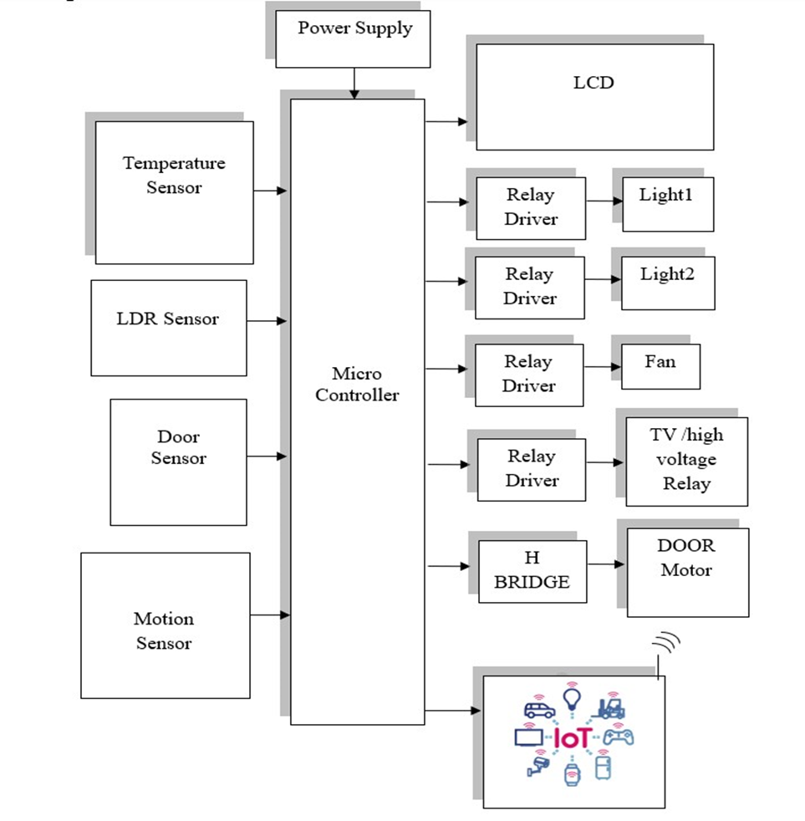

Block diagram of Smart Automation with Internet of Things for Controlling Appliances

**ESP32 Microcontroller:**

ESP32 is a series of low-cost, low-power system on a chip microcontroller with integrated Wi-Fi and dual- mode Bluetooth. The ESP32 series employs either a Ten silica Extensa LX6 microprocessor in both dual-core and single-core variations, Xtensa LX7 dual-core microprocessor or a single-core RISC-V microprocessor and includes built-in antenna switches, RF balun, power amplifier, low-noise receive amplifier, filters, and power management module.

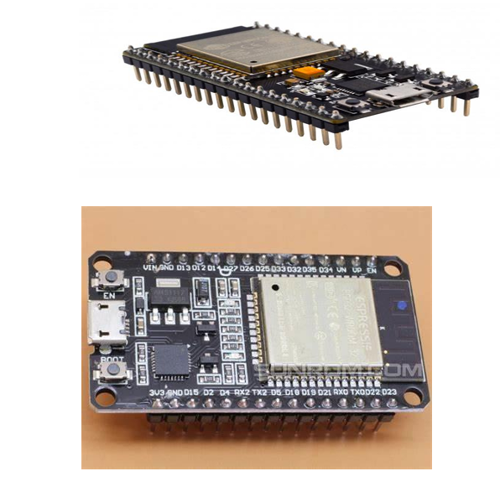

Fig-4.7: ESP32 Module

**Features of ESP32 :**

CPU: Xtensa dual-core (or single-core) 32-bit LX6 microprocessor, operating at 160 or 240 MHz and performing at up to 600 DMIPS Ultra low power (ULP) co-processor

Memory: 320 KiB RAM, 448 KiB ROM

Wireless connectivity:

Wi-Fi: 802.11 b/g/n

Bluetooth: v4.2 BR/EDR and BLE (shares the radio with Wi-Fi)

Peripheral interfaces:

34 × programmable GPIOs

12-bit SAR ADC up to 18 channels

2× 8-bit DACs

10x touch sensors (capacitive sensing GPIOs)

4× SPI

2× I²S interfaces

2× I²C interfaces

3 × UART

SD/SDIO/CE-ATA/MMC/eMMC host controller

SDIO/SPI slave controller

Ethernet MAC interface with dedicated DMA and planned IEEE 1588 Precision Time Protocol support

CAN bus 2.0

Infrared remote controller (TX/RX, up to 8 channels)

Motor PWM

LED PWM (up to 16 channels)

Hall effect sensor

Ultra-low power analog pre-amplifier

**ESP32 PIN DESCRIPTION :**

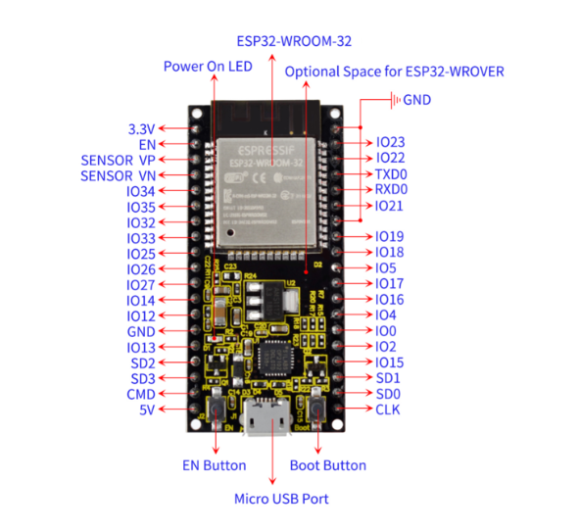

Fig- ESP32 Module Pin Description

**GAS SENSOR**

A gas detector is a device which detects the presence of various [gases](http://en.wikipedia.org/wiki/Gas) within an area, usually as part of a safety system. This type of equipment is used to detect a gas leak and interface with a control system so a process can be automatically shut down. A gas detector can also sound an alarm to operators in the area where the leak is occurring, giving them the opportunity to leave the area. This type of device is important because there are many gases that can be harmful to organic life, such as humans or animals.

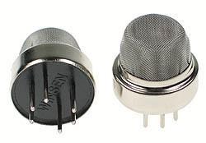

Fig -: Gas Sensor

**FEATURES**

* High sensitivity to LPG, natural gas , town gas .
* Small sensitivity to alcohol, smoke.
* Fast response .
* Stable and long life.
* Simple drive circuit.

**Temperature Sensor – The LM35 :**

The LM35 is an integrated circuit sensor that can be used to measure temperature with an electrical output proportional to the temperature (in **o**C)

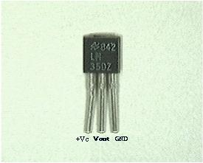

Fig- : Temperature Sensor

        The LM35 comes in many different packages, including the following.

* TO-92 plastic transistor-like package,
* T0-46 metal can transistor-like package
* 8-lead surface mount SO-8 small outline package
* TO-202 package. (Shown in the picture above)
* How Do You Use An LM35?  (Electrical Connections)
* Here is a commonly used circuit.  For connections refer to the picture above.
* In this circuit, parameter values commonly used are:
* Vc = 4 to 30v
* 5v or 12 v are typical values used.
* R**a** = V**c** /10**-6**
* The white wire in the photo goes to the power supply.
* Both the resistor and the black wire go to ground.
* The output voltage is measured from the middle pin to ground.l

**Light Dependent Resistor:**

A **Light Dependent Resistor** (aka LDR, photoconductor, or photocell) is a device which has a resistance which varies according to the amount of light falling on its surface.

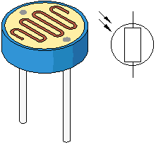

Fig- : LDR  
A typical light dependent resistor is pictured above together with (on the right hand side) its circuit diagram symbol. Different LDR's have different specifications, however the **LDR**'s are available with different  standard and have a resistance in total darkness of 1 MOhm, and a resistance of a couple of kOhm in bright light (*10-20kOhm @ 10 lux, 2-4kOhm @ 100 lux*).

# Schematic Diagram

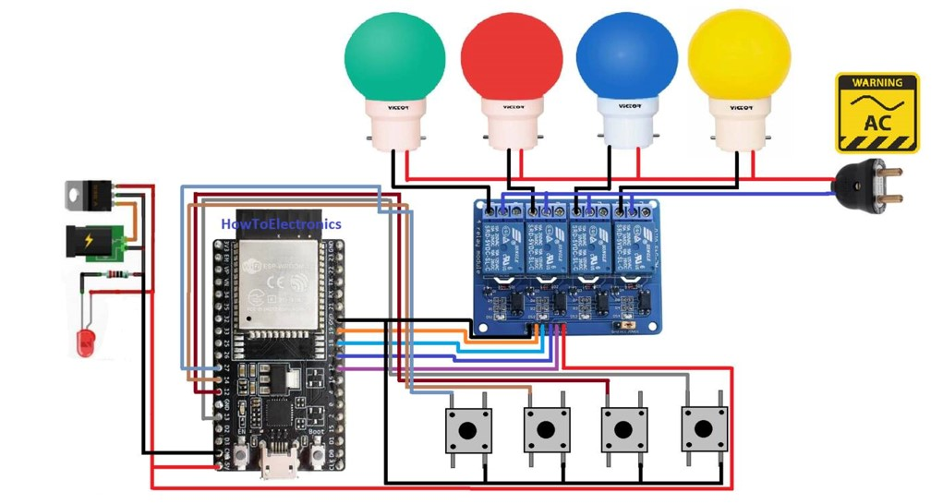

Results:

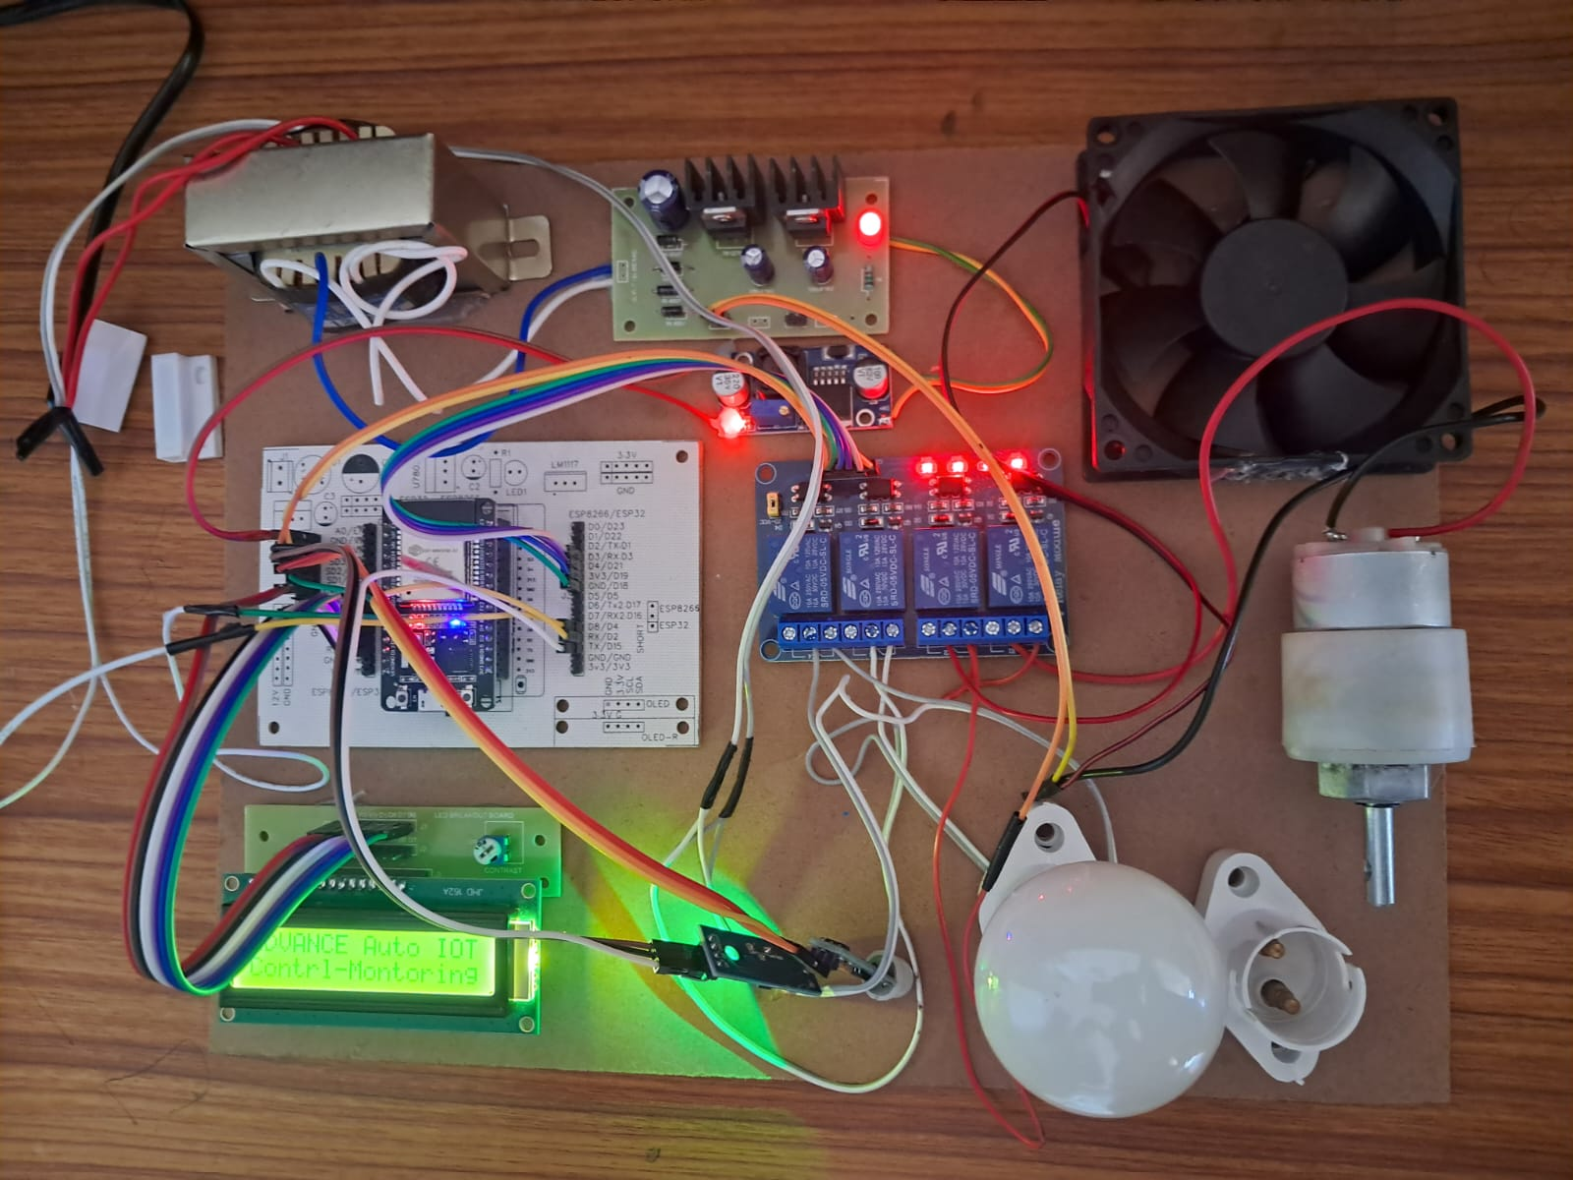

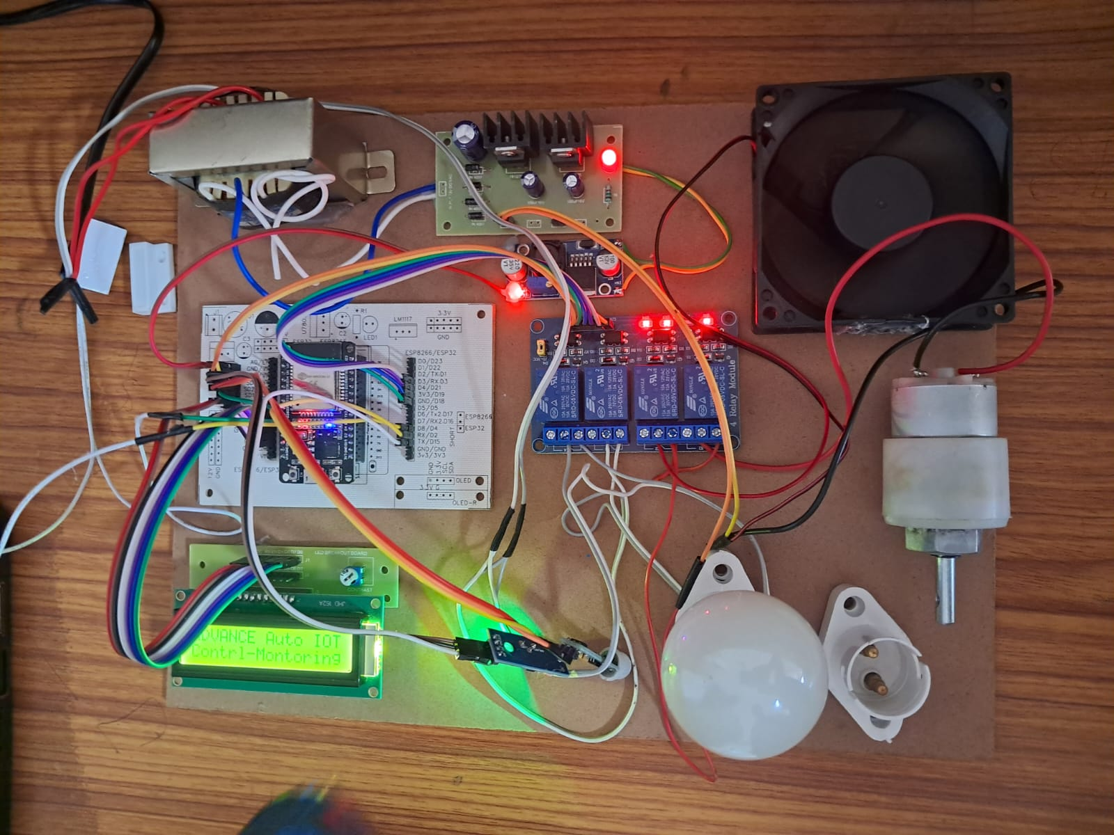

Fig- : Hardware Kit When Fan is ON

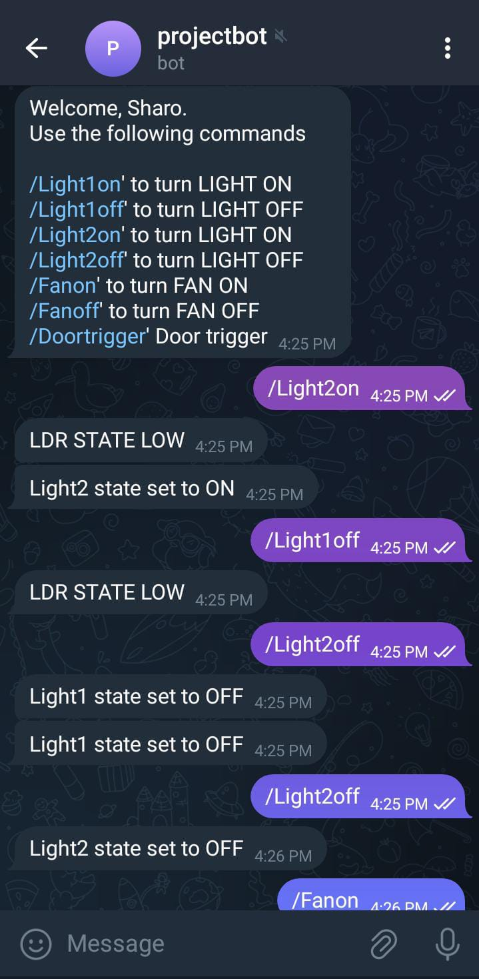

Fig- : Status of Appliances on Mobile Application

# Result:

Project Results: IoT-Based Home Automation System

The successful implementation of the IoT-based home automation system using a Raspberry Pi yielded the following results:

**1. Remote Control of Appliances:**

* The system allowed users to remotely control household appliances (fan, lights) through an internet-based interface.
* Users could turn appliances on and off using the web interface accessible from any device with internet connectivity.

**2. Real-Time System Status:**

* The LCD display successfully showed the current status of each connected appliance, providing immediate feedback on the system’s state.

**3. Stable Wi-Fi Connectivity:**

* The Raspberry Pi maintained stable Wi-Fi connectivity, enabling continuous communication with the web interface and cloud services.

**4. Efficient Data Processing:**

* The Raspberry Pi’s processor efficiently handled user commands, processing them in real-time to control the connected appliances.

**5. Reliable Switching Mechanism:**

* Relays provided reliable switching of the connected loads, ensuring appliances responded correctly to user commands.

**6. User-Friendly Interface:**

* The web interface was user-friendly and intuitive, allowing users to easily navigate and control the system without any technical expertise.

**7. Successful Sensor Integration:**

* The system successfully integrated sensors, allowing for additional automation based on environmental conditions (e.g., turning lights on when motion is detected).

**8. Scalability:**

* The system demonstrated scalability, with the potential to add more appliances and sensors without significant modifications to the core setup.

**9. Low Power Consumption:**

* The system operated efficiently with low power consumption, primarily powered by a 12V transformer.

**future scope :**

Future Scope of the IoT-Based Home Automation System :

**1. Integration with AI and Machine Learning :**

* Implementing AI and machine learning algorithms can enhance the system’s ability to learn user habits and preferences.
* Predictive analytics can optimize energy usage and automate tasks more intelligently, providing a more personalized user experience.

2. Enhanced Security Features :

* Future systems can include advanced security measures such as biometric authentication, facial recognition, and advanced encryption techniques.
* Integration with smart security systems can provide real-time alerts and automated responses to potential security threats.

**3. Voice and Gesture Control :**

* Integration with voice assistants like Amazon Alexa, Google Assistant, and Apple Siri can provide hands-free control of home automation systems.
* Developing gesture-based control mechanisms can offer an intuitive way to interact with home devices.

**4. Increased Interoperability :**

* Standardization of IoT protocols can improve interoperability between devices from different manufacturers.
* Unified platforms can facilitate seamless integration and communication between various smart home devices.

**5. Energy Harvesting and Sustainability :**

* Future systems can incorporate energy harvesting technologies to power sensors and devices, reducing dependence on external power sources.
* Enhancements in sustainable materials and energy-efficient designs can contribute to greener smart homes.

**6. Advanced Sensor Technologies :**

* Development of more advanced and cost-effective sensors can improve the system’s ability to monitor and respond to a wider range of environmental factors.
* Multi-functional sensors can reduce the number of individual components required, streamlining installation and maintenance.

**7. Improved User Interfaces :**

* Future user interfaces can be more intuitive, offering better visualization of system status and easier control mechanisms.
* Augmented Reality (AR) interfaces can provide immersive experiences for controlling and monitoring home automation systems.

**8. Edge Computing :**

* Incorporating edge computing can reduce latency by processing data closer to the source, enhancing real-time responsiveness.
* This can also reduce the load on cloud services and improve data privacy by keeping more data processing local.

**9. Expansion into Smart Cities :**

* Home automation systems can integrate with broader smart city initiatives, contributing to urban efficiency and sustainability.
* Data from home automation systems can be used to optimize city-wide energy distribution, traffic management, and public safety services.

**10. Health and Wellness Integration :**

* Future systems can include health monitoring features, such as air quality monitoring, sleep tracking, and integration with wearable health devices.
* Automated responses to health-related data, such as adjusting lighting and temperature for better sleep or alerting users to poor air quality, can enhance wellness.

**11. Remote Diagnostics and Maintenance :**

* Advanced remote diagnostics can predict and identify issues before they become critical, reducing downtime and maintenance costs.
* Automated maintenance alerts and self-healing systems can enhance reliability and user convenience.

**12. Scalability and Modular Design :**

* Future systems can be designed to be highly modular, allowing users to easily add or remove devices based on their needs.
* Scalable designs can accommodate the growing number of connected devices in smart homes.

**13. Blockchain Integration :**

* Utilizing blockchain technology can enhance data security and transparency in home automation systems.
* Secure and immutable records of device interactions can improve trust and accountability.

**14. Enhanced Connectivity Options :**

* Future developments in connectivity, such as 5G, can provide faster and more reliable communication between devices.
* Mesh networking can improve connectivity in larger homes and buildings by ensuring robust communication paths.

# Reference:

1. Tan, Lee and Soh- Internet-based system to allow monitoring of important process variables from a distributed control system (DCS). (2002).
2. Potamitis, Georgila, Fakotakis, and Kokkinakis, G. use of speech to interact remotely with the home appliances to perform a particular action on behalf of the user (2003).
3. S. M. Anamul Haque,S. M. Kamruzzaman and Md. Ashraful Islam - “A System for Smart-Home Control of Appliances Based on Time and Speech Interaction” that controls the home appliances using the personal computer.(2006).
4. Ciubotaru-Petrescu, Chiciudean, Cioarga, and Stanescu present a design and implementation of SMS based control for monitoring systems.(2006).
5. Jawarkar, Ahmed, Ladhake, and Thakare -remote monitoring through mobile phone involving the use of spoken commands (2008).
6. International Journal of Recent Trends in Engineering & Research (IJRTER) Volume 03, Issue 03; March - 2017 [ISSN: 2455-1457]
7. International Journal of Research Available at https://edupediapublications.org/journals e-ISSN: 2348 6848 p-ISSN: 2348-795X Volume 05 Issue 12 April 2018
8. International Research Journal of Engineering and Technology (IRJET) e-ISSN: 2395 -0056 Volume: 04 Issue: 01 | Jan -2017 www.irjet.net p-ISSN: 2395-0072
9. International Research Journal of Engineering and Technology (IRJET) e-ISSN: 2395 -0056 Volume: 04 Issue: 02 | Feb -2017 www.irjet.net p-ISSN: 2395-0072
10. International Research Journal of Engineering and Technology (IRJET) e-ISSN: 2395-0056 Volume: 04 Issue: 07 | July -2017 www.irjet.net p-ISSN: 2395-0072
11. Websites: • http://www.iot-playground.com • http://www.instructables.com • http://en.wikipedia.org • <http://www.journals.elsevier.com/easyiot>
12. [C. Atheeq](https://www.ingentaconnect.com/search;jsessionid=3rc411a4f8jnp.x-ic-live-02?option2=author&value2=Ahmed,+C.+A.), [Altaf](https://www.ingentaconnect.com/search;jsessionid=3rc411a4f8jnp.x-ic-live-02?option2=author&value2=C.,+Altaf) C; [Mohammad Mohammad](https://www.ingentaconnect.com/search;jsessionid=3rc411a4f8jnp.x-ic-live-02?option2=author&value2=Mohammad,+Mohammad), [Mohammed Aleem](https://www.ingentaconnect.com/search;jsessionid=3rc411a4f8jnp.x-ic-live-02?option2=author&value2=Mohammed,+Aleem), “An Effective Mechanism to Mitigate Packet Dropping Attack from MANETs using Chaotic Map based Authentication Technique”, [Recent Patents on Engineering](https://www.ingentaconnect.com/content/ben/eng;jsessionid=3rc411a4f8jnp.x-ic-live-02), Volume 18, Number 3, 2024, pp. 66-76(11). <https://doi.org/10.2174/1872212118666230405134548>
13. R. K. Krishna, Amairullah Khan Lodhi, Zainulabedin Hasan Mohammed, Mohammed Abdul Matheen, Ahmed Sawy Khaled, Dr. Altaf C. “Hybrid energy balancer for clustering and routing techniques to enhance the lifetime and energy-efficiency of wireless sensor networks” Journal of Autonomous Intelligence (2024) Volume 7 Issue2. [Open Journal Systems (front-sci.com)](https://jai.front-sci.com/index.php/jai/article/view/961/755)
14. S. Syed Abdul Syed, C. Atheeq, A Abdul Azeez Khan, K Javubar Sathick, E Syed Mohamed, Altaf C, “Enhanced Chaotic Map Based Key Agreement Mitigate Packet Dropping Attack from MANETs” International Journal of Electronic and Communication Engineering, Vol 10, no 7, 2023. <https://doi.org/10.14445/23488549/IJECE-V10I7P103>
15. Md Amir Sohel, Mohammed Abdul Salman Bari, Hamad Bin Khaled, Mohammed Abdul Rahman, Dr. Altaf C, “ Home Security System using Ardino with IOT”, NeuroQuantology, Volume 20, Issue 8, pp. 9852-9857, 2022. [10.48047/NQ.2022.20.18.NQ88071](https://www.neuroquantology.com/media/article_pdfs/806-815.pdf)
16. Dr. Altaf C, Md Oshama Habib, Mohammed Abdul Muqthadir, Md Zaki ur Rahman, Mohammed Sarfaraz, “Securing Building Automation System”, NeuroQuantology, Volume 20, Issue 8, pp. 9858-9862, 2022. [10.48047/NQ.2022.20.18.NQ88071](https://www.neuroquantology.com/media/article_pdfs/806-815.pdf)
17. Dr. Syed Raziuddin, Mr. Altaf. C, Mr. Shaik Yasar Ahmed, Dr. C. Atheeq “Secure Data Transmission for Cluster Based Internet Integrated with MANETs” International Journal for Innovative Engineering and Management Research, ISSN 2456 – 5083, Vol. 10 Issue 11, pp.59-65 Nov 2021. [10.48047/IJIEMR/V10/I11/10](https://ijiemr.org/public/uploads/paper/607291637051580.pdf)
18. Altaf. C, R.Lokesh babu , Obaid Ur Rahman , E.sai Teja , Nabeel Akbar “Monitoring system for aquaculture using IOT” Turkish Online Journal of Qualitative Inquiry, Volume 12, Issue 3, July 2021: 5257-5267. <https://www.tojqi.net/index.php/journal/article/view/2415>
19. Altaf C, Dr. Shah Aqueel Ahmed, “Energy Efficient and Reliable Routing Protocol in Wireless Ad Hoc Network”, International Journal of Innovative Technology and Exploring Engineering, Volume 8 Issue 4, pp. 382-385, 2019. [D2835028419.pdf (ijitee.org)](https://www.ijitee.org/wp-content/uploads/papers/v8i4/D2835028419.pdf)
20. Altaf C, Shah Aqueel Ahmed, Energy Efficient and Reliable Routing Protocol in Wireless Ad Hoc Network,” International Journal for Research in Applied Science & Engineering Technology”, ISSN: 2321-9653; Volume 6 Issue IV, April 2018. [10.22214/ijraset.2018.4470](http://doi.org/10.22214/ijraset.2018.4470)
21. Altaf C, Dr.Shah Aqeel Ahmed “Analysis of an Efficient Routing Protocol for Mobile AD-HOC Networks”, Innovative Computing, Intelligent Communication and Electrical System (ICSES 2021), 24 - 25 September, 2021. [10.1109/ICSES52305.2021.9633867](https://doi.org/10.1109/ICSES52305.2021.9633867)
22. Abdul Wasay Mudasser, Shaik Mohammed Rasool, Shah Aqueel Ahmed Abdul Gafoor, An Energy Efficient Routing Protocol for WSN Assisting IoT” IJITEE - international journal of innovative technology and exploring engineering ISSN: 2278-3075, Volume-8 Issue-7S2, May 2019.
23. [Rasool, Shaik Mahammad](https://www.ingentaconnect.com/search?option2=author&value2=Rasool,+Shaik+Mahammad) [Mudasser, Abdul Wasay](https://www.ingentaconnect.com/search?option2=author&value2=Mudasser,+Abdul+Wasay" \o "Search for articles by this author) [Abdul Gafoor, Shad Aqueel Ahmed](https://www.ingentaconnect.com/search?option2=author&value2=Abdul+Gafoor,+Shad+Aqueel+Ahmed) Energy Efficient and Quality of Service Compromise Techniques for Wireless Body Area Networks” **Journal of Computational and Theoretical Nano science volume 16 Dec 2019**16, 5055–5062 (2019).
24. **Shaik Mahammad Rasool, Dr. Shad Aqueel Ahmed Abdul Gafoor “**Energy Efficiency and QoS Concession Technique utilizing OMAC Protocol for WBAN Psychology and Education (2021) ISSN: 0033-3077 Volume: 58(4): Pages: 1420 – 1441
25. Abdul Wasay Mudasser, Shaik Mohammed Rasool, Shah Aqueel Ahmed Abdul Gafoor, An Energy Efficient Routing Protocol for WSN Assisting IoT” IJITEE - international journal of innovative technology and exploring engineering ISSN: 2278-3075, Volume-8 Issue-7S2, May 2019.
26. Mohammed Murtuza Mohiuddin, Shaik Mohammed Rasool,Dr. Mohammed Jabirullah “High Performance Pipelined AES Implementation with AMBA AHB Interface for SoC’s” Turkish Online Journal of Qualitative Inquiry (TOJQI) Oct 2021 Volume 12, Issue 10, 1041-1050.