Research On Smart Baby Cradle Using Sensor Technology

**Shubhangi Roshan Katakwar                                           Assistant Prof. Sunil Vasant Kuntawar**

**Department of Electronics & Telecommunication,              Department of Electronics & Telecommunication,**

**BIT college, Ballarpur.                                                           BIT college, Ballarpur.**

Shubhangikatakwar2396@gmail.comsunilkuntawar22@gmail.com

**ABSTRACT—** A cradle is a device designed to help babies fall asleep, employing a gentle side-to-side rocking motion. However, it demands considerable physical effort from parents to manually generate this swinging motion. Additionally, constant supervision is required to monitor the baby's activities when they are placed inside the cradle. In the contemporary age of technological advancement, parents frequently grapple with a myriad of challenges in balancing their professional responsibilities with the nurturing needs of their children.

Our paper aims to address the prevalent issues faced by parents by introducing an innovative IoT-based Smart Cradle Monitoring System. The key objective is to alleviate the parenting challenges by creating a solution that aids in the seamless monitoring of infants. The Smart Cradle features an automated swinging mechanism triggered by the detection of a baby's crying sound. Additionally, it incorporates a built-in camera to provide continuous surveillance, empowering parents with an enhanced ability to keep a vigilant eye on their child. To achieve this functionality, we have seamlessly integrated components such as Arduino, sound sensors, wetness sensors, and the swinging mechanism, among other electronic elements, into the traditional cradle design. This upgraded solution not only offers heightened efficiency and reliability but also surpasses the capabilities of conventional cradles, providing parents with a more effective means of caring for their infants.

# KEYWORDS- IoT Technology, Smart Baby Cradle.

1. **INTRODUCTION**

In recent decades, a substantial migration trend, particularly among women in the workforce, has seen individuals flock to metropolitan areas in search of improved job prospects. This phenomenon is especially challenging for dual-income couples, where both partners are employed, leading to difficulties in allocating sufficient time and care for their infants. The COVID-19 pandemic exacerbated these challenges as remote work became prevalent, intensifying the delicate balance between professional commitments and parenting duties. This struggle became even more pronounced when infants fell ill, requiring constant monitoring and potentially forcing parents to take leave from work. This not only impacts the career trajectories of parents but also places significant stress on them. The fusion of technological innovation with the fundamental fabric of childcare presents an opportunity to redefine parenting dynamics in the digital era.

Our proposed Smart Cradle System, a testament to this symbiotic relationship between technology and caregiving, seamlessly integrates an array of sensors and intelligent mechanisms to create a nurturing environment for infants.

In response to the pressing need to ease the challenges associated with monitoring and nurturing children, our paper introduces a cutting-edge solution: an automated Smart Cradle System leveraging IoT technology. This system is specifically designed to assist parents in efficiently monitoring their children, whether they are at work or at home. Through the implementation of this IoT-based smart cradle system, our aim is to grant parents the peace of mind that comes from knowing their child is being cared for and monitored effectively. This,

in turn, enables them to better navigate the balance between their professional and parenting responsibilities. By embracing this technological leap in childcare, we envision a landscape where parents no longer need to compromise their professional aspirations for the sake of their children's well-being. Instead, they can stride confidently knowing that their infants are receiving the utmost care and attention, while they continue to contribute meaningfully to their careers and society at large.

As we navigate the complex terrain of modernity, the Smart Cradle System serves as a beacon—a testament to the harmonious coalescence of technological ingenuity and compassionate caregiving, paving the way for a more balanced, empowered, and nurturing future for both parents and their cherished little ones.

# LITERATURE REVIEW

1. Symon, Aslam Forhad et al. In this the author presents a baby monitoring system for busy parents so that they can ensure the proper care and safety of their babies. This system can detect the baby’s motion and sound; especially crying and video output of the baby's present position can be displayed on a display monitor so that the mother or another responsible person can watch the baby while away from him or her.
2. S. Brangui, et. al, In this paper the author intends to build on the existing related work and suggests an enhanced noise cancelling system for a comprehensive monitoring and control to overcome the sound pollution and make the baby rooms more comfortable. The proposed system design and implementation are discussed and the corresponding components are detailed with their interactions. Additionally, a draft cost estimation is presented.
3. Prof. A.D. Anjikar, et. al, In this paper the author designed an automatic baby rocker having a noise sensor to detect baby cry. The goal of this framework is to structure a shrewd infant support with numerous highlights which helps in checking the children and updates the infant's status to guardians.
4. Yang Hu; Weihua Gui et. al, In this paper the author proposed a system for adjusting the bassinet swaying extent by the sensor signals. The bassinet is made up of an adaptive swaying device and other sensor network. To improve the household management and decrease the young parents' Labour intensity, a new baby bassinet is made.

a.

Marie R. Harper, et. al, In this paper the author invented a crib adapted to be rocked through an app. A baby crib or cradle adapted to be rocked automatically by an oscillatory, action motor having the same effect as would be achieved by a mother rocking a crib containing an infant, the crib being pivotally supported at each end thereof to a support rack and stand. The lower portion or bottom of the crib is adapted to be operable connected to the motor. The motor also includes a regulating, reciprocating means for motion

1. Gim Wong, ET. Al, In this paper the author presented an Electronic device that can be attached to conventional pivotally mounted type crib. The present device is electronically actuated and may be connected to a conventional crib which is often manually rocked by pushing and pulling on the foot or headboard to give the slight rocking action desired. The device is preferably actuated by a baby's voice picked up by a microphone or microphones and the periodicity and duration of the rocking may be adjusted within limits. It can also be set into motion by manual actuation of a switch.
2. Chau-Kai-Hsieh, et. al, In this paper the author proposed a baby cry recognizer which includes an amplifier circuit for amplifying a received sound signal. This paper presents the design and implementation of a new indigenous low cost E-Baby Cradle that swings automatically when baby cries, for this it has a cry analysing system which detects the baby cry voice and accordingly the cradle swings till the baby stops crying.
3. Amrita Ebenezer et. al, In this paper the author gives an approach to design a baby cradle consisting of a cry analysing system which detects baby cry. Our project is a novel approach in designing an automatic cradle swinging system for assisting infant care. This equipment can be mainly used in the hospitals to provide aid to the nurse in taking care of the infant or at home to monitor the baby while the parent is at work and the baby is under the care of baby sitters.
4. Amin Shaikh1, et. al, In this paper the author proposed this cradle system. There's a desire for a product that bridges this gap between parents and baby. This cradle system is proposed to assist these parents so they'll take excellent care of their baby from remote locations.
5. Sarah Ahmed Alswedani1 et. al, The author in this research paper provides significant attention on detecting baby cry, more accurately, by integrating four-sub modules in the cry classification process including voice analysis, face image analysis, body gesture analysis, and finally decision fusion.
6. N. Saude and P. A. H. Vardhini, This paper presents IoT based smart systems that act as baby cradle monitoring systems for engaged or working parents so that they can manage properly, and also for proper care and safety of the infant. Parents can recognize the baby's movement, sound like crying and video output of the baby's present position and motion will be visible on a screen monitor so the parent or any person can watch the infant even while away from the baby. This cradle system is useful for monitoring or detecting movement and crying conditions of the child automatically.
7. H. M. Ishtiaq Salehin, et al. In this paper, they are using a very efficient and user-friendly technology to implement automatic swinging of the baby bassinet with sound detection of the baby crying using sound sensor and playing lullaby through speakers. The humidity sensor has been used to know the diaper's moisture level, and notifications have been sent to parents with certain conditions through mobile calls and text messages. A webpage using HTML and CSS has been developed, where parents/guardians can supervise the baby in real-time. Finally, the system will detect if the baby is in the cradle using the face recognition technique.
8. M. P. Joshi and D. C. Mehetre, This paper presents the design of Smart Cradle which supports such video monitoring. This cradle swings automatically on detection of baby cry sound. Also it activates buzzer and gives alerts on phone if-first, baby cry continues till specific time which means now cradle cannot handle baby and baby needs personal attention and second, if the mattress in the cradle is wet. This cradle has an automatic rotating toy for baby's entertainment.
9. W. A. Jabbar, et al. In this paper, the author designed a system, which consists of a Node Micro-Controller Unit (NodeMCU) Controller Board that is exploited to gather the data read by the sensors and uploaded via Wi-Fi to the AdaFruit MQTT server. The proposed system exploits sensors to monitor the baby's vital parameters, such as ambient temperature, moisture, and crying. A prototype of the proposed baby cradle has been designed using Nx Siemens software, and a red meranti wood is used as the material for the cradle. The system architecture consists of a baby cradle that will automatically swing using a motor when the baby cries. Parents can also monitor their babies' condition through an external web camera and switch on the lullaby toy located on the baby cradle remotely via the MQTT server to entertain the baby.
10. Gare, Harshad Suresh, et al. In this paper, the author is proposing an automated cradle system which will connect to the parent’s mobile for sending alert messages. Sound sensor will be attached to cradle in such a way that it will take input sound of baby only, it will conclude the activity to be performed as per the range of sound in decibels, if the sound is more than certain amount then system will automatically start swinging the cradle, if baby still not sleepy or stop cry alert will send to the parents. Motion sensor that is PIR sensor will detect the motion it is used for security purpose and in point of view of any danger, if there is too, much motion detected alert will send to the parents. Wet sensor is used for check that the baby has pee? If any kind of wetness is detected it will send the alert message to the parents. There will be two temperature sensors used that are DHT11 and LM35, DHT 11 will check the temperature of the whole room and LM 35 sensor will measure temperature of the body, and it will alert the parent if there is a huge change.
11. N. L. Pratap, et al. In this paper, the author proposed a system, a smart cradle with an automated baby monitoring system was developed. The S.ODI board is used for interfacing the sensors and actuators. The baby monitoring system is attached to the cradle so that an incubator kind of environment will be created for the baby. The baby monitoring system monitors the baby 24×7. The measured parameters regarding the baby's health like temperature, heartbeat rate, dampness on the baby bed will be displayed in the mobile application. If the recorded readings show any abnormalities, the necessary actions like controlling temperature, switching on or off the fan, setting up the cradle's movement, and playing music for the baby will be taken. If the readings seem abnormal, the caretaker along with the parents will get an alert message. The motion and posture status of the infant can be monitored using motion Eye OS.
12. Prusty, Vedanta, Abhisek Rath, et al. In this paper, By using the concepts of Internet of Things, Embedded Systems & Cloud Technology, the author aims to build a smart system that can be productively used for efficient child care and management. In this paper they have focused on the child’s security and hygiene issues so as to raise the child in a good and healthy environment.
13. V. P. Hotur, et al. In this paper, the author introduces a cradle that includes an MP3 player for soothing music, temperature detector and bed wet sensor embedded into ESP32 wroom (microcontroller) platform. Availability of high speed internet facilitates using IoT platform with ease, and any ambiguity caused to the infant will be reported to parents in the form of SMS via GSM. Prevention for child abuse is also taken care in our model.
14. Kumar, V. Suresh, Lokaiah Pullagura, et al. This paper introduces the notion of a smart cradle, which enables for

imparting the actuating movement of the crib in a smooth rocking motion

1. Gim Wong, ET. Al, In this paper the author presented an Electronic device that can be attached to conventional pivotally mounted type crib. The present device is electronically actuated and may be connected to a conventional crib which is often manually rocked by pushing and pulling on the foot or headboard to give the slight rocking action desired. The device is preferably actuated by a baby's voice picked up by a microphone or microphones and the periodicity and duration of the rocking may be adjusted within limits. It can also be set into motion by manual actuation of a switch.
2. Chau-Kai-Hsieh, et. al, In this paper the author proposed a baby cry recognizer which includes an amplifier circuit for amplifying a received sound signal. This paper presents the design and implementation of a new indigenous low cost E-Baby Cradle that swings automatically when baby cries, for this it has a cry analysing system which detects the baby cry voice and accordingly the cradle swings till the baby stops crying.
3. Amrita Ebenezer et. al, In this paper the author gives an approach to design a baby cradle consisting of a cry analysing system which detects baby cry. Our project is a novel approach in designing an automatic cradle swinging system for assisting infant care. This equipment can be mainly used in the hospitals to provide aid to the nurse in taking care of the infant or at home to monitor the baby while the parent is at work and the baby is under the care of baby sitters.
4. Amin Shaikh1, et. al, In this paper the author proposed this cradle system. There's a desire for a product that bridges this gap between parents and baby. This cradle system is proposed to assist these parents so they'll take excellent care of their baby from remote locations.
5. Sarah Ahmed Alswedani1 et. al, The author in this research paper provides significant attention on detecting baby cry, more accurately, by integrating four-sub modules in the cry classification process including voice analysis, face image analysis, body gesture analysis, and finally decision fusion.
6. N. Saude and P. A. H. Vardhini, This paper presents IoT based smart systems that act as baby cradle monitoring systems for engaged or working parents so that they can manage properly, and also for proper care and safety of the infant. Parents can recognize the baby's movement, sound like crying and video output of the baby's present position and motion will be visible on a screen monitor so the parent or any person can watch the infant even while away from the baby. This cradle system is useful for monitoring or detecting movement and crying conditions of the child automatically.
7. H. M. Ishtiaq Salehin, et al. In this paper, they are using a very efficient and user-friendly technology to implement automatic swinging of the baby bassinet with sound detection of the baby crying using sound sensor and playing lullaby through speakers. The humidity sensor has been used to know the diaper's moisture level, and notifications have been sent to parents with certain conditions through mobile calls and text messages. A webpage using HTML and CSS has been developed, where parents/guardians can supervise the baby in real-time. Finally, the system will detect if the baby is in the cradle using the face recognition technique.
8. M. P. Joshi and D. C. Mehetre, This paper presents the design of Smart Cradle which supports such video monitoring. This cradle swings automatically on detection of baby cry sound. Also it activates buzzer and gives alerts on phone if-first, baby cry continues till specific time which means now cradle cannot handle baby and baby needs

personal attention and second, if the mattress in the cradle is wet. This cradle has an automatic rotating toy for baby's entertainment.

1. W. A. Jabbar, et al. In this paper, the author designed a system, which consists of a Node Micro-Controller Unit (NodeMCU) Controller Board that is exploited to gather the data read by the sensors and uploaded via Wi-Fi to the AdaFruit MQTT server. The proposed system exploits sensors to monitor the baby's vital parameters, such as ambient temperature, moisture, and crying. A prototype of the proposed baby cradle has been designed using Nx Siemens software, and a red meranti wood is used as the material for the cradle. The system architecture consists of a baby cradle that will automatically swing using a motor when the baby cries. Parents can also monitor their babies' condition through an external web camera and switch on the lullaby toy located on the baby cradle remotely via the MQTT server to entertain the baby.
2. Gare, Harshad Suresh, et al. In this paper, the author is proposing an automated cradle system which will connect to the parent’s mobile for sending alert messages. Sound sensor will be attached to cradle in such a way that it will take input sound of baby only, it will conclude the activity to be performed as per the range of sound in decibels, if the sound is more than certain amount then system will automatically start swinging the cradle, if baby still not sleepy or stop cry alert will send to the parents. Motion sensor that is PIR sensor will detect the motion it is used for security purpose and in point of view of any danger, if there is too, much motion detected alert will send to the parents. Wet sensor is used for check that the baby has pee? If any kind of wetness is detected it will send the alert message to the parents. There will be two temperature sensors used that are DHT11 and LM35, DHT 11 will check the temperature of the whole room and LM 35 sensor will measure temperature of the body, and it will alert the parent if there is a huge change.
3. N. L. Pratap, et al. In this paper, the author proposed a system, a smart cradle with an automated baby monitoring system was developed. The S.ODI board is used for interfacing the sensors and actuators. The baby monitoring system is attached to the cradle so that an incubator kind of environment will be created for the baby. The baby monitoring system monitors the baby 24×7. The measured parameters regarding the baby's health like temperature, heartbeat rate, dampness on the baby bed will be displayed in the mobile application. If the recorded readings show any abnormalities, the necessary actions like controlling temperature, switching on or off the fan, setting up the cradle's movement, and playing music for the baby will be taken. If the readings seem abnormal, the caretaker along with the parents will get an alert message. The motion and posture status of the infant can be monitored using motion Eye OS.
4. Prusty, Vedanta, Abhisek Rath, et al. In this paper, By using the concepts of Internet of Things, Embedded Systems & Cloud Technology, the author aims to build a smart system that can be productively used for efficient child care and management. In this paper they have focused on the child’s security and hygiene issues so as to raise the child in a good and healthy environment.
5. V. P. Hotur, et al. In this paper, the author introduces a cradle that includes an MP3 player for soothing music, temperature detector and bed wet sensor embedded into ESP32 wroom (microcontroller) platform. Availability of high speed internet facilitates using IoT platform with ease, and any ambiguity caused to the infant will be reported to parents in the form of SMS via GSM. Prevention for child abuse is also taken care in our model.
6. Kumar, V. Suresh, Lokaiah Pullagura, et al. This paper introduces the notion of a smart cradle, which enables for

this kind of video monitoring to be carried out on an infant. An infant’s scream triggers the automated swinging of this cradle, which begins when the sensor detects it. In addition, if the baby’s cry persists for an extended period of time, the gadget triggers a buzzer and sends a text message to the phone, signalling that the cradle is no longer capable of handling the infant and that the baby needs human assistance if the cradle’s mattress is wet. This cradle is equipped with an automatic spinning toy for the baby’s entertainment, which reduces the likelihood of a newborn crying throughout the day.

1. Ullah, Ahsan, and Afzal Hossain. In this paper, the author introduces a system which is an automatic music system that will be activated as soon as the baby's crying level is detected while the baby is in the swing, which will help stop the baby's crying. The prototype of the proposed system has been developed and tested to prove its effectiveness in terms of cost and simplicity and to ensure secure operation to enable child parenting anywhere and anytime over the network.
2. S. Durga, S. Itnal, K. Soujanya, et al. Here in this paper, the author proposed an algorithm which can effectively monitor the babies from distance and here a specialised algorithm is proposed. Here the proposed design consists of NodeMCU (Node Microcontroller unit) and the breadboard and also the sensors which are used for acquiring the data. Here the proposed design consists of NodeMCU (Node Microcontroller unit), the breadboard and also the sensors which are used for acquiring the data. Here the parameters are crying, moisture and ambient temperature.
3. R. Sonia, S. M. Jayadeva, et al. In this paper, the author aims at the construction of a smart cradle. This cradle is designed using various input elements, output elements, a controller module, and a mobile application. The input elements consist of a temperature sensor, a sound sensor or a microphone,a moisture sensor, and a music player. The output elements include the motor and The controller used in this study is the NodeMCU module. Cloud storage is also used and it is provided by the Arduino loT software. The sensors in the smart cradle begin recording relevant parameters such as temperature, humidity, and sound as soon as it is turned on. The information is then uploaded to the cloud The data is then processed in the cloud for analysis. If indeed the child's temperature is over the safe range, the user receives a warning. Moisture levels above normal suggest that the infant has urinated. The sound of the baby crying will be recorded in the microphone. The output elements are energised as a result of the sensor's data. If the baby has a high fever or has to go to the bathroom, the app will notify the parent.
4. Chauhan, Harsha, Deepali Gupta, et al. In this paper, the author have proposed a solution based on IoT and BT for monitoring the infants or toddlers. This proposed solution will help to reduce the burden of parents and healthcare staff by enabling the features of security and alarm systems.
5. Wadhokar, Nisha, and Balasaheb Tarle. In this paper, the author projects the personification of a Smart Baby Cradle, brought about by integrating distinctive features, i.e., cradle swing. The data read by the sensors are gathered by the developed system's Node Micro-Controller Unit (NodeMCU) Controller Board and uploaded via Wi-Fi to the Blynk server. The proposed system prototype is fabricated and tested to prove its effectiveness in simplicity and to ensure safe operation to enable the baby-parenting anywhere and anytime through the network. The system monitors the baby's situation and surroundings effectively.
6. Perumal, Vigneshwaran. et al. In this paper, the author proposed a cradle system which will be implemented with sensors and processed by ARDUINO. With the help of these sensors an Arduino is able to monitor the baby in the cradle system. The proposed new design system implemented in

the traditional cradle system makes it more convenient to use for caring mothers.

# METHODOLOGY

Infants or toddlers need parent’s attention 24x7, in this modern era, parents are involved in firm exploitation, office ferment and personal knead. So, they won’t be able to take care of their children. Therefore, in this paper we proposed a Smart baby cradle using sensor technology. This is an IoT based paper.

In this paper we used Arduino Uno as a microcontroller, orchestrating a network of sensors including the LM393 Wet Sensor for urine detection, a sound sensor for cry recognition, a camera module for visual monitoring, and a DHT11 sensor for temperature control. LM393 Comparator IC wet sensor which will detect the baby’s urine in the cradle and a sound sensor, when the baby will cry, the notification will be sent to Blynk App. And we used a camera module which will show the baby in the cradle. And also a high torque servo motor, with the help of servo motor mother can move baby cradle. One more feature in this is that here we used a DHT11 sensor which is used to detect the temperature. The system ensures optimal temperature and humidity levels within the cradle. collectively providing comprehensive care for infants and enabling parents to fulfil professional obligations with peace of mind.

# BLOCK DIAGRAM

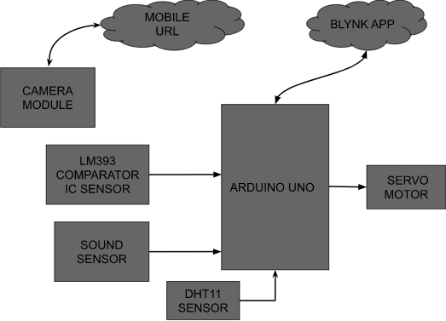

**DESCRIPTION**

In the above diagram we have used Arduino Uno as a microcontroller. As an output device we have used the servo motor. And in input devices we have used DHT11 Sensor, Sound Sensor, LM393 Comparator IC Sensor, a Camera Module connected to the microcontroller. And we have used the blynk app to show all the notifications.

# FLOW CHART

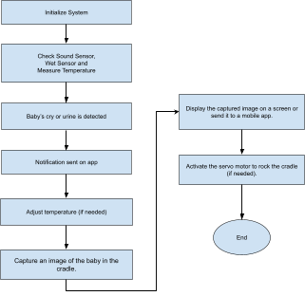

**CIRCUIT DIAGRAM**

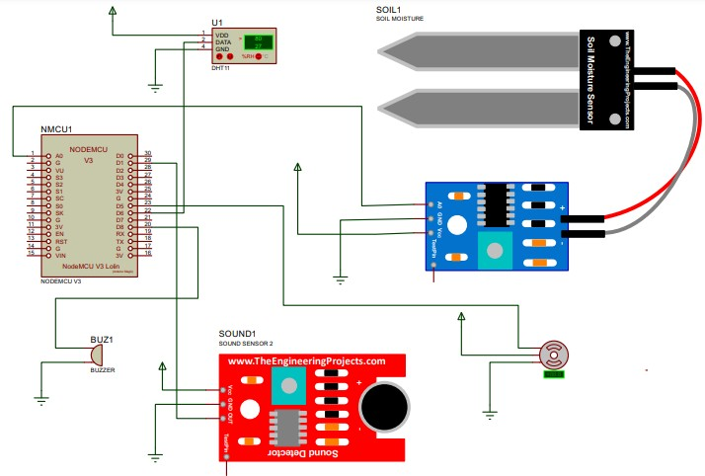

# WORKING

The "Smart Baby Cradle Using Sensor Technology" paper aims to provide parents with a comprehensive infant monitoring solution. It utilises various components, including sound sensors, LM393 comparator IC, ESP32 camera module, MG996R servo motor, Arduino Uno, and a mobile application powered by Blynk. The paper initiates by initialising its components, and sensors such as the sound sensor, LM393 IC, and DHT11 sensor collect data, monitoring the baby's temperature, detecting sounds indicative of the baby's crying, and identifying diaper wetness through the comparator IC. The camera module captures the baby's movements and images, which are transmitted to the Arduino Uno. All these parameters are then displayed in real-time on the Blynk mobile application, allowing parents to monitor their baby's well-being. In response to the baby's crying, the servo motor activates, gently rocking the cradle to soothe the baby. This system offers a user-friendly and effective solution for infant care and monitoring.

# SYSTEM REQUIREMENT HARDWARE REQUIREMENT

1. Arduino Uno
2. Sound Sensor
3. LM393 Comparator IC Sensor
4. Servo Motor
5. Camera Module
6. Temperature Sensor

# SOFTWARE REQUIREMENT

1. Arduino IDE
2. Blynk App

# IMPLEMENTATION

**EXPERIMENTAL SETUP**

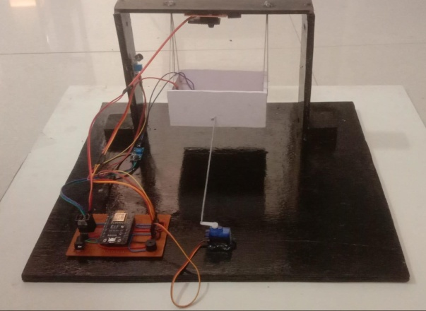

# SIDE VIEW

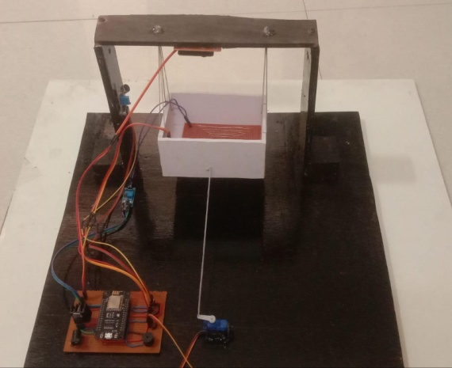

**TOP VIEW OF SETUP**

# Fig. shows the experimental setup of the system

**RESULT**

The "Smart Baby Cradle Using Sensor Technology" paper has been executed successfully, meeting its predefined objectives with remarkable outcomes. The Blynk mobile application serves as a robust platform, enabling parents to monitor crucial parameters essential for the baby's well-being. These include real-time tracking of the baby's temperature, sound levels in the vicinity, and even the detection of urine. The integration of the paper with the Blynk app underscores its effectiveness in providing seamless access to comprehensive data, enhancing the ease of use for parents. Through the Blynk mobile application, parents gain not only valuable insights into their baby's current status but also the ability to view images of their infant. The incorporation of visual data further enhances the monitoring capabilities, contributing to a holistic tool that empowers parents to stay closely connected with their baby's health and comfort.

For a more detailed understanding, visual representations within the Blynk app offer a clear glimpse into the monitored parameters. These images provide a visual breakdown, illustrating how parents can effortlessly navigate and interpret the real-time data on the baby's temperature, ambient sound levels, and the system's capability to detect urine. Overall, the successful implementation of this paper, coupled with the intuitive Blynk mobile application, presents a robust solution for parents seeking a comprehensive and user-friendly tool to oversee and ensure their baby's well-being.

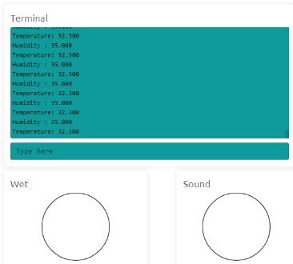

# PARAMETER: TEMPERATURE AND HUMIDITY

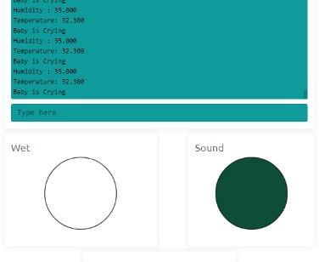

**PARAMETER: SOUND DETECT AFTER BABY IS CRYING**

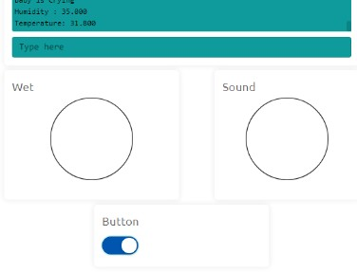

# PARAMETER: BUTTON GET ON MANUALLY BY BLYNK APP

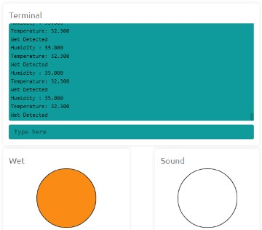

**PARAMETER: WET IS DETECTED**

# CONCLUSION

The advent of the Internet of Things (IoT) has ushered in a new era of intelligence for devices. A smart cradle, integrated with a baby monitoring system leveraging IoT, has been conceptualised and crafted. This innovative system is designed to track crucial parameters of a baby, including their crying condition, humidity levels, and ambient temperature. The utilisation of IoT technology has significantly expanded the scope of information that can be transmitted over the internet, offering remote access to parents or caregivers. The incorporation of a camera module in the cradle enables meticulous monitoring of the baby within a defined area, capturing continuous insights into their movements. This paper harnesses IoT technology to monitor the baby's activities, with related notifications promptly transmitted to mobile applications. This technological marvel not only elevates the efficiency of baby monitoring but also augments the support system available to parents and caregivers. The captured insights, conveyed through the integration of IoT and cutting-edge sensor technology, pave the way for a more informed and responsive approach to nurturing infants. Furthermore, the symbiotic relationship between IoT and the smart cradle embodies an ethos of adaptability, catering to the evolving needs of modern parenting in an increasingly interconnected world.

In essence, this paper underscores the profound implications of IoT-driven innovation in revolutionising infant care practices. It heralds a future where technology seamlessly intertwines with caregiving, promising not just convenience but also an invaluable sense of security and empowerment for parents, fostering a nurturing environment where the well-being of infants remains at the forefront.

# FUTURE SCOPE

The future trajectory of the Smart Baby Cradle Using Sensor Technology paper is poised for transformative advancements. This involves the incorporation of cutting-edge sensors and artificial intelligence to enable a more thorough infant monitoring system with predictive capabilities. The paper's horizon extends towards facilitating remote medical consultations and tailoring caregiving approaches through advanced technology. Its global expansion aims to ensure widespread accessibility and sustainability, with a continuous commitment to enhancing data security and privacy. Collaborative efforts with experts and ongoing research initiatives will unlock the full potential of this technology, providing parents with an ever-evolving and effective tool for nurturing and safeguarding the well-being of their infants. In essence, the paper is set to redefine the landscape of modern childcare.

# REFERENCE

1. Symon, Aslam Forhad et al. “Design and development of a smart baby monitoring system based on Raspberry Pi and Pi camera.” 2019 4th International Conference on Advances in Electrical Engineering (ICAEE) (2019): 117-122.
2. S. Brangui, M. El Kihal and Y. Salih-Alj, "An enhanced noise cancelling system for a comprehensive monitoring and control of baby environments", 2020 International Conference on Electrical and Information Technologies (ICEIT), pp. 404-409, 2020.
3. Prof. A.D. Anjikar, Arshad, Khan Pathan, Pranjal R. Dandekar, “GENERAL IDEA ABOUT SMART BABY CRADLE” in

International Journal of Innovative Computer Science & Engineering Volume 4 Issue 1; JanuaryFebruary-2020

1. Yang Hu; Weihua Gui; , “Adaptive Sway Control for Baby Bassinet Based on Artificial Metabolic Algorithm” School of Information Science and Engineering, Central South University, China. 2019.
2. Marie R. Harper; La Mirada; Maxine R. Blea; , “Automatically rocking baby cradle”, US 3769641, Date of Patent: Nov. 6,2019.
3. Gim Wong, “Automatic baby crib rocker” US 3952343, Date of Patent: Apr. 27, 2019.
4. Chau-Kai-Hsieh; Chiung Lin; Taiwan; , “Baby Cry Recognizer” US 5668780, Date of Patent Sep. 16, 2019
5. Amrita Ebenezer; Anupreethi. S; , “Automatic Cradle Movement for Infant Care” Undergraduate Academic Research Journal (UARJ), ISSN : 2278 – 1129, Vol.-1, Issue-1, 2021
6. Amin Shaikh1, Ankit Sharma2, Naveen Yadav3, Omkar Mane4, Prof. Sneha Deshmukh5 Review on Internet of Things based Smart Baby Cradle International Research Journal of Engineering and Technology (IRJET) e-ISSN: 2395-0056 Volume: 08 Issue: 03, Mar 2021
7. Sarah Ahmed Alswedani1; Fathy Elbouraey Eassa2 A Smart Baby Cradle Based on IoT International Journal of Computer Science and Mobile Computing ISSN 2320–088X IMPACT FACTOR: 7.056 IJCSMC, Vol. 9, Issue. 7, July 2020, pg.64 – 76
8. N. Saude and P. A. H. Vardhini, "IoT based Smart Baby Cradle System using Raspberry Pi B+," 2020 International Conference on Smart Innovations in Design, Environment, Management, Planning and Computing (ICSIDEMPC), Aurangabad, India, 2020, pp. 273-278, doi: 10.1109/ICSIDEMPC49020.2020.9299602.
9. H. M. Ishtiaq Salehin, Q. R. Anjum Joy, F. T. Zuhra Aparna, A. T. Ridwan and R. Khan, "Development of an IoT based Smart Baby Monitoring System with Face Recognition," 2021 IEEE World AI IoT Congress (AIIoT), Seattle, WA, USA, 2021, pp. 0292-0296, doi: 10.1109/AIIoT52608.2021.9454187.
10. M. P. Joshi and D. C. Mehetre, "IoT Based Smart Cradle System with an Android App for Baby Monitoring," 2019 International Conference on Computing, Communication, Control and Automation (ICCUBEA), Pune, India, 2017, pp. 1-4, doi: 10.1109/ICCUBEA.2017.8463676.
11. W. A. Jabbar, H. K. Shang, S. N. I. S. Hamid, A. A. Almohammedi, R. M. Ramli and M. A. H. Ali, "IoT-BBMS: Internet of Things-Based Baby Monitoring System for Smart Cradle," in IEEE Access, vol. 7, pp. 93791-93805, 2019, doi: 10.1109/ACCESS.2019.2928481.
12. Gare, Harshad Suresh, B. K. Shahane, Kavita Suresh Jori, and Sweety G. Jachak. "IOT based smart cradle system for baby monitoring." International Research Journal of Engineering and Technology 6, no. 10 (2019).
13. N. L. Pratap, K. Anuroop, P. N. Devi, A. Sandeep and S. Nalajala, "IoT based Smart Cradle for Baby Monitoring System," 2021 6th International Conference on Inventive Computation Technologies (ICICT), Coimbatore, India, 2021, pp. 1298-1303, doi: 10.1109/ICICT50816.2021.9358684.
14. Prusty, Vedanta, Abhisek Rath, Pradyut Kumar Biswal, and Kshirod Kumar Rout. "Internet of Things Based Smart Baby Cradle." In Innovative Data Communication Technologies and Application: ICIDCA 2019, pp. 793-799. Springer International Publishing, 2020.
15. V. P. Hotur, A. T. N. R, A. P, C. R and A. B. B, "Internet of Things-based Baby Monitoring System for Smart Cradle," 2021 International Conference on Design Innovations for 3Cs Compute Communicate Control (ICDI3C), Bangalore, India, 2021, pp. 265-270, doi: 10.1109/ICDI3C53598.2021.00060.
16. Kumar, V. Suresh, Lokaiah Pullagura, Nalli Vinaya Kumari, S. Pooja Nayak, B. Padmini Devi, Adnan Alharbi, and Simon Atuah Asakipaam. "Internet of Things-Based Patient Cradle System with an Android App for Baby Monitoring with Machine Learning." Wireless Communications and Mobile Computing 2022 (2022).
17. Ullah, Ahsan, and Afzal Hossain. "A Cost-effective Smart Cradle Baby Monitoring System for assist the Parents." Advanced Innovations in Computer Programming Languages 4, no. 3 (2022).
18. S. Durga, S. Itnal, K. Soujanya, C. Z. Basha and C. Saxena, "Advanced and effective baby care monitoring Smart cradle system

using Internet of Things," 2021 2nd International Conference on Smart Electronics and Communication (ICOSEC), Trichy, India, 2021, pp. 35-42, doi: 10.1109/ICOSEC51865.2021.9591955.

1. R. Sonia, S. M. Jayadeva, S. D. P. Ragavendiran, R. N, J. Arumugam and S. S. Kumar, "IoT based Smart Cradle for Neonatal Monitoring," 2022 6th International Conference on Electronics, Communication and Aerospace Technology, Coimbatore, India, 2022, pp. 432-437, doi: 10.1109/ICECA55336.2022.10009138.
2. Chauhan, Harsha, Deepali Gupta, Sheifali Gupta, and Mohammad Junedul Haque. "A smart cradle system to monitor infants for healthcare baby wards based on IoT and blockchain." In 2021 3rd International Conference on Advances in Computing, Communication Control and Networking (ICAC3N), pp. 606-609. IEEE, 2021.
3. Wadhokar, Nisha, and Balasaheb Tarle. "Smart Cradle Monitoring System Using IoT." Available at SSRN 4626053 (2023).
4. Perumal, Vigneshwaran. "Smart cradle monitoring system for babies." In AIP Conference Proceedings, vol. 2581, no. 1. AIP Publishing, 2023.