Lifespan Enhancement of WSN for IoT - Modified Fuzzy Grey Wolf Optimizer (MFGWO) Approach

1B. Krishna Satish, 2R. V. S. Satyanarayana

1M.Tech Student, Department of ECE, S. V. University College of Engineering, Tirupati, Andhra Pradesh, India.

2Professor, Department of ECE, S. V. University College of Engineering, Tirupati, Andhra Pradesh, India.

E-Mail: 1 kskrishnasatish4@gmail.com, 2 v.s.ravinutala@gmail.com

# Abstract

Wireless Sensor Networks (WSNs) are gaining prominence for diverse applications, including environmental monitoring and industrial automation. Yet, their energy constraint poses a significant challenge. Clustering, a prevalent technique, optimizes energy utilization by grouping nodes into clusters and appointing a cluster head (CH) to aggregate data and communicate with the base station (BS). This paper presents a novel clustering and CH selection algorithm for a energy varied WSNs, leveraging modified fuzzy c-means (FCM) clustering and Grey Wolf Optimization (GWO). Modified FCM partitions nodes based on their similarity, while GWO identifies CHs in each cluster, considering energy levels, centrality, distance from the BS, and dynamic node distribution. Simulation results demonstrate the superior energy efficiency and network lifetime of our proposed approach compared to existing algorithms.

**Keywords** Wireless Sensor Networks, Modified Fuzzy C Means algorithm (MFCM), Grey Wolf Optimizer (GWO)

# Introduction

The Internet of Things (IoT) had been rapidly unfolded into a ubiquitous paradigm, encompassing a vast array of interconnected devices that collect, assess, and exchange raw data to enable cognitive decision-making and automation. Within this complex ecosystem, Wireless Sensor Networks (WSNs) serve as the sensory backbone, providing real-time insights into the physical world[1],[2].

WSNs are comprised of numerous sensor nodes deployed throughout a designated area, each equipped with sensing capabilities for various physical phenomena for example temperature, pressure, and vibration, etc. These nodes communicate wirelessly, forming a network that transmits data to a central hub for aggregation and analysis. This intricate network architecture enables WSNs to monitor diverse environments and applications, ranging from industrial automation and environmental monitoring to agricultural precision and healthcare diagnostics[3].

The integration of WSNs into the IoT landscape unlocks a multitude of potentialities. As an example, in smart buildings, WSNs monitor temperature, humidity, and energy consumption, enabling intelligent systems to optimize Heating, Ventilation, and Air Conditioning (HVAC) operations[4], leading to significant energy savings and improved occupant comfort. Similarly, in precision agriculture, WSNs collect data on soil moisture, nutrient levels, and weather conditions, allowing farmers to optimize irrigation and fertilizer usage, thereby boosting crop yields and resource efficiency.

Beyond offering data acquisition capabilities, WSNs also facilitate real-time decision-making and automation. In industrial settings, WSNs monitor equipment health and performance, allowing proactive maintenance and mitigating costly downtime[3]. Furthermore, in environmental monitoring, WSNs detect prior indications of pollution or natural disasters, enabling timely interventions and mitigating potential damage.

The synergy between WSNs and the IoT is poised to revolutionize various industries, fostering innovation and driving sustainable progress. As the demand for real-time data and automation persists to rise, WSNs is indubitable in acting a central participation to shape the future of interconnected intelligence[2].

In the intricate dance of information retrieval, every sensor node operates on a finite energy budget. Batteries, once depleted, necessitate replacement or network reconfiguration, often impractical or impossible in remote deployments. This energy limitation dictates a strategic methodology to network design, data exchange, and computational tasks[5].

However, these constraints also present opportunities for innovation[5]. Research in energy-efficient communication protocols, lightweight data processing algorithms, and energy-aware network topologies is flourishing. Additionally, the development of self-organizing networks[6], where nodes can dynamically adjust their behaviour based on energy availability, holds promise for future deployments.

By recognizing the energy limitations of WSNs and embracing innovative solutions, we can unlock their full potential and pave the way for a more sustainable and interconnected future. The delicate threads of sensing hold the promise of transforming countless fields, but only through careful consideration and skilful design can they weave their magic without unravelling[7],[5].

Clustering emerges as a conductor, skilfully organizing nodes into efficient ensembles. By grouping nodes and appointing cluster head as data aggregators, energy expenditure plummets extending the network lifespan like a well-rehearsed orchestra. This planned configuration not only boosts energy efficiency but also elevates responsiveness, scalability on hands with data processing ensuring the network plays for longer[8],[9].

This paper propounds a novel strategy to refine the energy efficiency and lifespan of WSNs. Our approach leverages the divergency of sensor nodes with varying energy levels and employs a two-pronged optimization strategy. Firstly, we utilize Modified Fuzzy C-Means (MFCM) clustering to group nodes into clusters in accordance with their leftover energy, ensuring a balanced distribution of workload. This approach minimizes energy expenditure compared to traditional schemes that ignore energy variations. Secondly, within each cluster we implement the Grey Wolf Optimizer (GWO) which is a bio-inspired algorithm (which mimics the hunting behaviour of grey wolves in the wild) to pick and rotate the cluster head of each cluster. For ease of access and understanding paper , most of the abbreviations used in the study are illustrated in the **Table 1**.

**Table 1: List of abbreviations**

|  |  |
| --- | --- |
| **Notation** | **Description** |
|  | Distance limit between transmitter and receiver |
|  | Transmission energy |
|  | Electronic system energy expenditure |
|  | Length of message packet |
|  | Data aggregation energy |
|  | Energy expenditure factor in free space |
|  | Energy expenditure factor in multipath transmission |
|  | Reception energy as one bit of message is received |
|  | Initial energy of the node |
|  | Energy surge factor for the enhanced node |
|  | Energy surge factor for the power nodes |
|  | Total number of nodes in the network |
|  | Proportion of the enhanced nodes |
|  | Proportion of power nodes |
|  | Initial amount of energy of all nodes in the network |
| K | Optimum number of clusters |
|  | Sensing area |
|  | Distance to base station |
|  | Objective function of the FCM |
|  | Membership of the node to the cluster |
|  | Centroid of the cluster |
| m | Fuzzifier parameter |
|  | Permittivity of the environment |
|  | Amount of energy in the node i |
|  | Total initial energy in the network |
|  | Number of enumerated nodes |
|  | Current node |
|  | Number of nodes in the current cluster |
|  | Sensing range in which the nodes are counted |
| RS | Location of the radio station |
|  | Count for headship of a node |

# Literature Survey

Wireless Sensor Networks (WSNs) have become increasingly prevalent in various applications due to their ability to collect and transmit data from the physical world. However, one of the key challenges in WSNs is their limited energy resources. Clustering algorithms have emerged as a powerful technique to address this challenge by grouping nodes into clusters, thereby reducing overall energy consumption and extending network lifetime.

## Early Clustering Algorithms

Minimum Transmission Energy (MTE) protocol[10], prioritizes energy for transmission cost for each node, which reduces overall network energy consumption, improves scalability, but this method ignores residual energy and adds up energy overhead.

Distributed Cluster Algorithm (DCA) forms clusters in WSNs without a central coordinator, relying on local information exchange among nodes[11]. This collaborative approach avoids single point failures and adapts to dynamic network changes. However, it suffers from higher communication overhead and may lead to suboptimal cluster formations due to limited information availability at each node.

LEACH (Low Energy Adaptive Clustering Hierarchy), a pioneering WSN clustering algorithm, reduces energy consumption by forming clusters and electing Cluster Heads (CHs) for data aggregation[10]. Its simple to implement and offers scalability. However, its random CH selection can lead to uneven energy depletion and short network lifespan due to potential selection of low-energy nodes as CHs.

PEGASIS **(Power Efficient Gathering in Sensor Information Systems)** forms a chain of nodes for data gathering, minimizing long-distance transmissions and energy consumption. It is simple and scalable, but suffers from potential bottlenecks at the chain leader and limited adaptability to dynamic network changes[12].

PEACH (Power-Efficient and Adaptive Clustering Hierarchy) combines PEGASIS's chain-based data gathering with LEACH's cluster formation, creating energy-efficient clusters in WSNs. It minimizes long-distance transmissions and balances energy consumption across nodes. However, PEACH's chain structure can create bottlenecks at leader nodes, and its reliance on random CH selection in LEACH can still lead to uneven energy depletion if low-energy nodes are chosen as CHs.

K-means algorithm groups nodes based on proximity to centroids, simplifying cluster formation and reducing long-distance transmissions. While easy to implement and scalable, it struggles with dynamic network changes, relies on random initialization, and may not handle complex data effectively. Hybrid approaches combining K-means with other algorithms are being explored to improve its performance in WSNs.

## Fuzzy Clustering Techniques

Conventional Fuzzy C-Means (CFCM) clusters nodes based on soft memberships, allowing flexibility in dynamic networks. Its advantages include energy efficiency through data aggregation and adaptability to diverse data[13]. However, FCM can be computationally expensive and sensitive to initial centroid placement, potentially leading to suboptimal clusters which increases energy consumption. Hybrid approaches combining FCM with other algorithms are being explored to address these limitations.

Modified FCM builds upon CFCM, offering soft membership for flexible clusters and incorporating domain knowledge for improved accuracy. It considers distance between nodes and centroids with precalculated limit which creates balanced and evenly spread clusters. Hybrid approaches and efficient optimization techniques are emerging to address these limitations, making modified FCM a powerful tool for diverse clustering tasks[14].

## Metaheuristic Optimisation for Clustering and CH Selection

Genetic Algorithms (GA) mimic natural selection, evolving populations of solutions through crossover and mutation. They excel in finding global optima and handling complex problems, but can be computationally expensive for large datasets. Their flexibility allows adaptation to diverse domains, but requires careful parameter tuning and may struggle with noisy data. Despite these limitations, their robustness and versatility make them a valuable tool for various optimization tasks.

Ant Colony Optimization (ACO) mimics real ants' pheromone trails for efficient routing in WSNs. Its advantages include adaptability to dynamic networks, robustness to obstacles, and discovery of diverse paths. However, ACO can be computationally expensive, prone to stagnation in certain scenarios, and require careful parameter tuning.

Particle Swarm Optimization (PSO) mimics birds flocking, searching for optimal solutions. Its advantages include fast convergence, global search ability, and adaptability to dynamic networks. However, PSO can suffer from premature convergence and sensitivity to parameter settings, potentially leading to suboptimal solutions.

Firefly Algorithm (FA) in WSNs mimics fireflies' flashing patterns, optimizing routing and resource allocation. Its advantages include strong global search, adaptability to dynamic networks, and resilience to obstacles. However, FA can be computationally expensive for large-scale WSNs and require careful parameter tuning to avoid premature convergence.

In WSNs, Grey Wolf Optimizer (GWO) mimics hunting strategies of grey wolves, balancing exploration and exploitation for efficient resource management and routing. Its advantages include fast convergence, global search potential, and adaptability to dynamic networks. However, GWO can be sensitive to initial population settings and prone to premature convergence. Hybrid approaches combining GWO with other algorithms are being explored to improve performance and address these limitations, making it a promising tool for dynamic optimization in WSNs.

This paper innovatively combines FCM clustering with GWO to tackle the dual challenge of efficient cluster formation and optimal cluster head selection in WSNs. By leveraging FCM's soft membership for flexible clustering and GWO's global search capabilities for robust CH selection, this hybrid approach promises improved energy efficiency, dynamic network adaptability, and ultimately, a longer network lifespan compared to existing techniques. This synergistic combination paves the way for a novel and promising solution in WSN optimization.

# Methodology and Proposed Method

## Radio Propagation Power Model

Radio communication is crucial to WSNs, which consumes a considerable chunk of node’s energy. Accurately modelling radio energy expenditure is crucial for optimizing network performance, prolonging lifetime and ensuring reliable data transmission. This paper considers radio model in relation with transmitter and receiver[14], [15]. Based on the distance, free space propagation or multi path propagation is followed. The model is formulated as

|  |  |
| --- | --- |
| If |  |
|  | (1) |
| If |  |
|  | (2) |

Where is the distance between transmitter and receiver, is distance limit between transmitter and receiver, is electronic system energy expenditure; is the data aggregation energy, and are the energy expenditure factors in free space and multi path transmission. is the energy consumed to transmit a data packet of length over a distance .

|  |  |
| --- | --- |
|  | (3) |

Where is the reception energy as one bit of message is received.

## Varied Network

This paper implements the network where the nodes of the network have varied energy levels[16]. It follows a three-energy model. The nodes of these energies are implied as standard, enhanced and power nodes. The network has the amalgamation of these nodes in different proportions. The energy levels of these nodes are implied as , , .

The distribution of energy levels for different nodes in the network is as follows

|  |  |
| --- | --- |
|  | (4) |
|  | (5) |
|  | (6) |

Where is the energy surge factor for enhanced nodes and is the energy surge factor for power nodes and is initial energy of the node.

If is the total number of nodes in the network, then is the proportion of enhanced nodes out of total nodes and is the proportion of power nodes. Here is the initial amount of energy of all nodes in the network.

|  |  |
| --- | --- |
|  | (7) |
|  | (8) |
|  | (9) |
|  | (10) |

### Merits of Varied Nodes

By incorporating nodes with diverse energy capacities, networks can distribute tasks and consumption, ensuring longer overall *network lifespan*. High-energy nodes can handle demanding tasks, while low-energy nodes perform simple tasks or got to sleep mode, conserving resources.

Introducing redundant nodes with varying energy levels enhances *network resilience*. If a high-energy node fails, lower-powered backup nodes can step in, minimizing service disruptions and maintaining data flow.

Utilizing energy-efficient nodes for data aggregation and routing near the periphery reduces *long-distance propagations*, saving valuable energy across the network. Additionally, low-powered nodes can act as relays, minimizing hops and further optimizing communication costs.

A strategic mix of nodes with different transmission ranges can fill *coverage* gaps and eliminate dead zones. High-powered nodes can reach distant sensors, while low-powered nodes can provide granular coverage within clusters, ensuring comprehensive data collection.

By deploying nodes with varying energy levels, networks can *adapt to failures* without significant performance degradation. High-powered nodes can take over tasks from failed low-energy nodes, dynamically adjusting resource allocation and maintaining network function.

## Optimized Cluster Quantity

The optimized cluster number [14] is given by

|  |  |
| --- | --- |
|  | (11) |

Where is the sensing area in which the nodes are deployed, is the total number of nodes in the network.

## Modified FCM

This method initially uses the conventional FCM[13]. The flexibility in the method allows nodes to belong to multiple clusters, fostering data aggregation and efficient routing within the network. FCM's focus on minimizing intra-cluster communication distances translates to reduced energy consumption. The equations for membership of a node and finding the centroid of the cluster[14] are given in eq.(12) (13), (14).

|  |  |
| --- | --- |
|  | (12) |
|  | (13) |
|  | (14) |

Here , refers to objective function of the FCM, the objective function aims to minimize the squared distance between the nodes and cluster centres considering degree of membership values. FCM does this by iteratively updating the membership matrix U and centroids matrix C. FCM stops this process when a convergence criterion is met. *k* refers to number of clusters, refers to number of nodes in the cluster, refers to membership of ith node to the jth cluster. refers to centroid of the cluster. *m* is defined as the fuzzifier parameter or weighting exponent, its value when approaches 1 , the clustering is said to be sharp, and when approaches infinity, the clustering is said to be fuzzified or soft. Typically, the value of *m* is taken as 2 in most of the cases and so this paper.

In the conventional FCM the membership matrix is normalized which relies on fuzziness degree which in turn increase intra cluster spread and increased energy expenditure. MFCM solves this.

|  |  |
| --- | --- |
|  | (15) |

|  |  |  |
| --- | --- | --- |
| **Algorithm 1:** Modified FCM | | |
| **Input** | | Total number of nodes |
|  | | Positions of all nodes. |
|  | | Location of Radio Station |
| **Output** | | Evenly distributed clusters |
| **Process** | |  |
| 1: | Assume random K number of cluster centres as initial centroids C | |
| 2: | While is negligible | |
| 3: | Update membership matrix U | |
| 4: | Update centroids matrix C | |
| 5: |  | |
| 6: | End | |
| 7: | Calculate | |
| 8: | Calculate the least populous number of all clusters | |
| 9: | If > | |
|  | * Clusters are evenly distributed | |
|  | * End algorithm | |
| 10: | else | |
|  | * Clusters are not even | |
| 11: | Find the squared distance between all nodes and clusters centres | |
| 12: | Assign cluster limit number of nodes to each cluster | |
| 13: | Assign remaining nodes to their nearest clusters | |
| 14: | Find the new centroids with mean of the node positions in each cluster | |
| 15: | End | |

In the modified FCM, formation of clusters depends on actual spread between nodes and centroids of the cluster. The modified FCM considers the latest centroids of conventional FCM as its initial centroids. Then it calculates the cluster limit using eq.(15), where is the permittivity of the environment. Then it compares the cluster limit with least populated cluster. If the number of least populated cluster is greater than the cluster limit, then the clusters are said to be balanced. If not the distance from each node to every cluster centroid is calculated and each cluster is assigned cluster limit number of nodes as its members, remaining nodes which are left are assigned to their nearest cluster. Finally new centroids are calculated for each cluster using the mean of distances of nodes in each cluster. The algorithm prototype is shown in **Algorithm 1**.

## Grey Wolf Optimizer (GWO)

### Introduction

In recent years, optimization techniques have become essential tools for tackling complex challenges across diverse fields. From engineering design to machine learning, these algorithms enable us to find the best solutions from a vast array of possibilities. Among these techniques, the GWO stands out as a promising contender, offering efficient solutions with its unique bio-inspired approach[17].

GWO has its simplicity, effectiveness, and suitability for specific problems like WSNs make it a valuable addition to the optimization toolbox. Lets delve into the key advantages of choosing GWO for WSN optimization.

WSNs face unique optimization challenges due to their resource constraints and dynamic environments. GWO excels in these scenarios thanks to its:

**Efficient Exploration and Exploitation:** Mimicking the hunting behaviour of grey wolves, GWO balances global search to explore the entire solution space with local exploitation to refine promising regions. This helps avoid getting stuck in suboptimal solutions, crucial for WSNs with diverse sensor data and changing network dynamics.

**Minimal Parameter Tuning:** Compared to other algorithms, GWO requires fewer parameters to adjust, making it easier to implement and adapt to specific WSN problems. This simplifies the optimization process and reduces the risk of overfitting to specific data sets.

**Robustness and Adaptability:** GWO's nature-inspired approach makes it resilient to noise and uncertainties inherent in WSN data. Additionally, its flexible structure allows for customization and hybridization with other algorithms, further enhancing its performance for specific WSN tasks.

By leveraging these advantages, GWO can optimize various aspects of WSNs, including:

**Sensor Placement and Coverage:** Optimally positioning sensors to maximize network coverage and data collection efficiency.

**Resource Allocation:** Efficiently allocating limited resources like energy and bandwidth among sensors to extend network lifetime and communication reliability.

**Data Routing:** Finding optimal paths for data transmission within the network, minimizing latency and energy consumption while ensuring data integrity.

GWO's efficient search and resource allocation capabilities make it ideal for selecting Cluster Heads (CHs) in WSNs. By mimicking wolf pack hunting, GWO can explore diverse sensor configurations, ensuring optimal CH placement for maximized network coverage, efficient resource utilization, and reliable data routing within clusters, ultimately leading to a longer-lasting and more efficient WSN.

### Working of the GWO

**Social Hierarchy:**

In GWO, wolves mimic a real pack hierarchy, where Alpha( leads the hunt, Beta( assists and refines the search, Delta( supports and surrounds the prey, and Omega( observes and learns from others. Alpha dictates the search direction, Beta fine-tunes it, and Delta's movements help pinpoint the optimal area. This dynamic interplay between exploration and exploitation drives the pack towards the best solution.

**Initialization:**

The method starts by scattering wolves randomly within the search space. Their fitness, measured by the problem's objective function, acts as the initial pack performance. This sets the stage for the iterative hunt, where wolves continuously improve their positions and converge towards the optimal solution.

**Encircling the Prey:**

Alpha leads, Beta flanks, and Delta surrounds, gradually tightening the "search circle" around promising solutions. This encirclement, given by eq.(16),(17) driven by random movements and leader guidance, where , are coefficient vectors which are constants, balances exploration (finding new areas) with exploitation (refining promising spots), ultimately leading the pack closer to the optimal prey: the best solution.

|  |  |
| --- | --- |
|  | (16) |
|  | (17) |
|  | (18) |
|  | (19) |

The value linearly reduces from 2 to 0 with respect to the number of iterations.

**Hunting:**

Alpha leads the assault with aggressive movements, Beta refines its search around the edges, and Delta explores nearby zones. This random ‘hunting’, guided by the leaders, helps fine-tune the solution and avoid getting stuck in suboptimal traps. By balancing exploration and exploitation within the narrowed search space, the wolves ultimately ‘capture’ the best solution. The hunting behaviour is given by the following equations

|  |  |
| --- | --- |
|  | (20) |
|  | (21) |
|  | (22) |
|  | (23) |
|  | (24) |
|  | (25) |
|  | (26) |

Where , , are the positions of alpha, beta and delta wolves, , , is the updated positions of alpha, beta and delta, is the current searching wolf in the population.

The values , , , , , are calculated using the eq.(18),(19).

|  |  |
| --- | --- |
| **Algorithm 2:** Pseudocode of GWO | |
| **Input** | K number of clusters |
|  | Fitness of each node in every cluster |
| **Output** | Efficient selected CH for each cluster |
| **Process** |  |
| 1: | Initialize grey wolves randomly (i=1,2,..n) |
| 2: | Initialize a=2, and calculate A, C using eq. (18), (19) |
| 3: | Calculate fitness of each wolf in the population  Where,   * , is the best fitness * is the second best * is the third best |
| 4: | For t=1 to maximum iterations(T)   * Update the positions of all the wolves using eq. (20) - (26) * Update a = 2(1-t/T) * Update A and C using eq. (18), (19) * Calculate fitness of all search agents. * Update , , * End For |
| 5: | Return |

**Attacking:**

The hunting process continues iteratively, with the wolves progressively refining their positions and converging towards the optimal solution.

The algorithm stops when a predefined termination criterion is met, such as a maximum number of iterations or a desired level of solution accuracy.

Grey wolves spread from each other when locating for solution called exploration which is defined by . When |A| > 1 the wolves spread away from the prey, the opposite makes the wolves converge and attack the prey called (exploitation) in which |A| < 1. The process of GWO working is shown in **Algorithm 2**.

## Implementation of MFGWO

This paper initially takes , number of nodes with varied energies as discussed in section 3.2. The nodes are randomly deployed in a 100 x 100 sq. meter area, which is called sensing area , The nodes are clustered initially using conventional FCM and are altered using Modified FCM as shown in **Algorithm 1**.

An objective function is calculated for every node, which considers few minimization functions to efficiently select the appropriate sensor node as cluster head to prolong the lifetime of the network. The objective function work as the fitness function to the GWO and inputs to the fitness function are the minimization functions which are 1) Average energy of node left, 2) Neighbour node enumeration, 3) Intra cluster spread, 4) Distance to radio transceiver station, 5) Headship occurrence metric.

In the grey wolf optimizer (GWO), multiple smaller objective functions are fused into a unified, composite function as shown in the eq. (27) with contribution factor( - dictating the contribution of each objective on optimization. More the number, more is the contribution of the objective function. The normalized contribution factors, collectively sum up to 1, guide the balanced approach, preventing the dominance of any single objective().

|  |  |
| --- | --- |
|  | (27) |
|  |  |
|  |  |

Where F is the composite function

|  |  |
| --- | --- |
| **Algorithm 3:** MFGWO | |
| **Input** | All the nodes in the network |
|  | Positions of all the nodes in the WSN |
| **Output** | Efficiently selected for K number of cluster |
| **Process** |  |
| 1: | Randomly deploy the nodes |
| 2: | Segregate the nodes as per section 3.2 |
| 3: | Initialize all network parameters |
| 4: | Input the entire network into **Algorithm 1** to get clustered optimally into K number of clusters |
| 5: | Calculate the optimization functions for i = 1 - 5 |
| 6: | Initially input all the ‘K’ optimum number of clusters into algorithm 2 |
| 7: | While i < max_iter |
| 8: | All the nodes of each cluster senses the values and send to CH |
| 9: | CH aggregates the data and send the information to radio station |
| 10: | The residual energy of all nodes are reduced according to the eq. (1), (2), (3) in the section 3.1 |
| 11: | If a node die |
|  | * Check if it is MN or CH |
|  | * If MN * remove the node form cluster and update no. of nodes in cluster and total nodes |
|  | * If CH |
|  | * Find the cluster number ‘K’ of dead node & run algorithm 2 with ‘K’ value |
| 12: | End while |

*Average energy of node left:* The first and most important objective function is related to the amount of energy left in the network and it is given below in the eq. (28).

|  |  |
| --- | --- |
|  | (28) |

Where , is amount of energy in the node i, and , is the total initial energy in the network taken from eq. (10).

*Neighbour node enumeration:* The second objective function takes into account the number of nodes which are in a close proximity to a current node

|  |  |
| --- | --- |
|  | (29) |
| Where |  |
|  |  |

Where , is the number of enumerated nodes, , is the current node, , is the number of nodes in the current cluster, , is the sensing range in which the nodes are counted.

*Intra cluster spread:* The third objective function concerns about the average distance of a node from its neighbouring nodes in the current cluster, this is given by the eq. (30)

|  |  |
| --- | --- |
|  | (30) |

|  |  |
| --- | --- |
|  | Figure 1 : Flow diagram of MFGWO |

Where , is the number of node in the cluster, is the number of neighbouring nodes in the cluster for the current node .

*Distance to radio transceiver station:* The fourth objective function comprises of average distance to radio station for a current node in the cluster and is given by eq. (31)

|  |  |
| --- | --- |
|  | (31) |

Where is the total number of nodes in the network, *RS* is the location of radio station.

*Headship occurrence metric:* The fifth objective function retains the value of number of times the current node got selected as cluster head previously and is given by the eq.

|  |  |
| --- | --- |
|  | (32) |

Where, , is the number of current node which has served as cluster head.

Depending on the fitness value obtained for each node the node which has the least fitness in a cluster will be elected as the cluster head of the cluster and the network operation continue as shown in the algorithm . If a node die in the middle it is removed from network and if it happens to be a cluster head, then the particular cluster will go through GWO algorithm to assign a new cluster head. The **Algorithm 3** discusses about implementation and its flow diagram is shown below in Figure 1. The flow of Figure 1 is explained below.

Initially all the nodes are randomly deployed in the geographical area where they are segregated using according to the section 3.2. ‘K’ number of random initial points are defined where ‘K’ is the optimum number of clusters. Now the conventional FCM is operated until the clusters are formed and the parameters required for the execution of modified FCM is calculated which yields balanced clusters. Now the functions f1 to f5 are calculated which act as inputs to the GWO. In the GWO minimizations functions f1 to f5 are calculation for all clusters for each iteration and fitness function is calculated until maximum iterations. When the maximum iterations are reached the nodes with least optimum fitness value have been selected as cluster head of the respective clusters. The operations of the WSN are carried away and if in the middle of the operation, a node dies, it is checked whether the node is cluster head or cluster member, if it happens to be cluster head then for that particular cluster, the new cluster head is assigned using GWO and if it happens to be a cluster member, alive nodes are updated.

# Results and Discussions

This section , discusses how the network got implemented using computer tools and the parameters being followed during simulation of the network. This network got simulated in MATLAB R2020a. The details of simulation parameters are discussed in the **Table 2**.

For simulation a single scenario with 100 varied energy nodes are deployed in 100 x 100 sq. meter area is used. The proposed method compares the simulation results with Improved Energy Efficient Clustering Protocol (IEECP) protocol. Figure 2 shows the deployment of nodes and base station in the geographical area. This formation ensure that the nodes are evenly distributed in each cluster and that the energy consumption will be similar for every node. The results are further discussed in the following sections

**Table 2 : Simulation parameters**

|  |  |
| --- | --- |
| **Parameter** | **Value** |
|  | 50 nj/bit |
|  | 10 pJ/bit/ |
|  | 0.0013 pJ/bit/ |
|  | 3200 bit |
|  | 1 j |
|  | 5nJ/bit |
|  | 100 |
|  | 100*100 |
| RS | (50,125) |
|  | 0.1 |
|  | 0.2 |
|  | 1 |
|  | 2 |

## Divergence in CFCM and MFCM

This section discusses about the difference in the layout of the nodes as structured by conventional FCM and modified FCM. The figures Figure 2, Figure 3 shows the conventional and modified FCM.

As it is evident from the table **Table 3** and 4,.the number of nodes are uneven in CFCM and are close to even in MFCM due to factor of cluster threshold. The modified FCM takes into account the actual distances to segregate the nodes instead of membership of nodes.

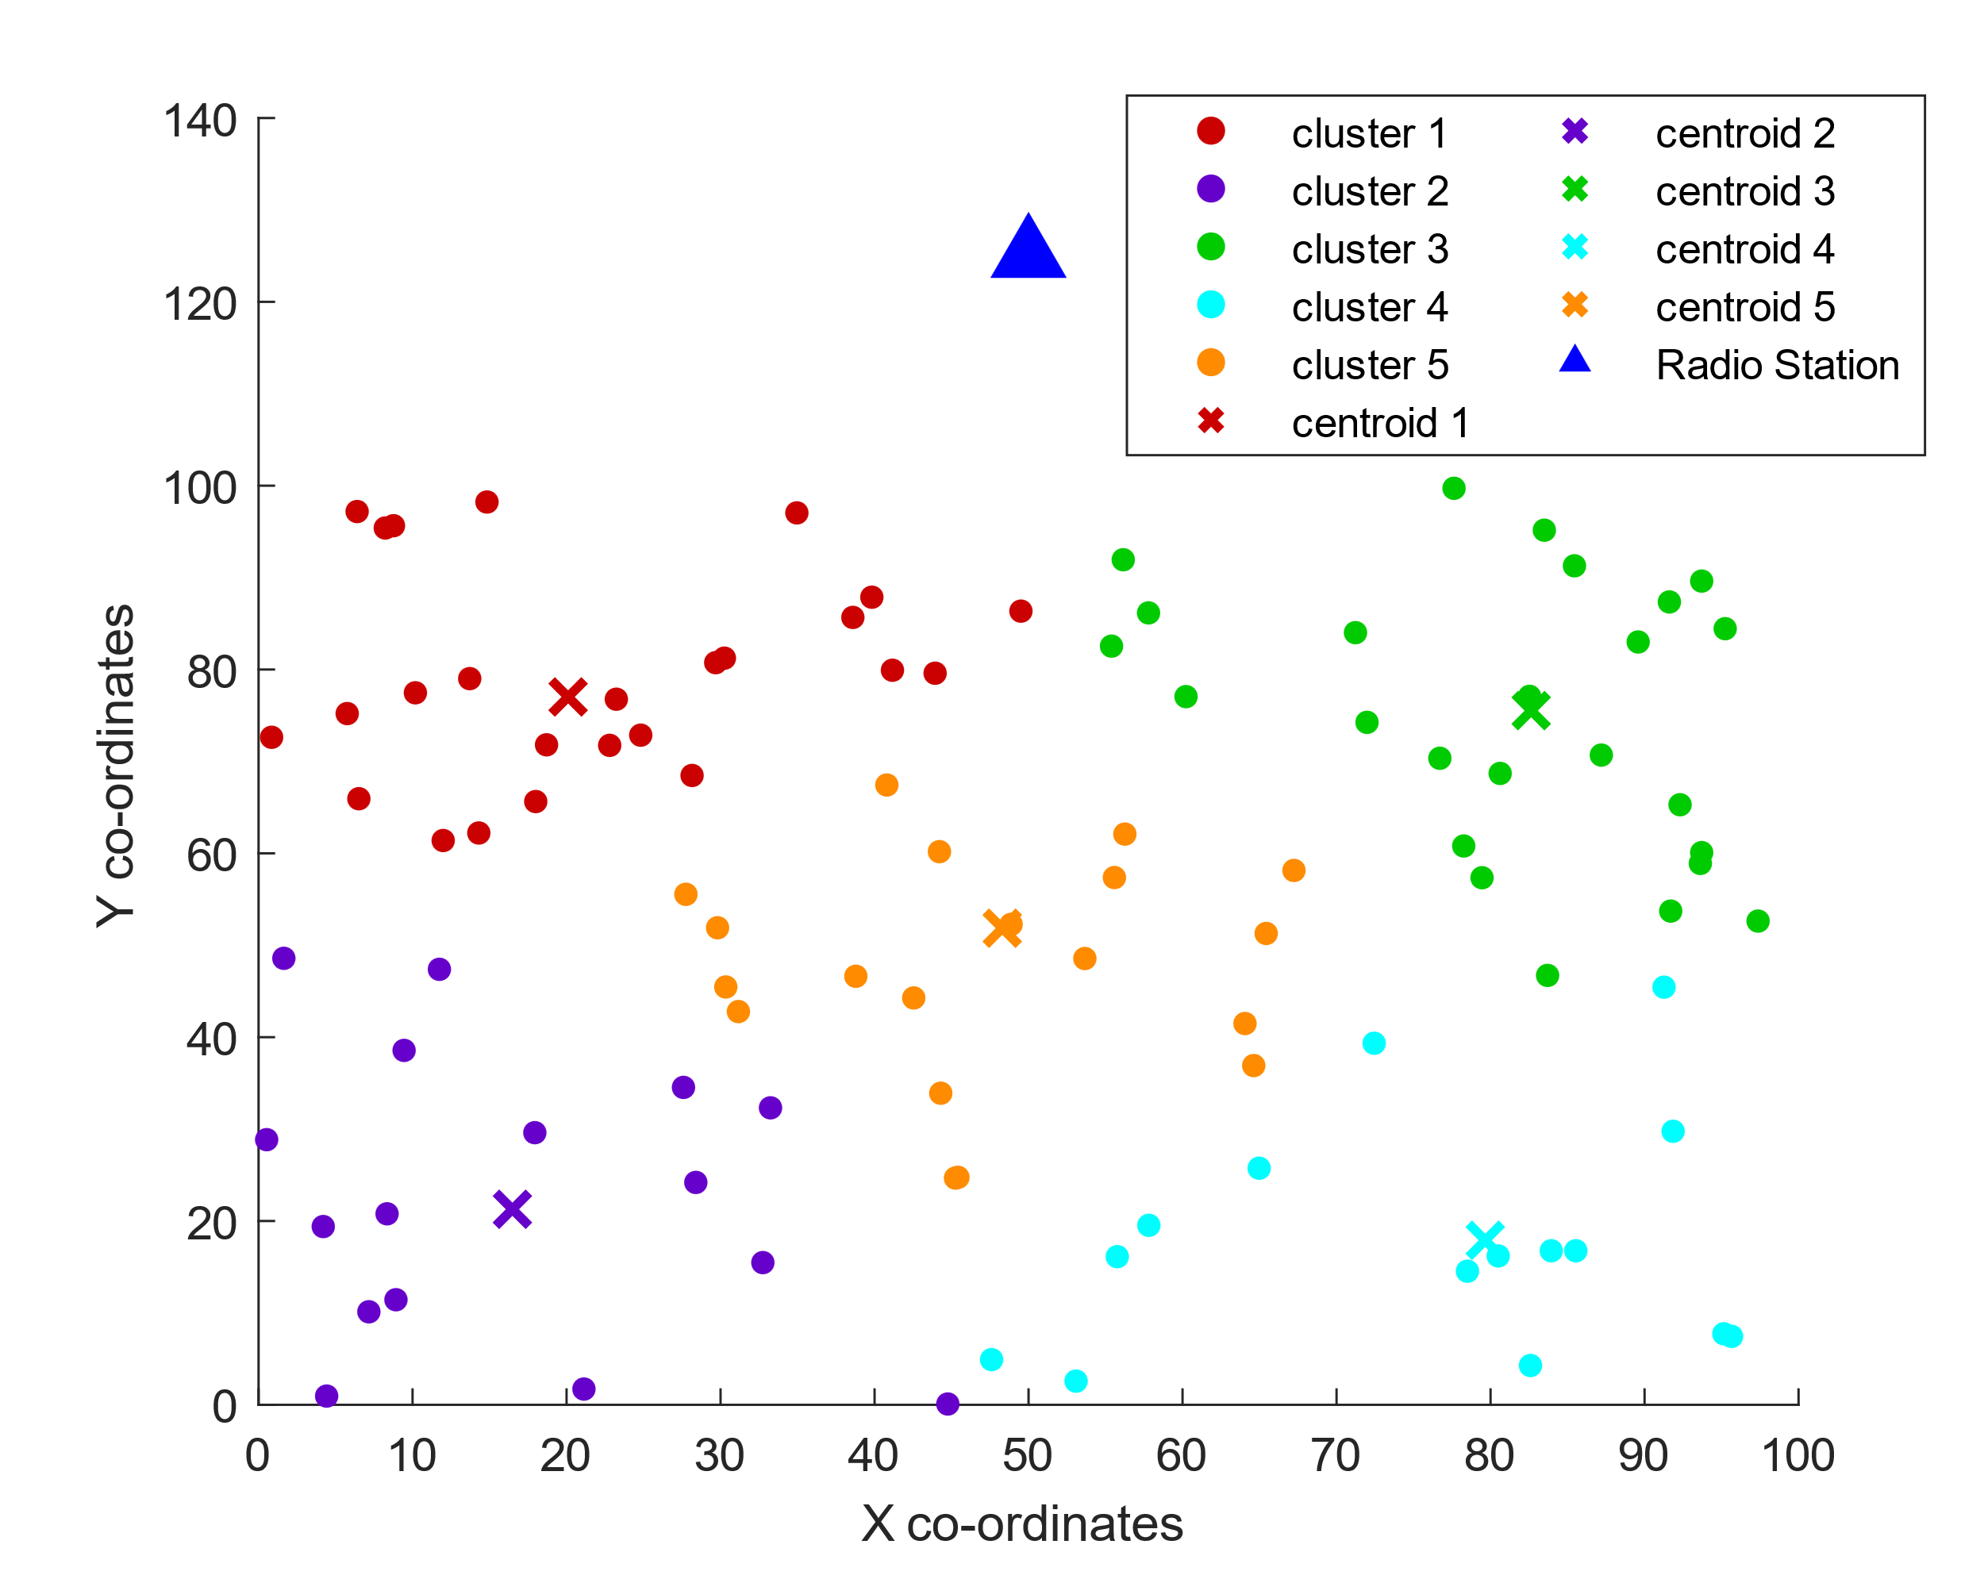

Figure 2 : Conventional FCM

**Table 3 : Number of nodes in CFCM**

|  |  |  |  |  |  |
| --- | --- | --- | --- | --- | --- |
| Cluster number | 1 | 2 | 3 | 4 | 5 |
| No. of nodes | 25 | 16 | 25 | 15 | 19 |

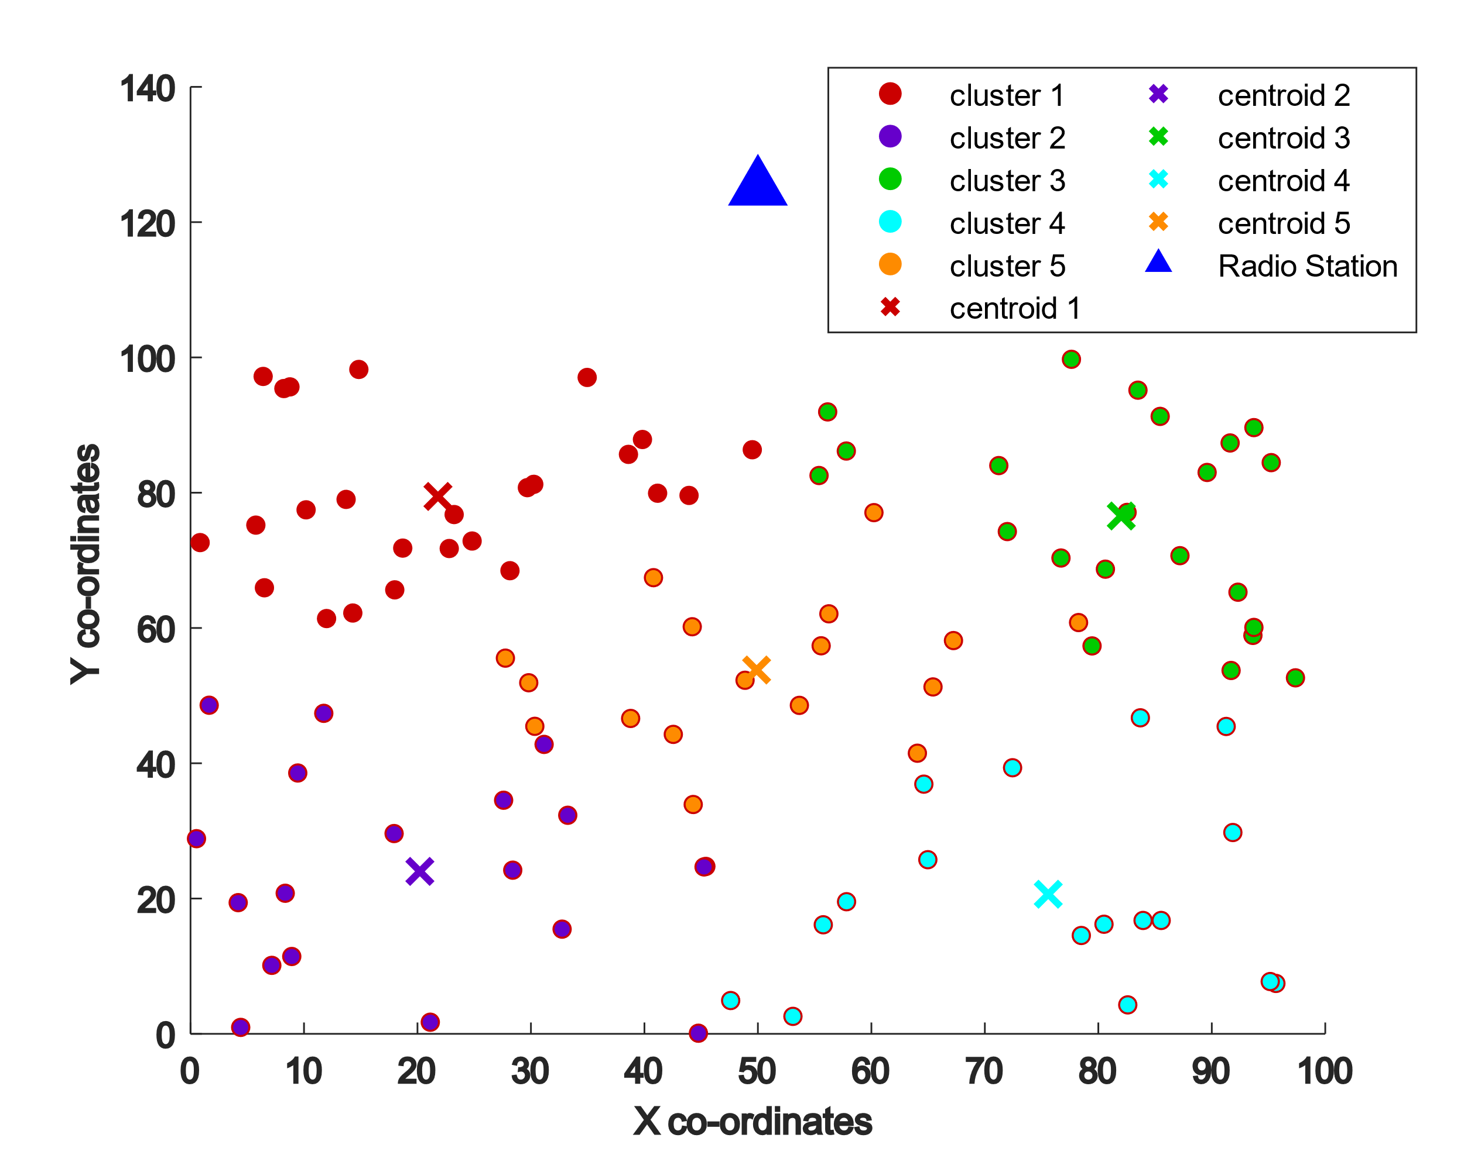

Figure 3 : Modified FCM

**Table 4 : Number of nodes in MFCM**

|  |  |  |  |  |  |
| --- | --- | --- | --- | --- | --- |
| Cluster number | 1 | 2 | 3 | 4 | 5 |
| No. of nodes | 25 | 19 | 22 | 17 | 17 |

## Energy consumption of network

Energy conservation in WSN is pivotal for prolonged network operation. Efficient energy management ensures extended sensor lifespan, reduced maintenance, and sustainable functionality. It is paramount for optimizing resource utilization, enabling prolonged data collection, and supporting the longevity of WSN applications in diverse domains.

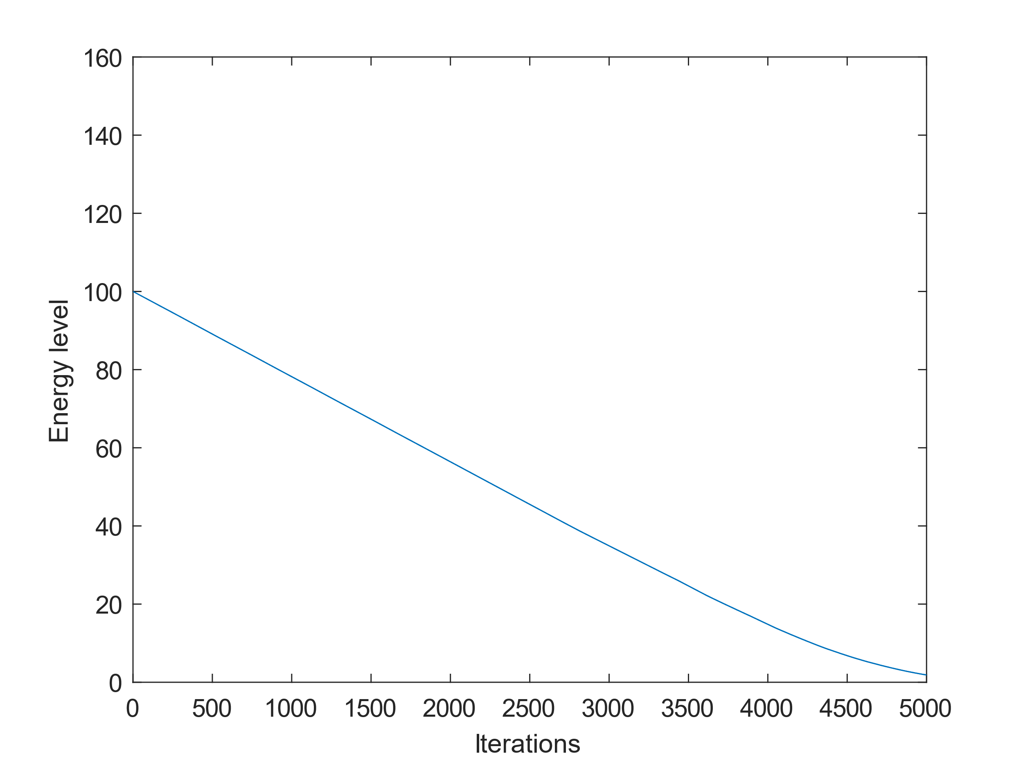

Figure 4 : Energy consumption in IEECP

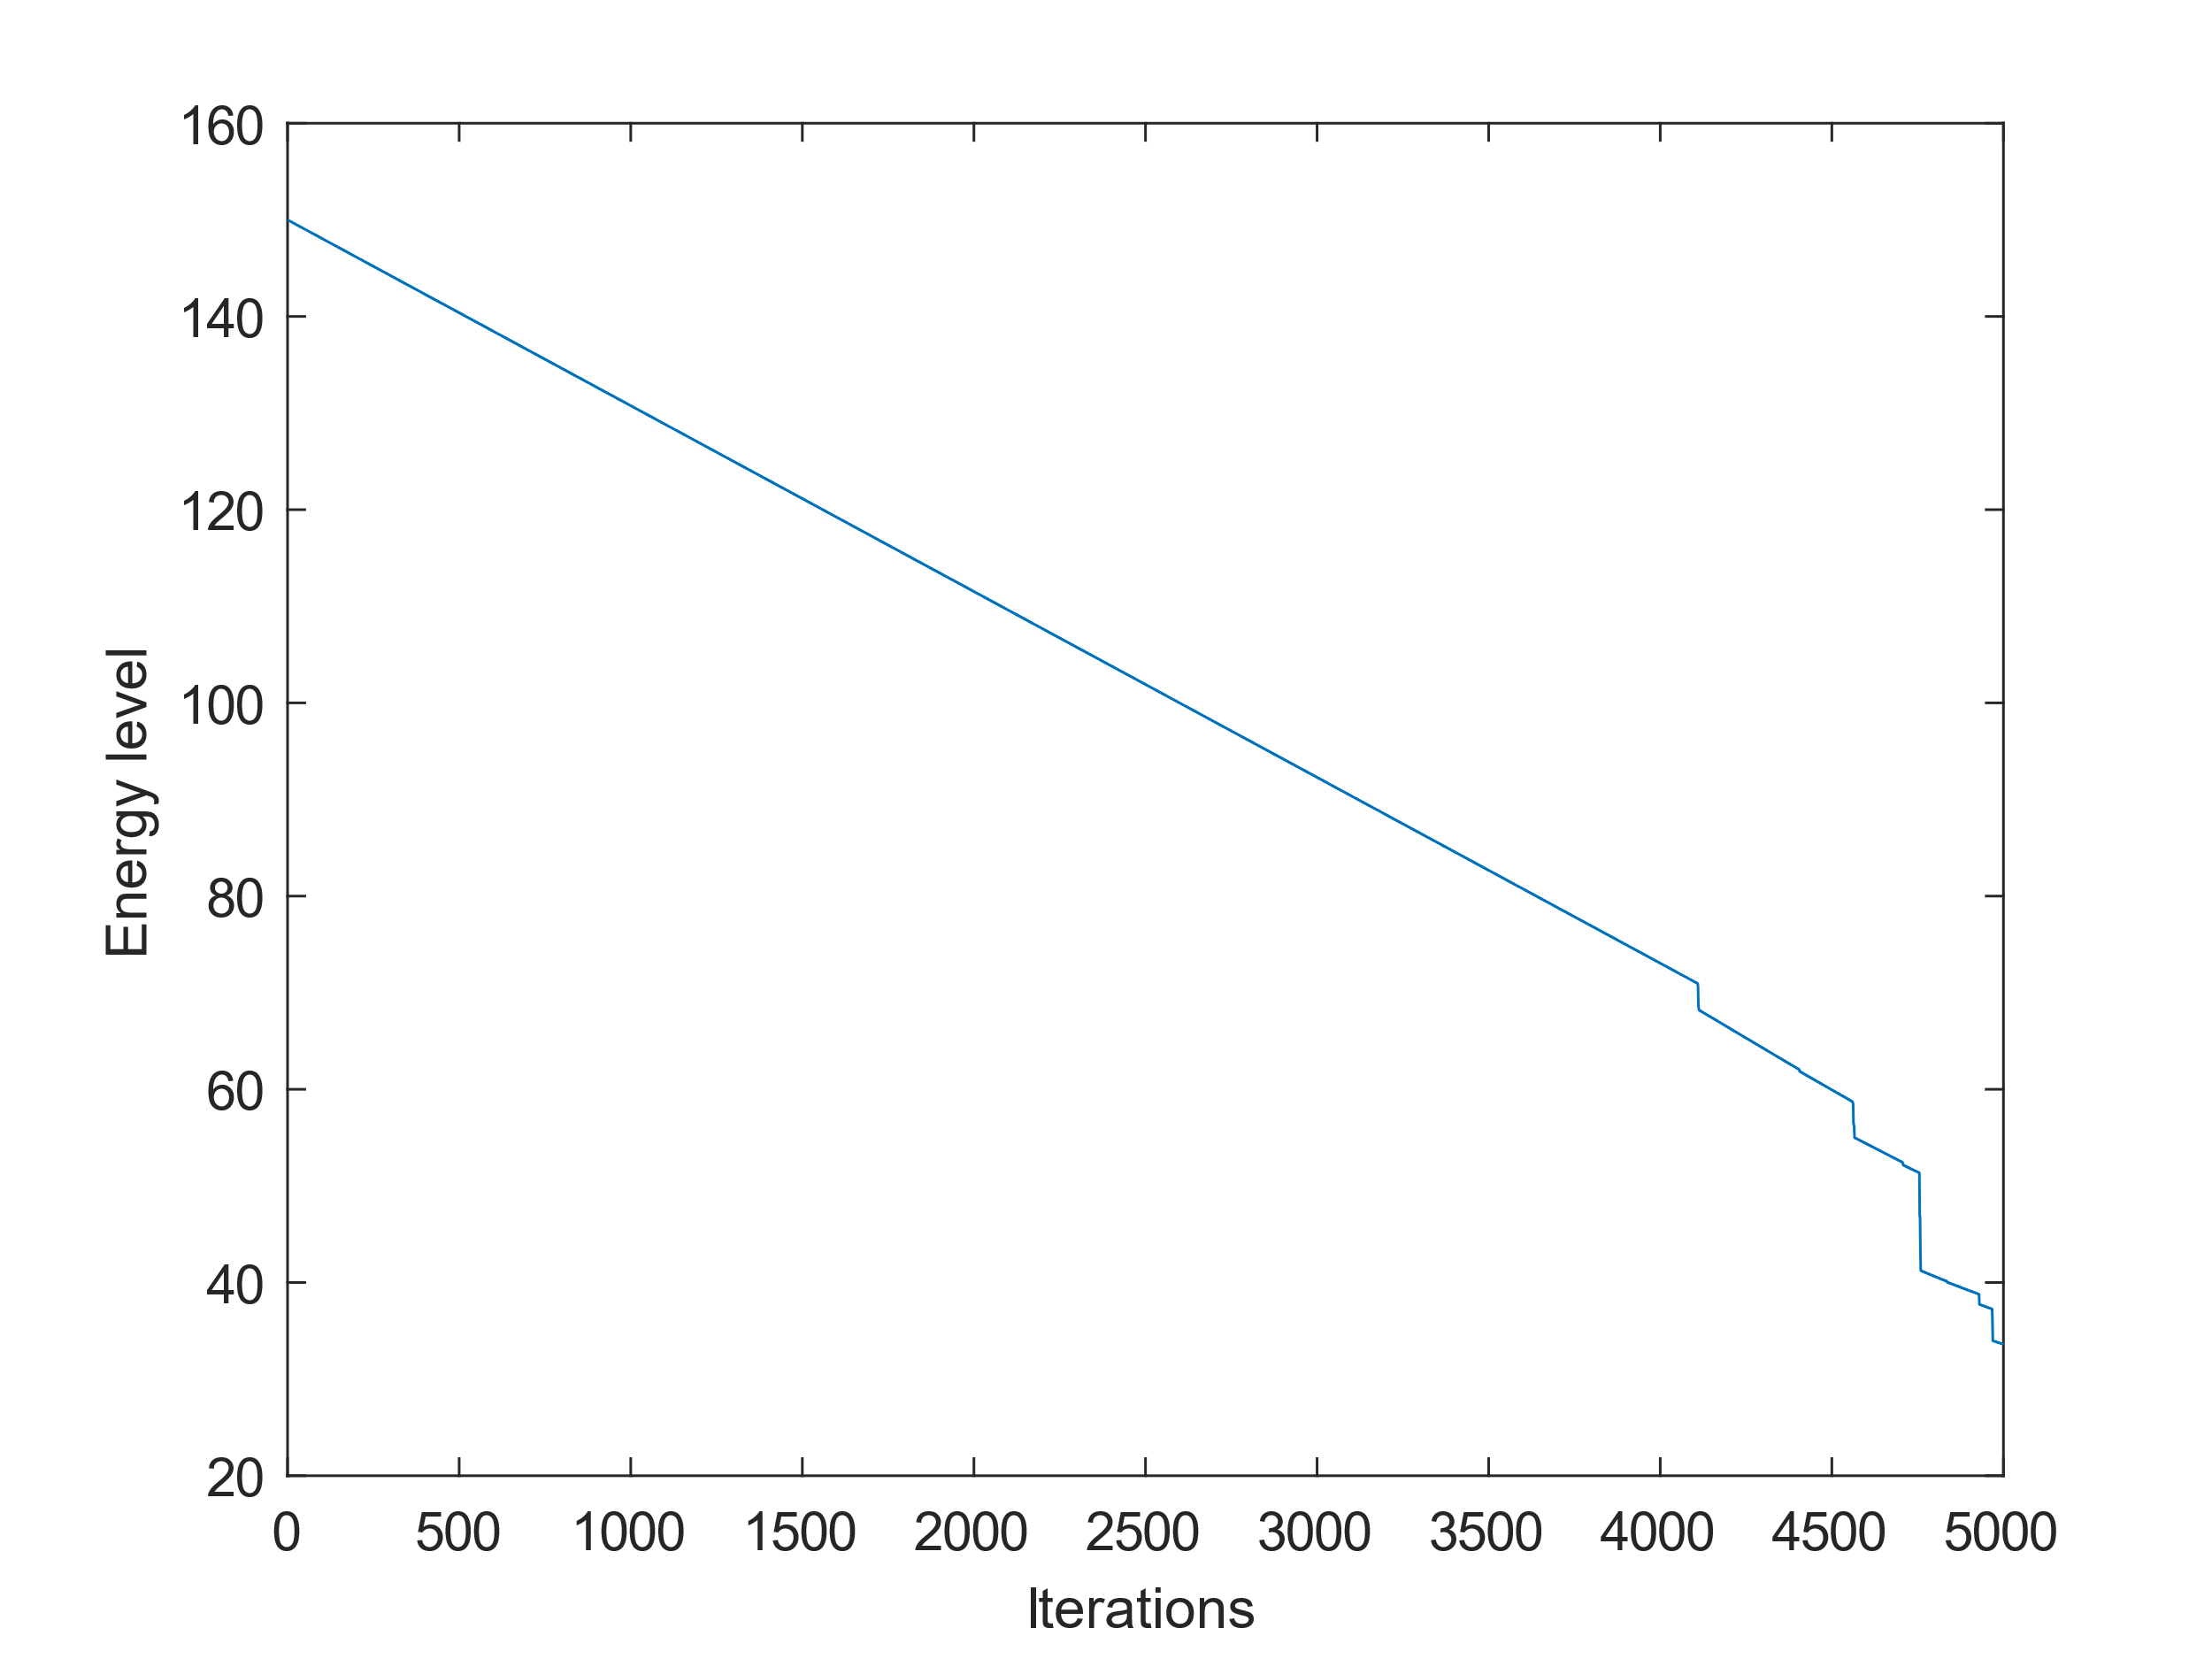

Figure 5 : Energy consumption in MFGWO

**Table 5 : Energy consumption between IEECP & MFGWO**

|  |  |  |
| --- | --- | --- |
|  | IEECP | MFGWO |
| Nodes left | 29 | 48 |
| Energy left | 1.8697 J | 33.6035 J |

As shown in **Table 5**. MFGWO shines in network longevity: Comparing IEECP and MFGWO for energy efficiency in a 5000-round network simulation reveals MFGWO's significant advantage. While both algorithms exhibited commendable performance, MFGWO emerges as the clear winner, boasting 20.4% higher remaining energy and 28% more surviving nodes at the end of the simulation as also seen from Figure 4 and Figure 5. These impressive figures highlight MFGWO's superior ability to optimize cluster head selection and network resource allocation, leading to prolonged network lifetime and enhanced robustness. This translates to potentially longer operational periods before network maintenance or redeployment, offering substantial cost and power savings in real-world applications. With its demonstrably superior energy management capabilities, MFGWO stands out as a valuable tool for extending the lifespan and operational efficiency of WSNs.

## Packets Sent to Radio Station

In WSN, the "number of packets delivered to the base station" signifies the count of data packets successfully transmitted from sensor nodes to the central base station. This metric is crucial in assessing the efficiency and reliability of data communication within the network. A higher number of delivered packets generally indicates a more robust and effective communication infrastructure, while a lower count may imply challenges such as packet losses, network congestion, or node failures. Monitoring this metric helps in evaluating the overall performance and data delivery capabilities of the WSN.

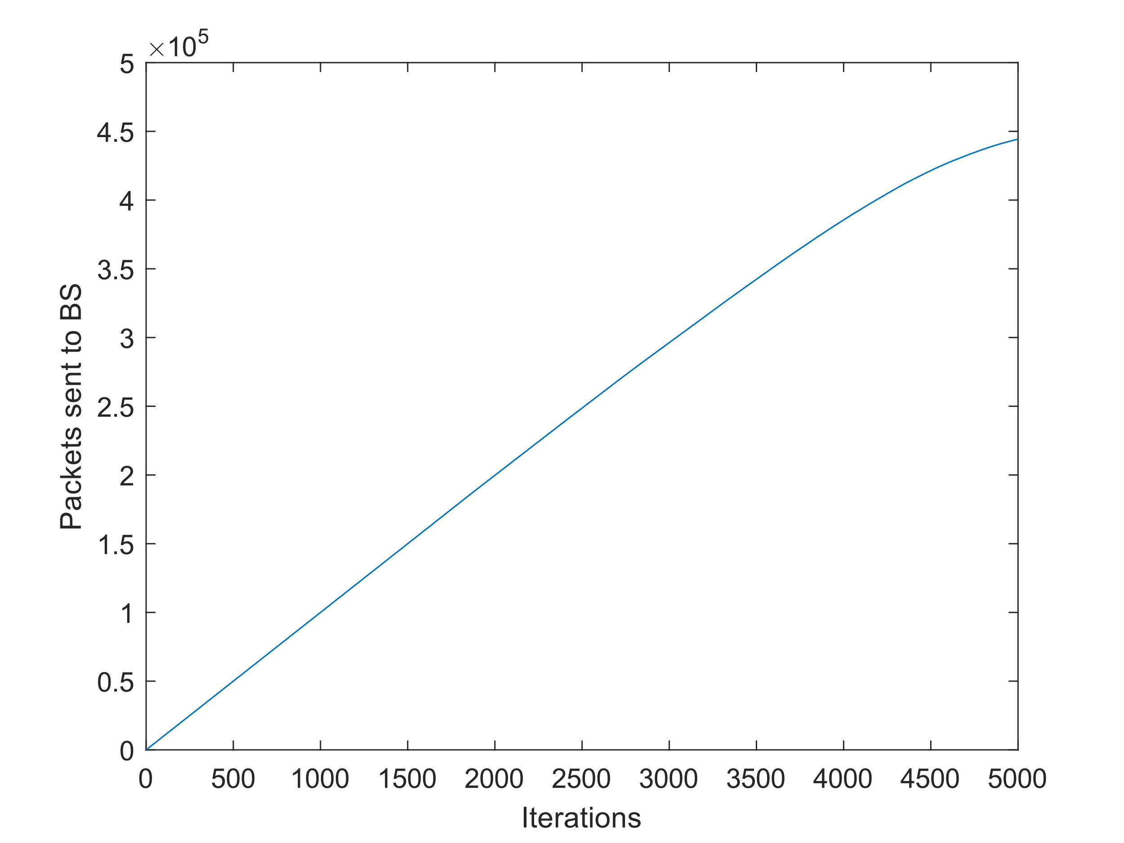

Figure 6 : Packets deliverd to radio station using IEECP

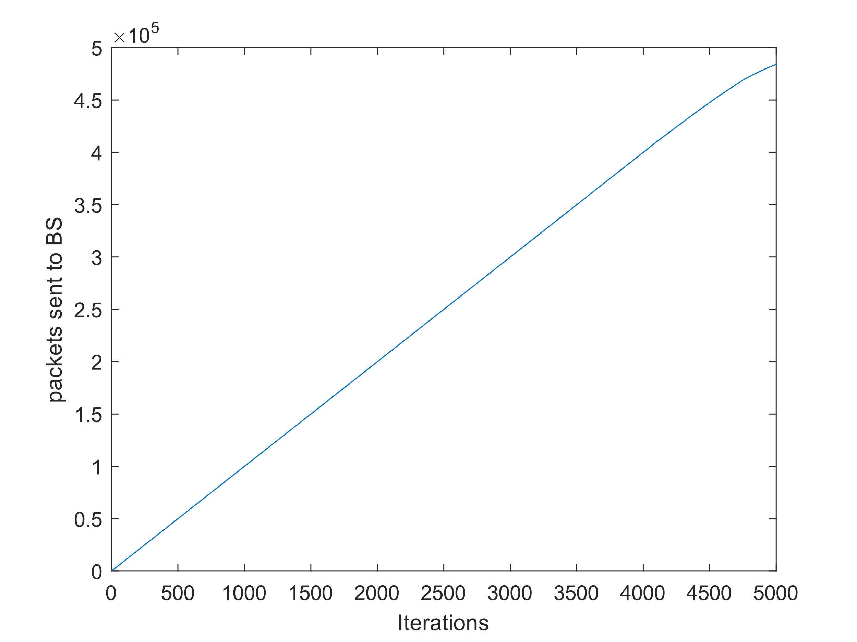

Figure 7 : Packets sent to radio station using MFGWO

As shown in Figure 6 and Figure 7, in this comparative analysis of packet delivery, the performance disparity between IEECP and MFGWO is striking. MFGWO's delivery of packets reflects a significant leap in efficiency compared to the packets delivered by IEECP.

This substantial increase underscores MFGWO's prowess in optimizing packet transmission within the WSN. The elevated packet delivery by MFGWO not only showcases its superior capabilities by 8.94 % but also highlights its potential to enhance the overall data communication reliability in WSN scenarios.

## Alive Nodes in Network

The vitality of alive nodes in WSN is paramount for sustained functionality. Alive nodes ensure continuous data sensing, processing, and transmission, fostering unbroken network operation. The real-time monitoring and collaboration of these nodes are essential for seamless communication, making them the backbone of WSNs, influencing the reliability and effectiveness of data collection and dissemination in various applications.

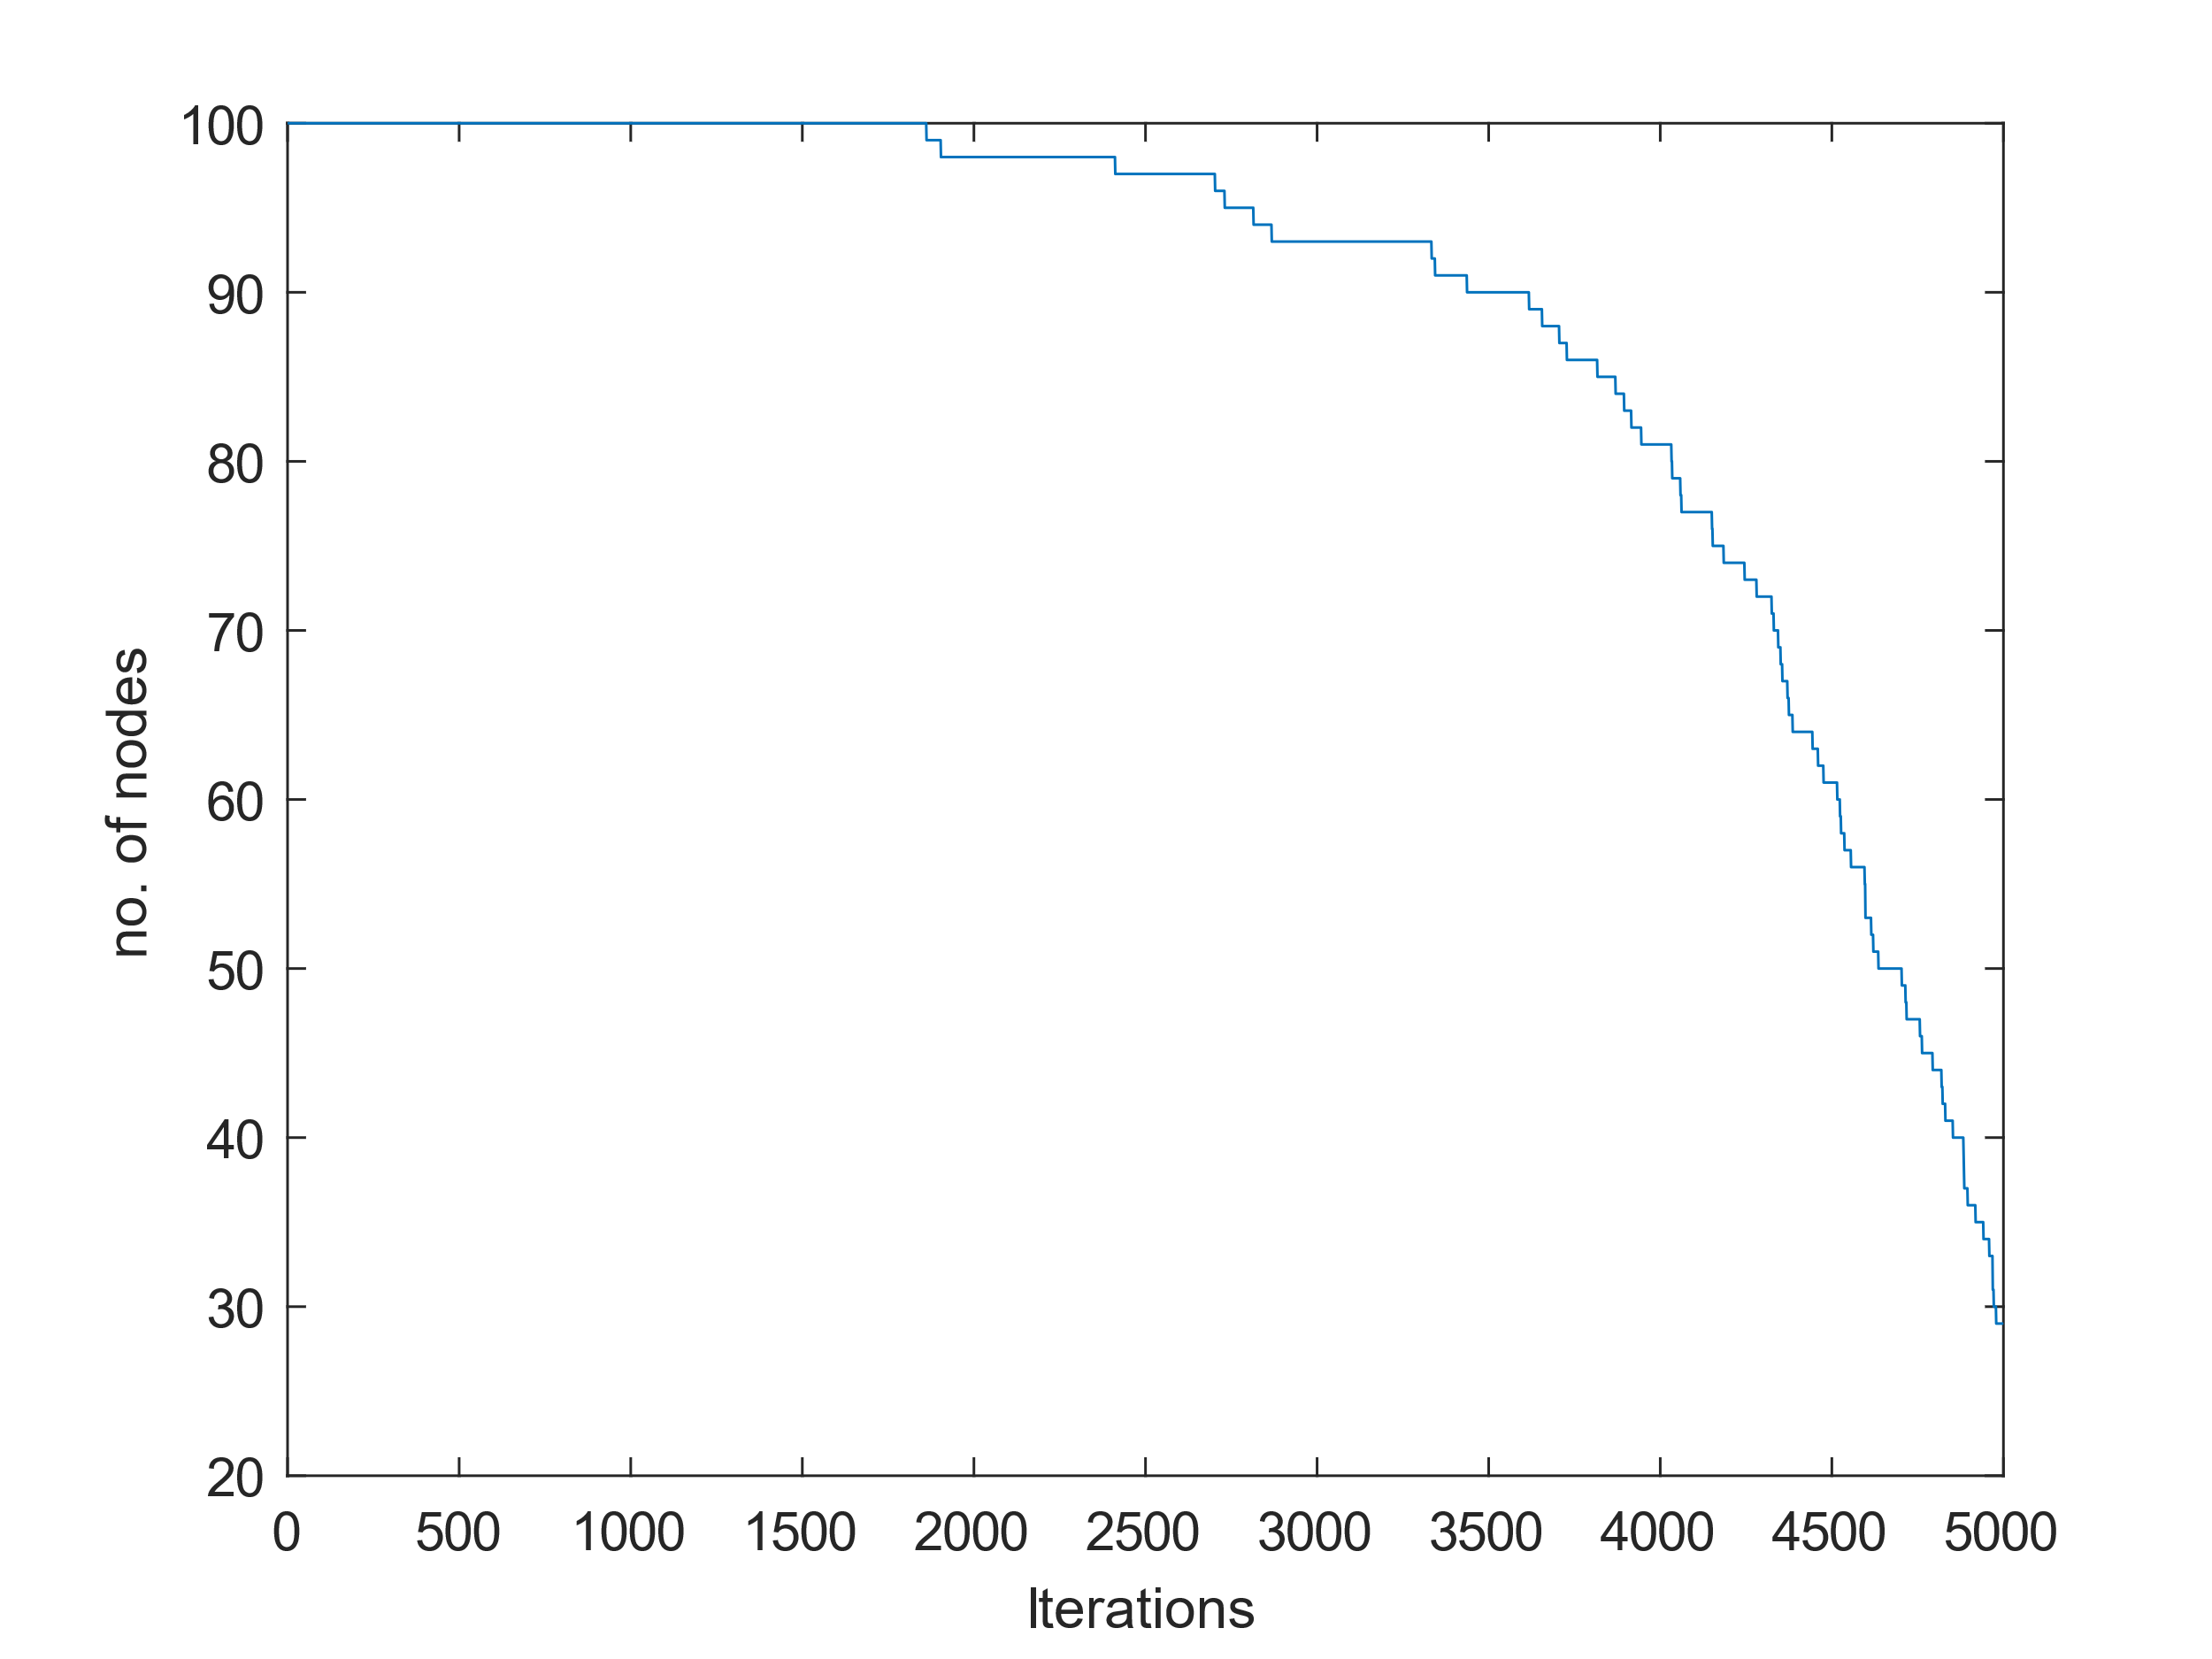

Figure 8 : Alive nodes in IEECP

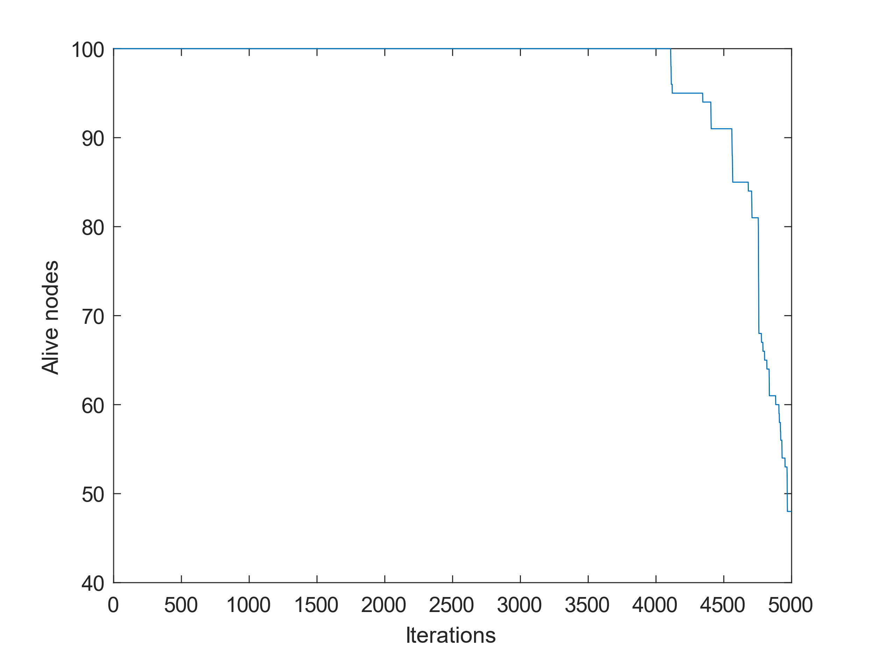

Figure 9 : Alive nodes in MFGWO

As it is discussed earlier in section 4.2 when comparing the available nodes in the network after 5000 rounds in IEECP and MFGWO, there is 65.52% more surviving nodes than IEECP which shows a significant improvement in performance and which is evident from Figure 8 and Figure 9.

**Table 6 : Node Sustainability**

|  |  |  |
| --- | --- | --- |
|  | first node dead | Half nodes dead |
| IEECP | 1861 iteration | 4635 iteration |
| MFGWO | 4109 iteration | 4968 iteration |

As shown in **Table 6**, in the comparative analysis of the IEECP and MFGWO protocols, MFGWO demonstrates superior performance concerning node longevity. In the MFGWO scenario, the first node succumbs at a later iteration compared to IEECP and even at the halfway mark, MFGWO exhibits greater resilience than IEECP, showcasing its enhanced efficiency and robustness in sustaining nodes.

# Conclusion

In this paper Improved Energy Efficient Clustering Protocol (IEECP) is compared with Modified Fuzzy Grey Wolf Optimizer (MFGWO). The varied energy nodes are deployed randomly and compared with the performance of IEECP. The results show a significant improvement in the lifetime of the network. Hence MFGWO algorithm proved to be suitable for Wireless Sensor Networks (WSN) where a longer lifetime is required.

# Declaration of Competing Interest

The authors declare that they have no known competing financial interest or personal relationships that could have appeared to influence the work reported in this paper.

# References

[1] K. Gulati, R. S. Kumar Boddu, D. Kapila, S. L. Bangare, N. Chandnani, and G. Saravanan, “A review paper on wireless sensor network techniques in Internet of Things (IoT),” *Mater Today Proc*, vol. 51, pp. 161–165, 2022, doi: 10.1016/j.matpr.2021.05.067.

[2] H. Landaluce, L. Arjona, A. Perallos, F. Falcone, I. Angulo, and F. Muralter, “A Review of IoT Sensing Applications and Challenges Using RFID and Wireless Sensor Networks,” *Sensors*, vol. 20, no. 9, p. 2495, Apr. 2020, doi: 10.3390/s20092495.

[3] R. V. Arvind, R. R. Raj, R. R. Raj, and N. K. Prakash, “Industrial Automation using Wireless Sensor Networks,” *Indian J Sci Technol*, vol. 9, no. 8, Mar. 2016, doi: 10.17485/ijst/2016/v9i8/87931.

[4] S. A. Rashid *et al.*, “Retrofitting low-cost heating ventilation and air-conditioning systems for energy management in buildings,” *Appl Energy*, vol. 236, pp. 648–661, Feb. 2019, doi: 10.1016/j.apenergy.2018.12.020.

[5] J. Amutha, S. Sharma, and J. Nagar, “WSN Strategies Based on Sensors, Deployment, Sensing Models, Coverage and Energy Efficiency: Review, Approaches and Open Issues,” *Wirel Pers Commun*, vol. 111, no. 2, pp. 1089–1115, Mar. 2020, doi: 10.1007/s11277-019-06903-z.

[6] S. Diaz, D. Mendez, and R. Kraemer, “A Review on Self-Healing and Self-Organizing Techniques for Wireless Sensor Networks,” *Journal of Circuits, Systems and Computers*, vol. 28, no. 05, p. 1930005, May 2019, doi: 10.1142/S0218126619300058.

[7] J. Singh, R. Kaur, and D. Singh, “A survey and taxonomy on energy management schemes in wireless sensor networks,” *Journal of Systems Architecture*, vol. 111, p. 101782, Dec. 2020, doi: 10.1016/j.sysarc.2020.101782.

[8] S. Dehghani, B. Barekatain, and M. Pourzaferani, “An Enhanced Energy-Aware Cluster-Based Routing Algorithm in Wireless Sensor Networks,” *Wirel Pers Commun*, vol. 98, no. 1, pp. 1605–1635, Jan. 2018, doi: 10.1007/s11277-017-4937-1.

[9] A. R. Rajeswari, K. Kulothungan, S. Ganapathy, and A. Kannan, “Trusted energy aware cluster based routing using fuzzy logic for WSN in IoT,” *Journal of Intelligent & Fuzzy Systems*, vol. 40, no. 5, pp. 9197–9211, Apr. 2021, doi: 10.3233/JIFS-201633.

[10] W. R. Heinzelman, A. Chandrakasan, and H. Balakrishnan, “Energy-efficient communication protocol for wireless microsensor networks,” in *Proceedings of the 33rd Annual Hawaii International Conference on System Sciences*, IEEE Comput. Soc, Jan. 2000, p. 10. doi: 10.1109/HICSS.2000.926982.

[11] S. Basagni, “Distributed clustering for ad hoc networks,” in *Proceedings Fourth International Symposium on Parallel Architectures, Algorithms, and Networks (I-SPAN’99)*, IEEE Comput. Soc, 2000, pp. 310–315. doi: 10.1109/ISPAN.1999.778957.

[12] S. Lindsey and C. S. Raghavendra, “PEGASIS: Power-efficient gathering in sensor information systems,” in *Proceedings, IEEE Aerospace Conference*, IEEE, Mar. 2002, pp. 3-1125-3–1130. doi: 10.1109/AERO.2002.1035242.

[13] A. S. Raghuvanshi, S. Tiwari, R. Tripathi, and N. Kishor, “Optimal number of clusters in wireless sensor networks: a FCM approach,” *International Journal of Sensor Networks*, vol. 12, no. 1, p. 16, 2012, doi: 10.1504/IJSNET.2012.047707.

[14] A. A. H. Hassan, W. M. Shah, A. H. H. Habeb, M. F. I. Othman, and M. N. Al-Mhiqani, “An Improved Energy-Efficient Clustering Protocol to Prolong the Lifetime of the WSN-Based IoT,” *IEEE Access*, vol. 8, 2020, doi: 10.1109/ACCESS.2020.3035624.

[15] H. Mostafaei, “Energy-Efficient Algorithm for Reliable Routing of Wireless Sensor Networks,” *IEEE Transactions on Industrial Electronics*, vol. 66, no. 7, pp. 5567–5575, Jul. 2019, doi: 10.1109/TIE.2018.2869345.

[16] D. Sharma, A. Ojha, and A. P. Bhondekar, “Heterogeneity consideration in wireless sensor networks routing algorithms: a review,” *J Supercomput*, vol. 75, no. 5, pp. 2341–2394, May 2019, doi: 10.1007/s11227-018-2635-8.

[17] S. Mirjalili, S. M. Mirjalili, and A. Lewis, “Grey Wolf Optimizer,” *Advances in Engineering Software*, vol. 69, pp. 46–61, Mar. 2014, doi: 10.1016/j.advengsoft.2013.12.007.

**Authors**

**Corresponding Author**

**Mr. Bollam Krishna satish** received his B.Tech. degree in Electronics and Communication Engineering from Jawaharlal Nehru Technological University, Kakinada, Andhra Pradesh India, in 2012, M.Tech. Pursuing in Communication Systems from SV University College of Engineering (SVUCE), Tirupati, Andhra Pradesh, India. His current research interests include Wireless Sensor Networks and IoT.

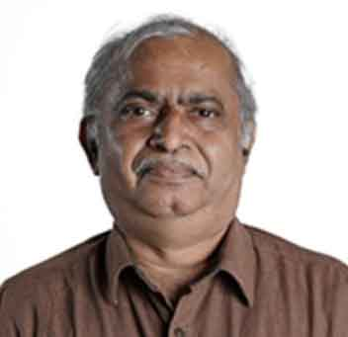**Prof. Ravinutala Satya Narayana** Professor in department of ECE and currently serving as the Principal of SV University College of Engineering (SVUCE), Tirupati, Andhra Pradesh, India. He completed his PhD in 2003 and has 33 years of teaching and research experience. He has guided twelve PhD candidates and eight more students are pursuing their PhD programme under his guidance. He received Best Teacher Award from Andhra Pradesh state government (2022). He received the "Bharat Jyothi Award" conferred by NGO, New Delhi (2011). Several of his papers has been recognized as best papers in various conferences.