**­­­­­­ Road Crack Detection Using Deep Neural Network Based on Attention Mechanism and Residual Structure**

**Y Mani Sai, N Prashanth, V Uday Kiran, Ch Gopi**

Department of IT, Guru Nanak Institutions Technical Campus, Hyderabad.

Assistant Professor, Department of IT, Guru Nanak Institutions Technical Campus, Hyderabad.

**Abstract:** The deteriorating condition of road infrastructure poses a significant challenge to public safety and transportation efficiency. This research presents a robust approach to road crack detection leveraging advanced deep learning techniques. Our proposed model combines the power of attention mechanisms and residual structures within a deep neural network architecture to enhance the accuracy and efficiency of road crack identification. The attention mechanism enables the model to focus on crucial features while disregarding irrelevant information, facilitating a more precise localization of road cracks. Concurrently, the integration of residual structures aids in mitigating the vanishing gradient problem, allowing for the effective training of deeper networks. We employ a diverse dataset containing various road surfaces, lighting conditions, and crack types to ensure the model's generalization capability. The training process involves optimizing the network's parameters using an appropriate loss function, leading to a highly discriminative model for road crack detection. This research contributes to the advancement of intelligent transportation systems by providing an efficient and reliable solution for automated road crack detection. The proposed deep neural network offers great potential for integration into smart infrastructure maintenance systems, ultimately contributing to the enhancement of road safety and durability.

**Keywords:** Residual structure, shortcut connection, CBAM attention mechanism, deep learning, road crack detection.

**I.INTRODUCTION**

Road Crack Detection Using Deep Neural Network Based on Attention Mechanism and Residual Structure outlines the key objectives and significance of the research. In this study, the focus is on addressing the critical issue of road infrastructure deterioration, particularly in the context of cracks, which poses a substantial threat to public safety and transportation efficiency. Traditional methods for crack detection often fall short in accurately identifying subtle cracks amidst various road conditions and lighting scenarios. To overcome these challenges, the research proposes a novel approach leveraging deep learning techniques. The deep neural network designed for this purpose incorporates both attention mechanisms and residual structures.

Attention mechanisms enable the model to selectively focus on important features, while the inclusion of residual structures addresses the challenge of training deeper networks more effectively. The motivation behind this research is the pressing need for automated and reliable road crack detection systems that can operate across diverse environments. By integrating attention mechanisms and residual structures into the deep neural network architecture, the aim is to enhance the accuracy and efficiency of detecting road cracks, contributing to the development of intelligent transportation systems and the overall improvement of road safety. The introduction sets the stage for the research, highlighting the significance of the proposed methodology in addressing a critical aspect of infrastructure maintenance and public safety.

The most prevalent type of road sickness is cracks. Cracks can potentially jeopardize traffic safety if repairs aren't funded in a timely manner. Thus, one of the transportation department's main duties is to locate and promptly fix cracks. Deep learning has been widely employed for crack identification in recent years due to the development of road crack detection algorithms for image and computer vision [1] [3], and [4]. In order to locate cracks, Zhang et al. [5] first designed and trained a supervised shallow neural network, then used deep learning to road crack extraction. In order to locate and extract cracks, CrackForest [6] integrated multi-level complimentary features utilizing structural information found in crack patches. For crack recognition, Yao et al. [7] designed a convolutional neural network that reduced background interference and significantly increased detection accuracy. A pixel-level classification network incorporating native and global information was designed by Liu et al. [8] in order to increase the accuracy of crack detection and provide richer multi-scale feature information.

By linking edge detectors and background variables, Dorafshan et al. [9] decreased the interference of background factors on crack extraction. deep neural networks with convolution. Dense connections were used by Li et al. [10] to enhance and extract multi-scale fracture characteristics. In order to achieve crack extraction, the feature maps at all scales were finally amalgamated by completing the choices at various levels. With several conflicting elements, these approaches are less effective at extracting tiny fractures from pavement photos.For the purpose of detecting defects in LED chips, Lin H et al. [11] presented the LEDNet neural network, which produced excellent detection results. Small blocks with a pixel as the center are created by Wu X et al. [12] at various sizes, and the blocks are then fed into various convolution procedures.The testing findings demonstrate the method's ability to learn more genuine fracture features and the high precision of the detection results.

II.RELATED WORKS

1. Top of Form

The objective of the project "Road Crack Detection Using Deep Neural Network Based on Attention Mechanism and Residual Structure" is to develop an advanced deep neural network architecture tailored for accurate road crack detection. By integrating attention mechanisms, the model aims to improve its ability to focus on critical features, while the inclusion of residual structures addresses challenges associated with training deeper networks. The project seeks to enhance detection accuracy, ensure robustness across diverse road conditions, implement adaptive feature attention, optimize training with residual structures, and validate generalization to various datasets. Ultimately, the goal is to contribute to Intelligent Transportation Systems by creating an efficient and automated road monitoring system that enhances public safety and infrastructure maintenance.

The Convolutional Block Attention Module (CBAM) is a crucial innovation in convolutional neural network (CNN) architecture, strategically designed to elevate the network's representational capacity by integrating attention mechanisms. Comprising two primary components, namely the Channel Attention Module (CAM) and the Spatial Attention Module (SAM), CBAM facilitates the discernment of both spatial and channel-wise dependencies within input feature maps.The fusion of these attention mechanisms refines the feature representation, enabling the network to focus on critical information and enhancing its discriminative power. Typically inserted into intermediate layers of a CNN, the CBAM module adapts dynamically to different hierarchical levels, enabling the network to better capture intricate patterns.It is a specialized module integrated into convolutional neural network (CNN) architectures to enhance their ability to capture intricate spatial and channel-wise dependencies within feature maps. It operates by combining two fundamental attention mechanisms: the Channel Attention Module (CAM) and the Spatial Attention Module (SAM).In the Channel Attention Module, global information is aggregated by performing global average pooling across the spatial dimensions of the feature maps. The resulting channel-wise attention weights are then learned through a small fully connected neural network.

Road pavement crack detection techniques fall into the following main categories: 1) manual detection; 2) threshold method; 3) wavelet transform; 4) processing and classifying morphological images; 5) path method; and 6) edge detection method. By manually detecting cracks in the pavement, an investigator may record the extent of damage, the diversity of data, and the crack condition while driving on the road. Although this method is thorough and cautious, it consumes a huge amount of resources and labor in an inefficient manner.

Image segmentation techniques based on thresholds have a long history and are often employed. By taking use of the fact that the gray value of the crack picture pixels is smaller than the background, the thresholding approach may identify cracks.A histogram-based threshold segmentation approach was presented by Kirschke et al. [2], however it is limited to more obvious fracture recognition. Removal methods [3] that rely on morphological operations, binary segmentation, and the elimination of isolated points and areas are vulnerable to the existence of gaps in the fractures they detect. Crack pictures may also be obtained by segmentation utilizing an enhanced adaptive iterative thresholding segmentation technique [4]. Zhang et al. [5] marked contours using FAST feature point recognition and employed PYNQ for crack detection, taking advantage of the notable differences between the backdrop and cracks. Unfortunately, when there is a lot of background noise, those techniques lose precision. Ju et al. [6] identify cracks using illumination compensation model (ICM) and k-means clustering method; after eliminating the shadow from the picture, they extract the crack region from the road backdrop using the same approach. The suggested approach performs well when it comes to average accuracy, recall, and F-measure. Wavelet transform is used by algorithms such as wavelet pavement crack detection [7] to turn noise and fractures into entirely distinct wavelet coefficients. High instrumentality requirements are required for these techniques, and they have drawbacks such as over-segmentation and vulnerability to outside influence.

Crack detection techniques include free-form path calculation methods, morphological image processing and logistic regression statistical classification, histogram statistics and shape analysis algorithms, and approaches that integrate brightness and connectivity in morphological image processing. When there are more background-interfering elements present and complex backdrops are present, for example, the detection becomes impractical. Using four structural element reconstructions, the median filtering technique improves grayscale pavement pictures and combines the morphological gradient operator and morphological closure operator to retrieve crack edges. These methods' crack extraction accuracy is low for cracks with subtle characteristics, but they can identify crack pixels in the crack picture that have notable contrast shifts.

III.**LITERATURE SURVEY**

J. Jeong, H. Jo, and G. Ditzler, road roughness is a measure of how uncomfortable a ride is, and provides an important indicator for the needs of roadway maintenance or repavement, which is closely tied to the state and federal budget prioritization. As such, accurate and timely monitoring of deteriorating road conditions and following maintenance are essential to improve the overall ride quality on the road. Various technologies, including vehicle-mounted laser profiling systems, have been developed and adopted for road roughness (e.g., IRI—International Roughness Index) measurement; however, their high cost limits their use. While recent advances in smartphone technologies allow us to use their embedded accelerometers for road roughness monitoring, the complicated process of necessary vehicle calibration hinders the widespread use of the technology in the actual practices. In this work, a deep learning IRI estimation method is proposed with the goal of using anonymous (i.e., calibration-free) vehicles and their responses measured by smartphones as road roughness sensors. A state-of-the-art deep learning algorithm (i.e., CNN—convolutional neural network) and multimetric vehicle dynamics data (i.e., accelerometer, gyroscope), possibly measured by drivers’ smartphones, are employed for the purpose. Optimized CNN architecture and data configuration have been investigated to achieve the best performance. The efficacy of the proposed method has been numerically validated using real road IRI information (i.e., Speedway, Tucson, AZ), real driving speed profiles, and four different types of vehicle data with associated uncertainties.

H. Y. Ju, W. Li, S. Tighe, Z. C. Xu, and J. Z. Zhai, achieving high detection accuracy of pavement cracks with complex textures under different lighting conditions is still challenging. In this context, an encoder-decoder network-based architecture named CrackResAttentionNet was proposed in this study, and the position attention module and channel attention module were connected after each encoder to summarize remote contextual information. The experiment results demonstrated that, compared with other popular models (ENet, ExFuse, FCN, LinkNet, SegNet, and UNet), for the public dataset, CrackResAttentionNet with BCE loss function and PRelu activation function achieved the best performance in terms of precision (89.40), mean IoU (71.51), recall (81.09), and F1 (85.04). Meanwhile, for a self-developed dataset (Yantai dataset), CrackResAttentionNet with BCE loss function and PRelu activation function also had better performance in terms of precision (96.17), mean IoU (83.69), recall (93.44), and F1 (94.79). In particular, for the public dataset, the precision of BCE loss and PRelu activation function was improved by 3.21. For the Yantai dataset, the results indicated that the precision was improved by 0.99, the mean IoU was increased by 0.74, the recall was increased by 1.1, and the F1 for BCE loss and PRelu activation function was increased by 1.24.

Z. Qu and W. Chen, crack detection is important to pavement condition surveys. The convolutional neural network (CNN) is one of the most powerful tools in computer vision. However, pixel-perfect crack segmentation based on CNNs is still challenging. This paper proposes an encoder-decoder network (EDNet) for crack segmentation to overcome the quantity imbalance between crack and non-crack pixels, which causes many false-negative errors. The decoder of the proposed EDNet is an autoencoder and self-encodes the ground-truth image to corresponding feature maps that are completely abstract, resulting in significantly reduced quantity imbalance between crack and non-crack pixels. Therefore, instead of fitting crack images directly with ground-truth images, EDNet’s encoder fits crack images with corresponding feature maps to overcome the quantity imbalance problem. EDNet achieves overall F1-scores of 97.80% and 97.82% on 3D pavement images and the CrackForest dataset, respectively. Experimental results show that EDNet outperforms other state-of-the-art models.

A. Dosovitskiy, L. Beyer, A. Kolesnikov, D. Weissenborn, X. H. Zhai, T. Unterthiner, M. Dehghani, M. Minderer, G. Heigold, S. Gelly, J. Uszkoreit, and N. Houlsby, while the Transformer architecture has become the de-facto standard for natural language processing tasks, its applications to computer vision remain limited. In vision, attention is either applied in conjunction with convolutional networks, or used to replace certain components of convolutional networks while keeping their overall structure in place. We show that this reliance on CNNs is not necessary and a pure transformer applied directly to sequences of image patches can perform very well on image classification tasks. When pre-trained on large amounts of data and transferred to multiple mid-sized or small image recognition benchmarks (ImageNet, CIFAR-100, VTAB, etc.), Vision Transformer (ViT) attains excellent results compared to state-of-the-art convolutional networks while requiring substantially fewer computational resources to train.

J. Chen, Y. Lu, Q. Yu, X. Luo, E. Adeli, Y. Wang, L. Lu, A. L. Yuille, and Y. Zhou, medical image segmentation is an essential prerequisite for developing healthcare systems, especially for disease diagnosis and treatment planning. On various medical image segmentation tasks, the ushaped architecture, also known as U-Net, has become the de-facto standard and achieved tremendous success. However, due to the intrinsic locality of convolution operations, U-Net generally demonstrates limitations in explicitly modeling long-range dependency.

Transformers, designed for sequence-to-sequence prediction, have emerged as alternative architectures with innate global self-attention mechanisms, but can result in limited localization abilities due to insufficient low-level details. In this paper, we propose TransUNet, which merits both Transformers and U-Net, as a strong alternative for medical image segmentation. On one hand, the Transformer encodes tokenized image patches from a convolution neural network (CNN) feature map as the input sequence for extracting global contexts. On the other hand, the decoder upsamples the encoded features which are then combined with the high-resolution CNN feature maps to enable precise localization. We argue that Transformers can serve as strong encoders for medical image segmentation tasks, with the combination of U-Net to enhance finer details by recovering localized spatial information. TransUNet achieves superior performances to various competing methods on different medical applications including multi-organ segmentation and cardiac segmentation.

**IV. PROPOSED SYSTEM**

The residual network comes from the literature. Typically, because the number of layers will increase, the training loss step by step decreases and then saturates, however the fact tells us that the training loss will increase when the network depth is increased again. this is often not overfitting because, in over fitting, the training loss endlessly decreases. The deeper the network is, the harder it is to train. Therefore, it is essential to integrate shortcut connections in U-Net networks to cut back network degradation. Since the original convolutional layer is computationally long and unsuitable for pixel-level prediction.

The project, "Road Crack Detection Using Deep Neural Network Based on Attention Mechanism and Residual Structure," focuses on developing an advanced system for automated road crack detection, leveraging deep learning methodologies. The deteriorating condition of road infrastructure due to cracks poses a significant challenge to public safety and transportation efficiency. Conventional methods often struggle with accurate detection, especially under diverse environmental conditions. To address this, the project proposes the utilization of a deep neural network that incorporates attention mechanisms and residual structures.

The attention mechanisms enable the model to selectively focus on crucial features, while the integration of residual structures aids in training deeper networks effectively. The primary goals include improving accuracy in crack detection, ensuring robustness across various road conditions, and facilitating adaptability to different datasets. The research aims to contribute to the advancement of intelligent transportation systems by providing a reliable solution for automated road crack detection, ultimately enhancing road safety and infrastructure maintenance.

**Description of the work**

1. **Image Dataset:**

This module involves collecting and organizing a set of images that will be used for a specific task, such as training a model or conducting experiments.

1. **Image Processing:**

Image processing involves manipulating images to improve their quality, extract useful information, or prepare them for further analysis. This could include tasks like resizing, filtering, or enhancing images.

1. **Image Segmentation:**

Image segmentation is the process of partitioning an image into multiple segments or regions to simplify its representation or make it easier to analyze. This can help identify objects or areas of interest within an image.

1. **Feature Extraction:**

Feature extraction involves identifying and extracting relevant features or patterns from images that can be used as input for machine learning models or other algorithms. These features could include shapes, textures, colors, or other characteristics.

1. **Model Application:**

This module involves applying a trained model or algorithm to process new images and perform tasks such as classification, object detection, or image enhancement.

1. **Accuracy Test:**

Accuracy testing involves evaluating the performance of a model or algorithm by comparing its predictions or results against ground truth data. This helps assess how well the model is performing and identify areas for improvement.

1. **Model Save:**

Once a model has been trained and validated, it's important to save it for future use. This module involves saving the trained model and its associated parameters so that it can be easily deployed and used for new tasks or applications**.**

**V.TECHNIQUE USED OR ALGORITHM USED**

It is a specialized module integrated into convolutional neural network (CNN) architectures to enhance their ability to capture intricate spatial and channel-wise dependencies within feature maps. It operates by combining two fundamental attention mechanisms: the Channel Attention Module (CAM) and the Spatial Attention Module (SAM). In the Channel Attention Module, global information is aggregated by performing global average pooling across the spatial dimensions of the feature maps. The resulting channel-wise attention weights are then learned through a small fully connected neural network.

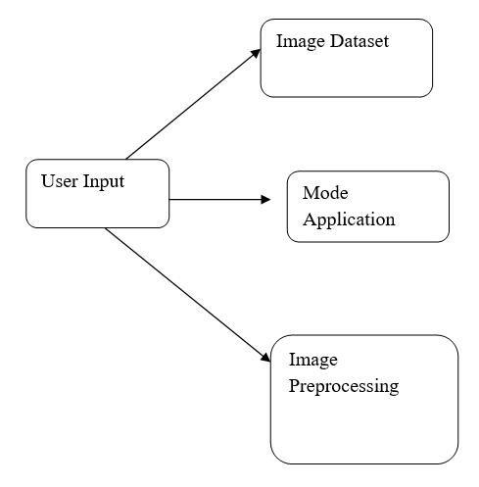

Figure 1.Basic flow diagram.

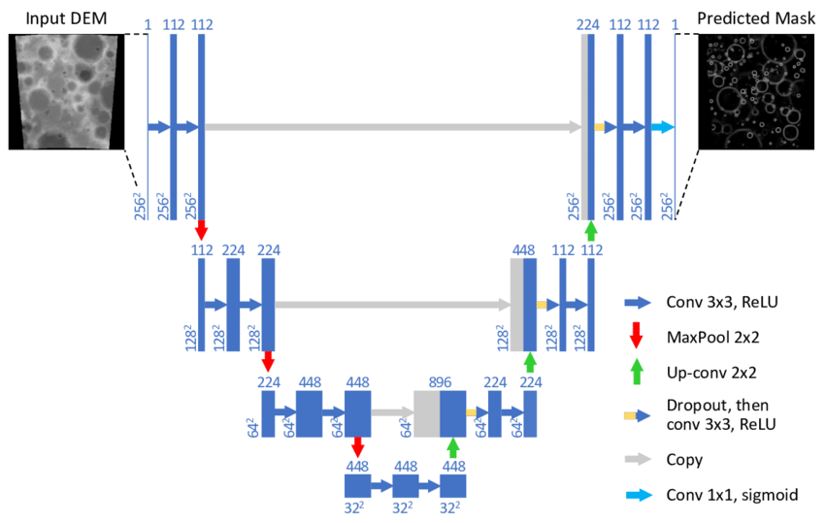

Figure 2. System architecture.

U-Net model is a popular neural network architecture primarily used for image segmentation tasks, such as identifying and delineating objects within images. Its structure resembles a U-shape, hence the name. The model consists of two main components: an encoder and a decoder. The encoder is responsible for capturing the context and features of the input image through a series of convolutional and pooling layers, gradually reducing its spatial dimensions. On the other hand, the decoder aims to reconstruct the segmented output by upsampling the feature maps produced by the encoder, recovering spatial information lost during down sampling**.** Ultimately, the U-Net model outputs a segmentation mask where each pixel represents the probability of belonging to a specific class or category, making it a powerful tool for tasks requiring precise image segmentation.

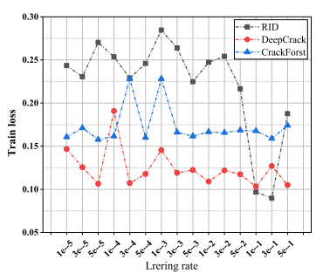

Figure 3. Statistical results of training loss values with different learning rates.

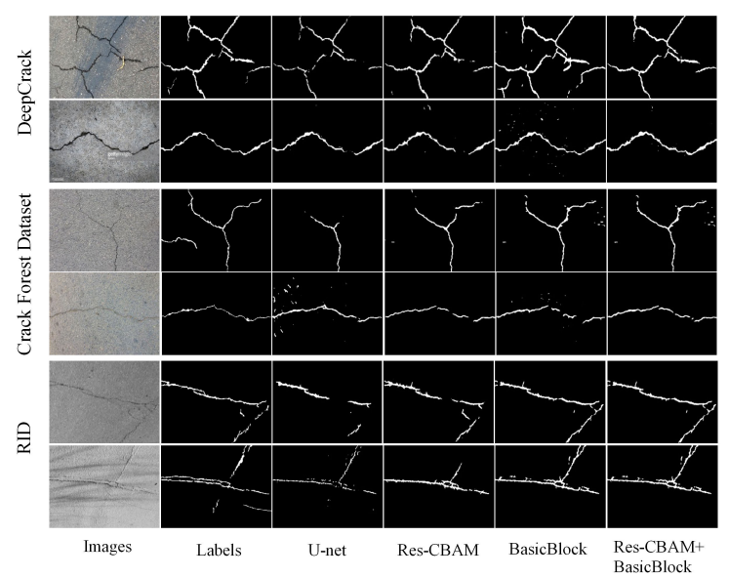

Figure 4. Experimental visualization results of three data sets

**V.CONCLUSION**

We introduced Res-CBAM and Basic Block into the U-Net to ascertain a neural network model for crack detection. The experimental results show that the introduction of CBAM enhances the attention of the neural network to the crack region, improves the extraction ability of the neural network for necracks, and suppresses the interference of background factors. Meanwhile, The shortcut connections of Res-CBAM and the replacement of the convolutional layer within the network structure by BasicBlock make sure the transmission of crucial information as with efficiency as potential and effectively suppress the matter of network degradation.

**REFERENCES**

1. S. C. Radopoulou and I. K. Brilakis, ‘‘Automated detection of multiple pavement defects,’’ J. Computer. Civil Eng., vol. 31, no. 2, Mar. 2017, Art. no. 04016057, doi: 10.1061/(ASCE)CP.1943-5487.0000623.
2. J. Jeong, H. Jo, and G. Ditzler, ‘‘Convolutional neural networks for pavement roughness assessment using calibration-free vehicle dynamics,’’ Comput.-Aided Civil Infrastruct. Eng., vol. 35, no. 11, pp. 1209–1229, Mar. 2020, doi: 10.1111/mice.12546.
3. H. Y. Ju, W. Li, S. Tighe, Z. C. Xu, and J. Z. Zhai, ‘‘CrackU-Net: A novel deep convolutional neural network for pixelwise pavement crack detection,’’ Struct. Control Health Monitor., vol. 27, no. 8, Mar. 2020, Art. no. e2551, doi: 10.1002/stc.2551.
4. Ravindra Changala, "Sentiment Analysis in Social Media Using Deep Learning Techniques", International Journal of Intelligent Systems and Applications In Engineering, 2024, 12(3), 1588–1597.
5. Ravindra Changala, “Integration of IoT and DNN Model to Support the Precision Crop”, International Journal of Intelligent Systems and Applications in Engineering, Volume 12, Issue 16s), February 2024.
6. E. H. Miller, ‘‘Crack detection and segmentation using deep learning with 3D reality mesh model for quantitative assessment and integrated visualization,’’ J. Comput. Civil Eng., vol. 34, no. 3, May 2020, Art. no. 04020010, doi: 10.1061/(ASCE)CP.1943-5487.0000890.
7. L. Zhang, F. Yang, Y. Daniel Zhang, and Y. J. Zhu, ‘‘Road crack detection using deep convolutional neural network,’’ in Proc. IEEE Int. Conf. Image Process. (ICIP), Sep. 2016, pp. 3708–3712, doi: 10.1109/ICIP.2016.7533052.
8. Ravindra Changala, “UI/UX Design for Online Learning approach by Predictive Student Experience”, 7th International Conference on Electronics, Communication and Aerospace Technology (ICECA 2023), DVD Part Number: CFP23J88-DVD; ISBN: 979-8-3503-4059-4.
9. Ravindra Changala, “Optimization of Irrigation and Herbicides Using Artificial Intelligence in Agriculture”, International Journal of Intelligent Systems and Applications in Engineering, Volume 11, Issue 3), July 2023.
10. Y. Shi, L. Cui, Z. Qi, F. Meng, and Z. Chen, ‘‘Automatic road crack detection using random structured forests,’’ IEEE Trans. Intell. Transp. Syst., vol. 17, no. 12, pp. 3434–3445, Dec. 2016, doi: 10.1109/TITS.2016.2552248.

G. Yao, F.-J. Wei, J.-Y. Qian, and Z.-G. Wu, ‘‘Crack detection of concrete surface based on

1. convolutional neural networks,’’ in Proc. Int. Conf. Mach. Learn. Cybern. (ICMLC), Jul. 2018, pp. 246–250, doi: 10.1109/ICMLC.2018.8527035.
2. Ravindra Changala ,”[Development of Predictive Model for Medical Domains to Predict Chronic Diseases (Diabetes) Using Machine Learning Algorithms And Classification Techniques](https://scholar.google.com/scholar?cluster=13320591687529567463&hl=en&oi=scholarr)”, ARPN Journal of Engineering and Applied Sciences, Volume 14, Issue 6, 2019.
3. Ravindra Changala, “Evaluation and Analysis of Discovered Patterns Using Pattern Classification Methods in Text Mining” in ARPN Journal of Engineering and Applied Sciences, Volume 13, Issue 11, Pages 3706-3717 with ISSN:1819-6608 in June 2018.
4. Z. Liu, Y. Cao, Y. Wang, and W. Wang, ‘‘Computer visionbased concrete crack detection using U-net fully convolutional networks,’’ Autom. Construct., vol. 104, pp. 129–139, Aug. 2019, doi: 10.1016/j.autcon.2019.04.005.
5. Ravindra Changala “A Survey on Development of Pattern Evolving Model for Discovery of Patterns in Text Mining Using Data Mining Techniques” in Journal of Theoretical and Applied Information Technology, August 2017. Vol.95. No.16, ISSN: 1817-3195, pp.3974-3987.
6. S. Dorafshan, R. J. Thomas, and M. Maguire, ‘‘Comparison of deep convolutional neural networks and edge detectors for image-based crack detection in concrete,’’ Construct. Building Mater., vol. 186, pp. 1031–1045, Oct. 2018, doi: 10.1016/j.conbuildmat.2018.08.011.
7. H. Li, J. Zong, J. Nie, Z. Wu, and H. Han, ‘‘Pavement crack detection algorithm based on densely connected and deeply supervised network,’’ IEEE Access, vol. 9, pp. 11835–11842, 2021, doi: 10.1109/ACCESS.2021.3050401.
8. H. Lin, B. Li, X. Wang, Y. Shu, and S. Niu, ‘‘Automated defect inspection of LED chip using deep convolutional neural network,’’ J. Intell. Manuf., vol. 30, no. 6, pp. 2525–2534, Aug. 2019, doi: 10.1007/s10845-018-1415-x.
9. X. Wu, J. Ma, Y. Sun, C. Zhao, and A. Basu, ‘‘Multi-scale deep pixel distribution learning for concrete crack detection,’’ in Proc. 25th Int. Conf. Pattern Recognit. (ICPR), Jan. 2021, pp. 397–400, doi: 10.1109/ICPR48806.2021.9413312.
10. O. Ronneberger, P. Fischer, and T. Brox, ‘‘U-Net: Convolutional networks for biomedical image segmentation,’’ in Proc. Int. Conf. Med. Image Comput. Comput.-Assist. Intervent. (MICCAI), vol. 9351. Cham, Switzerland: Springer, Nov. 2015, pp. 234–241.
11. Ravindra Changala, Framework for Virtualized Network Functions (VNFs) in Cloud of Things Based on Network Traffic Services, International Journal on Recent and Innovation Trends in Computing and Communication, ISSN: 2321-8169 Volume 11, Issue 11s, August 2023.
12. Ravindra Changala, Block Chain and Machine Learning Models to Evaluate Faults in the Smart Manufacturing System, International Journal of Scientific Research in Science and Technology, Volume 10, Issue 5, ISSN: 2395-6011, Page Number 247-255, September-October-2023.
13. Z. W. Zhou, M. M. R. Siddiquee, N. Tajbakhsh, and J. M. Liang, ‘‘UNet++: A nested U-Net architecture for medical image segmentation,’’ in Deep Learning in Medical Image Analysis and Multimodal Learning for Clinical Decision Support, vol. 11045. Cham, Switzerland: Springer, Sep. 2018, pp. 3–11.
14. J. Cheng, W. Xiong, W. Chen, Y. Gu, and Y. Li, ‘‘Pixel-level crack detection using U-Net,’’ in Proc. TENCON IEEE Region 10 Conf., Oct. 2018, pp. 462–466.