**Biomathematics: An Introduction**

Shivesh Mani Tripathee1, Lokesh Mishra2

*1(IET, Dr Shakuntala Misra National Rehabilitation University Lucknow , India )*

*2(Basic Science, Babasaheb Bhimrao Ambedkar University Lucknow, India )*

*Corresponding Author: shivangaaglory@gmail.com*

|  |  |
| --- | --- |
| How to cite this paper: Y. First Author1, Second Author2 Paper Title  IJIRE-VXIX,YYYY  Copyright © 2022 by author(s) and  5th Dimension Research Publication  This work is licensed under the Creative Commons Attribution International License  (CC BY 4.0). <http://creativecommons.org/licenses/by/4.0/> | ***Abstract:*** *The human body is such a sophisticated creation of God, in which various activities have been known as mystery. These processes are so complex that they cannot be easily studied in their entirety. Here we have studied mucus transport in the lung airways which will Give a better understanding of hydro-dynamical and some Physiological aspects of mucus transport in the human respiratory Tracts. As a section of Biomechanics we study Bio-fluid Dynamics, in which the information is obtained about the flow of various bio fluids in the human body by using the methods and principles of mathematics. It is known that the human body is also a very important mechanical system, in which there are various subsystems, which we have discussed and the mathematics behind it.*  ***Key Word****:* *Biomathematics; Mucus flow; human lung;* |

1. **Introduction**

Biomathematics is the branch of mathematics in which we use mathematical and numerical methods to solve various types of problems related to biology. From the year 1922, the mention of this branch is seen in the literature. It was heavily used in the 1930s and today it is in front of us as a futuristic (cutting-edge) mode of interdisciplinary study, in which we are also helping to find out the mystery of the human body using computers. The human body is divided into different systems for study. Such as respiratory system, circulatory system, nervous system, nutritional system, digestive system etc. If we study the human body given by God through the physical-mechanical ideology, then this branch of study is called Biomechanics. In short, Biomechanics is the branch of scientific knowledge which deals with the mechanical study of the structure and working of biological systems. As a section of Biomechanics we study Bio-fluid Dynamics, in which the information is obtained about the flow of various bio fluids in the human body by using the methods and principles of mathematics. It is known that the human body is also a very important mechanical system, in which there are various subsystems, which we have discussed. I would like to present some specific information related to this in front of you.

**Biomathematics**

* Mathematical Biomechanics :

1. Bio fluid Mechanics
2. Bio-fluid Dynamics

* Mathematical Zoology and Mathematical Botany
* Mathematical Ecology
* Mathematical Epidemiology / Disease Mapping
* Mathematical Biochemistry
* Mathematical Biophysics
* Mathematical Bioengineering
* Mathematical Theory of Diseases
* Mathematical Bio-economics and many more

1. **Flows in Human Lungs**

It is known that the human lung is a complex network of branches made of tubes. In the human lung, the respiratory system starts from the mouth and nostrils and ends at the alveoli through the larynx, trachea, and bronchi. The geometry of the respiratory system was studied in detail from time to time by E. Weibel and his assistants and other discoverers. In 1983, E. Weible presented in a tabular manner the length, radius, area, etc. of different segments present in a healthy human lungHe told that each duct in the human lung is again divided into two subdivisions, which can be small or large in length, but their radius is almost the same. While dividing the geometrical arrangement of the human lung into two forms – A : Irregular Dichotomy and B : Regular Dichotomy, respectively, he studied on the form B (Regular Dichotomy), dividing the human lung ducts into 24 generations and told about air circulation in them. The human respiratory system can be described by a tree known as the bronchial tree, as shown in Figure 1. This tree starts at the trachea and branches 23 times before reaches the alveolar sacs. We call all bifurcations in the human respiratory system a generation.. The trachea which is tube of 1.5 to 2 cm in diameter and 10-12 cm Long, is kept patent by incomplete rings of cartilage. The deficiency On the posterior surface being filled in with fibrous and muscular tissue. This structure allows the free movement of head and neck Without the danger of kinking and obstructing the airways. During Deep inspiration, the trachea increases in diameter about one tenth and In length by one fifth. The air we breathe passes through the trachea Which divides into two branches, the left and right bronchi, each of Which again divides into two ducts, each of which again divides into Two. This process continues up to 23rd generations. The first 15 Generations do not play any role in gas exchange and constitute the Anatomical dead space. Gas exchange commences from generation 15 Onwards with alveolar ducts appearing at generations 19-22.

Generation-23 does the last generation of the airways constitute the Alveolar sacs where gas exchange takes place. The total number of Alveoli ranges from 200 to 600 million. Airways are the tubes that carry air in and out of our lungs.

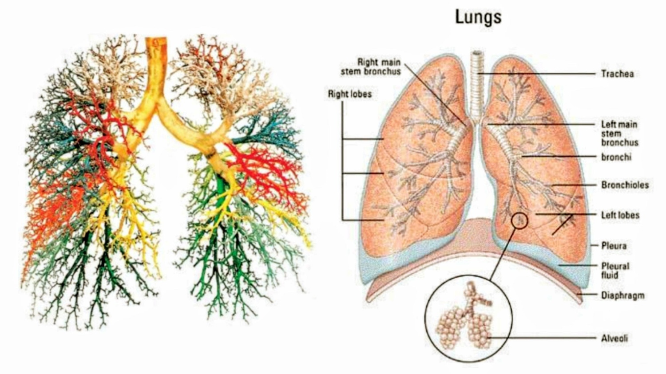Figure 1: Bronchial Tree. Figure 2 : Anatomy of Lungs [8] McGraw-Hill

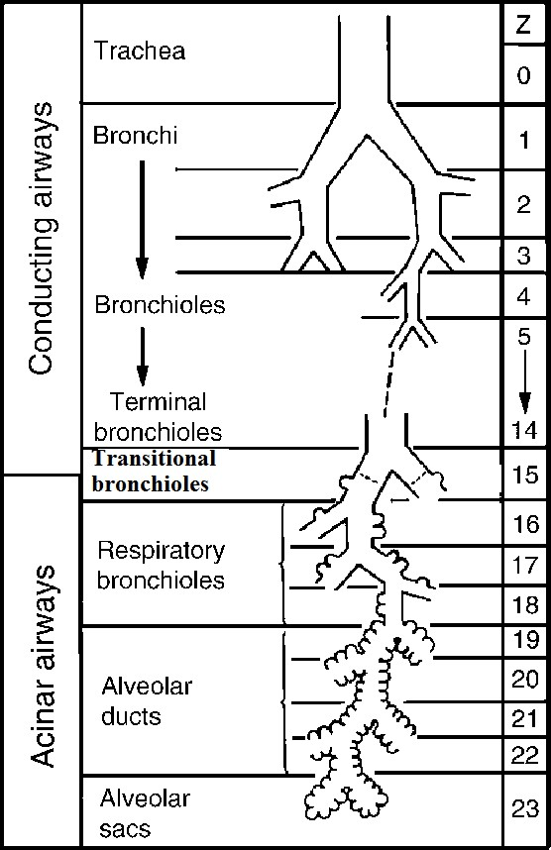

Figure 3 : Anatomy of Lungs [8] McGraw-Hill

The lineages 0-16 of the human lung are called the conducting zone and lineage 16 are called terminal bronchioles. The lineages of 17-23 are called Respiratory Zone. There are air brackets (Alveoli) on the walls of these lines. Lineage-23 ends at the alveolar.

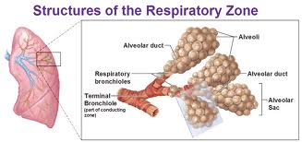

Figure 4 : Respiratory Zone [8] McGraw-Hill

Inhaled external air gets filled in the air sacs (alveoli) of the lungs. There are about 300 million (300x10°) alveoli in both our lungs. Each alveoli is again divided into two alveoli. The alveoli are almost circular. The diameter of each alveoli is 75 micrometers to 300 micrometers.

If the average radius of an air sac r = 125 micrometer, then its surface area can be found as follows:

Surface area of ​​an air sac =  meter-sq.

 2x10-7 meter-square

Hence, the surface area of ​​all the air sacs (300 x 105)

= (300 x 106) x 2 x 10-7 meter-square

= 60 meter-square

The surface area of the lungs is about 70 meter-sq.

Generally, the surface area of ​​an average human body is 1.7 sq. So some unbelievable facts come to the fore as follows -

1- If the total air sacs are opened and joined together and spread on the human body, then it can be wrapped around the human body about 40 times.

2- If the total air sacs are opened and spread on the ground after interconnecting, then it can cover a badminton field.

The structure of the human lung's blood supply is as complex and interesting as that of the air supply. The right ventricle of the heart sends venous blood to the pulmonary artery, which again divides into billions of smaller ducts and is cylindrical in shape, about 7-10 micrometers in diameter. These ducts are a complex network of capillaries on the wall of the alveolar duct, which forms a beautiful network of capillaries. There are about 28x1010 such pulmonary capillaries in the human heart.

Each of these cells has a length of 10 µm (micrometer) and an average diameter of 8 µm.

Hence the total length of all the lung cells

= (28 x 1010) x 10 µm = 2800 kilometers

Total surface area of ​​lung cells = (28 x 1010)  micrometer square

 70 meter-sq.

Total volume of lung cells = (28 x 1010) cubic micrometer

140 millimeter

Generally, the surface area of ​​an average human body is 1.7 meter-sq. Thus again some unbelievable facts come to the fore which are as follows -

1- If the total pulmonary capillaries are interconnected with each other, then it can be spread from Srinagar to Kanyakumari.

2- The surface area of ​​the pulmonary cells is approximately equal to the surface area of ​​the air sacs.

Since 2800 km long lung cells are required for the transmission of 140 ml of blood.

Hence, the length required to transmit 5 liters (5000 ml) of blood  kilometer = 100000 kilometer

So again an unbelievable fact comes to the fore, which is as follows:

“If all the blood cells are joined together, then it can be wrapped about twice on the equator of the earth.

**References:**

1. Mathematical Models in Biology by Leah Edelstein-Keshet <https://doi.org/10.1137/1.9780898719147.ch11>
2. L. A. Segel, (1980). Ed. Mathematical Models in Molecular and Cellular Biology, Cambridge University Press, Cambridge, England.
3. Blake, J.R. Mucus Flow. Math. Biosci.17, 301-313 (1973).
4. Vasquez, Paula & Jin, Yuan & Palmer, Erik & Hill, David & Forest, M.. (2016). Modeling and Simulation of Mucus Flow in Human Bronchial Epithelial Cell Cultures – Part I: Idealized Axisymmetric Swirling Flow. PLOS Computational Biology. 12. E1004872. 10.1371/journal.pcbi.1004872.
5. Thiyagarajan, Padmavathi & Sathiyamoorthy, Senthamilselvi & Karuppusamy, Loganathan & Makinde, Oluwole & Sarris, Ioannis. (2022). Mass Transfer Effects on the Mucus Fluid with Pulsatile Flow Influence of the Electromagnetic Field. Inventions. 10.3390/inventions7030050.
6. Rubenstein, David & Yin, Wei & Frame, Mary. (2022). Flow in the lungs. 10.1016/B978-0-12-818034-1.00010-4.
7. J.C. Misra, S. Samanta, A mathematical model for the biomechanics of the body of a vertebra <https://doi.org/10.1016/0898-1221(88)90078-8>
8. Niederer, Peter. (2010). Mathematical Foundations of Biomechanics. Critical reviews in biomedical engineering. 38. 533-77. 10.1615/CritRevBiomedEng.v38.i6.30
9. Widmaier Eric P Hershel Raff Kevin T Strang and Arthur J Vander. 2011. Vander’s Human Physiology : TheMechanisms of Body Function. 12th ed. New York: McGraw-Hill.
10. Rodhin, J.A.G. Ultrastructure and function of the human tracheal Mucosa. Am. Rev. Respir. Dis. 93, 1-15 (1966).
11. Puchelle, E., Zahm, J.M., Pollu, J.M. & Sadoul, P. Drug effect on visco- elasticity of mucus. Eur. J. Respir. Dis.61, (Supple.110), 195-208 (1980).