**Unprejudiced Strategic Suppliers Selection and Inspection: An Automated Industrial Approach**

**Prithwiraj Jana1a**

1Former Assistant Professor of Haldia Institute of Technology and Former NDT Engineer of Inspection Survey & Surveillance (India) Privet Limited, Kolkata, INDIA.

a,**E-mail address:** [prithwiraj.janahit@gmail.com](mailto:prithwiraj.janahit@gmail.com)

## Abstract

## The world is changing rapidly to global automated market places. As the result, environment is forcing the companies to take accurate decision and consideration at the same time. The relationship between the supplier and the company has been developed for a long time, so the selection of the supplier is a very significant task. In this research ventilated one of the major concerns in the field of Industrial engineering as well as Quality management in the automated selection and inspection domain. Determination the unprejudiced selection accuracy and defect rate for present & future inspection respectively in supplier evaluation of industry. Analyze the decision about future inspection 100% or not, on the basis of inspection cost during the examination and decision making activity. After selection process of supplier, next step is to checking the efficiency of this supplier, so inspection is implemented. Two model are deal with this paper, one is automated selection and second is implementation of inspection.

***Keywords:*** *Quality control; Inspection accuracy; entropy method; cross check; Optimization; MCDM*

1. **INTRODUCTION**

In this paper, the entropy method used to determine accurate unbiased weighted factor. The final suppliers’ selection goes through three type of MCDM methods to decide true value of ranking. Sensitivity analysis is appear to measure the impact of uncertainties in input variables on output variables in a model. This paper also deals with creating an inspection model to find out minimizing the risk factor.

* 1. **Inspection accuracy:** Refers to the capability of inspection process to avoid these types of errors; Measures of inspection accuracy are suggested by DRURY for the case in which parts are classified by an inspector. Inspected items of good quality are incorrectly classified as not conforming to accepted specification, and nonconforming items are mistakenly classified as conforming. These two kinds of errors are called “False alarm” and “Miss” respectively.

**Two types of errors in cross check inspection:**

**Conforming Item**  **Nonconforming Item**

|  |  |
| --- | --- |
| Right decision | Miss |
| False alarm | Right decision |

**Accepted Item**

**Rejected Item**

* 1. **Inspection or No inspection:** A model for deciding to inspect at a certain point in the production sequence is proposed in Juran and Gryna. The model uses the fraction defect rate in the inspection batch, the inspection cost per unit inspected, and the cost of damage that one defective unit would cause if it were not inspected.

1. **STATEMENT OF THE PROBLEM**

**2.1.** For a particular type of Supplier/vendor selection in industry, assume that, six different type of Supplier/vendor provided (A,B,C,D,E,F) four different machine those are to be ranked or selected considering nine conflicting criteria Ordered number of items (C1), Number of On-time delivered items (C2), Number of delayed items (C3), Number of conforming items (C4), Number of nonconforming items (C5), Machine velocity (m/sec) (C6) , Load Capacity (kg) (C7),

Repeatability in mm (C8), Cost in dollars (C9). Whereas C3, C5 and C9 are non-beneficiary criteria and the rest of criteria are benificiary.[Table 1] shows the performance matrix of the alternative supplier with importance weight of criteria. The present problem of supplier selection with six alternatives and nine conflicting criteria satisfies the condition of MCDM. The proposed approach has been applied to find the best robot as well as their ranking.

**2.2.** During raw material supply time, the efficiency checking of this supplier is an important part of supply chain management inspection. Sometimes error occurs in the inspection procedure such as those items of good quality are incorrectly classified and vice-versa. In manual inspection, these errors result from factors such as:

1. Inherent variations in the inspection procedure
2. Complexity, hazard and other various difficulty of the inspection task
3. Inaccuracy in measuring instrument
4. Mental fatigue etc.

For this irresolute inspection errors, its have possible chance to reduce the risk of the company before the next Inspection results-

* Production loss
* Drain of money
* Idle times are increase etc.

In this critical inspection cases, the inspection accuracy is very important. But these types of situation the exact accuracy as well as defect rate remain undetermined. Whenever, the risk is found for failure of inspection then it is impossible to assess the past inspection accuracy on the basis of inspected data. Modeling a system to make automated inspection accuracy for minimizing the decision criticality. For minimizing this type of errors, implemented the alternative/cross check inspection are frequently used.

1. **RESEARCH OBJECTIVES**

In this research, the objectives are divided into two parts. First used to several MCDM methods and sensitivity analysis to determine the accuracy of suppliers ranking. Second used to an inspection model to find out the efficiency of selected supplier for a long term.

**3.1.** Considering multiple conflicting criteria, selecting the best path from a set of feasible alternatives known as Multiple criteria decision making (MCDM). This process always goes through at least two alternatives and two conflicting criteria. MCDM are divided two broad categories: Multiple Attribute Decision Making (MADM) and Multiple Objective Decision Making (MODM). Several useful tools for solving of MCDM problems are

* Simple Additive Weighting method (SAW)
* Technique for Order Preference by Similarity to Ideal Solution (TOPSIS)
* Multi Objective Optimization Ratio Analysis (MOORA)
* Analytical Hierarchy Method (AHP)
* Analytical Network Method ANP etc.

**3.2.** In practical approaches, during first inspection, frequently errors are come out for hazarded condition. To avoid this kind of situation a different approach has been implemented i.e. sample inspection, spot sampling etc. As a result, processing time of inspection is maximized, risk factor is unpredictable, No future inspection can be done because of increasing the inspection cost etc.

In this research, addresses to analysis the inspection accuracy by

1. Automated computational methodology to determine the accuracy in cross check approaches.
2. Finding the errors for future inspection
3. Simplifying the decision about the plates will be replaced or not.
   * 1. **MODELING INSPECTION SYSTEM FLOW DIAGRAM**

**Number of inspected items**

**PRESENTATION**

**Determine the conforming & non conforming items on the basis of total number of inspected items by two times of examination.**

**EXAMINATION**

**Analysis the inspection accuracy & cost and determine the defect rate for present & future inspection respectively by automated checklist.**

**DECISION**

* **Assessment about the future inspection implemented 100% or not on the basis of inspection cost.**
* **Implemented the risk based better inspection accuracy.**

**ACTION**

1. **EXPERIMENT**
   1. **Supplier selection and sensitivity analysis**

|  |  |  |  |  |  |  |  |  |  |
| --- | --- | --- | --- | --- | --- | --- | --- | --- | --- |
| ***Criteria***    ***Suppliers*** | ***Ordered***  ***number of***  ***items***  ***(C1)*** | ***Number of***  ***on-time***  ***delivered***  ***items***  ***(C2)*** | ***Number of***  ***delayed***  ***items***  ***(C3)*** | ***Number of***  ***conforming***  ***items***  ***(C4)*** | ***Number of***  ***nonconforming***  ***items***  ***(C5)*** | ***Machine velocity***  ***(m/sec)***  ***(C6)*** | ***Load Capacity***  ***(kg)***  ***(C7)*** | ***Repeatability***  ***(mm)***  ***(C8)*** | ***Cost***  ***($)***  ***(C9)*** |
| A | 16 | 15 | 1 | 12 | 3 | 1.8 | 90 | 0.45 | 9500 |
| B | 14 | 14 | 1 | 14 | 1 | 1.4 | 80 | 0.35 | 5500 |
| C | 04 | 03 | 1 | 03 | 1 | 0.8 | 70 | 0.20 | 4500 |
| D | 27 | 20 | 7 | 18 | 2 | 0.8 | 60 | 0.15 | 4000 |
| E | 155 | 155 | 3 | 146 | 9 | 0.9 | 50 | 0.25 | 7000 |
| F | 81 | 68 | 13 | 68 | 1 | 1.5 | 50 | 0.30 | 6500 |

**Table - 1**

The weighted values [Table - 2] are calculated by entropy method: Columns 1 through 9

|  |  |  |  |  |  |  |  |  |  |
| --- | --- | --- | --- | --- | --- | --- | --- | --- | --- |
| **Criteria** | **(C1)** | **(C1)** | **(C1)** | **(C1)** | **(C1)** | **(C1)** | **(C1)** | **(C1)** | **(C1)** |
| **Weighted values** | 0.1151 | 0.1458 | 0.0722 | 0.1505 | 0.1349 | 0.0929 | 0.1073 | 0.1126 | 0.0687 |

**Table - 2**

**4.1.1. Simple Additive weighting method (SAW)**

The weighted values got from entropy method

STEP1: Determination of normalized decision matrix

|  |  |  |  |  |  |  |  |  |  |
| --- | --- | --- | --- | --- | --- | --- | --- | --- | --- |
|  | C1 | C2 | C3 | C4 | C5 | C6 | C7 | C8 | C9 |
| A | 0.1032 | 0.0968 | 0.0769 | 0.0822 | 0.3333 | 1.0000 | 0.5556 | 0.3333 | 0.4211 |
| B | 0.0903 | 0.0903 | 0.0769 | 0.0959 | 0.1111 | 0.7778 | 0.6250 | 0.4286 | 0.7273 |
| C | 0.0258 | 0.0194 | 0.0769 | 0.0205 | 0.1111 | 0.4444 | 0.7143 | 0.7500 | 0.8889 |
| D | 0.1742 | 0.1290 | 0.5385 | 0.1233 | 0.2222 | 0.4444 | 0.8333 | 1.0000 | 1.0000 |
| E | 1.0000 | 1.0000 | 0.2308 | 1.0000 | 1.0000 | 0.5000 | 1.0000 | 0.6000 | 0.5714 |
| F | 0.5226 | 0.4387 | 1.0000 | 0.4658 | 0.1111 | 0.8333 | 1.0000 | 0.5000 | 0.6154 |

**Table - 3**

STEP 2: Determination of weighted normalized decision matrix

|  |  |  |  |  |  |  |  |  |  |
| --- | --- | --- | --- | --- | --- | --- | --- | --- | --- |
|  | C1 | C2 | C3 | C4 | C5 | C6 | C7 | C8 | C9 |
| A | 0.0119 | 0.0141 | 0.0056 | 0.0124 | 0.0450 | 0.0929 | 0.0596 | 0.0375 | 0.0289 |
| B | 0.0104 | 0.0132 | 0.0056 | 0.0144 | 0.0150 | 0.0722 | 0.0671 | 0.0483 | 0.0500 |
| C | 0.0030 | 0.0028 | 0.0056 | 0.0031 | 0.0150 | 0.0413 | 0.0767 | 0.0844 | 0.0611 |
| D | 0.0201 | 0.0188 | 0.0389 | 0.0186 | 0.0300 | 0.0413 | 0.0894 | 0.1126 | 0.0687 |
| E | 0.1151 | 0.1458 | 0.0167 | 0.1505 | 0.1349 | 0.0464 | 0.1073 | 0.0676 | 0.0393 |
| F | 0.0602 | 0.0640 | 0.0722 | 0.0701 | 0.0150 | 0.0774 | 0.1073 | 0.0563 | 0.0423 |

**Table - 4**

STEP 3: Computation of composite score s......by sum of all weighted normalized rows

The values of (s) are:

|  |  |  |  |  |  |
| --- | --- | --- | --- | --- | --- |
| A | B | C | D | E | F |
| 0.3078 | 0.2961 | 0.2929 | 0.4383 | 0.8235 | 0.5647 |

**Table - 5**

STEP 4:

Arranging the final value (s) in descending order :--------->>> E > F >D >A > B > C in SAW method [Fig: 1]

>>

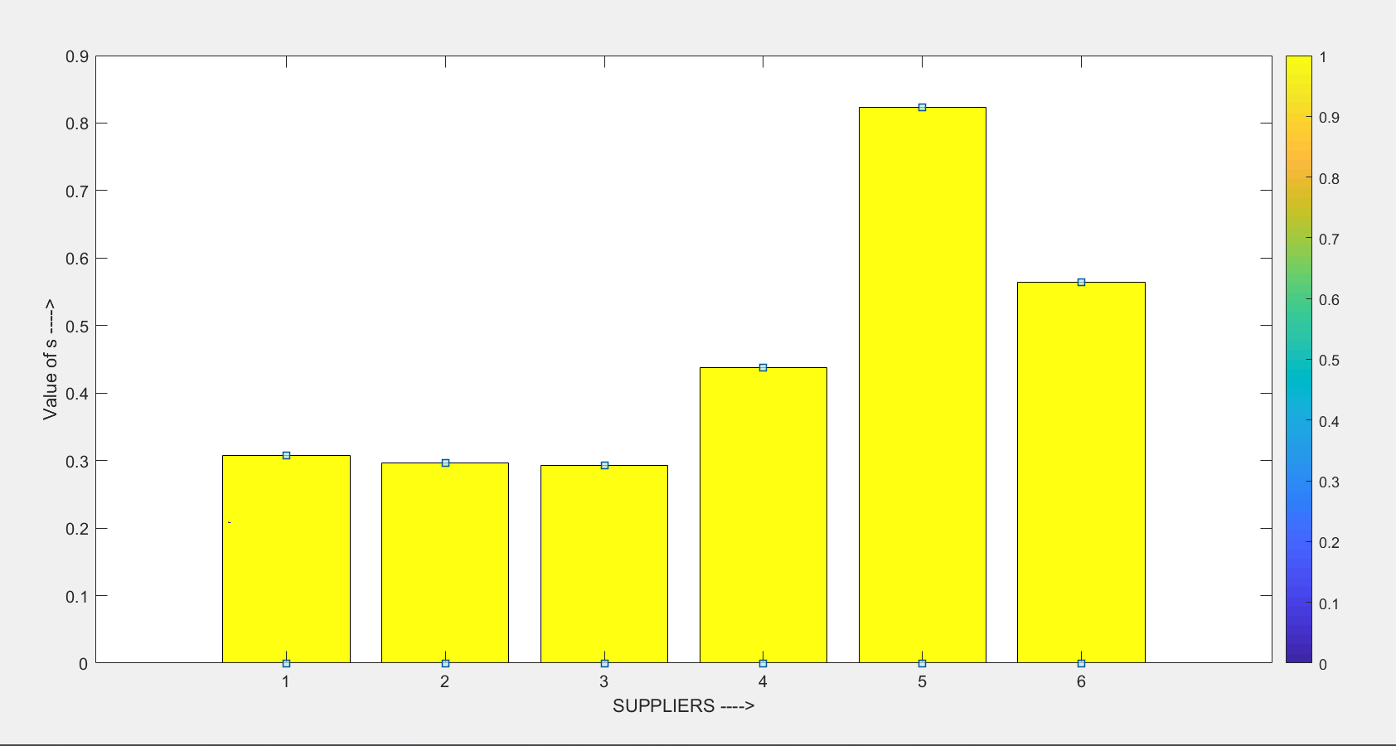

Fig: 1

**SAW to determine the sensitivity analysis graph:**

The value of closeness co-efficient in SAW method [Fig: 2]

when alpha=0 when alpha=1

|  |  |  |  |  |  |  |
| --- | --- | --- | --- | --- | --- | --- |
|  | A | B | C | D | E | F |
| alpha=0 | 0.1261 | 0.1653 | 0.2222 | 0.2707 | 0.2141 | 0.2059 |
| alpha=1 | 0.1817 | 0.1308 | 0.0707 | 0.1676 | 0.6094 | 0.3588 |

**Table - 6**

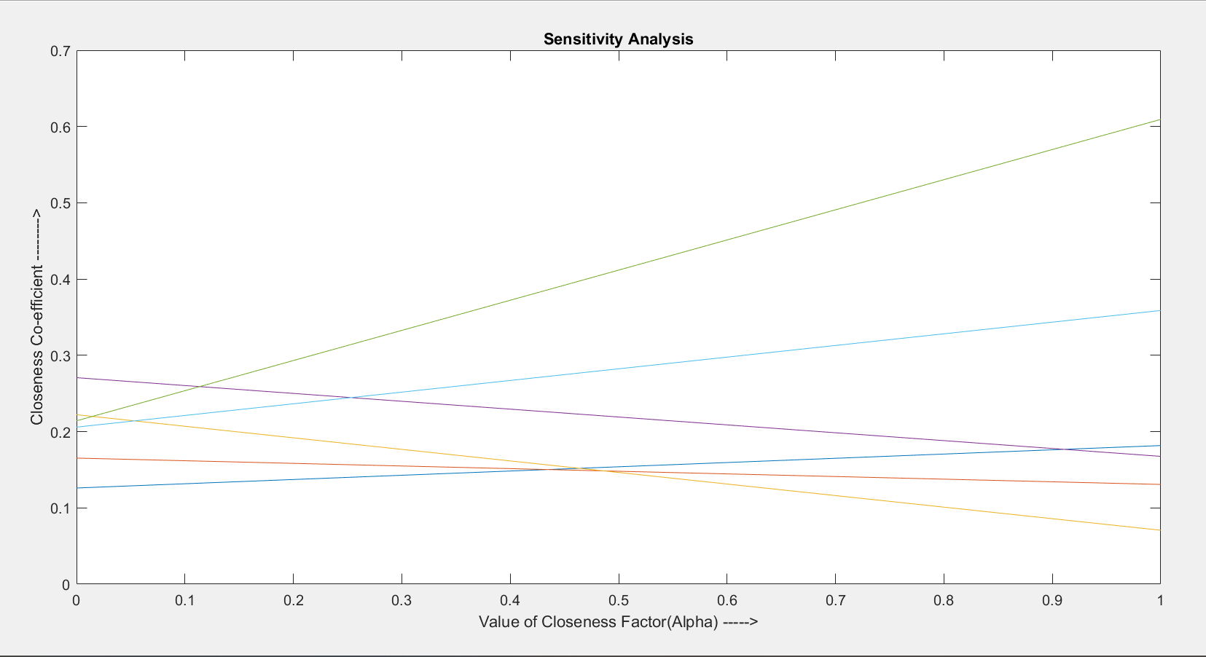

**Fig: 2**

* + 1. **Multi Objective Optimization Ratio Analysis (MOORA)**

In the MOORA method

STEP 1 Determination of normalized decision matrix

Columns 1 through 9

|  |  |  |  |  |  |  |  |  |  |
| --- | --- | --- | --- | --- | --- | --- | --- | --- | --- |
|  | C1 | C2 | C3 | C4 | C5 | C6 | C7 | C8 | C9 |
| A | 0.0897 | 0.0874 | 0.0659 | 0.0736 | 0.3046 | 0.5828 | 0.5379 | 0.6124 | 0.6033 |
| B | 0.0785 | 0.0815 | 0.0659 | 0.0858 | 0.1015 | 0.4533 | 0.4781 | 0.4763 | 0.3493 |
| C | 0.0224 | 0.0175 | 0.0659 | 0.0184 | 0.1015 | 0.2590 | 0.4183 | 0.2722 | 0.2858 |
| D | 0.1514 | 0.1165 | 0.4616 | 0.1103 | 0.2031 | 0.2590 | 0.3586 | 0.2041 | 0.2540 |
| E | 0.8694 | 0.9028 | 0.1978 | 0.8950 | 0.9138 | 0.2914 | 0.2988 | 0.3402 | 0.4445 |
| F | 0.4543 | 0.3961 | 0.8572 | 0.4168 | 0.1015 | 0.4856 | 0.2988 | 0.4082 | 0.4128 |

**Table - 7**

STEP 2 Determination of weighted normalized decision matrix

Columns 1 through 9

|  |  |  |  |  |  |  |  |  |  |
| --- | --- | --- | --- | --- | --- | --- | --- | --- | --- |
|  | C1 | C2 | C3 | C4 | C5 | C6 | C7 | C8 | C9 |
| A | 0.0103 | 0.0127 | 0.0048 | 0.0111 | 0.0411 | 0.0541 | 0.0577 | 0.0689 | 0.0414 |
| B | 0.0090 | 0.0119 | 0.0048 | 0.0129 | 0.0137 | 0.0421 | 0.0513 | 0.0536 | 0.0240 |
| C | 0.0026 | 0.0025 | 0.0048 | 0.0028 | 0.0137 | 0.0241 | 0.0449 | 0.0306 | 0.0196 |
| D | 0.0174 | 0.0170 | 0.0333 | 0.0166 | 0.0274 | 0.0241 | 0.0385 | 0.0230 | 0.0174 |
| E | 0.1001 | 0.1316 | 0.0143 | 0.1347 | 0.1232 | 0.0271 | 0.0321 | 0.0383 | 0.0305 |
| F | 0.0523 | 0.0577 | 0.0619 | 0.0627 | 0.0137 | 0.0451 | 0.0321 | 0.0460 | 0.0284 |

**Table - 8**

STEP 3: Determination of weighted multi objective optimization

The value of a ......sum of all weighted normalized values for all beneficial column

|  |  |  |  |  |  |
| --- | --- | --- | --- | --- | --- |
| A | B | C | D | E | F |
| 0.1341 | 0.0944 | 0.0504 | 0.1358 | 0.5310 | 0.2935 |

**Table - 9**

The value of b ......sum of all weighted normalized values for all non-beneficial column

|  |  |  |  |  |  |
| --- | --- | --- | --- | --- | --- |
| A | B | C | D | E | F |
| 0.1681 | 0.1289 | 0.0952 | 0.0789 | 0.1009 | 0.1064 |

**Table - 10**

STEP 4: the value of a-b

|  |  |  |  |  |  |
| --- | --- | --- | --- | --- | --- |
| A | B | C | D | E | F |
| -0.0340 | -0.0345 | -0.0448 | 0.0569 | 0.4301 | 0.1871 |

Table - 11

STEP 5

Arranging the final value(a-b) in descending order[Fig:3]:--------->>> E > F > D > A > B >C

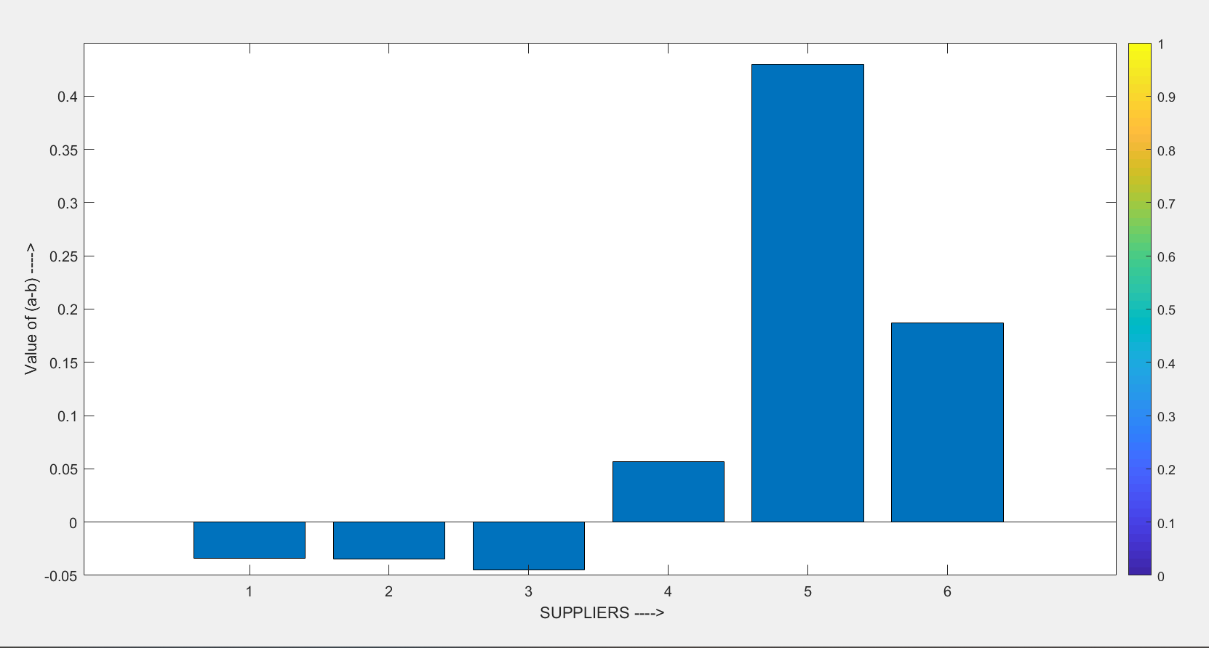

**Fig: 3**

MOORA to determine the sensitivity analysis graph:

The value of closeness co-efficient in MOORA method [Fig: 4]

when alpha=0 when alpha=1

|  |  |  |  |  |  |  |
| --- | --- | --- | --- | --- | --- | --- |
|  | A | B | C | D | E | F |
| alpha=0 | -0.1681 | -0.1289 | -0.0952 | -0.0789 | -0.1009 | -0.1064 |
| alpha=1 | 0.1341 | 0.0944 | 0.0504 | 0.1358 | 0.5310 | 0.2935 |

Table - 12

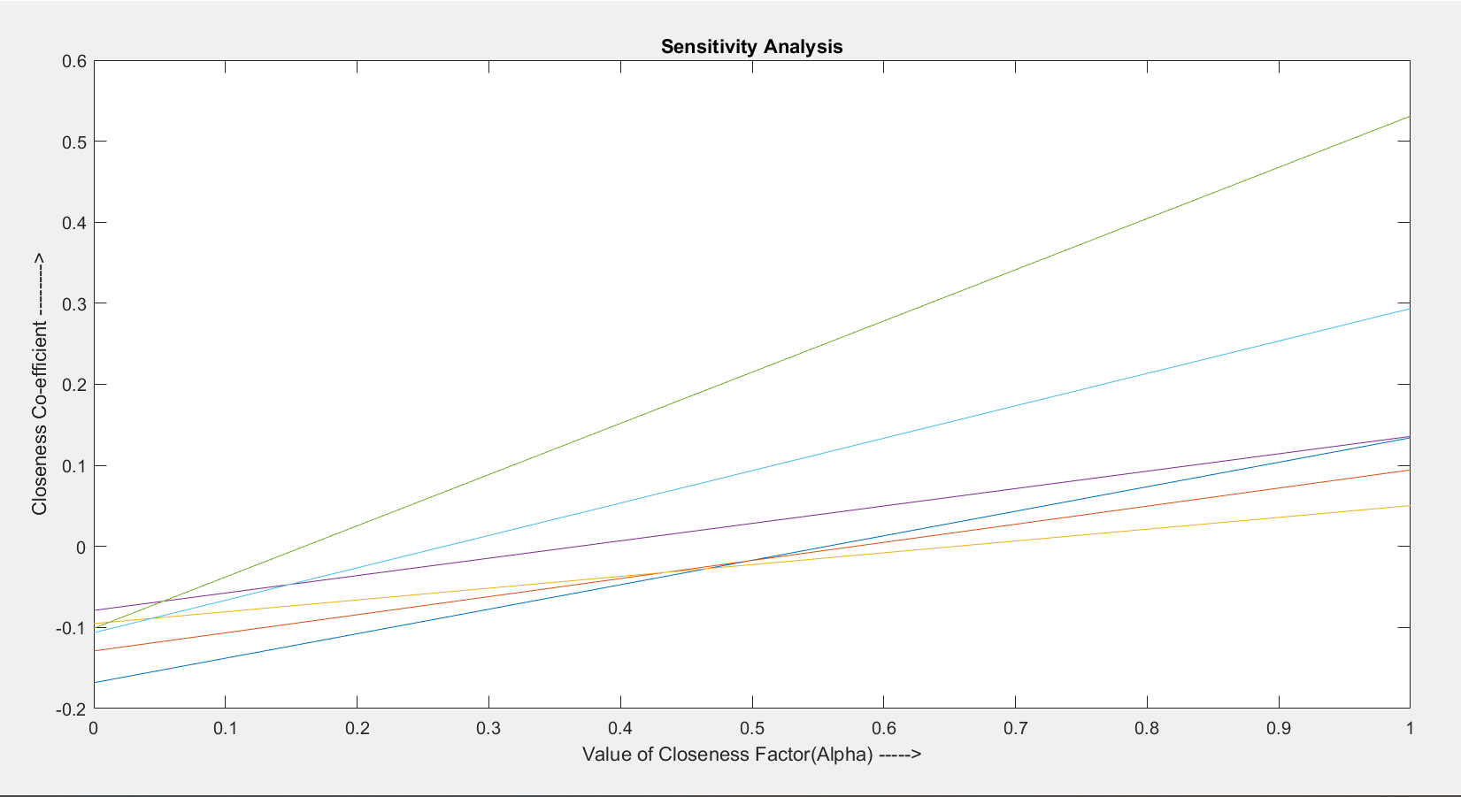

**Fig: 4**

**4.1.3 Technique for Order Preference by Similarity to Ideal Solution (TOPSIS)**

The weighted values got from entropy method

STEP1: Determination of normalized decision matrix

Columns 1 through 9

|  |  |  |  |  |  |  |  |  |  |
| --- | --- | --- | --- | --- | --- | --- | --- | --- | --- |
|  | C1 | C2 | C3 | C4 | C5 | C6 | C7 | C8 | C9 |
| A | 0.1032 | 0.0968 | 0.0769 | 0.0822 | 0.3333 | 1.0000 | 0.5556 | 0.3333 | 0.4211 |
| B | 0.0903 | 0.0903 | 0.0769 | 0.0959 | 0.1111 | 0.7778 | 0.6250 | 0.4286 | 0.7273 |
| C | 0.0258 | 0.0194 | 0.0769 | 0.0205 | 0.1111 | 0.4444 | 0.7143 | 0.7500 | 0.8889 |
| D | 0.1742 | 0.1290 | 0.5385 | 0.1233 | 0.2222 | 0.4444 | 0.8333 | 1.0000 | 1.0000 |
| E | 1.0000 | 1.0000 | 0.2308 | 1.0000 | 1.0000 | 0.5000 | 1.0000 | 0.6000 | 0.5714 |
| F | 0.5226 | 0.4387 | 1.0000 | 0.4658 | 0.1111 | 0.8333 | 1.0000 | 0.5000 | 0.6154 |

Table - 13

STEP 2:

Determination of positive ideal solution: taking the maximum values of each column from the normalized decision matrix

|  |  |  |  |  |  |  |  |  |
| --- | --- | --- | --- | --- | --- | --- | --- | --- |
| C1 | C2 | C3 | C4 | C5 | C6 | C7 | C8 | C9 |
| 1 | 1 | 1 | 1 | 1 | 1 | 1 | 1 | 1 |

**Table - 14**

Determination of negative ideal solution: taking the minimum values of each column from the normalized decision matrix

Columns 1 through 9

|  |  |  |  |  |  |  |  |  |
| --- | --- | --- | --- | --- | --- | --- | --- | --- |
| C1 | C2 | C3 | C4 | C5 | C6 | C7 | C8 | C9 |
| 0.0258 | 0.0194 | 0.0769 | 0.0205 | 0.1111 | 0.4444 | 0.5556 | 0.3333 | 0.4211 |

**Table - 15**

STEP 3:

Calculation of the separation measure from the positive ideal solution(di_Plus)

|  |  |  |  |  |  |
| --- | --- | --- | --- | --- | --- |
| A | B | C | D | E | F |
| 0.7444 | 0.7541 | 0.7793 | 0.6583 | 0.3108 | 0.5124 |

**Table - 16**

Calculation of the separation measure from the negative ideal solution (di_Minus)

|  |  |  |  |  |  |
| --- | --- | --- | --- | --- | --- |
| A | B | C | D | E | F |
| 0.1935 | 0.1427 | 0.1931 | 0.3229 | 0.7302 | 0.4317 |

**Table - 17**

STEP 3: Calculation of R_i

|  |  |  |  |  |  |
| --- | --- | --- | --- | --- | --- |
| A | B | C | D | E | F |
| 0.2063 | 0.1591 | 0.1986 | 0.3291 | 0.7014 | 0.4573 |

**Table - 18**

STEP 4:

Arranging the final value in descending order[Fig:5] :--------->>> E > F > D > A > C > B

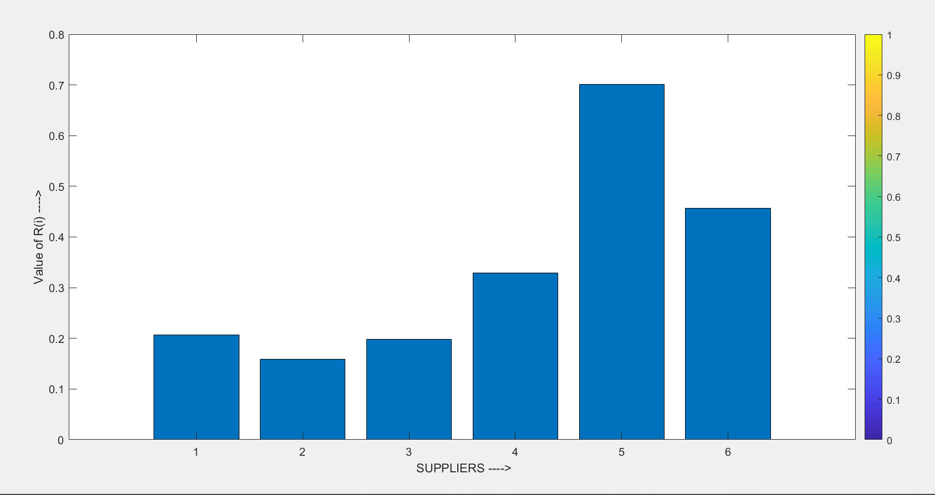

**Fig: 5**

**4.1.4 Comparative analysis of supplier selection ranking**

|  |  |  |  |
| --- | --- | --- | --- |
|  | **SAW** | **MOORA** | **TOPSIS** |
| **A** | **4** | **4** | **4** |
| **B** | **5** | **5** | **6** |
| **C** | **6** | **6** | **5** |
| **D** | **3** | **3** | **3** |
| **E** | **1** | **1** | **1** |
| **F** | **2** | **2** | **2** |

**Table – 19**

**4.2. Supplier Inspection**

Basically in industry looking over an inspection problem during supply lead time,as the result in manual inspection, various types of errors are occurring and the inspection report become incorrect by human error. To make the inspection accurate the cross check policy should be implemented by execution.

Total number of inspected item of delivery = J

* Each item inspection cost = CS
* Each item damage cost = Cd

**Inspection and Data Analysis**

* In First Inspection Report,

The number of defective item are detected = X

* The second inspection is implemented to minimize the risk. In this Inspection Report, it was found that Y of these reported defects were in facts good pieces. Whereas a total of Z defective plates in a tank were undetected through the inspection.

So, the total “FALSE ALARME” = Y

The total “MISSES” = Z

* + 1. **Constructing computing logic on the inspection data by Microsoft Excel as following**

Microsoft Excel has the basic features of all spreadsheets, using a grid of cells arranged in numbered rows and letter-named columns to organize data manipulations like arithmetic operations. It has a battery of supply functions to answer statistical, engineering and financial needs.

Developed a check sheet by Microsoft Excel [Figure: 11]:

* Actual Acceptance (A) = Good (G) in the 1st inspection + False Alarm (F) during cross check – Miss (M) during cross check.
* Actual Reject (R) = Bad (B) in the 1st inspection + Miss (M) during cross check – False Alarm (F) during cross check
* Probability of conforming item (P1) = [Total Item (Q) in batch – {Bad (B) in the 1st inspection + Miss (M) during cross check}] / Actual Acceptance (A)
* Probability of Non-conforming item (P2) = [Total Item (Q) in batch – {Good (G) in the 1st inspection + False Alarm (F) during cross check}] / Actual Reject (R)
* Accuracy = {Probability of conforming item (P1) + Probability of Non-conforming item (P2)} / 2
* Defect Rate (q) = (1 - over all inspection accuracy)
* Batch cost for 100% inspection(Cb) = Q.CS (Q= total parts in a batch) &

Cs = inspection cost

* Batch cost for NO inspection (Cn) = Q.q. Cd (Cd = inspection damage cost)
* The critical defect value (QC) = CS / Cd [critical value represents the breakeven point between inspection or no inspection]
  + 1. **RESULT**
* The proportion of good parts reported as conforming is =P1
* The proportion of defective parts reported as nonconforming is = P2
* The overall inspection accuracy = A
* Defect Rate = q
* In quality assurance approaches, if we consider the overall inspection accuracy is an average accuracy then it show the inspection status as a graph in Poisson distribution by MINITAB.

1. Batch cost for 100% inspection = Cu
2. Batch cost for NO inspection = Cn
3. The critical defect value = QC

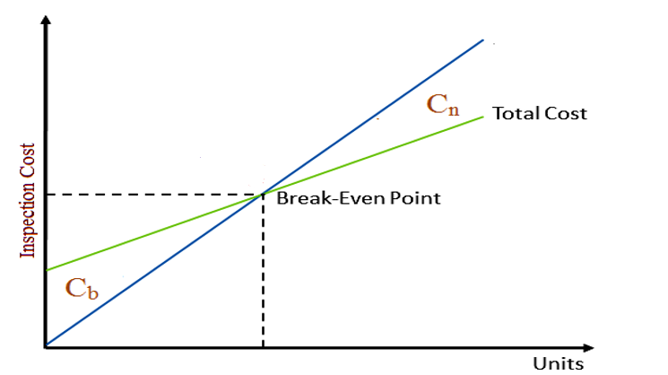

**Fig: 6** **Break even Analysis**

Based on past history with the inspected items, the batch fraction defect rate q is less than this critical level then no inspection is indicated. On the other hand, if it is expected that the fraction defect rate will be greater than QC, then further inspection is necessary.

|  |  |
| --- | --- |
| If, QC < q | Inspection is indicated |
| If, QC > q | NO inspection is indicated |

* + 1. **ADVANTAGES OF THIS METHODOLOGY**
* Determine the inspection accuracy easily in excel sheet.
* Assessment of the inspector’s responsibility on the particular job
* Analysis the risk based inspection report
* Inspections are less time consuming
* Determine the decision about future inspection under cost based inspection.
* Minimize the human error

**CONCLUSION**

It is quite clear that, ranking of a proper vendor for a given supplier application involves a large number of considerations. The use of SAW, TOPSIS and MOORA methods are observed to be quite capable and computationally easy to evaluate and select the proper supplier from a given set of alternatives. These methods use the measures of the considered criteria with their relative importance in order to arrive at the final ranking of the alternative. In this paper, we see that the result are almost same in three MCDM methods. A sample inspection model deployed here. Decisions such as length of contracts, vendor of vendors employed and location of vendor should be analysed in light of their strategic implications. Given the inherent multi-objective nature of vendor selection decisions and the financial importance of such decision in highly competitive environments it appears that multi-objective programming techniques could prove extremely useful in such strategic planning.

**About the Author**

**Prithwiraj Jana born in India 1990, obtained his Bachelor’s degree in Production Engineering, from Haldia Institute of Technology, during 2008-2012. & Master’s degree from School of Engineering & Technology (Govt.) under West Bengal University of Technology in the Industrial Engineering & Management during 2012-2014. He is having about 02 years industrial experience in Inspection Department at IOCL (Haldia Refinery) and having 20 International journals / Conference papers. He also obtained his professional qualification on ASNT (The American Society for Non-destructive Testing) Level- II (UT, PT, MPT & RT). He is also an author of engineering books. Former Assistant Professor of Haldia Institute of Technology, WB, India.**

**References**

1. Juran. (2002) Quality control handbook. McGraw-Hill Books
2. Mahajan.M., “Statistical Quality Control” Edition-1998,Dhanpat Rai & Sons, India
3. Telsang.M.,“Industrial Engineering and Production Management” Second Edition, S.Chand & Company Ltd.,2012,ISBN-81-219-1773-5.
4. DRURY,C.G., “Inspection Performance, ” Handbook of Industrial Engineering, Second Edition,G.Salvendy,Editor,John Wiley & Sons,Inc.,New York,1992,pp 2282-2314.
5. Juran, J.M., and Gryna, F.M., Quality Planning and Analysis, Third Edition, McGraw-Hill, Inc., New York, 1993.
6. Tannock, J.D.T., Automating Quality Systems, Chapman & Hall, London,1992.
7. Groover, M.P, “Automation, Production Systems, and Computer-Integrated Manufacturing” Second Edition, Pearson Education, Inc., 2007,ISBN-81-317-0227-8.
8. Prithwiraj Jana, Pranab Kumar Dan (2017) Optimization Treatment of Material Selection in Machine Design -Considering Technical, Economic And Supply Aspect. ISJ Theoretical & Applied Science, 03 (47): 128-138.
9. Ho W., Xu X., Dey K. P., 2010. Multi-criteria decision making approaches for supplier evaluation and selection: A literature review, European Journal of Operational Research, Volume 202, Issue 1, pp. 16-24, ISSN 0377-2217, <http://dx.doi.org/10.1016/j.ejor.2009.05.009>.

[10] Jana, Prithwiraj. "Supplier Selection under Strategic Decision Environment." Independent Journal of Management & Production, ISSN-e 2236-269X, Vol. 11, Nº. 1, 2020. <https://doi.org/10.14807/ijmp.v11i1.1018>

[11] Kara A Latorellaa, Prasad V Prabhul “A review of human error in aviation maintenance and inspection” International Journal of Industrial Ergonomics, Vol:26, Issue: 02, August-2000,Elsevier,Pages 133-161.

[12] Taylor. W et al. “The effects of static multiple sources of noise on the visual search component of human inspection” International Journal of Industrial Ergonomics, Vol:34, Issue: 03, September-2004,Elsevier,Pages 195-207.

[13] Madoranova, M., & Horvath, M. (2013). Multi-Criteria Decision Matrix Approach for Suppliers Evaluation in Micro and Small Organisations. Quality Innovation Prosperity, 17(1), 120–126. https://doi.org/10.12776/qip.v17i1.185.