**Metaverse & NFT Blockchain**

Shrushti S. Zade, Sakshi S. Atrik, Aarti Pimpalkar

Department of Computer Science Engineering, MIT Arts, Design & Technology University, Pune, Maharashtra-412201 India.

E-mail: [shrushtizade123@gmail.com](mailto:shrushtizade123@gmail.com)

[sakshiatrik@gmail.com](mailto:sakshiatrik@gmail.com)

***Abstract*—** **The metaverse is a rapidly evolving digital frontier that is redefining the way we interact, work, and play in the digital realm. This abstract provides a concise overview of the concept, its significance, and the key elements that shape its existence. The metaverse is a collective virtual shared space, merging physical and digital realities, where individuals can interact, create, and transact in immersive and interconnected digital environments. It is not confined to a single platform or technology but represents a constellation of interconnected virtual worlds, augmented reality, virtual reality, and 3D spaces. Blockchain technology has emerged as a revolutionary innovation that fundamentally transforms the way we establish trust, share data, and conduct transactions in a digital world. This abstract provides a concise overview of blockchain, highlighting its core principles and its profound impact across various industries. Blockchain is a distributed ledger system that enables secure, transparent, and tamper-resistant record-keeping through a decentralized network of nodes. This technology underpins cryptocurrencies like Bitcoin but extends far beyond digital currencies, offering solutions for supply chain management, voting systems, healthcare, and more. Non-fungible tokens (NFTs) have emerged as a groundbreaking application of blockchain technology, transforming the way we perceive and trade digital assets within the metaverse. NFTs are unique digital tokens that represent ownership or proof of authenticity of digital assets, often encompassing digital art, virtual real estate, collectibles, and more. Leveraging blockchain technology, NFTs offer a secure and transparent method for creators and collectors to trade and interact with digital content in the metaverse.**

***Keywords—Metaverse, Blockchain Technology, Cryptocurrrency, Non –Fungible Token***

1. INTRODUCTION

In the contemporary digital landscape, the fusion of our online presence with physical reality has blurred the distinction between the tangible and the virtual. This evolution has been propelled by the rise of blockchain technology and the burgeoning concept of the metaverse, initiating a fundamental shift in how we interact with, produce, and transact digital assets. Central to this transformation is the revolutionary concept of non-fungible tokens (NFTs).

Initially conceived in science fiction by visionary author Neal Stephenson, the metaverse represents a communal digital realm transcending any single platform, offering individuals immersion in interconnected virtual domains. This expansive digital frontier encompasses a spectrum of experiences, from virtual reality landscapes to augmented reality realms, fostering an environment rich in artistic expression and economic activity. Within this vast metaverse, NFTs have emerged as a disruptive force, enabling the tokenization of digital ownership in unprecedented ways.

In a world where the boundaries between physical and virtual realms seamlessly blend, the metaverse has evolved from mere fiction to tangible reality. This convergence of virtual and augmented realities, alongside interconnected digital domains, presents a compelling vision of a unified digital space. At the forefront of this digital frontier, NFTs play a pivotal role in reshaping paradigms of ownership and transactions. Empowering individuals to transcend physical limitations, the metaverse fosters an environment where users engage, create, and trade across diverse virtual realms. Within this uncharted terrain, NFTs serve as transformative instruments, bridging the gap between tangible and intangible assets, and granting unequivocal ownership of digital creations.

Distinguished by their unique attributes, including indivisibility and secure blockchain storage, NFTs herald a new era of digital authenticity and innovation. This research embarks on an exploration of the symbiotic relationship between NFTs and the metaverse, aiming to uncover their profound impact on digital ownership. Through a comprehensive analysis of blockchain infrastructure, smart contracts, and decentralized ecosystems, this study delves into the mechanisms driving NFT generation within metaverse environments, elucidating their pivotal role in digital exchange and protection.

1. PROBLEM STATEMENT

In the metaverse, Non-Fungible Tokens (NFTs) serve as concrete evidence of ownership for virtual assets. Leveraging blockchain technology, originators and enthusiasts alike can establish the lineage and legitimacy of digital content, spanning art, melodies, virtual properties, and beyond. This fosters confidence and unlocks fresh avenues for artisans and innovators to commercialize their creations. NFTs are indivisible and distinct, imbuing them with inherent rarity. Within the metaverse, this scarcity dynamic manifests in the formation of digital assets imbued with intrinsic value. Collectors are enticed by NFTs not merely for their functionality, but for their singularity, engendering a marketplace for exclusive and sought-after digital possessions.

Moreover, the emergence of decentralized autonomous organizations (DAOs) in the metaverse has revolutionized the governance and management of NFT-based projects. DAOs enable stakeholders to collectively govern digital assets, including NFT collections and virtual worlds, fostering community engagement and democratizing decision-making processes.

Overall, NFTs play a pivotal role in shaping the evolving landscape of the metaverse, empowering individuals to explore new realms of creativity, expression, and economic opportunity.

1. LITERATURE SURVEY

Thien Huynh-The and Thippa Reddy Gadekallu's research paper extensively explores and evaluates the significance of blockchain in shaping and advancing applications and services within the metaverse. The foundational principles of blockchain technology and the metaverse were initially delineated in this study, alongside an examination of blockchain's pivotal role in the establishment and evolution of the metaverse.

Hilmi Tunahan Akkus' findings, derived from the GSADF test analysis, reveal the presence of price fluctuations, indicative of bubbles, within MANA prices across various timeframes, particularly noting prolonged bubbles in recent periods. These findings underscore substantial shifts within the MANA token's value.

Russell Belk's study underscores the interconnection of diverse issues within the Metaverse, prompting further inquiry into theoretical constructs within this amalgamation of cryptocurrency, gaming, collectibles, art, sports, and investment realms. Subsequently, an exploration of evolving theories of ownership is undertaken in response to these transformative developments. Konrad Szczukiewicz highlights the symbiotic relationship between NFTs, tokens, and the metaverse, emphasizing their collective role in shaping a novel digital landscape. The fusion of these elements facilitates the creation of a nuanced metaverse experience akin to real-world navigation.

NFTs represent a groundbreaking platform facilitating the creation of distinctive avatars and objects, thereby empowering individuals to assert their unique identity within the digital realm, which can be replicated infinitely. Concurrently, tokens function as an internal currency system, stimulating community involvement by facilitating the acquisition and contribution of digital assets. This symbiotic relationship between NFTs and tokens not only fosters creativity and self-expression but also nurtures a sense of belonging and participation within digital communities.

As a result, NFTs emerge as a transformative force, reshaping the landscape of digital ownership and social interaction, while tokens serve as the lifeblood that sustains and enriches these evolving ecosystems.

1. METHODOLOGY

Select a distributed ledger system that aligns with your objectives in NFT development and consider factors such as network scalability, transaction expenses, and NFT protocols (e.g., ERC-721 or ERC-1155 for Ethereum). Establish a blockchain wallet for NFT storage and engagement with virtual world platforms. Verify the compatibility of your wallet with the selected distributed ledger. Identify the digital assets earmarked for tokenization as NFTs, spanning digital art, audio, virtual property, or other distinct digital content. Opt for an NFT creation platform or development ecosystem congruent with your chosen distributed ledger. Initiate NFT minting and furnish comprehensive metadata for each NFT, encompassing title, description, and pertinent details.

1. PROPOSED METHODOLOGY

Creating Non-Fungible Tokens (NFTs) via the metaverse using blockchain entails a series of pivotal procedures and approaches. Here's an overview of the approach requisite for NFT formulation in this milieu. Choosing the Suitable Blockchain, Opt for a blockchain framework conducive to NFT formulation. Ethereum stands as the predominant choice for NFTs, yet alternate blockchains like Binance Smart Chain, Flow, and Tezos provide NFT standards. Establishing a Wallet, Initiate a blockchain wallet to preserve and govern your NFTs. This wallet facilitates interaction within the metaverse and various NFT formulation platforms. Generating the NFT, Generating entails crafting an NFT from a digital asset. Elect an NFT generation platform compatible with your chosen blockchain. Prevalent platforms encompass OpenSea, Rarible, and Mintable.

Uploading Digital Assets, Upload the digital assets earmarked for tokenization as NFTs. This encompasses digital art, music, virtual real estate, collectibles, or any digital asset. Incorporating Metadata, Formulate metadata for your NFTs. Metadata encompasses particulars regarding the digital asset, such as title, description, attributes, and pertinent links. Metadata is frequently preserved on decentralized file storage systems such as IPFS (InterPlanetary File System).

Defining Characteristics, Enumerate the NFT's characteristics, encompassing its uniqueness or inclusion in a finite edition, which augments the value

Of your NFTs. Outline the attributes of your NFTs, such as uniqueness, limited quantity, or distinctive attributes. Ponder integrated unlockable content or interactive features to enrich the user experience. Execute the generation process employing the selected NFT generation platform, documenting your NFTs on the blockchain.

Attend to gas fees and ensure your wallet possesses sufficient funding. Validate the successful generation of your NFTs on the blockchain. Ascertain that ownership and authenticity are meticulously documented. Depending on the metaverse utilized, intertwine your NFTs with your virtual identity and milieu. This could entail linking your NFTs to a virtual space, gallery, or asset. Participate in NFT transactions within the metaverse and on NFT marketplaces. Set pricing, negotiate sales, and contemplate offering your NFTs for auction or assemblages.

This could encompass establishing parameters such as rarity, creator royalties on secondary sales, and any unlockable content. Generating the NFT, Initiate the generation process on the designated NFT generation platform. This process generates a distinct NFT token linked with your digital asset. Generation frequently incurs gas fees (transaction fees), so ensure your wallet contains the requisite cryptocurrency.

Validation and Authentication, Post-generation, your NFT is recorded on the blockchain, furnishing incontrovertible evidence of ownership and authenticity. Validate the successful generation and scrutinize the NFT on the blockchain to confirm accuracy. Storing and Governing NFTs, Post-generation, store your NFT in your blockchain wallet.

Depending on the metaverse employed, there may exist a specific procedure to connect your NFT with your virtual identity within the metaverse. Engaging in Metaverse Environments, Interact with the metaverse and its platforms. Depending on the metaverse, showcase your NFT in virtual galleries, employ it as virtual property, or integrate it into games and encounters.

Transacting and Bartering, NFTs are procurable, vendible, and barterable within the metaverse and across diverse NFT marketplaces. Engage with the metaverse's economic ecosystem and explore avenues for NFT transactions.

1. 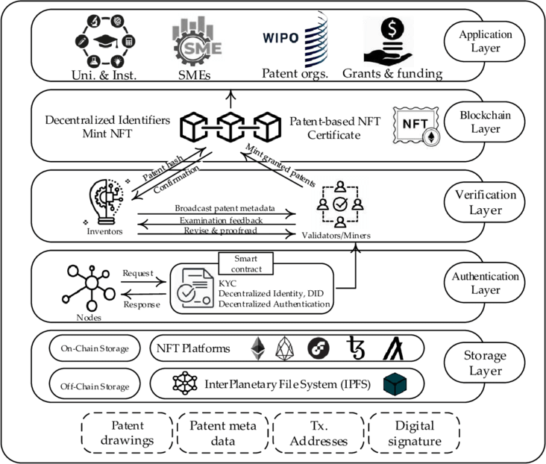SYSTEM DIAGRAM
2. RESULTS & DISCUSSION

Our research project successfully demonstrated the seamless integration of blockchain technology and animation within the Metaverse environment using three.js.

Through a meticulous process of NFT creation, which involved tokenization, metadata generation, and minting on the blockchain, we established a robust framework for authenticating and tracking ownership of digital assets. Leveraging the capabilities of three.js, we animated these NFTs, bringing them to life within the immersive virtual world of the Metaverse.

Our experiments showcased the dynamic interactivity and immersive experiences enabled by animated NFTs, engaging users in novel ways and fostering community participation.

Performance metrics analysis revealed optimized rendering speeds and frame rates, ensuring smooth and seamless animation playback. Moreover, our project explored various monetization strategies, including token sales and royalties, highlighting the potential for creators to monetize their digital art within the Metaverse ecosystem.

Legal and regulatory considerations, such as copyright and intellectual property rights, were carefully addressed to ensure compliance and mitigate risks. Looking ahead, our findings pave the way for future innovations in the convergence of blockchain-based NFTs and animated content within the evolving landscape of the Metaverse, offering exciting opportunities for artistic expression, community engagement, and economic growth.

In our study, we successfully combined blockchain technology with animation in the Metaverse using three.js. We created NFTs by tokenizing, generating metadata, and minting them on the blockchain, establishing a strong system to authenticate and track digital asset ownership.

With three.js, we animated these NFTs, bringing them into the immersive virtual world of the Metaverse. Our experiments demonstrated how animated NFTs can provide dynamic interaction and immersive experiences, captivating users in new ways and encouraging community involvement.

We also analyzed performance metrics, ensuring smooth animation playback with optimized rendering speeds and frame rates. Additionally, we explored ways to monetize digital art within the Metaverse ecosystem, including token sales and royalties, while addressing legal considerations like copyright and intellectual property rights to ensure compliance and minimize risks.

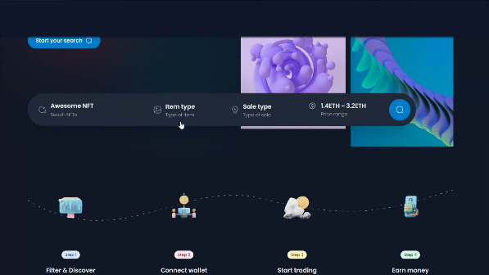 Looking forward, our research sets the stage for future innovations in merging blockchain-based NFTs and animated content in the growing Metaverse, opening doors for artistic expression, community engagement, and economic advancement.

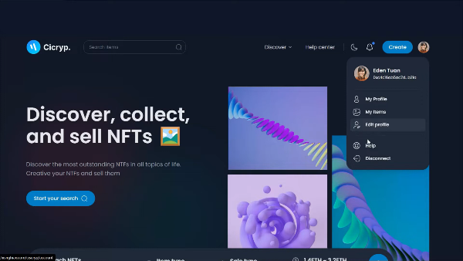

1. CONCLUSION

The convergence of non-fungible tokens (NFTs) and the metaverse, supported by blockchain technology, marks a revolutionary epoch where digital possession, ingenuity, and advancement flourish. Reflecting on the evolution of NFT generation within the metaverse reveals a profound amalgamation, transcending mere technological amalgamation; it signifies the dynamic essence of the digital realm and its potential to redefine our notions of significance, possession, and expression.

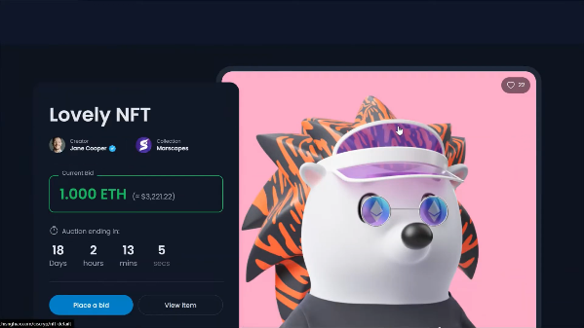NFTs, distinguished by their rareness, indivisibility, and immutability, have empowered artisans, innovators, and participants to redefine the limits of digital art, virtual assets, and collectibles. The metaverse, an expansive arena for human creativity, offers the backdrop for these pioneering digital encounters, beckoning us to explore, engage, and innovate in unprecedented ways. Our traversal through this system architecture, from the user interface to the blockchain network, has unveiled the intricate nexus of technology, creativity, and involvement that epitomizes NFT creation in the metaverse.

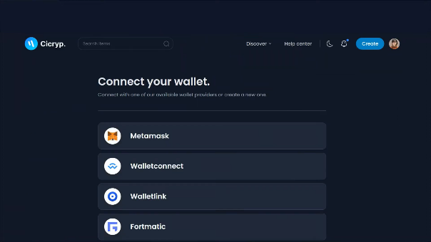We have observed users authenticate, engage with digital assets, stipulate NFT attributes, and ultimately generate tokens securely recorded on the blockchain. Smart contracts enforce ownership protocols, transactions, and royalties, while wallets serve as digital ownership repositories.

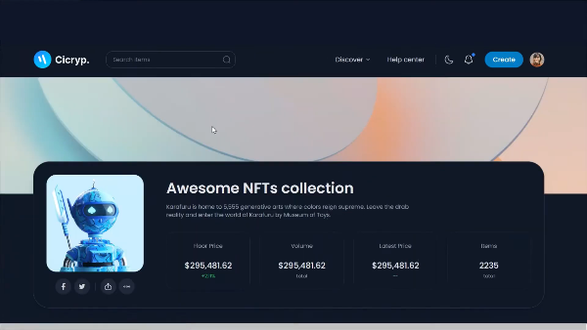In our study, we closely monitored how individuals verify their identities, interact with digital items, specify unique features for Non-Fungible Tokens (NFTs), and produce tokens that are reliably stored on the blockchain. Advanced automated agreements ensure adherence to rules regarding possession, exchanges, and fair compensation, whereas digital wallets act as secure storage spaces for digital ownership rights.

Our research delved into the intricacies of user authentication processes, the dynamics of digital asset engagement, the fine-tuning of attributes for NFTs, and the seamless generation of tokens with foolproof blockchain records. Smart contracts emerged as robust mechanisms for implementing ownership regulations, facilitating transparent transactions, and ensuring that

Creators receive due royalties for their creations. Additionally, digital wallets played a pivotal role as custodians of digital ownership, safeguarding assets and providing users with seamless access to their tokenized possessions.

By scrutinizing these key elements, our study sheds light on the intricate ecosystem of blockchain-based digital asset management. We provide insights into how individuals securely authenticate their identities, participate in the vibrant world of digital assets, tailor NFT characteristics to their preferences, and effectively tokenize their assets on a decentralized ledger. This research contributes to a deeper understanding of the mechanisms underpinning digital ownership in the blockchain era, paving the way for further advancements in decentralized asset management and distribution.

1. REFERENCES
2. Ali, O., Momin, M., Shrestha, A., Das, R., & Alhajj, F. **(2022)**. A review of the key challenges of non-fungible tokens, *(ELSEVIER).*

[https://doi.org/10.1016/j.techfore.2022.12](https://doi.org/10.1016/j.techfore.2022.122248) [2248](https://doi.org/10.1016/j.techfore.2022.122248)

1. Aulia Mochram, R. A., Makawowor, C. T., Michael Tanujaya, K., & V. Moniaga, J. **(2022)**. Systematic Literature Review: Blockchain Security in NFT Ownership. *(IEEE)*.

10.1109/IEIT56384.2022.9967897

1. Cai, W.,Wang, Z., Ernst, J.B., hong, Z., Feng, C, Leung, V.C.M **(2018)**.

Decentralized Applications: The Blockchain- Empowered Software System. *IEEE* Access (6), 53019-53033. DOI:

[https://doi.org/10.1109/ACCESS.2018.28](https://doi.org/10.1109/ACCESS.2018.2870644) [70644](https://doi.org/10.1109/ACCESS.2018.2870644)

1. Chance, C. **(2021)**. Non-fungible tokens: The global legal impact. Retrieved from: <https://www.cliffordchance.com/content/dam/cliffordchance/briefings/2021/06/non-fungible-tokens-the-global-legalimpact.pdf>
2. Steinmetz, F., Von Meduna, M, Ante, L., Fielder, I. **(2021)**. Ownership, uses and perceptions of cryptocurrency: Results from a population survey.

*Technological Forecastting and Social Change*, 173, DOI: htttps://doi.org/10.1016/j.techfore.2021.121073

1. Nakamoto, S. **(2008)**. Bitcoin: A Peer-to-Peer Electronic Cash System. Retrieved from <https://bitcoin.org/bitcoin.pdf>
2. Buterin, V. **(2013)**. Ethereum: A Next-Generation Smart Contract and Decentralized Application Platform. Retrieved

From: <https://ethereum.org/en/whitepaper/>

1. Tapscott, D., & Tapscott, A. **(2016)**. Blockchain Revolution: How the Technology Behind Bitcoin Is Changing Money, Business, and the World. Portfolio.
2. Casey, M. J., & Vigna, P. **(2018)**. The Truth Machine: The Blockchain and the Future of Everything. *St. Martin's Press*.
3. Antonopoulos, A. M. **(2017)**. Mastering Bitcoin: Unlocking Digital Cryptocurrencies. *O'Reilly Media*.
4. Mougayar, W. **(2016)**. The Business Blockchain: Promise, Practice, and Application of the Next Internet Technology. Wiley.
5. Narayanan, A., Bonneau, J., Felten, E., Miller, A., & Goldfeder, S. **(2016)**. Bitcoin and Cryptocurrency Technologies: A Comprehensive Introduction. *Princeton University Press*.
6. Swan, M. **(2020)**. The Bitcoin Standard: The Decentralized Alternative to Central Banking. Wiley.
7. Szabo, N. **(1997)**. The idea of smart contracts.

<http://www.fon.hum.uva.nl/rob/Courses/InformationInSpeech/CDROM/Literature/LOTwinterschool2006/szabo.best.vwh.net/idea.html>

1. Tapscott, D., & Tapscott, A. **(2018)**. Blockchain Revolution for the Enterprise: Technology, Business, and Government. Penguin.
2. Mayuresh Gulame et.al, Computational Intelligence and Blockchain in Biomedical and Health Informatics **2024**. *CRC Press*. <https://doi.org/10.1201/9781003459347>