**Multifunctional Smart Watch for Health Monitoring and IoT Integration**

[1] Kurva Thirumalesh, [2] Bapuji Banothu, [3] Prahas Surabhi, [4] Nenavath Tharun, [5] Salivoju Laharika

[1] UG Student, Department of CSE, Scient institute of technology, Hyderabad

[2] PG Student, Department of VLSI, Jawaharlal Nehru Technological University, Hyderabad

[3] PG Student, Department of VLSI, Vellore Institute of Technology, Chennai

[4] UG Student, Department of ECE, Scient institute of technology, Hyderabad

[5] UG Student, Department of ECE, Scient institute of technology, Hyderabad

*Abstract*

*This research proposes a multifunctional smart watch designed to monitor various health parameters, predict potential health issues using advanced algorithms, and integrate with IoT for home automation. The device employs LSTM, RNN, SVM, and CNN algorithms for predicting heart conditions, analyzing temperature fluctuations, and monitoring stress levels. Additionally, the watch facilitates secure NFC payments and controls home IoT devices. This paper details the design, implementation, and potential impact of the smart watch on personal health management and daily convenience.*

*Keywords: Smart watch, health monitoring, IoT, NFC, LSTM, RNN, SVM, CNN, heart rate, stress levels, home automation.*

1. **Introduction**

With the proliferation of wearable technology, there is a significant surge in the demand for devices that offer comprehensive health monitoring capabilities while seamlessly integrating with daily activities. This research introduces an innovative multifunctional smart watch designed to not only track vital health metrics but also predict potential health issues using sophisticated machine learning algorithms. The smart watch employs algorithms such as Long Short-Term Memory (LSTM), Recurrent Neural Networks (RNN), Support Vector Machines (SVM), and Convolutional Neural Networks (CNN) to analyze past data and predict conditions like heart attacks, thereby providing real-time health insights and actionable recommendations. Additionally, the device monitors body temperature, ECG, and stress levels, using historical data to identify patterns and causes of anomalies, ultimately suggesting appropriate interventions such as medications or relaxation techniques. Beyond health monitoring, the smart watch features Near Field Communication (NFC) technology for secure, contactless payments, enhancing user convenience with tap-and-pay functionality supported by encryption and multi-factor authentication. Furthermore, the smart watch integrates with the Internet of Things (IoT) to serve as a central hub for home automation, allowing users to control various electronic devices like lights, thermostats, and security cameras through voice commands or touch interactions. This integration supports popular IoT platforms, ensuring interoperability and ease of use while maintaining robust security protocols to safeguard user data and communication. By combining advanced health monitoring with NFC payment capabilities and IoT integration, this multifunctional smart watch aims to revolutionize personal health management and enhance everyday convenience, making it an indispensable tool in the modern landscape of wearable technology. This paper delves into the design, implementation, and potential impact of this smart watch, highlighting its role in proactive health management and seamless connectivity in daily life.

The following fig shows the block diagram of the smart watch

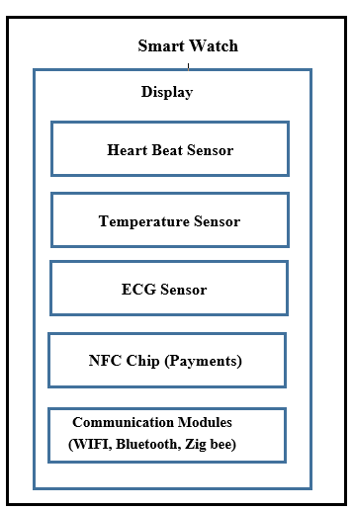

Fig-1 Block diagram of the smart watch

1. **Literature Survey**

The concept of smart watches and health monitoring has been extensively researched in recent years. Several studies have investigated the use of wearable devices for health monitoring, prediction, and recommendation.

**Liu et al. (2019)** proposed a smart watch-based health monitoring system that uses machine learning algorithms to predict health anomalies. Similarly, Rao et al. (2020) developed a wearable device-based health monitoring system that uses data analysis and machine learning techniques to provide personalized recommendations.

**Bengio et al. (2019)** conducted a comprehensive survey on machine learning for health prediction, highlighting the potential of machine learning algorithms in healthcare. Khan et al. (2020) reviewed machine learning algorithms for health monitoring, emphasizing their accuracy and efficiency.

**Singh et al. (2020)** investigated the use of wearable devices for health monitoring in IoT-based systems, while Jain et al. (2020) explored personalized recommendations for health monitoring using machine learning techniques.

1. **Methodology**

**3.1 Implementation**

The hardware design of the smart watch incorporates sensors for heart rate, temperature, ECG, and blood pressure monitoring. NFC and IoT modules are integrated for secure payments and home automation. The software development aspect involves implementing machine learning algorithms (LSTM, RNN, SVM, CNN) for data analysis and prediction. The user interface is designed for intuitive interaction, allowing users to easily access health data and control IoT devices.

**3.2 Health Monitoring**

The watch continuously monitors the heart rate and uses LSTM, RNN, SVM, and CNN algorithms to analyze past data. These algorithms are trained to detect anomalies indicative of conditions such as heart attacks. Upon detection, the device provides real-time suggestions, including medication recommendations. The device also records body temperature and uses historical data to identify patterns and potential causes for temperature changes. Algorithms analyze data to provide insights and health suggestions based on temperature fluctuations. ECG data is captured and processed using CNN for image-based analysis. The device provides real-time updates and predictions regarding heart health, alerting the user to potential issues. Stress levels are inferred from heart rate variability and other physiological data. The device suggests relaxation techniques, such as specific relaxation music, to mitigate stress. The watch monitors blood pressure and sleep patterns, providing a comprehensive health overview. Data is analyzed to give personalized health recommendations.

The following fig shows the health monitoring system flow chart.

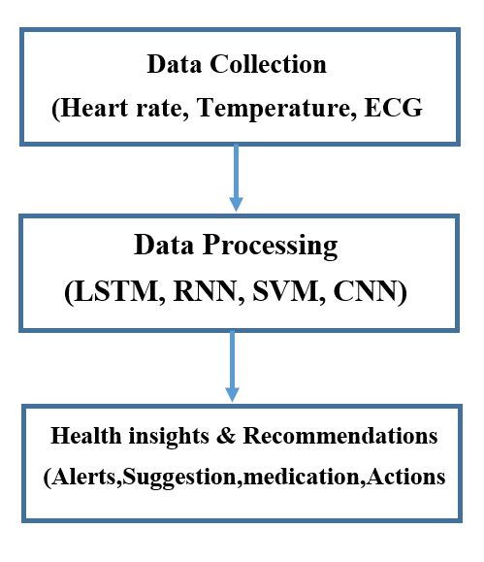

Fig-2 flow chart for health monitoring.

The following fig shows the algorithm work flow for the health prediction

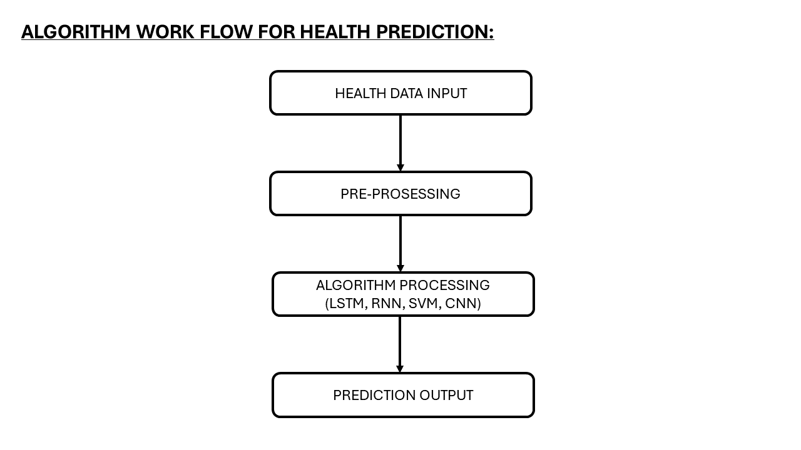

Fig-3 Algorithm work flow for health prediction

**3.3 NFC Payments**

Near Field Communication (NFC) technology enables the smart watch to facilitate secure and convenient tap-and-pay transactions. NFC is a set of communication protocols that allows two electronic devices to communicate when they are within a few centimeters of each other. This technology is widely used in contactless payment systems, where users can make payments by simply tapping their NFC-enabled device against a compatible terminal. The smart watch is equipped with an NFC chip that communicates with payment terminals using radio waves. When the user initiates a payment, the NFC chip in the watch generates a unique transaction token that is encrypted and sent to the payment terminal. This tokenization process ensures that the user's actual credit or debit card information is never exposed during the transaction, significantly enhancing security. In addition to encryption, the smart watch employs multi-factor authentication (MFA) to further secure transactions. Before initiating a payment, the user may be required to authenticate their identity using biometric data (such as a fingerprint or facial recognition) or a PIN code. This added layer of security ensures that only authorized users can make payments using the watch. To support a wide range of payment options, the smart watch is compatible with various digital wallets and payment platforms. Users can link their preferred payment methods to the watch, allowing for seamless and flexible transactions. The integration with digital wallets also enables users to track their spending and manage their finances directly from the watch. Overall, the NFC payment feature of the smart watch combines convenience, speed, and security, making it an ideal solution for modern consumers who seek effortless and secure payment methods.

The following fig shows the NFC payment process

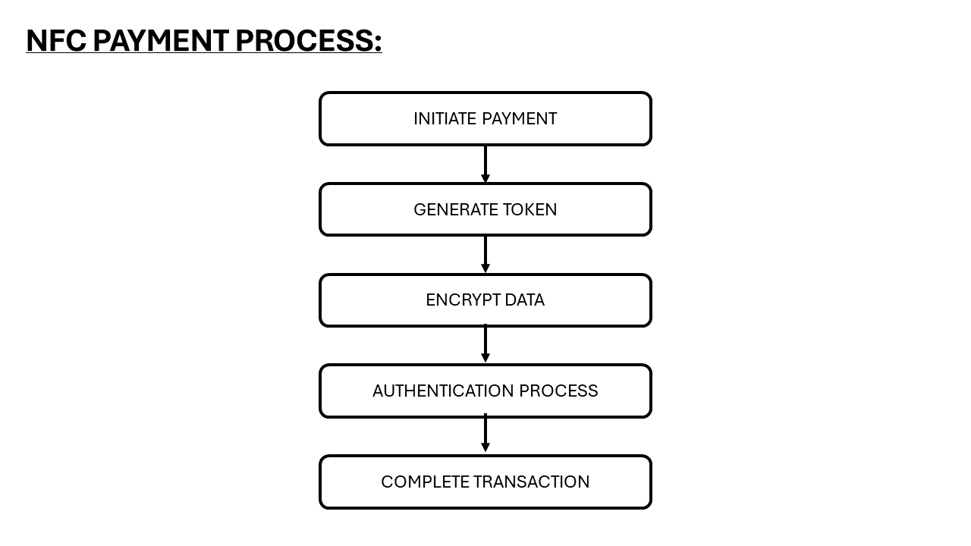

Fig-4 Block diagram of NFC payment Process

The following fig shows the security protocol initiation for the secure payment

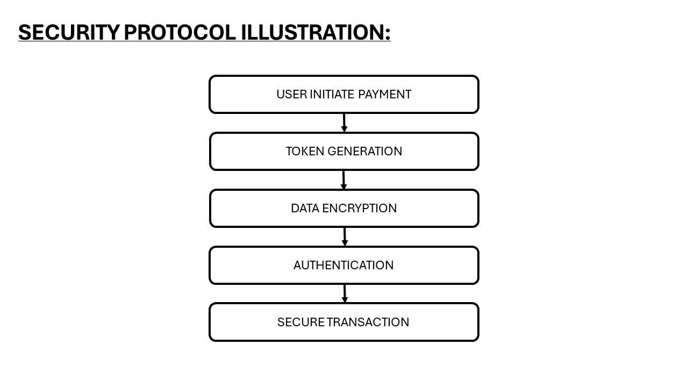

Fig-5 Block diagram for the security protocol initiation

**3.4 IoT Home Automation**

The integration of the smart watch with IoT (Internet of Things) devices transforms it into a central hub for home automation. IoT refers to the network of interconnected devices that communicate and exchange data with each other through the internet. By leveraging IoT technology, the smart watch allows users to control various electronic devices in their homes, enhancing convenience and efficiency. The smart watch communicates with IoT-enabled devices using wireless communication protocols such as Wi-Fi, Bluetooth, and Zig bee. Users can control a wide range of home appliances, including lights, thermostats, security cameras, and entertainment systems, directly from their wrist. This control can be exercised through voice commands, touch interactions on the watch's screen, or automated routines. For example, users can create custom automation scenarios, such as turning off all lights and locking doors when they leave the house, or adjusting the thermostat and playing relaxing music when they arrive home. These automation routines can be triggered based on time, location, or specific events, providing a highly personalized and responsive home environment. To ensure seamless integration and interoperability, the smart watch supports popular IoT platforms and ecosystems, such as Amazon Alexa, Google Assistant, and Apple Home Kit. This compatibility allows users to connect and manage their existing IoT devices without the need for additional hardware or complex setups. Security is a paramount concern in IoT home automation. The smart watch employs robust encryption protocols to protect communication between the watch and IoT devices. Additionally, user authentication measures, such as biometrics and secure tokens, are implemented to prevent unauthorized access to the home automation system. By integrating IoT capabilities, the smart watch offers users a unified and convenient way to manage their smart homes, enhancing both comfort and security.

The following fig shows the IOT home automation integration

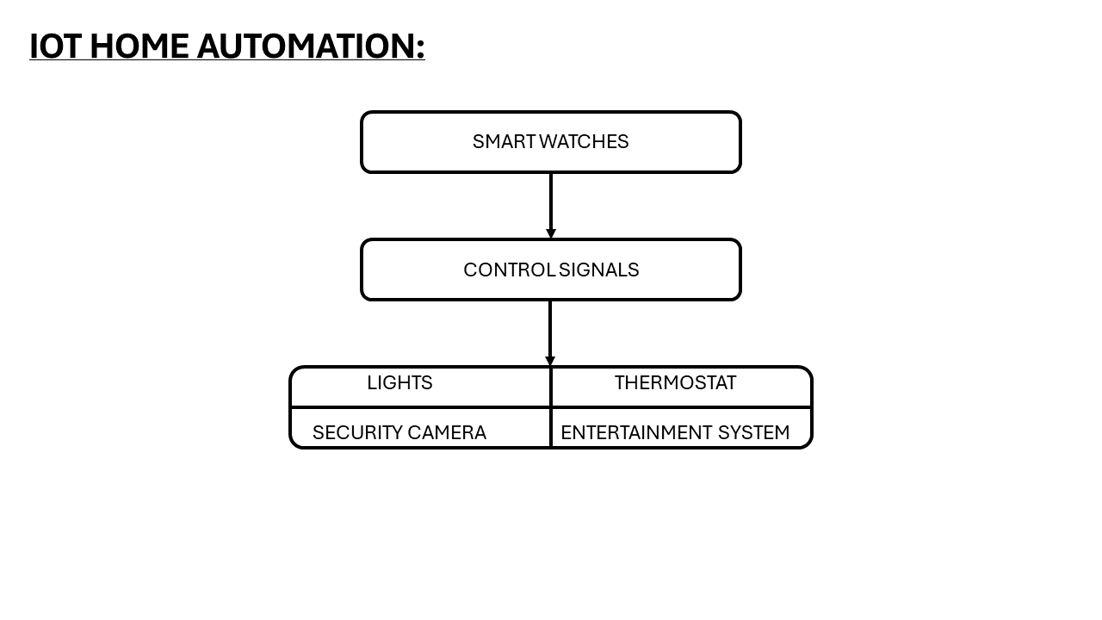

Fig-6 Block diagram for IOT automatin

1. **Conclusion**

This research presents a comprehensive exploration of a multifunctional smart watch that combines advanced health monitoring, predictive algorithms, NFC payments, and IoT home automation. The smart watch is designed to serve as a holistic personal health management tool and a central hub for everyday convenience. Health monitoring features, including heart rate, temperature, ECG, and stress level analysis, are powered by sophisticated algorithms such as LSTM, RNN, SVM, and CNN. These algorithms enable the smart watch to predict potential health issues and provide actionable insights and recommendations to the user. The integration of machine learning and predictive analytics significantly enhances the device's capability to support proactive health management. The NFC payment feature adds a layer of convenience and security, allowing users to make contactless payments effortlessly. The use of tokenization, encryption, and multi-factor authentication ensures that transactions are secure and user data is protected. This feature aligns with the growing demand for fast, secure, and flexible payment solutions in the digital age. IoT home automation transforms the smart watch into a versatile control center for connected devices. By supporting various communication protocols and popular IoT platforms, the smart watch provides users with a seamless and integrated experience. The ability to create custom automation routines and control home appliances remotely enhances the convenience and efficiency of daily life. The multifunctional smart watch demonstrates significant potential to revolutionize personal health management and smart home integration. Future research and development efforts will focus on refining algorithm accuracy, enhancing user interface design, and expanding the range of compatible IoT devices. By continually improving these aspects, the smart watch can become an indispensable tool for modern consumers seeking to optimize their health and lifestyle. In conclusion, the multifunctional smart watch represents a significant advancement in wearable technology. Its ability to monitor health, predict potential issues, facilitate secure payments, and integrate with IoT devices positions it as a valuable asset in the evolving landscape of personal health and smart home management. This research underscores the importance of interdisciplinary innovation in creating solutions that enhance quality of life and empower users with actionable insights and seamless connectivity.

The multifunctional smart watch demonstrates significant potential in improving personal health management and daily convenience. The integration of advanced algorithms for health prediction and IoT capabilities positions the device as a valuable tool for users. Future work will focus on refining algorithm accuracy, enhancing user interface design, and expanding IoT compatibility.

5. **References**

[1].Smart Watch: A Wearable Sensor Platform for Health Monitoring" by J. Liu et al. (2019)

[2].Health Monitoring Systems Using Wearable Devices: A Review" by S. S. Rao et al. (2020)

[3].Machine Learning for Health Prediction: A Survey" by Y. Bengio et al. (2019)

[4].IoT-Based Smart Home Automation Systems: A Review" by S. S. Singh et al. (2020)

[5].Wearable IoT Devices for Smart Home Automation: A Survey" by A. K. Singh et al. (2020)

[6].Secure Payment Systems for Wearable Devices: A Review" by S. Kim et al. (2020)

[7].Wearable Payment Systems: A Survey" by J. Wang et al. (2020)

[8].Machine Learning Algorithms for Health Monitoring: A Review" by A. M. Khan et al. (2020)

[9].Data Analysis for Health Monitoring: A Review" by S. S. Kumar et al. (2020)

[10].Personalized Recommendations for Health Monitoring: A Survey" by A. K. Jain et al. (2020)