**DESIGN OF TEXT RANK ALGORITHM FOR NEWS TEXT SUMMARIZATION**

B. Raju   
Assistant Professor  
Computer Science & EngineeringKakatiya Institute of Technology & Science, Warangal  
br.cse@kitsw.ac.in

Rusheek Ratna Reddy Gade  
Computer Science & EngineeringKakatiya Institute of Technology & Science, Warangal  
b20cs050@kitsw.ac.in Priyanka Kanakam  
Computer Science & EngineeringKakatiya Institute of Technology & Science, Warangal  
b20cs042@kitsw.ac.in

Kavya Sree Meesala  
Computer Science & EngineeringKakatiya Institute of Technology & Science, Warangal  
b20cs004@kitsw.ac.in Udaya Chandrika Ledalla  
Computer Science & EngineeringKakatiya Institute of Technology & Science, Warangal  
b20cs047@kitsw.ac.in

***Abstract*—*Through compressing the text while maintaining its essential information, automatic text summarization creates a summary. After that, users can read the summary to learn the essential information provided in the text. Among the primary types of research methodologies for summaries is the extraction summary method, which is frequently used in research literatures. Still, there are a few issues with this extraction summary technique. To address the problems, this paper suggests an automated text summarization technique built on an enhanced version of the TextRank algorithm. Using an ensemble model of cosine and BM25 similarity, this method determines the similarity of phrases and provides the (TextRank) TR scores of those sentences. According to the experimental results, compared to previous comparisons, the study approach finds less value in indicators like ROUGE-1, ROUGE-2, and ROUGE-L.***

**Keywords—*TextRank Algorithm, Automatic Text Summarization, Summary.***

# Introduction

Although automatic summarizing has the potential to be used for a wide range of information access applications, it has been widely utilized in natural language processing. Examples include question-answering systems, tailored recommendation engines, and tools that help consumers access and understand online material (such as news, social media, and product reviews). Single document summation has been recognized as one of the most essential summarizing tasks over time, it includes reducing a document's length without changing the information it contains [1].

These days, single document summarizing methods are data-driven, leveraging neural network architectures' success and their capacity to learn continuous features without the need for linguistic annotations or preprocessing tools [2]. Recent work has structured abstractive summarization as a sequence-to-sequence problem, using several rewriting techniques for text (e.g., reordering, deletion, substitution).

Textual data can be found in large amounts on the Internet because of social media networks, blogs, digital resources, news, websites, and other user reviews. Furthermore, there is a huge amount of textual material on the different archives of books, novels, news articles, legal documents, scientific studies, and biomedical documents, among other materials. Textual material is being added to archives and the Internet on a regular basis at an exponential rate [3]. Consumers frequently struggle to understand the textual content of search results and end up spending a considerable amount of time looking for information. The resultant texts include an extensive amount of repetition and unnecessary resources. It is therefore much more important and essential to summarize and condense the written resources. The process of manually summarizing takes a lot of effort and time and is expensive [4]. This large amount of textual information is practically impossible for humans to manually summarize. The key to overcoming this challenge is automatic text summarization (ATS). A summary that compresses the primary ideas from the input document into concised text, while minimizing repetition is the primary goal of an ATS system. Users can quickly understand the main concepts of a document without having to read it cover throughout with the use of ATS systems [5].

The summaries that are generated automatically will help users and save them a great deal of effort and time. Maybury (1995) provided the following definition of an automated summary: " Through highlighting the most crucial details from a source (or sources), a successful summary creates a shorter version of the initial content for a specific user(s) and task(s)". " A summary can be generally defined as a text generated from gathered resources which are originated from various articles, that provides an understanding of the original article or text, and it is frequently substantially concised version of the original text or texts, and it is half the size of original text(s). Text can be many entities like multimedia documents, speech, hypertexts etc. [6]. The resulting summary should contain the most important information from the input text, which should be shorter than the original text. Systems for summarizing many documents or only one document might be categorized as ATS systems. While the latter creates the summary from a collection of documents, the former does it from a single document [7]. ATS systems are created using one of the three text summarizing techniques: hybrid, extractive, or abstractive. The summary is produced by the extractive technique, this takes over the data provided and chooses the most important sentences. The abstractive method creates a summary using sentences and words that are different from those in the original text following an intermediate representation of the input content [8].

Text summarizing is essential for quickly obtaining important information from text content because there is a vast volume of textual data available in the information age. Text summary attempts to provide a condensed version of a document while keeping all of its important information [9]. Text summarization can be used extensively in a number of contexts, including sentence construction, question answering, legal document summarization, event summary, news summary, email summary, social media (blogs or tweets) summary, and review summarization. However, for many such activities, manual text summarizing becomes impossible due to its high time, effort, and financial resource requirements [10].

# Literature Survey

C. Limploypipat and N. Facundes., et.al [11] present text summary of COVID-19 news using an abstractive approach to approximate human summary. Abstractive text summarization, which uses natural language processing techniques to reproduce or rephrase material based on interpretation and understanding, is more like to human methodology. R. A. Rofiq and Suyanto., et.al [12] Automatic text summarization will be conducted by applying the GongLiu, Steinberger Jezek, and Cross approaches to the latent semantic analysis method. Local news related to politics will be used to test the test data. Based on a rate comparison of the three previously described approaches, Gongliu is considered the best way because it has the fastest processing time and the highest Rogue value. Y. Chen and Q. Song., et.al [13] provide a better solution to the abstractive summarization method's subject differences issue. They integrate the BART model with TextRank. To acquire a complete summary, we supply the newly added texts mentioned above into the BART model once again. Rouge-1, Rouge-2, and Rouge-L have improved average recall scores by 1.5%, 0.5%, and 1.3%, respectively, based on the trial results, when compared to a single BART model.

A. Mishra, A. Sahay, M. a. Pandey and S. S. Routaray, et.al [14] suggest use text summarization and the Natural Language Toolkit (NLTK) to conduct a text sentiment analysis on news content. Text summary enables the reduction of text or data size without sacrificing information. Long text pages are quite hard to manually summarize at the same time. Identifying and presenting the most important information from the provided text data is the main objective of the suggested text summarization methodology. F. Octavianus, A. Wihardi, M. K. Ario and D. Suhartono, et.al [15] created an automated topic detection and text summarizing system for news stories, making important information accessible to the public without losing important details. When it came to subject detection, the Support Vector Machine performed. A. P. Widyassari, E. Noersasongko, A. Syukur and Affandy,, et.al [16] A proposed preprocessing composition of seven phases is designed to clean text input and prepare it for data entry into summary methods like machine learning. A newspaper used the DUC 2002 dataset, the preprocessing model was evaluated. Recall, accuracy, and F-1 of the ROUGE-1 measurements were used to integrate the recommended preprocessing step for extractive summarization with additional comparative preprocessing stages, the performance of that stage was better. Barman U., Barman V., Rahman M. and Choudhury N. K., et.al [17] Various domain-neutral algorithms like as TextRank for different news article summarization domains are investigated, examining their efficiency in domain-specific tasks and conveniently obtaining different insights. Semantic cosine similarity was combined with NLP-based preprocessing techniques and static word embeddings to efficiently rank textual data and evaluate performance across many BBC News Article Summarization dataset domains using ROUGE metrics. An excellent ROUGE score is attained.

J. Chen and H. Zhuge, et.al [18] suggests an approach for captioning news images that summarizes the news text depending on the query image, implementing the model of attentional encoder-decoder. To compute the context vector, a multi-modal attentional technique is provided. The proposed approach performs better than both the text summarization and generic image captioning, according to experiments conducted on the DailyMail test dataset. Y. Du and H. Huo, et.al [19] genetic algorithm (GA), multi-feature, and fuzzy logic rules as basis, it is proposed a new automatic news content summarizing model. The first and most significant characteristic is word features; each word is given a score, and words that score higher than a certain limit are extracted as keywords. Each feature is given a weight through a genetic algorithm, and there are sentence features in the second set of data. Each sentence's significance is indicated by a linear combination of these qualities. To obtain automatic summarization, we finally compute the final score using a fuzzy logic structure. The ROUGE assessment method was used to evaluate the outcomes of the proposed method with those of other methods, such as Ranking SVM, SDS-NNGA, GCD, SOM, System19, System21, System31, and MS word.

M. Afsharizadeh, H. Ebrahimpour-Komleh and A. Bagheri, et.al [20] The methodology of extracting the most informative sentences is offered as a query-oriented text summarizing method. The ROUGE criteria have been applied in order to evaluate the automatically generated summaries. Gualti V, et.al [21] suggested productive approach for generating text summaries from an article by integrating conventional TextRank Algorithm with BM25 to produce improved results.

Karthik V, et.al [22] aimed to design text summarize which takes news article as input, using natural language processing and sequence architecture which has an mechanism to have attention details and important points, which helps in retaining the key points in summary. Anushka Gupta, Diksha Chugh, et.al [23] worked on automated news summarization using transformer based pre trained language models which produced enhanced results in generating accurate and sound summaries.

Tomer M, Rathie D and Kumar M [24] used an ensembled approach using RNN model based on LSTM architecture for generating extractive summarization, later on the summary generated is given as input for abstractive summarization. Singh P, Chhikara P, et.al [25] worked on extractive summarization by experimenting with several machine learning algorithms including Naïve Bayes, SVM models, Logistic Regression. These results are compared, analyzed and finally proposed an ensemble approach which produces better results. Jain M, Rastogi H, et.al [26] the methodology is used for extractive summarization based on centrality measures and cosine similarity. The resultants work better than LSA, Luhn and LexRank summarizers. Mallick C, et.al [27] used modified TextRank, the graph is generated using inverse sentence frequency cosine similarity for assigning weights to words. Performance of the model shows effective results as the graphs are sparse and categorized into clusters. Mir Tafseer Nayeem and Yllias Chali [28] aimed to develop Multi-Document Summarization by implementing a rank-based sentence selection. This methodology bought improvements by using Continuous vector representations.

S. Gunasundari, M. Jenifer Shylaja, et.al [29] aimed to achieve great accuracy in summaries by making use of Page Ranking algorithm and cosine similarity. Nenkova A and McKeown K [30] This paper have various approaches for automatic text summarization. It gives an overview on summarizing techniques, choosing sentences, scoring and summary generation.

# Design of TextRank Algorithm for News Text Summarization

In this section, block diagram for design of text rank algorithm for news text summarization is observed in Fig.1

After the input text is provided to the user, it is tokenized into a text sentence. If input is not text, then summarization will be ended. After the tokenized input, if sentence is having stop words, then stop words will be removed. If stop words are not available, then proceed for further process without stop words. After removing stop words similarity between words are built by using build similarity matrix. By observing the similarity, the sentences will be ranked. Then the ranked sentences will be selected from top ‘N’ position. The after that order summary will be generated. Then the generated summary will be displayed to the user.

Produced summarizing is the process of compressing an extensive a document into a short, accurate, and readable summary. The increasing volume of text data available online, presents opportunities for the development of automatic text summarizing techniques. This could allow the faster discovery and consumption of relevant data. Within the fields of machine learning and natural language processing (NLP), tokenization is the act of separating a text sequence into smaller units called tokens.

The length of these tokens might vary from words to characters. Stop words can be described as the words present in a language which are often used and contribute little importance to the context. Some common stop words used in English are "is," "a," "are," "the," “an” and so forth. In text mining and natural language processing (NLP), stop words are frequently used to weed out terms that are so frequently used that they fail to express much important data. Sentences are ranked in extractive and single-document text summarization using TextRank, a graph-based ranking algorithm, as compared to web pages. It does this by using an undirected network. The PageRank algorithm represented as its model. Therefore, in this similarity matrix, cosine similarity and BM25 is used.

## Cosine Similarity

Cosine Similarity is a metric measure which compares two vectors representing the text of the news article. It measures the cosine angle between the vectors in terms of direction or orientation. In order for both vectors to result in a scalar through inner product multiplication, they are a component of the same inner product space. The cosine of the angle that separates two vectors indicates the similarity they are to one another.

Cosine Similarity (A,B)=1- Cosine_distance (A,B) (1)

Cosine_distance(A,B)= $\frac{A.B}{\left\|A\right\|.\left\|B\right\|}$ (2)

## BM25

A combination of its efficiency in generating relevant search results and ease of use, BM25 is a ranking algorithm that is frequently utilized. In order to address the problem of document length bias, it considers both term frequency and document length normalization

The BM25 formula for calculating the similarity score between two sentences (documents) consists the following terms: Here, Di and Dj are the two documents (sentences) being compared. Common terms is the set of terms that are common to both documents. IDF(t) is the inverse document frequency of the terms t. TFi(t) and TFj (t) are the terms frequencies of term t in documents Di and Dj respectively. K1 and b are parameters controlling term saturation and document length normalization. Doc_lengthi and Doc_lengthj are the documents Di and Dj respectively. ‘avg_doc_length’ is the corpus's average document length.

IDF (t) = $\log\left(\frac{N-n\left(t\right)+0.5}{n\left(t\right)+0.5}\right)$ (3)

*BM25(Di, Dj*)=

(4)

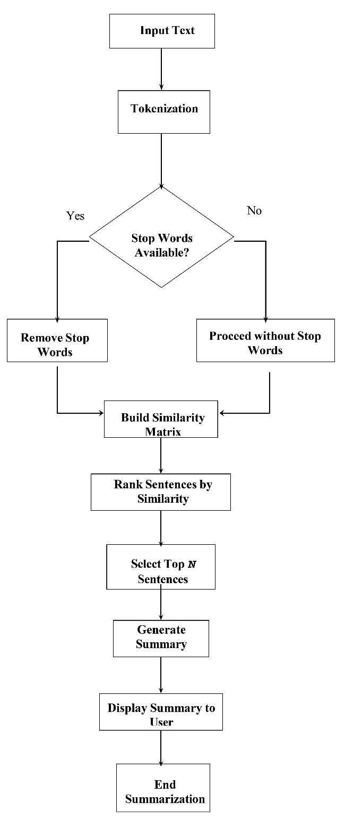

##### Fig. 1. Block Diagram for Design of Text Rank Algorithm for News text Summarisation

# Experimental Analysis

Similarity metrics are the mathematical measures which play a crucial role by quantifying the similarity between two data points or entities. Similarity metrics have significance in various fields like machine learning, Natural Language Processing (NLP) and data mining. Although similarity metrics are of many types, but the choice of similarity metrics depends entirely on specific requirements and nature of data. The similarity metrics we have used for analysis purposes are as follows.

## Jaccard Similarity

Jaccard Similarity is a metric measure of similarity between two binary vectors which are asymmetric. It used for determining the similarity between two sets. It is a widely used proximity metric to determine the similarity of two objects, such two or more articles, are to one another. The index is between 0 and 1.

J(A,B) = / 

Where:

* indicates the number of elements in sets A and B, or the intersection between them.
* ‘ $\left|A∪B\right|$ indicates the total number of distinctive objects that are in sets A and B, or the union of those sets.

## Word Embedding

A word embedding is word representation in natural language processing. Text analysis makes use of the embedding. The representation is usually a real-valued vector that encodes the word meaning so that words closer to each other in the vector space are assumed to have comparable meanings.

## Overlap Coefficient

By calculating the overlapping area of two distributions' distribution functions, the overlap coefficient (OVL) compares the similarity of two distributions are to one another.

OC (A,B)= $\frac{\left|A∩B\right|}{min⁡(\left|A\right|,\left|B\right|)}$ (6)

Where:

* $\left|A∩B\right|$ Indicates the size of the set A and set B intersection.
* $\left|A\right| and \left|B\right|$ Indicates, consequently, the sizes of sets A and B.

## Rouge Scores

A collection of measures known as the ROUGE score is frequently applied to text summarization tasks, the aim of which is to automatically provide a brief summary of a lengthy text. ROUGE was created to evaluate the quality of summaries. It is basically obtained by performing comparison of generated summaries with human-provided reference summaries.

ROUGE-1 refers to the overlap that exists between the reference summary and the system for unigrams (per word).

ROUGE-2 is used to describe the bigram overlap between reference summaries and the system. ROUGE-L is the abbreviation for Longest Common Subsequence (LCS) orientation. The longest word sequence that remains in the same order throughout the candidates and reference summaries is called LCS. The longest word sequence is automatically included.

## Precision

The ability of a system to generate only relevant results is measured by precision.

Precision= $\frac{True Positives}{True Positives+False Positives}$ (7)

## Recall

Recall is the metric measure which defines frequency of true positives out of all real positive examples or samples in the dataset.

Recall = $\frac{True Positives}{True Positives+False Negatives}$ (8)

## F1-score

The evaluation matrix known as the F1-score takes the average of the two matrices, Precision and Recall, to create a single metric. To put it simply, F1 score is the weighted average of Recall and Precision .

F1- Score = $\frac{2*Precision*Recall}{Precision+Recall}$ (9)

# Result

In this section, result analysis of design of text rank algorithm for news text summarization is observed. Consider two results for analyzing the quality of generated summary. For analyzing the quality of automate generated summaries, we have taken few other metrics like Jaccard Similarity, Word Embedding and Overlap Coefficient. The results are evaluated using Rouge scores.

TABLE I Comparison table

|  |  |  |  |
| --- | --- | --- | --- |
| **Metric** | **Rouge-1** | **Rouge-2** | **Rouge-L** |
| Cosine Similarity | 0.6523 | 0.4858 | 0.5602 |
| Jaccard Similarity | 0.4717 | 0.4309 | 0.4734 |
| BM25 | 0.6486 | 0.5702 | 0.6406 |
| Word Embedding | 0.4483 | 0.3838 | 0.4458 |
| Overlap Coefficient | 0.3714 | 0.4309 | 0.3734 |
| Proposed Model | 0.8394 | 0.7848 | 0.7304 |

As shown in table 1, among all metrics the proposed model which includes cosine similarity and BM25 has highest rouge values with 0.8394, 0.7848, 0.7304 as Rouge-1, Rouge -2 and Rouge-L respectively.

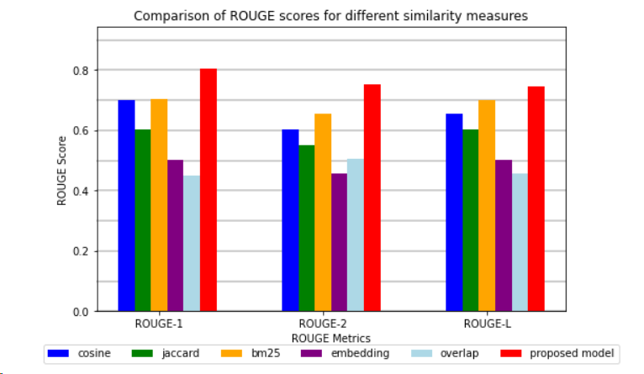

##### Fig. 2. Comparison Graph

The graphical representation of Rouge-1, Rouge-2 and Rouge-L are compared in Fig.2

TABLE 2 Comparison table

|  |  |  |  |
| --- | --- | --- | --- |
| **Metric** | **Rouge-1** | **Rouge-2** | **Rouge-L** |
| Cosine Similarity | 0.6501 | 0.5502 | 0.6003 |
| Jaccard Similarity | 0.6002 | 0.5003 | 0.5504 |
| BM25 | 0.6701 | 0.6002 | 0.6503 |
| Word Embedding | 0.5003 | 0.4504 | 0.4901 |
| Overlap Coefficient | 0.4502 | 0.5003 | 0.4603 |
| Proposed Model | 0.7004 | 0.6505 | 0.6878 |

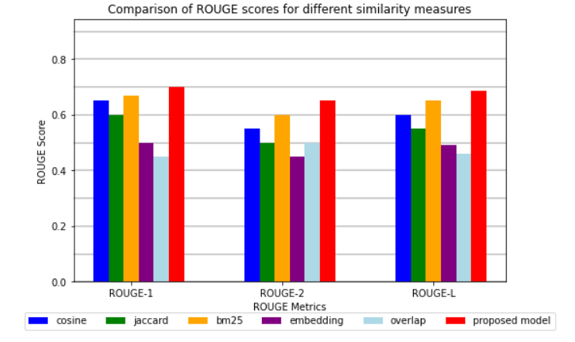

##### Fig. 3. Comparison Graph

In the above comparison table, the comparison between Cosine Similarity, Jaccard Similarity, BM25, Word Embedding, Overlap Coefficient and Proposed Model (Cosine Similarity and BM25) is done. The proposed model which is an ensembled model of cosine similarity and BM25 shows better results among all similarity metrics as shown in Fig 3.

# Conclusion

In this section, design of textrank algorithm for text summarization is concluded. The text will be compressed while preserving its essential information for the summary to be produced by the automatic text summarization. As a result, the (TextRank) TR scores of the sentences were calculated using the Ensembled model of cosine similarity and BM25 similarity to determine sentence similarity. According to the experimental data, compared to previous studies, such as ROUGE-1, ROUGE-2, and ROUGE-L, the methodology provided in this study has better assessment indicators.

##### References

[1] P. Gupta, S. Nigam and R. Singh, "A Ranking based Language Model for Automatic Extractive Text Summarization," 2022 First International Conference on Artificial Intelligence Trends and Pattern Recognition (ICAITPR), Hyderabad, India, 2022, pp. 1-5, doi: 10.1109/ICAITPR51569.2022.9844187.

[2] A. Kaddour, N. Zellal and L. Sayad, "Improving text classification using text summarization," 2022 2nd International Conference on New Technologies of Information and Communication (NTIC), Mila, Algeria, 2022, pp. 1-8, doi: 10.1109/NTIC55069.2022.10100492.

[3] M. S M, R. M P, A. R E and E. S. G SR, "Text Summarization Using Text Frequency Ranking Sentence Prediction," 2020 4th International Conference on Computer, Communication and Signal Processing (ICCCSP), Chennai, India, 2020, pp. 1-5, doi: 10.1109/ICCCSP49186.2020.9315203.

[4] T. B. Mirani and S. Sasi, "Two-level text summarization from online news sources with sentiment analysis," 2017 International Conference on Networks & Advances in Computational Technologies (NetACT), Thiruvananthapuram, India, 2017, pp. 19-24, doi: 10.1109/NETACT.2017.8076735.

[5] J. Deny, S. Kamisetty, H. V. R. Thalakola, J. Vallamreddy and V. K. Uppari, "Inshort Text Summarization of News Article," 2023 7th International Conference on Intelligent Computing and Control Systems (ICICCS), Madurai, India, 2023, pp. 1104-1108, doi: 10.1109/ICICCS56967.2023.10142549.

[6] F. Maryana, A. Kurniawati and D. Agusten, "Term Frequency Method For Automated Text Summarization Application Of Indonesian News Article," 2018 Third International Conference on Informatics and Computing (ICIC), Palembang, Indonesia, 2018, pp. 1-7, doi: 10.1109/IAC.2018.8780443.

[7] D. Kosmajac and V. Kešelj, "Automatic Text Summarization of News Articles in Serbian Language," 2019 18th International Symposium INFOTEH-JAHORINA (INFOTEH), East Sarajevo, Bosnia and Herzegovina, 2019, pp. 1-6, doi: 10.1109/INFOTEH.2019.8717655.

[8] S. Kemahduta, S. W. Sihwi and W. Widiarto, "Automatic Text Summarization with Categorization on Online News About Indonesian Public Figures Using Fuzzy Logic Method," 2021 International Conference on Artificial Intelligence and Big Data Analytics, Bandung, Indonesia, 2021, pp. 10-15, doi: 10.1109/ICAIBDA53487.2021.9689755.

[9] T. Priyadharshan and S. Sumathipala, "Text Summarization for Tamil Online Sports News Using NLP," 2018 3rd International Conference on Information Technology Research (ICITR), Moratuwa, Sri Lanka, 2018, pp. 1-5, doi: 10.1109/ICITR.2018.8736154.

[10] D. Taeho Jo, "Validation of Graph Based K Nearest Neighbor for Summarizing News Articles," 2019 International Conference on Green and Human Information Technology (ICGHIT), Kuala Lumpur, Malaysia, 2019, pp. 66-69, doi: 10.1109/ICGHIT.2019.00022.

[11] C. Limploypipat and N. Facundes, "Abstractive Text Summarization for Covid-19 News with Data Augmentation," 2022 International Conference on Digital Government Technology and Innovation (DGTi-CON), Bangkok, Thailand, 2022, pp. 56-59, doi: 10.1109/DGTi-CON53875.2022.9849194.

[12] R. A. Rofiq and Suyanto, "Indonesian News Extractive Text Summarization Using Latent Semantic Analysis," 2021 International Conference on Computer Science and Engineering (IC2SE), Padang, Indonesia, 2021, pp. 1-5, doi: 10.1109/IC2SE52832.2021.9792010.

[13] Y. Chen and Q. Song, "News Text Summarization Method based on BART-TextRank Model," 2021 IEEE 5th Advanced Information Technology, Electronic and Automation Control Conference (IAEAC), Chongqing, China, 2021, pp. 2005-2010, doi: 10.1109/IAEAC50856.2021.9390683.

[14] A. Mishra, A. Sahay, M. a. Pandey and S. S. Routaray, "News text Analysis using Text Summarization and Sentiment Analysis based on NLP," 2023 3rd International Conference on Smart Data Intelligence (ICSMDI), Trichy, India, 2023, pp. 28-31, doi: 10.1109/ICSMDI57622.2023.00014.

[15] F. Octavianus, A. Wihardi, M. K. Ario and D. Suhartono, "Automated Text Summarization and Topic Detection on News Aggregation System Using BART and SVM," 2022 International Symposium on Information Technology and Digital Innovation (ISITDI), Padang, Indonesia, 2022, pp. 108-113, doi: 10.1109/ISITDI55734.2022.9944521.

[16] A. P. Widyassari, E. Noersasongko, A. Syukur and Affandy, "The 7-Phases Preprocessing Based On Extractive Text Summarization," 2022 Seventh International Conference on Informatics and Computing (ICIC), Denpasar, Bali, Indonesia, 2022, pp. 1-8, doi: 10.1109/ICIC56845.2022.10006998.

[17] U. Barman, V. Barman, M. Rahman and N. K. Choudhury, "Graph Based Extractive News Articles Summarization Approach leveraging Static Word Embeddings," 2021 International Conference on Computational Performance Evaluation (ComPE), Shillong, India, 2021, pp. 008-011, doi: 10.1109/ComPE53109.2021.9752056.

[18] J. Chen and H. Zhuge, "News Image Captioning Based on Text Summarization Using Image as Query," 2019 15th International Conference on Semantics, Knowledge and Grids (SKG), Guangzhou, China, 2019, pp. 123-126, doi: 10.1109/SKG49510.2019.00029.

[19] Y. Du and H. Huo, "News Text Summarization Based on Multi-Feature and Fuzzy Logic," in IEEE Access, vol. 8, pp. 140261-140272, 2020, doi: 10.1109/ACCESS.2020.3007763.

[20] M. Afsharizadeh, H. Ebrahimpour-Komleh and A. Bagheri, "Query-oriented text summarization using sentence extraction technique," 2018 4th International Conference on Web Research (ICWR), Tehran, Iran, 2018, pp. 128-132, doi: 10.1109/ICWR.2018.8387248.

[21]Gulati, V., Kumar, D., Popescu, D., & Hemanth, D. J. (2023). *Extractive article summarization using integrated TextRank and BM25+ algorithm.* *Electronics (Basel)*,*12*(2),372. https://doi.org/10.3390/electronics12020372

[22] Karthik V, Naveen L, Ananda Raj. *Abstractive text summarizer: A comparative study on Dot product attention and cosine similarity*. (2021b, September 15). IEEE Conference Publication

[23] Anushka G, Diksha C, Anjum, Rahl K. *Automated News summarization using Tansformers.*

[24] Tomer, M., Rathie, D., & Kumar, M. (2021b). Ensembled approach for text summarization. In *Advances in intelligent systems and computing* (pp. 709–719). https://doi.org/10.1007/978-981-16-2597-8_61

[25] Singh, P., Chhikara, P., & Singh, J. (2020). An Ensemble Approach for Extractive Text Summarization. 2020 International Conference on Emerging Trends in Information Technology and Engineering (ic-ETITE). doi:10.1109/ic-etite47903.2020.95

[26] Jain, M., & Rastogi, H. (2020). Automatic Text Summarization using Soft-Cosine Similarity and Centrality Measures. 2020 4th International Conference on Electronics, Communication and Aerospace Technology (ICECA). doi:10.1109/iceca49313.2020.9297583

[27] Mallick, C., Das, A. K., Dutta, M., Das, A. K., & Sarkar, A. (2018). *Graph-Based Text Summarization Using Modified TextRank. Advances in Intelligent Systems and Computing, 137–146.* doi:10.1007/978-981-13-0514-6_14

[28] Mir Tafseer Nayeem and Yllias Chali. *Ensembled Extract with Order for coherent Multi – Document Summarization, 25 Jun 2020, arXiv:1706.06542v2 [cs.CL].*

[29] Dr.S. Gunasundari, M. Jenifer Shylaja, Dr.S. Rajalaksmi, Mrs.KC.Aarthi. *Improved Driven Text Summarization using PageRanking Algorithm and Cosine Similarity.* Eur. Chem. Bull. 2023, 12 (Special Issue 6), 4650– 4662

[30] Nenkova, A., & McKeown, K. (2012). *A Survey of Text Summarization Techniques. Mining Text Data, 43-76.* doi:10.1007/978-1-4614-3223-4_3, 10.1007/978-1-4614-3223-