**Exploring Mathematical Concepts in RamcharitManas: A Unique Perspective on ‘Navadha Bhakti’**

1Ram Bushan, 2Pawan Kumar ,3Shivesh Mani Tripathee \*

*1Department of Computer Science & Engineering*

*BabuBanarasi Das Institute of Technology & Management Lucknow, India*

*2,3Department of Applied Sciences and Humanities, IET,*

*Dr Shakuntala Misra National Rehabilitation University, Lucknow, India*

***Email:*** *1*[*bhushan.ram@gmail.com*](mailto:bhushan.ram@gmail.com)*,* [*2satgurukripadrpawan@gmail.com*](mailto:2satgurukripadrpawan@gmail.com)*, \*3*[*shiveshmanitripathee@gmail.com*](mailto:shiveshmanitripathee@gmail.com)

**Abstract:**

*This abstract examines the intertwining of mathematics and spirituality in "RamcharitManas." It investigates the integration of numerical concepts into the narrative, presenting a unique perspective on Navadha Bhakti. The analysis underscores the symbolic importance of mathematical elements, providing an enriching viewpoint that enhances our comprehension of both mathematical symbolism and devotional practices in the epic.*

*In this paper we have discussed the nine fold of Navadha Bhakti on the basis of Set Theory. It is also shown that the union of all nine folds of Navadha bhakti makes a universal set N.*

***Keywords:*** *Navdha bhakti, Ramcharitmanas, mathematical concept, spirituality, set theory.*

1. **Introduction:**

In this paper, we explore the fascinating convergence of mathematical concepts and spirituality in the enduring epic, "RamcharitManas." Our focus is to symbolise nine folds of Navadha Bhakti in the form of sets, providing a unique perspective on “Navadha Bhakti”, the nine-fold path of devotion. This study unfolds against the backdrop of Tulsidas' seminal work, seeking to unveil the profound significance inherent in the mathematical components interwoven into the narrative [Goswami Tulasidas(1574 CE), Sambvat (1631), Chinmayananda, Swami, (2002), Goyandka, Shri Harikrishnadas, (2006), Goyandka, Jayadayal, (2011), Karanbelkar, Dr. P.V., (2013), Saraswati, Swami Akhandananda (tr), (2004), Swami Prabhupada, A.C., Autry, J. (2001). Bennis, W. and Goldsmith, J. (1997].

The core of this investigation lies in unveiling an original perspective that enhances comprehension of both mathematical symbolism and the devotional practices intermingled in the fabric of "RamcharitManas." While navigating this interdisciplinary landscape, our analysis aims to elucidate the symbolic layers of mathematical elements, bringing to light their role in the depth and complexity of the epic.



**Fig.1. Lord Ram Preaching Mata Shabari About Navadha Bakti**

Our goal is to present a nuanced view point that not only widens scholarly dialogue but also nurtures a heightened appreciation for the intricate interplay between mathematics and spirituality within this literary masterpiece.

When lord Ram met Mata Shabari duration the exile of forest when he was searching Mata Seeta then he taught Navdha Bhakti to Mata Shabri which is given below.

*“Navadhaa Bhagati Kahaun Tohi Pahee.*

*Savdhan Sun Dharu Man Maahee.*

*Pratham Bhagati Santan Kar Sangaa.*

*Dusari Rati Mam Katha Prasanga.*

*Guru Pad Pankaj Seva Teesari Bhagati Amaan,*

*Chauthi Bhagati Mam Gun Gan Karai Kapat Taji Gaan.*

*Mantra Jaap Mam Dridh Vishwasha.*

*Pacham Bhajan So Ved Prakasha.*

*Chhath Dam Sheel Birati Bahu Karma.*

*Nirat Nirantar Sajjan Dharma.*

*Saatav Sam Mohi May Jag Dekhaa.*

*Moten Sant Adhik Kar Lekhaa.*

*Aathav Jathalaabh Santoshaa.*

*Sapnehun Nahi Dekhai Pardosh.*

*Navam Saral Sab San Chhalheena.*

*Mam Bharos Hiyan Harash Na Deena”*

***[Ramcharitmanas by Tulasidas]***

Explanation of these lines are given below in methodology.



**Fig.2. Bhakt Shiromani Goswami Tulasidas**

1. **Methodology:**

$N_{1}$ and $N_{2}$**.**

***“Navdhaa Bhagati Kahaun Tohi Pahee, Savdhan Sun Dharu Man Maahee.***

***Pratham Bhagati Santan Kar Sangaa, Dusari Rati Mam Katha Prasanga****.”*

A person who forges companionship with virtuous individuals fulfils the initial devotion of Navadha Bhakti, as mentioned in Ramcharit Manas. Here, $c_{v}=company of virtuous persons$ this implies that $N_{1}=\{c_{v}\}$ is a singleton set.

One achieves the second devotion of Navadha Bhakti, as delineated in RamcharitManas, by finding joy upon hearing the story of Ram. Here,

$h_{j}=collection of those persons which are happy with listning rambhajan$ this implies that $N_{2}=\{h_{j}\}$ is singleton set

$N_{3}$ and $N_{4}$**:**

***“Guru Pad Pankaj Seva Teesari Bhagati Amaan,***

***Chauthi Bhagati Mam Gun Gan Karai Kapat Taji Gaan”.***

Eliminating: "By forsaking pride and faithfully serving the Sat Guru, one achieves the third stage of devotion in Navadha Bhakti as outlined in Ramcharit Manas." Here are two elements in set $N_{3}s_{g} and p_{f}$ i.e $N_{3}=\{s_{g}, p_{f}\}$ where $S_{g}$ = collection of those persons faithfully serving the Sat guru and $p_{f}$ =collection of persons forsaking pride i.e. $N_{3}$ is finite set.

The person who, leaving aside deceit and deceit, sings praises of all the virtues of Lord Rama, attains the fourth bhakti of Navadha Bhakti mentioned in Ramcharit Manas. Here are two elements $d_{l}$ and $r_{s}$ where

$N_{4}=\{d_{l}$, $r_{s}\}$ where $d_{l}$ = collection of people leaving aside deceit and deceit and $r_{s}$ = collection of people who sings praise of all the virtues of Lord Ram

$N_{5}$:

***“Mantra Jaap Mam Dridh Vishwasha, Pacham Bhajan So Ved Prakasha”****.*

Ensuring originality, the individual who recites the mantra with unwavering faith (strong belief) achieves the fifth level of devotion as outlined in the Navadha Bhakti of RamcharitManas.

Here $s_{b}$ = collection of people who have strong belief in Lord Ram and $r_{s}$ = collection of people who sings praise of all the virtues of Lord Ram i.e. $N_{5}$ = {$s_{b}$, $r_{s}$}

$N_{6}$:

***“Chhath Dam Sheel Birati Bahu Karma, Nirat Nirantar Sajjan Dharma”.***

The person who achieves the sixth stage of Navadha Bhakti in Ramcharit Manas does so by exercising control over the senses, upholding modesty, refraining from superfluous actions, and actively participating in the virtuous religious pursuits of righteous individuals. Here $c_{s}$ = Group of people who have the control on their senses, $p_{f}$ =collection of persons forsaking pride or who uphold modesty, $l_{u}$ = collection of those persons who leave the unnecessary task, $c_{v}=$ collection of virtuous persons or who actively participating in the virtuous religious pursuits of righteous individuals this implies that $N_{6}$ = {$c_{s}$, $p_{f}$, $l_{u}$, $c_{v}$}

$N_{7}$:

***“Saatav Sam Mohi May Jag Dekhaa, Moten Sant Adhik Kar Lekhaa”***

The individual who perceives Ram among all living beings and regards devotees of Ram even more highly than Ram Bhagwan achieves the seventh level of devotion as described in the Navadha Bhakti of RamcharitManas. Here $s_{r}$ = group of persons who see the Lord Ram in everyone and $c_{v}$ = collection of virtuous people or this implies that $N_{7}= \{s_{r}, c_{v}\}$

$N_{8}$ =

***“Aathav Jathalaabh Santoshaa, Sapnehun Nahi Dekhai Pardosha”***

The one who finds contentment in all blessings bestowed by Lord Ram and refrains from perceiving faults, even in dreams, attains the eighth level of devotion as stated in the Navadha Bhakti of RamcharitManas. Here $r_{b}$ =one who finds contentment in all blessings bestowed by Lord Ram, $f_{d}$ = who not seeing fault in dreams. This implies that $N_{8}$ ={$r_{b}$, $f_{d}$}

$N_{9}$:

***“Navam Saral Sab San Chhalheena Mam Bharos Hiyan Harash Na Deena”***

According to Ramcharit Manas Navadha Bhakti, one who believes in Ram, behaves truthfully and no deceptively toward everyone, and remains steady in the face of both happiness and suffering is said to have attained the ninth bhakti. Here $s_{b}$ = one who believes in Ram or collection of people who have strong belief in Lord Ram, $D_{l}$ = collection of people leaving aside deceit and deceit $r_{c}$ = the group of people who remain constant in all situations or remains steady in the face of both happiness and suffering this implies that

={}.[[Mirna Džamonja](https://link.springer.com/article/10.1007/s40961-016-0082-6" \l "auth-Mirna-D_amonja-Aff1)(2017)]

1. **Mathematical Formulation of Navadha Bhakti:**
2. **Vein diagram of Navadha Bhakti:**

**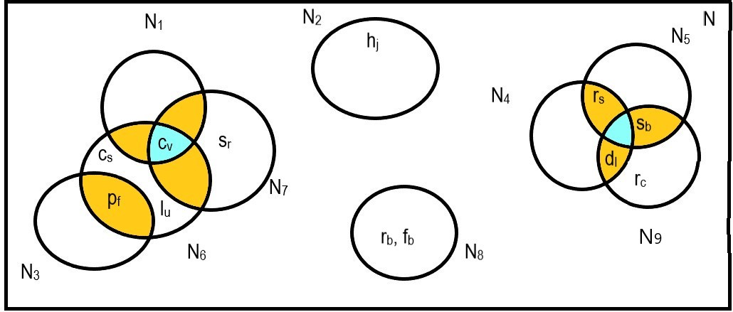**

**Fig.3. Ven Diagram of Navadha Bhakti**

$N=$ Navadha Bhakti that is universal set

$$N_{1}=\{c_{v}\}N_{2}=\{h_{j}\}N_{3}=\{s_{g}, p_{f}\}$$

$N_{4}=\{d_{l}$, $r_{s}\}N_{5}$ = {$s_{b}$, $r_{s}$} $N_{5}$ = {$s_{b}$, $r_{s}$}

$N_{6}$ = { $c_{s}$, $p_{f}$, $l_{u}$, $c_{v}$} $N_{7}= \{s_{r}, c_{v}\}N_{8}$ ={$r_{b}$, $f_{d}$}

$N_{9}$ ={$s_{b},d_{l},r_{c}$}

According to Ven diagram of Navadha Bhakti we can see that

1. $N_{1}∪N_{2}∪N_{3}∪N_{4}∪N_{5}∪N_{6}∪N_{7}∪N_{8}∪N_{9}=N$ = Navadha Bhakti
2. $N_{1}∩N_{6}∩N_{7}=\left\{c_{v}\right\}=N_{1}$ =First bhakti (Worship) of Navadha Bhakti
$N_{3}∩N_{6}=\{p_{f}\}$

$N_{4}∩N_{9}=\{d_{l}\}$

$N_{4}∩N_{5}=\{r_{s}\}$

$N_{9}∩N_{9}=\{s_{b}\}$

3. $N_{2}∩N_{i}=ϕ$ where $i=1,3,4,5,6,7,8,9$
4. $N_{8}∩N_{i}=ϕ$ where $i=1,2,3,4,5,6,7,9$

Here, we see that $ϕ$ is null set i.e that person who doesn’t have any Navadha Bhakti but if he has *Guru Kripa.*

(Grace of guru) can also achieve ‘Navadha Bhakti’.

The collection N is the universe of anvadha bhakti [Hamkins, J. D. (2012)]

1. **Scope of the work**

The scope of "Examining Mathematical Concepts in Ramcharit Manas: A Distinct Perspective on “Navadha Bhakti” is comprehensive. This study seeks to explore and scrutinize the incorporation of mathematical concepts in the narrative of "RamcharitManas." It involves a thorough examination of numerical elements, investigating their symbolic significance concerning “Navadha Bhakti”, the nine-fold path of devotion.

This research delves into Tulsidas' significant work to uncover the profound implications of mathematical elements interwoven into the fabric of the epic. This analysis explore concept between mathematics and spirituality, providing a unique perspective on the depth and complexity of "Ramcharit Manas".

Furthermore, the aim this study is contribute to academic discourse by offering a novel prospective on the convergence of mathematics and spritulity. By increasing the understanding of mathematical symbolism and its use in devotional activities this study aims to promote deep appreciation of the complex relationship between these apperentaly disparate domains. Finally the scope of this research is to enhance the overall understanding of the spiritual and mathematical dimensions embedded in this paper.

1. **Objective of the Study**

The objective of this study to investigate deeply how mathematical ideas are incorporated in the story of Ramcharit Manas particularly focusing on its unique narrative approach on Navadha Bhakti that is nine fold of devotion. The mentioned objectives include:

1. **Set Theoric analysis:** investigate and analyse the set theatrical method to create into the epic and analysing their symbolic significance in the context of Navadha Bakti.
2. **Unravelling symbolic implications**: Examine the deep meanings behind the set theory in Tulasidas’s masterwork in order to understand their symbolic meaning and understanding how they contribute to depth and complexity of the narrative.
3. **Relationship between mathematics and spirituality:** Our goal is to enlightening the relationship between mathematical ideas and spiritual concerns within "Ramcharit Manas” and giving a unique prospective to understand the complex relationships across various domain.
4. **Contribution to academic conversations:** Present a thoughtful analysis on the relationship between mathematics and spirituality. In order to further academic conversation and increase awareness of the understanding of mathematical symbolism and its significance in devotional practices.
5. **Enhancing Awareness:** Our aim is to enhance the awareness of the complex relationship between mathematics and spirituality. Finally our aim to contribute a deeper understanding of the spirituality and mathematics which are present in "RamcharitManas."
6. **The Review of Literature**

The literature review for “Exploring mathematical concepts in RamcharitManas: A unique prospective on Navadha Bhakti” involves the analysis of existing scholarship on relevant subjects:

* 1. **Key features:**

1. **Mathematics in Literary Works:** Previous studies has examine that how numbers symbolically convey deeper meanings and how the integration of mathematical concepts are incorporated in literature.
2. **Scholarship on ‘Ramcharit Manas’:** The literature which exist on "Ramcharit Manas" has extensively covered aspects of cultural importance, interpretations based on religion, and narrative frameworks. But there is still a gap in our understanding of the mathematical elements incorporated into the epic.
3. **Inter-disciplinary Approaches:** Works exploring the study on relationship between mathematics and spirituality in various cultural and religious context give more insights and can help this study in methodology and theoretical framework.
4. **Symbolism in Religious Texts:** Research on the symbolic language used in religious texts illuminate the way in which numerical elements may have particular meanings, that can infer the overall spiritual message.
5. **Navadha Bhakti Studies:** The aim of literature review is create wide understanding of ‘Navadha Bhakti’ (nine-fold devotion to God), the devotional route that forms main focus on the analysis it includes the devotional path that serve as focal point in this analysis.

By amalgamating insights from these sources, the study aims to present a distinctive perspective in scholarly discussions, bridging the gap between mathematics, literature, and spirituality within the context of "RamcharitManas."

1. **Results and outcomes**

The outcomes of "Exploring Mathematical Concepts in RamcharitManas: A Unique Perspective on Navadha Bhakti" are as follows:

1. The union of all sets ($N_{1}, N_{2},N_{3}, N_{4}, N_{5},N_{6}, N_{7}, N_{8}, N_{9}$) that is the nine fold pathway of devotion (Navadha Bhakti) is the set N that is Salvation (Moksha ) means the union of these none fold devotion is the achievement of God.
2. We see that anyone by applying any path way of Navdha Bhakti (by choosing any path way of nine fold devotion) achieve the salvation (Moksha).
3. We also see that some $N_{i}'s$ intersect each other means groups good people search the good people.
4. Intersection of some $N_{i}'s$ is empty this means an individual can also achieve the salvation. For example Eklavaya Was able learn Dhnurvidya (knowledge of Archery).

Finally we can say that these results provide valuable insightful information into the complex relationship between mathematics and spirituality. Overall these result significantly enhance our understanding of “RamcharitManas” and its depiction of Navadha Bhakti.

1. **Conclusion and future scope:**
   1. **Conclusion:**

The study “Exploring the mathematical concepts in RamcharitManas: A unique prospective on Navadha Bhakti” successfully conclude the embedding of set theory within the Navadha Bhakti i.e Nine-fold path way of Devotion goes to the salvation. One who comprises any one of the nine fold devotion (Navadha Bhakti) achieve the salvation (Moksha). This research brings to the light of symbolic significance of set theory with the help of Venn diagram which demonstrate the role of nine-fold pathway (Navadha Bhakti) in enhancing the depth and complexity between mathematics and sprituality. Moreover, the research emphasizes how mathematical symbolism contributes to the portrayal of Navadha Bhakti, influencing devotional practices within "RamcharitManas”. This research works as bridge between mathematics and spirituality. More importantly it contribute to our understating of the spiritual, cultural and intellectual components present in this master piece work of art.

It also conclude that if a man belongs any one of nine-fold pathways of Navadha Bhakti i.e the person who belongs to any of the above set, can easily achive salvation. These are some examples given below.

1. As Sri, Sri...... Anant, Anant Prakash Ji Maharaj
2. Sri, Sri......1008 Aadi Shakti Maa Surya Kumari
3. Sri, Sri......108 Brahmaleen Suresh Chandra Agnihotri

All By doing the work of devotees one has easily attained salvation. In Tulsikrit Ramcharit Manas, Mata Shabari has attained salvation by accepting all the devotees. Similarly, devotees Prahlad, Narsi, etc. have easily attained the path of moksha (salvation) by doing Navadha Bhakti. Bhakt prahlaad also achieve moksha i.e salvation by applying pathway of Navadha Bhakti. Sant Kabeer was also belong to this kind of pathway of Navadha Bhakti.

* 1. **Future Scope:**

Looking forward the following are some areas in this discipline that could more research:

1. **Comparative Studies:** Conducting comparative analysis with other religious or cultural texts to develop the ability to communicate spiritual lessons.
2. **Reader Reception Studies:** Investigating various points of view and reactions by examing how readers interpret and perceive the mathematical elements within "Ramcharit Manas".
3. **Digital Humanities Approaches:** By using digital tools for quantitative study of numerical patterns within the epic in order to gain a more comprehensive understanding (grasp) of their distribution and importance.
4. **Educational Applications:** By employing educational resources and research field that increase mathematical concepts and ideas into the study of religious or literary texts, fostering interdisciplinary learning.
5. **Expanded Literary Analysis:** Extending the concept of other literary works to examine the frequency and function of mathematical symbolism in constructing narratives and expressing the deeper meanings to other literary works.

Researchers and investigators can enhance the knowledge of the relationship between mathematics and spirituality thereafter by exploring these pathways and ideas and contributing conversation in this multidisciplinary field.

In future we will also able to explain algebraic structure, vector spaces, topological spaces, groupoid, monoid and group by utilizing set theoretic approach.



**Fig.4.Shree, Shree ….1008 Aadi Shakti Maa Surya Kumari**

**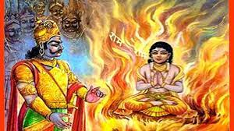**

**Fig.5. Bhakt Shiromani Prahlaad**

**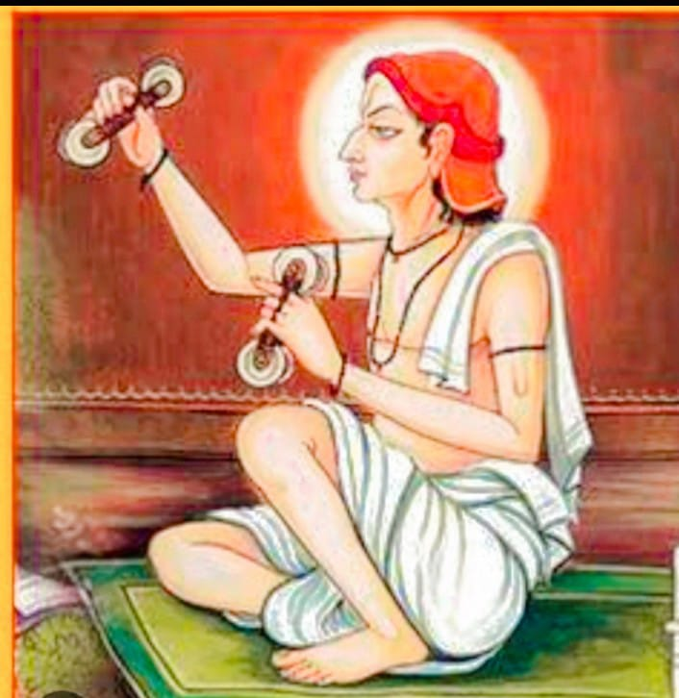**

**Fig.6. Bhakt Narsi Mehata**

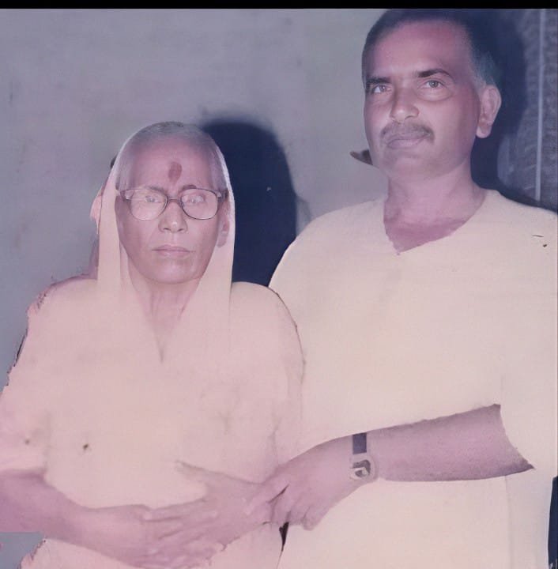

**Fig.7. Shree, Shree…..108 Bhakt Suresh Chandra with Aadi Shakti Maa Surayakumari**

**(1997)**

**References:**

1. Goswami Tulasidas, Ramcharimanas, Aranyakand (Kand 3), Doha 34-35. (1574 CE), Sambvat 1631.
2. Chinmayananda, Swami. The Holy Geeta: Mumbai, 2002
3. Goyandka, Shri Harikrishnadas. Translation of Shankracharya's Commentary of theBhagavad Gita (Hindi): Gorakhpur, 2006.
4. Goyandka, Jayadayal. Navadha Bhakti: Gorakhpur, 2011.
5. Karanbelkar, Dr. P.V. Patanjala Yoga Sutras: Lonavla.
6. Khemka, Radheyshaym (ed). Bhaktamala: Gorakhpur, 2013.
7. Saraswati, Swami Akhandananda (tr). Shrimad Bhagavata Purana (2 Volumes): Gorakhpur, 2004.
8. Swami Prabhupada, A.C. Bhaktivedanta. Srimad Bhagavatam: Mumbai.
9. Autry, J. (2001). *The servant leader*. Roseville, California: Prima Publishing, 50-56, 178.
10. Bennis, W. and Goldsmith, J. (1997). *Learning to lead.* Reading, Massachusetts: Perseus Books, 24-25, 70-73.
11. Gardiner, J. (1998). Quiet presence: The holy ground of leadership. In L. Spears (Ed.). *Insights on leadership: Service, stewardship, spirit, and servant-leadership*. New York: John Wiley & Sons, Inc., 116-125.
12. Glickman, C., Gordon, S., and Ross-Gordon, J. (2005). *The basic guide to supervision and instructional leadership.* Toronto: Pearson Education Ltd., 156.
13. Greenleaf, R. (1970/1991). *The servant as leader*. Indianapolis: The Robert K. Greenleaf Center, 1-37.
14. Greenleaf, R. (1976). *The institution as servant.* Indianapolis: The Robert K. Greenleaf Center, 1-16.
15. Greenleaf, R. (1977). *Servant leadership: A journey into the nature of legitimate power and greatness.* New York: Paulist Press, 5.
16. Greenleaf, R. (1986). *On becoming a servant-leader.* Indianapolis: Robert K. Greenleaf Center, 343, 347.
17. Greenleaf, R. (2002). *Teacher as servant: A parable*. Indianapolis: The Robert K. Greenleaf Center, 151.
18. John Gilbert, A Brief Note on Set Theory and its Applications, Research & Reviews: Journal of Statistics and Mathematical Sciences, 6-7, 2022.
19. [Mirna Džamonja](https://link.springer.com/article/10.1007/s40961-016-0082-6#auth-Mirna-D_amonja-Aff1) (2017), Journal of Indian council of philosophical research, vol. (34), 415-424, 2017.
20. Awodey, S. (2014). Structuralism, invariance, and univalence. *Philosophia Mathematica*, *22*(1), 1–11.
21. Cohen, P. (1966). *Set theory and the continuum hypothesis*. New York: Benjamin.
22. Džamonja, M. (2013). Forcing axioms, finite conditions and some more. In: Logic and its applications, volume 7750 of Lecture Notes in Computer Science (pp. 17–26). Heidelberg: Springer.
23. Feferman, S. (1977). Categorical foundations and foundations of category theory. In: *Logic, foundations of mathematics and computability theory. Proceedings of the Fifth International Congress Logic, Methodology and Philosopy of Science, University of Western Ontario, London, Ontorio, 1975*, Part I, University of Western Ontario Series Philosophical Science (Vol. 9, pp. 149–169). Reidel, Dordrecht.
24. Fraenkel, A. A., Bar-Hillel, Y., & Lévy, A. (1973). *Foundations of set theory* (2nd ed.). Amsterdam, North-Holland: Elsevier.
25. Friedman, H. (2014). Boolean relation theory and incompleteness. <https://u.osu.edu/friedman.8/files/2014/01/0EntireBook061311-wh0yjy>.
26. Gödel, K. (1930). Die vollständigkeit der axiome des logischen funktionenkalküls. *MonatshefteMathematik Physics*, *37*(1), 349–360.
27. Gödel, K. (1938). The consistency of the axiom of choice and of the generalized continuum hypothesis. *Proceedings of the National Academy of Sciences*, *24*, 556–557.
28. Hamkins, J. D. (2012). The set-theoretic multiverse. *Review of Symbolic Logic*, *5*, 416–449.
29. Kapulkin, C., Lumsdaine, P. L. (2012). The simplicial model of univalent foundations (after Voevodsky). [arxiv:1211.2851](http://arxiv.org/abs/1211.2851).
30. Kunen, K. (2011). *Set theory, volume 34 studies in logic (London)*. London: College Publications.
31. Lévy, A., & Solovay, R. M. (1967). Measurable cardinals and the continuum hypothesis. *Israel Journal Mathematics*, *5*, 234–248.
32. Mac Lane, S. (1971). Categorical algebra and set-theoretic foundations. In: *Axiomatic Set Theory. Proceedings of Symposia in Pure Mathematics*, Vol. XIII, Part I, Univ. California, Los Angeles, Calif., 1967), Amer. Math. Soc., (pp. 231–240. Providence, R.I.
33. Osius, G. (1974). Categorical set theory: A characterization of the category of sets. *Journal of Pure Applied Algebra*, *4*, 79–119.
34. (2013). The Univalent Foundations Program. *Homotopy type theory: Univalent foundations of mathematics*. Institute for Advanced Study.
35. Shapiro, S. (1999). Do not claim too much: Second-order logic and first-order logic. *Philosophia Mathematics*, *7*, 42–64.
36. Venturi, G. (2016). On the naturalness of new axioms in set theory. Preprint.