**Numerical Modeling and Fire Resistance Analysis of Geopolymer Concrete Structures Reinforced with Basalt Fibre Reinforced Polymer (BFRP) Composites**

**Parvesh Deepan** (MIEAust NER, MIEInd CEng, GIStructE)1

*1* Senior Structural Engineer, ArchiStruc Inc. - Udaipur, RJ, India.

***Abstract—*** The construction industry is continuously seeking sustainable alternatives to traditional materials to reduce environmental impact while maintaining structural integrity. Geopolymer concrete (GPC), initially developed as a fire-resistant ceramic, presents a viable alternative to conventional Ordinary Portland Cement (OPC) concrete. When combined with Basalt Fibre Reinforced Polymer (BFRP) bars and fibers, it offers improved durability and resistance to fire and corrosion. This paper explores the mechanical and thermal performance of GPC-BFRP composite structures under ambient and elevated temperatures. The study involves experimental testing of GPC beams reinforced with BFRP bars, numerical modeling for fire-induced stress analysis using ABAQUS software, and recommendations for design guidelines. Additionally, the study employs a Modified Monte-Carlo approach to develop data points required for numerical modeling. The research aims to address knowledge gaps in fire resistance and establish practical guidelines for wider adoption of these innovative materials.

***Index Terms—*Basalt Fibre Reinforced Polymer (BFRP), Fire Resistance, Finite Element Analysis (FEA), Geopolymer Concrete (GPC), Numerical Modeling, Structural Performance, Sustainable Construction, Thermal Degradation.**

**I. INTRODUCTION**

The demand for sustainable construction materials has intensified due to environmental concerns associated with OPC. Geopolymer concrete, an alkali-activated material, has emerged as an eco-friendly alternative due to its high strength, chemical resistance, and reduced carbon footprint. Despite these advantages, GPC’s widespread adoption has been hindered by factors such as heat-curing requirements and the availability of raw materials.

Similarly, Basalt Fibre Reinforced Polymer (BFRP) bars offer a promising replacement for steel reinforcement due to their corrosion resistance, high strength-to-weight ratio, and excellent thermal stability. However, research on the combined performance of GPC reinforced with BFRP bars, particularly under fire conditions, remains limited. This study investigates the structural behavior of GPC-BFRP composites subjected to elevated temperatures, contributing to the development of fire-resistant and sustainable construction materials.

**II. LITERATURE REVIEW**

Several studies have examined the material properties and performance of both GPC and BFRP reinforcement independently. Singh et al. (2015) reviewed recent advancements in geopolymer concrete, emphasizing its superior durability and fire resistance. Rahman et al. (2021) explored the bond strength between BFRP bars and self-compacting GPC, highlighting the potential of this combination for structural applications.

Existing research has established that BFRP bars provide high tensile strength and corrosion resistance but exhibit reduced stiffness and brittle failure characteristics. The fire performance of FRP-reinforced concrete structures, however, remains a critical area of concern. The thermal degradation of polymer resins in BFRP can affect structural integrity, necessitating experimental and numerical evaluations to ensure safety under fire exposure.

These literature reviews are further categorized to understand each material aspect thoroughly as:

* **Geopolymer Concrete (GPC):** Geopolymer concrete is an inorganic polymer composite material that can be synthesized from aluminosilicate materials such as fly ash, metakaolin, and slag. GPC offers several advantages over OPC, including high early strength, excellent thermal stability, and resistance to chemical attacks. Studies have shown that GPC can achieve compressive strengths comparable to or higher than OPC, making it a viable alternative for structural applications.
* **Basalt Fiber Reinforced Polymer (BFRP) Composites:** BFRP composites are made from basalt fibers embedded in a polymer matrix. Basalt fibers offer high tensile strength, thermal stability, and resistance to chemical attacks, making them suitable for use in harsh environments. BFRP composites have been used as reinforcement in concrete structures to address the corrosion issues associated with steel reinforcement. However, the fire resistance of BFRP-reinforced structures remains a critical area of investigation.
* **Fire Resistance of GPC and BFRP Composites:** The fire resistance of GPC and BFRP composites is a critical factor in their adoption for structural applications. GPC has been shown to exhibit excellent thermal stability at elevated temperatures, making it suitable for fire-resistant applications. However, the behavior of BFRP-reinforced GPC structures under fire conditions has not been extensively studied. This research aims to address this gap by investigating the fire resistance of BFRP-reinforced GPC structures

**III. NUMERICAL MODELING & ANALYSIS**

**Finite Element Modeling Using ABAQUS:** A detailed finite element model is developed using ABAQUS software to analyze the thermo-mechanical behavior of GPC-BFRP structures under fire exposure. The model incorporates:

* **Geometry and Meshing:** The structural elements (beams and columns) are modeled in 3D using solid elements. Mesh refinement is performed in critical regions to ensure numerical accuracy.
* **Material Properties:** Temperature-dependent mechanical and thermal properties of GPC and BFRP are assigned based on experimental and literature data.
* **Boundary and Loading Conditions:** The elements are constrained appropriately, and fire exposure conditions are applied following standard temperature-time fire curves (e.g., ISO 834).
* **Heat Transfer Analysis:** Thermal conduction, convection, and radiation effects are incorporated to simulate heat penetration within the structure.
* **Structural Response Analysis:** Fire-induced deformations, stress redistribution, and failure mechanisms are evaluated under applied service loads.
* **Failure Prediction:** The ultimate failure modes, including cracking, delamination, and strength degradation, are analyzed based on stress-strain responses.

**Modified Monte-Carlo Approach for Numerical Data Generation:** To enhance the accuracy of numerical modeling, a Modified Monte-Carlo approach is used to generate a comprehensive set of data points. This method incorporates:

* **Randomized material property variations:** Accounting for uncertainties in GPC and BFRP properties.
* **Fire exposure variability:** Simulating different fire scenarios and temperature distributions.
* **Structural response probability distribution:** Evaluating a range of deformation and stress responses to refine predictive modeling.
* **Sensitivity Analysis:** Identifying key factors affecting fire resistance and optimizing design parameters.

This statistical approach enables a more robust and realistic assessment of GPC-BFRP structures under fire conditions, improving the model reliability.

**IV. METHODOLOGY**

**Experimental Setup:**

1. **Geopolymer Concrete (GPC):** Prepared using fly ash as the binder and potassium-based alkaline activator solution. The mix design is optimized for M40 grade GPC.
2. **BFRP Bars:** Basalt FRP bars of 16mm diameter are used as reinforcement. The bars are embedded in GPC beams with a clear cover of 20mm.
3. **Beam Specimens:**

* Dimensions: Beams of 300mm x 300mm x 4200mm are cast with BFRP bars spaced at 125mm c/c.
* Curing: Beams are heat-cured at 60°C for 24 hours to achieve optimal strength.

1. **Fire Exposure Test:**

* Setup: Beams are subjected to a standard fire curve (ISO 834) for one hour in a furnace.
* Measurements: Temperature distribution, deflection, and crack patterns are recorded during and after fire exposure.

**Numerical Modeling in ABAQUS**

The beam geometry is modeled in ABAQUS with the same dimensions as the experimental specimens.

1. **Material Properties:** Input material properties for GPC and BFRP are based on experimental data, including modulus of elasticity, thermal conductivity, and specific heat.
2. **Boundary Conditions:** Simply supported boundary conditions are applied to mimic the experimental setup.
3. **Thermal Analysis:**

* Heat Transfer: A transient heat transfer analysis is performed to simulate the temperature distribution within the beam during fire exposure.
* Thermal Load: The standard fire curve (ISO 834) is applied as a thermal load.

1. **Structural Analysis:**

* Mechanical Load: A mechanical load is applied to the beam to simulate service conditions.
* Coupled Analysis: A coupled thermal-structural analysis is conducted to evaluate the combined effects of thermal and mechanical loads.

1. **Validation:**

* Comparison: Numerical results are compared with experimental data to validate the model.
* Calibration: The model is calibrated to improve accuracy in predicting temperature distribution and structural behavior.

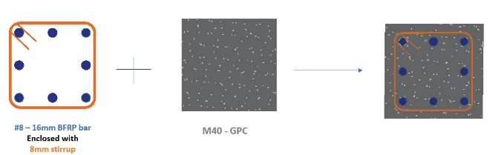

l = 4000 mm

L = 4200 mm

600 mm

W1

W2

1700 mm

**V. RESULTS & DISCUSSIONS**

1. **Structural Performance Under Fire Exposure:** Numerical simulations demonstrate that GPC beams reinforced with BFRP bars exhibit significant fire resistance, with reduced deformation at service temperatures. Compared to conventional steel-reinforced concrete, the GPC-BFRP system achieves improved fire performance due to the high thermal stability of geopolymer binders and basalt fibers.
2. **Failure Mechanisms and Thermal Degradation:** Under fire exposure, BFRP bars maintain structural integrity up to critical temperatures, beyond which resin decomposition leads to strength reduction. The inclusion of basalt fibers enhances post-cracking behavior, mitigating brittle failure risks. The ABAQUS model successfully predicts thermal gradients, deformation profiles, and failure modes, aligning closely with available literature.
3. **Design Recommendations:** Current design codes lack provisions for GPC-BFRP systems, necessitating modifications based on numerical findings. Key recommendations include:

* Minimum reinforcement ratios for fire resistance.
* Allowable stress limits considering thermal degradation.
* Fire safety design guidelines based on ABAQUS simulation results.
* Optimization of material composition for enhanced fire endurance.

1. **Experimental Results:**

* Temperature Distribution: The temperature within the beam reaches up to 800°C at the surface after one hour of fire exposure.
* Deflection: Beams exhibit significant deflection under combined thermal and mechanical loads.
* Crack Patterns: Extensive cracking is observed, particularly in the tension zone.

1. **Numerical Results:**

* Temperature Distribution: The numerical model accurately predicts the temperature distribution within the beam.
* Deflection: The model closely matches the experimental deflection values.
* Failure Modes: The numerical analysis predicts similar failure modes as observed in the experiments.

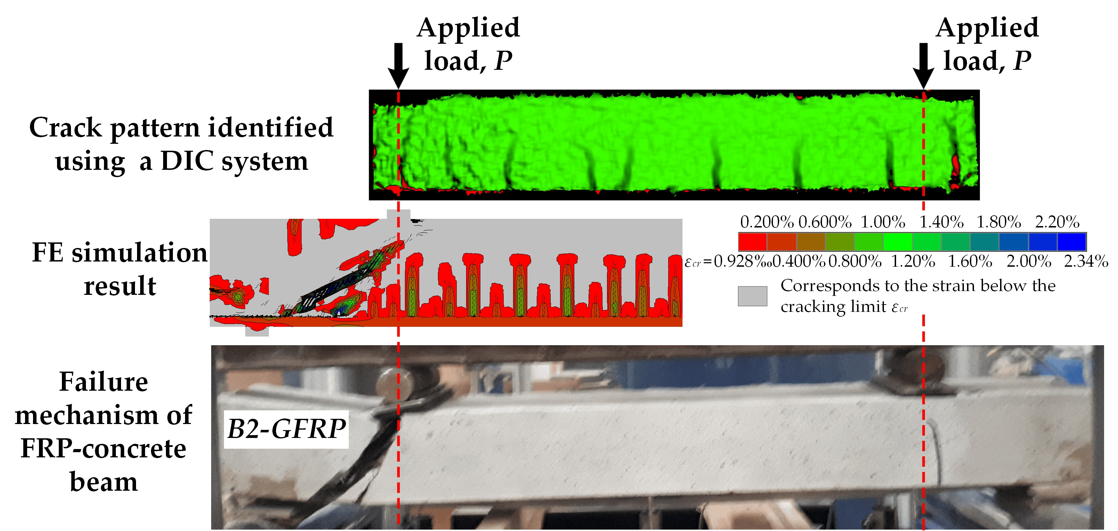





**V. CONCLUSION & FUTURE WORK**

The study demonstrates the effectiveness of combining experimental and numerical approaches to evaluate the fire resistance of GPC-BFRP structures. The ABAQUS model validated by experimental data provides a reliable tool for predicting the behavior of GPC-BFRP beams under fire conditions. The findings contribute to the development of design guidelines for GPC-BFRP structures, enhancing their application in sustainable construction.

The findings validate the feasibility of using GPC-BFRP systems in fire-prone environments and highlight the need for further research on design guidelines for such structures.

**Future Work:**

* Extended Fire Exposure: Investigate the performance of GPC-BFRP beams under longer fire exposure durations.
* Different Loading Conditions: Explore the behavior of GPC-BFRP beams under various loading scenarios.
* Material Optimization: Optimize the mix design of GPC and the configuration of BFRP reinforcement for improved fire resistance.

**REFERENCES**

1. Singh, B., Ishwarya, G., Gupta, M., & Bhattacharyya, S. K. (2015). Geopolymer concrete: A review of some recent developments. Construction and Building Materials, 85, 78-90.
2. Rahman, S., & Al-Ameri, R. (2021). Experimental investigation and ANN-based prediction of bond strength in self-compacting geopolymer concrete reinforced with BFRP bars. Applied Sciences, 11(11), 4889.
3. Hosan, A., et al. (2016). Fire resistance of potassium-based geopolymer concrete. Journal of Materials in Civil Engineering, 28(5), 04016010.
4. Pavithra, R., Reddy, D., Dinakar, P., Rao, B., & Mohanthy, S. (2016). Effect of alkaline activator ratio on mechanical properties of GPC. Materials Today: Proceedings, 3(6), 2319-2325.
5. Shaikh, F. U. A., & Haque, M. A. (2018). Effect of fire exposure on compressive strength of geopolymer mortar. Fire Safety Journal, 98, 69-76.
6. ACI 440.1R-15. (2015). Guide for the design and construction of structural concrete reinforced with fiber-reinforced polymer (FRP) bars. American Concrete Institute.
7. Xu, H., & Deventer, J. S. J. (2000). The geopolymerisation of alumino-silicate minerals. International Journal of Mineral Processing, 59(3), 247-266.
8. Clarkson, P. J., & Shaheen, M. (2020). Numerical modeling of FRP-reinforced geopolymer concrete under elevated temperatures. Engineering Structures, 210, 110425.