Optimization of Process Parameters for Turning Operation on D3 Die Steel

Asabe Maruti P1 & Dr Sonawane S.A.2

1 *PG Student Department of Mechanical Engineering, SVERI College of Engineering, Pandharpur, Maharashtra, India*

*2Assistant Professor, Department of Mechanical Engineering, SVERI College of Engineering, Pandharpur, Maharashtra, India*

email address : [asabemaruti@gmail.com](mailto:asabemaruti@gmail.com)

***Abstract —* This research aims to determine the optimal Surface Roughness for machining D3 die steel alloy with uncoated carbide inserts. It will do this by studying the most efficient turning parameters, such as cutting speed, feed, and depth of cut. Models have been generated using a variety of statistical modeling approaches, including Genetic Algorithm with Response Surface Methodology. This research aimed to use the regression technique to develop a model that could predict surface roughness. It has also been investigated if the Taguchi Technique may be used to optimize process parameters. To decide the primary boundaries affecting Surface Unpleasantness, we used Signal-to-Noise (S/N) ratio and Analysis of Variance (ANOVA) tests. This paper aims to contribute valuable insights into achieving the best Surface Roughness outcomes in the machining process for D3 die steel alloy with Uncoated Carbide Inserts. The utilization of Genetic Algorithm and Response Surface Methodology showcases a robust approach for modelling intricate parameter interactions. If you know the values of the parameters, you may use the Regression Technique to forecast the surface roughness. Process parameter optimization may be made more systematic with the use of the Taguchi Technique.**

**Keywords - Turning operation, Surface Roughness, Mathematical Model, ANOVA, Taguchi Technique.**

1. Introduction

The increasing demand for precision machining in industries working with D3 Die Steel has ignited a crucial need for the optimization of turning operations. D3 Die Steel characterized by its uncommon hardness and wear opposition, remains as a crucial material in different modern applications,. However the intricate nature of this alloy presents specific challenges during machining processes, necessitating a meticulous exploration of optimal parameters. This research endeavors to address these challenges by employing a systematic approach to experiment design through Design of Experiments (DOE) techniques. The primary focus revolves around investigating the influential factors of shaft speed, feed rate, and profundity of cut on machining performance. Each parameter is carefully chosen due to its recognized impact on the intricate nature of turning operations on D3 Die Steel. The inherent hardness and wear resistance of D3 Die Steel make it a demanding material for machining processes. Achieving a superior surface finish (Ra) is of paramount importance in applications where precision is critical. Consequently this study aims to unravel the complex interplay between the chosen process parameters and the resulting surface finish aiming to identify the optimal combination that yields enhanced machining performance. The significance of this research extends beyond the immediate challenges posed by machining D3 Die Steel. It contributes to a deeper understanding of the underlying dynamics involved in precision machining, particularly in the context of high-performance materials. By systematically analyzing the obtained results, the study seeks to not only optimize the process parameters for D3 Die Steel but also to provide valuable insights that can be applied to similar materials in the future. The outcomes of this research hold the potential to advance manufacturing processes, ensuring efficiency and precision in the production of components from high-performance materials.

1. Taguchi technique

A novel approach to experimental design based on clearly specified criteria has been proposed by Taguchi. A unique kind of arrays known as orthogonal arrays are used by this technique. Using these typical arrays as a guide, one may determine how many tests are necessary to uncover all the elements influencing the performance metric. Selecting different combinations of input design variables at different levels is the orthogonal arrays method's meat and potatoes. The Englishman R.A. Fisher was the first to suggest the method of designing experiments with many components [6]. As a common term, this approach is called the factorial design of experiments.

For any given collection of elements, a complete factorial design will reveal every conceivable combination. It takes a lot of tests to get a complete factorial design right since there are generally a lot of elements in industrial studies. Only a subset of all possible outcomes is chosen in order to keep the number of trials manageable. Performing a partial fraction experiment is the best way to get the most information out of a small number of trials. Despite the method's fame, there are no standards for using it or interpreting the data collected from tests. For factorial experiments, Taguchi developed a unique set of general principles that have various uses.

The Taguchi methods are a set of statistical techniques originally intended to enhance product quality that have found new uses in fields as diverse as engineering, biotechnology, advertising, and marketing.

1. Turning process parameters

As an example of a common machining technique, turning involves rotating the work piece with a single-point tool to produce chips, which are then used to remove undesired material. Using a lathe as a machine tool allows for this to be achieved. During a turning process, there are a few variables that can be adjusted. One of these is the cutting speed, Vc, which is measured in feet per minute or meters per second. The other is the feed, f, which is measured in inches per revolution or millimeters per revolution. Lastly, there is the depth of cut, d, which is measured in inches or millimeters. The chip is often made in plane strain, which means that its width is equal to its unreformed chip width. This is because the depth of cut (d) is typically at least five times the feed (f).

Table 1: D3 die steel's chemical composition

|  |  |  |  |  |  |
| --- | --- | --- | --- | --- | --- |
| **Element** | **C** | **Cr** | **Mn** | **Ni** | **Si** |
| Wt% | 0.21 | 0.11 | 0.40 | 0.31 | 0.30 |

Table 2: D3 Die Steel's Mechanical Characteristics

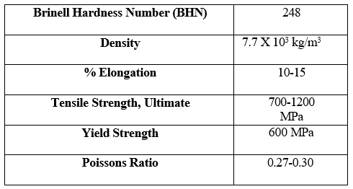

Table 3: Experimental Conditions

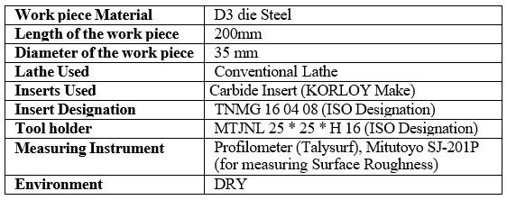

Table 4: Three-level values for process parameters

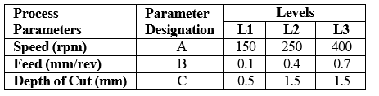

In order to design the experiment, we looked to Taguchi's Orthogonal Array Experimentation Technique. The experimental configuration that met the minimal number of requirements for the factors and levels reported in Table 5 was a L9 orthogonal array.

Table 5: Levels, Factors, and Degrees of Freedom

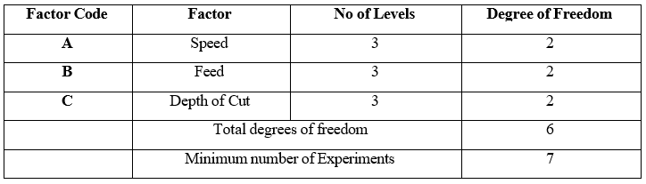

Table 6: L9 Orthogonal Array Standard

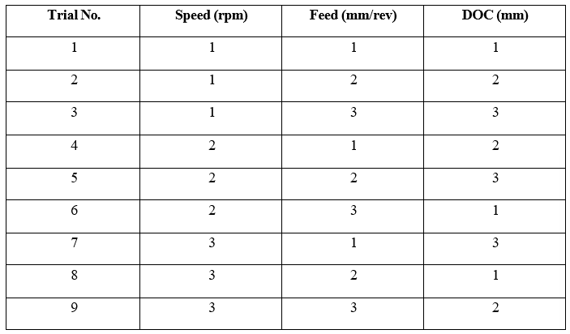

Table 7: L9 Array Standard with Observations

|  |  |  |  |  |
| --- | --- | --- | --- | --- |
| Trial No. | **Speed (rpm)** | **Feed (mm/rev)** | **DOC**  **(mm)** | Ra |
| 1 | 150 | 0.22 | 0.5 | 2.73 |
| 2 | 150 | 0.40 | 1.0 | 5.43 |
| 3 | 150 | 0.70 | 1.5 | 8.56 |
| 4 | 250 | 0.22 | 1.0 | 6.02 |
| 5 | 250 | 0.40 | 1.5 | 8.11 |
| 6 | 250 | 0.70 | 0.5 | 3.10 |
| 7 | 400 | 0.22 | 1.5 | 10.16 |
| 8 | 400 | 0.40 | 0.5 | 3.75 |
| 9 | 400 | 0.70 | 1.0 | 8.64 |

In Table 1 we can see the exact chemical make-up of the D3 die steel test specimen. Results for the specimen's mechanical characteristics are shown in Table 2. We followed these experimental protocols for this investigation, as shown in Table 3. Procedure parameters are shown in Table 4, along with their values at three different levels. You may find the minimum number of experiments, factors, levels, and degrees of freedom in Table 5. Conventional L9 Orthogonal Array (OA) data is shown in Table 6. L9 OA with noticed values for every boundary is displayed in Table 7.

Table 8: A Linear Model of Surface Roughness Ra

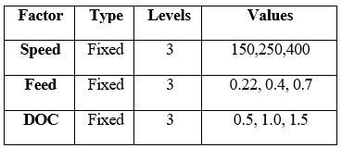

Table 9: Surface Roughness Ra Analysis of Variance (ANOVA)

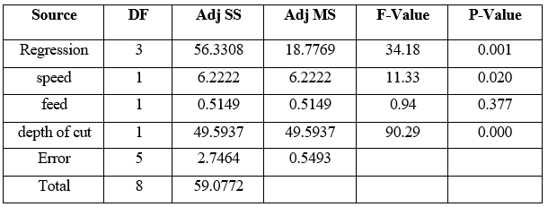

S =0.741132 R-Sq = 95.35% R-Sq (adj) = 92.56%

Table 10: Signal-to-Noise Ratio Response Table

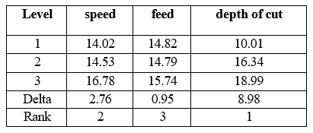

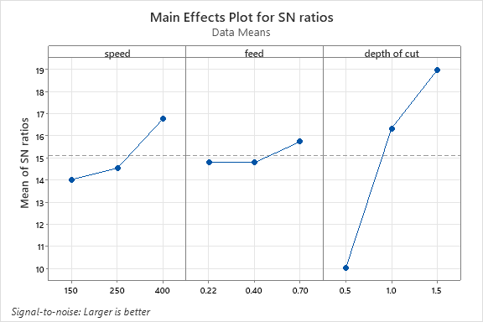

Graph 1: Surface Roughness S/N ratio values

As shown in Table 8, the General Linear Model for Surface Roughness Ra's.

Table 9 is the Surface Roughness Ra Analysis of Variance (ANOVA).

Table 10 displays the results of the Signal-to-Noise Ratio Response Table.

4.Conclusion

There was a statistically significant relationship between turning parameters (such as feed rate, depth of cut, and speed) and work piece surface roughness, according to the experimental results. This data also demonstrates a correlation between cutting speed, feed rate, and depth of cut and the work piece's induced surface roughness.

1. The minimum surface roughness is observed at spindle speed is 150, feed is 0.22 and depth of cut is 0.5 as compared to other results for D3 die steel. Where the surface roughness is most affected by the feed rate.
2. The minimum surface roughness is observed at spindle speed is 250, feed is 0.22 and depth of cut is

0.5 as compared to other results for D3 die steel. Where the surface roughness is most affected by the feed rate.

1. The minimum surface roughness is observed at spindle speed is 250, feed is 0.40 and depth of cut is

1.0 as compared to other results for D3 die steel. Where the surface roughness is most affected by the feed rate.

Hence it’s observed that the surface roughness is minimum for D3 die steel. According to the primary effect plot, the work piece's surface roughness is most impacted by feed rate and speed, whereas depth of cut has no discernible impact.

The surface roughness of the work piece increases with a higher feed rate and decreases with a higher cutting speed. Thus, the optimal machining parameters for minimising the work piece's surface roughness are feed rate and speed.

5. References

1. Özel T, Karpat Y, Figueira L, Davim JP (2007) Modelling of surface finish and tool flank wear in turning of AISI D2 steel with ceramic wiper inserts, Journal of materials processing technology, 189, PP 192-198.
2. Thamizhmanii S, Hasan S (2009) Investigation of surface roughness and flank wear by CBN and PCBN tools on hard Cr-Mo steel, Proceedings of the World Congress on Engineering, PP. 5.
3. Bartarya G, Choudhury SK Effect of cutting parameters on cutting force and surface roughness during finish hard turning AISI52100 grade steel, Procedia Cir P vol 1, (2012) PP 651-656.
4. K. Venkatesan, R Ramanujam, Vimal saxsena Nilendukar Chawdhury and Vikah Choudhray (2014). Influnce of cutting parameters on dry machining og Inconel 625 alloy coted carbide insert a statistical approch ARPN Journal of Engineering and Applied Science, Vol 9PP 1819-6608.
5. Dilbag Singh & Venkateswara Rao, P (2007), A surface roughness prediction model for hard turning process, International Journal of Advanced Manufacturing Technology, Vol. 32, PP. 1115 - 1124.
6. C.O. Izelu, S.C. Eze, B.U. Oreko, B.A Edward (2014).Effect of Depth of Cut, Cutting Speed and Work-piece Overhang on Induced Vibration and Surface Roughness in the Turning of 41Cr4 Alloy

Steel. International Journal of Emerging Technology and Advanced Engineering, Vol 1 PP 225-245.

1. Motgi Rakesh S., Misal Nitin D. (2017) Effect of Speed, Feed and Depth of Cut On Vibration on cutting tool International Journal of Innovative and Emerging Research in Engineering Vol 4 PP 77-82.
2. Jinesh Kumar Jain; (2012), Optimization of Speed and Feed Rate for a Low Vibration and Better Surface Finish in Mild Steel on Lathe. International Journal of Engineering and Computer Science Vol 1PP 178-184.
3. Mr.T.EswaraRao & Mr. G.BalaMurali, (2015). Vibration Analysis for Different Materials of Single Point Cutting Tool during Turning, IOSR Journal of Engineering (IOSRJEN), Vol. 05PP 16- 24.
4. L. B. Raut, Matin Amin Shaikh, (2014) Prediction of Vibrations of Single Point Cutting tool using ANN in Turning. IJMEIT Vol. 2 PP 643-649.
5. A.Purushotham & G.Sravan Kumar, (2013) Experimental tudies On Vibration Characteristics ofS Lathe Machine Tool Under Different Cutting Conditions.”International Journal of Mechanical and Production Engineering Research and Development (IJMPERD), Vol. 3 PP 45- 48.
6. B.P.Kolhe, S.P.Rahane, D.S.Galhe; (2015). Prediction And Control Of Lathe Machine Tool Vibration By Using Passive Damping. International Journal of Innovations in Engineering Research And Technology [IJIERT], Vol 2 PP 293-369.
7. Vivek Kumar, R.N. Mall(2015) Analysis and Modeling of Single Point Cutting Tool with help of ANSYS for Optimization of Vibration Parameter.” IJSRD - International Journal for Scientific Research & Development, Vol. 3 PP 175-217.
8. NBV Lakshmi Kumri, S. Irfan Sadaq, G.prasana Kumar (2015). Analysis of Single Cutting Tool of Lathe Machine Using FEA. International Journal of Engineering Trends and Technology (IJETT) Vol 20 PP 214-217.
9. Maheshwari Patil, Dr.R.J.Patil (2012) Study Effect of HSS Single Point Cutting Tool Nose Radius on Cutting Edge Strength and Tool Wear in Machining of EN9.International Journal of Science and Research (IJSR) Vol4 PP-2563-2567.
10. Raman Kumar, Paramjit Singh Bilga, Sehijpal Singh (2017),Multi objective optimization using different methods of assigning weights to energy consumption.
11. Sajid Raza Zaidi, Mushtaq Khan, Syed Husain Imran Jaffery, Salman Sagheer Warsi (2021) Effect of Machining Parameters on Surface Roughness During Milling Operation.