Performance Analysis of Positive Output (P/O) Push-Pull Switched Capacitor Converter for High Power Density Applications

Dr.T.S.Sivakumaran

Professor / Power

Engineering Electrical

and computer science

Engineering, Bule Hora University Oramia region, Ethiopia [sivakumaran1969@gmail.com](mailto:sivakumaran1969@gmail.com)

Mr. Henok G/Medihen Teklu (MSc.)

Power System Engineering (Electrical Engineering)

Head of Department at Bule

Hora University CET, ECE Department

hennateygo@gmail.com or [erimtsister@gmail.com](mailto:erimtsister@gmail.com).

Reta Denguise

Lecturer / Power Engineering

Electrical and computer science Engineering, CET, Bule Hora University

Oramia region, Ethiopia

*Abstract*— **The micro-power-consumption technique requires high power density DC/ DC converters and power supply sources. In this research, a PI and Fuzzy Logic Controllers for an elementary circuit of positive output (P/O) push-pull switched capacitor converter has developed for high power density applications with high sustainability under enormous line and load disturbances. The voltage lift technique is a popular application in electronic circuit design. The power converter performs DC-DC step-up voltage conversion with high efficiency, high power density and cheap topology in a simple structure. The proposed converter combines both switched-capacitor and voltage lift techniques. Referable to the time varying and switching nature of the power electronic converter their dynamic behavior becomes highly nonlinear. Conventional controllers are incapable of providing excellent dynamic performance and hence the fuzzy logic controller can be used as a feed forward controller for controlling power electronic converters. The control algorithm is developed to ensure tracking of the reference voltage and rejection of system disturbances by successive measurements of the converter output voltage at certain time instants within a conduction period. The simulation of PI and Fuzzy logic controls have been carried out using MATLAB/Simulink software to evaluate the controller’s performances.**

***Keywords—*** Luo converter, DCDC converter, PI Controller, Fuzzy Controller

1. INTRODUCTION

In many PWM DC-DC converter topologies, the controllable switches are operated in switch mode where they are required to turn the entire load current on and off during each switching cycle. Under these conditions, the switches are subjected to high switching stresses and power losses. P/O Push-Pull switched capacitor converters are an alternative to PWM DC-DC converters. The operation of P/O Push-Pull switched capacitor converter is quite different from the operation of PWM converters[1-9]. The minimum power-utilization performance needs far above the ground power concentration DC/ DC converters and power offer foundation. A voltage carry technique could be the standard submission of the electronic circuit style. A facility device performs DC-DC change of magnitude voltage translation with large potency, large power concentration and low cost module with an exceedingly straight forward arrangement. The target for this work is to develop PI and Fuzzy controllers for Elementary circuit of P/O Push-Pull switched electrical device converters to confirm stable load voltage underneath offer and cargo troubles mistreatment Simulink code. The simulation results are given and evaluated. Recently DC-DC convertors technique had expanded in

topical years, it was needed for to achieve a large power concentration, large -voltage transport expand and large power potency. Two-output DC-DC converters exchange a positive i/p supply voltage to positive and negative Vo. They incorporate2 translation ways, one is positive conversion path and also the different could be a negative conversion path. These parallel symmetrical double-o/p voltages were particularly needed on factory applications with boundary circuits like prepared amplifiers, boundary power provides, degree of difference servo drives with a few proportioned voltage medical objects. To manage the o/p voltage of DC-DC convertors regardless of consignment differences and provide distractions, it's required to work the DC-DC convertors as control systems. Its PWM simulation management, the instruction of voltage output of DC-DC convertors are accomplish by variable the duty cycle for the electronic switch maintenance that frequency of functional invariable[10-13]. These converters generally have complicated non-linear models in to variation issues. PI and Fuzzy controllers are employed during that work of regulation the voltage output for above converters underneath offer and cargo interruptions. Tests for load parameter and line parameter are dispensed with gauge controllers' recitals. The consequences were given and tested.

1. P/O PUSH-PULL SWITCHED CAPACITOR (PPSC) CONVERTER
2. *Basic Circuit of P/O PPSC CONVERTER*

The Basic circuits and corresponding circuits throughout switch-on , switch-off were show in Fig.2.1 switches S and S1 function in PPSC mode . Fig2.2 shows the equivalent circuit during S on and fig.2.3 shows the Equivalent circuit during S on S1 on. The potential difference throughout condenser C1 is incriminated to Vin through output on. A voltage throughout condenser C2 is incriminated to VO = 2Vin throughout flip. Thereafter, the output voltage was, thinking the voltage drops throughout a switches and diodes, to mix every charges during a picture of ΔV1. The important voltage output was

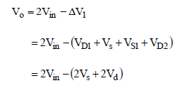

XXX-X-XXXX-XXXX-X/XX/$XX.00 ©20XX IEEE

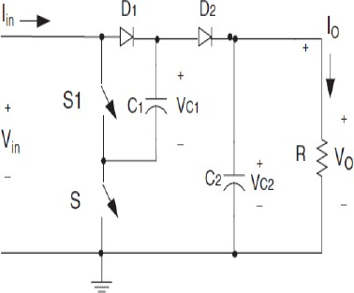

Fig.2.1 Basic diagram of P/O-Circuit

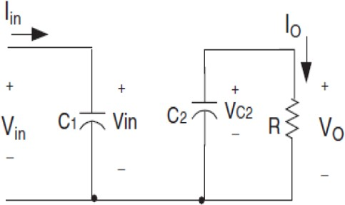

Fig.2.2 Equivalent circuit during S on

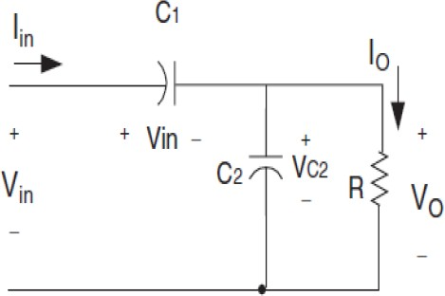

Fig 2.3.Equivalent circuit during S on S1 on

1. *Design of Conventional Controllers*

PI managements are used for many decades in industries for method control applications. The explanation for his or her wide quality lies within the simplicity of style and sensible performance together with low share overshoot and tiny subsidence time for slow method plants .The most appreciated feature of the PI controllers is their relative easiness of use, as a result of the 3concerned parameters have a transparent physical that means. This makes their calibration potential for the operators additionally by trial and error and in any case, an oversized range of tuning rules are developed. Although all the prevailing techniques for the PI controller parameter standardization perform well, endless and an intensive analysis work remains current towards system management quality improvement and performance enhancements. A PI controller was basically a common control system pointer methods. In rule was this it supervises the mistake connecting a computed method changeable and a preferred set point; from that error, a counteractive signal was calculated and was ultimately feedback to the input facet with regulate a method consequently. It equation with the PI controllor was as follows, Thus, the PID management algorithmic rule is delineates with the burdened add for thrice occupations were the 3 different burdens are Proportional gain establishes the authority into current mistake worth of the control methods, integral gain come to a decisions the feedback supported to

realm beneath the mistake time camber up to a current purpose explanations for the coverage of the response to the speed for modification of the mistake with period. The structure for PI controller was shown in Fig.2.4.

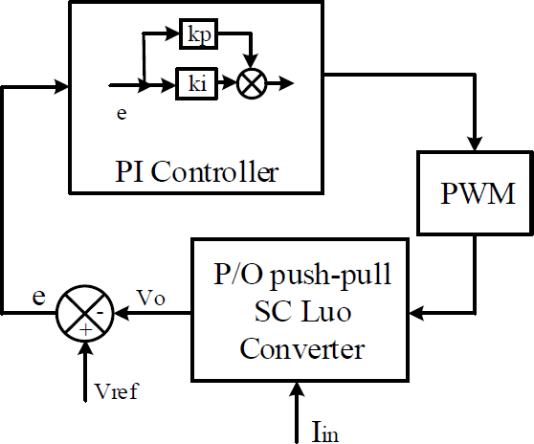

Fig.2.4 Structure of PI controller

1. *Design of Fuzzy logic Controllers*

The Fuzzy Logic Controller (FLC) provides an adaptive control for better system performance. Fuzzy logic is aimed to provide solution for controlling non-linear processes and to handle ambiguous and uncertain situations. Fuzzy control is based on the fundamental of fuzzy sets. The fuzzy control for the chosen converter is developed using input membership functions for error ‘e’ and change in error ‘ce’ and the output membership function for D, the duty ratio of converter. GE and GC are the gain factors of the error and change in error respectively, which are defined as

e * GE = Vr-Vo ce * GC= e k-e k-1

where Vr is the reference or the desired output voltage and Vo is the actual output voltage. The subscript ‘k’ denotes values at the beginning of kth sampling cycle. The duty ratio of the converter will be determined by the fuzzy inference. For instance, if the output voltage continues to increase gradually while the current is low during the charging process, the fuzzy controller will maintain the increase in voltage to reach the set point. A drop in the output voltage level triggers the fuzzy controller to increase the output voltage of the converter by modifying the duty cycle of the converter. The resolution of fuzzy logic control system relies on the fuzziness of the control variables while the fuzziness of the control variables depends on the fuzziness of their membership functions. Fuzzy control involves three stages: fuzzification, inference or rule evaluation and defuzzification as shown in Fig.2.5 P/O Push-Pull switched capacitor converters is modeled using Matlab software. Fuzzy control is developed using the fuzzy toolbox. The fuzzy variables ‘e’, ’ce’ and ’D’ are described by triangular membership functions. Seven triangular membership functions are chosen for simplicity and Table I shows the fuzzy rule base created in the present work based on

intuitive reasoning and experience. Fuzzy memberships NB, NM, NS, ZE, PS, PM, PB are defined as negative big, negative medium, negative small, zero and positive small, positive medium and positive big. The block diagram for fuzzy logic controller for chosen converter is shown in Fig.2.

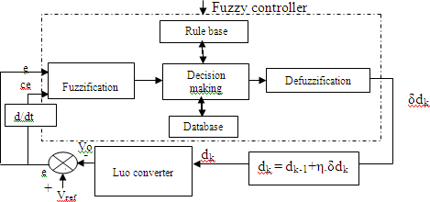

Fig.2.5 Block diagram of fuzzy control for P/O Push-Pull switched capacitor converters

TABLE I. FUZZY RULE BASE

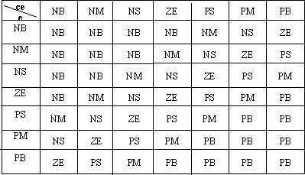

1. MODULE SIMULATION RESULTS OF P/O PPSC CONVERTER

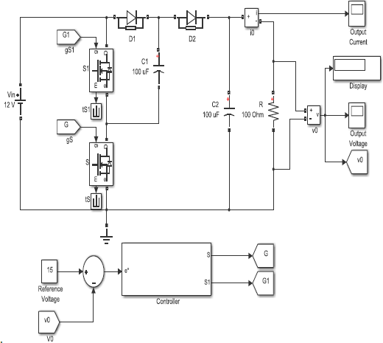

Fig. 3.1 Closed Loop of Basic Circuit of P/O -PPSC Converter

TABLE II. STATEMENT OF CIRCUIT PARAMETERS –P/O PPSC CONVERTER

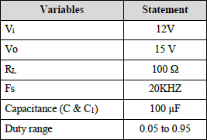

1. *Conventional Controllers*

Fig.3.1 shows the control system reply of initial of the voltage output and current wave for Elementary Circuit of P/O Push-Pull SC converter device with point 15V and nominal load 100Ω with PI controller. Fig.3.2 shown the simulated voltage output and current wave of Elementary Circuit of P/O Push-Pull SC converter device with explosive line disturbances thanks to offer decrement. The Fig.3.3 shows the servo response with twentieth decrement from set voltage at time t=0.06 sec. (t =0 – 0.06 sec, V= 15 V, t=0.06

-0.12 sec, V= 12 V, twentieth decrement). The Fig.3.4 shows the servo response with twentieth increment from set voltage at time t = zero.16 sec (t =0.12 – 0.16 sec, V= 15 V, t=0.16 -0.24 sec, V= 18 V, twentieth increment. the simulated voltage output and current wave in Basic Circuit of P/O PPSC device with explosive load disturbances. The Fig.3.5 shows the response with increment and decrement of fifty load of t =0 – 0.06 sec, Vo= 15 V, R = one hundred ohm; t=0.06 -0.12 sec, V= 15 V, R = one hundred fifty ohm; t=0.12 –

0.16 sec, V= 15 V, R = one hundred ohm; t= 0.16 –

0.24 sec, V= 15 V, R = fifty ohm; t=0.24 – 0.35 sec, V= 15 V, R = one hundred ohm.

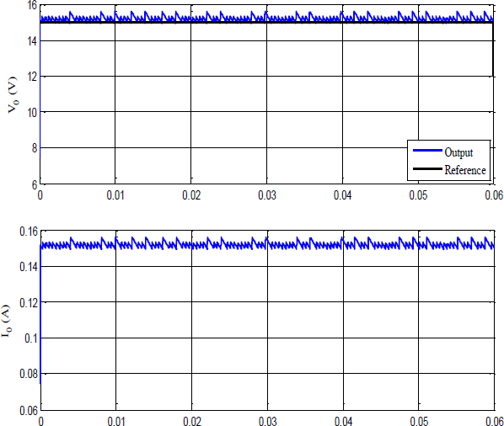

Fig. 3.2 Simulated start-up of the Vo and current wave of Basic Circuit of P/O PPSC converter with point 15V and nominal load 100Ω.

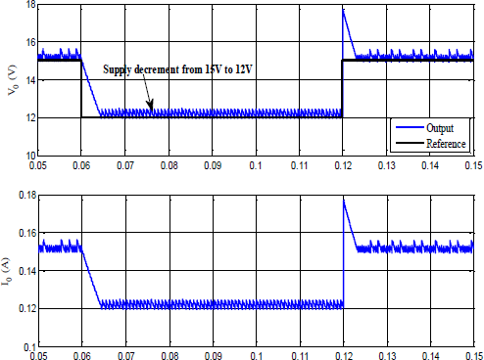

Fig. 3.3 Simulated Vo and current wave form of Basic Circuit of P/O PPSC device with unforeseen line disturbances (15V-12V-15V)

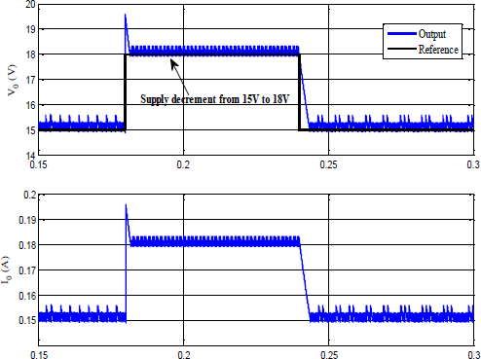

Fig. 3.4 Simulated Vo and current wave form of Basic circuit of PPSC converter with unforeseen line disturbances (15V-18V-15V)

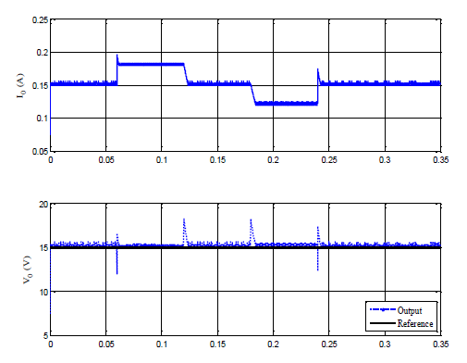

Fig. 3.5 Simulated output voltage and current undulation of Basic Circuit of P/O PPSC device with unexpected load disturbances (100Ω –50 Ω - 100Ω)

1. *Fuzzy Logic Controllers*

Fig.3.1 shows the control system reply of initial of the voltage output and current wave for Elementary Circuit of P/O Push-Pull SC converter device with point 15V and nominal load 100Ω with Fuzzy controller. Fig.3.6 shown the simulated voltage output and current wave of Elementary Circuit of P/O Push-Pull SC converter device with explosive line disturbances thanks to offer decrement. The Fig.3.7 shows the servo response with twentieth decrement from set voltage at time t=0.06 sec. (t =0 – 0.06 sec, V= 15 V, t=0.06

-0.12 sec, V= 12 V, twentieth decrement). The Fig.3.8 shows the servo response with twentieth increment from set voltage at time t = zero.16 sec (t =0.12 – 0.16 sec, V= 15 V, t=0.16 -0.24 sec, V= 18 V, twentieth increment. the simulated voltage output and current wave in Basic Circuit of P/O PPSC device with explosive load disturbances. The Figs 3.9 and 3.10 shows the response with increment and decrement of fifty load of t =0 – 0.06 sec, Vo= 15 V, R = one hundred ohm; t=0.06 -0.12 sec, V= 15 V, R = one hundred fifty ohm; t=0.12 – 0.16 sec, V= 15 V, R = one hundred ohm; t= 0.16 – 0.24 sec, V= 15 V, R = fifty ohm; t=0.24 – 0.35 sec, V= 15 V, R = one hundred ohm. Fig.3.11 shows the graphical representation of performance evaluation of controllers for Basic Track of P/O PPSC Converter using MATLAB

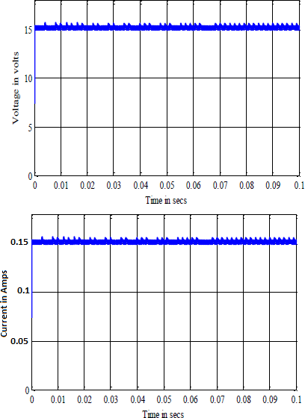

Fig. 3.6 Simulated start-up of the Vo and current wave of Basic Circuit of P/O PPSC converter with point 15V and nominal load 100Ω**.**

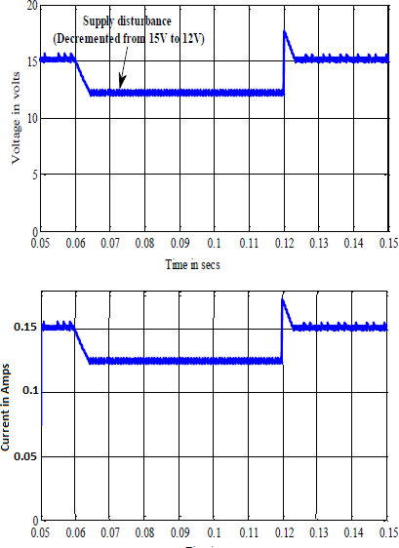

Fig.3.7 Simulated Vo and current wave form of Basic Circuit of P/O PPSC device with unforeseen line disturbances (15V-12V-15V)

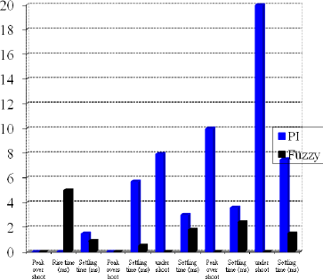

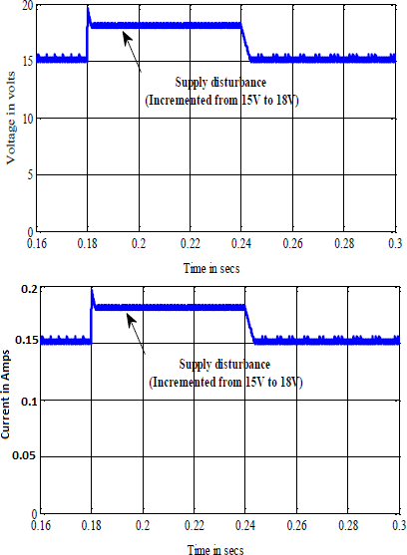Fig. 3.8 Simulated Vo and current wave form of Basic Circuit of P/O PPSC device with unforeseen line disturbances (15V-12V-15V)

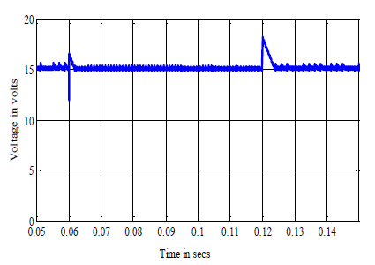

Fig.5.15 Simulated Vo with load disturbances (100Ω –90 Ω -100Ω)

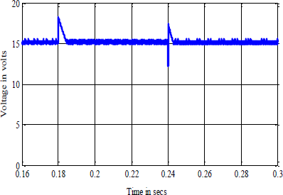

Fig.3.9 Simulated Vo with load disturbances (100Ω –110 Ω -100Ω)

TABLE III. PERFORMANCE EVALUATION OF P/O PPSC CONVERTER WITH RESISTIVE LOAD USING MATLAB

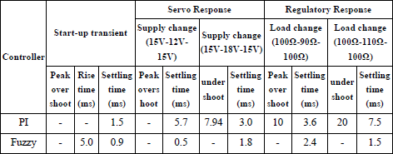

Fig.3.11 Graphical representation of performance evaluation of controllers for Basic Track of P/O PPSC Converter using MATLAB

V. CONCLUSION

The Simulation results show that the proposed PI and fuzzy controller regulates satisfactorily the output voltage of of p/o ppsc converter with resistive load irrespective of line and load disturbances. These establish the validity of the proposed fuzzy controller that effectively rejects changes in DC supply voltage and load resistance which achieving fast tracking of the converter output voltage.

REFERENCES

1. Luo F. L. “Positive Output Luo-Converters: Voltage Lift Technique” IEE-EPA Proceedings Vol. 146, No.4, July 1999, pp. 415-432.
2. Luo F. L. “Positive Output Luo-Converters: Voltage Lift Technique” IEE-EPA Proceedings Vol. 146, No.4, July 1999, pp. 415-432.
3. Luo F. L. “Negative Output Luo-Converters: Voltage Lift Technique” IEE- EPA Proceedings Vol. 146, No.2, March 1999, pp. 208-224.
4. Luo F. L. “Re-Lift Converters: Design, Test, Simulation and Stability Analysis” IEE-EPA Proceedings Vol. 145, No.4, July 1998, pp. 315- 325.
5. Luo F. L. “Double Output Luo-Converters” Proceedings of the IEEE International conference IPEC’99, Singapore, 24-26 May 1999, pp. 647-652.
6. ] Luo F. L. and Ye H. “Switched Inductor Two-Quadrant DC/DC Converter with Fuzzy Logic Control” Proceedings of the IEEE International conference PEDS’99, Hong Kong, 26-29 July 1999, pp. 773-778.
7. Luo F. L. and Ye H. “Switched Inductor Two-Quadrant DC/DC Converter with Neural Network Control” Proceedings of the IEEE International conference PEDS’99, Hong Kong, 26-29 July 1999, pp. 1114-1119.
8. Smedley K. M. and Cuk S. “Dynamics of One-Cycle controlled Cuk Converter” IEEE transactions on PE, Vol. 10,No. 6, November 1995, pp. 634-639.
9. Kassakian J. G., Wolf. H., Miller. J. M. and Hurton. C. J., “Automotive Electrical systems circa 2005” IEEE Spectrum, August 1996, pp. 22-27.
10. Joseph Basanth, A. Natarajan, S.P. and Sivakumaran, T.S. (2009). Development of FLC for ZCS Nilotic QRC. International conference PESA-09, Hong Kong.
11. Joseph Basanth, A. Natarajan, S.P. and Sivakumaran, T.S. (2009). Development of FLC for ZCS Nilotic QRC. International conference PESA-09, Hong Kong.
12. Joseph Basanth, A. Natarajan, S.P. and Sivakumaran, T.S. (2013). Performance analysis of positive output super-lift re-lift Niloticconvertor With PI and neuro controllers. IOSR Journal of Electrical and physics Engineering (IOSR-JEEE). 6 (3), 21-27.
13. Joseph Basanth, A. Natarajan, S.P. and Sivakumaran, T.S. (2013). Performance analysis of positive output super-lift re-lift Niloticconvertor With PI and neuro-controllers. IOSR Journal of Electrical and physics Engineering (IOSR-JEEE). 6 (3), 21-27.