**PDF-Chat SaaS Platform Using MERN Stack**

Harsh Srivastava1, Shraddha Gupta2, Kritika Anand3, Ashnika Sharma4

*1,2,3,4(Final Year B.TECH(IT) Students, Department of COMPUTER SCIENCE & ENGINEERING, INSTITUTE OF TECHNOLOGY & MANAGEMENT, INDIA)*

*Corresponding Author: harshsrivastava09682@gmail.com*

|  |
| --- |
| ***Abstract:****With the rise of PDF-Driven Question Answering Software as a Service (SaaS) platforms in recent years, the field of document processing technology has experienced a paradigm shift. Examining these systems difficulties in detail, this review article concentrates on how they include Next.js, React, Prisma, TRPC, and Tailwind CSS into the MERN (MongoDB, Express.js, React, Node.js) stack. With a careful analysis of the architecture, functions, and ramifications, this study seeks to offer a thorough grasp of the technological developments behind this groundbreaking methodology. The research holds significance due to its intersectionality, as it seamlessly integrates document processing, user interaction, and data administration. The foundation of these systems is the use of Prisma for effective database administration, Next.js and React for creating dynamic and responsive user interfaces, TRPC for reliable API connectivity, and Tailwind CSS for contemporary and beautiful styling. A comprehensive strategy like this tackles the difficulties in processing PDF documents for user identification, question-answering, and facilitating seamless communication between front-end and back-end components. The research attempts to significantly advance our understanding of PDF-driven question-answering SaaS systems by doing this thorough review. Giving insights into the opportunities and complexities of technology, it is a useful tool for practitioners, academics, and developers. These results highlight how important MERN stack technologies are for developing reliable, scalable, and user-focused solutions for the changing document-centric application market.*  ***Key Word****:**PDF-Driven; MERN; TRPC; API* |

1. **Introduction**

The rapid development of digital technologies has completely changed how information is produced, accessed, and handled. In the modern digital era, especially documents that are in Portable Document Format, or PDF are widely used in a variety of fields, from commerce and administration to education and research. The necessity for effective document processing solutions has grown as the number and complexity of digital documents continue to rise. Platforms that provide PDF-Driven Question Answering Software as a Service (SaaS) have become cutting-edge technologies for gathering insights and streamlining interaction with PDF documents in response to this need. These platforms provide a comprehensive solution for tackling the difficulties related to document-centric jobs by utilizing a wide range of technologies to facilitate seamless document processing, user interaction, and data management.

The goal of this review is to give a thorough overview of PDF-driven QA SaaS platforms, with an emphasis on appreciating and understanding their features, architecture, and consequences of document processing technologies. We aim to explore the complexities of these platforms' design and highlight their potential applications across a range of sectors by investigating the integration of frontend and backend components and the underlying technologies that power these platforms. The digital environment is defined by an excess of documents in different formats, each with a specific function and important data. Due to their platform independence, which makes them perfect for sharing and transferring information across many devices and operating systems, PDF documents in particular have become increasingly popular. Nevertheless, there are many obstacles in the way of processing and deriving valuable insights from PDF documents, particularly in large-scale applications where human interaction is laborious and unfeasible.

This cutting-edge Software as a Service (SaaS) platform is intended to completely transform document management and teamwork. This Software was created as part of a large-scale final-year project, that uses the MERN stack's cutting-edge technologies like Next. JS 13, React, Prisma, TRPC, and Tailwind—to provide a feature-rich and seamless user experience. Next.js 13, a powerful and adaptable web development framework that makes it easier to create contemporary, responsive applications, is the foundation of Software. React, a JavaScript user interface package is included to guarantee a dynamic and effective front-end experience that lets users interact with documents naturally and easily.

A strong basis for data storage, retrieval, and manipulation is provided by Prisma, a contemporary database toolkit that improves its backend architecture. To handle the various needs of document-centric workflows, the platform's scalability and responsiveness are ensured. To provide safe and effective client-server communication, this software leverages TRPC, a framework for creating type-safe APIs. This leads to a more efficient procedure for exchanging data, which enhances dependability and efficiency in situations involving real-time cooperation. Tailwind is a utility-first CSS framework that provides a responsive and aesthetically pleasing design for the user interface. Tailwind's versatility ensures a consistent and enjoyable user experience across all platforms, enabling software to adjust to a variety of screen sizes and device types. This Software proves to be innovative as a service (SaaS) solution that integrates cutting-edge technologies to handle the complication of document management. This platform, which combines the best features of Next.js 13, React, Prisma, tRPC, and Tailwind, is set to revolutionize document-centric workflows and change the way users interact with and collaborate on documents.

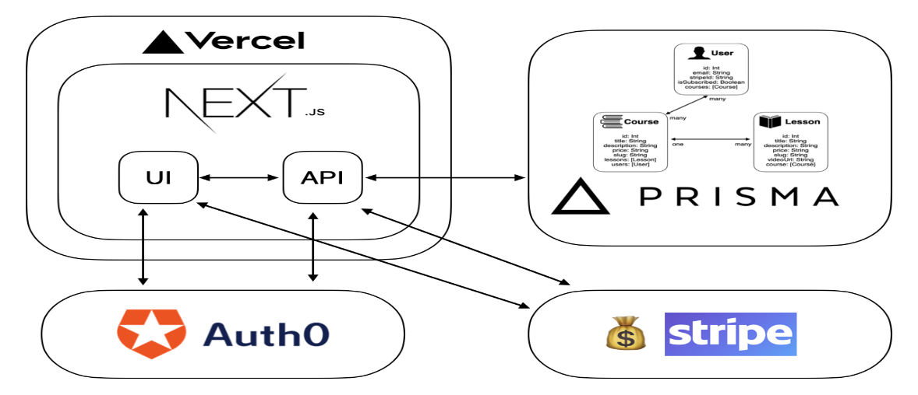

**Figure 1:** Architecture of Building a SaaS Application with Next.js, Prisma, Auth0, and Stripe.

1. **Objectives**

Some of the Objectives are listed below:

* **PDF Experience:** Develop a feature-rich PDF viewer that enables users to interact with PDF documents by asking questions directly within the platform.
* **Seamless User Engagement:** Create a captivating and user-friendly interface, ensuring a seamless onboarding experience through visually appealing landing pages, intuitive navigation, and responsive design.
* **Technological Excellence:** Implement cutting-edge technologies, including Next.js 13, React, Prisma, TRPC, and Tailwind CSS, to build a robust, secure, and performant SaaS platform from scratch, providing users with a modern and innovative solution for document interactions.

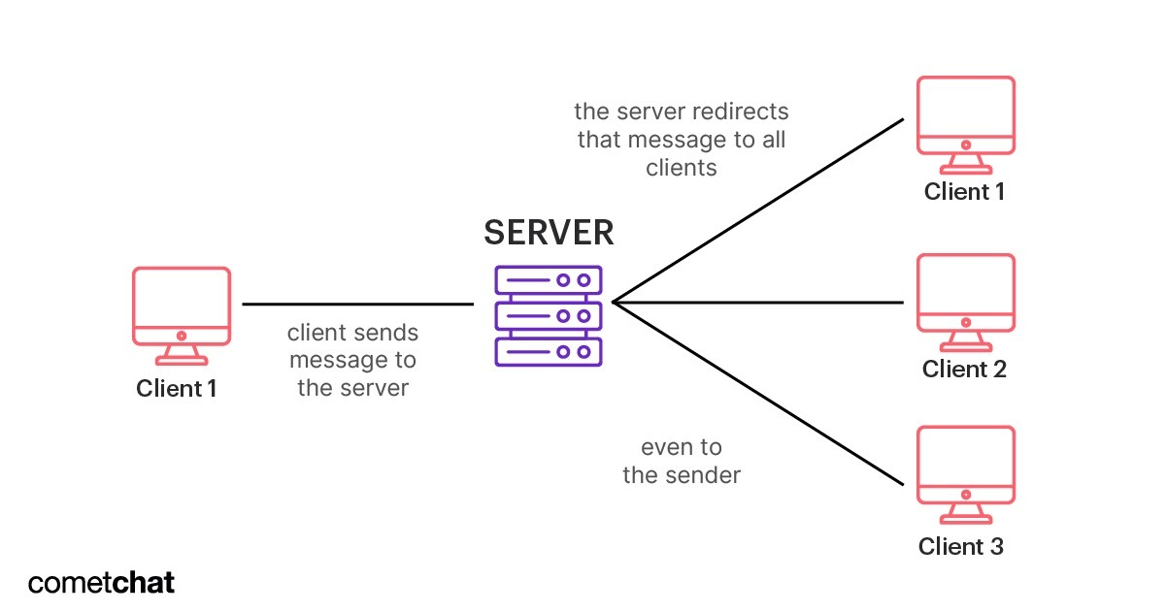

**Figure 2:** Client Server Architecture.

1. **Features**

All the Features of the software are described below:

* **Complete SaaS Development**: A comprehensive Software as a Service (SaaS) platform built from scratch, ensuring a tailored and efficient solution.
* **Captivating Landing Pages:** Visually appealing landing pages designed to engage users and facilitate a smooth onboarding process.
* **Secure Authentication with Kinde:** Robust user authentication using Kinde, prioritizing the security of user data.
* **Optimized Performance:** Leveraging features such as infinite message loading and real-time streaming API response for optimal platform performance.
* **Advanced PDF Viewer:** A sophisticated PDF viewer that goes beyond aesthetics, allowing users to interact by asking questions directly from the document.
* **Modern UI with 'shadcn-ui':** Crafting a clean and modern user interface using 'shadcnui' to enhance the overall user experience.
* **Optimistic UI Updates:** Ensuring a positive user experience with optimistic UI updates, and maintaining responsiveness during data transactions.
* **Intuitive Drag n’ Drop Uploads:** User-friendly file upload system with intuitive drag-and-drop functionality, simplifying the process for users.
* **Infinite AI Memory with LangChain:** Implementing LangChain for infinite artificial intelligence (AI) memory, adding an intelligent layer to the platform.
* **Vector Storage with Pinecone:** Utilizing Pinecone for vector storage to optimize data retrieval and storage processes.
* **ORM with Prisma:** Incorporating Prisma as the Object-Relational Mapping (ORM) tool for seamless and efficient database interaction.

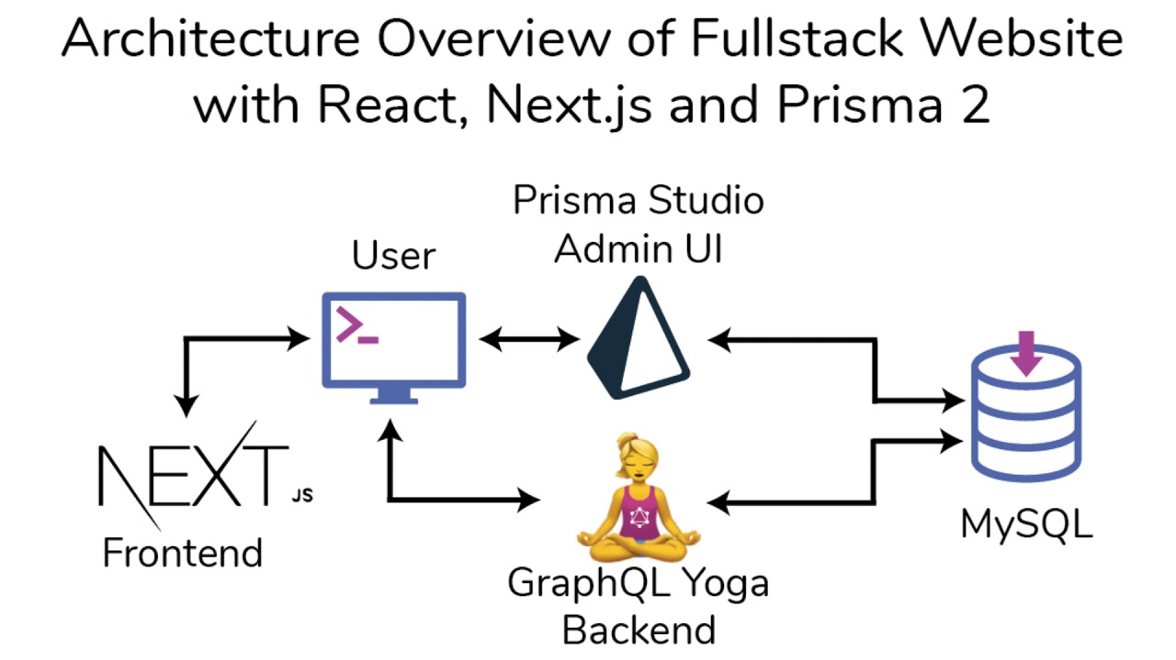

**Figure 3:** Architecture Overview of Web app with React, Next. JS, and Prisma 2.

* **Modern Data Fetching with TRPC & Zod:** Exploring modern data fetching techniques using TRPC and Zod for efficient and type-safe data retrieval.
* **Real-time Streaming Demo:** Demonstrating the capabilities of real-time streaming through an interactive demo, showcasing its impact on user interaction.

1. **Literature Review**

**1. Title-** Software-as-a-service (SaaS): Perspectives and Challenges.

**Location-** China (2014).

**Name of Author-** TSAI WeiTek, BAI XiaoYing & HUANG Yu.

In this research, the viewpoints and difficulties around software-as-a-service (SaaS) in cloud computing are covered in this article. A summary of SaaS design and important technological concerns, including scalability, redundancy and recovery mechanisms, multi-tenancy architecture, and customization, is given. The paper also examines the necessity of redundancy and recovery methods in SaaS systems, as well as various customization tactics and trade-offs, the significance of multi-tenancy design, and more. It also includes software design techniques, automated data migration, and load balancers as SaaS scaling solutions. The main technological obstacles to creating and executing software as a service (SAAS) solutions include scalability, redundancy and recovery procedures, multi-tenancy architecture, and customization. To guarantee the efficiency and dependability of SaaS systems, these issues need to be carefully considered and approached using specific tactics. SAAS system modification is not the same as traditional software customization in a few aspects. SaaS customization possibilities include intelligent customization, SaaS infrastructure that is customizable, fixed variation points with fixed options, tenant-supplied options, tenant-created variation points and options, and SaaS and PaaS setup. Compared to traditional software modification, this enables a more dynamic and flexible approach to customization.

**2. Title-** Analysis of SaaS Business Platform Workloads for Sizing and Collocation.

**Location-** Bangalore, India (2012).

**Name of Author-** Rajeshwari Ganesan, Santonu Sarkar, Akshay Narayan.

In this research, an offline analysis approach for data center workloads is proposed, which is especially appropriate for SaaS commercial applications. The technique focuses on finding workloads that are suitable for collocation and makes the assumption that resource use patterns are understood. It also offers a way to figure out how much capacity each job can have in terms of set-aside shared resources that are both static and dynamic. Workload utilization logs from several locations are used to assess the methodology. The 99th percentile utilization for reserved capacity is used for low-variation workloads, and heuristics are used for high-variation workloads. The study takes into account upcoming work on integrating business-specific constraints and recognizes the necessity to look into the best levels of reserved capacity. The suggested program, iCirrus-WoP, calculates virtual machine capacity and creates a workload compatibility matrix. Infrastructure specifics are disregarded, though, so future research into placement algorithms taking these limitations into account is still open.

**3. Title-** Encryption Methods and Comparison of Popular Chat Applications.

**Location-** Turkey (2021).

**Name of Author-** Muhammed Burak KILIÇ.

In this research, the study examines the ongoing and growing security threats to communication, especially in light of the current international situation. It draws attention to the security problems' exponential rise, particularly in light of our growing reliance on technology. To address the growing concerns about the confidentiality of data, including photos, videos, and sound recordings, the study focuses primarily on the necessity of end-to-end encryption in chat programs. The main goal is to put up a system that permits users to securely exchange private information with one another. To offer a reliable and secure platform for communication in the digital age, the paper goes on to propose a detailed list of prerequisites for the creation of a secure chat application.

**4. Title-** Lifeline Messenger Real-Time Chat Application: Using Mern Stack.

**Location-** Pune, Maharashtra, India (2023).

**Name of Author-** Abhishek Bedare, Harsh Jaiswal, Nehalika Kantule, Shubham Kale.

In this research, Lifeline Messenger has effectively showcased its potential as an all-inclusive chat program that provides users with a smooth and feature-rich interactive conversation experience. Our application's ability to offer media sharing and private and group chat features is made possible by the creation and deployment of the MERN stack.  
User-friendliness, dependability, and security were carefully considered at every stage of the development process. Users can easily connect with friends and family with Lifeline Messenger's intuitive layout, which makes registration and login simple. The real-time chat feature of the application facilitates quick communication, leading to productive and interesting discussions. Users may easily share files, photos, videos, and other media within their chats thanks to the integration of media-sharing facilities, which improves the entire user experience. Increased engagement is encouraged, and a framework for easy collaboration and content sharing is provided. In addition, Lifeline Messenger gives its users security and privacy a top priority. Steps have been taken to secure user data and guard against unapproved access or possible data breaches. We have made an effort to provide a safe and secure environment for users to interact and exchange information by implementing strong security protocols and encryption techniques. By providing real-time texting and doing away with pointless meetings, Lifeline Messenger transforms communication. Collaboration is improved by effective file sharing and storage. Decisions can be made with knowledge and in real-time, thanks to instant reporting. The robust tool Lifeline Messenger promotes smooth communication in the contemporary workplace and maximizes efficiency.

**5. Title-** Analysis of Language-Model-Powered Chatbots for Query Resolution in PDF-Based Automotive Manuals.

**Location-** Basel Switzerland (2023).

**Name of Author-** Thaís Medeiros, Morsinaldo Medeiros, Mariana Azevedo, Marianne Silva, Ivanovitch Silva and Daniel G. Costa.

In this research, the examination of language-model-driven chatbots for question answering in PDF-based car manuals is covered in this article. The use of large language models (LLMs) to produce AI-assisted tools for the automotive industry is examined in this paper. Based on answer accuracy, cost, and user experience, the authors evaluate three distinct approaches. The findings demonstrate that selecting a method has a variety of practical ramifications and is dependent on certain factors. The paper sheds light on chatbots' usefulness and application in the automotive sector, especially when it comes to engaging with owner's manuals. According to the study, customer assistance and post-sale services in the automobile sector could undergo a revolution with the use of AI-driven chatbots. In addition to offering prompt and precise responses to questions, these chatbots may help users understand car manuals and encourage safe driving and the upkeep of their vehicles. Additionally, voice command integration and user-friendly interfaces can improve the accessibility of vehicle information for users of different technical skill levels. However, the research also emphasizes difficulties with things like reading PDF documents' visual features and the requirement for constant enhancements to user experience and accuracy.

1. **Conclusion**

The review article on the "PDF Chat SAAS platform" concludes by offering a full analysis of the application's performance and highlighting its effectiveness, low latency, and real-time communication capabilities. The transformational potential for customer assistance is shown by exploring the deployment of language-model-powered chatbots in the automotive industry. The study addresses workload compatibility issues with SaaS and suggests an offline analysis method. End-to-end encryption is recommended in response to security and privacy issues in chat applications. In summary, the document provides insightful information about the technical and industry-specific features of the PDF Chat SAAS platform, which adds to the current conversations about SAAS applications and their wider outcome.

1. **References**
2. Tsai, W., Bai, X., & Huang, Y. (2014). Software-as-a-service (SaaS): Perspectives and Challenges. *Science China Information Sciences*, 57, 1–15.
3. Ganesan, R., Sarkar, S., Narayan, A., (2012). Analysis of SaaS Business Platform Workloads for Sizing and Collocation. *IEEE Fifth International Conference on Cloud Computing*, 868-875.
4. KILIÇ, M.B., (2021). Encryption Methods and Comparison of Popular Chat Applications. *Advances in Artificial Intelligence Research (AAIR).* 1(2), 52-59.
5. Bedare, A., Jaiswal, H., Kantule, N. and Kale, S. (2023). Lifeline Messenger Real-Time Chat Application: Using Mern Stack. *International Research Journal of Modernization in Engineering Technology and Science*, 05(05), 5627-5634.
6. Medeiros, T., Medeiros, M., Azevedo, M., Silva, M., Silva, I., & Costa, D. G. (2023). Analysis of Language-Model-Powered Chatbots for Query Resolution in PDF-Based Automotive Manuals. *Multidisciplinary Digital Publishing Institute Basel Switzerland*, 5(4), 1384-1399.